Homo sapiens FUS RNA binding protein (FUS), NM_004960.4, mRNA sequence
1191 TGGAGGTGGTGGCAGTGGTGGTGGTGGCCGAGGAGGATTTCCCAGTGGAGGTGGTGGCGGTGGAGGACAG

1261 CAGCGAGCTGGTGACTGGAAGTGTCCTAATCCCACCTGTGAGAATATGAACTTCTCTTGGAGGAATGAAT
FUS-splicing-F
1331 GCAACCAGTGTAAGGCCCCTAAACCAGATGGCCCAGGAGGGGGACCAGGTGGCTCTCACATGGGGGGTAA

1401 CTACGGGGATGATCGTCGTGGTGGCAGAGGAGGCTATGATCGAGGCGGCTACCGGGGCCGCGGCGGGGAC

1471 CGTGGAGGCTTCCGAGGGGGCCGGGGTGGTGGGGACAGAGGTGGCTTTGGCCCTGGCAAGATGGATTCCA

1541 GGGGTGAGCACAGACAGGATCGCAGGGAGAGGCCGTATTAATTAGCCTGGCTCCCCAGGTTCTGGAACAG
G V S T D R I A G R G R I N *
1611 CTTTTTGTCCTGTACCCAGTGTTACCCTCGTTATTTTGTAACCTTCCAATTCCTGATCACCCAAGGGTTT
FUS-splicing-R
1681 TTTTGTGTCGGACTATGTAATTGTAACTATACCTCTGGTTCCCATTAAAAGTGACCATTTTAGTTAAATT

Supplementary Figure 1. The translation product of FUS with the c.1394-2delA mutation. The sequence of WT FUS exon14 was highlighted in blue; The bases with yellow background indicated the newly translated sequences. The underlined sequences represent the primer targeting region for RT-PCR.

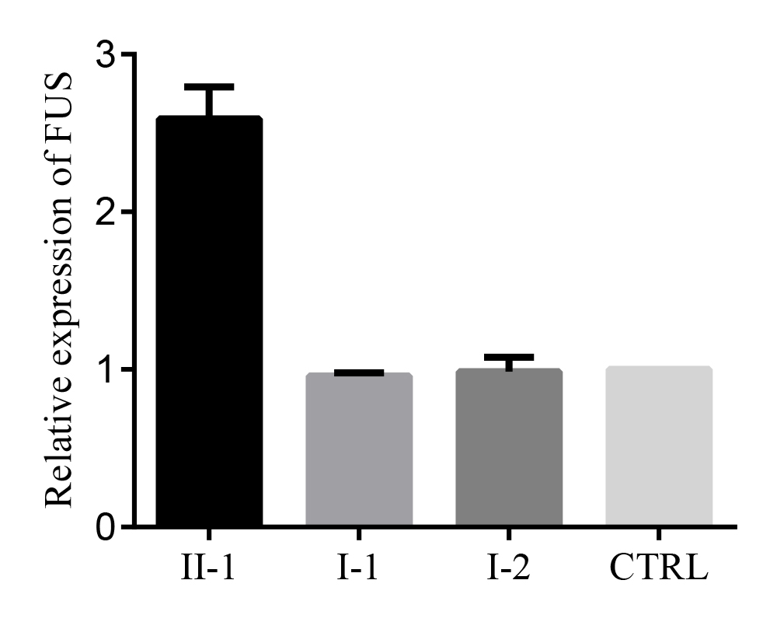
Supplementary Figure 2. Relative total FUS mRNA expression level in the mutation carrier (II-1), and three wild type carriers (I-1, I-2, and another independent healthy control [CTRL]). The expression of FUS was normalized to the expression housekeeping gene (GAPDH).

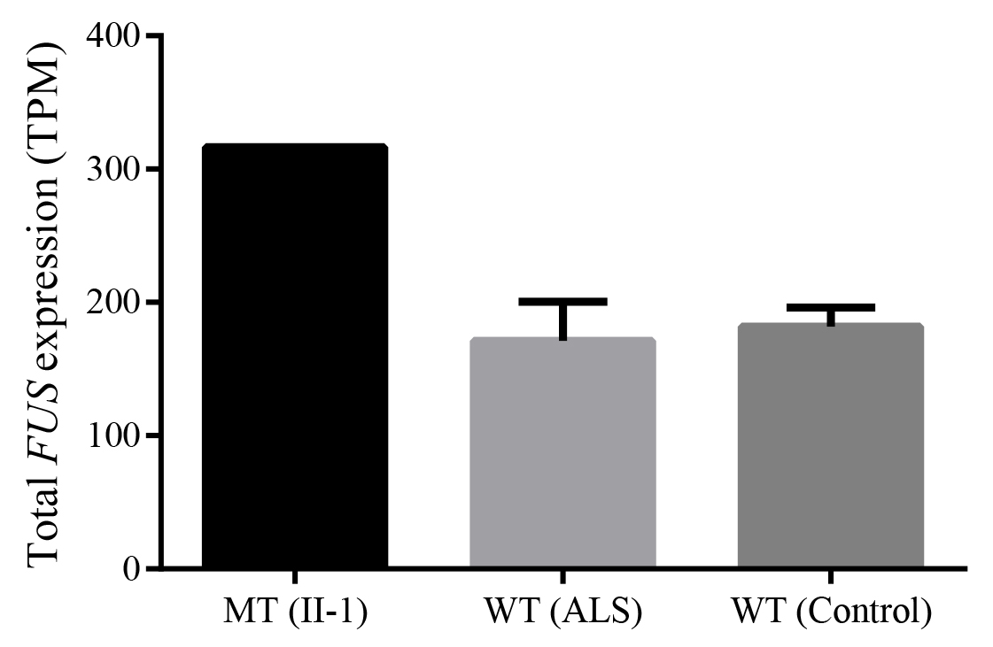

Supplementary Figure 3. RNA-seq revealed increased total FUS expression in splice site mutation carrier (II-1) when compared to non-carriers, including 3 ALS cases and 3 healthy controls. The error bar represents standard deviation. MT: mutant; WT: wild type; TPM: Transcript per million.

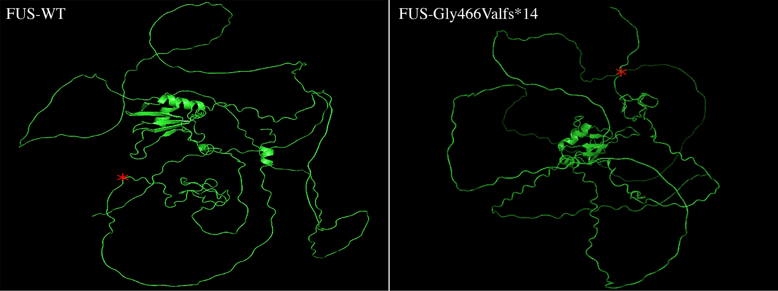
Supplementary Figure 4. Prediction of protein structures based on Alphafold. Left: FUS protein with wild type (WT) allele; Right: FUS protein with the FUS mutation (p.Gly466Valfs*14). FUS protein with the mutation showed a truncated structure. The asterisk indicates the 465 locus of FUS protein.

Supplementary Table 1 List of primers used for RT-qPCR
Primer name | Sequence (5’ to 3’)
FUS-qPCR-F | ATGGCCTCAAACGATTATACCCA
FUS-qPCR-R | GTAACTCTGCTGTCCGTAGGG
GAPDH-F | GGAGCGAGATCCCTCCAAAAT
GAPDH-R | GGCTGTTGTCATACTTCTCATGG

