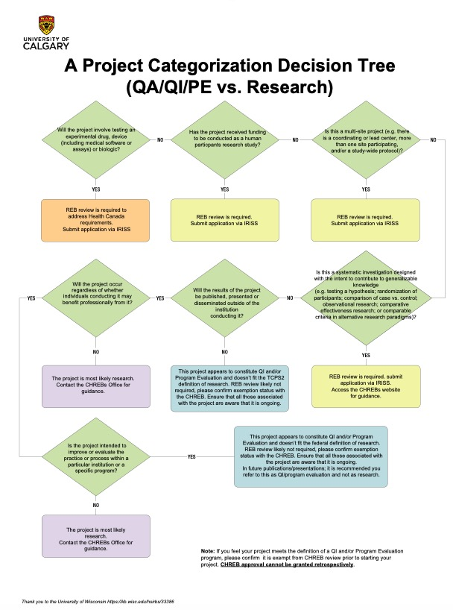

Figure S1: Project categorization as quality improvement. The local institutional review board (IRB) waived the requirement for approval and indicated that our project was to be categorized as quality improvement (QI), which has a unique approval system at our centre (https://arecci.albertainnovates.ca/resources/)

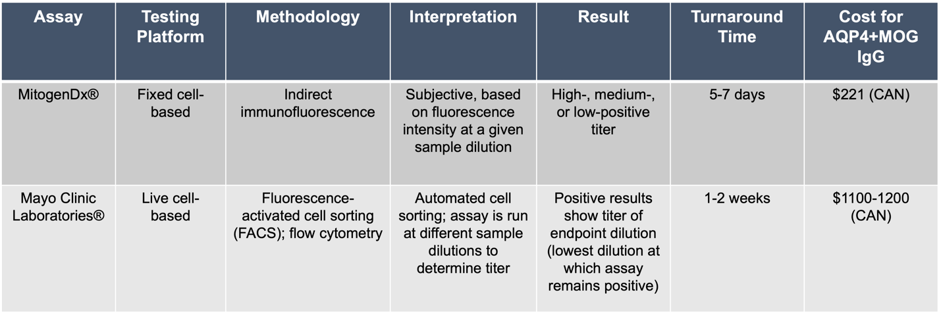

Table S1: Comparison of cell-based anti-AQP4/MOG autoantibody assays. More specific information can be found at the laboratory websites (linked in main manuscript). Costs are estimated based on unpublished conversations with local laboratory personnel as of 2020 and includes the cost to send the test out.

