SUPPLEMENTAL MATERIAL

Title
The impact of stroke public awareness campaigns differs between sociodemographic groups

Authors
Bastien Rioux, MD^{1,2}; Vincent Brissette³; Francine Forget Marin, PDt, MBA⁴; Patrice Lindsay, RN, PhD⁴; Mark R Keezer, MDCM, PhD^{1,2,5}; Alexandre Y Poppe, MDCM^{1,2}

Affiliations
¹ Centre hospitalier de l’Université de Montréal (CHUM), Montreal, Quebec, Canada
² Department of Neurosciences, Faculty of Medicine, University of Montreal, Montreal, Quebec, Canada
³ Faculty of Medicine, McGill University, Montreal, Quebec, Canada
⁴ Heart and Stroke Foundation of Canada
⁵ School of Public Health, University of Montreal, Montreal, Quebec, Canada

Corresponding author
Bastien Rioux, MD
Centre hospitalier de l’Université de Montréal, Montreal, Quebec, Canada
1000, St. Denis Street, H2X 0C1, Montreal, Quebec, Canada (postal address)
Email: bastien.rioux@umontreal.ca; Phone: 1 514 890-8000

Table of contents
Supplemental Table I. Characteristics of individual FAST campaigns. 3
Supplemental Table II. Individual FAST stroke signs named by respondents per wave. 4
Supplemental Table III. Individual non-FAST stroke signs named by respondents per wave. 5
Supplemental Figure I. FAST stroke signs identified per statistically significant variables (multivariable model) in wave 4. 7
Supplemental Table IV. Method by which respondents became aware of the FAST campaigns. 8
Supplemental Table V. Logistic regression models for awareness of the previous campaign in wave 4. 9
Supplemental Table VI. Stroke definition as per respondents by wave. 10
Supplemental Table VII. First response to a suspected stroke by respondents per wave. 11

Supplemental Table I. Characteristics of individual FAST campaigns.
Campaign | Date of press release | Duration (days) | Total investment (CAD $) | Global PSA value (CAD $)ª | French campaign budget (%) | Interviews and known coverage | Spokespersons (celebrities) | Impressions generated^{b}
2016 | March 30th,  2016 | 108 | 152,037 | >1,300,000 | 100 | 43 | 38 (ML, JD) | 20,270,300
Spring 2017 | April 3rd,  2017 | 70 | 134,703 | 678,299^{c} | 75 | 75 | 34 (JB, LPR) | 16,543,253
Fall  2017 | None | 22 | 286,326 |  | 59 | NA | NA (JB, LPR) | NA
Spring  2018 | May 28th,  2018 | 35 | 170,667 | 212,090 | NA | 7 | 41 (JB, LPR) | 2,346,446
Fall  2018 | October 29th,  2018 | 48 | 390,700 | NA | NA | NA | 41 (JB, LPR) | 9,161,608

ªPublic service announcements (PSA) refer to donated ad time or space. ^{b}Impressions refer to prints and screen displays. ^{c}Combined spring and fall 2017 campaigns. Abbreviations: CAD $, Canadian dollars; JB, Josée Boudreault; JD, Jacques Demers; LPR, Louis-Philippe Rivard; ML, Michel Labrecque; NA, not available; PSA, public service announcements.

Supplemental Table II. Individual FAST stroke signs named by respondents per wave.
Stroke sign named | Wave 1 | Wave 2 | Wave 3 | Wave 4 | Total
Face | 20.8 (16.7, 25.4) | 34.0 (29.1, 39.1) | 30.4 (25.8, 35.4) | 36.2 (33.0, 39.5) | 31.9 (29.8, 34.0)
Arm | 42.8 (37.6, 48.1) | 54.8 (49.5, 60.0) | 53.9 (48.6, 59.1) | 53.8 (50.5, 57.2) | 51.9 (49.7, 54.2)
Speech | 44.1 (38.9, 49.4) | 51.3 (46.1, 56.6) | 57.3 (52.0, 62.4) | 54.4 (51.0, 57.8) | 52.5 (50.2, 54.7)

Frequencies are presented in % weighted proportions (95% confidence interval). Face refers to answers equivalent to “face drooping”. Arm refers to answers equivalent to “inability to raise arms”, “paralysis” or “weakness of one side of the body”. Speech refers to answers equivalent to “slurred or jumbled speech”.

Supplemental Table III. Individual non-FAST stroke signs named by respondents per wave.
Stroke sign named | Wave 1 | Wave 2 | Wave 3 | Wave 4 | Total
Confusion | 10.6 (7.6, 14.3) | 12.3 (9.2, 15.9) | 16.0 (12.4, 20.2) | 12.1 (10.1, 14.4) | 12.6 (11.2, 14.1)
Numbness | 15.4 (11.5, 20.0) | 16.4 (12.7, 20.6) | 9.5 (6.5, 13.3) | 10.1 (8.1, 12.4) | 12.1 (10.7, 13.7)
Do not know | 17.9 (13.9, 22.4) | 11.5 (8.2, 15.6) | 9.8 (6.5, 14.0) | 9.3 (7.5, 11.3) | 11.4 (10.0, 12.9)
Loss of consciousness | 12.8 (9.6, 16.5) | 10.7 (7.5, 14.7) | 13.6 (10.4, 17.4) | 9.9 (8.0, 12.2) | 11.3 (9.9, 12.8)
Dizziness | 10.9 (7.8, 14.5) | 10.7 (7.9, 14.0) | 12.0 (8.9, 15.7) | 9.3 (7.4, 11.5) | 10.3 (9.0, 11.7)
Vision problem | 8.7 (6.1, 11.9) | 7.6 (5.2, 10.6) | 8.3 (5.7, 11.5) | 9.2 (7.2, 11.5) | 8.6 (7.4, 10.0)
Chest or other pain | 9.8 (6.6, 13.8) | 10.2 (7.6, 13.4) | 4.9 (2.9, 7.8) | 6.9 (5.3, 8.8) | 7.7 (6.5, 8.9)
Headache | 9.1 (6.3, 12.6) | 6.1 (4.1, 8.8) | 8.4 (5.5, 12.0) | 5.1 (3.8, 6.6) | 6.6 (5.6, 7.8)
Problem with coordination or balance | 6.5 (3.8, 10.2) | 3.7 (2.3, 5.6) | 5.5 (3.5, 8.1) | 2.3 (1.4, 3.4) | 3.9 (3.1, 4.8)
Shortness of breath | 3.7 (2.0, 6.1) | 7.0 (4.4, 10.4) | 3.5 (2.1, 5.6) | 2.9 (1.9, 4.3) | 3.9 (3.1, 4.8)
Other | 6.7 (4.4, 9.7) | 3.9 (2.3, 6.3) | 5.2 (3.1, 8.0) | 1.1 (0.6, 1.9) | 3.4 (2.7, 4.3)
General weakness | 1.9 (0.8, 3.8) | 0.8 (0.1, 2.5) | 1.0 (0.3, 2.3) | 1.3 (0.6, 2.4) | 1.3 (0.8, 1.9)
Vomiting | 0.9 (0.3, 2.1) | 1.4 (0.6, 2.9) | 1.9 (0.7, 4.0) | 0.5 (0.2, 1.1) | 1.0 (0.6, 1.5)
Sweating | 0.9 (0.1, 3.8) | 0.8 (0.2, 2.0) | 1.2 (0.3, 3.3) | 0.5 (0.2, 1.0) | 0.7 (0.4, 1.3)
Seizure | 0.4 (0.0, 2.3) | 0.0 (0.0, 0.7) | 0.8 (0.1, 2.8) | 0.8 (0.3, 1.9) | 0.6 (0.3, 1.2)
Problem with blood pressure | 1.5 (0.6, 3.1) | 0.2 (0.0, 0.9) | 0.4 (0.0, 2.3) | 0.3 (0.1, 0.9) | 0.5 (0.3, 1.0)

Frequencies are presented in % weighted proportions (95% confidence interval). The proportions do not sum up to 100% because FAST signs are presented in a separate table and participants could name multiple signs. We collapsed the following answers: “confusion, difficulty thinking, memory loss” and “incoherence in general” into a single “confusion” answer; “sudden headache” and “headache in general” into a single “headache” answer.

Supplemental Figure I. FAST stroke signs identified per statistically significant variables (multivariable model) in wave 4.
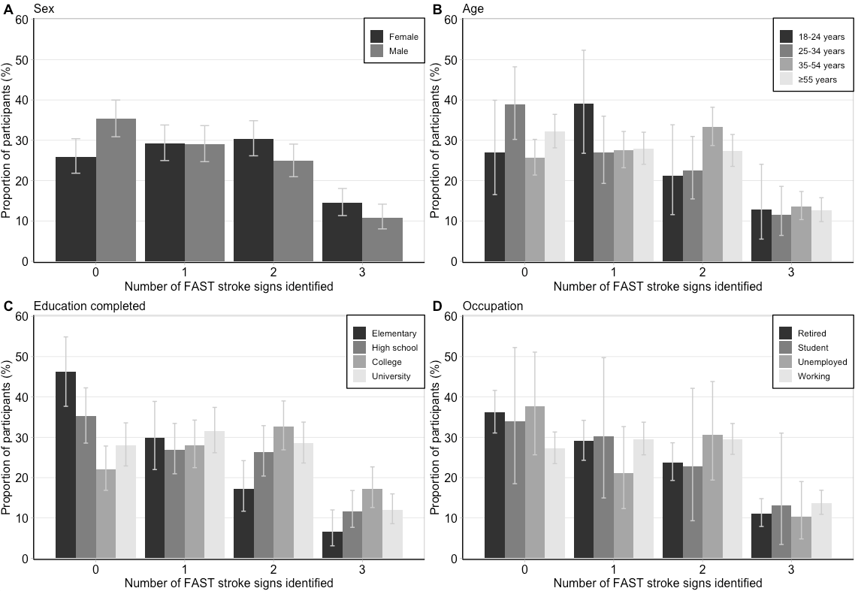

Supplemental Table IV. Method by which respondents became aware of the FAST campaigns.
Method | Wave 1 | Wave 2 | Wave 3 | Wave 4 | Total
Television | 80.6 (73.2, 86.6) | 67.9 (60.2, 75.0) | 82.2 (75.1, 88.0) | 83.3 (79.4, 86.7) | 80.1 (77.3, 82.7)
Social media | 11.5 (6.9, 17.7) | 17.7 (12.4, 24.2) | 12.5 (7.5, 19.0) | 12.6 (9.7, 16.1) | 13.3 (11.1, 15.7)
Radio | 15.4 (9.9, 22.4) | 24.1 (17.8, 31.4) | 11.5 (7.4, 16.9) | 7.4 (5.2, 10.2) | 12.2 (10.2, 14.4)
Newspaper | 6.8 (3.7, 11.2) | 3.4 (1.4, 7.0) | 5.8 (3.0, 9.9) | 4.6 (3.0, 6.6) | 4.9 (3.8, 6.3)
Other | 10.4 (6.1, 16.2) | 5.2 (2.4, 9.6) | 3.6 (1.6, 6.8) | 2.5 (1.3, 4.4) | 4.3 (3.1, 5.7)
Word of mouth | 1.3 (0.3, 3.7) | 0.4 (0.0, 2.0) | 4.1 (1.1, 10.3) | 4.2 (2.2, 7.3) | 3.1 (1.9, 4.9)
Online searches, banner ads | 0.4 (0.0, 2.4) | 3.6 (0.9, 9.6) | 3.6 (1.4, 7.3) | 1.9 (1.0, 3.3) | 2.3 (1.4, 3.5)
Do not know | 1.4 (0.1, 5.5) | 1.5 (0.3, 4.3) | 0.4 (0.0, 2.2) | 1.7 (0.8, 3.2) | 1.4 (0.8, 2.3)
Billboards, bus shelters | 0.0 (0.0, 0.7) | 1.0 (0.1, 3.7) | 1.5 (0.4, 3.9) | 0.8 (0.2, 1.8) | 0.9 (0.4, 1.6)
Magazines | 1.0 (0.1, 3.7) | 0.0 (0.0, 0.7) | 0.7 (0.1, 2.5) | 0.4 (0.1, 1.3) | 0.5 (0.2, 1.0)

Frequencies are presented in % weighted proportions (95% confidence interval). Frequencies are for respondents who reported being aware of the previous FAST campaign. The proportions do not sum up to 100% because participants could give multiple answers.

Supplemental Table V. Logistic regression models for awareness of the previous campaign in wave 4.
Variables | Univariable model |  | Multivariable model
 | OR (95% CI) | p-value | OR (95% CI) | p-value
Male sex | 0.59 (0.46, 0.74) | <0.001 | 0.66 (0.49, 0.88) | 0.006
Age (reference: ≥55 years)
18-24 | 0.38 (0.25, 0.56) | <0.001 | 0.33 (0.16, 0.66) | 0.002
25-34 | 0.72 (0.50, 1.02) | 0.064 | 0.73 (0.42, 1.27) | 0.259
35-54 | 1.17 (0.87, 1.58) | 0.299 | 0.99 (0.61, 1.60) | 0.964
Education completed (reference: university)
Elementary school | 0.33 (0.21, 0.50) | <0.001 | 0.45 (0.26, 0.75) | 0.002
High school | 0.71 (0.51, 0.99) | 0.042 | 0.88 (0.59, 1.32) | 0.543
College | 0.79 (0.58, 1.06) | 0.121 | 0.99 (0.70, 1.42) | 0.973
Marital status (reference: married/common-law)
Single (never married) | 0.57 (0.44, 0.75) | <0.001 | 1.04 (0.72, 1.51) | 0.820
Divorced/separated | 0.87 (0.56, 1.34) | 0.522 | 1.11 (0.66, 1.89) | 0.687
Widowed | 0.83 (0.47, 1.46) | 0.508 | 0.84 (0.40, 1.76) | 0.652
Occupation (reference: working)
Retired | 1.05 (0.77, 1.41) | 0.772 | 1.06 (0.63, 1.79) | 0.834
Student | 0.67 (0.41, 1.09) | 0.111 | 1.21 (0.63, 2.31) | 0.571
Unemployed | 0.66 (0.41, 1.05) | 0.085 | 0.78 (0.44, 1.37) | 0.395
Household income (reference: CAD $≥80,000)
<40,000 | 0.42 (0.30, 0.58) | <0.001 | 0.52 (0.34, 0.80) | 0.003
≥40,000 to <80,000 | 0.68 (0.49, 0.94) | 0.021 | 0.73 (0.50, 1.07) | 0.105
English language | 0.52 (0.35, 0.78) | 0.002 | 0.66 (0.40, 1.09) | 0.110
Landline contact method | 1.96 (1.54, 2.50) | <0.001 | 1.47 (1.05, 2.05) | 0.026

All models are weighted. Multivariable model includes all variables. Abbreviations: CAD $, Canadian dollars; CI, confidence interval; OR, odds ratio.

Supplemental Table VI. Stroke definition as per respondents by wave.
Stroke definition | Wave 1 | Wave 2 | Wave 3 | Wave 4 | Total
Blockage of blood circulation to the brain | 28.5 (23.9, 33.4) | 39.3 (34.3, 44.5) | 35.7 (30.7, 40.9) | 35.3 (21.1, 38.6) | 34.8 (32.7, 37.0)
Problem with the heart | 40.6 (35.3, 46.1) | 30.4 (25.8, 35.3) | 23.7 (19.6, 28.2) | 28.8 (25.8, 31.9) | 30.4 (28.3, 32.4)
Rupture of blood vessel to the brain | 6.3 (4.3, 9.0) | 13.7 (10.6, 17.4) | 20.0 (16.1, 24.4) | 20.0 (17.4, 22.8) | 16.3 (14.8, 18.0)
Problem with the brain (unspecified) | 21.0 (16.9, 25.6) | 13.8 (10.4, 17.7) | 13.4 (10.1, 17.4) | 13.4 (11.2, 15.9) | 14.9 (13.4, 16.6)
Problem with blood flow (unspecified) | 7.1 (4.4, 10.7) | 28.9 (24.3, 33.8) | 9.5 (6.8, 12.8) | 9.2 (7.3, 11.4) | 12.3 (10.9, 13.9)
Paralysis of the brain or body | 6.4 (4.2, 9.2) | 12.7 (9.2, 16.9) | 15.1 (11.5, 19.3) | 9.3 (7.3, 11.6) | 10.4 (9.0, 11.9)
Do not know | 8.0 (5.4, 11.2) | 7.3 (4.6, 11.0) | 7.8 (4.8, 12.0) | 7.8 (6.1, 9.8) | 7.8 (6.6, 9.1)
Problem with brain function | 0.6 (0.1, 2.0) | 2.7 (1.3, 4.9) | 3.9 (2.1, 6.5) | 4.2 (2.9, 5.7) | 3.2 (2.5, 4.1)
Other | 3.1 (1.7, 5.3) | 0.2 (0.0, 1.3) | 2.0 (1.0, 3.7) | 0.3 (0.1, 0.8) | 1.1 (0.8, 1.6)
Problem with oxygen to the brain | 0.6 (0.1, 2.3) | 0.8 (0.1, 2.5) | 2.1 (0.6, 4.8) | 0.0 (0.0, 0.3) | 0.6 (0.3, 1.2)
Serious condition (unspecified) | 1.7 (0.5, 4.4) | 0.0 (0.0, 0.7) | 1.6 (0.5, 3.6) | 0.0 (0.0, 0.3) | 0.6 (0.3, 1.2)

Frequencies are presented in % weighted proportions (95% confidence interval). The proportions do not sum up to 100% because participants could give multiple definitions.

Supplemental Table VII. First response to a suspected stroke by respondents per wave.
First response | Wave 1 | Wave 2 | Wave 3 | Wave 4 | Total
Call EMS/911/Ambulance | 81.5 (77.3, 85.1) | 80.9 (76.7, 84.5) | 85.5 (81.5, 88.7) | 80.1 (77.4, 82.6) | 81.5 (79.7, 83.1)
Put in recovery position | 4.0 (2.4, 6.6) | 4.3 (2.4, 7.6) | 1.6 (0.8, 3.2) | 7.1 (5.5, 9.1) | 5.0 (4.1, 6.2)
Bring to hospital | 2.2 (1.1, 4.0) | 5.9 (4.2, 8.4) | 1.9 (1.0, 3.6) | 3.0 (2.2, 4.1) | 3.2 (2.6, 3.9)
Do not know | 2.9 (1.7, 4.9) | 2.1 (1.0, 4.3) | 3.2 (1.6, 6.2) | 2.6 (1.7, 3.8) | 2.7 (2.0, 3.5)
Make comfortable | 3.5 (2.2, 5.7) | 1.9 (1.1, 3.5) | 1.6 (0.8, 3.3) | 2.5 (1.7, 3.8) | 2.5 (1.9, 3.2)
Give aspirin or other medication | 0.9 (0.4, 2.1) | 1.6 (0.9, 3.0) | 2.2 (1.2, 3.9) | 1.3 (0.7, 2.2) | 1.4 (1.0, 2.0)
Assess responsiveness | 0.7 (0.2, 1.8) | 0.6 (0.2, 1.8) | 1.8 (0.8, 4.2) | 1.5 (0.9, 2.6) | 1.3 (0.8, 1.9)
Check vital signs | 1.7 (0.6, 4.4) | 0.9 (0.4, 2.1) | 0.2 (0.0, 1.1) | 1.1 (0.6, 1.9) | 1.0 (0.6, 1.5)
Perform cardiopulmonary resuscitation | 0.6 (0.2, 1.8) | 0.3 (0.1, 1.3) | 1.1 (0.4, 2.9) | 0.6 (0.3, 1.5) | 0.7 (0.4, 1.1)
Other | 1.5 (0.7, 3.1) | 0.4 (0.1, 1.6) | 0.5 (0.2, 1.5) | 0.3 (0.1, 0.8) | 0.6 (0.3, 0.9)
Help have a seat | 1.1 (0.4, 2.4) | 1.0 (0.3, 2.4) | 0.7 (0.1, 2.1) | 0.0 (0.0, 0.3) | 0.5 (0.3, 0.9)
Wait and see if it gets better | 0.6 (0.0, 2.2) | 0.3 (0.0, 1.2) | 0.0 (0.0, 0.7) | 0.0 (0.0, 0.3) | 0.2 (0.0, 0.5)
Get more information | 0.1 (0.0, 0.8) | 0.0 (0.0, 0.7) | 0.2 (0.0, 0.9) | 0.1 (0.0, 0.4) | 0.1 (0.0, 0.3)

Frequencies are presented in % weighted proportions (95% confidence interval).

