Supplementary materials

Supplementary Table 1 Demographics and clinical features of PD patients
Supplementary Table 2 Foot pressure distribution in subjects compared to normals
Supplementary Figure 1 Foot pressure distribution in subjects compared to normals

Supplementary Table 1 Demographics and clinical features of PD patients
Number | 1 | 2 | 3 | 4 | 5 | 6
Age (y) | 63 | 63 | 54 | 47 | 60 | 61
Gender (M/F) | F | F | M | F | F | F
PD disease duration (y) | 2 | 3 | 3 | 3 | 6 | 4
UPDRS-III | 17 | 18 | 23 | 17 | 14 | 12
H-Y | 1.5 | 2 | 2 | 1.5 | 1.5 | 1.5
LEDD (mg) | 350 | 475 | 475 | 150 | 275 | 200
HAMA | 7 | 14 | 7 | 3 | 2 | 7
HAMD-17 | 7 | 13 | 6 | 2 | 1 | 7
PDQ-39 | 21 | 32 | 37 | 15 | 17 | 22
MMSE | 28 | 28 | 24 | 29 | 30 | 30
Side of foot dystonia (L/R) | R | L | R | L | R | R
Foot dystonia duration (y) | 2 | 3 | 3 | 2 | 2 | 2
Foot posture
Inversion, plantar and toe flexion |  | √ | √
Plantar and toe flexion | √ |  |  | √ | √ | √
Injected muscle (units) | FDL 50U  FDB 20U  FHL 40U  FHB 10U | TP 60 U  GM 30 U  FDL 50U  FDB 20U | TP 60 U  GM 30U  FDL 40U  FDB 20U | FDL 40U  FDB 10U  FHL 40U  FHB 10U | FDL 40U  FDB 10U  FHL 40U  FHB 10 U | FDL 50U  FDB 20U  FHL 40U  FHB 10 U
PD=Parkinson’s disease, UPDRS-III=Unified Parkinson’s disease rating scale-III，H-Y=Hoehn and Yahr，LEDD=Levodopa equivalent daily dose，HAMA=Hamilton anxiety scale, HAMD-17=Hamilton depression scale-17, PDQ-39=The 39-item Parkinson’s disease questionnaire, MMSE=Mini-mental state examination, TP=tibialis posterior, GM=gastrocnemius medialis, FDL=flexor digitorum longus, FDB=Flexor digitorum brevis, FHL= flexor hallucis longus, FHB=flexor hallucis brevis.

Supplementary Table 2 Foot pressure distribution in subjects compared to normals
Foot pressure  N (%) | Baseline  (n=6) | 1 month  (n=6) | 3 months  (n=6) | Normals  (n=24)
Toe 1 | 98.15±76.07  (6.09%) | 48.83±36.19  (4.20%) | 55.35±49.60  (4.34%) | 94.14±53.15  (5.62%)
Toe 2-5 | 8.52±7.86  (0.53%) | 16.23±7.47  (1.40%) | 13.83±5.07  (1.09%) | 30.07±24.57  (1.79%)
Meta 1 | 91.62±56.74  (5.69%) | 93.53±57.10  (8.05%) | 88.42±49.06  (6.94%) | 139.59±67.42  (8.33%)
Meta 2 | 158.50±70.13  (9.84%) | 145.35±49.96  (12.51%) | 147.52±57.85  (11.58%) | 242.28±74.55  (14.46%)
Meta 3 | 208.37±64.69  (12.94%) | 148.43±66.52  (12.77%) | 171.70±42.68  (13.48%) | 216.73±65.87  (12.93%)
Meta 4 | 187.10±105.37  (11.62%) | 117.15±44.67  (10.08%) | 135.63±50.85  (10.65%) | 162.53±66.47  (9.70%)
Meta 5 | 199.08±181.26  (12.36%) | 95.15±102.01  (8.19%) | 113.03±111.52  (8.87%) | 103.09±52.53  (6.15%)
Midfoot | 226.53±119.69  (14.07%) | 108.48±74.75  (9.34%) | 140.55±78.22  (11.03%) | 162.57±70.70  (9.70%)
Heel Medial | 226.90±31.69  (14.09%) | 229.23±33.54  (19.73%) | 225.87±37.72  (17.73%) | 286.74±81.47  (17.11%)
Heel Lateral | 205.67±92.01  (12.77%) | 159.68±43.54  (13.74%) | 182.02±46.48  (14.29%) | 238.19±80.61  (14.21%)
Toe 1=Hallux, Meta=Metatarsal.

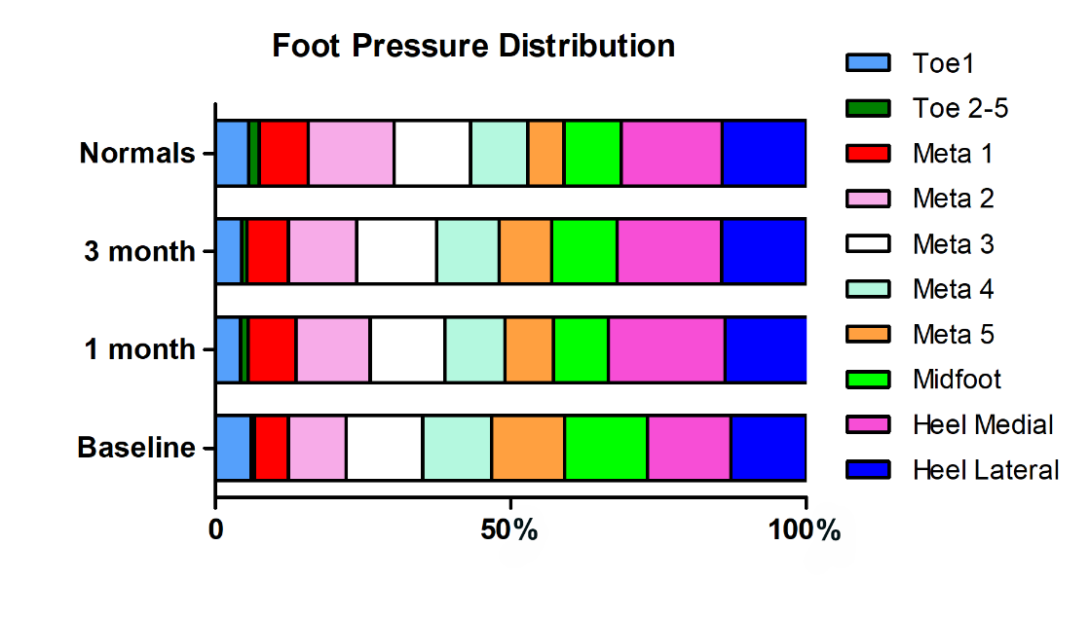
Supplementary Figure 1 Foot pressure distribution in subjects compared to normals. Toe 1=Hallux, Meta=Metatarsal.

