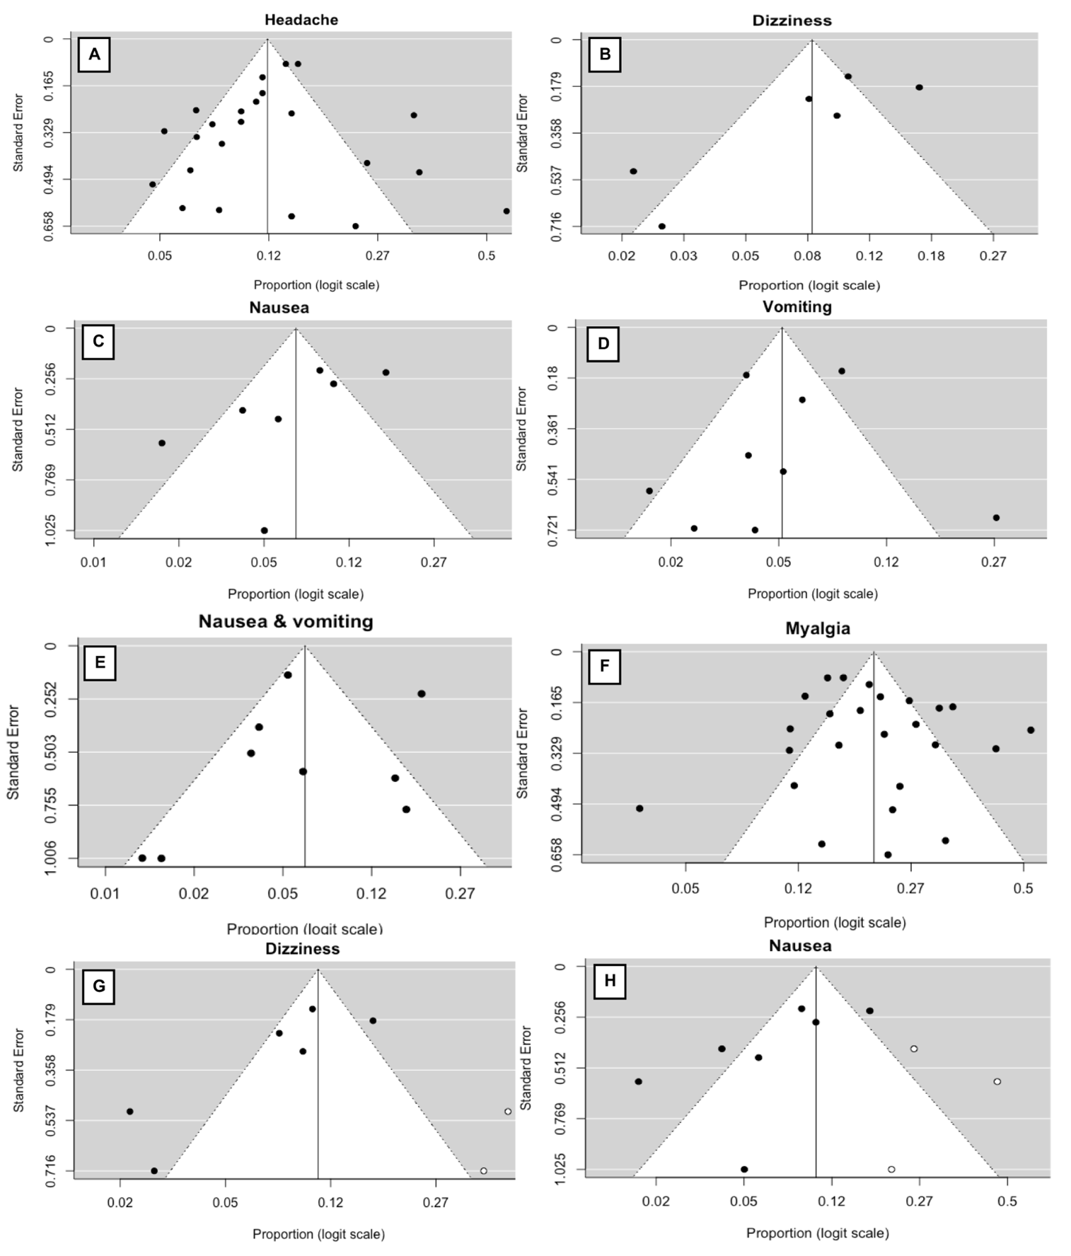
Supplementary Material 1. Pertinent funnel and trim-and-fill plots of studies reporting
neurological symptoms associated with COVID-19 infection.

