**Supplementary Table 1.** Normality tests for the ACE

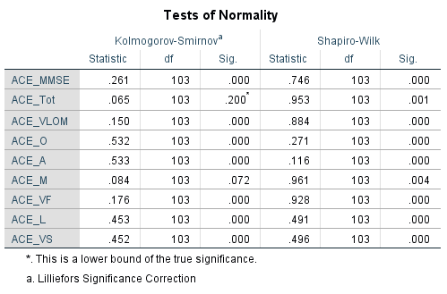

**Supplementary Table 2.** Normality tests for neuropsychometric battery



**Supplementary Table 3.** Mean scores of patients and controls on the ACE.

|  |  |  |  |
| --- | --- | --- | --- |
| **ACE Domains** | **Patients**  **(n = 54)** | **Controls**  **(n=49)** | ***p*** |
| ACE Total Score | 87.1 ± 7.3 | 88.6 ± 5.7 | 0.82 |
| Orientation | 9.9 ± 0.4 | 9.9 ± 0.3 | 0.77 |
| Attention | 7.9 ± 0.3 | 8.0 ± 0.0 | 0.22 |
| Memory | 26.3 ± 5.7 | 26.9 ± 4.8 | 0.47 |
| Verbal Fluency | 10.6 ± 2.2 | 11.4 ± 1.8 | 0.22 |
| Language | 27.6 ± 0.9 | 27.8 ± 0.5 | 0.12 |
| Visuospatial abilitya | 4.8 ± 0.4 | 4.6 ± 0.7 | 0.05 |
|  |  |  |  |
| MMSE | 29.0 ± 1.5 | 29.2 ± 0.9 | 0.74 |
| VLOM ratio | 2.7 ± 0.5 | 2.7 ± 0.4 | 0.52 |

*p* – Significance level of group comparisons using analysis of covariance with education as a covariate; a Strong trend in Visuospatial ability revealed with controls performing lower than patients (p=0.051). Investigating this further, we noted that one control obtained score of 1 in this domain. Group comparisons excluding this control removed the trend noted (p=0.114 after excluding control).

Values are represented as Mean ± SD

ACE – Addenbrooke’s Cognitive Examination

MMSE – Mini-Mental State Examination

VLOM – Verbal Fluency, Language, Orientation and Memory (delayed recall) ratio

**Supplementary Table 4.** Mean scores of patients and controls on the neuropsychometric battery.

|  |  |  |  |  |  |
| --- | --- | --- | --- | --- | --- |
| **Neuropsychometric Tests** | **Patients** | |  | **Controls** | ***p*** |
| **n** | **Med (Min-Max)** | **n** | **Med (Min-Max)** |
| Verbal fluency (Letter F) a | 35 | 12.7 ± 4.1 | 38 | 13.6 ± 4.5 | 0.41b |
| Verbal fluency (Letter A) a | 31 | 10.8 ± 4.2 | 34 | 12.7 ± 4.2 | 0.30c |
| Digit Span Total | 22 | 16.0 (11-22) | 17 | 14.0 (10-21) | 0.11 |
| Digit Ordering Test | 21 | 7.0 (4-12) | 18 | 6.0 (4-10) | 0.05 |
| Boston Naming Test | 6 | 15.0 (14-15) | 8 | 15.0 (14-15) | 0.85 |
| BDI-II | 19 | 7.0 (1-21) | 17 | 2.0 (0-13) | **<0.01** |
| Judgement of Line Orientation | 21 | 27.0 (16-30) | 18 | 24.5 (18-30) | 0.04 |
| CVLT-II Immediate Recall Total | 5 | 46.0 (36-52) | 6 | 48.0 (39-65) | 0.43 |
| CVLT-II Short Delayed Recall | 5 | 9.0 (9-11) | 6 | 8.5 (7-12) | 0.66 |
| CVLT-II Long Delayed Recall | 5 | 11.0 (8-13) | 6 | 10.5 (7-15) | 0.66 |
| Stroop Words Total | 15 | 90.0 (73-100) | 8 | 100.0 (90-117) | <0.01 |
| Stroop Color Total | 15 | 71.0 (50-110) | 8 | 75.5 (64-95) | 0.15 |
| Stroop Interference Total | 14 | 41.0 (23-98) | 7 | 44.0 (36-48) | 0.44 |

a values represented as Mean ± SD, b p-values from Student’s t-test and c analysis of covariance with education as covariate. Note: All other tests are presented as Median (Min-Max) and group comparisons were performed using the Mann-Whitney U-test. The p-values represented in bold font survive FDR-correction. BDI-II = Beck’s Depression Inventory - II, CVLT-II = California Verbal Learning Test - II.

Supplementary Table 5. Spearman correlations between the ACE and the neuropsychometric battery.

| **Diagnosis** | **ACE Domains** | **VF_F** | **VF_A** | **DS** | **DOT** | **BNT** | **JLO** | **CVLT Total** | **CVLT Short Delay** | **CVLT Long Delay** | **Stroop (Int. task)** | **WTAR raw** |
| --- | --- | --- | --- | --- | --- | --- | --- | --- | --- | --- | --- | --- |
| Controls | ACE Total Score | **0.6\*\*** | **0.5\*\*** | - | - | -0.8* | - | - | - | 0.5*†* | - | - |
| Orientation | - | - | - | - | - | -0.5* | - | - | - | 0.8* | - |
| Attention | n.d. | n.d. | n.d. | n.d. | n.d. | n.d. | n.d. | n.d. | n.d. | n.d. | n.d. |
| Memory | 0.4* | 0.4* | - | - | - | - | - | - | - | -0.8* | - |
| Verbal Fluency | **0.5\*\*** | **0.6\*\*** | - | - | - | - | - | - | - | - | - |
| Language | - | - | - | - | - | - | - | - | - | - | - |
| Visuospatial ability | - | 0.4* | - | - | - | - | - | - | - | - | n.d. |
| MMSE | - | - | - | - | - | - | - | - | 0.8*†* | - | - |
| VLOM ratio | - | - | - | - | - | - | - | -0.9* | -0.8*†* | - | - |
| Patients | ACE Total Score | 0.5** | **0.7\*\*** | - | - | - | - | - | 0.9* | - | - | - |
| Orientation | - | - | n.d. | n.d. | n.d. | n.d. | n.d. | n.d. | n.d. | n.d. | n.d. |
| Attention | - | - | n.d. | n.d. | n.d. | n.d. | n.d. | n.d. | n.d. | n.d. | n.d. |
| Memory | 0.4* | **0.6\*\*** | - | - | - | - | - | 0.9* | - | - | - |
| Verbal Fluency | **0.7\*\*** | **0.6\*\*** | 0.4* | - | - | - | - | - | - | - | - |
| Language | - | - | - | - | - | - | - | - | - | - | - |
| Visuospatial ability | - | - | - | - | - | - | - | - | - | - | - |
| MMSE | - | - | - | - | - | - | - | - | - | - | - |
| VLOM ratio | - | - | - | - | - | - | - | - | 0.8*†* | - | - |

*p<0.05; **p<0.01; *†*p<0.09; n.d. = not done (low variance); - = non-significant associations. VF_F = Verbal Fluency (letter F); VF_A = Verbal Fluency (letter A); DS = Digit Span; DOT = Digit Ordering Test; JLO = Judgement of Line Orientation. The values in bold font survive FDR-corrections.

**Supplementary Figure**

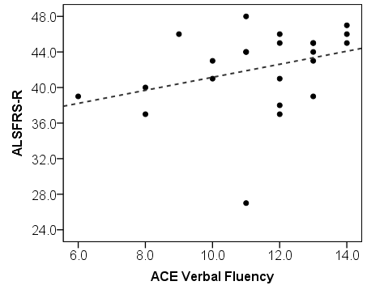

Correlations with (a) ALSFRS-R and ACE Verbal Fluency (Spearman’s *ρ*=0.4, p=0.07).