APPENDICES

Appendix 1: Literature Search Strategy
Appendix 2: Evidence Quality Assessment
Appendix 3: Functional Independence Risk Difference and Subgroup Results

Appendix 4: Secondary Outcome Results

Appendices

Appendix 1: Literature Search Strategies
Database: EBM Reviews - Cochrane Central Register of Controlled Trials <February 2015>, EBM Reviews - Cochrane Database of Systematic Reviews <2005 to January 2015>, EBM Reviews - Database of Abstracts of Reviews of Effects <1st Quarter 2015>, EBM Reviews - Health Technology Assessment <1st Quarter 2015>, EBM Reviews - NHS Economic Evaluation Database <1st Quarter 2015>, Embase <1980 to 2015 Week 10>, All Ovid MEDLINE(R) <1946 to Present>
Search Strategy:
--------------------------------------------------------------------------------
1 exp Brain Ischemia/ (198337)
2 ((isch?emi* adj3 (stroke* or apoplex* or cerebr* or brain or encephalopath* or neur*)) or AIS).tw. (198076)
3 exp Stroke/ (189703)
4 (stroke* adj3 (acute or cerebr* or attack* or accident* or lacunar or cardioembol*)).tw. (76907)
5 Intracranial Arteriosclerosis/ (10347)
6 exp "Intracranial Embolism and Thrombosis"/ (367169)
7 Carotid Artery Thrombosis/ (5356)
8 ((occlus* or block* or infarct* or clot* or termination) adj6 (carotid or cerebr* or MCA or ACA)).tw. (96218)
9 or/1-8 (786703)
10 exp Thrombectomy/ (15008)
11 Embolectomy/ (4255)
12 ((Mechanical adj3 (thromb* or embol* or clot disruption* or clot retrieval*)) or ((clot* or thromb* or embol*) adj3 (retriev* or disruption* or fragmentation)) or ((stent* or stent-assisted) adj3 retriev*) or stentriever*).tw. (9056)
13 ((Merci or Trevo or Penumbra or Solitaire) adj3 (retriever* or system* or device*)).mp. (1233)
14 or/10-13 (24914)
15 9 and 14 (14515)
16 exp Animals/ not (exp Animals/ and Humans/) (8045601)
17 15 not 16 (14213)
18 (case reports or congresses).pt. (1780093)
19 17 not 18 (13866)
20 limit 19 to english language [Limit not valid in CDSR,DARE; records were retained] (12321)
21 limit 20 to yr="2005 -Current" [Limit not valid in DARE; records were retained] (9737)
22 21 use pmoz,cctr,coch,dare,clhta,cleed (970)
23 exp Brain Ischemia/ (198337)
24 ((isch?emi* adj3 (stroke* or apoplex* or cerebr* or brain or encephalopath* or neur*)) or AIS).tw. (198076)
25 exp Cerebrovascular Accident/ (189703)
26 Stroke Patient/ (13478)
27 (stroke* adj3 (acute or cerebr* or attack* or accident* or lacunar or cardioembolic)).tw. (76838)
28 exp Occlusive Cerebrovascular Disease/ (26483)
29 exp Carotid Artery Obstruction/ (25862)
30 Brain Embolism/ (8515)
31 ((occlus* or block* or infarct* or clot* or termination) adj6 (carotid or cerebr* or MCA or ACA)).tw. (96218)
32 or/23-31 (478286)
33 Mechanical Thrombectomy/ (1828)
34 Thrombectomy/ (10732)
35 Embolectomy/ (4255)
36 ((Mechanical adj3 (thromb* or embol* or clot disruption* or clot retrieval*)) or ((clot* or thromb* or embol*) adj3 (retriev* or disruption* or fragmentation)) or ((stent* or stent-assisted) adj3 retriev*) or stentriever*).tw. (9056)
37 ((Merci or Trevo or Penumbra or Solitaire) adj3 (retriever* or system* or device*)).mp. (1233)
38 or/33-37 (22583)
39 32 and 38 (4742)
40 exp animal experimentation/ or exp models animal/ or exp animal experiment/ or nonhuman/ or exp vertebrate/ (38090949)
41 exp humans/ or exp human experimentation/ or exp human experiment/ (29700691)
42 40 not 41 (8416467)
43 39 not 42 (4642)
44 case report/ or conference abstract.pt. (5381946)
45 43 not 44 (2728)
46 limit 45 to english language [Limit not valid in CDSR,DARE; records were retained] (2466)
47 limit 46 to yr="2005 -Current" [Limit not valid in DARE; records were retained] (2248)
48 47 use emez (1362)
49 22 or 48 (2332)
50 remove duplicates from 49 (1624)

Appendix 2: Evidence Quality Assessment
Table A1: GRADE Evidence Profile for Comparison of Mechanical Thrombectomy and Best Medical Therapy on Clinical Outcomes
Number of Studies (Design) | Risk of Bias | Inconsistency | Indirectness | Imprecision | Publication Bias | Upgrade Considerations | Quality
Functional Independence (mRS)
5 (RCTs) | No serious limitations | No serious limitations | No serious limitations | No serious limitationsª | Undetected | No other considerations | ⊕⊕⊕⊕ High
Mortality
5 (RCTs) | No serious limitations | No serious limitations | No serious limitations | Serious limitations (–1)ª | Undetected | No other considerations | ⊕⊕⊕ Moderate
SICH
5 (RCTs) | No serious limitations | No serious limitations | No serious limitations | Serious limitations (–1)ª | Undetected | No other considerations | ⊕⊕⊕ Moderate
Reperfusion
5 (RCTs) | No serious limitations | No serious limitations | No serious limitations^{b} | Serious limitations (–1)ª | Undetected | No other considerations | ⊕⊕⊕ Moderate
Recanalization
3 (RCTs) | No serious limitations | No serious limitations | Serious limitations (–1)^{c} | Serious limitations (–1)ª | Undetected | No other considerations | ⊕⊕ Low
Abbreviations: mRS, modified rankin scale; SICH, symptomatic intracranial hemorrhage
ªOptimal information size (OIS) may not be met for this outcome as 4 out of 5 RCTs were stopped early.
^{b}Reperfusion can be considered a surrogate outcome.
^{c}Recanalization can be considered a surrogate outcome.

Table A2: Risk of Bias Among Randomized Controlled Trials for the Comparison of Mechanical Thrombectomy and Clinical Outcomes
Author, Year | Allocation Concealmentª | Blinding^{b} | Complete Accounting of Patients and Outcome Events | Selective Reporting Bias | Other Limitations
Berkhemer et al, 2014 | No limitations | No limitations | No limitations | Limitations^{c} | No limitations^{f}
Campbell et al, 2015 | No limitations | No limitations | No limitations | No limitations | Limitations^{e,f}
Goyal et al, 2015 | No limitations | No limitations | No limitations | Limitations^{d} | Limitations^{e,f}
Jovin et al, 2015 | No limitations | No limitations | No limitations | No limitations | Limitations^{e,f}
Saver et al, 2015 | No limitations | No limitations | No limitations | No limitations | Limitations^{e,f}
Abbreviations:
ªAll 5 RCTs used a web-based randomized minimization procedure.
^{b}All 5 included RCTs had blind outcome evaluation but physicians conducting the intervention were aware of treatment assignment. This was appropriate as a sham procedure was not ethical and standard of care is intravenous thrombolysis which is a more appropriate comparator.
^{c}RCT protocol states the functional outcome measured by ‘Academic Linear Disability Scale’ would be collected at 90 days, but this outcome is not reported in the published article.
^{d}RCT protocol states the functional outcome measured by ‘miFUNCTION scale’ would be collected, but this outcome is not reported in the published article.
^{e}After the Berkhemer et al (2015) study was presented at the World Stroke Conference in October 2014, the 4 following RCTs stopped early based on prespecified boundary for efficacy during interim analysis.
^{f}All studies had grant support from Covidien/ev3 (the company that manufactures the Solitaire FR stent retriever) and/or other manufacturers/industry support.

Appendix 3: Subgroup Results

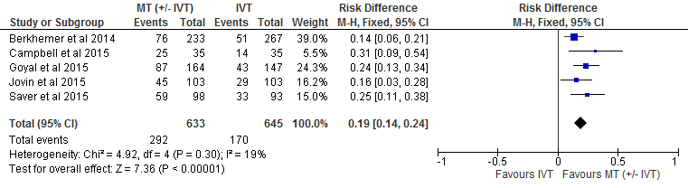
Figure A1: Risk Difference of Mechanical Thrombectomy Versus Best Medical Therapy on Proportion of Functionally Independent Patients at 90-Day Follow-up

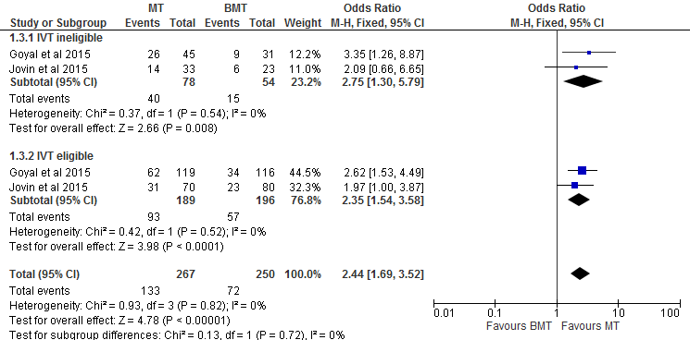

Figure A2: Mechanical Thrombectomy Versus Best Medical Therapy on the Proportion of Functionally Independent Patients at 90-Day Follow-up by Status of IVT
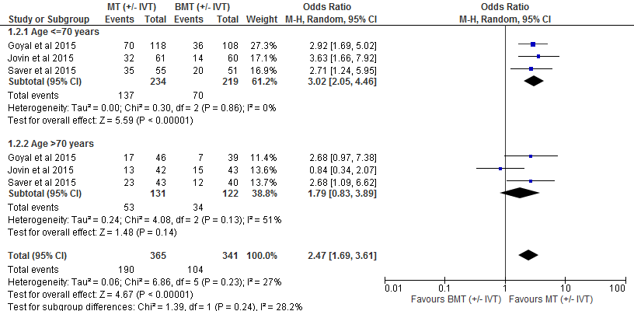

*Goyal et al divided age in <=80 years and >80 years in the age sensitivity analysis.

Figure A3: Mechanical Thrombectomy Versus Best Medical Therapy on the Proportion of Functionally Independent Patients at 90-Day Follow-up by Age, Secondary Analysis
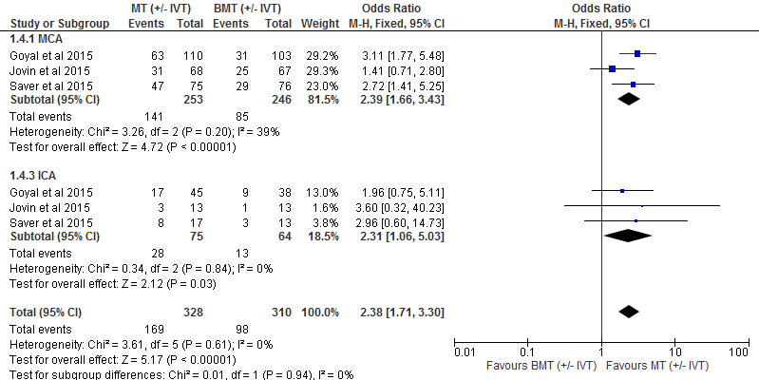

Figure A4: Mechanical Thrombectomy Versus Best Medical Therapy on the Proportion of Functionally Independent Patients at 90-Day Follow-up by Occlusion Site
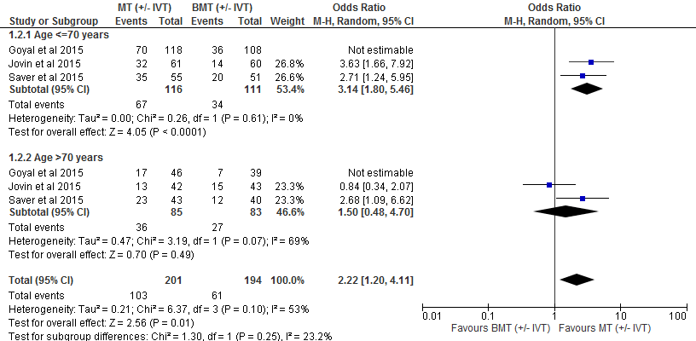

*Goyal et al estimate not included in this sensitivity analysis as this trial divided patients into <=80 years and >80 years and we wanted to determine if the estimate influenced results.

Figure A5: Mechanical Thrombectomy Versus Best Medical Therapy on Proportion of Functionally Independent Patients at 90-Day Follow-up by Age, Secondary Analysis without ESCAPE Study

Appendix 4: Secondary Outcome Results

Table 1: Reperfusion and Recanalization Rates in Included RCTs
Author, Year | Intervention | Control | Adjusted Value (95% CI)
Berkhemer et al
Reperfusion | 115/196 (58.7%)ª | NR | NR
Recanalization | 141/187 (75.4%)^{b} | 68/207 (32.9%)^{b} | 6.88 (4.34 to 10.94)
Campbell et al
Reperfusion | 100 (100 to 100)^{c} | 37 (-0.5 to 96) | 4.7 (2.5 to 9.0)^{d}
Recanalization | 33 (94%)^{e} | 15 (43%)^{e} | 29.0 (5.4 to 155.0)^{d}
Goyal et al
Reperfusion | 113/156 (72.4%)^{f}:  79/112 (70.5%) with IVT  34/44 (77%) w/o IVT | NR | NR
Recanalization | NR | 43/138 (31.2%)^{g}:  41/110 (32.3%) with IVT  2/28 (7%) w/o IVT | NR
Jovin et al
Reperfusion | 67/102 (65.7%)ª | NR | NR
Recanalization | NR | NR | NR
Saver et al
Reperfusion | 73/83 (88%)ª  53/64 (83%)^{h} | 21/52 (40%) | 2.05 (1.45 to 2.91)^{d}
Recanalization | NR | NR | NR
Abbreviations: IVT, intravenous thrombolysis, NR, not reported
ªReperfusion was measured by the modified Thrombolysis in Cerebral Infarction (TICI) score where a score of 2b or 3, indicating complete filling of the expected vascular territory – no./total no. (%).
^{b}Measured as number of patients with no intracranial occlusion on follow-up CT angiography – no./total no. (%).Data for follow-up CT angiography were not available for 106 patients owing to imminent death or death (24 patients), decreased kidney function (13 patients), insufficient scan quality (5 patients), and other reasons (64 patients).
^{c}Reperfusion was defined as the percentage reduction in the perfusion-lesion volume between initial imaging and 24-hour imaging (IQR). This value can be negative if hypoperfusion becomes more severe over time. This analysis was adjusted for the site of vessel occlusion at baseline.
^{d}P<0.001.
^{e}Recanalization was defined as a Thrombolysis in Myocardial Infarction score of 2 or 3 (partial or complete restoration of flow at the site of arterial occlusion) and measured at 24 hours. This analysis was adjusted for the site of vessel occlusion at baseline.
^{f}Reperfusion was measured by the Thrombolysis in Cerebral Infarction (TICI) score where a score of 2b or 3, indicating complete filling of the expected vascular territory – no./total no. (%).
^{g}Recanalization was measured by a modified Arterial Occlusive Lesion (AOL) score of 2 or 3 indicates partial or complete recanalization – no./total no.
^{h}Saver et al also reported successful reperfusion at 27 hr. – no./total no (%). Successful reperfusion was defined as reperfusion at least 90%, as assessed with the use of perfusion CT or MRI. Data on successful reperfusion were not obtained for all patients after the adoption of the protocol amendment making penumbral imaging optional

