Appendix

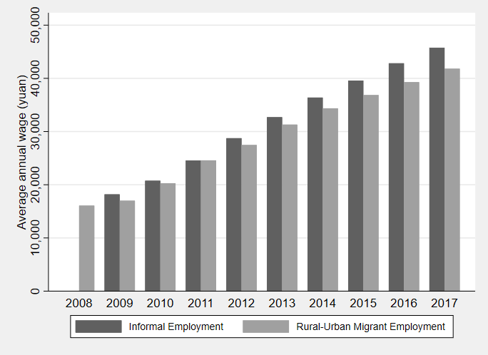
Figure A.1: Rural-Urban and Informal Average Annual Wages
Source: Rural–urban migrant wage data are from NBS “Annual report of monitoring survey on national rural–urban migrant workers” (NBS 2009–2017); NBS (www.stats.gov.cn).

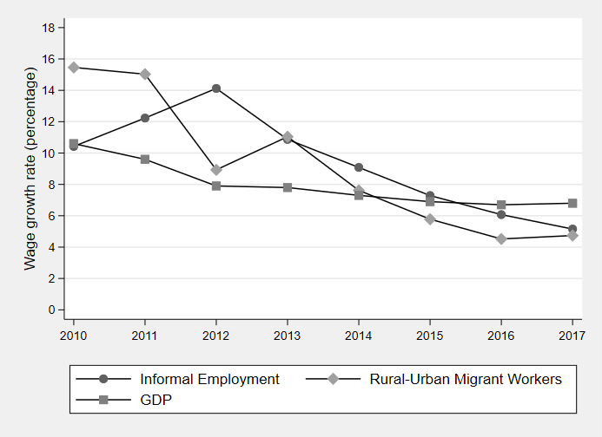
Figure A.2: Rural–Urban and Informal Average Annual Wages, Real Growth Rates
Source: Rural–urban migrant wage data are from NBS “Annual report of monitoring survey on national rural–urban migrant workers” (NBS 2009–2017); NBS (www.stats.gov.cn).

Figure A.3: Industry Trends in Urban Employment, Eastern China
Source: NBS (www.stats.gov.cn).
Notes: Low-skilled services include wholesale and retail trades, transport, storage and post, hotels and catering services, leasing and business services and services to household, repair and other services. High-skilled services include information, transmission, software and information technology, financial intermediation, real estate, scientific research and technical services, education, health and social service, and culture, entertainment and sports. Eastern regions include: Beijing, Tianjin, Hebei, Liaoning, Shanghai, Jiangsu, Zhejiang, Fujian, Shandong, Guangdong and Hainan.

Figure A.4: Industry Trends in Urban Employment, Central China
Source: NBS (www.stats.gov.cn).
Notes: Low-skilled services include wholesale and retail trades, transport, storage and post, hotels and catering services, leasing and business services and services to household, repair and other services. High-skilled services include information, transmission, software and information technology, financial intermediation, real estate, scientific research and technical services, education, health and social service, and culture, entertainment and sports. Central regions include: Shanxi, Jilin, Heilongjiang, Anhui, Jiangxi, Henan, Hubei and Hunan.

Figure A.5: Industry Trends in Urban Employment, Western China
Source: NBS (www.stats.gov.cn).
Notes: Low-skilled services include wholesale and retail trades, transport, storage and post, hotels and catering services, leasing and business services and services to household, repair and other services. High-skilled services include information, transmission, software and information technology, financial intermediation, real estate, scientific research and technical services, education, health and social service, and culture, entertainment and sports. Western regions include: Sichuan, Inner Mongolia, Guizhou, Yunnan, Tibet, Shanxi, Gansu, Qinghai, Ningxia, Xinjiang, Guangxi and Chongqing.

Figure A.6: Industry Trends in Formal and Informal Employment, Eastern China
Panel A (Formal Employment)
Source: NBS (www.stats.gov.cn).
Notes: Low-skilled services include wholesale and retail trades, transport, storage and post, hotels and catering services, leasing and business services and services to household, repair and other services. High-skilled services include information, transmission, software and information technology, financial intermediation, real estate, scientific research and technical services, education, health and social service, and culture, entertainment and sports. Eastern regions include: Beijing, Tianjin, Hebei, Liaoning, Shanghai, Jiangsu, Zhejiang, Fujian, Shandong, Guangdong and Hainan.

Figure A.6: Industry Trends in Formal and Informal Employment, Eastern China
Panel B (Informal Employment)
Source: NBS (www.stats.gov.cn).
Notes: Low-skilled services include wholesale and retail trades, transport, storage and post, hotels and catering services, leasing and business services and services to household, repair and other services. High-skilled services include information, transmission, software and information technology, financial intermediation, real estate, scientific research and technical services, education, health and social service, and culture, entertainment and sports. Eastern regions include: Beijing, Tianjin, Hebei, Liaoning, Shanghai, Jiangsu, Zhejiang, Fujian, Shandong, Guangdong and Hainan.

Figure A.7: Industry Trends in Formal and Informal Employment, Central China
Panel A (Formal Employment)
Source: NBS (www.stats.gov.cn).
Notes: Low-skilled services include wholesale and retail trades, transport, storage and post, hotels and catering services, leasing and business services and services to household, repair and other services. High-skilled services include information, transmission, software and information technology, financial intermediation, real estate, scientific research and technical services, education, health and social service, and culture, entertainment and sports. Central regions include: Shanxi, Jilin, Heilongjiang, Anhui, Jiangxi, Henan, Hubei and Hunan.

Figure A.7: Industry Trends in Formal and Informal Employment, Central China
Panel B (Informal Employment)
Source: NBS (www.stats.gov.cn).
Notes: Low-skilled services include wholesale and retail trades, transport, storage and post, hotels and catering services, leasing and business services and services to household, repair and other services. High-skilled services include information, transmission, software and information technology, financial intermediation, real estate, scientific research and technical services, education, health and social service, and culture, entertainment and sports. Central regions include: Shanxi, Jilin, Heilongjiang, Anhui, Jiangxi, Henan, Hubei and Hunan.

Figure A.8: Industry Trends in Formal and Informal Employment, Western China
Panel A (Formal Employment)
Source: NBS (www.stats.gov.cn).
Notes: Low-skilled services include wholesale and retail trades, transport, storage and post, hotels and catering services, leasing and business services and services to household, repair and other services. High-skilled services include information, transmission, software and information technology, financial intermediation, real estate, scientific research and technical services, education, health and social service, and culture, entertainment and sports. Western regions include: Sichuan, Inner Mongolia, Guizhou, Yunnan, Tibet, Shanxi, Gansu, Qinghai, Ningxia, Xinjiang, Guangxi and Chongqing.

Figure A.8: Industry Trends in Formal and Informal Employment, Western China
Panel B (Informal Employment)
Source: NBS (www.stats.gov.cn).
Notes: Low-skilled services include wholesale and retail trades, transport, storage and post, hotels and catering services, leasing and business services and services to household, repair and other services. High-skilled services include information, transmission, software and information technology, financial intermediation, real estate, scientific research and technical services, education, health and social service, and culture, entertainment and sports. Western regions include: Sichuan, Inner Mongolia, Guizhou, Yunnan, Tibet, Shanxi, Gansu, Qinghai, Ningxia, Xinjiang, Guangxi and Chongqing.

Figure A.9: Formal and Informal Average Annual Wages, Eastern China, Real Growth Rates
Source: NBS (www.stats.gov.cn).
Notes: Eastern regions include: Beijing, Tianjin, Hebei, Liaoning, Shanghai, Jiangsu, Zhejiang, Fujian, Shandong, Guangdong and Hainan. Real wages are defined as nominal wages adjusted for CPI.

Figure A.10: Formal and Informal Average Annual Wages, Central China, Real Growth Rates
Source: NBS (www.stats.gov.cn).
Notes: Central regions include: Shanxi, Jilin, Heilongjiang, Anhui, Jiangxi, Henan, Hubei and Hunan. Real wages are defined as nominal wages adjusted for CPI.

Figure A.11: Formal and Informal Average Annual Wages, Western China, Real Growth Rates
Source: NBS (www.stats.gov.cn).
Notes: Western regions include: Sichuan, Inner Mongolia, Guizhou, Yunnan, Tibet, Shanxi, Gansu, Qinghai, Ningxia, Xinjiang, Guangxi and Chongqing. Real wages are defined as nominal wages adjusted for CPI.

