APPENDIX 1: Balance Tests Results
1.1 Balance Tests of 1:1 propensity score matching without replacement
Table A1 reports the balance tests results for controlled covariates before and after matching. It shows that matching substantially improves the balance of each controlled covariate between returnees and locals. First, all the absolute values of the mean differences and standardized biases are considerably smaller after matching. Second, the mean of each covariate, except for male, age and tenure, is statistically different between the returnees and locals before matching. The difference becomes statistically insignificant at least at a 10% level after matching.
Table A1. Balance tests on controlled covariates
 | Before matching |  |  |  | After matching
 | Mean difference | P-value of T-test | Standardized bias |  | Mean difference | P-value of T-test | Standardized bias
Bachelor | -0.0988 | 0.0000 | -0.2461 |  | 0.0000 | 1.0000 | 0.0000
Master | 0.0574 | 0.0005 | 0.1624 |  | 0.0000 | 1.0000 | 0.0000
PhD | 0.0414 | 0.0001 | 0.1808 |  | 0.0000 | 1.0000 | 0.0000
Male | 0.0083 | 0.7234 | 0.0167 |  | 0.0000 | 1.0000 | 0.0000
Age | -0.3596 | 0.3932 | -0.0404 |  | 0.0560 | 0.9199 | 0.0063
Tenure | -0.6170 | 0.1616 | -0.0661 |  | 0.2401 | 0.6899 | 0.0257
Married | -0.0417 | 0.0640 | -0.0875 |  | -0.0041 | 0.8923 | -0.0087
Urban | -0.0296 | 0.0357 | -0.0984 |  | -0.0062 | 0.7438 | -0.0208
N | 6051 |  |  |  | 964
Notes: The mean difference is equal to the mean of the returnees minus the mean of the locals; P-value of T-test is for the significance of the mean difference; standardized bias is defined as the mean difference divided by the standard deviation; same for Tables A2 and A3.
It turns out that matching also reduces the differences in uncontrolled characteristics, such as ability and family background, between returnees and locals. The best proxies for ability that we can find in the CHFS data are two questions on the ability to understand the questionnaire. Family background variables include parents' educational level and positions. Table A2 reports balance tests results on these variables. After matching, almost all of the mean differences are reduced considerably, while all the differences between the returnees and locals become statistically insignificant. Therefore, even the uncontrolled proxy variables for ability and family background become comparable between the two groups. As the possible endogeneity problem in our analysis is mainly caused by ability and family background, the findings here help explain the fact that no significant endogeneity problem is found in our matched sample, and our OLS estimates, with and without proxy variables, and the instrumental variables estimates, are close to each other.
Table A2. Balance tests on uncontrolled characteristics
 | Before matching |  |  |  | After matching
 | Mean difference | P-value of T-test | Standardi- zed bias |  | Mean difference | P-value of T-test | Standardi- zed bias
Ability proxy
Ability1 | -0.0450 | 0.0263 | -0.1047 |  | -0.0062 | 0.8217 | -0.0145
Ability2 | -0.0157 | 0.4022 | -0.0395 |  | 0.0270 | 0.3032 | 0.0680
N | 6050 |  |  |  | 964
Mom’s education level
No schooling | 0.0451 | 0.0320 | 0.1053 |  | -0.0243 | 0.4127 | -0.0565
High school and below | -0.0412 | 0.0898 | -0.0836 |  | 0.0218 | 0.5080 | 0.0441
Associate degree | -0.0230 | 0.0865 | -0.0855 |  | -0.0097 | 0.5973 | -0.0361
Bachelor and above | 0.0191 | 0.1823 | 0.0653 |  | 0.0123 | 0.5201 | 0.0416
N | 5602 |  |  |  | 907
Dad’s education level
No schooling | 0.0770 | 0.0007 | 0.1715 |  | -0.0166 | 0.4579 | -0.0370
High school and below | -0.0745 | 0.0034 | 0.1491 |  | 0.0008 | 0.9821 | 0.0015
Associate degree | -0.0152 | 0.2998 | -0.0529 |  | 0.0055 | 0.7756 | 0.0192
Bachelor and above | 0.0127 | 0.4007 | 0.0425 |  | 0.0103 | 0.4829 | 0.0342
N | 5466 |  |  |  | 863
Mom’s position
No job | 0.0402 | 0.0074 | 0.1404 |  | 0.0249 | 0.1764 | 0.0875
Farmer | 0.0336 | 0.1743 | 0.0698 |  | -0.0297 | 0.2781 | -0.0616
Self-employed | 0.0129 | 0.3155 | 0.0513 |  | 0.0087 | 0.4881 | 0.0345
Worker | -0.0179 | 0.4605 | -0.0380 |  | 0.0093 | 0.7753 | 0.0197
Group leader | -0.0027 | 0.5456 | -0.0316 |  | -0.0067 | 0.3443 | 0.0787
Section chief | -0.0133 | 0.3088 | -0.0528 |  | -0.0277 | 0.1399 | -0.1114
Department head | 0.0060 | 0.4184 | 0.0412 |  | 0.0080 | 0.3892 | 0.0542
Bureau head | 0.0215 | 0.0540 | 0.0976 |  | 0.0133 | 0.2266 | 0.0601
N | 5027 |  |  |  | 834
Dad’s position
No job | -0.0086 | 0.6210 | -0.0267 |  | -0.0007 | 0.7416 | 0.0240
Farmer | 0.0200 | 0.4464 | 0.0410 |  | -0.0169 | 0.1271 | -0.1106
Self-employed | -0.0002 | 0.9885 | -0.0008 |  | 0.0084 | 0.5798 | 0.0336
Worker | -0.0081 | 0.7477 | -0.0174 |  | 0.0031 | 0.9222 | 0.0070
Group leader | 0.0040 | 0.5537 | 0.0316 |  | 0.0040 | 0.6401 | 0.0316
Section chief | -0.0018 | 0.8962 | -0.0070 |  | 0.0018 | 0.8231 | 0.0078
Department head | -0.0099 | 0.0193 | -0.1350 |  | -0.0019 | 0.7348 | -0.0263
Bureau head | 0.0046 | 0.5934 | 0.0286 |  | 0.0022 | 0.7877 | 0.0138
N | 4836 |  |  |  | 779
Notes: 1. Ability1 is based on the question: when the respondents were answering the questions, did they need you to explain? 1. not needed; 2. mostly not needed; 3. occasionally needed; 4. frequently needed; 5. very frequently needed; 6. constantly needed. We assign Ability1 1 for choices 1 and 2, and 0 otherwise.
2. Ability2 is based on the question: do you think the respondent understands these topics in general? 1. did not understand at all; 2. understood very little; 3. occasionally understood; 4. understood most; 5. understood almost all; 6. understood everything. We assign Ability2 1 for choices 5 and 6, and 0 otherwise.
1.2 Balance Tests of other Matching Methods
We also try other matching methods. Table A3 reports the balance tests results of 1:2 and 1:4 nearest neighbor matching. Notice that the mean difference and standardized bias increase for age with 1:2 matching and for marital status with 1:4 matching. Compared with Table A1, one can see clearly that 1:1 matching without replacement provides better balance test results than 1:2 and 1:4 matching.
Table A3. Balance tests on controlled covariates
 | Before matching |  |  |  | After matching
 | Mean difference | P-value of T-test | Standardi-  zed bias |  | Mean difference | P-value of T-test | Standardi-  zed bias
 | 1:2 matching
Bachelor | -0.0988 | 0.0000 | -0.2461 |  | 0.0000 | 1.0000 | 0.0000
Master | 0.0574 | 0.0005 | 0.1624 |  | 0.0000 | 1.0000 | 0.0000
PhD | 0.0414 | 0.0001 | 0.1808 |  | 0.0000 | 1.0000 | 0.0000
Male | 0.0083 | 0.7234 | 0.0167 |  | 0.0000 | 1.0000 | 0.0000
Age | -0.3596 | 0.3932 | -0.0404 |  | 1.2360 | 0.628 | 0.1609
Tenure | -0.6170 | 0.1616 | -0.0661 |  | 0.1130 | 0.963 | 0.0160
Married | -0.0417 | 0.0640 | -0.0875 |  | 0.0000 | 1.0000 | 0.0000
Urban | -0.0296 | 0.0357 | -0.0984 |  | 0.0000 | 1.0000 | 0.0000
N | 6051 |  |  |  | 1232
 | 1:4 matching
Bachelor | -0.0988 | 0.0000 | -0.2461 |  | 0.0000 | 1.0000 | 0.0000
Master | 0.0574 | 0.0005 | 0.1624 |  | 0.0000 | 1.0000 | 0.0000
PhD | 0.0414 | 0.0001 | 0.1808 |  | 0.0000 | 1.0000 | 0.0000
Male | 0.0083 | 0.7234 | 0.0167 |  | 0.0000 | 1.0000 | 0.0000
Age | -0.3596 | 0.3932 | -0.0404 |  | 0.3830 | 0.881 | 0.0499
Tenure | -0.6170 | 0.1616 | -0.0661 |  | 0.1734 | 0.943 | 0.0246
Married | -0.0417 | 0.0640 | -0.0875 |  | -0.0441 | 0.732 | -0.1031
Urban | -0.0296 | 0.0357 | -0.0984 |  | 0.0000 | 1.0000 | 0.0000
N | 6051 |  |  |  | 1903
Notes: The mean difference is equal to the mean of the returnees minus the mean of the locals; P-value of T-test is for the significance of the mean difference; standardized bias is defined as the mean difference divided by the standard deviation.

APPENDIX 2: Analyses on Annual Income
2.1 The IV estimation results
OLS does not consider the possible endogeneity problem caused by unobservable variables, here mainly ability and family background, which may bias the estimation results.
Table A4. IV estimates of returnees’ income premium
 | Income
Returnee*Bachelor | -0.0295
 | (0.0735)
Returnee*Graduate | 0.2976***
 | (0.0987)
Bachelor | 9.0282***
 | (0.6929)
Graduate | 9.3229***
 | (0.6958)
Male | 0.1450***
 | (0.0553)
Age | 0.0910**
 | (0.0378)
Age square | -0.0011**
 | (0.0005)
Other controls | Yes
KP F-statistic | 16.23
N | 863
Notes: 1. “Other controls” include tenure at current job and tenure squared, a marital status dummy, a dummy for living in urban versus rural areas, province and industry fixed effects.
2. The numbers in parentheses are standard errors clustered at the city level, same for tables below.
3. ***, **, and * indicate significance at the 1%, 5%, and 10% level, respectively, same for tables below.
Table A4 reports the IV estimate of Model (1). We use the number of study-abroad intermediary service agencies in each city, which is published by the Ministry of Education of China in 2012, as the instrumental variable of returnees to identify the causal effect of studying abroad. The estimates of $β_{2}$ are similar to those in Table 2. We also report the weak IV test results in Table A5. We find the KP F-statistics well above the critical value ten, which indicates that our IVs are not weak.
Table A5. First stage results using IV
 | Returnee* Bachelor | Returnee* Graduate
IV*Bachelor | 0.0028*** | 0.0003***
 | (0.0005) | (0.0001)
IV*Graduate | 0.0010*** | 0.0028***
 | (0.0003) | (0.0004)
Other controls | Yes | Yes
F-stat of instrument | 419.85 | 1246.05
P-value | (0.0000) | (0.0000)
Notes: 1. Column 1 uses the interaction term of $Returnee$ and $Bachelor$ as the dependent variable, while column 2 uses the interaction term of $Returnee$ and $Graduate$ as the dependent variable.
2. Other controls include a dummy for Bachelor’s degrees, a dummy for graduate degrees, a gender dummy, age and age squared, tenure at current job and tenure squared, a marital status dummy and a dummy for living in urban areas versus rural areas, province and industry fixed effects.
3. The instrumental variable is the number of study-abroad intermediary service agencies in each city.
Table A5 presents the results from our first stage estimates. We find a positive relationship between our instruments and the endogenous variables. The F statistics are relatively large, implying a rejection of weak IV. In summary, our IVs appear to be valid.
2.2 The estimation results using different matching variables and matching methods
We also tried using family background and personal ability variables as matching variables, and we get the results as in Table A6, which tells the same story as Table 2 with a smaller sample size.
Table A6. Estimates of returnees’ log income premium
 | (1) | (2)
Returnee*Bachelor | 0.0939 | 0.1139
 | (0.0696) | (0.0736)
Returnee*Graduate | 0.2546* | 0.3189**
 | (0.1524) | (0.1510)
Bachelor | 10.2196*** | 11.2163***
 | (0.7089) | (0.9657)
Graduate | 10.5538*** | 11.4549***
 | (0.7614) | (0.9931)
Other controls | Yes | Yes
Proxies for ability & background | N.A. | Yes
R-square | 0.3840 | 0.3963
N | 624 | 624
Notes: 1. “Other controls” include a gender dummy, age and age squared, tenure at current job and tenure squared, a marital status dummy, a dummy for living in urban versus rural areas, province and industry fixed effects.
2. Proxy variables for ability and family background include the ability to understand the questionnaire, parents’ educational level and positions.
In addition, Table A7 reports the estimated results of Model (1) using 1:2 and 1:4 matching. Again they give similar results as those for 1:1 matching.
Table A7. Estimates of returnees’ log income premium
 | 1:2 matching | 1:4 matching
Returnee*Bachelor | 0.0125 | 0.0285
 | (0.0483) | (0.0438)
Returnee*Graduate | 0.2626*** | 0.1926**
 | (0.0851) | (0.0793)
Other controls | Yes | Yes
R-square | 0.3205 | 0.3097
N | 1113 | 1722
Notes: “Other controls” include a dummy for Bachelor’s degrees, a dummy for graduate degrees, a gender dummy, age and age squared, tenure at their current job and tenure squared, a marital status dummy, a dummy for living in urban versus rural areas, province and industry fixed effects, proxies for personal ability and family background.
2.3 Figures of point estimates in different setups
To show that our results are robust against different specifications using matched data, Figures A1 and A2 plot 95 different estimates for $β_{1}$ and $β_{2}$, respectively. The 95 specifications include submodels of Model (1) using different controls, as well as different proxy variables and IV estimates. From the plotted densities of estimated $β_{1}$’s and $β_{2}$’s, one can see that estimates have characters of concentrated distribution in the preprocessed data. The estimates of $β_{1}$ are close to zero, ranging from -0.05 to 0.1, while the estimates of $β_{2}$ are all positive, ranging from 0.15 to 0.34.

Figure A1. Estimated bachelor returnees’ income premium in different setups
Note: This figure presents an estimated density plot of different point estimates of the coefficient of returnee*bachelor from 95 different models using the matched data.
Figure A2. Estimated post-graduate returnees’ income premium in different setups
Note: This figure presents an estimated density plot of different point estimates of the coefficient of returnee*graduate from 95 different models using the matched data.
In summary, we find very robust results that a foreign graduate degree increases one’s income by about 20 per cent relative to a local one, while a foreign Bachelor’s degree does not significantly raise the income relative to a domestic one.
2.4 The income trend with tenure rising
To study the income trends as tenure rises, it makes sense to control the impact of other factors first. Therefore, we regress the log income on all the controls in column (2) of Table 2 except tenure and the degree terms to get the income residuals, and we then plot the residuals against tenure for bachelors in Figure A3 and for postgraduates in Figure A4.
We can see that returnee and local bachelors have similar income residuals for any tenure. Meanwhile, the income residual for bachelors remains roughly the same across different tenures.
The income residual of local postgraduates basically remains constant for tenure less than 20, and it starts to increase when tenure is above 20. Contrarily, the income residual of returnee postgraduates is an increasing function of tenure. Overall, the income gap between returnee and local postgraduates increases over tenure, which supports the human capital effect interpretation.

Figure A3. The estimated income trends for Bachelor’s degree recipients
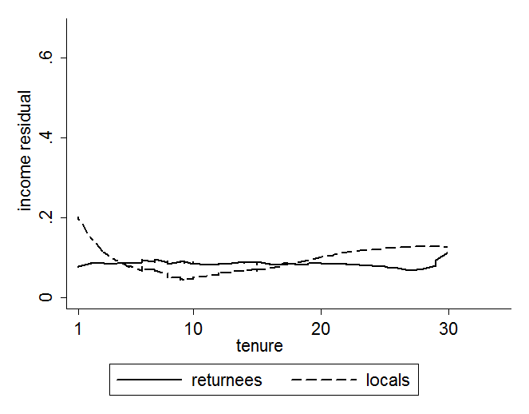
Figure A4. The estimated income trends for graduate degree recipients
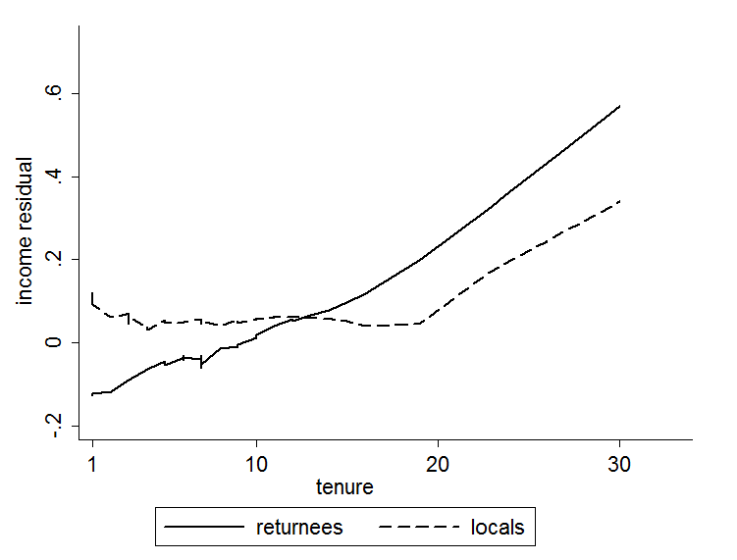

2.5 The estimation results when controlling for occupations, positions and business types
Table A8. Estimates of returnees’ income premium with occupations, positions and business types
 | (1) | (2) | (3)
Returnee*Bachelor | -0.0399 | -0.0353 | 0.0231
 | (0.0884) | (0.0730) | (0.0679)
Returnee*Graduate | 0.1815* | 0.1912* | 0.1877*
 | (0.1088) | (0.1777) | (0.0968)
Department head | 0.3062***
 | (0.1029)
Professional/technician | 0.1631
 | (0.1142)
Service personnel | 0.2861**
 | (0.1376)
Worker in primary industry | -0.2499
 | (0.2190)
Group leaders |  | 0.3176**
 |  | (0.1549)
Section chiefs |  | 0.4086***
 |  | (0.0806)
Department heads |  | 0.5174***
 |  | (0.1384)
Bureau heads |  | 0.6731*
 |  | (0.3332)
Privately-funded |  |  | 0.0215
 |  |  | (0.0709)
Foreign-funded |  |  | 0.5520***
 |  |  | (0.1107)
Other enterprise |  |  | 0.1835
 |  |  | (0.2305)
Other controls | Yes | Yes | Yes
R-square | 0.3129 | 0.3580 | 0.3390
N | 607 | 623 | 836
Notes: 1. Columns 1-3 use the log annual income of individuals as the dependent variable.
2. “Other controls” include a dummy for Bachelor’s degrees, a dummy for graduate degrees, a gender dummy, age and age squared, tenure at their current job and tenure squared, a marital status dummy, a dummy for living in urban versus rural areas, province and industry fixed effects, proxies for personal ability and family background.

See Notes to Table A2.
See the results in Section 2.1 of Appendix 2.
We use proxy variables for ability and family background to illustrate the effects of matching on unobserved characteristics. One may also argue to use these variables as matching variables, and we try this and find similar results as tables below. One may find these results in Section 2.2 of Appendix 2.
Ministry of Education of China 2012. “The list of self-supported study-abroad intermediary service agencies” (Zifei chuguo liuxue zhongjie fuwu jigou mingdan 自费出国留学中介服务机构名单), http://www.moe.gov.cn/jyb_sjzl/moe_166/moe_344/moe_232/tnull_11251.html. Accessed 10 August 2018.

