**Guns and Butter in China: How Chinese Citizens Respond to Military Spending**

Han Xiao, Michael Sadler and Kai Quek

**Online Appendices**

*Appendix 1*

Table S1: **Demographic Targets**

|  |  |  |  |  |
| --- | --- | --- | --- | --- |
|  |  | **2010 National Census** | | **2016**  **Sample** |
| **Targets** |  | **Full**  **population** | **Age 18 or above** |
| Gender | Male | 51.2% | 50.5% | 52.6% |
| Geography | Northern | 12.4% | N/A | 13.1% |
|  | North-eastern | 8.2% | N/A | 9.7% |
|  | Eastern | 29.5% | N/A | 28.0% |
|  | Central & Southern | 28.2% | N/A | 25.9% |
|  | South-western | 14.5% | N/A | 15.9% |
|  | North-western | 7.3% | N/A | 7.3% |
| Age | ≤19 | 24.1% | 4.0% | 2.0% |
|  | 20-29 | 17.1% | 21.7% | 25.6% |
|  | 30-39 | 16.1% | 20.4% | 24.1% |
|  | 40-49 | 17.3% | 21.9% | 18.2% |
|  | ≥50 | 25.3% | 32.0% | 30.0% |
|  | Average | 35.6 | 42.7 | 39.8 |
| Income | Average disposable household income | ¥68,095 | N/A | ¥60,000-¥69,000 |
| Ethnicity | Han | 91.6% | 92.3% | 94.9% |

*Sources:*

China National Census 2010 and *China Statistical Yearbook 2016*.

*Notes:*

¥60,000-¥69,000 is the average disposable household income category reported by respondents. Percentages may not sum to 100% owing to rounding.

*Appendix 2*

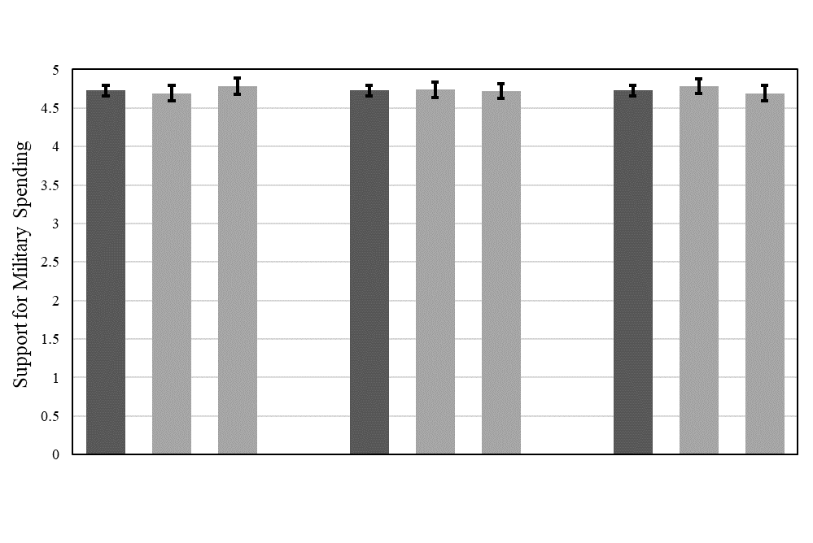

Figure S1: **Public Support for Increased Military Spending by Randomized Variable**

Overall Good Bad

Economic Condition

Overall Good Bad

Security Environment

Overall Increase Decrease

Others Military Spending

*Appendix 3*

Table S2: **Ordered Logit – Support for Military Spending, War Avoidance, and Isolationism**

|  |  |  |  |
| --- | --- | --- | --- |
|  | **Military spending** | **War avoidance** | **Isolationism** |
| National pride | 0.508*** | 0.315*** | -0.079 |
|  | (0.060) | (0.059) | (0.057) |
| Age | 0.010* | 0.009* | 0.018*** |
|  | (0.004) | (0.004) | (0.004) |
| Male | 0.492*** | -0.051 | -0.116 |
|  | (0.096) | (0.094) | (0.093) |
| Income | 0.030** | 0.021* | 0.013 |
|  | (0.009) | (0.009) | (0.009) |
| Bachelor’s degree/aboveα | 0.119 | -0.195* | 0.142 |
|  | (0.098) | (0.097) | (0.096) |
| N | 1,471 | 1,471 | 1,470 |
| *Notes*:  Standard errors in parentheses; *** p<0.001, ** p<0.01, * p<0.05; constant cuts omitted. α Bivariate regression for war avoidance shows “Bachelor’s degree or above” is statistically insignificant, although it is significant in the multivariate regression here. | | | |

Table S3: **Ordered Logit – Support for Military Spending**

|  |  |  |  |  |  |
| --- | --- | --- | --- | --- | --- |
|  | **(1)** | **(2)** | **(3)** | **(4)** | **(5)** |
| National pride | 0.473*** | 0.497*** | 0.499*** | 0.502*** | 0.508*** |
|  | (0.059) | (0.060) | (0.060) | (0.060) | (0.060) |
| Age |  | 0.016*** | 0.012** | 0.009* | 0.010* |
|  |  | (0.004) | (0.004) | (0.004) | (0.004) |
| Male |  |  | 0.519*** | 0.497*** | 0.492*** |
|  |  |  | (0.095) | (0.096) | (0.096) |
| Income |  |  |  | 0.032*** | 0.030** |
|  |  |  |  | (0.009) | (0.009) |
| Bachelor’s degree/above |  |  |  |  | 0.119 |
|  |  |  |  |  | (0.098) |
| N | 1,482 | 1,476 | 1,475 | 1,473 | 1,471 |
| *Notes:*  Standard errors in parentheses; *** p<0.001, ** p<0.01, * p<0.05, Ϯ p < 0.1; constant cuts omitted. | | | | | |

Table S4: **Ordered Logit – Preference for War Avoidance**

|  |  |  |  |  |  |
| --- | --- | --- | --- | --- | --- |
|  | **(1)** | **(2)** | **(3)** | **(4)** | **(5)** |
| National pride | 0.309*** | 0.328*** | 0.325*** | 0.324*** | 0.315*** |
|  | (0.059) | (0.059) | (0.059) | (0.059) | (0.059) |
| Age |  | 0.010** | 0.010** | 0.009* | 0.009* |
|  |  | (0.004) | (0.004) | (0.004) | (0.004) |
| Male |  |  | -0.038 | -0.056 | -0.051 |
|  |  |  | (0.094) | (0.094) | (0.094) |
| Income |  |  |  | 0.016 Ϯ | 0.021* |
|  |  |  |  | (0.009) | (0.009) |
| Bachelor’s degree/above |  |  |  |  | -0.195* |
|  |  |  |  |  | (0.097) |
| N | 1,482 | 1,476 | 1,475 | 1,473 | 1,471 |
| *Notes:*  Standard errors in parentheses; *** p<0.001, ** p<0.01, * p<0.05, Ϯ p < 0.1; constant cuts omitted. | | | | | |

Table S5: **Ordered Logit – Preference for Isolationism**

|  |  |  |  |  |  |
| --- | --- | --- | --- | --- | --- |
|  | **(1)** | **(2)** | **(3)** | **(4)** | **(5)** |
| National pride | -0.100Ϯ | -0.071 | -0.075 | -0.070 | -0.079 |
|  | (0.056) | (0.057) | (0.057) | (0.057) | (0.057) |
| Age |  | 0.018*** | 0.019*** | 0.017*** | 0.018*** |
|  |  | (0.004) | (0.004) | (0.004) | (0.004) |
| Male |  |  | -0.112 | -0.117 | -0.116 |
|  |  |  | (0.093) | (0.093) | (0.093) |
| Income |  |  |  | 0.016Ϯ | 0.013 |
|  |  |  |  | (0.009) | (0.009) |
| Bachelor’s degree/above |  |  |  |  | 0.142 |
|  |  |  |  |  | (0.096) |
| N | 1,481 | 1,475 | 1,474 | 1,472 | 1,470 |
| *Notes:*  Standard errors in parentheses; *** p<0.001, ** p<0.01, * p<0.05, Ϯ p < 0.1; constant cuts omitted. | | | | | |

*Appendix 4*

Table S6: **Difference in Means – Support for Military Spending, War Avoidance and Isolationism**

|  |  |  |  |
| --- | --- | --- | --- |
|  | **Military spending** | **War avoidance** | **Isolationism** |
| **Gender** |  |  |  |
| Male | 4.91 | 5.15 | 4.48 |
| Female | 4.54 | 5.23 | 4.53 |
| *Difference in means* | 0.37*** | -0.08 | -0.06 |
| **Ageα** |  |  |  |
| 28 and older | 4.80 | 5.21 | 4.66 |
| Younger than 28 | 4.54 | 5.11 | 4.03 |
| *Difference in means* | 0.26** | 0.10 | 0.64*** |
| **Education** |  |  |  |
| Bachelor’s degree/above | 4.80 | 5.12 | 4.60 |
| Otherwise | 4.68 | 5.23 | 4.43 |
| *Difference in means* | 0.13Ϯ | -0.11 | 0.17Ϯ |
| **Incomeβ** |  |  |  |
| High income | 4.86 | 5.26 | 4.61 |
| Otherwise | 4.61 | 5.11 | 4.41 |
| *Difference in means* | 0.26*** | 0.15Ϯ | 0.19* |
| **National prideγ** |  |  |  |
| Strong pride | 4.85 | 5.27 | 4.48 |
| Otherwise | 4.21 | 4.79 | 4.63 |
| *Difference in Means* | 0.63*** | 0.49*** | -0.15 |
| **Increasing military strength as top priority** |  |  |  |
| Yes | 5.38 | 5.13 | 4.20 |
| No | 4.58 | 5.21 | 4.56 |
| *Difference in means* | 0.80*** | -0.08 | -0.36** |
| *Notes:*  *** p<0.001, ** p<0.01, * p<0.05, Ϯ p < 0.1. Reported differences may differ slightly owing to rounding. | | | |
| α Since there is no standard cut-off for age, we use 28 as it is the maximum age for membership in the Communist Youth League of China. β We use the median income category as the cut-off point. **γ** National pride measured with the question “Are you proud to be a Chinese citizen?” on a four-point scale (from “Not proud at all” to “Very proud”). We use three points as the cut-off. | | | |

*Appendix 5*

Table S7: **Subgroup Means – Respondents for whom Increasing Military Capability Was Top Priority vs Others**

|  |  |  |
| --- | --- | --- |
|  | **Increasing military strength as top priority**  **(group mean)** | **Other policy options  as top priority**  **(group mean)** |
| Age | 39.70 | 40.01 |
| Male | 57.21% | 52.76% |
| Bachelor’s degree/above | 42.11% | 43.83% |
| Incomeα | 10.76 | 11.29 |
| National prideβ | 2.37 | 2.07 |
| *Notes:*  α Numbers refer to the annual income category that respondents reported in the survey.β Difference is statistically significant (*p* < 0.001, *n* = 1,313). | | |

Table S8: **Ordered Logit – Increasing Military Capability as Top Priority**

|  |  |  |  |  |  |
| --- | --- | --- | --- | --- | --- |
|  | **(1)** | **(2)** | **(3)** | **(4)** | **(5)** |
| National pride | 0.479*** | 0.479*** | 0.484*** | 0.482*** | 0.503*** |
|  | (0.100) | (0.100) | (0.100) | (0.100) | (0.101) |
| Age |  | 0.001 | 0.000 | 0.002 | 0.002 |
|  |  | (0.006) | (0.006) | (0.006) | (0.006) |
| Male |  |  | 0.215 | 0.229 | 0.222 |
|  |  |  | (0.150) | (0.150) | (0.151) |
| Income |  |  |  | -0.017 | -0.017 |
|  |  |  |  | (0.014) | (0.014) |
| Bachelor’s degree/above |  |  |  |  | 0.001 |
|  |  |  |  |  | (0.156) |
| N | 1,313 | 1,309 | 1,309 | 1,308 | 1,307 |
| *Note*:  Standard errors in parentheses. Constant cuts omitted. *** p<0.001, ** p<0.01, * p<0.05, Ϯ p < 0.1. | | | | | |