Appendix A: Visualisation of the Dependency Model with feature values for manual articulations (van der Kooij, 2002, pp. 280, Figure 5.43).

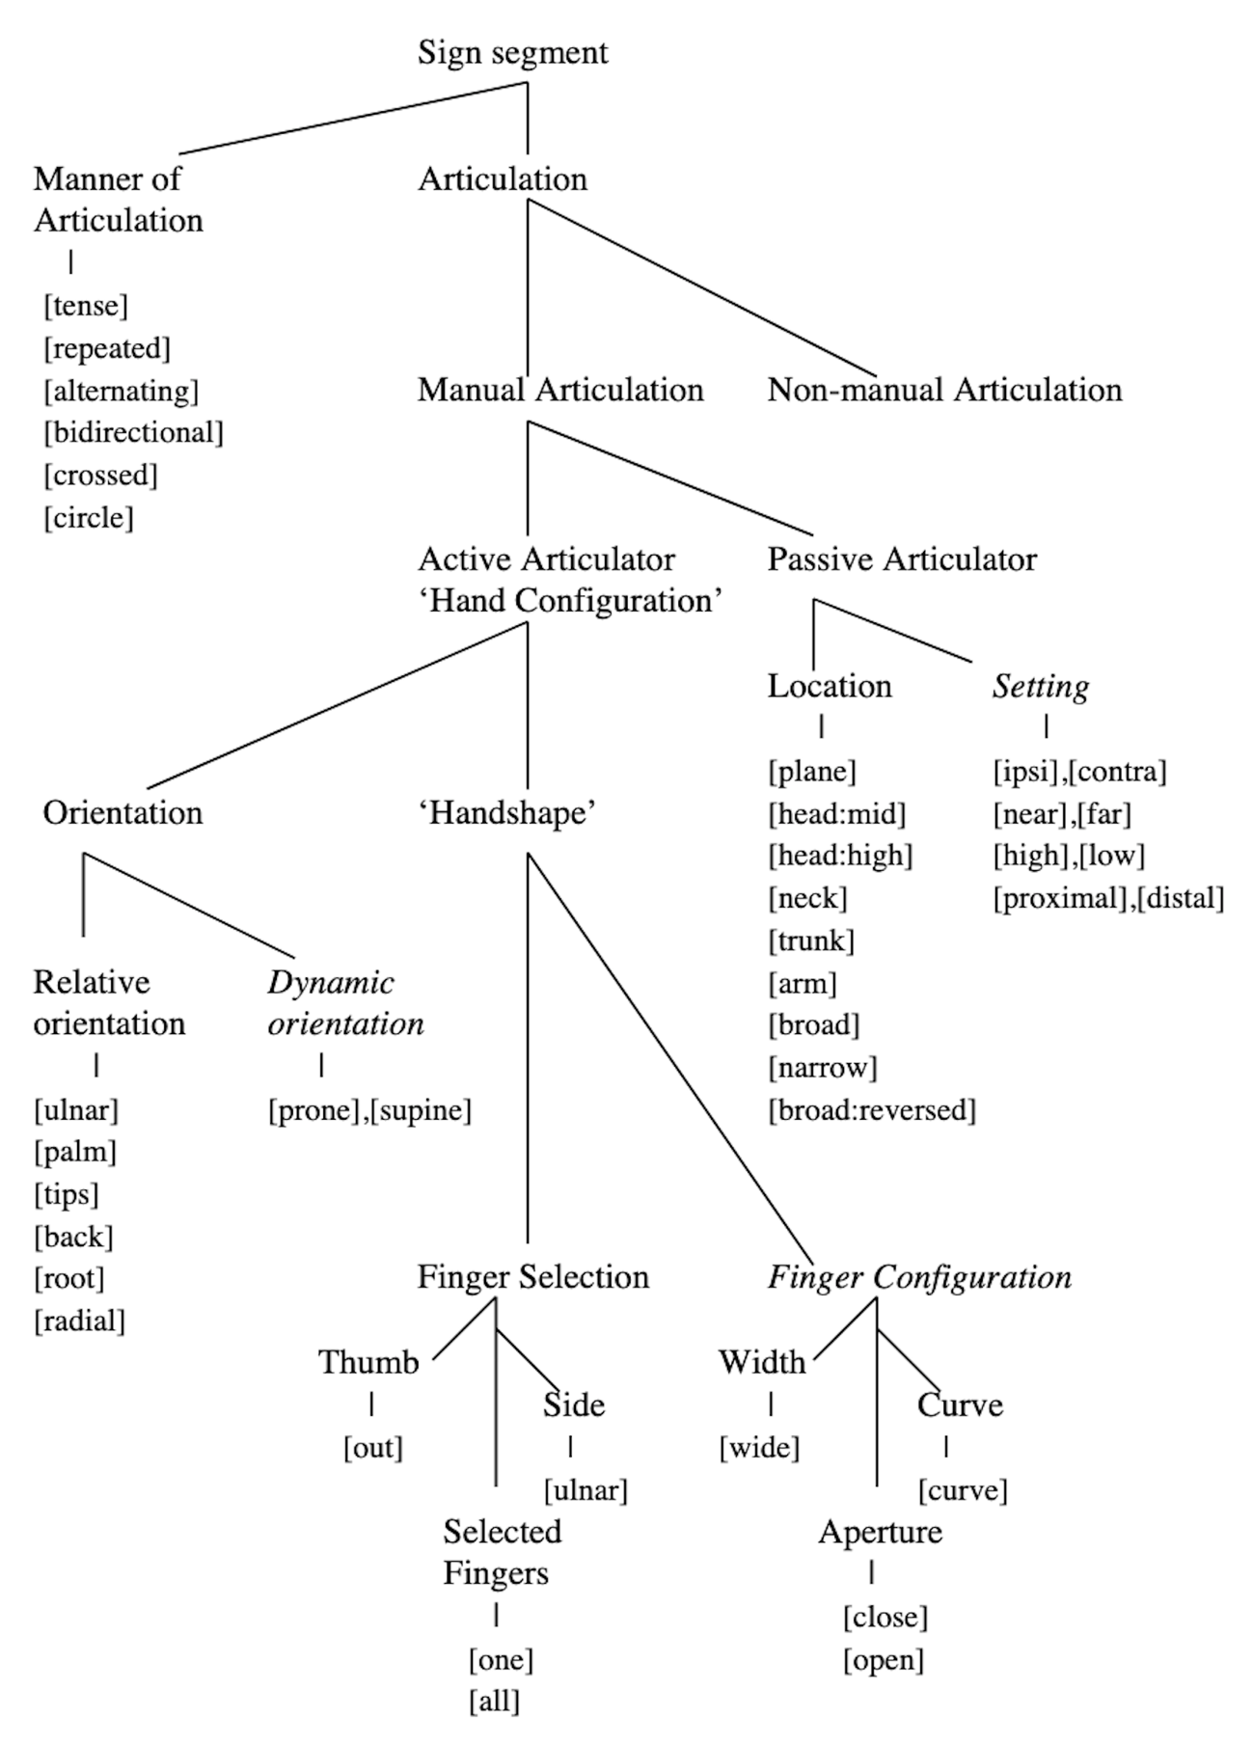

Appendix B: Overview of handshapes mentioned in the paper

Handshape (KOMVA) | Handshape representation
1
1_curved | 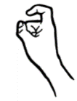
5 | 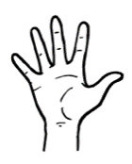
A
B
Beak | 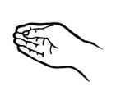
Baby_beak | 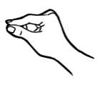
C_spread
ILY
S
Y | 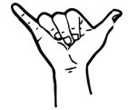

Appendix C: Coding Scheme

Tier | Coding dimensions | Coding values | Explanation
Main gloss | Gloss of sign | CV:gloss | CV indicates a child sign that deviates from the adult target  gloss indicates the adult target
non dominant hand |  | CV:gloss
CV_type | comma-separated list | omission  addition  substitution  body contact  assimilation  proximalization | lists aspects where the sign varies
CV_summary | comma-separated list |  | summary of all relevant tiers
CV_form | free description | Any | free description of child form
handshape | RH:handshape; LH:handshape | handshapes available from Global Signbank (addition if needed); else NA | handshape of right and left hand
handshape change | values from Global Signbank | opening  closing  curving  bending  spreading  unspreading  wiggling  rubbing  NA | Describes whether or not there is a handshape change, if so, what
movement | movement direction; movement shape  values from Global Signbank | Direction:  up  Down  Back  forwards  etc.  Shape:  straight  circle  zigzag  arc  etc. | Describes the (path) movement in two dimensions
location | values from Global Signbank | Head  back of head  cheek  cheekbone  chin  ear  eye  face  forehead  Head (top or side)  mouth  neck  nose  temple  tongue  upper lip  Body  back  belly  trunk  chest  flank  shoulder  hip  Extremities  arm  knee  leg  weak hand: +spec  upper arm  elbow  lower arm  wrist  Space  neutral space  horizontal plane  R loc  variable | Describes place of articulation
contact | contact type; contact location | Type:  brush  initial  final  continuous  etc.  Location:  see location  NA | Describes the type of the contact and where the hands make contact (e.g., in space with each other or with the body)
non-manual | free description | own words  NA | Describes use or lack of non-manuals in the sign
palm orientation | Initial palm position | forwards  backwards  inwards  outwards | Describes the initial position of the palm(s)

Appendix D: Overview of number of child modification tokens per minute of recordings, broken down per recording session.

Focus Child | Age in days at recording | Modification tokens | Length of recording (min) | Ratio modification per minute of recording
CSA | 479 | 74 | 235 | 0.31
CSA | 500 | 0 | 79 | 0
CSA | 523 | 43 | 116 | 0.37
CSA | 556 | 20 | 221 | 0.09
CSA | 584 | 34 | 147 | 0.23
CSA | 630 | 24 | 189 | 0.13
CSA | 663 | 12 | 58 | 0.21
CSA | 673 | 37 | 168 | 0.22
CSC | 468 | 20 | 252 | 0.08
CSC | 502 | 17 | 247 | 0.07
CSC | 530 | 59 | 289 | 0.2
CSC | 560 | 21 | 240 | 0.09
CSC | 585 | 61 | 241 | 0.25
CSC | 614 | 159 | 260 | 0.61
CSC | 648 | 59 | 303 | 0.19
CSC | 676 | 62 | 304 | 0.2
CSC | 711 | 29 | 329 | 0.09
CSC | 742 | 91 | 366 | 0.25
CSC | 772 | 54 | 290 | 0.19
P3 | 716 | 6 | 33 | 0.18
P3 | 719 | 12 | 60 | 0.2
P3 | 720 | 33 | 61 | 0.54
P3 | 741 | 7 | 61 | 0.11
P3 | 753 | 8 | 24 | 0.33
P3 | 820 | 7 | 50 | 0.14
P3 | 829 | 0 | 17 | 0
P3 | 832 | 1 | 53 | 0.02
P3 | 846 | 9 | 90 | 0.1
P3 | 862 | 1 | 19 | 0.05
P3 | 874 | 0 | 1 | 0
P3 | 877 | 0 | 29 | 0
P3 | 911 | 1 | 43 | 0.02
P3 | 982 | 13 | 182 | 0.07
P3 | 997 | 5 | 61 | 0.08
P3 | 1011 | 3 | 61 | 0.05
P3 | 1028 | 2 | 56 | 0.04
P3 | 1082 | 5 | 43 | 0.12
SS | 745 | 0 | 36 | 0
SS | 773 | 11 | 29 | 0.38
SS | 848 | 3 | 44 | 0.07
SS | 852 | 14 | 53 | 0.26
SS | 866 | 14 | 90 | 0.16
SS | 897 | 9 | 22 | 0.41
SS | 925 | 4 | 26 | 0.15
SS | 1002 | 12 | 182 | 0.07
SS | 1017 | 8 | 61 | 0.13
SS | 1029 | 17 | 88 | 0.19
SS | 1048 | 18 | 61 | 0.3
SS | 1083 | 7 | 60 | 0.12
SS | 1102 | 4 | 15 | 0.27
SS | 1104 | 9 | 58 | 0.16

Appendix E: Sign-level combinations (all data)

