Supplementary Materials
Appendix A
Table S1. Prompts used in SA Task
Trial Number | Referent | Prompt | Data
Training 1 |  | Put the ball in the basket | 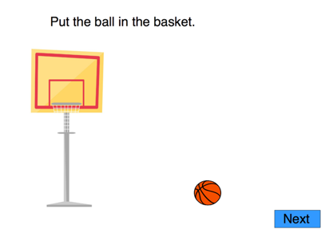
Training 2 |  | Put the candy in the basket | 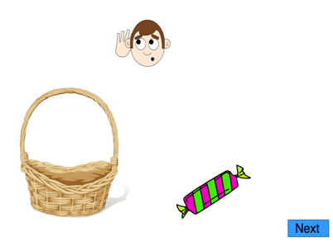
Training 3 |  | Put the fish in the pond | 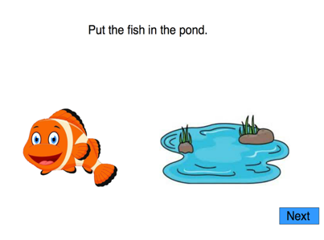
Training 4 |  | Put the dog on the towel | 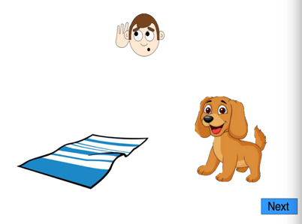
Test Trials
1 | 1 | Put the fish on the sponge on the plate | 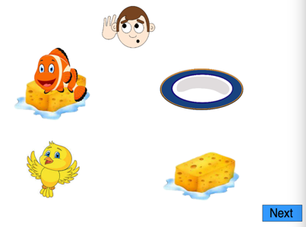
2 | 1 | Put the frog on the napkin in the box | 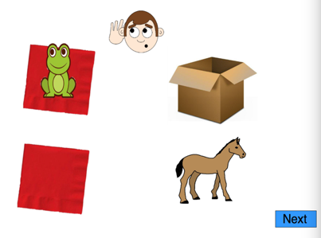
3 | 2 | Put the donkey on the plate in the wagon | 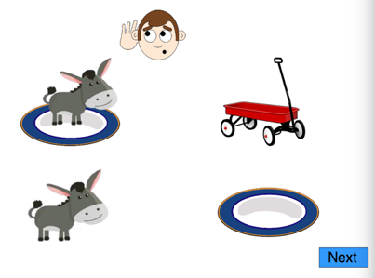
4 | 2 | Put the bird in the bowl on the towel | 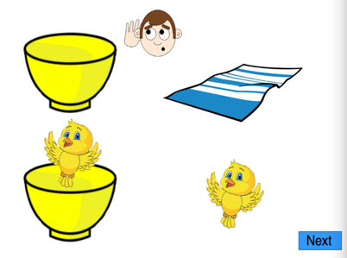
5 | 1 | Put the dog with the stick on the tray | 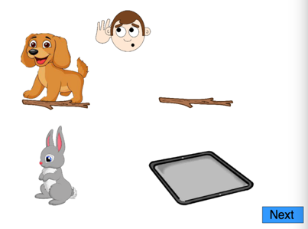
6 | 2 | Put the frog on the napkin in the box | 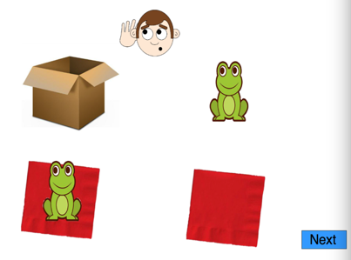
7 | 1 | Put the rabbit on the towel in the cage | 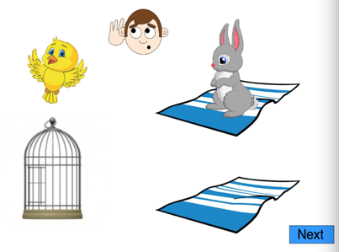
8 | 2 | Put the bird in the yellow mug on the napkin | 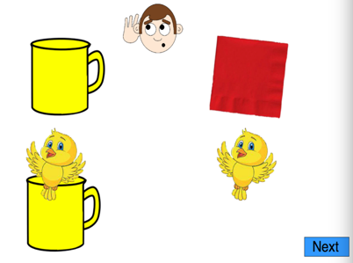
9 | 2 | Put the dog with the stick on the tray | 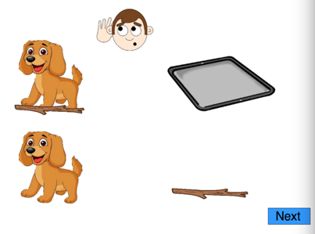
10 | 1 | Put the cat on the sponge in the truck | 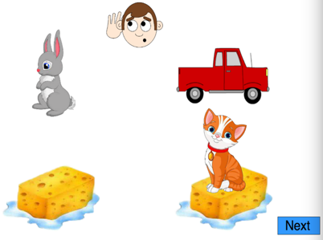
11 | 1 | Put the bird in the bowl on the towel | 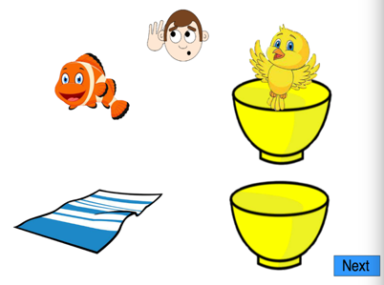
12 | 2 | Put the fish on the sponge on the plate | 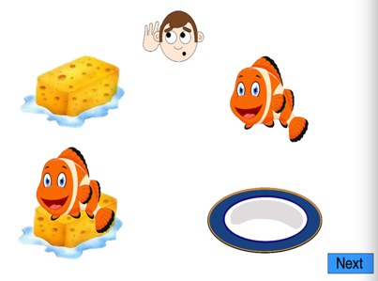
13 | 1 | Put the lamb with the pink napkin in the tent | 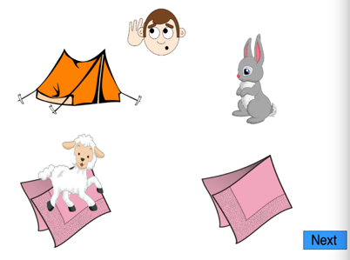
14 | 2 | Put the lamb on the soap in the field | 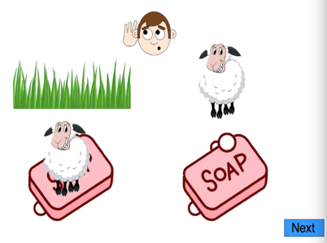
15 | 1 | Put the lamb on the soap in the field | 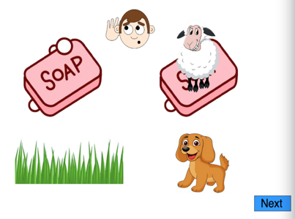
16 | 2 | Put the lamb with the pink napkin in the tent | 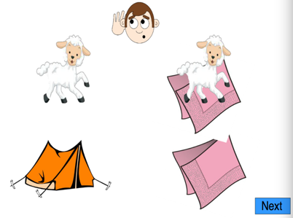
17 | 1 | Put the donkey on the plate in the wagon | 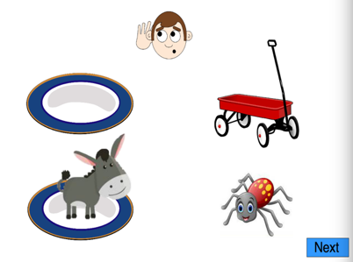
18 | 2 | Put the rabbit on the small plate in the cage | 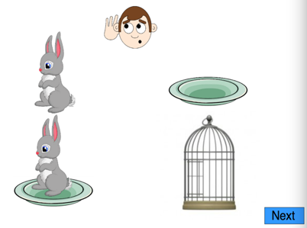
19 | 2 | Put the cat on the sponge in the truck | 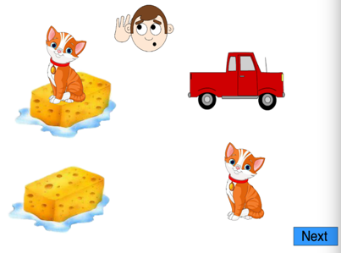
20 | 1 | Put the bird in the yellow mug on the napkin | 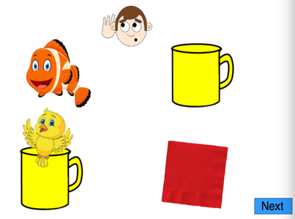
21 | 1 | Put the fish with the blue towel in the pond | 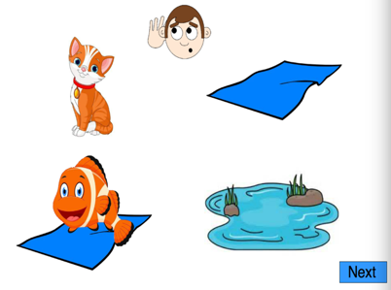
22 | 2 | Put the sheep on the white saucer with the flag | 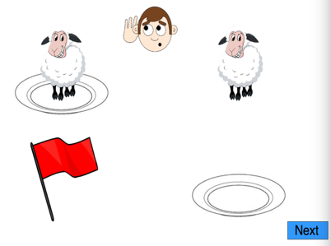
23 | 2 | Put the cat on the napkin in the basket | 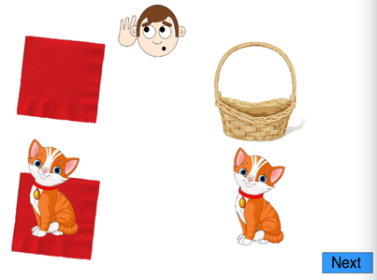
24 | 1 | Put the cat on the napkin in the basket | 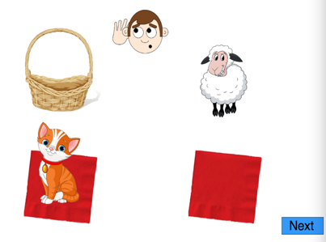
25 | 1 | Put the rabbit on the small plate in the cage | 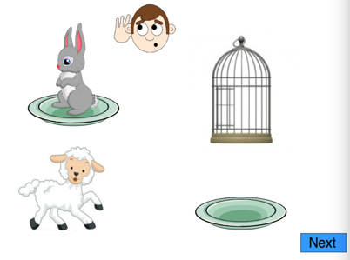
26 | 2 | Put the fish with the blue towel in the pond | 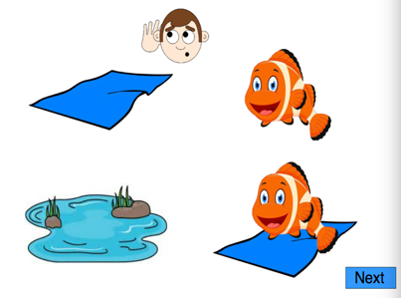
27 | 2 | Put the rabbit on the towel in the cage | 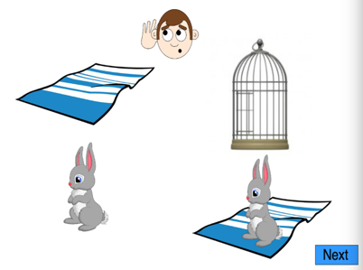
28 | 1 | Put the sheep on the white saucer with the flag | 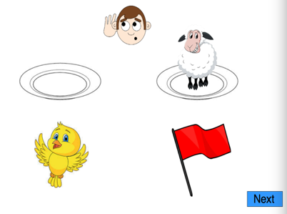

Appendix B: Inhibitory Control Rasch Analysis
Table S2. IC Dichotomous Rasch Model Item Calibration
Task ID | Proportion Correct | Item Location | Item SE | Outfit MSE | Std. Outfit | Infit MSE | Std. Infit
DNS_Score.1 | 0.81 | -1.69 | 0.32 | 1.11 | 0.61 | 1.01 | 0.13
DNS_Score.10 | 0.81 | -1.69 | 0.32 | 0.87 | -0.71 | 0.9 | -0.49
DNS_Score.11 | 0.81 | -1.69 | 0.32 | 0.91 | -0.46 | 0.9 | -0.5
DNS_Score.12 | 0.84 | -1.9 | 0.33 | 0.92 | -0.33 | 1.03 | 0.21
DNS_Score.13 | 0.84 | -1.9 | 0.33 | 1.23 | 1.02 | 0.99 | 0
DNS_Score.14 | 0.84 | -1.9 | 0.33 | 0.72 | -1.4 | 0.94 | -0.24
DNS_Score.15 | 0.79 | -1.5 | 0.3 | 0.86 | -0.84 | 0.86 | -0.83
DNS_Score.16 | 0.81 | -1.69 | 0.32 | 0.92 | -0.4 | 0.92 | -0.38
DNS_Score.17 | 0.8 | -1.59 | 0.31 | 1.38 | 1.97 | 1.22 | 1.19
DNS_Score.18 | 0.85 | -2.01 | 0.35 | 1.31 | 1.28 | 1.1 | 0.52
DNS_Score.19 | 0.8 | -1.59 | 0.31 | 1.2 | 1.05 | 1.07 | 0.46
DNS_Score.2 | 0.84 | -1.9 | 0.33 | 1.05 | 0.29 | 0.94 | -0.23
DNS_Score.20 | 0.8 | -1.59 | 0.31 | 0.9 | -0.52 | 0.99 | -0.02
DNS_Score.21 | 0.72 | -1.08 | 0.28 | 1.04 | 0.31 | 1.04 | 0.33
DNS_Score.22 | 0.75 | -1.24 | 0.28 | 0.9 | -0.67 | 0.89 | -0.75
DNS_Score.23 | 0.85 | -2.01 | 0.35 | 1.07 | 0.35 | 0.97 | -0.05
DNS_Score.24 | 0.84 | -1.9 | 0.33 | 1.24 | 1.11 | 1.04 | 0.26
DNS_Score.25 | 0.83 | -1.79 | 0.32 | 1.03 | 0.2 | 1.01 | 0.12
DNS_Score.26 | 0.87 | -2.14 | 0.36 | 1.74 | 2.55 | 1.07 | 0.38
DNS_Score.27 | 0.87 | -2.14 | 0.36 | 0.85 | -0.59 | 0.93 | -0.2
DNS_Score.28 | 0.8 | -1.59 | 0.31 | 1.12 | 0.67 | 1.06 | 0.4
DNS_Score.29 | 0.88 | -2.27 | 0.37 | 0.86 | -0.51 | 1.01 | 0.11
DNS_Score.3 | 0.88 | -2.27 | 0.37 | 1.03 | 0.18 | 0.94 | -0.16
DNS_Score.30 | 0.81 | -1.69 | 0.32 | 0.97 | -0.1 | 0.88 | -0.6
DNS_Score.31 | 0.88 | -2.27 | 0.37 | 1.38 | 1.37 | 1 | 0.07
DNS_Score.4 | 0.77 | -1.41 | 0.29 | 0.86 | -0.87 | 0.95 | -0.24
DNS_Score.5 | 0.81 | -1.69 | 0.32 | 1.48 | 2.25 | 1.12 | 0.65
DNS_Score.6 | 0.84 | -1.9 | 0.33 | 0.91 | -0.4 | 0.96 | -0.14
DNS_Score.7 | 0.83 | -1.79 | 0.32 | 0.89 | -0.54 | 0.95 | -0.2
DNS_Score.8 | 0.75 | -1.24 | 0.28 | 1.19 | 1.22 | 1.03 | 0.28
DNS_Score.9 | 0.84 | -1.9 | 0.33 | 0.99 | 0 | 0.96 | -0.15
Flanker_Score.1.1 | 0.68 | -0.86 | 0.27 | 0.96 | -0.37 | 0.96 | -0.3
Flanker_Score.1.10 | 0.73 | -1.16 | 0.28 | 1.02 | 0.18 | 1.04 | 0.36
Flanker_Score.1.11 | 0.59 | -0.39 | 0.25 | 0.99 | -0.14 | 1 | -0.02
Flanker_Score.1.12 | 0.64 | -0.66 | 0.26 | 1 | 0.05 | 1 | 0.01
Flanker_Score.1.13 | 0.67 | -0.79 | 0.26 | 0.91 | -0.79 | 0.92 | -0.74
Flanker_Score.1.14 | 0.67 | -0.79 | 0.26 | 1.03 | 0.26 | 1.03 | 0.33
Flanker_Score.1.15 | 0.64 | -0.66 | 0.26 | 1.1 | 0.98 | 1.09 | 0.86
Flanker_Score.1.16 | 0.68 | -0.86 | 0.27 | 0.86 | -1.22 | 0.91 | -0.77
Flanker_Score.1.17 | 0.69 | -0.93 | 0.27 | 0.88 | -1.02 | 0.89 | -0.93
Flanker_Score.1.18 | 0.81 | -1.69 | 0.32 | 0.93 | -0.34 | 1 | 0.07
Flanker_Score.1.19 | 0.67 | -0.79 | 0.26 | 0.88 | -1.07 | 0.9 | -0.93
Flanker_Score.1.2 | 0.71 | -1.01 | 0.27 | 0.96 | -0.28 | 0.96 | -0.26
Flanker_Score.1.20 | 0.64 | -0.66 | 0.26 | 1.05 | 0.47 | 1.03 | 0.3
Flanker_Score.1.3 | 0.68 | -0.86 | 0.27 | 1.1 | 0.83 | 1.05 | 0.46
Flanker_Score.1.4 | 0.67 | -0.79 | 0.26 | 0.9 | -0.89 | 0.93 | -0.61
Flanker_Score.1.5 | 0.76 | -1.32 | 0.29 | 1 | 0.04 | 1.05 | 0.34
Flanker_Score.1.6 | 0.69 | -0.93 | 0.27 | 1.1 | 0.8 | 1.05 | 0.4
Flanker_Score.1.7 | 0.8 | -1.59 | 0.31 | 1.03 | 0.2 | 1.16 | 0.89
Flanker_Score.1.8 | 0.76 | -1.32 | 0.29 | 1.01 | 0.09 | 0.99 | -0.01
Flanker_Score.1.9 | 0.79 | -1.5 | 0.3 | 1.02 | 0.17 | 1.06 | 0.4

Table S3. IC Dichotomous Rasch Model Person Calibration
Person ID |  | Proportion Correct | Person Location | Person SE | Outfit MSE | Std. Outfit | Infit MSE | Std. Infit
1 |  | 0.84 | 0.26 | 0.39 | 0.98 | 0.05 | 0.98 | -0.02
2 |  | 0.88 | 0.58 | 0.43 | 1.07 | 0.3 | 0.97 | 0.02
3 |  | 0.9 | 0.78 | 0.46 | 1.11 | 0.39 | 0.98 | 0.07
4 |  | 0.9 | 0.78 | 0.46 | 0.76 | -0.52 | 0.91 | -0.15
5 |  | 0.92 | 1 | 0.5 | 1.17 | 0.5 | 0.94 | -0.02
6 |  | 0.59 | -1.09 | 0.29 | 0.9 | -1.12 | 0.9 | -1.22
7 |  | 0.84 | 0.26 | 0.39 | 0.9 | -0.26 | 0.97 | -0.06
8 |  | 0.94 | 1.28 | 0.56 | 1.01 | 0.2 | 0.91 | -0.05
9 |  | 0.88 | 0.58 | 0.43 | 1.12 | 0.44 | 1 | 0.11
10 |  | 0.84 | 0.26 | 0.39 | 1.16 | 0.6 | 1.05 | 0.28
11 |  | 0.92 | 1 | 0.5 | 1.2 | 0.55 | 0.99 | 0.12
12 |  | 0.84 | 0.26 | 0.39 | 0.94 | -0.09 | 0.94 | -0.17
13 |  | 0.92 | 1 | 0.5 | 0.89 | -0.08 | 0.9 | -0.13
14 |  | 0.65 | -0.83 | 0.3 | 0.95 | -0.38 | 0.96 | -0.37
15 |  | 0.86 | 0.41 | 0.41 | 0.59 | -1.36 | 0.81 | -0.64
16 |  | 0.71 | -0.55 | 0.31 | 1.2 | 1.25 | 1.16 | 1.17
17 |  | 0.8 | -0.01 | 0.36 | 1.31 | 1.24 | 1.13 | 0.68
18 |  | 0.76 | -0.24 | 0.34 | 0.9 | -0.43 | 0.94 | -0.28
19 |  | 0.82 | 0.12 | 0.37 | 1.04 | 0.25 | 1.01 | 0.11
20 |  | 0.78 | -0.13 | 0.35 | 0.74 | -1.23 | 0.84 | -0.83
21 |  | 0.96 | 1.64 | 0.66 | 0.86 | 0.01 | 0.86 | -0.05
22 |  | 0.92 | 1 | 0.5 | 0.73 | -0.47 | 0.9 | -0.13
23 |  | 0.96 | 1.64 | 0.66 | 0.86 | 0 | 0.86 | -0.07
24 |  | 0.9 | 0.78 | 0.46 | 0.69 | -0.71 | 0.87 | -0.27
25 |  | 0.75 | -0.35 | 0.33 | 1.13 | 0.72 | 1.12 | 0.77
26 |  | 0.8 | -0.01 | 0.36 | 1.07 | 0.36 | 1.06 | 0.36
27 |  | 0.9 | 0.78 | 0.46 | 1.19 | 0.58 | 1.02 | 0.16
28 |  | 0.53 | -1.34 | 0.29 | 0.94 | -0.75 | 0.94 | -0.8
29 |  | 0.92 | 1 | 0.5 | 1.26 | 0.66 | 0.99 | 0.11
30 |  | 0.8 | -0.01 | 0.36 | 1.03 | 0.18 | 1.04 | 0.27
31 |  | 0.78 | -0.13 | 0.35 | 0.89 | -0.43 | 0.93 | -0.29
32 |  | 0.9 | 0.78 | 0.46 | 1.17 | 0.53 | 0.99 | 0.08
33 |  | 0.9 | 0.78 | 0.46 | 0.58 | -1.07 | 0.83 | -0.41
34 |  | 0.76 | -0.24 | 0.34 | 0.85 | -0.68 | 0.92 | -0.41
35 |  | 0.88 | 0.58 | 0.43 | 1.25 | 0.75 | 1.01 | 0.14
36 |  | 0.82 | 0.12 | 0.37 | 0.91 | -0.24 | 0.93 | -0.27
37 |  | 0.65 | -0.83 | 0.3 | 0.89 | -0.95 | 0.91 | -0.9
38 |  | 0.73 | -0.46 | 0.32 | 0.94 | -0.28 | 0.95 | -0.3
39 |  | 0.75 | -0.35 | 0.33 | 0.95 | -0.19 | 0.98 | -0.06
40 |  | 0.71 | -0.55 | 0.31 | 0.84 | -1.07 | 0.87 | -1
41 |  | 0.65 | -0.83 | 0.3 | 0.96 | -0.32 | 0.98 | -0.11
42 |  | 0.69 | -0.65 | 0.31 | 1.27 | 1.79 | 1.22 | 1.74
43 |  | 0.86 | 0.41 | 0.41 | 1.16 | 0.57 | 1.03 | 0.21
44 |  | 0.76 | -0.24 | 0.34 | 0.74 | -1.33 | 0.85 | -0.88
45 |  | 0.88 | 0.58 | 0.43 | 0.68 | -0.88 | 0.87 | -0.32
46 |  | 0.22 | -2.79 | 0.34 | 0.89 | -0.43 | 0.97 | -0.12
47 |  | 0.76 | -0.24 | 0.34 | 1.34 | 1.58 | 1.14 | 0.84
48 |  | 0.94 | 1.28 | 0.56 | 0.88 | -0.05 | 0.9 | -0.07
49 |  | 0.78 | -0.13 | 0.35 | 1.09 | 0.46 | 1.09 | 0.55
50 |  | 0.78 | -0.13 | 0.35 | 0.88 | -0.51 | 0.94 | -0.25
51 |  | 0.76 | -0.24 | 0.34 | 1.24 | 1.17 | 1.11 | 0.69
52 |  | 0.61 | -1.01 | 0.29 | 0.82 | -1.99 | 0.83 | -2
53 |  | 0.73 | -0.46 | 0.32 | 1.11 | 0.68 | 1.06 | 0.48
54 |  | 0.73 | -0.46 | 0.32 | 1.05 | 0.36 | 1.07 | 0.52
55 |  | 0.57 | -1.17 | 0.29 | 0.89 | -1.3 | 0.9 | -1.37
56 |  | 0.35 | -2.09 | 0.3 | 1.09 | 0.77 | 1.06 | 0.61
57 |  | 0.41 | -1.83 | 0.29 | 0.87 | -1.52 | 0.89 | -1.5
58 |  | 0.94 | 1.28 | 0.56 | 0.96 | 0.12 | 0.91 | -0.03
59 |  | 0.67 | -0.74 | 0.3 | 0.93 | -0.47 | 0.93 | -0.62
60 |  | 0.9 | 0.78 | 0.46 | 1.27 | 0.75 | 1.02 | 0.18
61 |  | 0.78 | -0.13 | 0.35 | 0.83 | -0.71 | 0.86 | -0.72
62 |  | 0.65 | -0.83 | 0.3 | 0.99 | -0.01 | 1.01 | 0.11
63 |  | 0.69 | -0.65 | 0.31 | 0.8 | -1.44 | 0.82 | -1.5
64 |  | 0.59 | -1.09 | 0.29 | 0.99 | -0.11 | 1 | 0.01
65 |  | 0.8 | -0.01 | 0.36 | 0.88 | -0.42 | 0.91 | -0.37
66 |  | 0.57 | -1.17 | 0.29 | 0.89 | -1.34 | 0.9 | -1.3
67 |  | 0.31 | -2.27 | 0.31 | 1.43 | 2.67 | 1.27 | 2.14
68 |  | 0.86 | 0.41 | 0.41 | 0.69 | -0.96 | 0.85 | -0.5
69 |  | 0.86 | 0.41 | 0.41 | 1.02 | 0.17 | 0.98 | 0.01
70 |  | 0.94 | 1.28 | 0.56 | 1.09 | 0.34 | 0.93 | 0.01
71 |  | 0.94 | 1.28 | 0.56 | 0.94 | 0.08 | 0.91 | -0.03
72 |  | 0.82 | 0.12 | 0.37 | 0.72 | -1.06 | 0.85 | -0.62
73 |  | 0.82 | 0.12 | 0.37 | 0.98 | 0.01 | 0.98 | 0
74 |  | 0.57 | -1.17 | 0.29 | 0.95 | -0.62 | 0.95 | -0.7
75 |  | 0.8 | -0.01 | 0.36 | 0.93 | -0.21 | 0.98 | -0.04

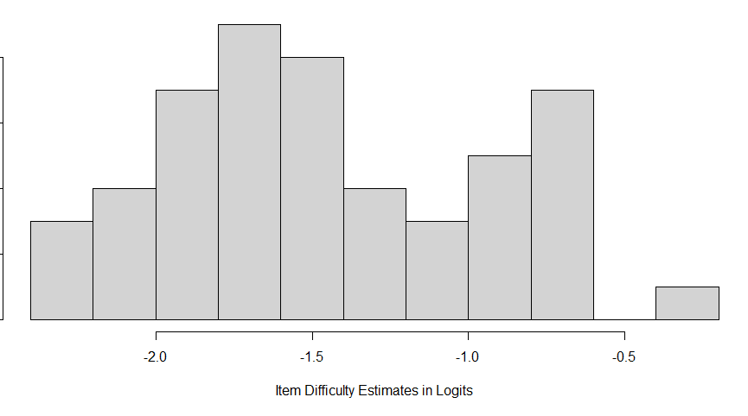
Figure S1. Histogram of Item Difficulty Estimates for the IC Data

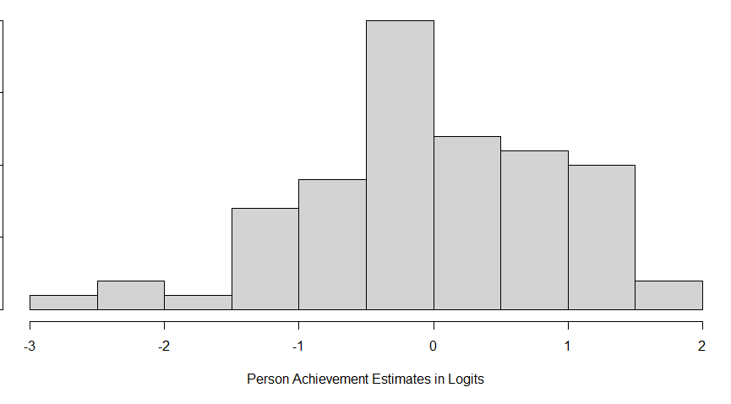
Figure S2. Histogram of Person Achievement Estimates for the IC Data

