Appendix B. Stimuli
A. Warm up items

Prompted with the statement in (1), the child is expected to describe the seven pictures that s/he is shown. The events depicted in the pictures require the use of the verbs listed in (2).
(1) Let us look at the pictures and tell what the cat in the picture does every day.
(2) 1. televizyon izle-r ‘watches TV’
2. top oyna-r ‘plays (with the ball)’
3. yüz-er ‘swims’
4. bisiklete bin-er ‘rides/ gets on (the bike)’
5. (yemek) ye-r ‘eats (meal)’
6. (kitap) oku-r ‘reads (book)’
7. uyu-r ‘sleeps’

B. Test items

Sample Protocol:
Prompted with the question ‘X burada ne yap-ar?’ ‘What does X do in the picture?’ the child is expected to describe the events that are depicted in the pictures referring to the test items in a, b, c and d.

- In items a4, a7, a9, b7, for example, the child is given a scenario such as ‘What happens if you do not water a plant?’, ‘What happens if you leave the juice in the fridge?’ and asked to comment on the possible outcome – triggering the epistemic function of aorist.
- In items b2, b5, b6, the targeted verbs are elicited by giving the child a scenario and asking her to request something from someone, triggering the request function of aorist.
The test items are listed in alphabetical order. Each child has seen the pictures in a randomized order except for a couple of thematically related items such as c1 and c5; (The boy throws fish at the penguin and the penguin catches the fish) or d1 and a9 (The piggy brings tea and if the teapot touches the frog’s leg it would burn), c2 and b4 (The girl looks in the mirror and sees herself), etc.

a. Sonorant-ending Ar-taking regular monosyllabic verbs:
Items Verb-Aorist Gloss
- The cat gets on the car. bin- er gets on
- The frog plays the drum. çal- ar plays
- The boy dives into the pool. dal- ar dives
4. If you leave the juice in the fridge it would freeze. don- ar would freeze
5. The boy laughs at the clown. gül- er laughs
6. The monkey breaks the egg. kır- ar breaks
7. If we do not water the plant, it would fade. sol- ar would fade
8. The cat drives a tractor. sür- er drives
9. If the teapot touches the frog it would burn. yan- ar would burn

b. Sonorant-ending Ir-taking irregular monosyllabic verbs:
Items Verb-Aorist Gloss
1. The girl takes the teddy bear on her lap. al- ır takes
2. Ask your father to find your toy for you. bul- ur would you find
3. The monkey stands on the tree. dur- ur stands
4. The girl sees herself in the mirror. gör- ür sees
5. Ask your friend to stay longer. kal- ır would you stay
6. Ask your friend to be quieter. ol- ur would you be
7. If we do not water a plant, it would die. öl- ür would die
8. The girl gives the ball to the boy. ver- ir gives
9. The boy kicks the ball. vur- ur kicks

c. Non-sonorant-ending Ar-taking regular monosyllabic verbs:
Items Verb-Aorist Gloss
1. The boy throws fish at the penguin. at- ar throws
2. The girl looks in the mirror. bak- ar looks
3. The mouse walks up the stairs. çık- ar walks up
4. The mouse gets up in the morning. kalk- ar get up
5. The penguin catches the fish. tut- ar holds
6. The kitty draws a picture. yap- ar does/paints
7. The cat lies down. yat- ar lies down

d. Multisyllabic verbs:
Items Verb-Aorist Gloss
1. The piggy brings tea to the frog. getir- ir brings
2. The child points at the picture. göster- ir points
3. The girl misses the bus. kaçır- ır misses
4. The girl sits in the armchair. otur- ur sits
5. The frog swings. sallan- ır swings
6. The boy sweeps the floor. süpür- ür sweeps
7. The cat climbs the tree. tırman- ır climbs

C. Sample protocol

(1) is a typical child response to the question ‘What does X do here?’. (2) is an example for a request.
(1) Exp: Çocuk burada ne yap-ar?
child here what do-AORIST.3S
What does the boy do here?

Child: Havuz-a dal-ar.
pool-DAT dive-AORIST.3S
‘(The boy) dives into the pool.’

(2) Exp: Oyuncağ-ın-ı kaybet-ti-n. Anne-n-den bul-ma-sın-ı iste lütfen?
toy-POSS.3S-ACC lost mother-POSS.2S-ABL find-NOM-POSS-ACC want please
‘You lost your toy. Ask your mother to find it for you, please?’

Child: Oyuncağ-ım-ı bul-ur mu-sun?
toy-POSS.1S-ACC find-AORIST Question.particle-2S
‘Could you find my toy?’

D. Sample test items

i. sonorant-ending regular verbs:

çal ‘play’ dal ‘dive’
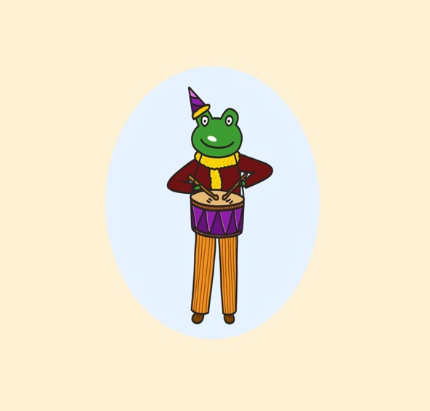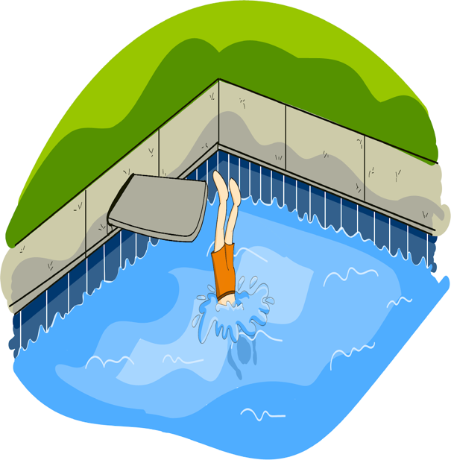

kır ‘break’ sür ‘ride’
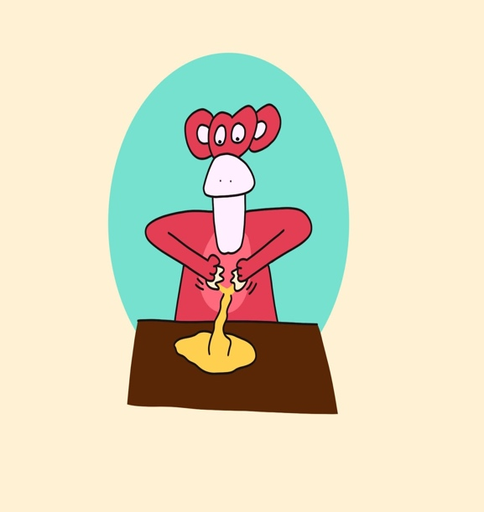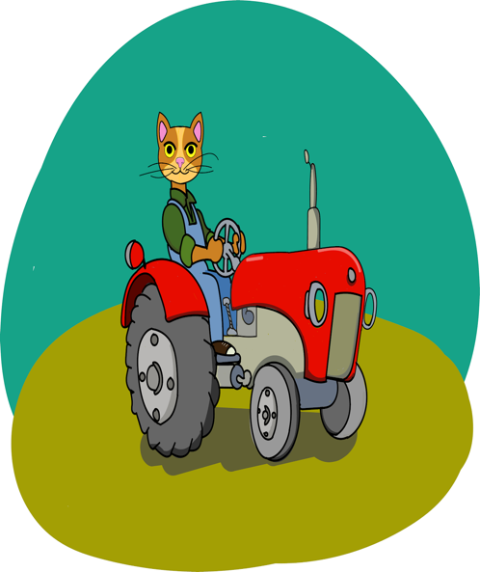

ii. sonorant-ending irregular verbs:

al ‘take’ dur ‘stand’
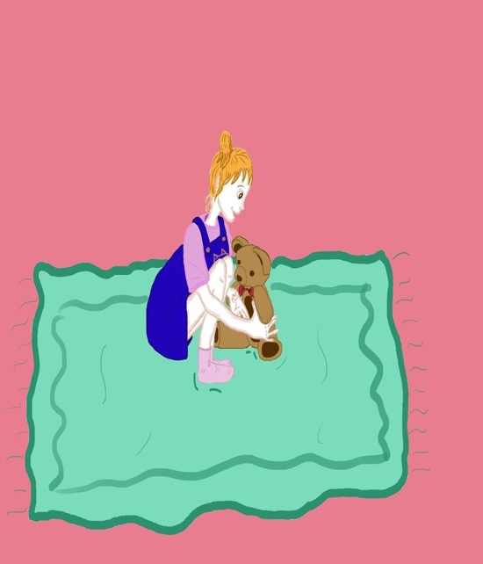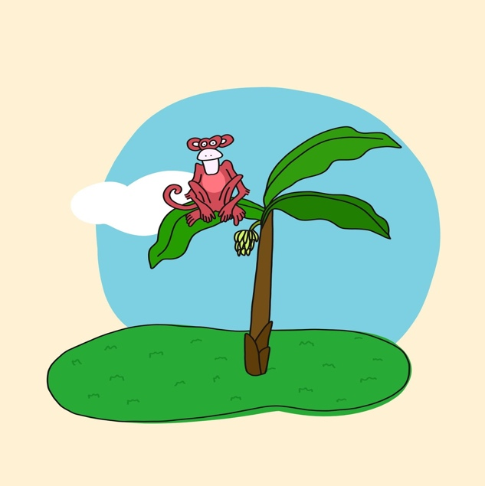

gör ‘see’ ver ‘give’
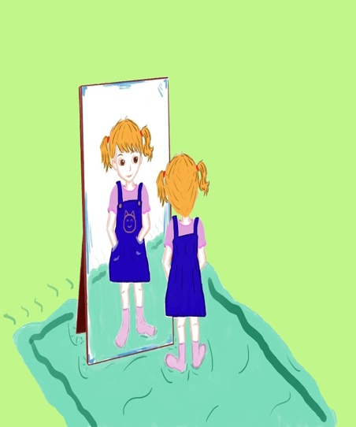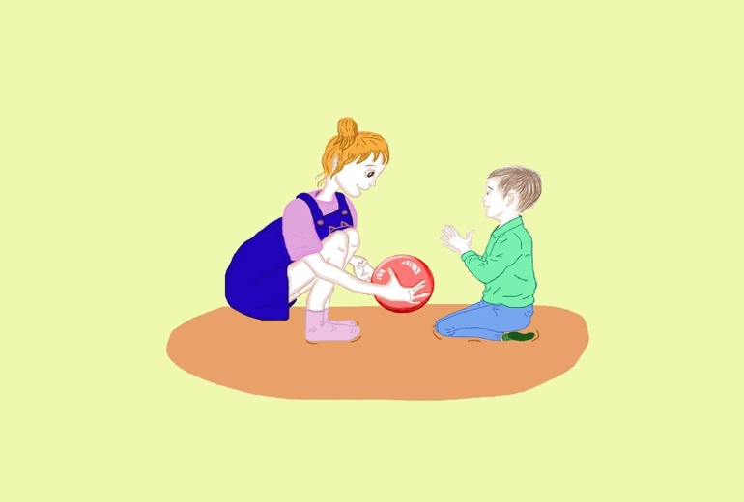

iii. Non-sonorant-ending regular verbs:

at ‘throw’ çiz ‘draw’

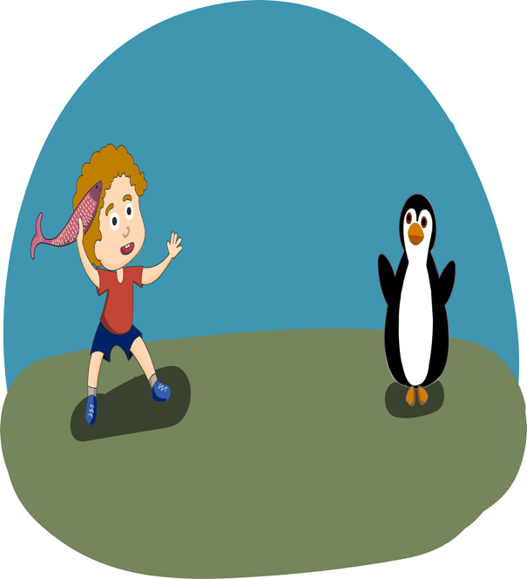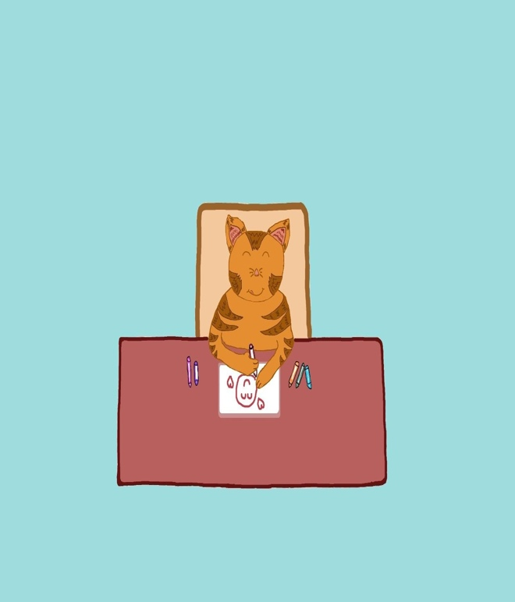

tut ‘catch’ bak ‘look at’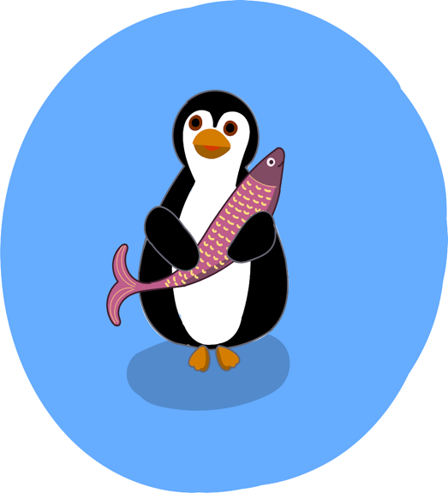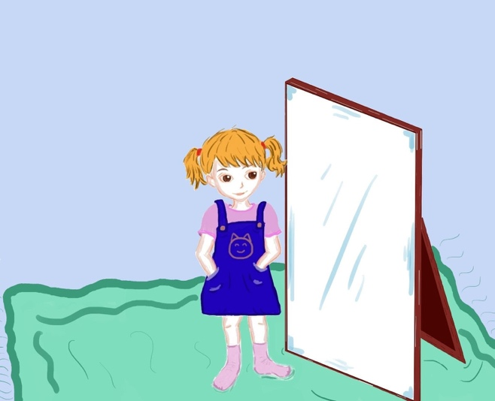
iv. Multisyllabic verbs

getir ‘bring’ kaçır ‘miss’
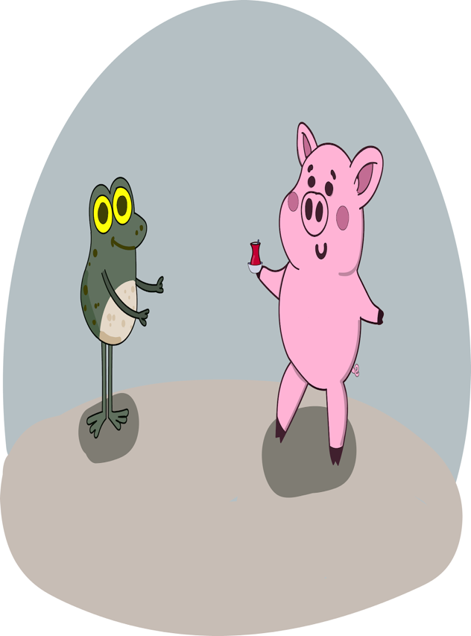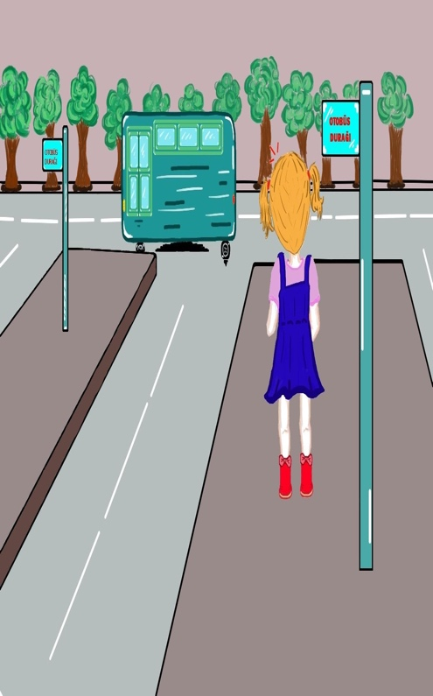
sallan ‘swing’ süpür ‘sweep’