Appendix
 | CDS |  |  | OCDS |  |  | ADS
 | MOT | ADU | OCHI | MOT | ADU | OCHI | MOT | ADU | OCHI
Sesotho Hlobohang | 13.74 | 37.08 | 39.01 | 1.02 | 3.01 | 2.77 | .21 | .54 | 2.58
Sesotho Litlhare | 40.25 | 2.06 | 48.64 | 2.55 | 0.23 | 2.58 | .39 | .35 | 2.55
Sesotho Neuoe | 4.89 | 5.49 | 16.61 | 18.55 | 7.12 | 24.61 | .29 | .16 | 21.60
French Anaé | 79.88 | .15 | 7.01 | 5.59 | .22 | .47 | .44 | .37 | 4.73
French Anais | 65.37 | 27.40 | 1.51 | 2.42 | 0 | .01 | .41 | .24 | 2.38
French Theotime | 90.37 | 0 | 1.43 | 4.06 | 0 | 0 | .12 | 0 | 3.37

Table A1. Percentage of speech produced by mothers (MOT), other adults (ADU) and other children (OCHI) comprising CDS, OCDS and ADS for each child. The largest number in each register-based group of cells is in bold. We observe that CDS, OCDS and ADS were mostly produced by other children for all Sesotho-learning children, except for Hlobohang, for whom other adults and other children contributed almost equally to the total OCDS. For the French-learning children, the mother was the main source of CDS and OCDS, and other children were the main source of ADS. CDS stands for child-directed speech. OCDS stands for speech directed to other children. ADS stands for adult-directed speech.
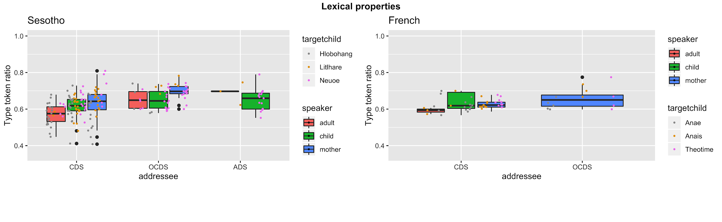
Figure A1. Moving average type token ratio for Sesotho (left) and French (right) within a window of 100 words. The absence of ADS French data is due to the little amount of ADS speech within sessions. CDS stands for child-directed speech. OCDS stands for speech directed to other children. ADS stands for adult-directed speech.

