Supplementary Materials

Figure S1. Objects used in the study and the assignment of objects and words to trial type.

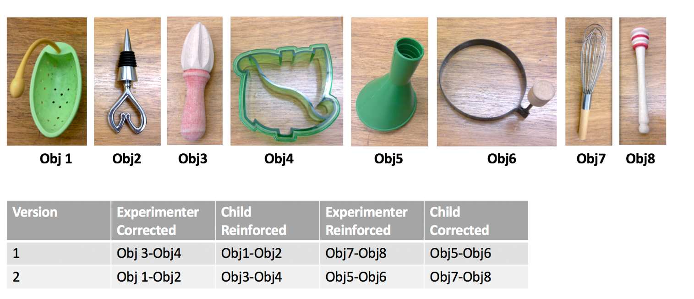

Supplementary Analysis

GEE with covariates:

Table 1 Generalized estimating equation model results: main effects and interactions of Group (EL, TL), Participant type (Child, Experimenter) and Feedback type (Reinforced, Corrected) for word learning accuracy including covariates of child age and sex
 | Variable | Wald χ2 (df) | p
 | Likelihood group | 0.09 (1) | .767
 | Participant type | 0.04 (1) | .953
 | Feedback type | 9.55 (1) | .002
 | Child age | 0.43 (1) | .512
 | Child sex | 0.07 (1) | .788
 | Group * Participant type | 0.63 (1) | .429
 | Group * Feedback type | 1.28 (1) | .259
 | Participant type * Feedback type | 1.44 (1) | .230
 | Group * Participant type * Feedback type | 0.67 (1) | .413
 | Child age | 0.40 (1) | .527
 | Child sex | 0.06 (1) | .806

GEE excluding ASD participants

Table 2 Generalized estimating equation model results: main effects and interactions of Group (EL, TL), Participant type (Child, Experimenter) and Feedback type (Reinforced, Corrected) for word learning accuracy excluding children who later received an ASD diagnosis
 | Variable | Wald χ2 (df) | p
 | Likelihood group | 0.18 (1) | .670
 | Participant type | 0.07 (1) | .792
 | Feedback type | 11.28 (1) | .001
 | Group * Participant type | 0.22 (1) | .639
 | Group * Feedback type | 0.83 (1) | .362
 | Participant type * Feedback type | 0.65 (1) | .422
 | Group * Participant type * Feedback type | 0.99 (1) | .319

