Supplemental Material
Mean comparisons with the matched sample including older time point. The trilingual group had a mean vocabulary size of 182 words (SD = 187) and the matched bilingual group had a mean vocabulary size of 247 words (SD = 210). Thus, trilinguals had a smaller French–English vocabulary size, knowing 74% as many words as bilinguals. The difference between these matched groups was, however, not statistically significant with either the independent t-test, t(38) = 1.04, p = .307, d = .33, or the repeated measures t-test, t(19)= 1.19, p = .249, d = .25, mean difference = 65.15. Because the data were skewed, planned non-parametric tests were also conducted. A Mann-Whitney-Wilcoxon test for independent data indicated that the difference between trilinguals and bilinguals was not statistically significant: trilinguals had a median score of 87 words while bilinguals had a median score of 184 words (U = 159, p = .273, r = .18). Finally, a Wilcoxon Signed Rank test for paired data showed no statistically significant differences between trilinguals and bilinguals (Z = -1.55, p = .127, r = .35). Participants’ characteristics for the matched sample with the older data point are presented in Table 1S and total vocabulary scores for the trilingual and bilingual matched sample with the older data point are presented in Figure 1S.
Table 1S
Demographic Characteristics of the Trilingual and Bilingual Pair-Wise Matched Groups
 | Trilinguals |  |  |  | Bilinguals | p value
 |  | (n = 20)  M ± SD |  | (n = 20)  M ± SD
Age in months |  | 21.85 ± 3.39 |  | 21.85 ± 3.39 |  | N/Aª
Sex |  | 65% female |  | 65% female |  | 1
Maternal education in years |  | 16.65 ± 2.28 |  | 16.25 ± 1.68 |  | .163
Language exposure English (%) |  | 43.82 ± 10.81 |  | 56.09 ± 12.54 |  | < .001
Language exposure French (%) |  | 29.72 ± 9.28 |  | 43.91 ± 12.54 |  | < .001
Language exposure Other (%) |  | 26.59 ± 9.20 |  | N/A |  | N/A
Language exposure ratio  (English to French) |  | 1.67 ± 0.74 |  | 1.44 ± 0.61
Note. Dataset with 19-month-old observation and its bilingual match.
p value reflects t-tests (for continuous variables) or chi-square results (for categorical variables).
ªAge matched exactly between the trilingual and bilingual group.

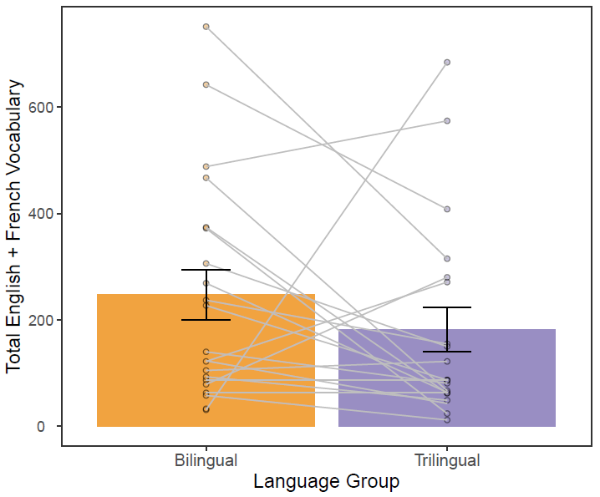

Figure 1S. Bar graphs showing total vocabulary scores (French + English) across pairwise-matched trilinguals and bilinguals with data from 19-month-old trilingual toddler who participated in two studies.

