Appendix 1
The equations for the measurements of lexical tones, including the computation of central tone contours and the calculation of tonal space dispersion, tone variation, and tone differentiation.
Equation 1. The calculation of the overall central tone contour CF0:
${CF0}^{k}$= $\frac{1}{m} \sum_{i=1}^{m}{{f0}_{i}^{k}}$
${f0}_{i}^{k}$ stands for the f0 value of the token i at the time point k. k ranges from 1 to 10, since there are in total 10 time points sampled for each tone contour. m stands for the total number of tone tokens produced by a caregiver, so i ranges from 1 to m.
For example, the f0 of the overall central tone contour at the time point 1 ${CF0}^{1}$ was calculated by averaging the f0 values of all tone tokens at the time point 1. This calculation was done at all 10 time points.
Equation 2. The calculation of tonal space dispersion TS:

TS = $\frac{1}{10m} \sum_{k=1}^{10}{\sum_{i=1}^{m}{|{f0}_{i}^{k}}}-{CF0}^{k}|$
${f0}_{i}^{k}$ stands for the f0 value of the token i at the time point k.${CF0}^{k}$stands for the f0 value of the overall central tone contour at the time point k. k ranges from 1 to 10, since there are in total 10 time points sampled for each tone contour. m stands for the total number of tone tokens produced by a caregiver, so i ranges from 1 to m.
For example, the Euclidean distance between tone token 1 and the overall central tone contour at the time point 1 was calculated as the absolute difference value between the f0 of tone token 1 at the time point 1 ${f0}_{1}^{1}$ and the f0 of the overall central tone contour at the time point 1 ${CF0}^{1}$. This calculation was done for every tone token at each of the 10 time points. Then the results were averaged across all tone tokens and all 10 time points.
Equation 3. The calculation of the central tone contour ${CF0}_{t}$ for each of the six lexical tones:
${CF0}_{t}^{k}$= $\frac{1}{n} \sum_{i=1}^{n}{{f0}_{i}^{k}}$
${f0}_{i}^{k}$ stands for the f0 value of the token i at the time point k. k ranges from 1 to 10, since there are in total 10 time points sampled for each tone contour. n stands for the total number of tokens of a tone category, so i ranges from 1 to n. t stands for the number of lexical tones, thus ranging from 1 to 6 as there are six lexical tones.
For example, the f0 of the central tone contour of Tone 1 at the time point 1 ${CF0}_{1}^{1}$ was calculated by averaging the f0 values of all tone tokens of Tone 1 at the time point 1. This calculation was done at all 10 time points.
Equation 4. The calculation of variation ${TV}_{t}$ for each of the six lexical tones:
${TV}_{t}$= $\frac{1}{10n} \sum_{k=1}^{10}{\sum_{i=1}^{n}{{|f0}_{i}^{k}- {CF0}_{t}^{k}}}|$
${f0}_{i}^{k}$ stands for the f0 value of the token i at the time point k.${CF0}_{t}^{k}$stands for the f0 value of the central tone contour of the tone category t at the time point k. k ranges from 1 to 10, since there are in total 10 time points sampled for each tone contour. t stands for the number of lexical tones, thus ranging from 1 to 6 as there are six lexical tones. n stands for the total number of tokens of a tone category, so i ranges from 1 to n.
For example, for the variation of Tone 1 ${TV}_{1}$, the Euclidean distance between tone token 1 of Tone 1 and the central tone contour of Tone 1 at the time point 1 was calculated as the absolute difference value between the f0 of the tone token 1 at the time point 1 ${f0}_{1}^{1}$ and the f0 of the central tone contour of Tone 1 at the time point 1 ${CF0}_{1}^{1}$. This calculation was done for every tone token of Tone 1 at each of the 10 time points. Then the results were averaged across all tone tokens of Tone 1 and all 10 time points.
Equation 5. The calculation of the overall tone variation TV:

TV = $\frac{1}{6} \sum_{t=1}^{6}{{TV}_{t}}$
${TV}_{t}$ stands for the variation of the tone category t. t stands for the number of lexical tones, thus ranging from 1 to 6 as there are six lexical tones.
The results of tone variation obtained by Equation 4 for each of the six lexical tones were averaged.
Equation 6. The calculation of tone differentiation TD:

TD = ${TS}/{TV}$
The ratio of tonal space dispersion to overall tone variation obtained by Equation 2 and 5 respectively were calculated for every caregiver.

Appendix 2

The distribution of target words in the utterance-final position
The table below shows the number and percentage of the tokens in the utterance-final position for all six target words (averaged across caregivers) in IDS and ADS. In general, the target words were not often produced in the utterance-final position. When comparing the two speech registers using the percentage of tokens in the utterance-final position as the dependent variable, the target words appeared in the utterance-final position in IDS more than in ADS (paired t-test: t(27)=2.22, p=0.035).
 | Number of the tokens in the utterance-final position | Percentage of the tokens in the utterance-final position
IDS | M=6.18; SD=3.27 | M=8.11%; SD=4.61%
ADS | M=3.46; SD=2.99 | M=5.74%; SD=4.9%

The effect of utterance position on lexical tones
Since the current study was not designed to investigate the effect of utterance position on lexical tones, the number of tokens in utterance-final vs. non-final positions was unbalanced. The number of the tokens in the utterance-final position was too small to conduct a direct comparison for lexical tones in the utterance-final vs. non-final positions. Therefore, to test whether there is any effect of utterance position on lexical tones in our data, we compared the measures of lexical tones based on the data including vs. excluding the tokens in the utterance-final position. The results are shown by the figures below. In general, it seems that the results were quite similar when the tokens in the utterance-final position were excluded compared to when they were not.

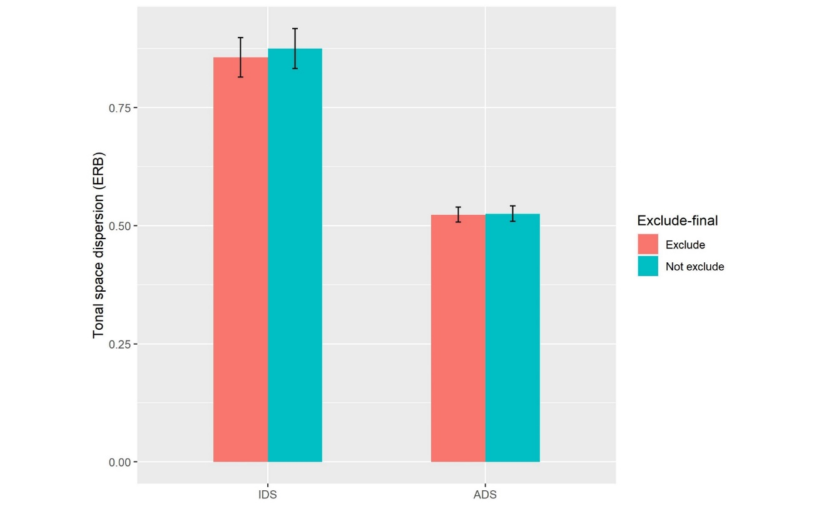

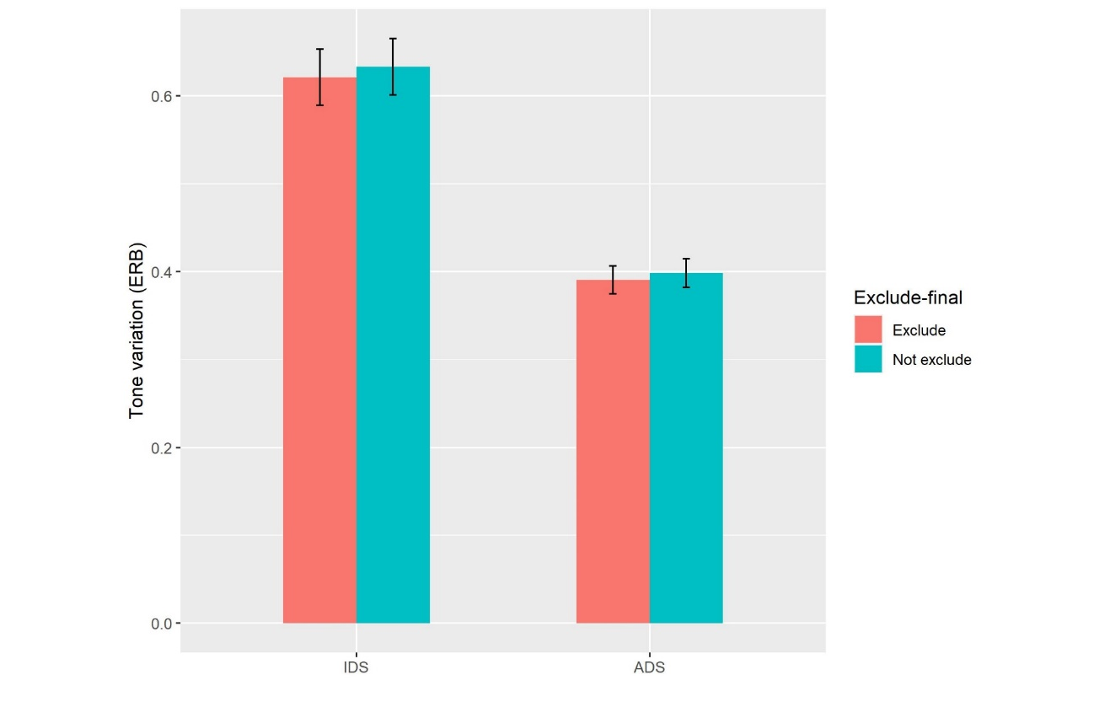
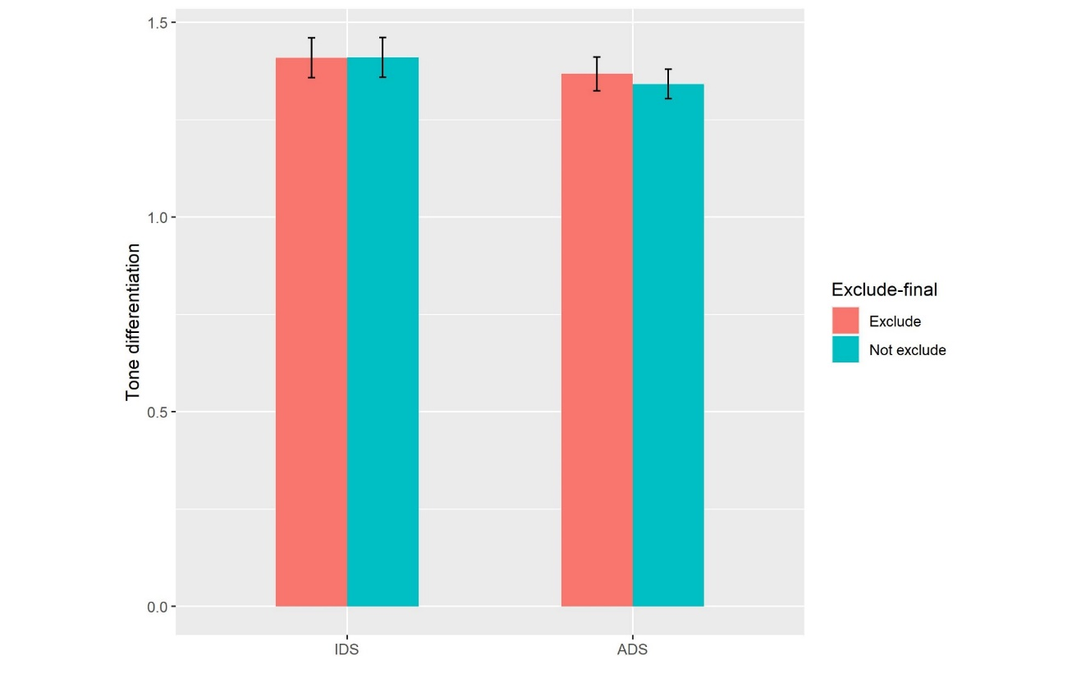

The observed effects tested when excluding the tokens in the utterance-final position
All the analyses were conducted with tokens excluding those in the utterance-final position. The results were listed in the two tables below in comparison with the results based on all the tokens including those in the utterance-final position. All the effects were found both when the tokens in the utterance-final position were included and excluded.

 |  | Exclude the tokens in the utterance-final position | Not-exclude the tokens in the utterance-final position
IDS vs. ADS (paired  t-test) | Tonal space dispersion | t(27)=8.49, p<.001, d=1.84 | t(27)= 8.88, p<.001, d=1.88
 | Tone variation | t(27)=7.15, p<.001, d=1.68 | t(27)= 7.33, p<.001, d=1.69
 | Tone differentiation | t(27)=.56, p= .58, d=.16 | t(27)= 1.02, p= .32, d=.29

Pearson correlation | Intonational mean pitch |  | Intonational pitch variability across utterances |  | Intonational pitch variability within utterance
 | Exclude | Not exclude | Exclude | Not exclude | Exclude | Not exclude
Tonal space dispersion | r=.52, p=.0044 | r=.51, p=.0059 | r=.77, p<.001 | r=.79,  p<.001 | r=.62,  p<.001 | r=.65,  p<.001
Tone variation | r=.21, p=.28 | r=.22, p=.26 | r=.74, p<.001 | r=.76,  p<.001 | r=.5, p=.0071 | r=.51,  p=.0053

