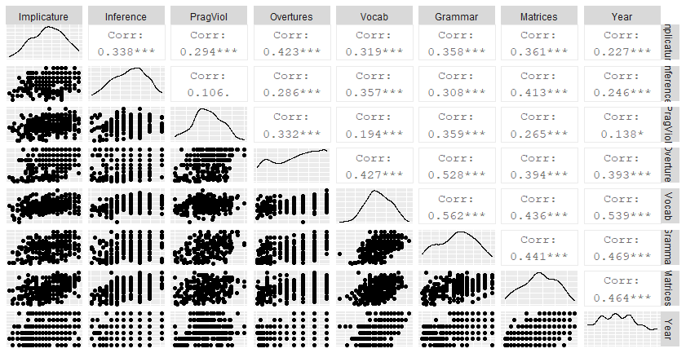
Matrix of scatter plots showing relationships between variables. Implicature = Implicature Comprehension Test; Inference = Children’s Test of Local Textual Inference; PragViol = Pragmatic Violations; Overtures = Social Overtures; Vocab = Receptive Vocabulary; Grammar = Receptive Grammar; Matrices = Animal Matrices; Year = Year Group.
. p < .100; * p < .05; ** p < .01; p < .001

