APPENDIX A
Task 1 Sample Experimental Trial.

Target Trial | Script | Pictures
Researcher: | Ahora te voy a contar una historia de lo que les pasa a estos personajes cuando toman pastillas mágicas. ‘I am going to tell you a story about what happens when these characters take magic pills.’
Researcher: | Cuando Shrek y Woody las toman.  ‘When Shrek and Woody take them.’ | 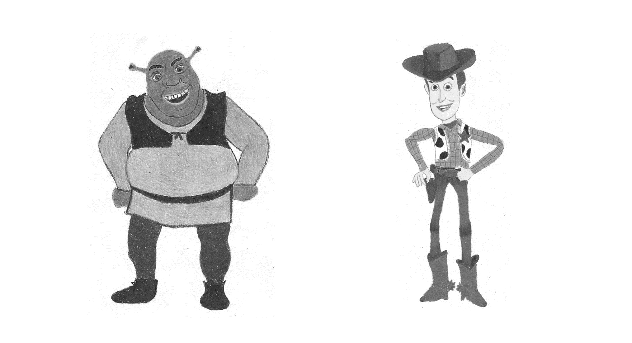
Researcher: | ¡Míralos!  1. ¿Cuál es flaco?  2. ¿Cuál está flaco?  Look at them!  1. Which one is:ser thin?  2. Which one is:estar thin? | 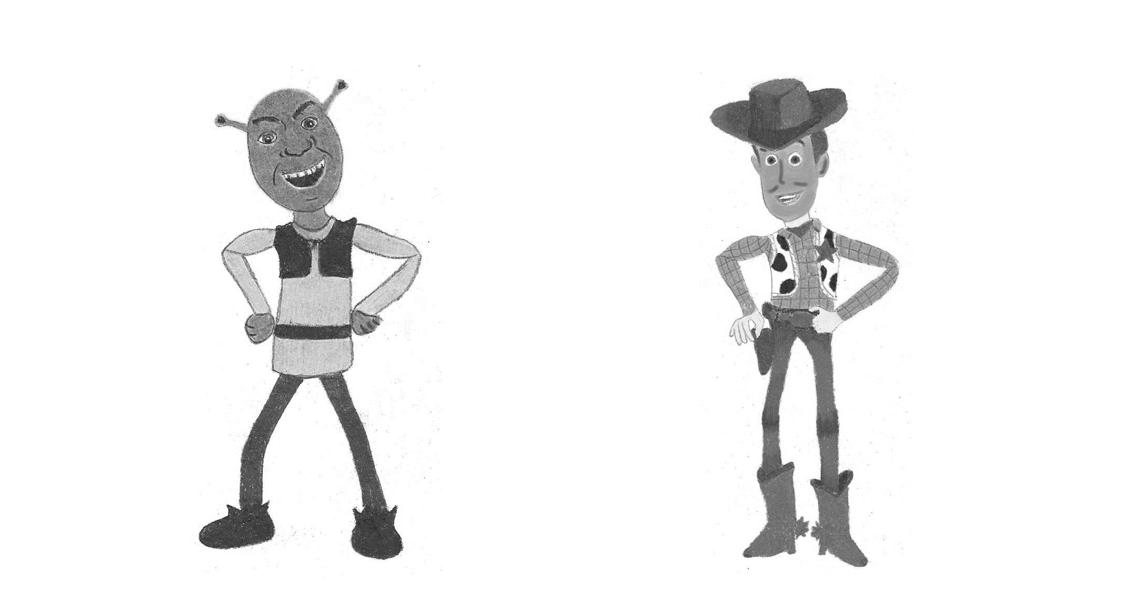

APPENDIX B
Task 2 Sample Experimental Trial.

Target Trial | Script | Pictures
Researcher:  Researcher: | ¿Los conoces? ¿Cómo se llaman? ¿Dónde los has visto? ¿Tienen amigos? (niño responde)(Experimentador señala a Juan) Este se llama Juan, ¿Cómo se llama? (niño repite ‘Juan’) Ahora te voy a contar historias. Presta atención. ‘Do you know them? What are their names? Where have you seen them? Do they have friends? (child answers) (Experimenter points at Juan) This one’s called Juan. Can you say his name? (child repeats ‘Juan’).  Ahora viene una historia de Juan y alguien más. Adivina adivinador ¿Qué otros personajes aparecerán con Juan en esta historia? (niño responde) A ver… ‘Now it comes the story about Juan and somebody else. Can you guess which characters will appear together with Juan in this story? (child answers) Let’s see...’  Un día, a Juan (1) la bruja le dio un dulce mágico (2). Juan lo comió y míralo qué POGO! (3). Pero después de un rato… míralo otra vez (4). ‘One day, to Juan (1) the witch gave a magic candy (2). Juan ate it and look how POGO! (3 – Image of Juan with holes throughout all his body). But after a while… look at him again (4).’ | 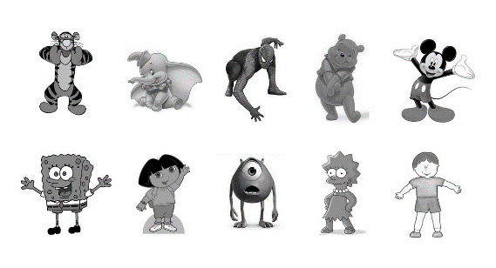  (1)  (3)  (4)  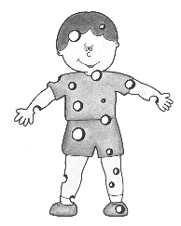  (2)
Researcher: | Y de estos dos:  1. ¿Cuál es POGO?  2. ¿Cuál está POGO?  And from these two:  1. Which one is:ser POGO?  2. Which one is:estar POGO? | 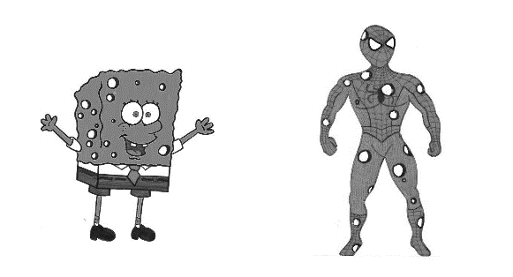

APPENDIX C
Analyses by trial – Task 1
A descriptive analysis by trial indicates that at age four the increased selection of temporary picture with estar occurs across trials (Figure 1 below). The same analysis by trial among the three-year-olds indicates that the younger children treated each copula + adjective combination differently and do not associate estar with the temporary picture across trials (Figure 2 below). With one of the adjectives (grande), these children selected the temporary picture more when tested on estar. With two adjectives (flaco and pequeña) they showed the opposite pattern, and with the last adjective (gorda), the selection of the temporary picture was very high, regardless of the condition.

Figure 1. Rate of temporary picture selection by the older group per condition in each trial of Task 1

Figure 2. Rate of temporary picture selection by the younger group per condition in each trial of Task 1

APPENDIX D
Analyses by trial - Task 2
A descriptive analysis by trial indicates that at age four the increased selection of temporary picture with estar occurs across trials (Figure 3 below). The same analysis by trial among the three-year-olds indicates that the younger children treated copula + adjective combinations differently than the older children and do not seem to associate estar with the temporary picture (Figure 4 below).

Figure 3. Rate of temporary picture selection by the older group per condition in each trial of Task 2

Figure 4. Rate of temporary picture selection by the younger group per condition in each trial of Task 2

APPENDIX E
Generalized Linear Mixed Model

GENLINMIXED
/DATA_STRUCTURE SUBJECTS=subject
/FIELDS TARGET=TEMP_PIC TRIALS=NONE OFFSET=NONE
/TARGET_OPTIONS REFERENCE=0 DISTRIBUTION=BINOMIAL LINK=LOGIT
/FIXED EFFECTS= condition age condition*age USE_INTERCEPT=TRUE
/RANDOM USE_INTERCEPT=TRUE SUBJECTS=subject COVARIANCE_TYPE=VARIANCE_COMPONENTS
/BUILD_OPTIONS TARGET_CATEGORY_ORDER=ASCENDING INPUTS_CATEGORY_ORDER=ASCENDING MAX_ITERATIONS=100
CONFIDENCE_LEVEL=95 DF_METHOD=SATTERTHWAITE COVB=ROBUST PCONVERGE=0.000001(ABSOLUTE) SCORING=0
SINGULAR=0.000000000001.

