SUPPLEMENTARY MATERIALS

Supplemental Methods

Sample
The Promise Project at Columbia Clinic is an outpatient neuropsychology clinic located in New York City. The program was created to provide comprehensive neuropsychological assessments and education coordination to low-income children residing in upper Manhattan communities who have suspected learning and attention problems. Children are referred to the clinic by parents, school staff, pediatricians, community mental health providers, and/or various other providers. The clinic is staffed by licensed neuropsychologists and post-doctoral fellows who conduct assessments. Educational coordinators provide ongoing educational advocacy by attending school meetings with families (following their child’s evaluation) for up to three years. All educational coordinators are bilingual (Spanish and English) and consult with families on approximately a quarterly basis.
Income criteria is determined based on family income level and number of household members. All families are below 250% of the federal poverty level. Eighty-seven percent of families earned less than $50,000 per year and 20 percent earned less than $10,000 per year. Parent education levels ranged from less than seventh grade to holding a graduate degree, with the majority of parents (76% for mothers, 87% for fathers) obtaining less than a Bachelor’s degree.
Demographic Information and Background Assessment. Information is obtained via parent interview and surveys and review of relevant records. Depending upon their language preference, parents complete questionnaires in either English or Spanish. In response to the question: “Describe the language(s) spoken in the home,” they select either “English Only, “Mostly English, Some Spanish,” “Bilingual,” “Mostly Spanish, Some English,” “Spanish Only,” or “Other.” Parents also provide the child’s age, grade, sex (male, female), race (American Indian/Alaska Native, Asian, Black or African American, Native Hawaiian or Other Pacific Islander, White, Other), ethnicity (Hispanic or Latino, Not Hispanic or Latino), maternal employment (full time, part time), and household income (<10,000, 10,000-20,000, 20,000-30,000, 30,000-40,000, 40,000-50,000, 50,000-60,000, 60,000-70,000, 70,000-80,000, 80,000-90,000, 90,000-100,000, >100,000).
Neuropsychological Assessment
Assessment at the clinic consists of an intake session, two or three testing sessions lasting approximately four to five hours in duration, and a feedback session with the family to share the results of testing. A comprehensive battery measuring intelligence, attention/executive functioning, language, memory, visual-spatial, visual-motor and fine motor, academic, adaptive behavior, and social-emotional-behavioral functioning is completed.
Participants were diagnosed with a language disorder following a comprehensive neuropsychological evaluation which included standardized speech language assessment measures. Diagnoses were made according to DSM IV or DSM 5 criteria depending on which was current at the time of the assessment. The bilingual evaluator in the clinic made decisions about whether a child needed to be assessed in Spanish or in English. This decision was made by taking into account information about a child’s language proficiency gathered from conversations with the child’s parents and school personnel such as teachers, as well as based on the child’s current school placement.

Table S1. Average performance for children with and without RD on phonological memory, phonological awareness, word reading accuracy, and overall reading composite scores.
Measure | RD | Non- RD
CTOPP Awareness | 80.0 (14.2) | 88.0 (13.2)
CTOPP Memory | 85.0 (13.6) | 93.0 (15.0)
GORT Accuracy | 5.3 (2.1) | 8.4 (2.6)
KTEA Letter Word | 81.0 (11.4) | 100.0 (12.3)
GORT Oral Reading | 69.0 (20.1) | 81.0 (25.0)
KTEA Reading Composite | 79.4 (10.0) | 98.2 (12.5)
Note: Scores reflect performance on the edition of the measure current at time of assessment.

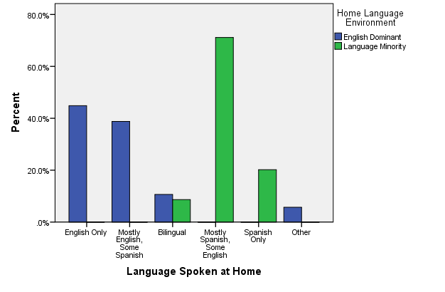

Figure S1. Percentage of families reporting language spoken at home within each home language environment. Among ED families, 45% spoke only English, 39% spoke mostly English, some Spanish, 11% identified as speaking equal parts English and Spanish (bilingual) and 5% endorsed, “other.” Seventy-one percent of LM families spoke mostly Spanish, some English, 20% spoke Spanish only, and 9% were bilingual.

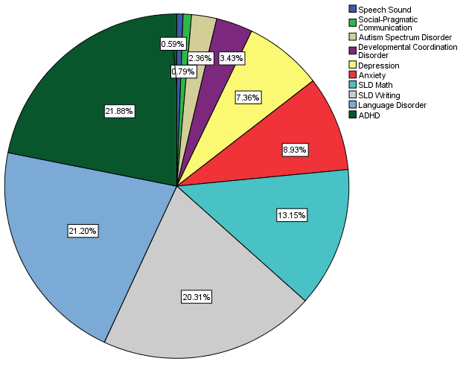

Figure S2. Frequency of comorbid diagnoses in the sample.

