Appendix A
Experimental Procedure
Habituation Phase

1. Speaker Familiarization x1
Two speakers played a familiarization game, each appeared behind a table
individually and then both appeared together.

2. Habituation Trial x15 maximum
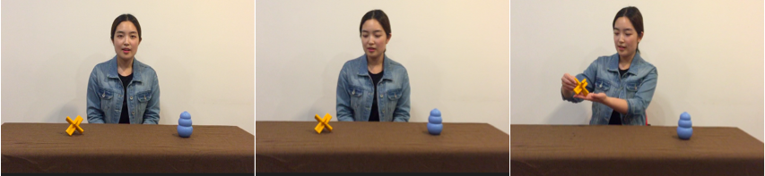
In each habituation trial, the habituation speaker greeted the infants, looked at the target object, saying “midou”, grasped the target and named it again by saying “yi ge midou” ‘a midou’. Infants repeatedly watched this habituation trial until they reached the habituation criteria or after 15 trials were played.

3. “Where is it” Test Pair x 3
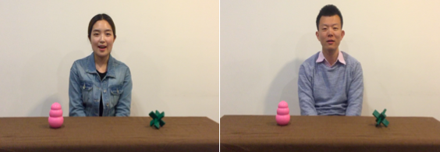
Following every five habituation trials, there was a “where is it” test pair. In the test pair, the two objects from habituation changed color and position. The habituation speaker first asked infants to looked at the “midou” and this action was then repeated by a new speaker.

Test Phase

4. Post-habituation Test Pair x4
Test pair 1
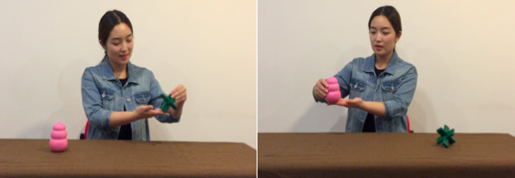
The habituation speaker took turns to name the target “midou” and the distractor “midou” (half infants watched the target being named first, another half watched the distractor being named first).

Test pair 2
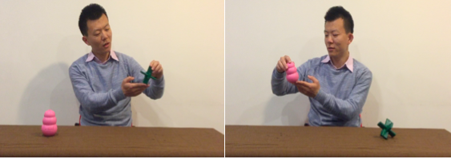
The new speaker took turns to name the target “midou” and the distractor “midou” (half infants watched the target being named first, another half watched the distractor being named first).

Test pair 3 (same as test pair 1)

Test pair 4 (same as test pair 2)

5. Infants watched a final pair of “where is it” tests and the experiment ended

Appendix B
Additional Analyses for Test Pair Two and Three in the Post-habituation Phase
Since in the post-habituation test phase the habituation speaker always appeared before the new speaker, this order of appearance could have potentially affected infants’ looking response for the test trials. Thus, additional analyses were performed on the second and third test pair only (i.e., the test pairs in the middle of the test phase, excluding the first and last test pair). In these series of tests, the new speaker was presented before the habituation speaker.
To investigate whether infants would generalize a word to objects of different colours regardless of who the speaker was during test pair two and three, a 2 (test trial type: target, distracter) x 2 (speakers: habituation speaker, new speaker) repeated-measures ANOVA was conducted on infants’ average looking time in these two test pairs. Results showed a significant main effect of test trial type, F(1, 29) = 4.33, p = .046, η²_{Partial} = .13. To further explore this main effect, a paired samples t-test revealed that infants looked significantly longer towards the distractor test trials (M = 12.14, SD = 6.05) than they did towards the target test trials (M = 9.97, SD = 5.10), t(29) = 2.08, p = .046, d = .39, r = .19. There was also a significant main effect of speakers, F(1, 29) = 22.00, p < .001, η²_{Partial} = .43. A follow-up paired samples t-test showed that infants looked significantly longer towards the new speaker (M = 13.72, SD = 5.83) than the habituation speaker (M = 8.40, SD = 5.62), t(29) = 4.69, p < .001, d = .93, r = .42. This particular pattern was similar to what was found in analyses with all four test pairs: infants tend to look longer towards the speaker who appeared earlier in the post-habituation test phase. Since the new speaker appeared before the habituation speaker in these two middle test pairs, infants looked longer towards the new speaker.
Critically, the ANOVA revealed no significant interaction between speaker and test trial type, p > .05. This suggests that infants’ looking response for the two types of tests was not affected by who the speaker was. To further confirm that infants showed similar looking pattern regardless of speakers, a paired samples t-test was conducted on infants’ average total looking time towards each type of test trials for different speakers. Results revealed that for the new speaker, infants looked significantly longer towards the distractor test trials (M = 15.13, SD = 7.70) than they did towards the target test trials (M = 12.31, SD = 6.02), t(29) = 2.08, p = .046, d = .41, r = .20. However, for the habituation speaker, infants’ looking time towards the target and distractor test trials did not significantly differ, p > .05. This could be a result of infants’ general decline of attention after repetitive presentation of test pairs (i.e., they were not paying attention to the habituation speaker’s actions), however, the presentation of the new speaker before the habituation speaker could also have had an impact on infants’ responses.
In sum, when analyzing the test pairs presented in the middle of the post-habituation test phase where the new speaker appeared before the habituation speaker, the overall results were similar to the those produced by analyses of all post-habituation test pairs. This suggests that the order of speaker presentation was unlikely to have largely affected infants’ looking responses during the post-habitation tests. However, a close examination revealed that infants did not discriminate between the target and distractor test trials for the habituation speaker. This could be a result of the news speaker being presented earlier; thus future studies should present speakers in a counterbalanced order to further confirm and validate findings from present study.

