Developmental changes in articulation rate and phonic groups during narration
in French children aged 4 to 11 years

Supplementary Materials

Statistical details for “Narration time”

Post-hoc test to compare difference across age groups:
A Kruskal-Wallis H test was run to determine if there were differences in duration of narration time between the six age groups. Distributions of duration of narration time were similar for all groups, as assessed by visual inspection of a boxplot. Median scores of duration of narration were statistically significantly different between groups, χ²(5) = 23.950, p < .001.

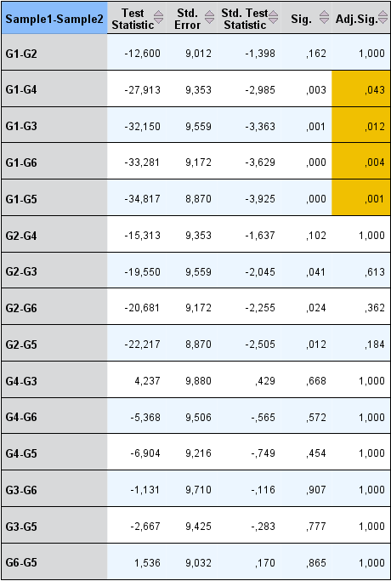

Statistical details for “Articulation Rate”

Fischer’s LSD Post-hoc test to compare differences in articulation rate between age groups:

 | G1 | G2 | G3 | G4 | G5 | G6
G1
G2 | 0,808
G3 | 0,099 | 0,061
G4 | 0,299 | 0,420 | 0,011
G5 | 0,157 | 0,241 | 0,003 | 0,754
G6 | 0,010 | 0,019 | 0,000 | 0,134 | 0,207

Statistical details for narration measures (number of clauses, words, syllables and phonic groups)

Games-Howell Post-Hoc Test :

Clauses (nb) |  |  |  |  |  |  |  | Words (nb)
 | G1 | G2 | G3 | G4 | G5 | G6 |  |  | G1 | G2 | G3 | G4 | G5 | G6
G1 |  |  |  |  |  |  |  | G1
G2 | 0,332 |  |  |  |  |  |  | G2 | 0,299
G3 | 0,026 | 0,343 |  |  |  |  |  | G3 | 0,021 | 0,438
G4 | 0,017 | 0,338 | 1,000 |  |  |  |  | G4 | 0,009 | 0,342 | 1,000
G5 | 0,004 | 0,058 | 0,897 | 0,839 |  |  |  | G5 | 0,001 | 0,059 | 0,884 | 0,886
G6 | 0,000 | 0,008 | 0,931 | 0,863 | 0,999 |  |  | G6 | 0,000 | 0,016 | 0,900 | 0,900 | 1,000
Syllables (nb) |  |  |  |  |  |  |  | Phonic Group (nb)
 | G1 | G2 | G3 | G4 | G5 | G6 |  |  | G1 | G2 | G3 | G4 | G5 | G6
G1 |  |  |  |  |  |  |  | G1
G2 | 0,350 |  |  |  |  |  |  | G2 | 0,986
G3 | 0,023 | 0,422 |  |  |  |  |  | G3 | 0,103 | 0,255
G4 | 0,011 | 0,315 | 1,000 |  |  |  |  | G4 | 0,156 | 0,442 | 0,991
G5 | 0,002 | 0,058 | 0,885 | 0,920 |  |  |  | G5 | 0,017 | 0,103 | 1,000 | 0,989
G6 | 0,000 | 0,027 | 0,918 | 0,951 | 1,000 |  |  | G6 | 0,147 | 0,607 | 0,839 | 0,990 | 0,738

Statistical details for “PG time”

Fisher’s LSD post hoc test

Fisher's LSD post hoc
 | G1 | G2 | G3 | G4 | G5 | G6
G1
G2 | 0,003
G3 | 0,004 | 0,923
G4 | 0,009 | 0,825 | 0,762
G5 | 0,001 | 0,705 | 0,795 | 0,556
G6 | 0,000 | 0,021 | 0,037 | 0,015 | 0,047

Statistical details for density measures (number of syllables, words and clauses per phonic group)

Kruskal Wallis Test Results
 | Syllable/PG (nb) | Words/PG (nb) | Clauses/PG (nb)
Chi-Square | 37,061 | 30,982 | 29,383
df | 5 | 5 | 5
Asymp. Sig. | 0,000 | 0,000 | 0,000
Pairwise Post-hoc test to compare differences of syllable per PG across age groups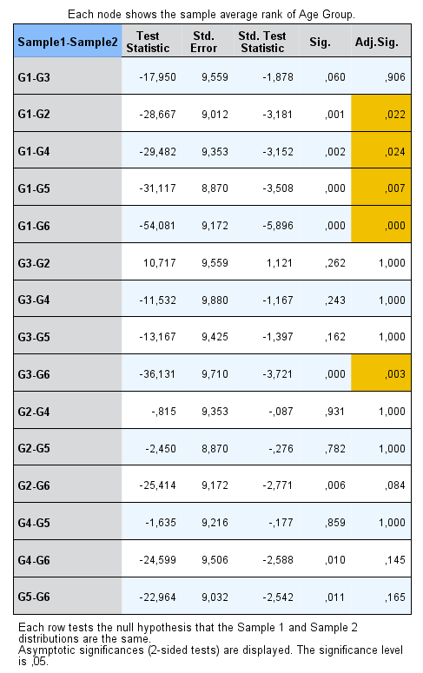

Pairwise Post-hoc test to compare differences of words per PG across age groups
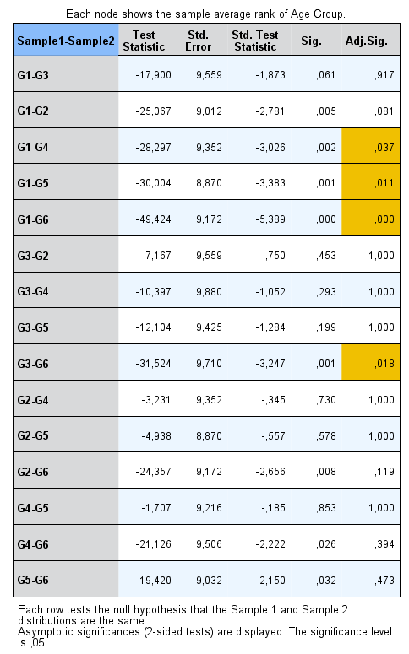
Pairwise Post-hoc test to compare differences of clauses per PG across age groups