S1 Descriptive Statistics and Graphs for Mid-Clause Silent Pause Rate, Duration, and Proportion
Table S1-1
Mean (SDs) of Rate, Duration, and Proportion for the Narrative and Interview Task for L2 at Pre-sojourn, L2 at In-sojourn 2, and L1
 | Narrative |  |  | Interview
 | Rate | Duration | Proportion | Rate | Duration | Proportion
Pre-sojourn | 0.297 (0.131) | 755.58 (141.12) | 0.090 (0.019) | 0.191 (0.087) | 614.28 (136.95) | 0.099 (0.027)
In-sojourn 2 | 0.158 (0.094) | 619.68 (110.58) | 0.067 (0.020) | 0.113 (0.066) | 606.17 (129.90) | 0.077 (0.023)
L1 | 0.057 (0.046) | 523.35 (124.33) | 0.041 (0.019) | 0.070 (0.028) | 648.30 (182.55) | 0.074 (0.019)

Figure S1-1
Boxplots for Rate for the Narrative and Interview Task for L2 at Pre-sojourn, L2 at In-sojourn 2, and L1
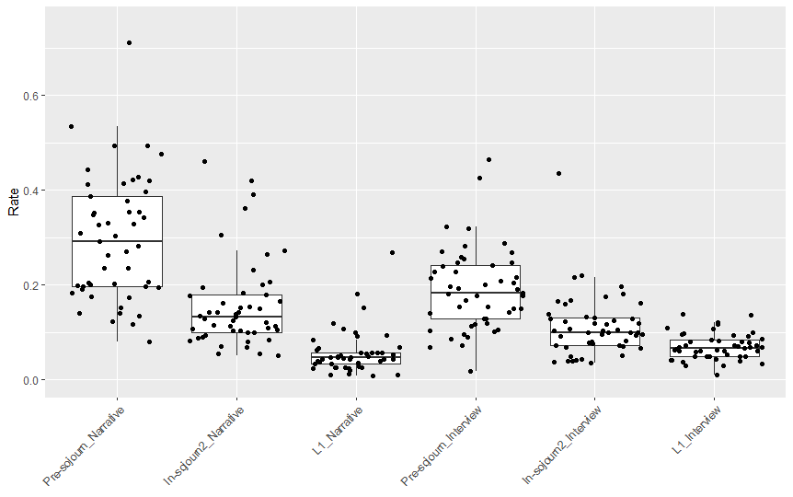

Figure S1-2
Histograms and QQ plots for Rate for the Narrative and Interview Task for L2 at Pre-sojourn, L2 at In-sojourn 2, and L1
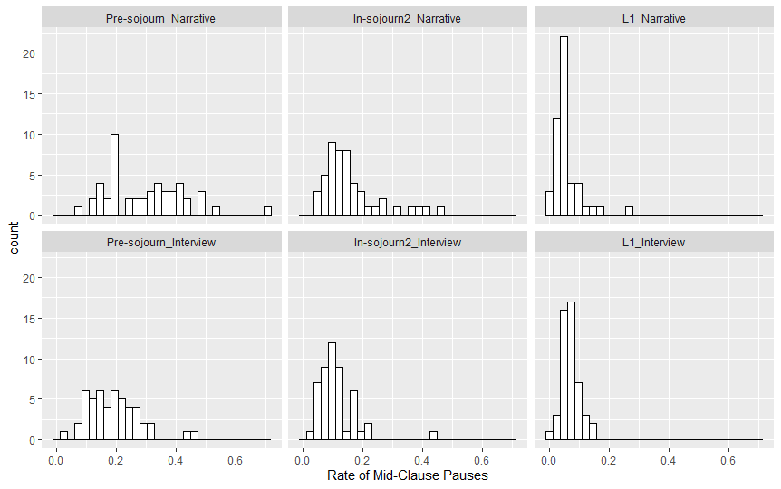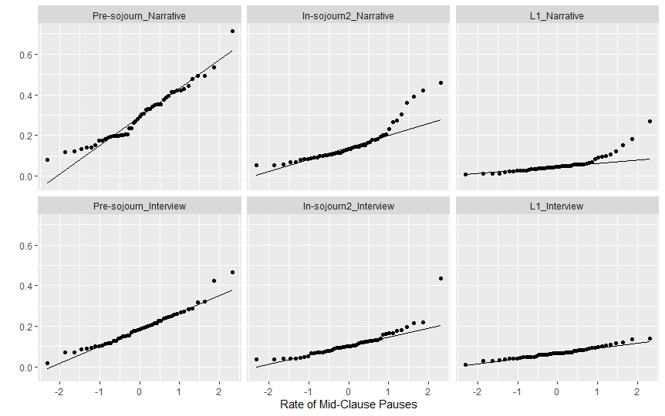
Figure S1-3
Boxplots for Duration for the Narrative and Interview Task for L2 at Pre-sojourn, L2 at In-sojourn 2, and L1
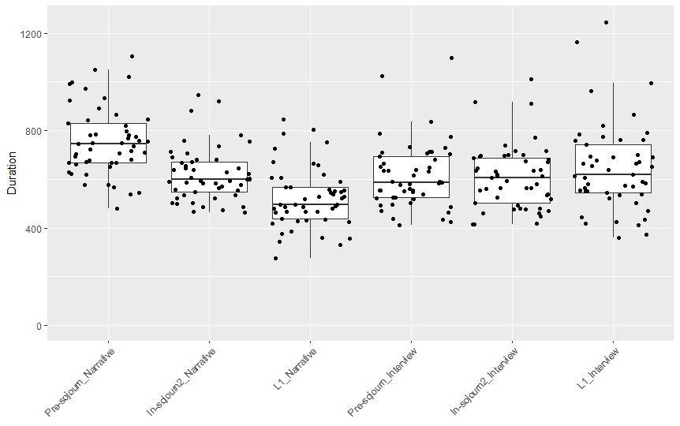
Figure S1-4
Histograms and QQ plots for Duration for the Narrative and Interview Task for L2 at Pre-sojourn, L2 at In-sojourn 2, and L1
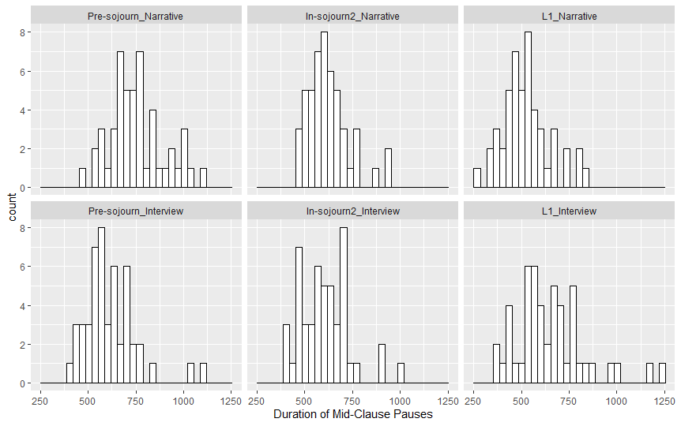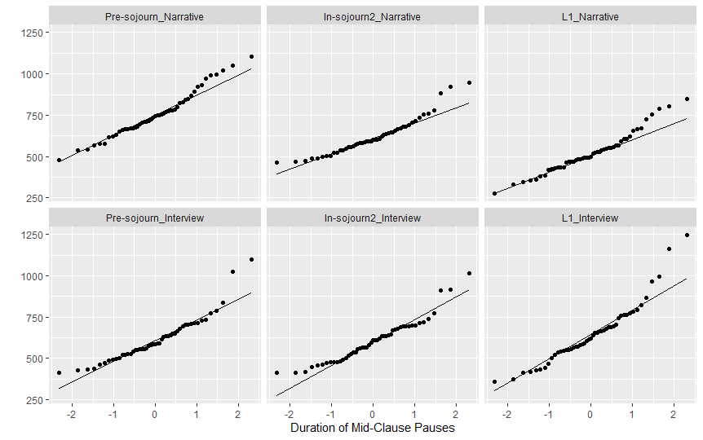
Figure S1-5
Boxplots for Proportion for the Narrative and Interview Task for L2 at Pre-sojourn, L2 at In-sojourn 2, and L1
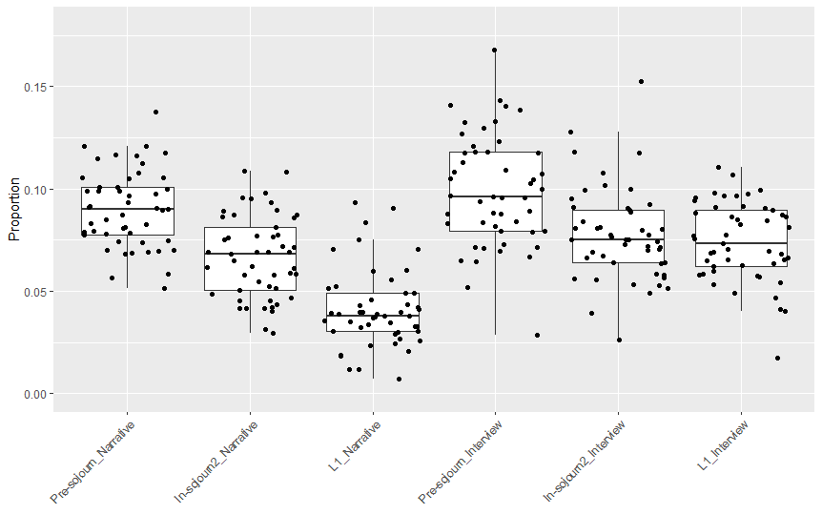
Figure S1-6
Histograms and QQ plots for Proportion for the Narrative and Interview Task for L2 at Pre-sojourn, L2 at In-sojourn 2, and L1
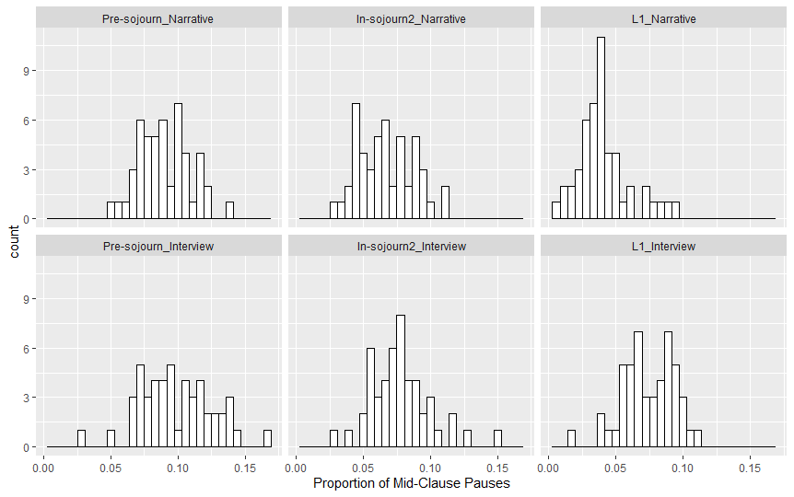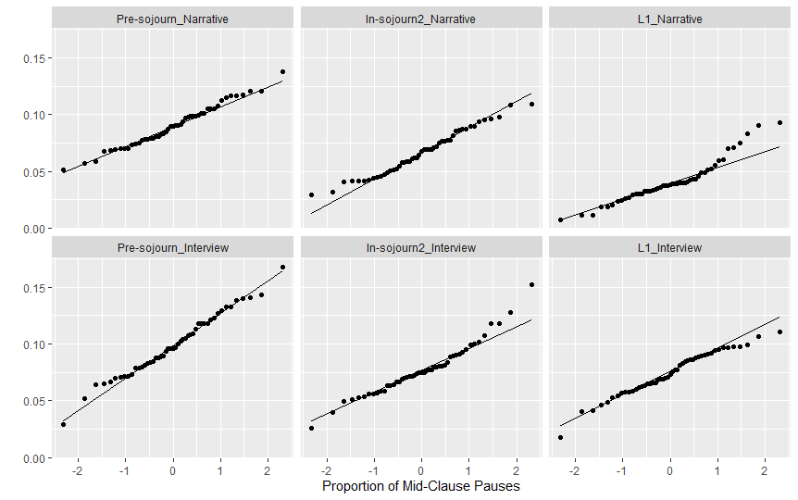
Table S1-2
Shapiro-Wilk Test of Normality
 | Narrative |  |  | Interview
 | Rate | Duration | Proportion | Rate | Duration | Proportion
Pre-sojourn | W = 0.95, p = .051 | W = 0.97, p = .245 | W = 0.99, p = .798 | W = 0.96, p = .064 | W = 0.90, p = .001* | W = 0.99, p = .919
In-sojourn 2 | W = 0.82, p < .001* | W = 0.92, p = .003* | W = 0.97, p = .371 | W = 0.80, p < .001* | W = 0.93, p = .009* | W = 0.96, p = .081
L1 | W = 0.73, p < .001* | W = 0.96, p = .130 | W = 0.93, p = .005* | W = 0.97, p = .353 | W = 0.92, p = .003* | W = 0.97, p = .376

S2 Mixed Effects Model Results for Research Question 1
Table S2-1
Summary of Mixed-Effects Model Fit for L1 Rate
 | Maximal Model |  |  |  |  | Final Model
Fixed effects | Estimates | SE | 95% CI | t | p | Estimates | SE | 95% CI | t | p
(Intercept) | –0.24 | 0.23 | [–0.70, 0.22] | –1.04 | 0.299 | 0.02 | 0.02 | [–0.01, 0.05] | 1.28 | 0.202
Task [Narrative] | –0.01 | 0.01 | [–0.02, 0.00] | –1.31 | 0.192
MATTR | 0.30 | 0.25 | [–0.20, 0.79] | 1.19 | 0.238
Syntactic Complexity | 0.02 | 0.01 | [–0.00, 0.03] | 1.88 | 0.064 | 0.02 | 0.01 | [0.00, 0.03] | 2.62 | 0.010
Random Effects
σ² | 0.00 |  |  |  |  | 0.00
τ₀₀ | 0.00 _{Participant} |  |  |  |  | 0.00 _{Participant}
ICC | 0.31 |  |  |  |  | 0.31
N | 49 _{Participant} |  |  |  |  | 49 _{Participant}
Observations | 98 |  |  |  |  | 98
Marginal R² / Conditional R² | 0.076 / 0.363 |  |  |  |  | 0.059 / 0.354

Figure S2-1
Checking for Linearity, Homogeneity of Variances, and Normally Distributed Model Residuals in the Final L1 Rate Model
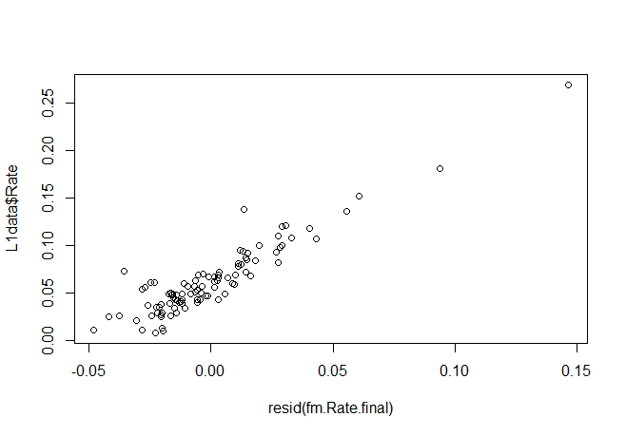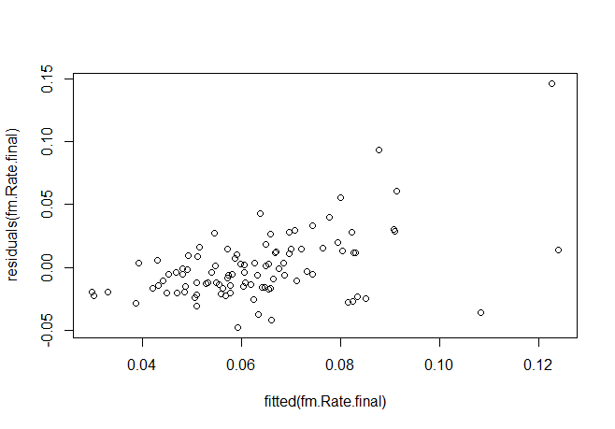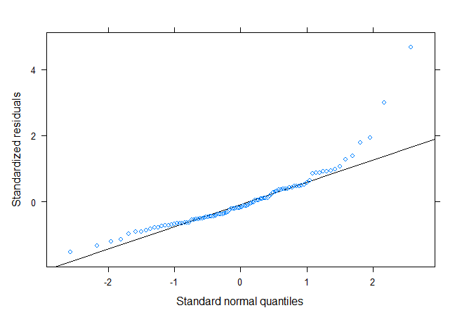

Table S2-2
Summary of Mixed-Effects Model Fit for L1 Duration
 | Maximal Model |  |  |  |  | Final Model
Fixed effects | Estimates | SE | 95% CI | t | p | Estimates | SE | 95% CI | t | p
(Intercept) | –597.23 | 977.76 | [–2539.16, 1344.69] | –0.61 | 0.543 | 648.30 | 22.31 | [604.00, 692.60] | 29.06 | <0.001
Task [Narrative] | –122.42 | 31.41 | [–184.81, –60.04] | –3.90 | <0.001 | –124.95 | 28.60 | [–181.74, –68.17] | –4.37 | <0.001
MATTR | 1273.47 | 1045.28 | [–802.54, 3349.48] | 1.22 | 0.226
Syntactic Complexity | 20.76 | 34.71 | [–48.19, 89.70] | 0.60 | 0.551
Random Effects
σ² | 20997.47 |  |  |  |  | 20039.25
τ₀₀ | 3236.35 _{Participant} |  |  |  |  | 4352.17 _{Participant}
ICC | 0.13 |  |  |  |  | 0.18
N | 49 _{Participant} |  |  |  |  | 49 _{Participant}
Observations | 98 |  |  |  |  | 98
Marginal R² / Conditional R² | 0.155 / 0.268 |  |  |  |  | 0.139 / 0.293

Figure S2-2
Checking for Linearity, Homogeneity of Variances, and Normally Distributed Model Residuals in the Final L1 Duration Model
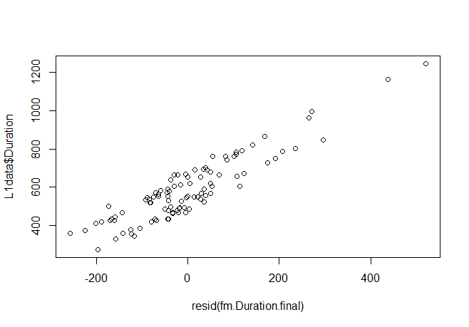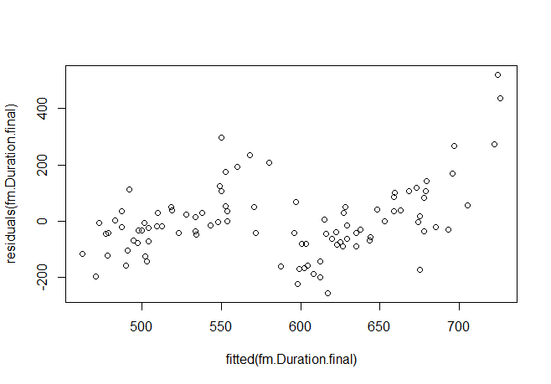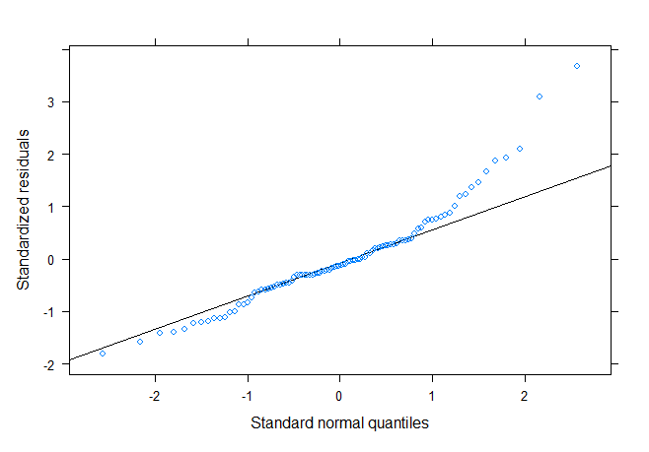

Table S2-3
Summary of Mixed-Effects Model Fit for L1 Proportion
 | Maximal Model |  |  |  |  | Final Model
Fixed effects | Estimates | SE | 95% CI | t | p | Estimates | SE | 95% CI | t | p
(Intercept) | 0.02 | 0.12 | [–0.21, 0.25] | 0.15 | 0.881 | 0.05 | 0.01 | [0.03, 0.06] | 4.74 | <0.001
Task [Narrative] | –0.03 | 0.00 | [–0.04, –0.02] | –8.23 | <0.001 | –0.03 | 0.00 | [–0.04, –0.02] | –8.33 | <0.001
MATTR | 0.03 | 0.12 | [–0.22, 0.28] | 0.24 | 0.809
Syntactic Complexity | 0.01 | 0.00 | [0.00, 0.02] | 3.02 | 0.003 | 0.01 | 0.00 | 0.00 – 0.02 | 3.09 | 0.003
Random Effects
σ² | 0.00 |  |  |  |  | 0.00
τ₀₀ | 0.00 _{Participant} |  |  |  |  | 0.00 _{Participant}
ICC | 0.22 |  |  |  |  | 0.22
N | 49 _{Participant} |  |  |  |  | 49 _{Participant}
Observations | 98 |  |  |  |  | 98
Marginal R² / Conditional R² | 0.474 / 0.587 |  |  |  |  | 0.476 / 0.590

Figure S2-3
Checking for Linearity, Homogeneity of Variances, and Normally Distributed Model Residuals in the Final L1 Proportion Model
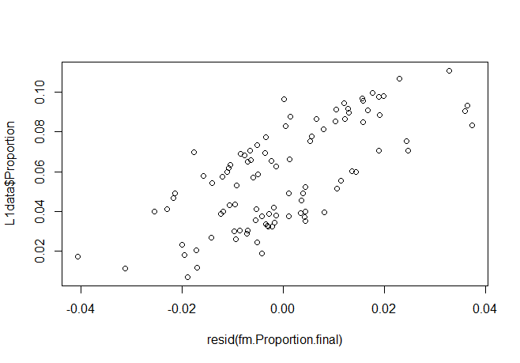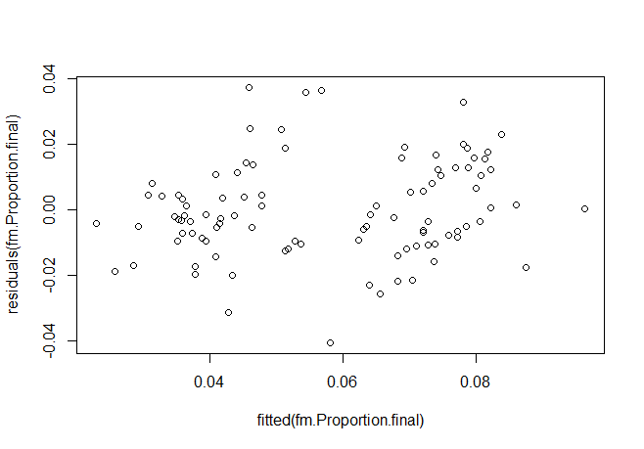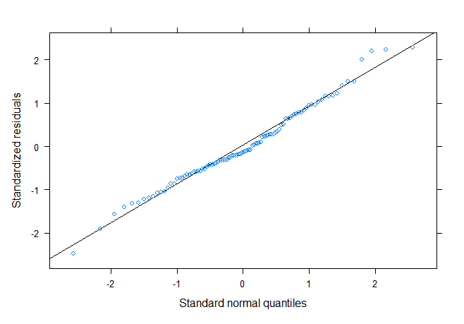

S3 Mixed Effects Model Results for Research Question 2
Table S3-1
Summary of Mixed-Effects Model Fit for Rate
 | Maximal Model |  |  |  |  | Rate: Final Model
Fixed effects | Estimates | SE | 95% CI | t | p | Estimates | SE | 95% CI | t | p
(Intercept) | 0.65 | 0.22 | [0.22, 1.08] | 2.97 | 0.003 | 0.61 | 0.21 | [0.20, 1.03] | 2.90 | 0.004
L2Group [Spanish] | 0.04 | 0.02 | [–0.01, 0.08] | 1.62 | 0.106
Task [Narrative] | 0.10 | 0.02 | [0.06, 0.13] | 5.45 | <0.001 | 0.10 | 0.01 | [0.07, 0.12] | 7.33 | <0.001
Round [In-sojourn_2] | –0.07 | 0.02 | [–0.10, –0.03] | –3.97 | <0.001 | –0.08 | 0.01 | [–0.11, –0.06] | –6.74 | <0.001
Round [L1] | –0.11 | 0.02 | [–0.14, –0.07] | –6.39 | <0.001 | –0.12 | 0.01 | [–0.15, –0.10] | –10.23 | <0.001
MATTR | –0.49 | 0.23 | [–0.95, –0.03] | –2.11 | 0.036 | –0.44 | 0.22 | [–0.88, –0.01] | –2.00 | 0.047
SyntacticComplexity | –0.01 | 0.01 | [–0.02, 0.01] | –0.57 | 0.569
L2Group [Spanish] X Task  [Narrative] | –0.02 | 0.02 | [–0.06, 0.03] | –0.65 | 0.517
L2Group [Spanish] X Round  [In-sojourn_2] | –0.04 | 0.02 | [–0.09, 0.01] | –1.48 | 0.139
L2Group [Spanish] X Round  [L1] | –0.03 | 0.02 | [–0.08, 0.02] | –1.33 | 0.185
Task [Narrative] X Round  [In-sojourn_2] | –0.06 | 0.02 | [–0.11, –0.01] | –2.36 | 0.019 | –0.05 | 0.02 | [–0.09, –0.02] | –2.83 | 0.005
Task [Narrative] X Round  [L1] | –0.11 | 0.02 | [–0.16, –0.06] | –4.40 | <0.001 | –0.11 | 0.02 | [–0.14, –0.07] | –5.97 | <0.001
(L2Group [Spanish] X Task  [Narrative]) X Round  [In-sojourn_2] | 0.02 | 0.03 | [–0.05, 0.09] | 0.65 | 0.514
(L2Group [Spanish] X Task  [Narrative]) X Round [L1] | 0.01 | 0.03 | [–0.06, 0.07] | 0.20 | 0.841
Random Effects
σ² | 0.00 |  |  |  |  | 0.00
τ₀₀ | 0.00 _{Participant} |  |  |  |  | 0.00 _{Participant}
ICC | 0.47 |  |  |  |  | 0.47
N | 49 _{Participant} |  |  |  |  | 49 _{Participant}
Observations | 294 |  |  |  |  | 294
Marginal R² / Conditional R² | 0.502 / 0.737 |  |  |  |  | 0.499 / 0.735

Figure S3-1
Checking for Linearity, Homogeneity of Variances, and Normally Distributed Model Residuals in the Final Rate Model
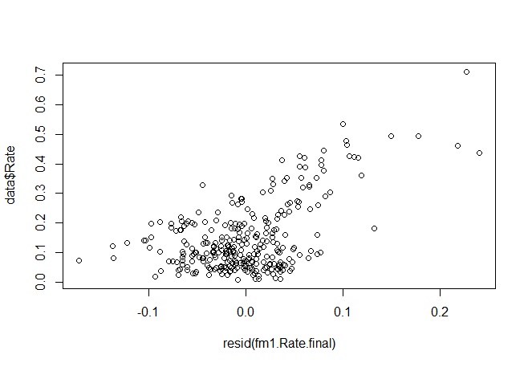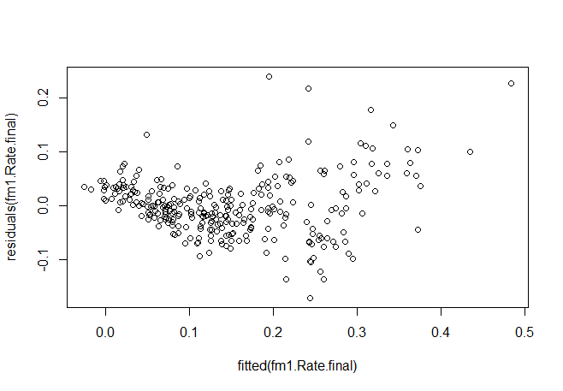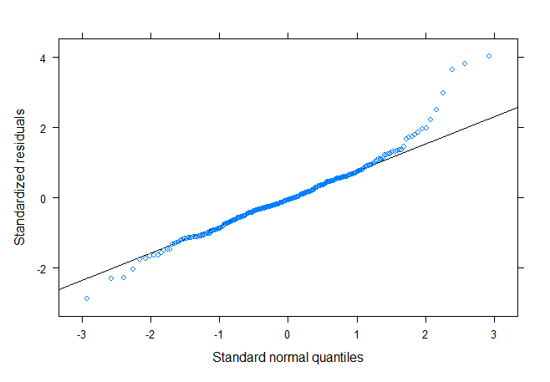
Table S3-2
Estimated Marginal Means for the Final Rate Model
Task | Round | emmean | lower.CL | upper.CL
Interview | Pre-sojourn | 0.195 | 0.172 | 0.219
Narrative | Pre-sojourn | 0.291 | 0.267 | 0.315
Interview | In-sojourn_2 | 0.112 | 0.089 | 0.135
Narrative | In-sojourn_2 | 0.157 | 0.134 | 0.180
Interview | L1 | 0.070 | 0.047 | 0.094
Narrative | L1 | 0.059 | 0.036 | 0.082

Table S3-3
Summary of Mixed-Effects Model Fit for Duration
 | Maximal Model |  |  |  |  | Duration: Final Model
Fixed effects | Estimates | SE | 95% CI | t | p | Estimates | SE | 95% CI | t | p
(Intercept) | 748.46 | 408.33 | [–55.36, 1552.27] | 1.83 | 0.068 | 614.28 | 19.91 | [575.09, 653.47] | 30.85 | <0.001
L2Group [Spanish] | 59.84 | 40.45 | [–19.78, 139.46] | 1.48 | 0.140
Task [Narrative] | 174.54 | 34.25 | [107.11, 241.97] | 5.10 | <0.001 | 141.30 | 22.86 | [96.31, 186.30] | 6.18 | <0.001
Round [In-sojourn_2] | 35.86 | 32.70 | [–28.51, 100.24] | 1.10 | 0.274 | –8.10 | 22.86 | [–53.10, 36.89] | –0.35 | 0.723
Round [L1] | 63.71 | 32.04 | [0.63, 126.79] | 1.99 | 0.048 | 34.02 | 22.86 | [–10.97, 79.02] | 1.49 | 0.138
MATTR | –215.86 | 437.09 | [–1076.30, 644.57] | –0.49 | 0.622
SyntacticComplexity | 19.95 | 17.32 | [–14.14, 54.04] | 1.15 | 0.250
L2Group [Spanish] × Task  [Narrative] | –48.27 | 46.49 | [–139.80, 43.25] | –1.04 | 0.300
L2Group [Spanish] × Round  [In-sojourn_2] | –77.65 | 47.04 | [–170.25, 14.95] | –1.65 | 0.100
L2Group [Spanish] × Round  [L1] | –72.93 | 46.71 | [–164.87, 19.02] | –1.56 | 0.120
Task [Narrative] × Round  [In-sojourn_2] | –158.00 | 45.92 | [–248.40, –67.61] | –3.44 | 0.001 | –127.79 | 32.33 | [–191.43, –64.16] | –3.95 | <0.001
Task [Narrative] × Round  [L1] | –279.36 | 46.07 | [–370.05, –188.68] | –6.06 | <0.001 | –266.26 | 32.33 | [–329.89, –202.62] | –8.24 | <0.001
(L2Group [Spanish] × Task  [Narrative]) × Round  [In-sojourn_2] | 48.17 | 65.92 | [–81.60, 177.95] | 0.73 | 0.466
(L2Group [Spanish] × Task  [Narrative]) × Round [L1] | 20.92 | 65.39 | [–107.80, 149.64] | 0.32 | 0.749
Random Effects
σ² | 12801.13 |  |  |  |  | 12804.08
τ₀₀ | 6939.28 _{Participant} |  |  |  |  | 6622.12 _{Participant}
ICC | 0.35 |  |  |  |  | 0.34
N | 49 _{Participant} |  |  |  |  | 49 _{Participant}
Observations | 294 |  |  |  |  | 294
Marginal R² / Conditional R² | 0.203 / 0.483 |  |  |  |  | 0.196 / 0.470

Figure S3-2
Checking for Linearity, Homogeneity of Variances, and Normally Distributed Model Residuals in the Final Duration Model
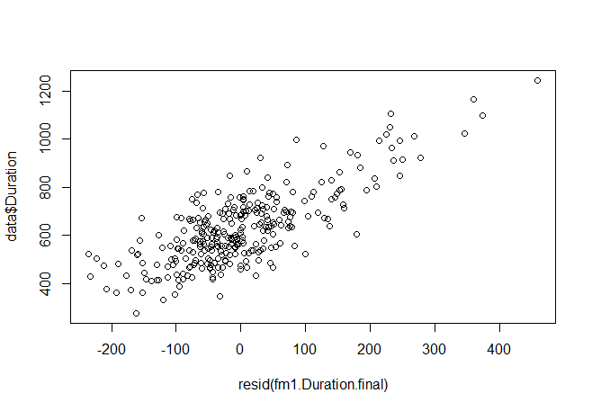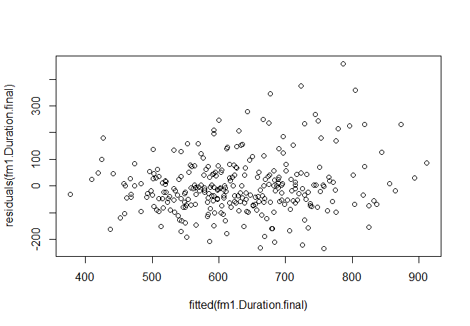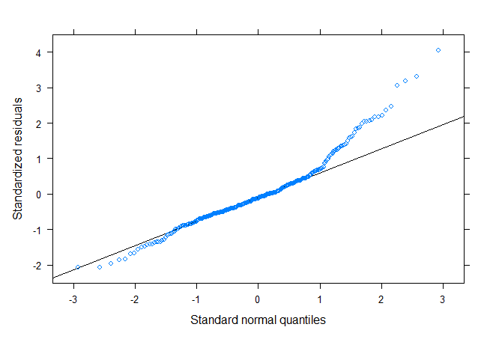

Table S3-4
Estimated Marginal Means for the Final Duration Model
Task | Round | emmean | lower.CL | upper.CL
Interview | Pre-sojourn | 614 | 575 | 654
Narrative | Pre-sojourn | 756 | 716 | 795
Interview | In-sojourn_2 | 606 | 567 | 645
Narrative | In-sojourn_2 | 620 | 580 | 659
Interview | L1 | 648 | 609 | 688
Narrative | L1 | 523 | 484 | 563

Table S3-5
Summary of Mixed-Effects Model Fit for Proportion
 | Maximal Model |  |  |  |  | Proportion: Final Model
Fixed effects | Estimates | SE | 95% CI | t | p | Estimates | SE | 95% CI | t | p
(Intercept) | 0.18 | 0.06 | [0.06, 0.31] | 2.87 | 0.004 | 0.06 | 0.01 | [0.05, 0.08] | 9.43 | <0.001
L2Group [Spanish] | 0.02 | 0.01 | [0.01, 0.03] | 3.50 | 0.001 | 0.02 | 0.01 | [0.01, 0.03] | 3.27 | 0.001
Task [Narrative] | 0.01 | 0.01 | [–0.00, 0.02] | 1.88 | 0.061 | 0.01 | 0.01 | [0.00, 0.02] | 2.08 | 0.038
Round [In-sojourn_2] | –0.01 | 0.01 | [–0.02, –0.00] | –2.40 | 0.017 | –0.01 | 0.01 | [–0.02, –0.00] | –2.45 | 0.015
Round [L1] | –0.02 | 0.01 | [–0.03, –0.01] | –3.32 | 0.001 | –0.02 | 0.01 | [–0.03, –0.01] | –3.29 | 0.001
MATTR | –0.13 | 0.07 | [–0.26, 0.01] | –1.86 | 0.064
SyntacticComplexity | 0.01 | 0.00 | [0.01, 0.02] | 4.80 | <0.001 | 0.01 | 0.00 | [0.01, 0.02] | 4.51 | <0.001
L2Group [Spanish] × Task  [Narrative] | –0.03 | 0.01 | [–0.04, –0.01] | –3.48 | 0.001 | –0.02 | 0.01 | [–0.04, –0.01] | –3.19 | 0.002
L2Group [Spanish] × Round  [In-sojourn_2] | –0.01 | 0.01 | [–0.03, 0.00] | –1.41 | 0.159 | –0.01 | 0.01 | [–0.02, 0.01] | –1.02 | 0.311
L2Group [Spanish] × Round  [L1] | –0.02 | 0.01 | [–0.04, –0.01] | –3.30 | 0.001 | –0.02 | 0.01 | [–0.04, –0.01] | –3.01 | 0.003
Task [Narrative] × Round  [In-sojourn_2] | –0.01 | 0.01 | [–0.03, 0.00] | –1.61 | 0.108 | –0.01 | 0.01 | [–0.03, 0.00] | –1.75 | 0.081
Task [Narrative] × Round  [L1] | –0.04 | 0.01 | [–0.05, –0.02] | –5.08 | <0.001 | –0.04 | 0.01 | [–0.05, –0.02] | –5.31 | <0.001
(L2Group [Spanish] × Task  [Narrative]) × Round  [In-sojourn_2] | 0.01 | 0.01 | [–0.01, 0.03] | 1.00 | 0.320 | 0.01 | 0.01 | [–0.01, 0.03] | 0.70 | 0.483
(L2Group [Spanish] × Task  [Narrative]) × Round [L1] | 0.02 | 0.01 | [0.00, 0.04] | 2.03 | 0.043 | 0.02 | 0.01 | [–0.00, 0.04] | 1.77 | 0.077
Random Effects
σ² | 0.00 |  |  |  |  | 0.00
τ₀₀ | 0.00 _{Participant} |  |  |  |  | 0.00 _{Participant}
ICC | 0.24 |  |  |  |  | 0.25
N | 49 _{Participant} |  |  |  |  | 49 _{Participant}
Observations | 294 |  |  |  |  | 294
Marginal R² / Conditional R² | 0.486 / 0.609 |  |  |  |  | 0.479 / 0.608

Figure S3-3
Checking for Linearity, Homogeneity of Variances, and Normally Distributed Model Residuals in the Final Proportion Model
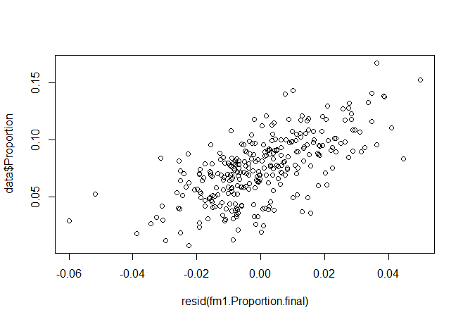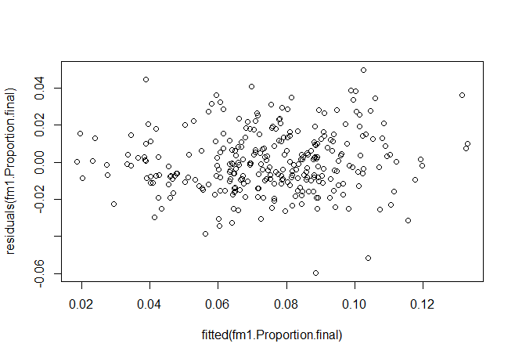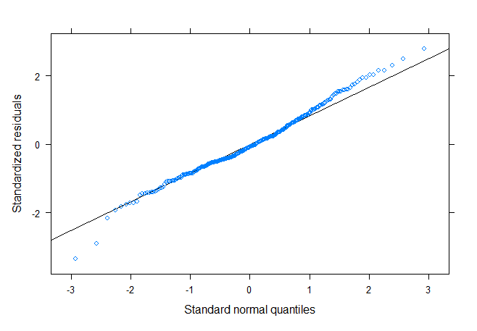

Table S3-6
Estimated Marginal Means for the Final Proportion Model
L2Group | Task | Round | emmean | lower.CL | upper.CL
French | Interview | Pre-sojourn | 0.086 | 0.078 | 0.094
French | Narrative | Pre-sojourn | 0.097 | 0.089 | 0.106
French | Interview | In-sojourn_2 | 0.074 | 0.066 | 0.082
French | Narrative | In-sojourn_2 | 0.072 | 0.064 | 0.081
French | Interview | L1 | 0.070 | 0.061 | 0.078
French | Narrative | L1 | 0.043 | 0.034 | 0.051
Spanish | Interview | Pre-sojourn | 0.106 | 0.097 | 0.114
Spanish | Narrative | Pre-sojourn | 0.094 | 0.085 | 0.102
Spanish | Interview | In-sojourn_2 | 0.086 | 0.077 | 0.094
Spanish | Narrative | In-sojourn_2 | 0.068 | 0.060 | 0.077
Spanish | Interview | L1 | 0.067 | 0.058 | 0.076
Spanish | Narrative | L1 | 0.035 | 0.027 | 0.044

