ON-LINE SUPPLEMENTARY MATERIAL
ST1
Posterior mean point estimates and 95% highest density intervals for subject-level variability in participants’ friendliness ratings of the Austrian dialect (M1, M2, M3) and intelligence ratings of standard German (M4, M5, M6) as a function of standard/dialect proficiency, exposure, and motivation. % in ROPE displays the percentage of the posterior distribution of the respective intercept/effect that falls in the ROPE [-0.08, 0.08]––the closer to zero, the more credible the effect. The intercepts represent the deviation from the group-level evaluative judgement estimates when the respective z-scored predictors are at their mean (i.e., zero). See Figure 3 for a visual summary of these models.

Parameter | Estimate | 95% CI | % in ROPE
Model 1: Dialect x Friendly Variability ~ Proficiency
Intercept | 0.00 | [-0.28, 0.28] | 48.25%
Standard Proficiency | 0.28 | [-0.03, 0.57] | 7.83%
Dialect Proficiency | 0.03 | [-0.25, 0.32] | 44.95%
Standard Proficiency x  Dialect Proficiency | 0.00 | [-0.26, 0.27] | 45.68%
Model 2: Dialect x Friendly Variability ~ Exposure
Intercept | 0.11 | [-0.16, 0.37] | 35.80%
Standard Exposure | 0.35 | [0.04, 0.66] | 2.13%
Dialect Exposure | 0.19 | [-0.13, 0.52] | 20.56%
Standard Exposure x  Dialect Exposure | -0.14 | [-0.36, 0.08] | 27.91%
Model 3: Dialect x Friendly Variability ~ Motivation
Intercept | 0.02 | [-0.22, 0.26] | 48.58%
Standard Motivation | 0.15 | [-0.09, 0.41] | 26.06%
Dialect Motivation | 0.25 | [-0.01, 0.53] | 8.15%
Standard Motivation x  Dialect Motivation | 0.03 | [-0.25, 0.34] | 42.83%
Model 4: Standard x Intelligent Variability ~ Proficiency
Intercept | -0.10 | [-0.38, 0.17] | 34.74%
Standard Proficiency | 0.34 | [ 0.04, 0.64] | 1.39%
Dialect Proficiency | -0.04 | [-0.33, 0.26] | 43.96%
Standard Proficiency x  Dialect Proficiency | 0.25 | [-0.03, 0.52] | 9.58%
Model 5: Standard x Intelligent Variability ~ Exposure
Intercept | 0.07 | [-0.24, 0.35] | 40.52%
Standard Exposure | 0.13 | [-0.25, 0.48] | 27.05%
Dialect Exposure | 0.18 | [-0.18, 0.52] | 22.58%
Standard Exposure x  Dialect Exposure | -0.11 | [-0.36, 0.14] | 36.94%
Model 6: Standard x Intelligent Variability ~ Motivation
Intercept | -0.01 | [-0.25, 0.24] | 54.15%
Standard Motivation | 0.15 | [-0.11, 0.39] | 27.22%
Dialect Motivation | 0.22 | [-0.07, 0.50] | 13.80%
Standard Motivation x  Dialect Motivation | 0.08 | [-0.22, 0.38] | 37.40%

SF1
Distribution (Cleveland dotplot and boxplot) of age within the sample. The Cleveland dotplot displays each subject’s respective value. The boxplot illustrates the spread of values: It indicates the median and the respective quartiles; the white circle at the center represents the mean, and darker colors represent lower values.

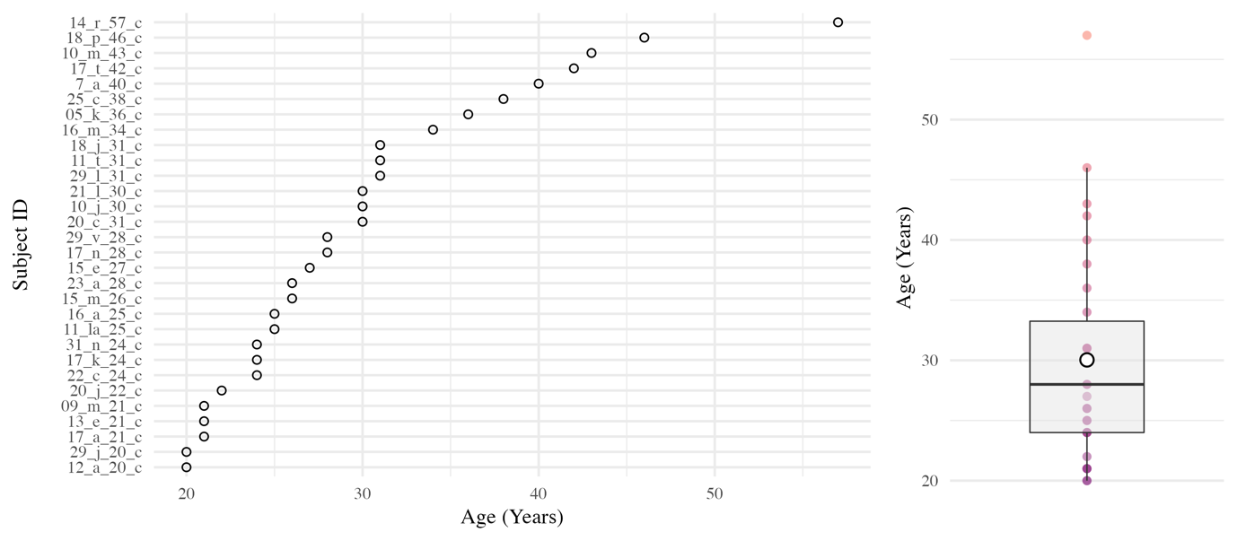

SF2
Distribution (Cleveland dotplot and boxplot) of length of residence (LoR) within the sample. The Cleveland dotplot displays each subject’s respective value. The boxplot illustrates the spread of values: It indicates the median and the respective quartiles; the white circle at the center represents the mean, and darker colors represent lower values.

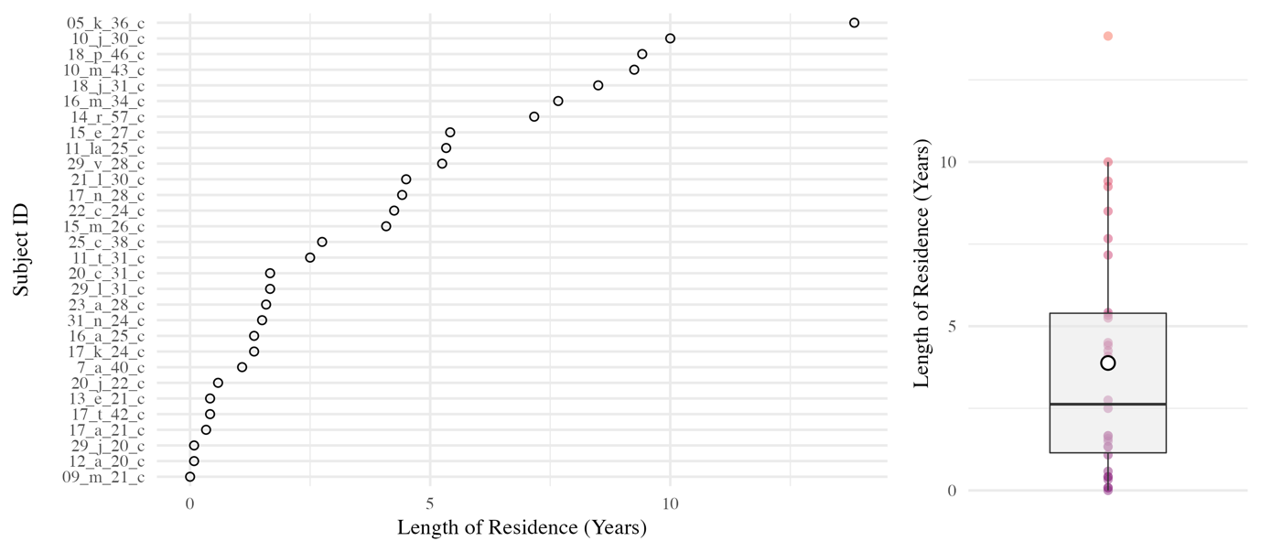

SF3
Distribution (Cleveland dotplot and boxplot) of standard German and dialect proficiency within the sample. The Cleveland dotplot displays each subject’s respective value. The boxplot illustrates the spread of values: It indicates the median and the respective quartiles; the white circle at the center represents the mean, and darker colors represent lower values.

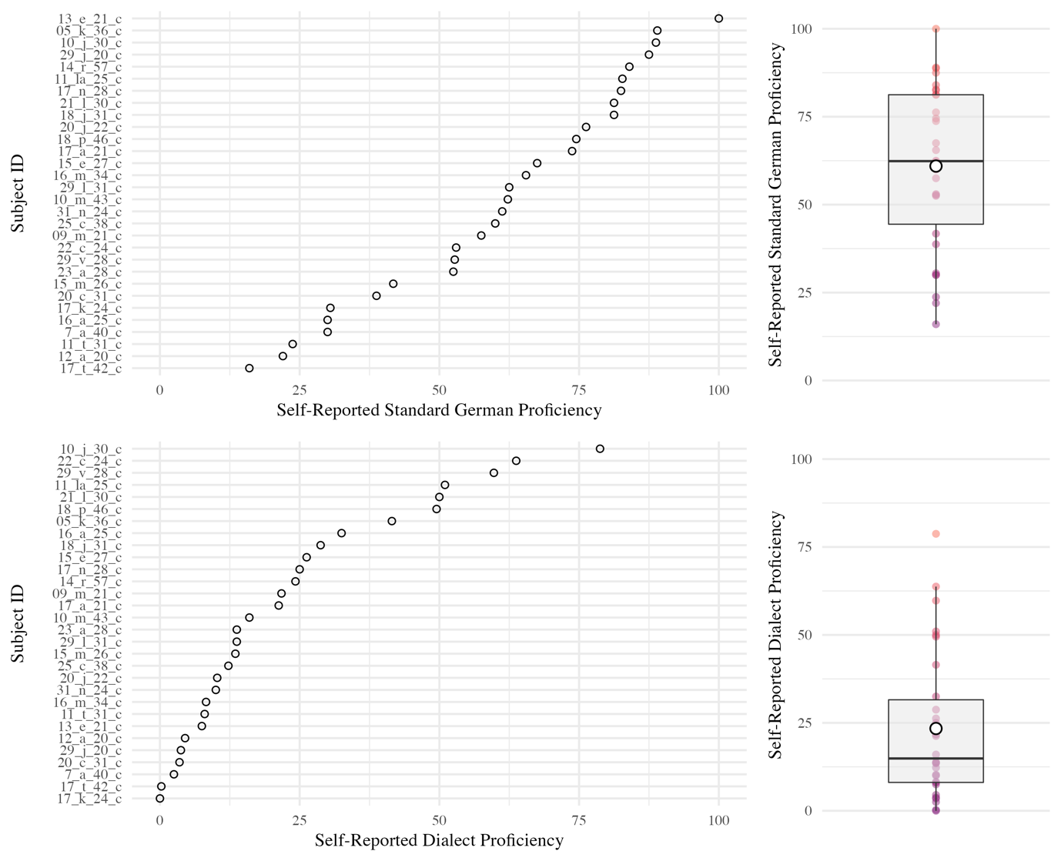

SF4
Distribution (Cleveland dotplot and boxplot) of standard German and dialect exposure within the sample. The Cleveland dotplot displays each subject’s respective value. The boxplot illustrates the spread of values: It indicates the median and the respective quartiles; the white circle at the center represents the mean, and darker colors represent lower values.

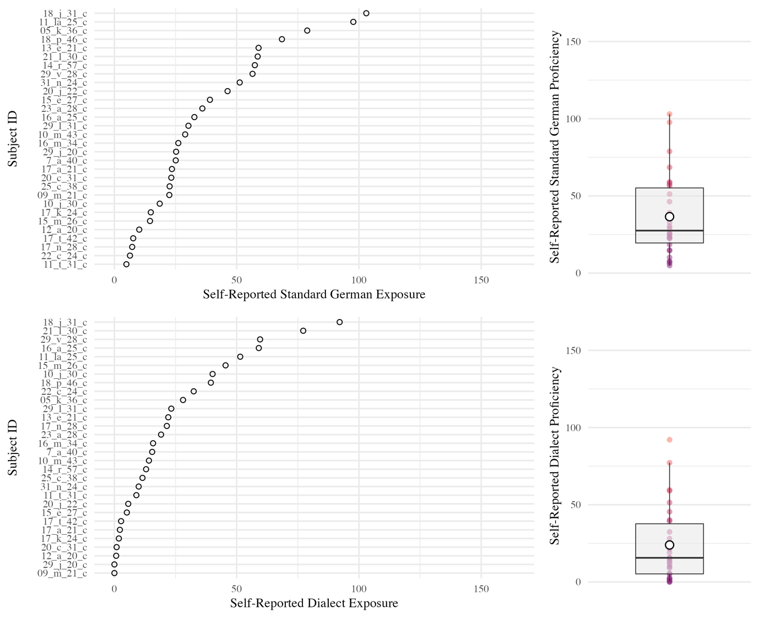

ST2
Posterior mean point estimates and 95% highest density intervals for the intercept-only (i.e., mean group estimate) models. Note that the model estimates are reported on the log-odds scale.

Parameter | Estimate | 95% HDI
Dialect x Friendly Intercept-Only Model
Intercept | 1.44 | [-1.54, 4.73]
Standard x Intelligent Intercept-Only Model
Intercept | 1.39 | [-0.87, 3.55]

SF5
Posterior point estimates ±70% and 95% highest density intervals (HDIs; the black lines) for the intercept-only (i.e., mean group estimate) models. The parameter estimates are visualized using quantile dotplots, the goal being to represent the posterior distribution not as one canonical point or interval, but as 100 equally likely points (see Fernandes, Walls, Munson, Hullman, & Kay, 2018; Kay, Kola, Hullman, & Munson, 2016). Each point of a given distribution represents 1%, i.e. if there are 7 points stacked on top of each other, then the likelihood of this value is 7%. Note that the model estimates are visualized on the log-odds scale.

