Language proficiency modulates listeners’ selective attention to a talker’s mouth:
a conceptual replication of Birulés et al. (2020)

Online Supplementary Materials

APPENDIX A: Analysis of subset of participants
This appendix contains a report of results parallel to those in the main manuscript but including only self-identified native speakers with no exposure to languages other than English during childhood (N=25, 'English early monolinguals') and only self-identified non-native speakers whose first language is Japanese (N=36, 'Japanese learners of English'). For demographic and proficiency information of these subgroups, see Table 1 in the main manuscript. Insufficient data quality (calibration accuracy, tracking ratio) led to the exclusion of Video 1 data from 1 participant and Video 2 data from 3 participants in this subset; we thus report Video 1 data from 60 (25 L1, 35 L2) and Video 2 data from 58 (24 L1, 34 L2) participants.
Table A1 presents descriptive statistics; Figures A1 and A2 present visualizations analogous to Figures 2 and 3 in the main document.

Table A1
Mean PTLT to Eyes and Mouth
 | Video 1 |  | Video 2
 | Eyes | Mouth | Eyes | Mouth
English early monolinguals | 0.69 (0.31) | 0.13 (0.21) | 0.81 (0.23) | 0.13 (0.20)
Japanese learners of English | 0.67 (0.21) | 0.14 (0.15) | 0.59 (0.28) | 0.28 (0.26)
Figure A1
Video 1: Mean Proportion Total Looking Time (PTLT) scores to the eyes and mouth for the English early monolinguals and the Japanese learners of English.

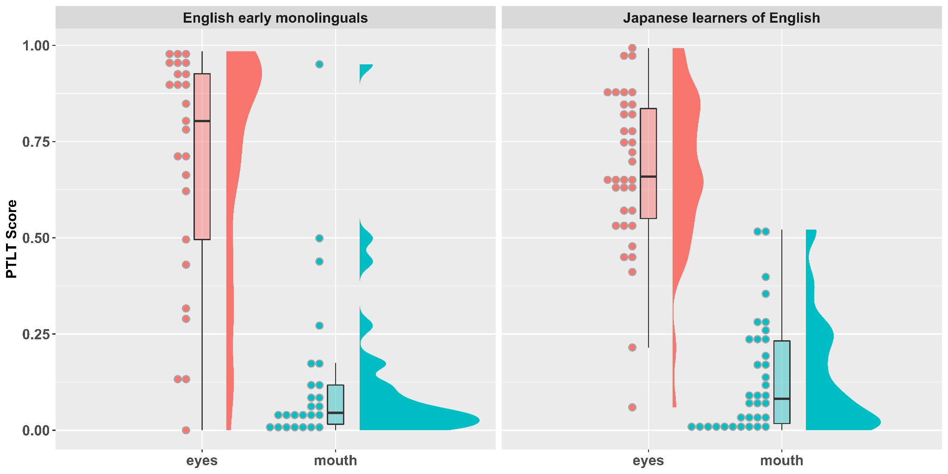

Figure A2
Video 2: Mean PTLT scores to the eyes and mouth for the English early monolinguals and the Japanese learners of English.

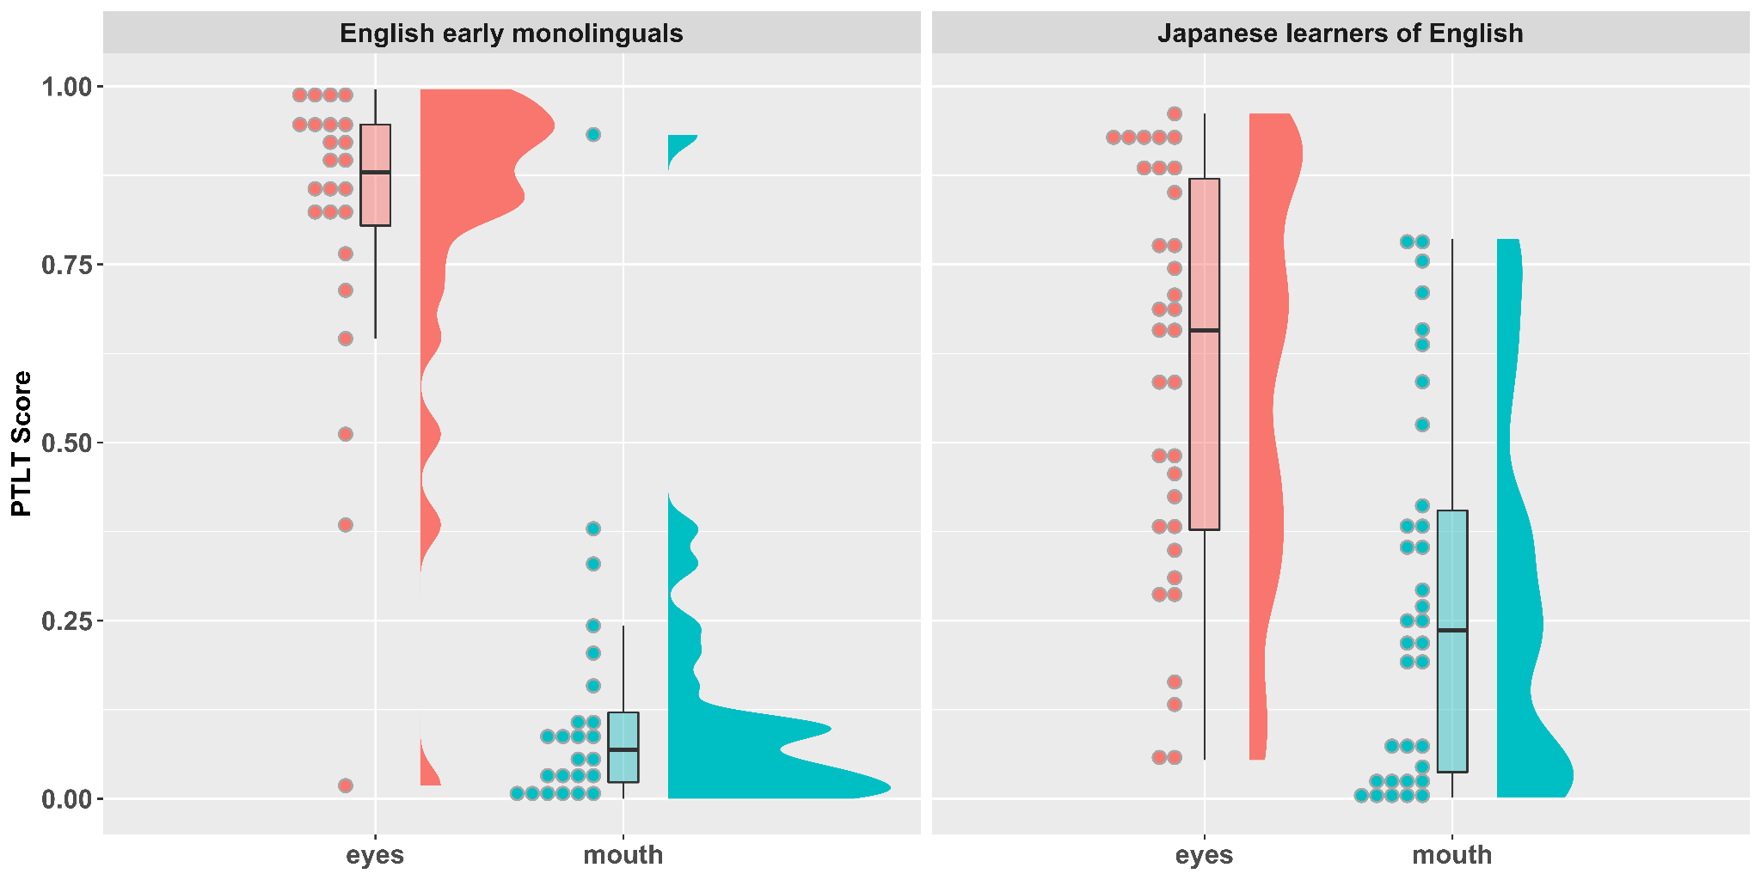

ANOVA
Video 1: ANOVA results showed a main effect of AOI, indicating an overall preference to look at the eyes, F(1,58) = 114.88, p < .001, η_{p}² = .66. This preference was not modulated by Group, as evidenced by a non-significant interaction between Group and AOI, F(1,58) = 0.04, p = .837, η_{p}² = .001.
Video 2: ANOVA results yielded a main effect of AOI, F(1,56) = 51.74, p < .001, η_{p}² = .48, modulated by a significant interaction with Group, F (1,56) = 7.99, p = .007, η_{p}² = .125. Follow-up independent-samples t-tests indicated more looks to the eyes among English early monolinguals than among Japanese learners of English, t(54) = 3.24, p = .002, d = 0.833, and fewer looks to the mouth among English early monolinguals than among Japanese learners of English, t(55) = -2.56, p = .013, d = 0.651.

Correlations
(compare to Tables 2 and 3, and Figures 4 and 5, in main manuscript)

Table A2
Intercorrelations between proficiency measures within the Japanese learner group (Pearson's r)
 | Cambridge Test | LexTALE
LexTALE | r(36) = 0.29  p = 0.088 | --
Self-rating | r(36) = 0.24  p = 0.152 | r(36) = 0.15  p = 0.368

Table A3
Correlations between proficiency measures and PTLT difference scores in the Japanese learner group (N = 36; Spearman's rho, ρ)
 | Cambridge Test | LexTALE | Self-rating | Mean proficiency z-score | Comprehension accuracy
Video 1  PTLT difference | ρ = 0.35  p = 0.04 | ρ = 0.03  p = 0.864 | ρ = 0.27  p = 0.116 | ρ = 0.30  p = 0.08 | ρ = 0.33  p = 0.055
Video 2  PTLT difference | ρ = 0.12  p = 0.116 | ρ = -0.10  p = 0.572 | ρ = 0.10  p = 0.589 | ρ = -0.003  p = 0.986 | ρ = 0.15  p = 0.398

Figure A3
Video 1: Correlation between PTLT difference scores (PTLTeyes - PTLTmouth) and scores on the Cambridge English Test (panel A) and on the post-viewing comprehension test (panel B) in the Japanese learner group (N=35).

A B
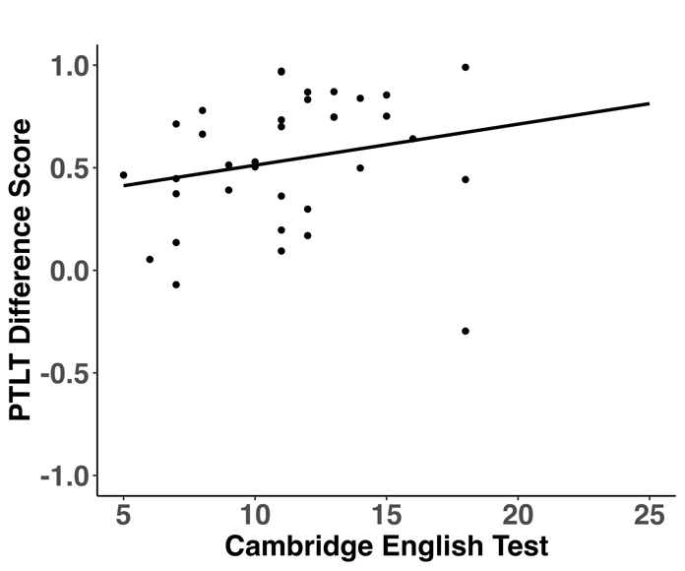
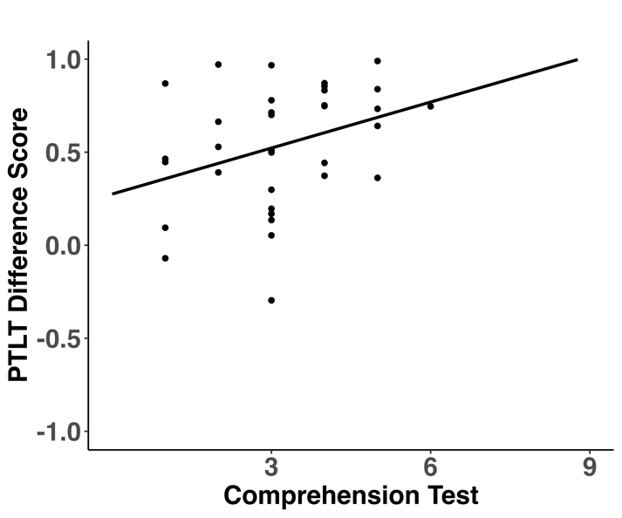

Figure A4
Video 2 : Correlation between PTLT difference scores (PTLTeyes - PTLTmouth) and scores on the Cambridge English Test (panel A) and on the post-viewing comprehension test (panel B) in the Japanese learner group (N=35).

A B
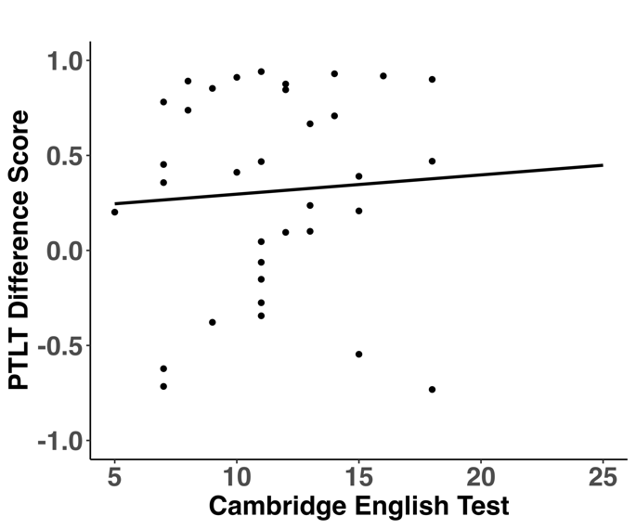
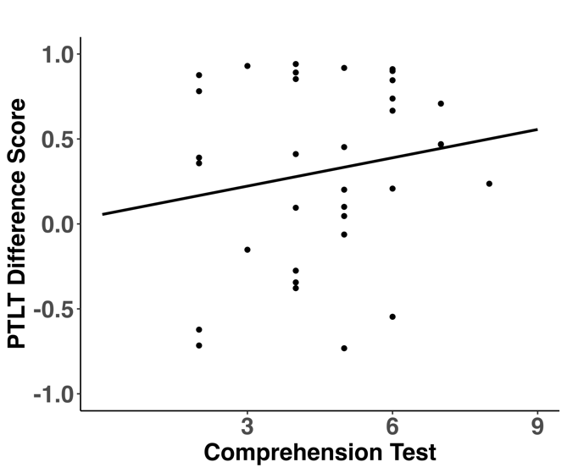

APPENDIX B: Analysis of nativeness ratings and PTLT

Table B1
Mean (SD) nativeness rating by listener groups
 | Video 1 (Caucasian) | Video 2 (Asian)
L1 group | 8.73 (2.00) | 6.11 (2.73)
L2 group | 8.44 (2.22) | 6.48 (2.63)

Correlations between nativeness ratings and PLTL scores (Spearman's rho):
Video 1: ρ = 0.12, p = 0.282
Video 2: ρ = -0.02, p = 0.854

Figure B1
Correlation between PTLT difference scores (PTLTeyes - PTLTmouth) and the nativeness rating for Video 1 (panel A) and Video 2 (panel B)
A B
