APPENDIX S1
Scale Items

HL Self-guides
Whenever I think of my future career, I imagine myself using Spanish
I can imagine myself writing Spanish e-mails/letters fluently
The things I want to do in the future require me to use Spanish
I can imagine myself studying in a university where all my courses are taught in Spanish
Studying Spanish is necessary because people surrounding me expect me to do so
I consider studying Spanish important because the people I respect think that I should do it
Studying Spanish is important to me in order to gain the approval of my peers/teachers/family/boss
It will have a negative impact on my life if I don’t study Spanish

Family Influence
My parents/family believe(s) that I must study Spanish to be an educated person
Studying Spanish is important to me in order to bring honor to my family
Being successful in Spanish is important to me so that I can please my parents/relatives
My family put a lot of pressure on me to study Spanish
My parents encourage me to practice my Spanish as much as possible
I have to study Spanish, because, if I don’t do it, my parents will be disappointed with me

Intended Effort
I would like to spend lots of time studying Spanish
I would like to study Spanish even if I were not required
I would like to concentrate on studying Spanish more than any other topic
If a Spanish course was offered in the future, I would like to take it
If my Spanish teacher would give the class an optional assignment, I would certainly volunteer to do it
I am prepared to expend a lot of effort in learning Spanish

Achievement Goal Orientations
In Spanish class…
My aim is to avoid showing incompetence in my Spanish
My focus is to avoid showing incompetence in Spanish
My goal is to avoid demonstrating that I lack knowledge of Spanish
My focus is to show my Spanish competence
My aim is to demonstrate that I am knowledgeable in Spanish
My goal is to demonstrate my Spanish ability
My aim is to avoid becoming less competent in my Spanish
My focus is to develop my Spanish ability
My goal is to increase my Spanish competence
My goal is to avoid a decrease in my Spanish ability
My aim is to develop my Spanish knowledge
My focus is to avoid losing my Spanish knowledge

HL Enjoyment
I don’t get bored
I enjoy it
I’m a worthy member of the Spanish class
In class, I feel proud of my accomplishments
It’s a positive environment
It’s cool to know Spanish
It’s fun
The peers are nice
There is a good atmosphere
We laugh a lot

HL Anxiety
Even if I am well prepared for Spanish class, I feel anxious about it
I always feel that the other students speak Spanish better than I do
I can feel my heart pounding when I'm going to be called on in Spanish class
I don't worry about making mistakes in Spanish class
I feel confident when I speak in Spanish class
I get nervous and confused when I am speaking in my Spanish class
I start to panic when I have to speak without preparation in Spanish class
It embarrasses me to volunteer answers in my Spanish class

Classroom Environment
Tasks designed in this class are useful
Tasks designed in this class are attracting
I know what I am trying to accomplish in this class
Activities in this class are clearly and carefully planned
Class assignments are clear so everyone knows what to do
I work well with other class members
I am friendly to members of this class
I make friends among students in this class
I help other class members who are having trouble with their work
The instructor provides a timely response to students’ concerns
The instructor is patient in teaching
The instructor smiles at the class while talking
The instructor asks questions that solicit viewpoints or opinions

Critical Language Awareness
People from Spain speak the purest form of Spanish
In my opinion, people should use standard Spanish to communicate all the time
I believe Spanish-speaking Hispanics in the U.S. don’t speak correct Spanish
I feel speaking Spanish is less prestigious than speaking other foreign languages such as French
I believe people who speak Spanglish should switch to just Spanish or English
I don’t like it when people say ‘parquear’ instead of ‘estacionar’
I don’t like it when people code-switch because it is not a proper way of speaking a language
I believe Spanglish should not be allowed in Spanish classes
I would tease a friend when speaking Spanish if they forget or invent words
I would try to avoid mixing Spanish and English in the same conversation as much as I can
I would not code-switch in front of my teachers because they may think I am less intelligent

APPENDIX S2
Results for Exploratory Factor Analyses

Exploratory factor analyses (EFA) were performed on items related to the possible HL selves, family influence, intended effort, HL achievement goal orientations, HL enjoyment, HL anxiety, classroom environment, and critical language awareness. Using direct oblimin as the rotation method, factors were extracted using a minimum-eigenvalue criterion of 1.0. The EFA results showed that the items for the Family Influence (Table 6), Intended Effort (Table 7), HL Enjoyment (Table 9), and HL Anxiety (Table 10), Classroom Environment (Table 11), and Critical Language Awareness (Table 12) scales loaded onto a single factor. With respect to the possible HL selves (Table 5), the analysis yielded two factors, each including four items tapping onto the Ought-to HL Self and the Ideal HL Self, respectively. The analysis for achievement goal orientations (Table 8) also revealed two factors, with items loading into the Performance and Mastery Goal Orientation factors. Standardized mean scores for each scale and subscale were used for the analyses reported in the manuscript (note that one of the items probing into Mastery Goal Orientation was excluded because it loaded slightly more strongly onto Performance Goal Orientation).
Table 4
Tests of Sampling Adequacy and Sphericity by Scale
 | Kaiser-Meyer-Olkin Measure | Bartlett’s Test of Sphericity
HL Self-guides | .796 | χ² (28) = 813.46, p <.001
Family Influence | .841 | χ² (15) = 740.65, p <.001
Intended Effort | .886 | χ² (15) = 676.71, p <.001
Achievement Goal Orientations | .847 | χ² (66) = 1834.83, p <.001
HL Enjoyment | .886 | χ² (45) = 1342.47, p <.001
HL Anxiety | .861 | χ² (28) = 685.92, p <.001
Classroom Environment | .912 | χ² (78) = 1945.33, p <.001
Critical Language Awareness | .868 | χ² (55) = 895.57, p <.001

Table 5
Factor Loadings for HL Self-guides
 | Ought-to HL Self | Ideal HL Self
Whenever I think of my future career, I imagine myself using Spanish |  | .837
I can imagine myself writing Spanish e-mails/letters fluently |  | .863
The things I want to do in the future require me to use Spanish |  | .752
I can imagine myself studying in a university where all my courses are taught in Spanish |  | .538
Studying Spanish is necessary because people surrounding me expect me to do so | .804
I consider studying Spanish important because the people I respect think that I should do it | .876
Studying Spanish is important to me in order to gain the approval of my peers/teachers/family/boss | .893
It will have a negative impact on my life if I don’t study Spanish | .431
Note. Ought-to HL Self proportion var. = .312; Ideal HL Self proportion var. = .295 (cumulative = .606).

Table 6
Factor Loadings for Family Influence
 | Factor
My parents/family believe(s) that I must study Spanish to be an educated person | .828
Studying Spanish is important to me in order to bring honor to my family | .767
Being successful in Spanish is important to me so that I can please my parents/relatives | .838
My family put a lot of pressure on me to study Spanish | .863
My parents encourage me to practice my Spanish as much as possible | .413
I have to study Spanish, because, if I don’t do it, my parents will be disappointed with me | .753
Note. Proportion var. = .576.

Table 7
Factor Loadings for Intended Effort
 | Factor
I would like to spend lots of time studying Spanish | .790
I would like to study Spanish even if I were not required | .845
I would like to concentrate on studying Spanish more than any other topic | .652
If a Spanish course was offered in the future, I would like to take it | .796
If my Spanish teacher would give the class an optional assignment, I would certainly volunteer to do it | .725
I am prepared to expend a lot of effort in learning Spanish | .783
Note. Proportion var. = .589.

Table 8
Factor Loadings for Achievement Goal Orientation
 | Performance Goal Orientation | Mastery Goal Orientation
My aim is to avoid showing incompetence in my Spanish | .915
My focus is to avoid showing incompetence in Spanish | .915
My goal is to avoid demonstrating that I lack knowledge of Spanish | .843
My focus is to show my Spanish competence | .646
My aim is to demonstrate that I am knowledgeable in Spanish | .583 | .321
My goal is to demonstrate my Spanish ability | .445 | .354
*My aim is to avoid becoming less competent in my Spanish | .374 | .330
My focus is to develop my Spanish ability |  | .907
My goal is to increase my Spanish competence |  | .859
My goal is to avoid a decrease in my Spanish ability |  | .648
My aim is to develop my Spanish knowledge |  | .751
My focus is to avoid losing my Spanish knowledge |  | .560
Note. Performance Goal Orientation proportion var. = .320; Mastery Goal Orientation proportion var. = .293 (cumulative = .612). *Item was excluded from the analysis.

Table 9
Factor Loadings for HL Enjoyment
 | Factor
I don’t get bored | .443
I enjoy it | .827
I’m a worthy member of the Spanish class | .582
In class, I feel proud of my accomplishments | .714
It’s a positive environment | .826
It’s cool to know Spanish | .634
It’s fun | .825
The peers are nice | .753
There is a good atmosphere | .900
We laugh a lot | .616
Note. Proportion var. = .525.

Table 10
Factor Loadings for HL Anxiety
 | Factor
Even if I am well prepared for Spanish class, I feel anxious about it | .623
I always feel that the other students speak Spanish better than I do | .739
I can feel my heart pounding when I'm going to be called on in Spanish class | .813
I don't worry about making mistakes in Spanish class | .424
I feel confident when I speak in Spanish class | .746
I get nervous and confused when I am speaking in my Spanish class | .630
I start to panic when I have to speak without preparation in Spanish class | .715
It embarrasses me to volunteer answers in my Spanish class | .638
Note. Proportion var. = .456.

Table 11
Factor Loadings for Classroom Environment
 | Factor
Tasks designed in this class are useful | .736
Tasks designed in this class are attracting | .646
I know what I am trying to accomplish in this class | .740
Activities in this class are clearly and carefully planned | .810
Class assignments are clear so everyone knows what to do | .787
I work well with other class members | .764
I am friendly to members of this class | .756
I make friends among students in this class | .560
I help other class members who are having trouble with their work | .489
The instructor provides a timely response to students’ concerns | .784
The instructor is patient in teaching | .775
The instructor smiles at the class while talking | .703
The instructor asks questions that solicit viewpoints or opinions | .703
Note. Proportion var. = .515.

Table 12
Factor Loadings for Critical Language Awareness
 | Factor
People from Spain speak the purest form of Spanish | .368
In my opinion, people should use standard Spanish to communicate all the time | .457
I believe Spanish-speaking Hispanics in the U.S. don’t speak correct Spanish | .660
I feel speaking Spanish is less prestigious than speaking other foreign languages such as French | .545
I believe people who speak Spanglish should switch to just Spanish or English | .653
I don’t like it when people say ‘parquear’ instead of ‘estacionar’ | .777
I don’t like it when people code-switch because it is not a proper way of speaking a language | .855
I believe Spanglish should not be allowed in Spanish classes | .702
I would tease a friend when speaking Spanish if they forget or invent words | .504
I would try to avoid mixing Spanish and English in the same conversation as much as I can | .573
I would not code-switch in front of my teachers because they may think I am less intelligent | .533
Note. Proportion var. = .382.

APPENDIX S3
Intraclass Correlation Coefficients for Classroom- and School-level Variation

We computed intraclass correlation coefficients (ICCs) to assess the proportion of variance in our variables that was attributable to HL students’ nesting within classrooms (k = 45) and universities (k = 11). In this study, the fact that HL learners belong to a particular classroom and school can cause ratings from that classroom and school to be more similar to each other. Such similarity may be connected to a multiplicity of factors, such as students’ shared classroom experiences, socialization processes, actual and/or perceived social norms about student behavior in school, or the local sociolinguistic status of the HL across different geographic locations, to name a few. The expected degree of ‘relatedness’ within the same cluster can differ based on the nature of each construct and the extent to which it is impacted by the aforementioned potential sources of variability.
The ICCs are reported in Table 13. Classroom-level clustering explained the highest amount of variance in HL Enjoyment and, to a lesser degree, Classroom Environment, Mastery Goal Orientation, and Critical Language Awareness. School-level clustering explained the highest amount of variance in Classroom Environment, closely followed by Performance Goal Orientation and HL Anxiety. In contrast, classroom- and school-level clustering effects were minimal for variables such as the Ideal and Ought-to HL Selves, Family Influence, or Intended Effort.
The higher ICCs observed for variables such as HL Enjoyment and Classroom Environment are in line with the notion that learners’ ratings for these constructs rely to some extent on common experiences across shared educational and socio-local spaces. For instance, with regards to Classroom Environment, it is interesting to note that the highest ratings were reported among students in two universities located in Florida and Texas, both of which have strong Spanish-English bilingual communities. Additionally, it is worth mentioning that the ICC for HL Enjoyment observed here is greater than what has been previously reported in L2 contexts (see Khajavy et al., 2018). We hypothesize that this may be due to differences in the scales used across studies. Specifically, the fact that the HL Enjoyment scale employed here (which was adapted from Dewaele et al., 2019; Dewaele & McIntyre, 2014) considered multiple social dimensions of enjoyment at the classroom level likely contributed to the more pronounced clustering effects.

Table 13
ICCs for Classroom- and School-Level Variation
 | Random Component
Variable | Classroom | School
Ideal HL Self | <.001 | .06
Ought-to HL Self | <.001 | .09
Family Influence | <.001 | .03
Intended Effort | <.001 | .04
Mastery Goal Orientation | .14 | .02
Performance Goal Orientation | <.001 | .12
HL Enjoyment | .32 | .05
HL Anxiety | .08 | .10
Classroom Environment | .18 | .13
Critical Language Awareness | .13 | <.001
Note. Classrooms, k = 45; Schools, k = 11. Except for the subsample for whom the questionnaire was not anonymous (see endnote 2), classrooms were determined based on the following information provided by respondents: university, course name, days and times class meets, and teacher initials.

APPENDIX S4
Descriptive Statistics by Variable

Table 14
Descriptive Statistics by Variable
Variable | M (SD) | Min-Max
Ideal HL Self | 4.68 (1.04) | 1.25-6.00
Ought-to HL Self | 3.88 (1.35) | 1.00-6.00
Family Influence | 3.53 (1.32) | 1.00-6.00
Intended Effort | 4.32 (1.09) | 1.00-6.00
Mastery Goal Orientation | 5.47 (.70) | 1.00-6.00
Performance Goal Orientation | 4.72 (1.14) | 1.00-6.00
HL Enjoyment | 4.48 (.53) | 1.90-5.00
HL Anxiety | 2.71 (.87) | 1.00-5.00
Classroom Environment | 4.41 (.54) | 1.76-5.00
Critical Language Awareness | 4.85 (.85) | 1.00-6.00

APPENDIX S5
Nonparametric Bootstrapped Edge Weights with Y-Axis Labels

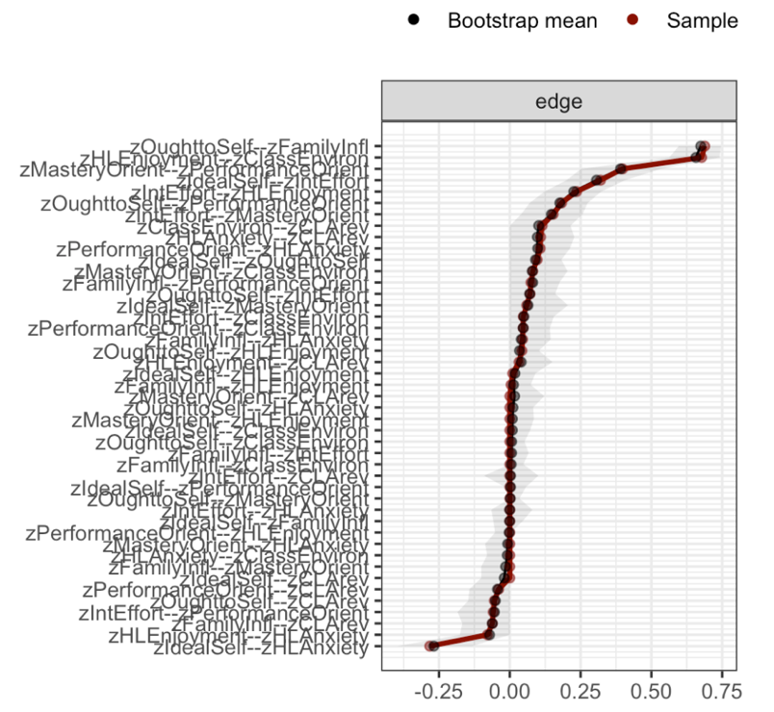
Figure 5. Nonparametric bootstrapped edge weights (ordered from highest to lowest), with 95% CIs depicted as grey area.

APPENDIX S6
Network Model Estimated after Applying a Nonparanormal Transformation

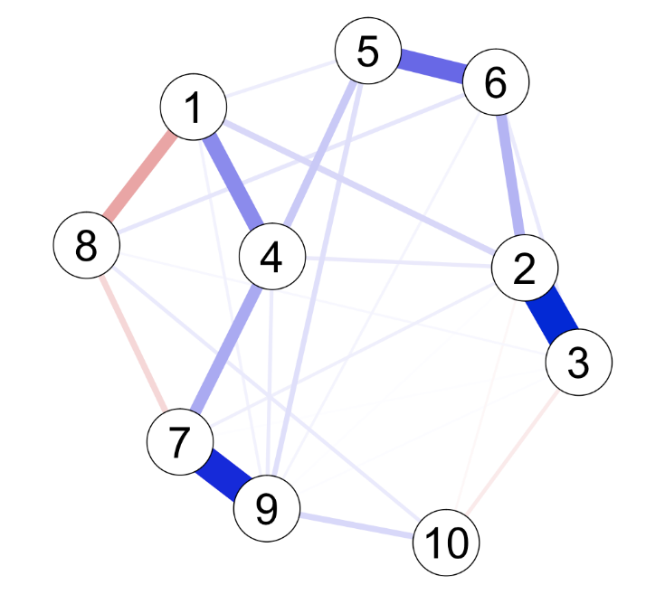
1. Ideal HL Self
2. Ought-to HL Self
3. Family Influence
4. Intended Effort
5. Mastery Goal Orientation
6. Performance Goal Orientation
7. HL Enjoyment
8. HL Anxiety
9. Classroom Environment
10. Critical Language Awareness
Figure 6. EBICglasso regularized network model estimated after nonparanormal transformation on continuous data.

