Figure S1.
The F0 Profiles of the Female- (Top) and Male- (Bottom) produced Thai Tones in the Syllable /k^{h}ɯː/.
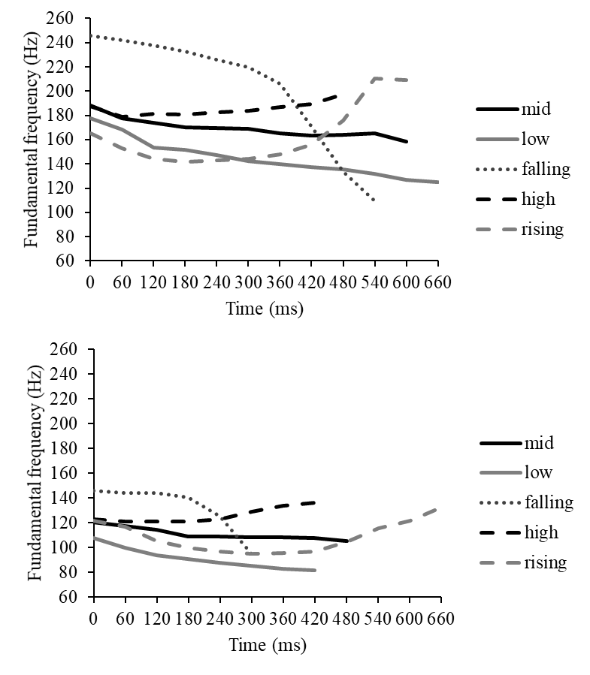
Note. The first detectable f0 value of each stimulus is at the zero-time point.

Figure S2.
The F0 Profiles of the Female- (Top) and Male- (Bottom) produced Thai Tones in the Syllable /tɕʰɔ:/.
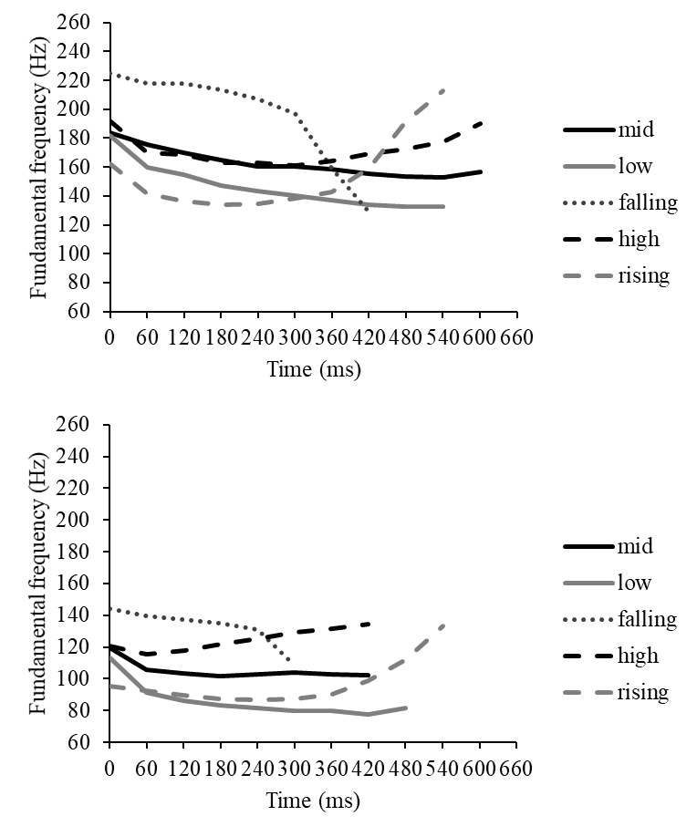
Note. The first detectable f0 value of each stimulus is at the zero-time point.

Figure S3.
The F0 Profiles of the Female- (Top) and Male- (Bottom) produced Thai Tones in the Syllable /wuːa/.
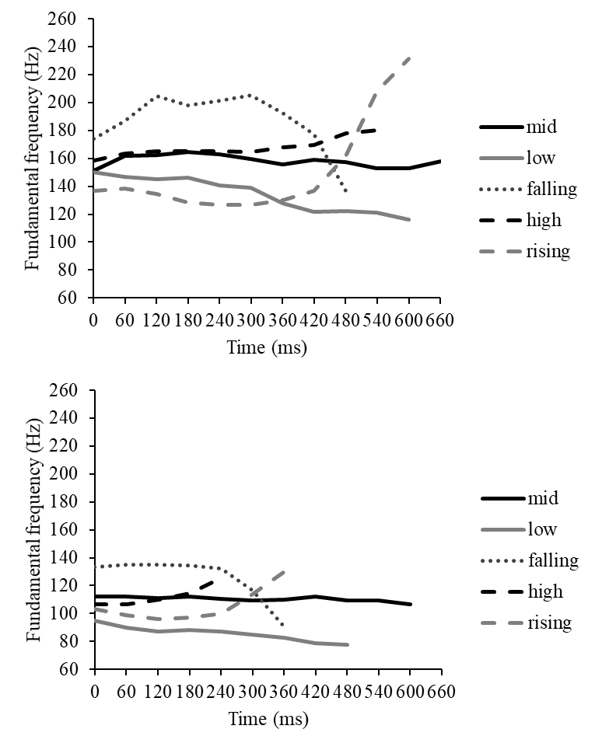
Note. The first detectable f0 value of each stimulus is at the zero-time point.

