Appendix A: Mind Map “The Sun” in English

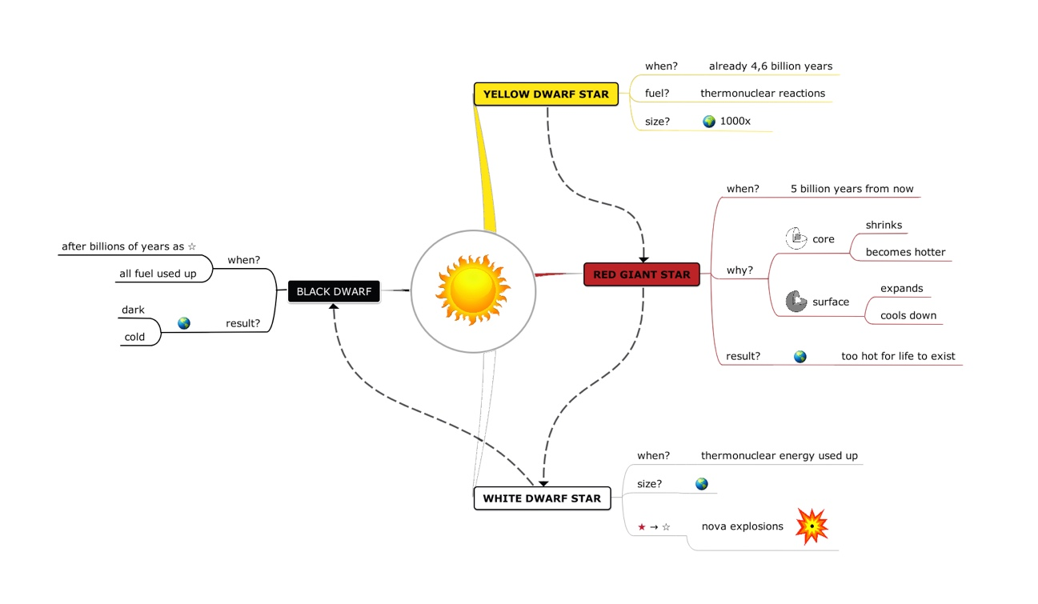

Appendix B: Mind Map “Sea Otters” in English

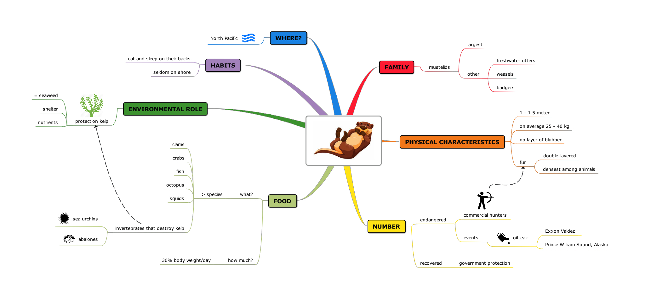

Appendix C: Mind Map “The Sun” in Dutch

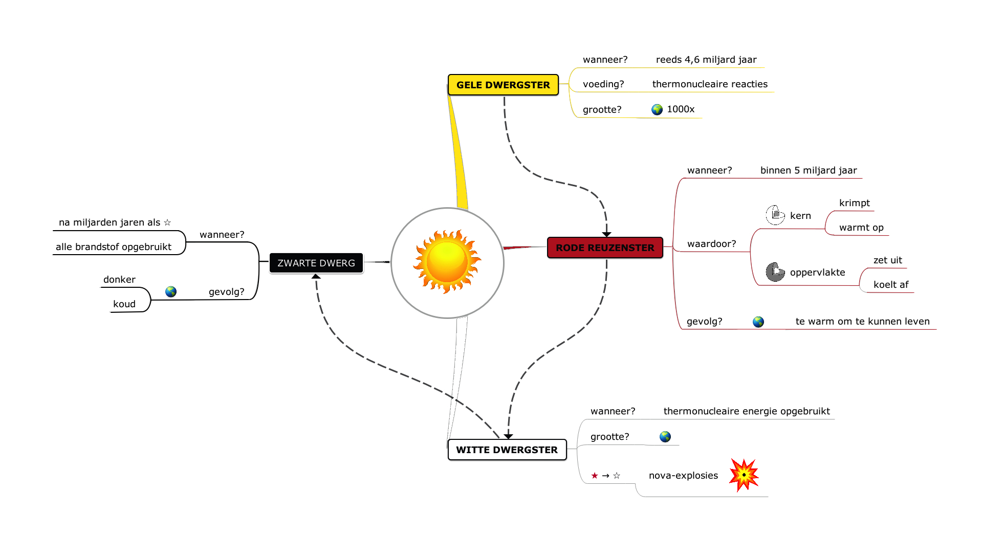

Appendix D: Mind Map “Sea Otters” in Dutch

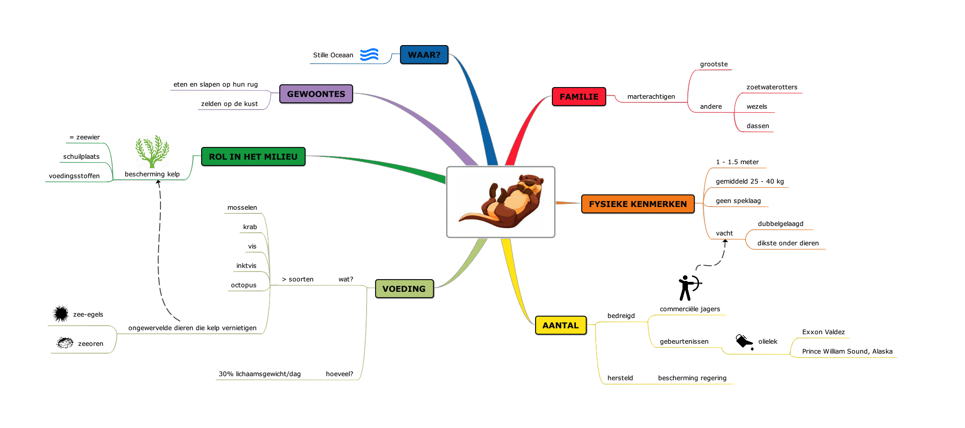

Appendix E: Group Comparisons

|  |  |  |  |  |  |  |
| --- | --- | --- | --- | --- | --- | --- |
|  |  | L1 group | L2 group | Test-statistic | *p* | *p* adjusted |
| Welch two-sample t-tests | Age | 20.04 (1.89) | 20.01(2.15) | t(97.248) = -0.093 | .926 | > .999 |
|  | LexTALE L1 | 87.86 (7.83) | 87.80 (7.59) | t(97.489) = 0.038 | .970 | > .999 |
|  | LexTALE L2 | 73.70 (11.46) | 73.62 (11.26) | t(97.665) = 0.035 | .972 | > .999 |
| Wilcoxon rank sum tests | Prior knowledge | 2.24 (1.48) | 1.95 (1.42) | W = 5668.0 | .077 | > .999 |
|  | Difficulty (content) | 3.49 (1.45) | 3.77 (1.38) | W = 4417.0 | .148 | > .999 |
|  | Difficulty (structure) | 2.89 (1.36) | 3.16 (1.26) | W = 4360.5 | .109 | > .999 |
|  | Interest | 4.88 (1.33) | 4.60 (1.50) | W = 5378.0 | .342 | > .999 |
|  | Motivation | 5.47 (1.12) | 5.44 (1.30) | W = 5036.5 | .921 | > .999 |
|  | Estimated performance | 4.46 (1.09) | 4.11 (0.95) | W = 5993.5 | .010 | .162 |

Appendix F: Text Comparisons

|  |  |  |  |  |  |  |
| --- | --- | --- | --- | --- | --- | --- |
|  |  | The Sun | Sea Otters | Test-statistic | *p* | *p* adjusted |
| Welch two-sample t-tests | Test Score | 17.01 (4.40) | 14.37 (3.81) | t(99) = 7.22 | < .001 | < .001 |
| Wilcoxon signed-rank tests | Prior knowledge | 2.55 (1.65) | 1.63 (1.06) | V = 1617.5 | < .001 | < .001 |
|  | Difficulty (content) | 3.93 (1.42) | 3.33 (1.35) | V = 2153.5 | < .001 | .012 |
|  | Difficulty (structure) | 3.02 (1.33) | 3.03 (1.31) | V = 1272.0 | .812 | > .999 |
|  | Interest | 4.92 (1.40) | 4.55 (1.42) | V = 1514.5 | .034 | .538 |
|  | Motivation | 5.50 (1.23) | 5.41 (1.21) | V = 307.5 | .203 | > .999 |
|  | Estimated performance | 4.29 (1.05) | 4.27 (1.02) | V = 786.0 | .892 | > .999 |

**Appendix G: Generalised mixed effect modelling**

Model without covariates, as reported in the manuscript

**

**

**

**

Model with covariates



Table 4. *Generalised Mixed Effects Model: output fixed effects*

|  |  |  |  |  |
| --- | --- | --- | --- | --- |
|  | Estimate | SE | *z*-value | *p*-value |
| (Intercept) | -0.534 | 0.379 | -1.411 | .158 |
| Language | 0.168 | 0.061 | 2.746 | **.006** |
| AO | 0.084 | 0.048 | 1.726 | .084 |
| Item Type | -0.533 | 0.114 | -4.662 | **< .001** |
| Motivation | 0.090 | 0.062 | 1.442 | .149 |
| Prior knowledge | 0.070 | 0.039 | 1.784 | .075 |
| AO * Item Type | 0.283 | 0.044 | 6.411 | **< .001** |
| AO * Language | -0.001 | 0.037 | -0.028 | .978 |

In order to account for the heterogeneity of items, formal analysis of memory performance was conducted at item-level (resulting in 30 observations per participant per text). The variable Item ranged from 1-60, each value coding for one of the 30 ideas in the two texts. Using the lme4 package (version 1.1-25) in R (R Core Team, 2020), a generalised linear mixed effect model was fitted with memory performance as binary dependent variable. Items for which at least 50% of the subideas were correctly recalled, were allocated a value of 1; items for which less than 50% were correctly recalled, were assigned a value of 0.

The variables Language (two levels: L1 and L2), AO (two levels: ‘NAO’ when the text was learned without the use of an AO and ‘AO’ otherwise), and Item Type (‘included’ when the item was depicted in the AO and ‘not included’ otherwise) were entered as categorical predictors. Self-rated motivation and prior knowledge of the learning material were entered as covariates. The model contained a full random structure (cf. Barr, Levy, Scheepers, & Tily, 2013), with random intercepts for participants and items, as well as by-participant and by-item random slopes for all five predictors. To allow for the effect of AO to depend on both Language and Item Type, two- and three-way interactions between these variables were also included. In response to convergence issues, however, the three-way interaction was omitted from the final model. Results for the fixed effects are displayed in Table 4; full output of the final model is provided in the Appendix. In line with visual inspection of the data, results indicate a significant interaction between AO and Item Type (p < .001). The interaction between Language and AO, however, was not significant (p = .978).