Supplementary Materials

Table S1: Descriptive statistics for learners from 5 selected L1s and for all learners together (standard deviations in parentheses for all variables except Sex).

 | Arabic (N=7510) | German (N=7245) | Serbian (N=2301) | Somali (N=411) | Turkish (N=2869) | Total (N=58299)
Speaking | 498.44 (33.03) | 549.48 (33.88) | 513.14 (30.39) | 481.18 (31.88) | 498.62 (39.53) | 517.56  (36.15)
Writing | 496.36 (41.07) | 556.88 (39.62) | 517.00 (37.91) | 482.35 (42.56) | 494.66 (47.05) | 520.86  (45.50)
Reading | 489.77 (24.78) | 561.67 (41.33) | 519.71 (32.28) | 487.36 (23.37) | 497.48 (30.51) | 520.77  (42.34)
Listening | 487.63 (25.91) | 545.29 (44.04) | 508.43 (32.21) | 484.22 (27.22) | 488.06 (29.59) | 510.62  (38.75)
Sex (Female) | 2860 (38.1%) | 5793 (80.0%) | 1469 (63.8%) | 82 (20.0%) | 1301 (45.3%) | 39561 (67.9%)
Age at arrival | 26.78 (5.95) | 25.57 (7.01) | 28.40 (6.73) | 26.32 (6.50) | 24.57 (5.07) | 27.13  (6.30)
Length of residence | 4.36  (4.09) | 1.69  (2.85) | 4.06  (3.05) | 5.59 (3.85) | 5.46  (5.51) | 3.90  (3.91)
Educational quality | -28.90 (21.55) | 21.97 (5.36) | 4.32  (6.50) | -68.44 (8.26) | -3.89 (23.30) | 0.53  (27.50)
Daily education | -0.02 (1.09) | -0.29 (1.07) | 0.12  (0.75) | -0.35 (1.00) | -0.17 (0.97) | 0.00  (1.00)
Lexical Distance | 1.00 | -1.88 | -0.03 | 1.00 | 1.00 | -0.02  (1.00)
Morphological Distance | 0.29 | -1.16 | 0.29 | -0.10 | 0.04 | -0.08  (0.82)
Phonological Distance | 1.15 | -1.48 | -0.60 | 1.15 | -1.13 | -0.02  (0.99)

Table S2: Parameter estimates for the speaking, writing, reading, and listening proficiency models (standard errors in parentheses), [standard deviations in brackets].

Model | Speaking | Writing | Reading | Listening
Intercept | 515.80***  (1.82) | 511.80***  (2.76) | 513.70***  (2.70) | 513.80***  (2.69)
In model 1:
Female | 6.48***  (.30) | 7.92***  (.39) | –.40  (.33) | –.40  (.33)
Age of arrival (AoA) | –1.09***  (.04) | –.59***  (.05) | –.51***  (.05) | –.52***  (.04)
(AoA)² | –.01*  (.00) | –.27***  (.01) | –.05***  (.01) | –.05***  (.00)
(AoA)³ | .00  (.00) | .00  (.00) | .01**  (.00) | .01**  (.00)
Education | 2.76***  (.15) | 5.23***  (.19) | 5.76***  (.17) | 5.80***  (.17)
Gross enrolment | .17***  (.02) | –.18***  (.02) | .06**  (.02) | .07***  (.02)
Female x Gross enrolment | –.06***  (.01) | .02  (.01) | –.04***  (.01) | –-.04***  (.01)
Education x Gross enrolment | .02***  (.00) | .01  (.01) | .07***  (.01) | .07***  (.01)
In model 2:
Length of residence  (LoR) | .59***  (.09) | –1.33***  (.12) | .29***  (.08) | –.10  (.06)
(LoR)² | –.00  (.00) | .05***  (.01) | .02***  (.00) | .01***  (.00)
AoA x LoR | –.08***  (.01) | –.04***  (.01) | –.04***  (.00) | –.04***  (.01)
In model 3:
Lexical distance (LEX) | –7.19***  (1.46) | –10.88***  (2.04) | –10.25***  (2.24) | –10.34***  (2.24)
LEX² | –.79  (1.20) | –2.12  (1.68) | 1.63  (1.83) | 1.68  (1.52)
Morphological distance (MOR) | –6.28***  (1.54) | –4.44*  (2.16) | –3.35  (2.30) | –3.39  (2.30)
MOR² | 1.14***  (.32) | 1.11*  (.45) | .84  (.48) | .87  (.48)
Phonological distance (PHON) | –2.41*  (1.06) | –2.64  (1.47) | –2.90  (1.63) | –2.89  (1.64)
PHON² | 1.62  (1.02) | 4.47**  (1.44) | 1.68  (1.52) | 1.66  (1.52)
In model 5:
LEX x AoA | –.04  (.05) | –.14*  (.06) | –.02  (.05) | .01  (.05)
LEX² x AoA | .11***  (.03) | .06  (.04) | .11**  (.03) | .10**  (.03)
MOR x AoA | –.06  (.05) | –.09  (.07) | –.20***  (.06) | –.21***  (.06)
MOR² x AoA | .04**  (.01) | .05**  (.02) | .04**  (.01) | .05**  (.01)
PHON x AoA | –.09**  (.03) | –.03  (.04) | –.03  (.03) | –.04  (.03)
PHON² x AoA | .15***  (.04) | .12**  (.05) | .11**  (.04) | .12**  (.04)
Variance components
Residual | 874  [29.57] | 1,429  [37.80] | 1,050  [32.35] | 1,016  [31.87]
Variance L1 | 20.88  [4.57] | 39.27  [6.27] | 56.98  [7.55] | 36.17  [6.01]
Variance L2 | 16.62  [4.08] | 39.71  [6.30] | 32.64  [5.71] | 24.62  [4.96]
Variance L1 x L2 | 6.45  [2.54] | 22.04  [4.69] | 18.50  [4.30] | 10.03  [3.17]
LoR (Random slope on L1L2) | .50  [.71] | 1.01  [1.01] | .28  [.41] | .24  [.49]
Variance Country | 65.79  [8.11] | 248.73  [15.77] | 155.22  [12.46] | 44.28  [9.69]
REML (df = 31) | 539,371 | 567,069 | 549,742 | 547,710
*: p < .05; **: p < .01; ***: p < .001

Table S3: Model comparison for the speaking (S), writing (W), reading (R), and listening (L) models.
Model | df | AIC | BIC | deviance | –ΔChi² | Δdf
S0 | 6 | 543157 | 543211 | 543145
S1 | 14 | 541069 | 541195 | 541041 | 2103 | 8
S2 | 17 | 540189 | 540341 | 540155 | 886 | 3
S3 | 23 | 540133 | 540338 | 540087 | 69 | 6
S4 | 29 | 539736 | 539995 | 539678 | 409 | 6
S5 | 31 | 539333 | 539610 | 539271 | 407 | 2
W0 | 6 | 569488 | 569542 | 569476
W1 | 14 | 569277 | 569358 | 569259 | 217 | 8
W2 | 17 | 567822 | 567973 | 567788 | 1471 | 3
W3 | 23 | 567778 | 567984 | 567732 | 55 | 6
W4 | 29 | 567527 | 567786 | 567469 | 264 | 6
W5 | 31 | 567044 | 567321 | 566982 | 486 | 2
R0 | 6 | 551922 | 551976 | 551910
R1 | 14 | 550145 | 550270 | 550117 | 1793 | 8
R2 | 17 | 550038 | 550190 | 550004 | 112 | 3
R3 | 23 | 550000 | 550206 | 549954 | 50 | 6
R4 | 29 | 549777 | 550036 | 549719 | 235 | 6
R5 | 31 | 549713 | 499990 | 549651 | 68 | 2
L0 | 6 | 549900 | 549954 | 549888
L1 | 14 | 548729 | 548854 | 548701 | 1187 | 8
L2 | 17 | 548209 | 548361 | 548175 | 526 | 3
L3 | 23 | 548171 | 548377 | 548125 | 50 | 6
L4 | 29 | 547773 | 548032 | 547715 | 410 | 6
L5 | 31 | 547676 | 547953 | 547614 | 101 | 2
Note. All model comparisons in the table are significant at the p < .0001 level.
Table S4: Marginal and Conditional R2 for the speaking, writing, reading, and listening models.
Model | Speaking  Marginal R²  (Conditional R²) | Writing  Marginal R²  (Conditional R²) | Reading  Marginal R²  (Conditional R²) | Listening  Marginal R²  (Conditional R²)
0 | .00 (.24) | .00 (.22) | .00 (.29) | .00 (.21)
1 | .04 (.24) | .00 (.23) | .03 (.29) | .04 (.20)
2 | .07 (.25) | .03 (.25) | .03 (.29) | .06 (.22)
3 | .24 (.32) | .12 (.27) | .19 (.35) | .23 (.31)
4 | .24 (.32) | .12 (.27) | .20 (.35) | .23 (.31)
5 | .23 (.32) | .11 (.29) | .19 (.35) | .23 (.31)

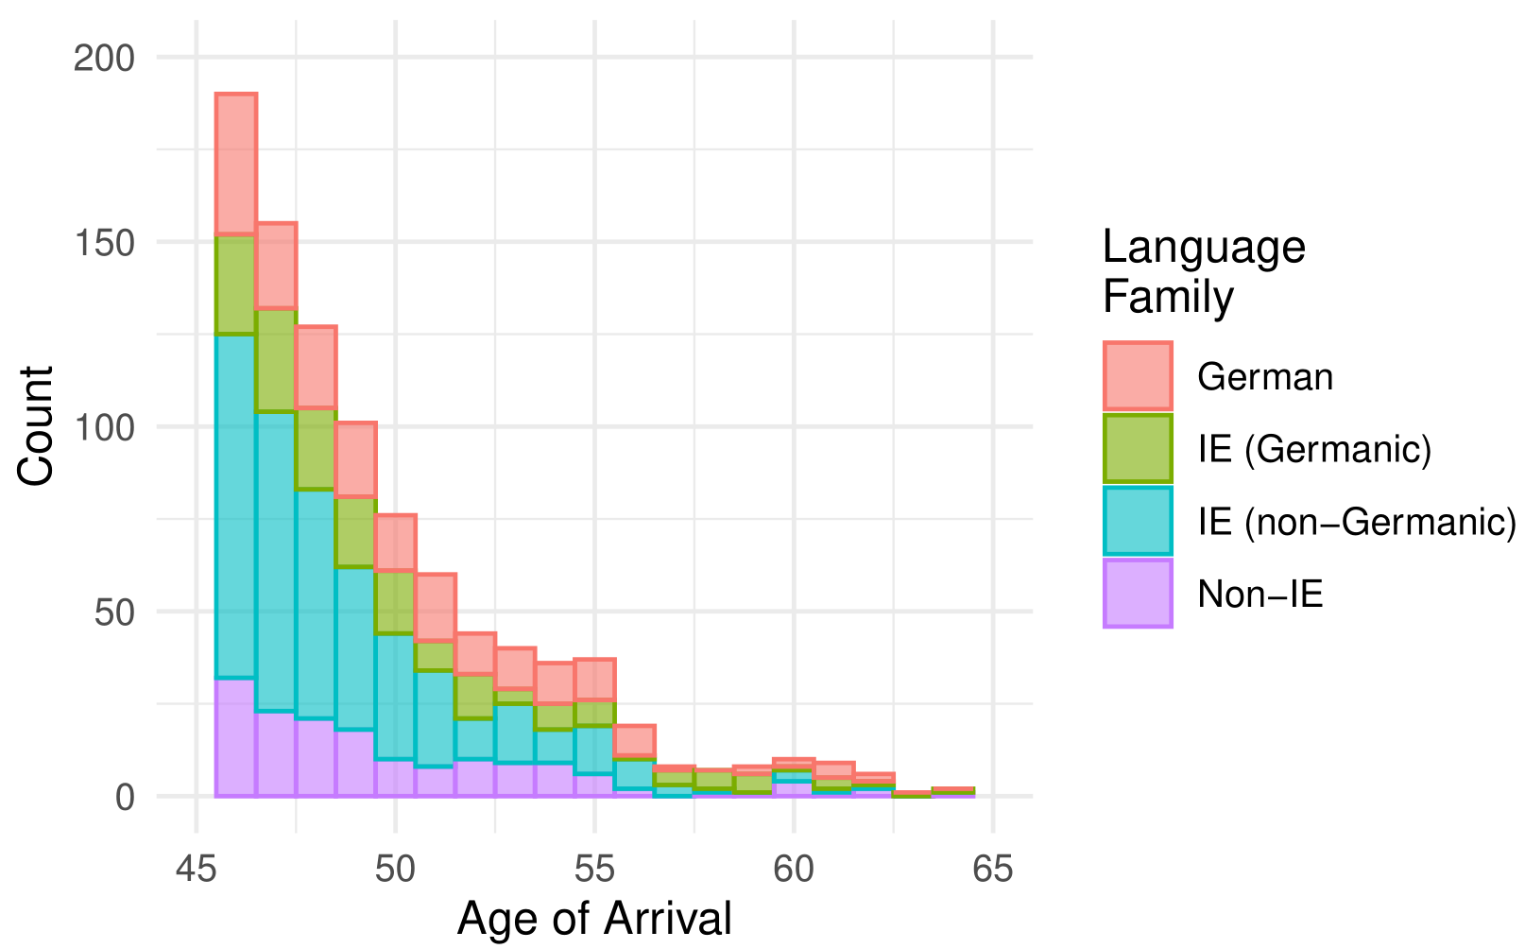
Figure S1. Age of arrival distribution for learners by their language background; IE = Indo-European. The figure shows only learners older than 45 to focus on the ages where fewer scores are available (only a small percentage of all learners).

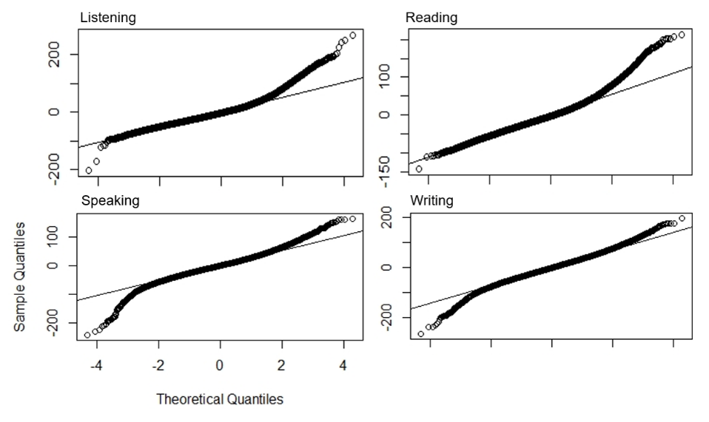
Figure S2: Q-Q plots of residual scores for the speaking, writing, listening and reading models 5.

