Appendix A. Results of mixed ANOVA
Variable | Type III Sum of Squares | Mean Square | F (1.46, 4.05) | p | ηp²
Brain area | 15.91 | 10.90 | 2.69 | .09 | 0.06
Brain area x Group | 29.88 | 20.47 | 5.05 | .02 | 0.10
Error (Region) | 260.15 | 4.05

Appendix B. Scatterplot Between LLAMA_F and the GSI (Word Monitoring Task)
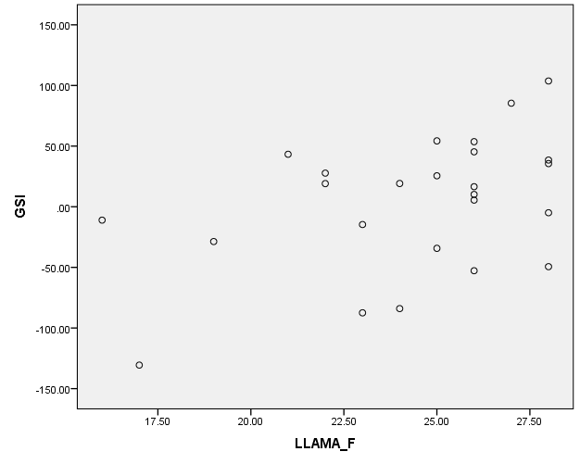

Appendix C. Debriefing Questionnaire Administered after
the Word Monitoring Task
For exploratory purposes, a retrospective questionnaire was administered immediately after the word-monitoring task to examine the participants’ attention allocation during the word-monitoring task, as well as their noticing of any errors in the items presented to them. The respondents were first asked to indicate what was the focus of their attention while listening to and repeating the sentences. They were instructed to choose as many options as they found applicable from the following list: (1) the sentence meaning, (2) the monitoring word in word-monitoring, (3) the sentence form, (4) grammatical errors, and (5) others.
Next, the participants were asked whether they noticed any errors while listening. If they responded affirmatively, they were instructed to respond to the open-ended question “What kinds of grammatical errors did you notice?” as well as indicate how many of the 96 sentences comprising the word-monitoring task they believed contained those errors. The responses provided should, however, be interpreted with caution, given that four target structures were embedded in a cognitively demanding task, making them harder to recall than a single structure.
Results on attention allocation. Table C1 shows the attention allocation during the word-monitoring task, based on the responses provided in the questionnaire. Both L1 and L2 learners focused primarily on meaning and the monitoring word. Only one L2 speaker reported to have paid attention to linguistic form. About 20% of L1 and L2 learners reported to have paid attention to grammatical errors, even though no indication of the presence of grammatical errors in the sentences was given in the word-monitoring task instructions.

Table C1
Attention Allocation During Word-Monitoring Task
 | Meaning | Monitoring Word | Form | Errors | Others
L1 Speakers | 86%  (18/21) | 95%  (20/21) | 0%  (0/21) | 24%  (5/21) | 5%  (1/21)
L2 learners | 96%  (24/25) | 92%  (23/25) | 4%  (1/25) | 20%  (5/25) | 0%  (0/25)

Results on noticing. According to their questionnaire responses, both L1 and L2 learners noticed grammatical errors during the word-monitoring task. Yet, while all 21 L1 speakers noticed the ungrammaticality in the stimuli, only 52% of the L2 learners (13/25) were aware of these errors. When a more stringent noticing criterion (“noticing at the level of understanding”, Schmidt, 2001) was applied, whereby “accurate noticing” was indicated only when participants could explain one or more target structures embedded in the sentences, only 57% of L1 speakers (12/21) and 24% of L2 learners (6/25) were aware of the errors.
These results suggest that even L1 speakers struggled with accurately reporting ungrammatical structures, probably due to the memory decay and lack of metalinguistic awareness (see also Table C2). This observation lends some support for the claim that the adopted measure of awareness was insufficiently sensitive, especially for abstract rules in a complex linguistic task. These results leave too much ambiguity to be used for discussing the extent to which L2 learners were unaware of linguistic errors, because even L1 speakers could not accurately report the results. While, as explained at the outset, the retrospective questionnaire was primarily given for exploratory reasons, the current finding may suggest that administering retrospective questionnaires after L2 grammar tests like the word-monitoring task may not be sufficient if the aim is to elucidate the consciousness of linguistic knowledge (cf., Rebuschat, 2013).
Table C2
Self-reported Noticing of Four Ungrammatical Structures in the Word-Monitoring Task
 | Transitive | Adverbial Clause | Relative Clause | Ni/De
L1 Speakers | 43%  (9/21) | 0%  (0/21) | 5%  (1/21) | 29%  (6/21)
L2 learners | 12%  (3/25) | 0%  (0/25) | 0%  (0/25) | 16%  (4/25)

Comparison between the noticing and the non-noticing groups. Exploratory analyses were conducted to compare the behavioral and neural responses of L2 learners who reported noticing grammatical errors (n = 13) with those who did not (n = 12). For this purpose, a two-sample t-test was conducted on the GSI and the results showed that the noticing group obtained a significantly higher score (M = 31.07, SD = 39.42) than the non-noticing group (M = -26.54, SD = 54.61), t(23) = 3.04, p = .006, d = 1.22, 95% CI of d [0.33, 2.03]. At the neural level, a two-sample t-test implemented in SPM12 was conducted at the whole brain level using each ungrammatical−grammatical contrast in the noticing and non-noticing groups. The findings revealed that, relative to non-noticing group, four brain regions activated more strongly in the noticing group with the liberal statistical threshold (p < .005, uncorrected), namely the left caudate (MNI: x, y, z coordinates = -8, 14, -12), the right hippocampus (26, -10, -10), the right middle/inferior temporal cortex (58, -38, -8), and the right fusiform gyrus (44, -32, -16).

Retrospective Questionnaire (English Translation)
- When you were listening to the sentences, what were you paying attention to? (Please choose as many options as applicable)

Sentence meaning / The target word in word-monitoring / Sentence form / Grammatical errors / Others ( )

- Did you notice any grammatical errors in the sentences you heard?

Yes / No

- If you answered Yes to Question 2, what kinds of errors did you hear?

Types of rules | Examples
1.
2．
3.
4.
5.

- For each type of the grammatical errors you indicated above, please state how many sentences contained them? In this task, there were 96 sentences in total.

Types of rules
1. | About ___ sentences
2. | About ___ sentences
3. | About ___ sentences
4. | About ___ sentences
5. | About ___ sentences

References
Rebuschat, P. (2013). Measuring implicit and explicit knowledge in second language research. Language Learning, 63, 595-626.
Schmidt, R. (2001). Attention. In P. Robinson (Ed.), Cognition and second language instruction (pp. 3-32). New York, NY: Cambridge University Press.

