Complete test battery

1. Remember the form
In this first section, you will find a context written in Chinese and then a sentence in English which summarizes or completes that context. Write the appropriate word in the space using the information given or implicit in the context, so that the sentence in Chinese means the same as the sentence in English. You will only need one word for each question (one word in each blank). The first letter of each word is shown to help you.

Example:
我们游览巴黎时一路登上了埃菲尔铁塔的顶层，但我不敢往下看，因为我太害怕了。
Because I was very scared, the tourist guide told me not to look d___own____.

我们需要告诉孩子们红灯时行人要止步
For their safety, we need to teach the children what it m______________.
上周我买了一副新眼镜，但它们不够结实，很快就碎了。
They weren´t very h______________.
克里斯汀已经在一所学校任职多年。
She has been e______________ for many years now.
我的邻居邀请我去他家喝咖啡。虽然他的咖啡已经做好了，但他还是给我新做了一杯。
My neighbour made a f______________ one for me.
玛利亚一直是个很吸引人、很有个性的女人。认识她的人全都立刻被她吸引。
María has a lot of ch______________ [NOT ‘charisma’].
如果您想在这份期刊上发表您的文章，就需要在每个新段落的首行给出相应的空格。
In order to publish, you need to i______________ each new one.
多年之后，我妈妈终于要在明年圆她环游世界的梦了。
She is going to f______________ that dream next year.
他们说这孩子遗传了妈妈的风度和性情。
He has the ch______________ of his mum.
这场足球赛惨不忍睹，但中锋在下半场射入两粒精彩进球，挽救了自己。
He r______________ himself in the second half of the game.
儿童的成长过程分为不同阶段，成年人应当了解并顺应这些阶段。
There are different stages in their d______________.
我生日那天，我的伴侣让我合上眼睛，用一份美妙的礼物给了我惊喜。
He asked me to c______________ them to give me a surprise.
对我来说夏天是一年里最好的时候，因为我特别喜欢在温暖的天气里去海滩。
It is my favorite s______________.
我现在没有支付给你比赛门票的钱，但我午饭时会去取些钱还给你。
I am going to the b______________ at lunch time.
交通事故的伤员伤得很重。医生已经宣布无力回天，他很快就要死了。
He is in t______________ condition.
我进屋时不得不遮住眼睛，因为灯光太刺眼了。
It was too b______________ for my eyes. [NOT ‘brilliant’].
英国与美国英语存在许多差异，在词汇方面尤其如此。
There is a clear d______________ between them. [NOT ‘difference’ or ‘divergence’].
老师请我关上窗户，因为教室里有穿堂风。
There was a d______________ in the classroom.
我决定明年去爬珠穆朗玛峰。我知道这很困难，但我正加强锻炼。
It is a big ch______________.
纽约城的街道十分开阔。
The streets are very b______________.
约翰不喜欢胡萝卜，他的爸爸只好把胡萝卜擦成丝给他吃。
Juan’s dad always g______________ the carrot for him.

2. Remember the meaning

Choose the correct meaning of the underlined words in italics and circle how sure you are about your answer (1 = not sure at all; 2 = not very sure; 3 = almost sure; 4 = totally sure). See Example 1.
Example 1:
 |  | How sure are you of your answer?
 | He was told to get down.  - Get to a higher place  - Get to a lower place  - Go to the first place  - Go to the last place  - I don’t know | 1 | 2 | 3 | 4

If you don’t know the answer at all, select the “I don’t know” option, and don’t say how secure you are of the answer. See Example 2.

Example 2:
 |  | How sure are you of your answer?
 | I left the plates in the sink.  - Place to show things  - Place to store things  - Place to fix things  - Place to wash things  - I don’t know | 1 | 2 | 3 | 4

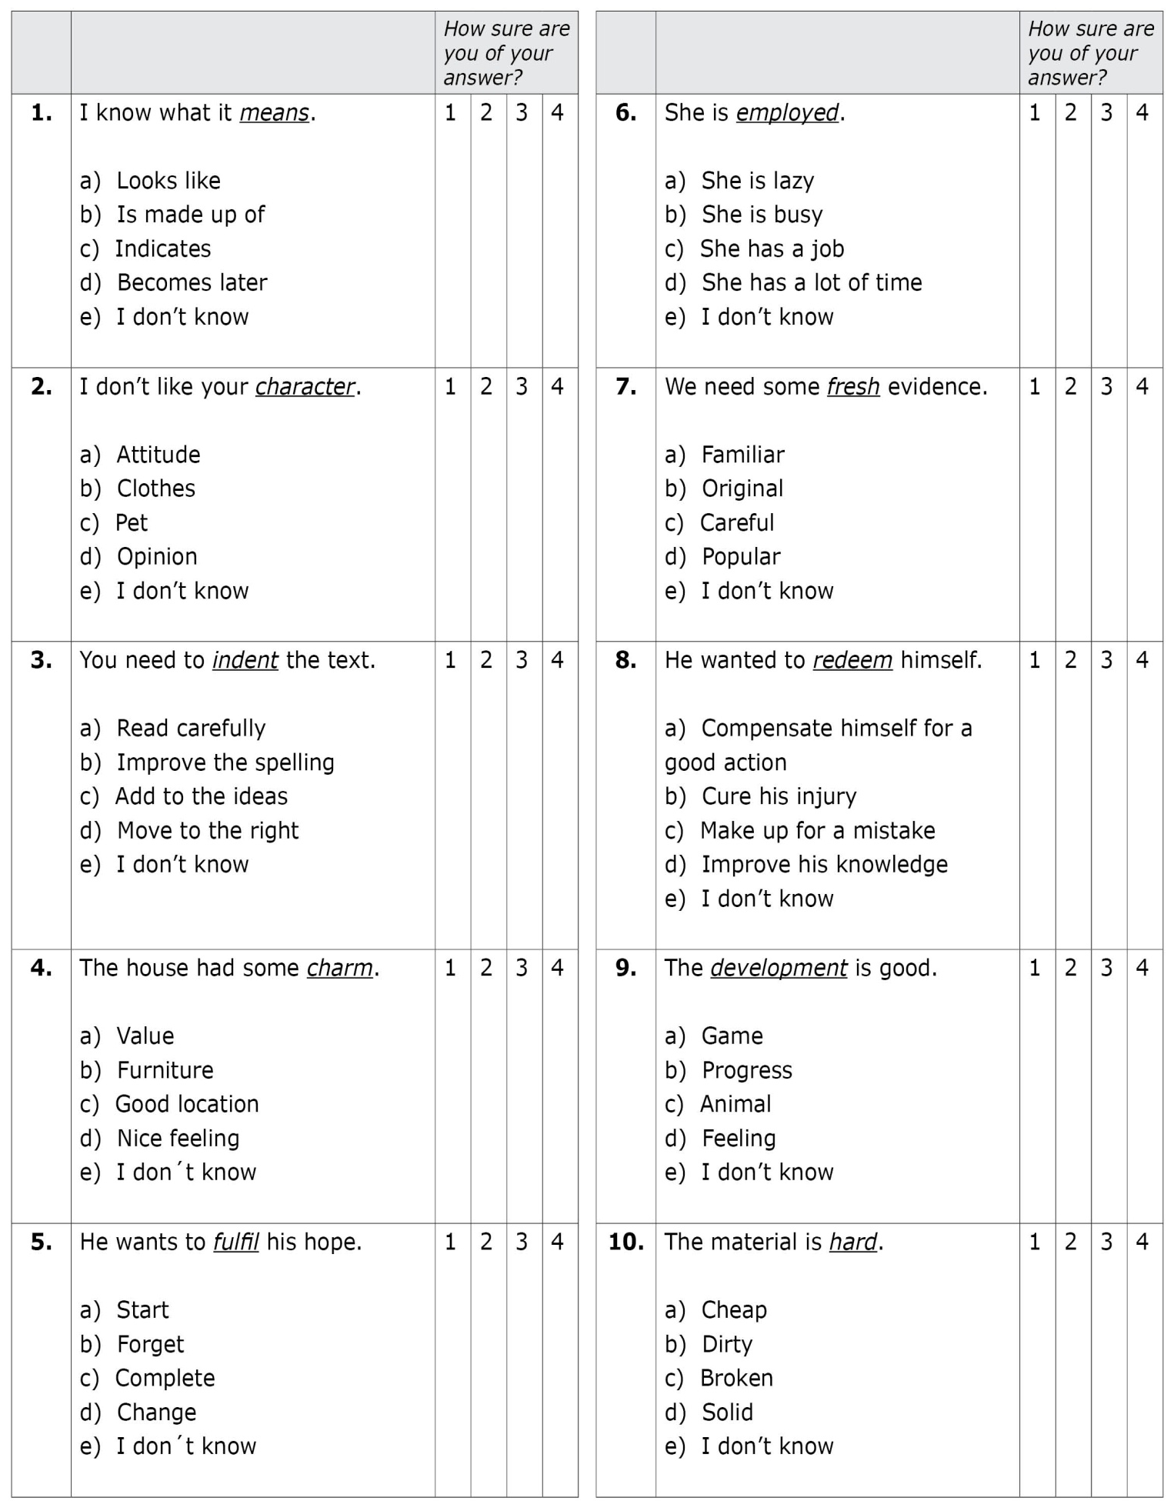
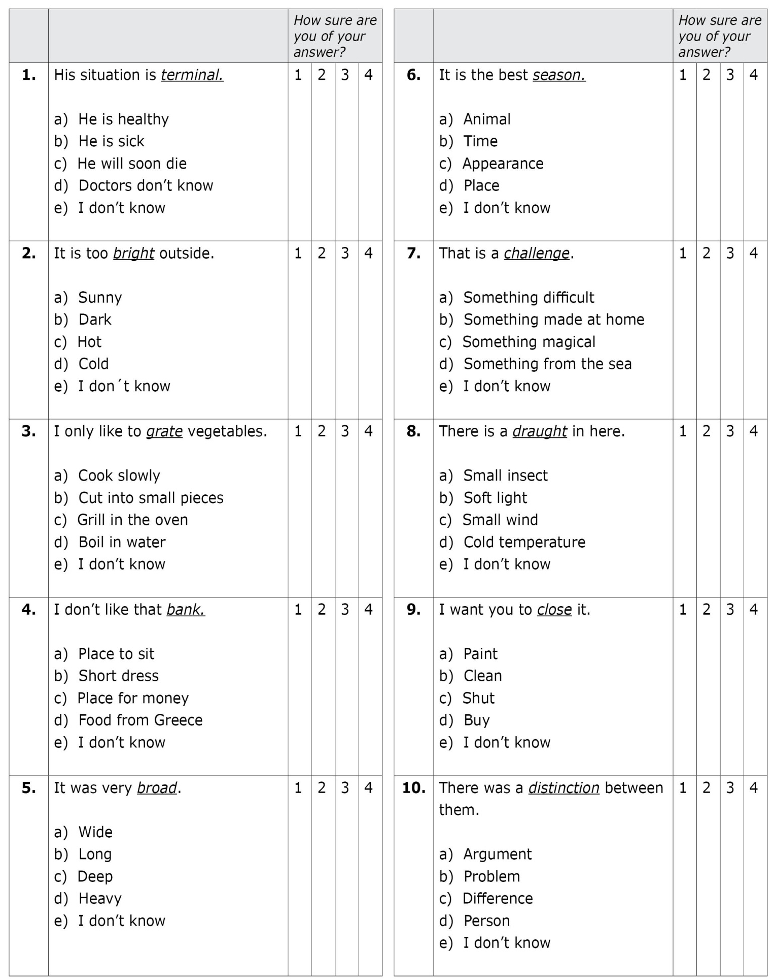

3. Word class formation

Most words in English can be changed into different words with different word classes (this is, noun, verb, adjective or adverb). For example, STIMULATE is a verb in English, but it can be changed into a noun STIMULATION; or an adjective STIMULATING. In this case, STIMULATE does not have an adverb form, but many other words have all the forms. In other cases, the form can be the same in different word classes. For example, BENEFIT is a noun, and BENEFIT is also the verb.

In this section, write the form of the word in italics that corresponds to the noun, verb, adjective and adverb in each sentence. You only need one word for each gap. If there is more than one possibility (e.g., more than one adjective form) you only need to write the one that fits the best in the context. If there is no form for a word class, put an “X” in the blank. Sometimes the word in italics will not need changing, as it might already be correct (such as STIMULATE in the following example). Please, do not guess. If you do not know the answer, just leave it blank.

Example 1:

Stimulate
Noun | A massage gives good ___stimulation_____.
Verb | Massages can _____stimulate_______ tired muscles.
Adjective | A massage has a _____stimulating___ effect.
Adverb | He massaged ___X___.

Example 2:

Benefit
Noun | The __benefit__ of charity centres is happier children.
Verb | Charity centres organize activities that __benefit__ children.
Adjective | Charity centres are __beneficial__.
Adverb | Charity centres organize children´s activities __beneficially__.

Development
Noun | The _______________________ of a person depends on everything that is around them.
Verb | The environment is very important for a person to _____________________ well.
Adjective | The environment is very important in the ______________________ stages of a person.
Adverb | A good environment is _______________________ important for children.

Charm
Noun | The _____________________ of the old cathedral impressed me a lot.
Verb | The old cathedral could _____________________ anyone.
Adjective | The old cathedral was very _____________________.
Adverb | The cathedral was _____________________ designed.

Character
Noun | Politeness is traditionally part of the British _______________________.
Verb | Politeness is said to _______________________ British people.
Adjective | Politeness is traditionally _______________________ of British people.
Adverb | Politeness _______________________ describes British people.

Employ
Noun | I am very happy to gain _____________________ in this company.
Verb | This company will _____________________ 150 people when it grows.
Adjective | My good qualifications made me very __________________ at this company.
Adverb | I want to work _____________________ at this company.

Redeem
Noun | The _____________________ of the winning lottery ticket will pay £1 million.
Verb | He has to _____________________ the winning lottery ticket.
Adjective | The winning lottery ticket is _____________________ in any shop.
Adverb | He got the winning lottery ticket _____________________

Hard
Noun | The _____________________ of steel makes it a good building material.
Verb | The company must _____________________ its steel to make it stronger.
Adjective | Steel is a _____________________ material.
Adverb | The steel company _____________________ produces waste.

Mean
Noun | The _____________________ of these reports is clear; our company is in big trouble.
Verb | These reports _____________________ that some people will be fired.
Adjective | These reports are _____________________, because they will change the company´s future.
Adverb | We can _____________________ compare these reports with last year´s reports, and see that our company is getting worse.

Fulfill
Noun | My job gives me a sense of _____________________.
Verb | My job helps me to _____________________ my hopes.
Adjective | My job is very _____________________.
Adverb | I do my job _____________________.

Indent
Noun | You need to make an _____________________ for each quote.
Verb | You need to _____________________ each quote.
Adjective | You need to edit the _____________________ quotes.
Adverb | You need to edit the quote _____________________.

Fresh
Noun | I enjoy the _____________________ of the early morning in summer days.
Verb | The wind will always ____________________ in the early morning in summer days.
Adjective | The wind is very ____________________ in the early morning in summer days.
Adverb | The wind blows __________________ in the early morning in summer days.

Terminal
Noun | Because of the baby´s disorder, she agreed to the _____________________ of her pregnancy.
Verb | Because of the baby´s disorder, she decided to ______________________ her pregnancy.
Adjective | The baby had a _____________________ disorder.
Adverb | The baby was _____________________ ill.

Challenge
Noun | Finding a cure for cancer is the biggest _______________________ in medicine today.
Verb | Finding a cure for cancer will _______________________ medical researchers for many years.
Adjective | Finding a cure for cancer is a _______________________ job.
Adverb | Medical researchers are working _______________________ to find a cure for cancer.

Grate
Noun | Our ___________________ broke, so I had to buy a new one for the carrots.
Verb | Carrots taste better when you __________________ them on top of a salad.
Adjective | _____________________ carrots are good on top of a salad.
Adverb | I always serve the carrots _____________________ for salads.

Bright
Noun | My mum will like the _____________________ of my living room.
Verb | The large number of lights will _____________________ the living room.
Adjective | My mum will like my _____________________ living room.
Adverb | My living room will be lit _____________________.

Distinction
Noun | Marcos and Pedro are twins; there is almost no _____________________ between them.
Verb | It is very difficult to _____________________ between Marcos and Pedro, because they are very similar.
Adjective | There is no _____________________ feature between Marcos and Pedro.
Adverb | Nobody can _____________________ say who is Marcos and who is Pedro.

Season
Noun | In this country, each _____________________ is clearly different.
Verb | In this country, the temperature variations _____________________ clearly.
Adjective | In this country, the _____________________ temperature variations are clearly different.
Adverb | In this country, the temperature variations occur _____________________.

Close
Noun | The _____________________ of my children’s school will happen in July.
Verb | My children’s school will _____________________ for ever in July.
Adjective | My children’s school will be _____________________ from August on.
Adverb | My children’s school will stop working _____________________.

Broad
Noun | The _____________________ of the road was impressive.
Verb | We didn’t need to _____________________ the road; it was already wide enough.
Adjective | When we arrived, we found that the road was very ____________________.
Adverb | The road extended _____________________ in front of us.

Draught
Noun | The window was open and there was a ____________________ in the room.
Verb | I opened the window to_____________________ the room.
Adjective | The room was _____________________ because the window was open.
Adverb | I opened the window _____________________.

Bank
Noun | My family always goes to the same _____________________.
Verb | My family likes to _____________________ with just one company.
Adjective | My mum is a very _____________________ Hollywood star.
Adverb | My mum always goes to that company because the interest is _____________________ high.

4. Word class recognition

In this part, given the word in bold, choose the appropriate word (form) that corresponds to the noun, verb, adjective and adverb in each sentence. Choose the letter from the options (a-h) that represents that word and write it in the blank.
There are some incorrect forms among the options given, so be careful. In Example 1, stimulize, stimulatement, stimulaty and stimulatable are words that do not exist in English. Some words may not have a specific form for one or more of their word classes (for example, not having a form for the verb). If there is no form (X), choose the option “h”. Then, select how sure you are of your answers from 1 to 4 (1 = not sure at all; 2 = not very sure; 3 = almost sure; 4 = totally sure). Please, do not guess. If you do not know the answer, just leave it blank.
a. Stimulize | b. Stimulate | c. Stimulaty | d. Stimulating
e. Stimulatement | f. Stimulation | g. Stimulatable | h. X

Example 1:

Stimulate

 |  | How sure are you of your answers?
Noun | A massage gives good ___f_____. | 1 | 2 | 3 | 4
Verb | Massages can _____b_______ tired muscles. | 1 | 2 | 3 | 4
Adjective | A massage has a _____d___ effect. | 1 | 2 | 3 | 4
Adverb | He massaged ___h___. | 1 | 2 | 3 | 4

In some cases, you may need to use the same form two or more times. In the following example, the form “benefit” can be used both as a noun and as a verb.

Example 2:
a. Benefit | b. Beneficially | c. Benefate | d. Benefist
e. Beneficial | f. Benefary | g. Benefarily | h. X

Benefit
 |  | How sure are you of your answers?
Noun | Child activities have the __a__ of support from charity centers. | 1 | 2 | 3 | 4
Verb | Charity centers support activities that __a__ children. | 1 | 2 | 3 | 4
Adjective | Charity centers are __e__. | 1 | 2 | 3 | 4
Adverb | Charity centers support children activities __b__. | 1 | 2 | 3 | 4

Fresh
a. Freshen | b. Fresh | c. Freshable | d. Freshness
e. Freshment | f. Freshate | g. Freshly | h. X

 |  | How sure are you of your answers?
Noun | I enjoy the ____________ of the early morning in summer days. | 1 | 2 | 3 | 4
Verb | The wind will always ____________ in the early morning in summer days. | 1 | 2 | 3 | 4
Adjective | The wind is very ____________ in the early morning in summer days. | 1 | 2 | 3 | 4
Adverb | The wind blows ____________ in the early morning in summer days. | 1 | 2 | 3 | 4

Indent

a. Indentment | b. Indentive | c. Indentify | d. Indentedly
e. Indented | f. Indent | g. Indentively | h. X
 |  | How sure are you of your answers?
Noun | You need to make an ____________ for each quote. | 1 | 2 | 3 | 4
Verb | You need to ____________ each quote. | 1 | 2 | 3 | 4
Adjective | You need to edit the ____________ quotes. | 1 | 2 | 3 | 4
Adverb | You need to edit the quote ____________. | 1 | 2 | 3 | 4

Character

a. Characterous | b. Characterness | c. Character | d. Characterify
e. Characteristically | f. Characteristic | g. Characterize | h. X
 |  | How sure are you of your answers?
Noun | Politeness is traditionally part of the British ____________. | 1 | 2 | 3 | 4
Verb | Politeness is said to ____________ British people. | 1 | 2 | 3 | 4
Adjective | Politeness is traditionally ____________ of British people. | 1 | 2 | 3 | 4
Adverb | Politeness ____________ describes British people. | 1 | 2 | 3 | 4

Hard
a. Hard | b. Hardful | c. Hardness | d. Hardify
e. Harden | f. Hardly | g. Hardity | h. X

 |  | How sure are you of your answers?
Noun | The ____________ of steel makes it a good building material. | 1 | 2 | 3 | 4
Verb | The company must ____________ its steel to make it stronger. | 1 | 2 | 3 | 4
Adjective | Steel is a ____________ material. | 1 | 2 | 3 | 4
Adverb | The steel company ____________ produces waste. | 1 | 2 | 3 | 4

a. Redeem | b. Redeemit | c. Redeemable | d. Redeemably
e. Redemption | f. Redeemity | g. Redeemal | h. X
Redeem

 |  | How sure are you of your answers?
Noun | The ____________ of the winning lottery ticket will pay £1 million. | 1 | 2 | 3 | 4
Verb | He has to ____________ the winning lottery ticket. | 1 | 2 | 3 | 4
Adjective | The winning lottery ticket is ____________ in any shop. | 1 | 2 | 3 | 4
Adverb | He got the winning lottery ticket ____________. | 1 | 2 | 3 | 4

Development
a. Develop | b. Developate | c. Developmental | d. Developable
e. Developmentally | f. Development | g. Developness | h. X

 |  | How sure are you of your answers?
Noun | The ____________ of a person depends on everything that is around them. | 1 | 2 | 3 | 4
Verb | The environment is very important for a person to ____________ well. | 1 | 2 | 3 | 4
Adjective | The environment is very important in the ____________ stages of a person. | 1 | 2 | 3 | 4
Adverb | A good environment is ____________ important for children. | 1 | 2 | 3 | 4

Employ

a. Employ | b. Employance | c. Employable | d. Employably
e. Employment | f. Employify | g. Employal | h. X
 |  | How sure are you of your answers?
Noun | I am very happy to gain ____________ in this company. | 1 | 2 | 3 | 4
Verb | This company will ____________ 150 people when it grows. | 1 | 2 | 3 | 4
Adjective | My good qualifications made me very ____________ at this company. | 1 | 2 | 3 | 4
Adverb | I want to work ____________ at this company. | 1 | 2 | 3 | 4

Charm
a. Charmness | b. Charmate | c. Charming | d. Charm
e. Charmfully | f. Charmingly | g. Charmful | h. X

 |  | How sure are you of your answers?
Noun | The ____________ of the old cathedral impressed me a lot. | 1 | 2 | 3 | 4
Verb | The old cathedral could ____________ anyone. | 1 | 2 | 3 | 4
Adjective | The old cathedral was very ____________. | 1 | 2 | 3 | 4
Adverb | The cathedral was ____________ designed. | 1 | 2 | 3 | 4

Fulfil
a. Fulfilingly | b. Fulfilness | c. Fulfilize | d. Fulfiling
e. Fulfil | f. Fulfilment | g. Fulfilish | h. X

 |  | How sure are you of your answers?
Noun | My job gives me a sense of ____________. | 1 | 2 | 3 | 4
Verb | My job helps me to ____________ my hopes. | 1 | 2 | 3 | 4
Adjective | My job is very ____________. | 1 | 2 | 3 | 4
Adverb | I do my job ____________. | 1 | 2 | 3 | 4

Mean

a. Meaningable | b. Meaningful | c. Meaningness | d. Meaning
e. Mean | f. Meanify | g. Meaningfully | h. X
 |  | How sure are you of your answers?
Noun | The ____________ of these reports is clear; our company is in big trouble. | 1 | 2 | 3 | 4
Verb | These reports ____________ that some people will be fired. | 1 | 2 | 3 | 4
Adjective | These reports are ____________, because they will change the company´s future. | 1 | 2 | 3 | 4
Adverb | We can ____________ compare these reports with last year´s reports, and see that our company is getting worse. | 1 | 2 | 3 | 4

Bright
a. Brightly | b. Bright | c. Brightify | d. Brighten
e. Brightness | f. Brightment | g. Brightful | h. X

 |  | How sure are you of your answers?
Noun | My mum will like the ____________ of my living room. | 1 | 2 | 3 | 4
Verb | The large number of lights will ____________ the living room. | 1 | 2 | 3 | 4
Adjective | My mum will like my ____________ living room. | 1 | 2 | 3 | 4
Adverb | My living room will be lit ____________. | 1 | 2 | 3 | 4

Close
a. Closen | b. Closure | c. Close | d. Closed
e. Closement | f. Closive | g. Closely | h. X

 |  | How sure are you of your answers?
Noun | The _________________ of my children’s school will happen in July. | 1 | 2 | 3 | 4
Verb | My children’s school will _________________ for ever in July. | 1 | 2 | 3 | 4
Adjective | My children’s school will be _________________ from August on. | 1 | 2 | 3 | 4
Adverb | My children’s school will stop working _________________. | 1 | 2 | 3 | 4

Draught

a. Draughty | b. Draughtness | c. Draughted | d. Draught
e. Draughtedly | f. Draughtify | g. Draughtily | h. X
 |  | How sure are you of your answers?
Noun | The window was open and there was a ____________ in the room. | 1 | 2 | 3 | 4
Verb | I opened the window to ____________ the room. | 1 | 2 | 3 | 4
Adjective | The room was ____________ because the window was open. | 1 | 2 | 3 | 4
Adverb | I opened the window ____________. | 1 | 2 | 3 | 4

Broad

a. Breadth | b. Broadment | c. Broaden | d. Broadful
e. Broadly | f. Broadify | g. Broad | h. X
 |  | How sure are you of your answers?
Noun | The ____________ of the road was impressive. | 1 | 2 | 3 | 4
Verb | We didn’t need to ____________ the road; it was already wide enough. | 1 | 2 | 3 | 4
Adjective | When we arrived, we found that the road was very ____________. | 1 | 2 | 3 | 4
Adverb | The road extended ____________ in front of us. | 1 | 2 | 3 | 4

a. Grate | b. Grated | c. Grater | d. Gratedly
e. Grateful | f. Grateness | g. Gratate | h. X
Grate

 |  | How sure are you of your answers?
Noun | Our ____________ broke, so I had to buy a new one for the carrots. | 1 | 2 | 3 | 4
Verb | Carrots taste better when you ____________ them on top of a salad. | 1 | 2 | 3 | 4
Adjective | ____________ carrots are good on top of a salad. | 1 | 2 | 3 | 4
Adverb | I always serve the carrots ____________ for salads. | 1 | 2 | 3 | 4

Season

a. Season | b. Seasonize | c. Seasonally | d. Seasonation
e. Seasonate | f. Seasonal | g. Seasony | h. X
 |  | How sure are you of your answers?
Noun | In this country, each ___________ is clearly different. | 1 | 2 | 3 | 4
Verb | In this country, the temperature variations ___________ clearly. | 1 | 2 | 3 | 4
Adjective | In this country, the ____________ temperature variations are clearly different. | 1 | 2 | 3 | 4
Adverb | In this country, the temperature variations occur ___________. | 1 | 2 | 3 | 4

Challenge

a. Challengize | b. Challenge | c. Challenging | d. Challengefully
e. Challengingly | f. Challengeful | g. Challengeship | h. X

 |  | How sure are you of your answers?
Noun | Finding a cure for cancer is the biggest ____________ in medicine today. | 1 | 2 | 3 | 4
Verb | Finding a cure for cancer will ____________ medical researchers for many years. | 1 | 2 | 3 | 4
Adjective | Finding a cure for cancer is a ____________ job. | 1 | 2 | 3 | 4
Adverb | Medical researchers are working ____________ to find a cure for cancer. | 1 | 2 | 3 | 4

Bank
a. Bankness | b. Bankate | c. Bankably | d. Bank
e. Bankable | f. Bankedly | g. Bankful | h. X

 |  | How sure are you of your answers?
Noun | My family always goes to the same ____________. | 1 | 2 | 3 | 4
Verb | My family likes to ____________ with just one company. | 1 | 2 | 3 | 4
Adjective | My mum is a very ____________ Hollywood star. | 1 | 2 | 3 | 4
Adverb | My mum always goes to that company because the interest is ____________ high. | 1 | 2 | 3 | 4

Terminal

a. Terminal | b. Terminance | c. Terminous | d. Terminize
e. Terminate | f. Terminally | g. Termination | h. X
 |  | How sure are you of your answers?
Noun | Because of the baby´s disorder, she agreed to the _____________ of her pregnancy. | 1 | 2 | 3 | 4
Verb | Because of the baby´s disorder, she decided to ____________ her pregnancy. | 1 | 2 | 3 | 4
Adjective | The baby had a ____________ disorder. | 1 | 2 | 3 | 4
Adverb | The baby was ____________ ill. | 1 | 2 | 3 | 4

Distinction
a. Distinctly | b. Distinctable | c. Distinctify | d. Distinguish
e. Distinctment | f. Distinction | g. Distinct | h. X

 |  | How sure are you of your answers?
Noun | Marcos and Pedro are twins; there is almost no ____________ between them. | 1 | 2 | 3 | 4
Verb | It is very difficult to ____________ between Marcos and Pedro, because they are very similar. | 1 | 2 | 3 | 4
Adjective | There is no ____________ feature between Marcos and Pedro. | 1 | 2 | 3 | 4
Adverb | Nobody can ____________ say who is Marcos and who is Pedro. | 1 | 2 | 3 | 4

5. Polysemy recall

A lot of words in English are polysemous, that means, they have several meanings. All the words in this section are polysemous, and thus have different meanings. Some of these meanings are clearer than others.
To answer this part of the test you need to provide information about all the different meanings you know of the words in italics. You can give a definition, or a translation, or synonyms, or opposites, or use them in a correct sentence in that context, or any information that clearly shows that you know the different meanings. In order to help you, there are some prompts for each meaning written in brackets. But be careful, if you only provide a translation of the clues given, the answer will be considered incorrect.

Example:
Down
(Adverb= position/level): ______向下/ they walked down the mountain______________________
(Adjective= feeling)_________ 低落/feeling unhappy, without energy_______________
(Noun= birds/hair)________ 羽绒/soft feathers of a bird, or soft hair_____________

Charm
(Noun= kind of quality)_________________________________________________________
(Noun= object)_______________________________________________________________
(Verb/Noun= fairy tale)_________________________________________________________

Hard
(Adjective= hard table)_________________________________________________________
(Adjective= hard exam)________________________________________________________
(Adjective= with effort)_________________________________________________________

Fulfil
(Verb= fulfil a wish)___________________________________________________________
(Verb= obligation)_____________________________________________________________
(Verb= happy)________________________________________________________________

Fresh
(Adjective= ideas)_____________________________________________________________
(Adjective= weather)__________________________________________________________
(Adjective= water)____________________________________________________________

Character
(Noun= describing someone)____________________________________________________
(Noun= in a story)_____________________________________________________________
(Noun= character in writing)_____________________________________________________

Redeem
(Verb= done to past bad behaviour)_______________________________________________
(Verb= done to a coupon)_______________________________________________________
(Verb= when you are in debt)____________________________________________________

Development
(Noun= of a person)___________________________________________________________
(Noun= of new things)_________________________________________________________
(Noun= houses)______________________________________________________________

Employ
(Verb=to pay for something)____________________________________________________
(Verb= for a purpose)__________________________________________________________
(Verb= employ time)___________________________________________________________

Mean
(Verb= describing something)____________________________________________________
(Noun= maths)_______________________________________________________________
(Adjective= attitude)__________________________________________________________

Indent
(Verb= when writing)__________________________________________________________
(Verb= indent for equipment)____________________________________________________
(Noun= in a car accident)_______________________________________________________

Terminal
(Adjective= illness)____________________________________________________________
(Noun= train)________________________________________________________________
(Noun= electronic machine)_____________________________________________________

Grate
(Verb= cooking)______________________________________________________________
(Verb= teeth)________________________________________________________________
(Verb= how loud people make you feel)____________________________________________

Challenge
(Noun= describing a situation)___________________________________________________
(Verb= done in a competition)___________________________________________________
(Verb= to challenge the truth)___________________________________________________

Distinction
(Noun= distinction between two things)____________________________________________
(Noun= at university)__________________________________________________________
(Noun= something special)______________________________________________________

Season
(Noun= year)_________________________________________________________________
(Verb= cooking)______________________________________________________________
(Noun= animals in season)______________________________________________________

Close
(Verb= door)_________________________________________________________________
(Verb= a meeting)_____________________________________________________________
(Adjective= a close place)_______________________________________________________

Bank
(Noun= money)_______________________________________________________________
(Noun= water)________________________________________________________________
(Verb=plane)_________________________________________________________________

Draught
(Noun= wind)________________________________________________________________
(Noun= way of serving drinks)___________________________________________________
(Noun= game)________________________________________________________________

Bright
(Adjective= light)_____________________________________________________________
(Adjective= learning)__________________________________________________________
(Adjective= future of something)_________________________________________________

Broad
(Adjective= describing a river)___________________________________________________
(Adjective= variety)___________________________________________________________
(Adjective= way of speaking)____________________________________________________

6. Collocation recall
Some words occur together in a language more common than others. These are called collocations. In this section, you will find a context in Chinese and then a sentence in English. Write a word in the gap using the information given or implicit in the context, so that the word makes sense in the context and sounds natural together with the word underlined and in italics. You will only need one word for each question (one word in each blank), and the first letter of each word is shown to help you.

Example 1:
我的老师让我镇定下来。
The teacher told me to calm d_own_______ because I was really stressed.

Example 2:
陷入麻烦。
When Peter´s dad found out he had broken the TV, he told him: “you are in s_ erious__ trouble”.

在正文开始处缩进。
When writing, you should indent the first l________________ of a text.
他们的爸爸保证说会带他们去影院，但最终还是没带他们去。
Their dad did not fulfill his p________________ to take them to the movies.
给环境通通风。
It was too warm in the classroom, so I asked the teacher to let some fresh a________________ into the classroom.
提倡好习惯，以使环境长期保持良好。
Factories and big companies need to take more care about the environment and promote s________________ development.
每天只工作几小时。
He is only employed p_____________ -_____________ in the company, just 6 hours per week.
9.25是成绩的平均值。
The mean s________________ of all her tests in the competition was 9.25.
艰巨的任务。
Taking care of babies is very hard w________________.
最重要的角色。
There are three m________________ characters in this film: the mother, the daughter and her brother.
如果没有了它，你会觉得不受保护、容易发生不幸的事。
He didn’t get on the train because he had forgotten his l________________ charm and felt afraid of something happening.
挽救当前的形势，以让自己重新受到欢迎，得到尊重。
Pedro didn’t have many friends because he had stolen some money. Eventually, he managed to make up for his mistake and redeem his r________________.
可供选择的专业很多。
This University offers a broad r________________ of degrees, including sciences, arts and law.
玛塔和安德莉亚一直都很亲密。
Marta and Andrea are very close f________________. They are always together.
它在酒吧里就是这样卖给顾客的。人们觉得这么喝它味道比较好。
Every time we go to a pub, my cousin orders draught b________________, because he doesn’t like the bottled one.
向银行要钱。
Pedro asked for a bank l________________ to get some money to expand his own business.
迎难而上。
Most young people today have to f________________ the great challenge of going to university and study a degree.
让我们觉得快乐的、生动的色彩。
I like the paintings with a lot of bright c________________ in them. They make me feel happy.
找出不同。
In teaching, it is important to m________________ a distinction between oral and written language.
导致人死亡的健康问题。
There is a lot of research in medicine to fight against terminal d________________.
最多人选择出游的时期。
When you plan to go on holidays you should bear in mind that hotels are always more expensive in p________________ season.
买回一整块来在家擦成丝或者小条要便宜些。
I always grate the ch________________ at home to put on the pizzas.

7. Polysemy recognition
The words in italics in this section have different meanings. Each word is presented in 5 different situations, with a different meaning in each situation. Choose the sentences which are correct. Some are correct and some are not correct, but for each word there is a minimum of 1 and a maximum of 3 correct sentences.
Then, select how sure you are of your answers from 1 to 4 (1 = not sure at all; 2 = not very sure; 3 = almost sure; 4 = totally sure). Please, do not guess. If you do not know any meaning, select the “I don’t know” option, and do not circle how sure you are of your answer.

Example:
 | How sure are you of your answer?
Down  - I bent down to look under the table.  - He has been down all week.  - The down of my car broke.  - I wear down jackets all winter.  - I have a down on my guitar.  - I don’t know | 1  1  1  1  1 | 2  2  2  2  2 | 3  3  3  3  3 | 4  4  4  4  4

 |  | How sure are you of your answer?
 | Fresh  - After I had finished the work, my boss gave me fresh instructions.  - He bought a totally fresh car.  - The window glass was very fresh that morning.  - These plants only survive in fresh water.  - The mornings are always very fresh in the mountains.  - I don’t know. | 1  1  1  1  1 | 2  2  2  2  2 | 3  3  3  3  3 | 4  4  4  4  4
 | Redeem  - She decided to volunteer to redeem herself.  - The money required to redeem the mortgage was very high.  - The ticket can be redeemed at any store of this shopping centre.  - I bought myself a coffee to redeem my progress.  - The doctor told her to rest in order to redeem the pain.  - I don’t know | 1  1  1  1  1 | 2  2  2  2  2 | 3  3  3  3  3 | 4  4  4  4  4
 | Employ  - Matt has been employed for over 2 years now.  - She employs her days in gardening and playing cards.  - The purpose was to employ to his boss about his low salary.  - They have employed new methods in their research.  - Workers employ in the school from 9 to 5 pm, Monday to Friday.  - I don´t know. | 1  1  1  1  1 | 2  2  2  2  2 | 3  3  3  3  3 | 4  4  4  4  4
 | Fulfil  - You need a black pen to fulfil the form.  - The building does not fulfil any more people.  - You need to fulfil your goals to stay happy.  - The policy does not fulfil any need in the community.  - Her daughter fulfils her.  - I don´t know | 1  1  1  1  1 | 2  2  2  2  2 | 3  3  3  3  3 | 4  4  4  4  4
 | Charm  - Joe´s charm was scared and run away.  - Many people carry charms for protection against evil.  - The town´s charm made me want to return soon.  - The rude charm wasn´t allowed in the room.  - The story says the bad witch used magic to charm the children.  - I don’t know | 1  1  1  1  1 | 2  2  2  2  2 | 3  3  3  3  3 | 4  4  4  4  4
 | Indent  - The doctor had to indent our meeting to the following week.  - The Government will indent for new mobile phones next month.  - There was a small indent on the wall where I shot it.  - It took me very long to indent all the paragraphs.  - It is my turn to indent for drinks at the pub.  - I don’t know | 1  1  1  1  1 | 2  2  2  2  2 | 3  3  3  3  3 | 4  4  4  4  4
 | Mean  - The dog has a mean number of legs.  - He is very mean to his brother.  - The red sign means ‘Stop’.  - In mathematics, the mean is the same as the average.  - The chair means to be in the corner.  - I don’t know | 1  1  1  1  1 | 2  2  2  2  2 | 3  3  3  3  3 | 4  4  4  4  4
 | Character  - This is a character in Chinese writing.  - With the new head teacher, the character of the school has changed completely.  - Her character was taken to the doctors.  - The best character of the play died very early.  - The character tastes delicious when my mother cooks it.  - I don’t know | 1  1  1  1  1 | 2  2  2  2  2 | 3  3  3  3  3 | 4  4  4  4  4
 | Hard  - No matter how hard I tried, I couldn’t finish the book.  - Diamonds are very hard.  - We bought an original hard cat from India.  - When you are an adult you have to make hard decisions.  - The colour of the dress is hard for the shoes.  - I don’t know | 1  1  1  1  1 | 2  2  2  2  2 | 3  3  3  3  3 | 4  4  4  4  4
 | Development  - Marcos forgot his development in the supermarket.  - The film is about the development of music in the last 50 years.  - She is working on the development of a new computer.  - I sold the land for a new building development.  - Please, go and check the development of my phone charging.  - I don’t know | 1  1  1  1  1 | 2  2  2  2  2 | 3  3  3  3  3 | 4  4  4  4  4
 | Bank  - We put some money into the bank every week.  - I forgot the bank of the car at the petrol station.  - These flowers generally grow on the bank of the river.  - The helicopter started to bank to the left.  - She always buys a bank of books when she goes to the book shop.  - I don’t know | 1  1  1  1  1 | 2  2  2  2  2 | 3  3  3  3  3 | 4  4  4  4  4
 | Grate  - The potatoes need to be grated into a mixing bowl.  - Grated music is used in hospitals to calm down patients and relatives.  - Mary always grates her teeth when she is angry.  - Cook the grate into the microwave for 10 minutes.  - The way he talks about himself really grates on me.  - I don´t know | 1  1  1  1  1 | 2  2  2  2  2 | 3  3  3  3  3 | 4  4  4  4  4
 | Bright  - The snow was bright on that winter day.  - He was surprised reading the bright news in the magazine.  - His daughter is considered to be very bright.  - Things will be bright for the company next year.  - The boss felt very proud of his bright situation.  - I don´t know | 1  1  1  1  1 | 2  2  2  2  2 | 3  3  3  3  3 | 4  4  4  4  4
 | Terminal  - The tree was terminal because of the high temperatures.  - His condition was terminal.  - This bus will take you to the terminal.  - Nowadays we cannot live without computer terminals.  - We always meet at the school´s terminal.  - I don’t know | 1  1  1  1  1 | 2  2  2  2  2 | 3  3  3  3  3 | 4  4  4  4  4
 | Season  - The four seasons are winter, spring, summer and autumn.  - The car´s season breaks very often.  - Their dog is in season and can´t go out.  - It is important to check the season of your computer once a year.  - I forgot to season the fish with salt and pepper.  - I don´t know | 1  1  1  1  1 | 2  2  2  2  2 | 3  3  3  3  3 | 4  4  4  4  4
 | Broad  - I went to the supermarket and bought broad fruit.  - The bridge was broad and had plenty of space.  - The show was created for a broad public.  - The light in the city was very broad.  - His family have a broad accent.  - I don’t know | 1  1  1  1  1 | 2  2  2  2  2 | 3  3  3  3  3 | 4  4  4  4  4
 | Draught  - I prefer to drink it on draught, not from a bottle.  - I am very good at playing draughts.  - She took a draught of my sandwich.  - There was a draught in the director’s computer.  - This plant does not like cold draughts in the room.  - I don’t know | 1  1  1  1  1 | 2  2  2  2  2 | 3  3  3  3  3 | 4  4  4  4  4
 | Challenge  - Starting a new company is a big challenge for me.  - Most people now challenge the decisions of the politicians.  - The fisherman caught this challenge in the morning.  - Gary will challenge Matt to a game of tennis.  - She wants me to challenge her a motorbike for her birthday.  - I don’t know | 1  1  1  1  1 | 2  2  2  2  2 | 3  3  3  3  3 | 4  4  4  4  4
 | Distinction  - I bought my bag’s distinction in a street market in the USA.  - My dad had the distinction to celebrate my birthday at the beach.  - I can’t see the distinction between the two phones.  - She got a distinction for her paper.  - He has the distinction of being the tallest person in the world.  - I don’t know | 1  1  1  1  1 | 2  2  2  2  2 | 3  3  3  3  3 | 4  4  4  4  4
 | Close  - I have to return the book today because the library will close tomorrow.  - The politician closed the discussion saying thank you to the presenter.  - On our last holiday, we stayed at a hotel that was very close to the beach.  - She got up to close the TV.  - There is always a close atmosphere in the countryside.  - I don’t know | 1  1  1  1  1 | 2  2  2  2  2 | 3  3  3  3  3 | 4  4  4  4  4

8. Collocation recognition

In this final section of the test you need to choose the word that fits the best in the gap, the word that occurs more naturally in the context with the word underlined and in italics. All the options are possible to a greater or lesser degree, but there is only one best answer. Choose the most natural one, the best collocation of the word underlined and in italics.

Example:
 | How sure are you of your answer?
I left the building because I didn´t want to _________ any trouble.  - Make  - Get  - Create  - Cause  - I don´t know | 1 | 2 | 3 | 4

Then, select how sure you are of your answers from 1 to 4 (1 = not sure at all; 2 = not very sure; 3 = almost sure; 4 = totally sure). Please, do not guess. If you do not know the answer, just leave it blank.

 |  | How sure are you of your answer?
 | She enjoys a lot of free time because she is only employed __________.  - Part-time  - Part-hours  - Short-time  - Some-days  - I don´t know | 1 | 2 | 3 | 4
 | The Government party did not fulfill their __________.  - Words  - Agreements  - Promises  - Speeches  - I don´t know | 1 | 2 | 3 | 4
 | He got a very high mean __________.  - Result  - Mark  - Number  - Score  - I don’t know | 1 | 2 | 3 | 4
 | After his big mistake, my cousin tried very hard to redeem his _____________.  - Popularity  - Respect  - Reputation  - Blame  - I don’t know | 1 | 2 | 3 | 4
 | __________ development is important.  - Working  - Supportable  - Green  - Sustainable  - I don’t know | 1 | 2 | 3 | 4
 | A text is easier to read if you indent the first __________.  - Line  - Word  - Number  - Letter  - I don’t know | 1 | 2 | 3 | 4
 | It was hard __________.  - Money  - Work  - Traffic  - News  - I don’t know | 1 | 2 | 3 | 4
 | She is the __________ character in the book.  - Important  - Chief  - Main  - Special  - I don’t know | 1 | 2 | 3 | 4
 | Some people believe in __________ charms.  - Power  - Lucky  - Healthy  - Religious  - I don’t know | 1 | 2 | 3 | 4
 | After a day in the office, I need to go outside for some fresh _____________.  - Wind  - Sun  - Weather  - Air  - I don’t know | 1 | 2 | 3 | 4
 | There are always more tourists in __________ season.  - Main  - Peak  - Big  - Top  - I don’t know | 1 | 2 | 3 | 4
 | I like to drink draught __________ when it is hot in summer.  - Coke  - Juice  - Beer  - Cocktails  - I don’t know | 1 | 2 | 3 | 4
 | They are close __________.  - Players  - Partners  - Workers  - Friends  - I don’t know | 1 | 2 | 3 | 4
 | He has to __________ the challenge.  - Face  - Do  - Fill  - Connect  - I don’t know | 1 | 2 | 3 | 4
 | You can grate the _____________ into the bowl.  - Grapes  - Salt  - Cake  - Cheese  - I don´t know | 1 | 2 | 3 | 4
 | She has a terminal __________.  - Problem  - Disease  - Difficulty  - Sickness  - I don’t know | 1 | 2 | 3 | 4
 | There was a broad __________ of colors.  - Range  - Number  - Mixture  - Amount  - I don’t know | 1 | 2 | 3 | 4
 | In the summer people usually prefer bright __________.  - Beaches  - Colours  - Drinks  - Holidays  - I don´t know | 1 | 2 | 3 | 4
 | It is necessary to __________ a distinction between the two ideas.  - Create  - Make  - Do  - Perform  - I don’t know | 1 | 2 | 3 | 4
 | I asked for a bank _____________ to pay my many bills.  - Note  - Loan  - Notice  - Charge  - I don’t know | 1 | 2 | 3 | 4

In order to help us to better understand, interpret and classify your answers, would you mind telling us more about your personal and language learning background? Please provide the following information by ticking () in the box or writing your response in the space.

Gender: Male Female
Age: ____________________
How many years have you been studying English in school/language centers? ________________
Do you have a degree in English (e.g., Philology, Translation, Education)? Yes No
Are you studying English at the moment? Yes No Where? ____________________
Have you spent a long period (3 months or more) in English-speaking countries? Yes No
If your answer is Yes, how long? _________________
Which is your level of English? Beginner Intermediate Advanced
How much time per week do you spend…:
- reading books, magazines and newspapers in English, or visiting English language websites? 0 hours 0-1 h. 1-2 h. 2+ h.
- watching films, videos or TV in English? 0 hours 0-1 h. 1-2 h. 2+ h.
- listening to music in English? 0 hours 0-1 h. 1-2 h. 2+ h.
- using English to keep in contact with people? (Facebook, Twitter, Skype, email, SMS, etc.): 0 hours 0-1 h. 1-2 h. 2+ h.
- playing computer/internet games in English? 0 hours 0-1 h. 1-2 h. 2+ h.

Do you speak any other language, apart from English and your mother tongue? Yes No Which one(s)? _______________________

