Online supplementary materials

List of survey questions

Question # | Question | Response options
 | ATTITUDES
1.1 | Would you recommend other L2 researchers to carry out replications? | Select one response:  - No  - Yes  - No response
1.2 | If your graduate student wanted to carry out a replication study as part of their PhD project, would you support them? | Select one response:  - Yes, I would fully support this decision  - Yes, but I would have reservations that I would share with the student  - Yes, but only if an additional study was included  - Maybe  - No, I don’t think replication is appropriate for a PhD project  - No response  - Other [+ textbox]
1.3 | Do you think researchers should replicate their own studies, those of other researchers, or both? | Select one response:  - Their own empirical studies  - Those of other researchers  - Both  - I don’t think we should be replicating studies  - No response
1.4 | Use the sliding bars to indicate the extent to which you agree with the following statements about replication research:  - Replications lack originality  - Replications generalize previous results  - Replications question the original researcher and their findings  - Replications are not a priority in L2 research right now  - Replications build academic reputations  - Replications verify previous results  - Replications are negatively evaluated by reviewers  - Replications expand previous results  - Replications establish knowledge  - Replications are used to learn about research methods  - Replications are relevant to L2 research  - Replications strengthen a discipline  - Replications consolidate previous results  - Replications are valuable to the field  - Replications lack innovation | 0 – 100 sliding scale for each statement with ‘Strongly disagree’, ‘Neutral’, and ‘Strongly agree’ at the top of the rating scale. ‘No response’ option is available for each statement. The sliding scale must be moved for an answer to be accepted.
1.5 | What percentage of empirical studies in L2 research do you think have been replicated? | Select one response:  - None  - Up to 10%  - Up to 25%  - About 50%  - Up to 75%  - Nearly all studies have been replicated  - No response
1.6 | Do you think the amount of replication in L2 research should remain the same, increase or decrease? | Select one response:  - It should remain the same  - It should decrease (i.e., there should be fewer replications)  - It should increase (i.e., the number of replications should grow)  - No response
 | PRACTICES
2.1 | Have you ever been contacted by another researcher who wanted to replicate one of your studies? | Select one response:  - No  - Yes  - No response
2.2 | Have you ever tried to replicate an empirical study originally carried out by you or somebody else? | Select one response:  - No  - Yes  - No response
2.3 | Did you have a reason not to conduct a replication study?  (only received for participants who selected ‘no’ or ‘no response’ to question 2.2) | Select all that apply:  - I did not have a reason  - It is too time-consuming  - It is too costly economically  - It is too costly in terms of staff  - I am concentrated on an original line of research and have no time/interest/wish to replicate others  - It is not relevant to L2 research  - Replicating an empirical study is less impactful than conducting an original empirical study  - Editors and publishers are not interested in replicated studies  - Unsatisfactory replication could question my original findings  - I lack the knowledge and/or training to be able to replicate an empirical study  - I have no interest in replication  - Other [+ textbox]  - No response  (only one response allowed if either ‘no response’ or ‘I did not have a reason’ is selected)
2.4 | Do you want to carry out a replication study at some point in the future?  (only received for participants who selected ‘no’ or ‘no response’ to question 2.2) | Select one response:  - No  - Yes  - No response
2.5 | Do you want to replicate one of your own studies, a study conducted by someone else, or both?  (only received for participants who selected ‘yes’ or ‘no response’ to question 2.4) | Select one response:  - My own studies  - Studies by other people  - Both  - No response
2.6 | How many times have you been the author of both the original and the replicated study?  (only received for participants who selected ‘yes’ or ‘no response’ to question 2.2) | Select one response:  - 0  - 1  - 2  - 3  - 4  - 5  - 6  - 7  - 8  - 9  - 10+  - No response
2.7 | How many of your replications were exact/direct, close/partial, or conceptual?  Exact or direct replication = A study that matches the original as exactly as possible, using the same materials, the same manipulations, the same dependent variables, and the same kind of participants.  Close or partial replication = A study that closely follows the original but intentionally modifies a small number of additional elements.  Conceptual replication = An attempt to test the same fundamental idea or hypothesis behind the original study, but the operationalizations of the phenomenon, the independent and dependent variables, the type and design of the study, and the participant population may all differ substantially | Select one response for each category of replication:  - 0  - 1  - 2  - 3  - 4  - 5  - 6  - 10+  - No response
2.8 | How many of your replications reached the same conclusions as the original study? | Number of replications in which the conclusions were the same:  - 0  - 1  - 2  - 3  - 4  - 5  - 6  - 7  - No response  Number of replications in which the conclusions were different:  - 0  - 1  - 2  - 3  - 4  - 5  - 6  - 7  - No response  Number of replications in progress and so conclusions are not yet known:  - 0  - 1  - 2  - 3  - 4  - 5  - 6  - 7  - No response
2.9 | Did you present your replications at conferences or meetings? | Select one response:  - Yes, all of them  - Yes, but not all of them  - No  - No response
2.10 | Please indicate the number of replications that were published in the following publication types - | Select an option on a scale from ‘0’ to ‘10+’ for each of the categories. ‘No response’ is included as an option.  - Replications published in peer-reviewed journals:  - Replications published in non-peer-reviewed journals:  - Replications published in books or book chapters:  - Non-published replications:  - Replications currently under review / in preparation:
2.11 | Did you experience difficulties publishing your results because it was a replication? – Selected Choice | Select one response:  - Yes, the journal did not publish replication studies  - Yes, the editors/reviewers were reluctant to publish the results  - Yes, I had to submit the manuscript to several journals before it was published  - Yes, I had to expand the content of the manuscript (i.e., adding results from new empirical studies conducted by myself) in order to publish it  - No, I did not have any difficulty  - In progress  - Other [with textbox]  - No response
2.12 | How many of your replications have been explicitly labeled as a replication in the title or abstract of the publication? | Select one response:  - 0  - 1  - 2  - 3  - 4  - 5  - 6  - 10+  - No response
 | BACKGROUND
3.1 | In which country do you currently live? | Select one option  - A list of countries is provided  - No response
3.2 | When did you receive your PhD? | Select one option  - A list of years is provided  - In progress  - No response
3.3 | Current position | Select one option  - PhD student  - Post-doc or equivalent  - Assistant professor (or lecturer)  - Associate professor (or senior lecturer, reader)  - Full professor  - Other [with textbox]  - No response
3.4 | Approximately how many empirical studies do you publish in peer-reviewed journals per year? | Select one option  - 0  - 1  - 2  - 3  - 4  - 5  - 6  - 10+  - No response
3.5 | How many courses in research methods and/or statistics have you taken? | Select one option  - 0  - 1  - 2  - 3  - 4  - 5  - 6  - 10+  - No response
3.6 | What kind(s) of data and analyses do you use in your research? | Select one response  - All quantitative  - Mostly quantitative  - Equal parts quantitative & qualitative  - Mostly qualitative  - All qualitative  - No response

Scatter plots for correlations

Scatter plots showing correlations between attitudes towards replication (Q1.4) and the number of research methods courses taken (Q3.5)

Replications lack originality (Q1.4.1) | Replications generalize previous results  (Q1.4.2) | Replications question the original researcher and their findings  (Q1.4.3) | Replications are not a priority in L2 research right now  (Q1.4.4)
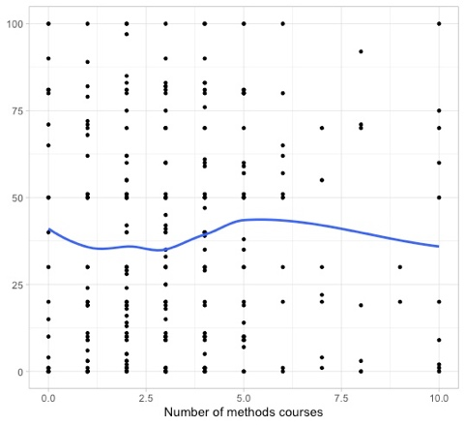 | 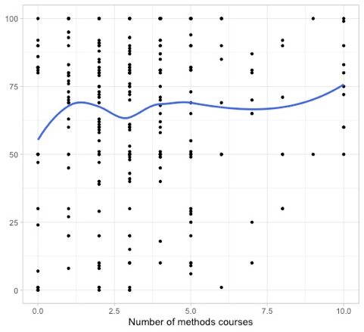 | 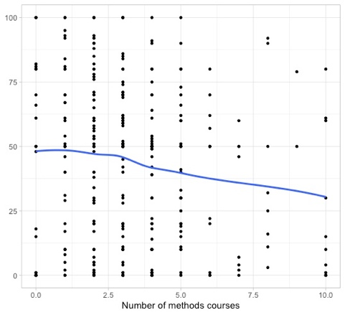 | 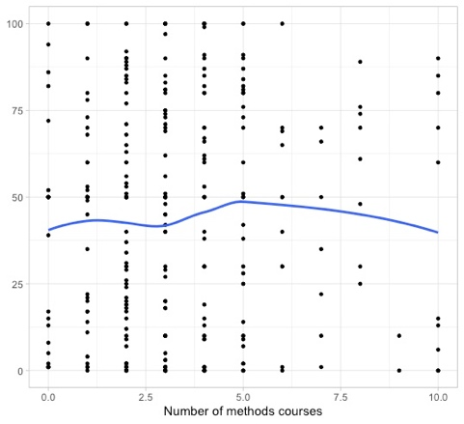
Replications build academic reputations  (Q1.4.5) | Replications verify previous results  (Q1.4.6) | Replications are negatively evaluated by reviewers  (Q1.4.7) | Replications expand previous results  (Q1.4.8)
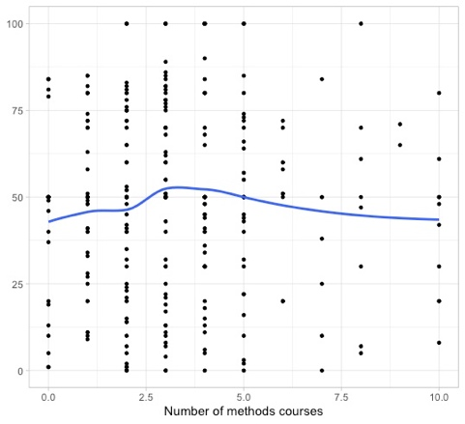 | 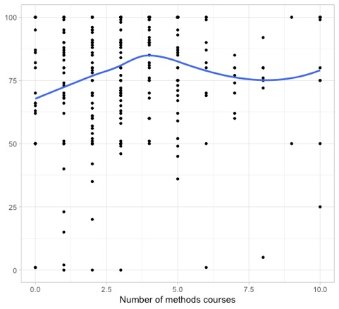 | 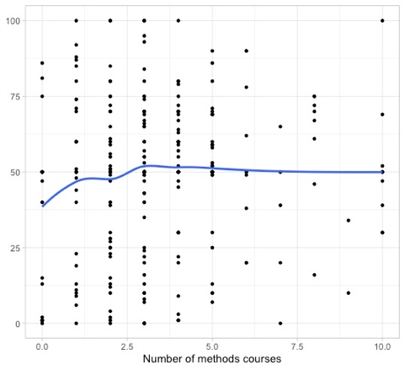 | 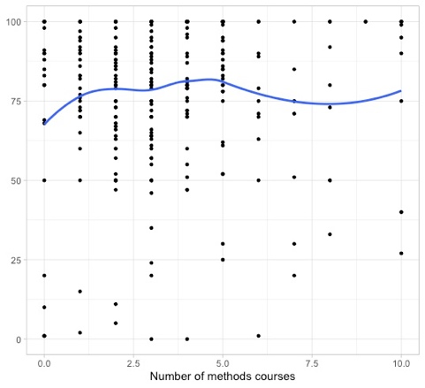
Replications establish knowledge  (Q1.4.9) | Replications are used to learn about research methods  (Q1.4.10) | Replications are relevant to L2 research  (Q1.4.11) | Replications strengthen a discipline  (Q1.4.12)
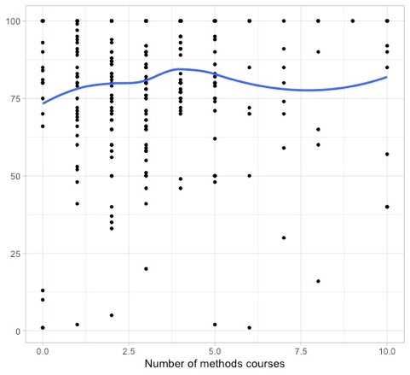 | 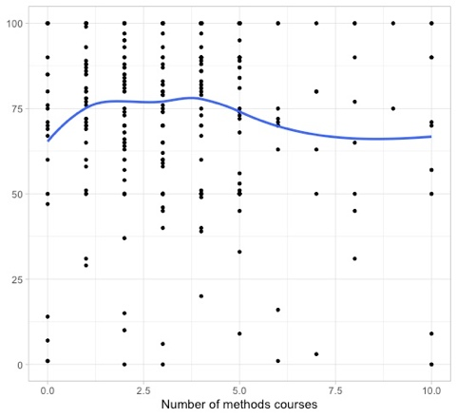 | 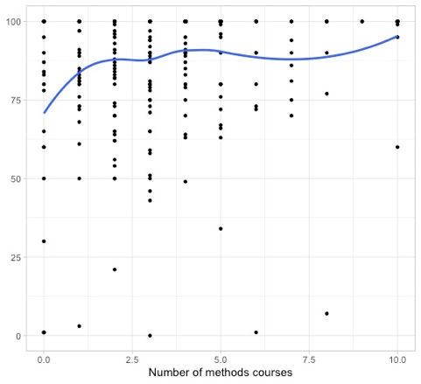 | 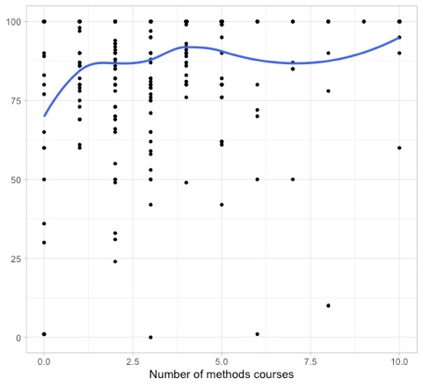
Replications consolidate previous results  (Q1.4.13) | Replications are valuable to the field  (Q1.4.14) | Replications lack innovation  (Q1.4.15)
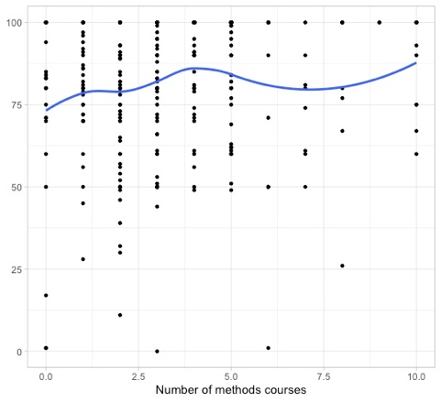 | 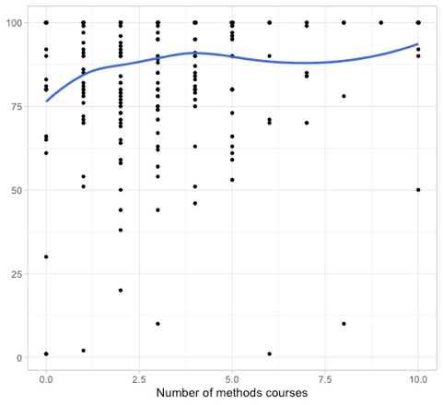 | 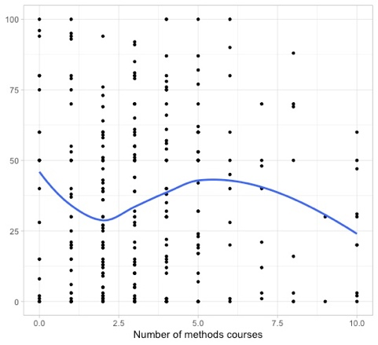

Scatter plots showing correlations between attitudes towards replication (Q1.4) and career stage (Q3.3)

Replications lack originality (Q1.4.1) | Replications generalize previous results  (Q1.4.2) | Replications question the original researcher and their findings  (Q1.4.3) | Replications are not a priority in L2 research right now  (Q1.4.4)
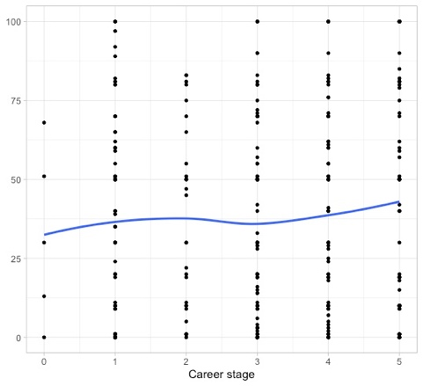 | 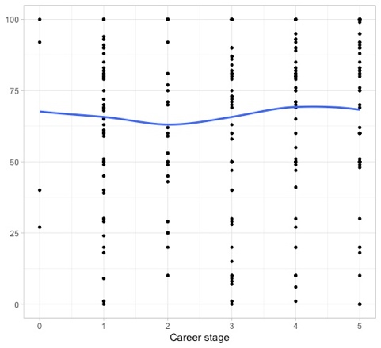 | 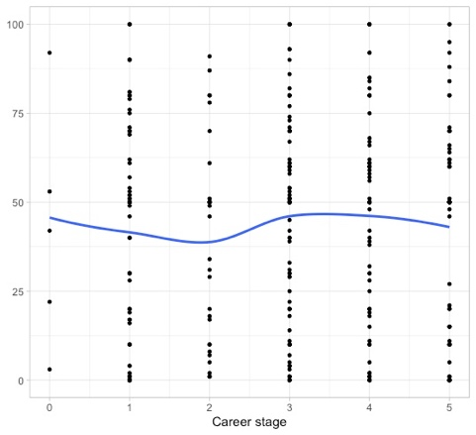 | 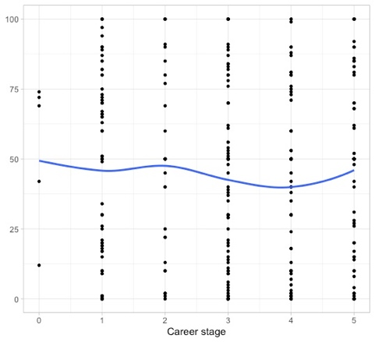
Replications build academic reputations  (Q1.4.5) | Replications verify previous results  (Q1.4.6) | Replications are negatively evaluated by reviewers  (Q1.4.7) | Replications expand previous results  (Q1.4.8)
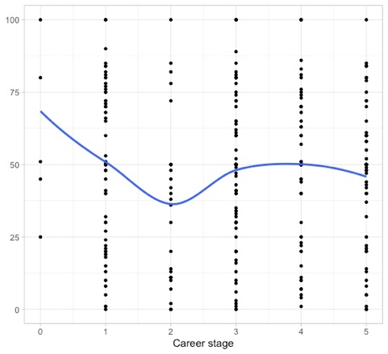 | 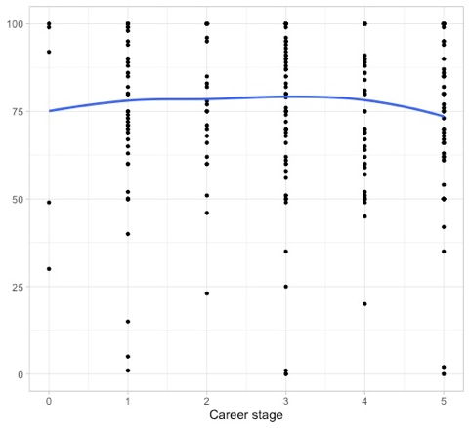 | 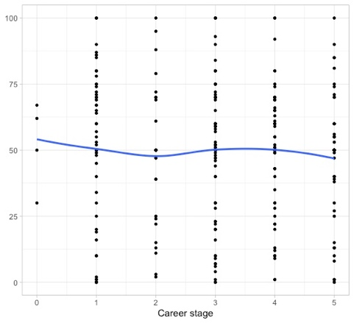 | 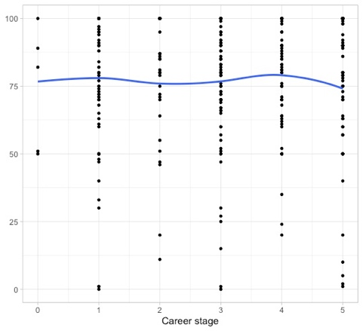
Replications establish knowledge  (Q1.4.9) | Replications are used to learn about research methods  (Q1.4.10) | Replications are relevant to L2 research  (Q1.4.11) | Replications strengthen a discipline  (Q1.4.12)
 | 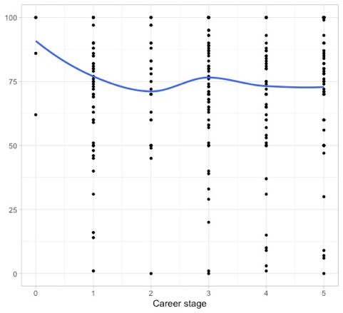 | 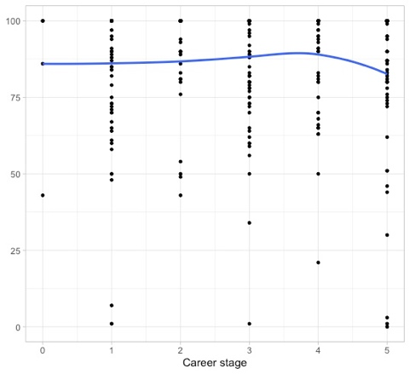 | 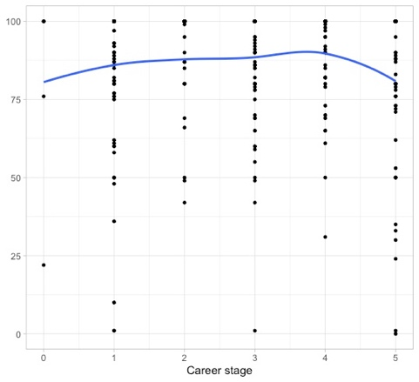
Replications consolidate previous results  (Q1.4.13) | Replications are valuable to the field  (Q1.4.14) | Replications lack innovation  (Q1.4.15)
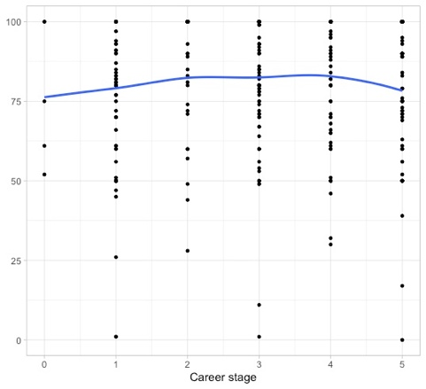 | 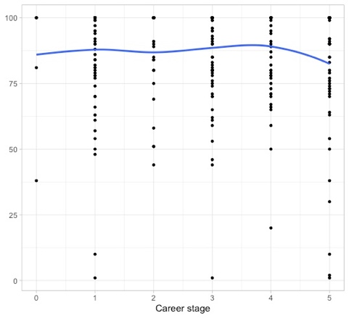 | 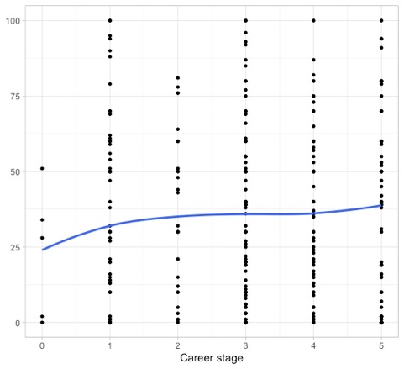

Note. Career stage was coded as: 0 =other, 1 = PhD student, 2 = Post-doc or equivalent, 3 = Assistant professor (or lecturer), 4 = Associate professor (or senior lecturer, reader), 5 = Full professor

Scatter plots showing correlations between attitudes towards replication (Q1.4) and publication rate (Q3.4)

Replications lack originality (Q1.4.1) | Replications generalize previous results  (Q1.4.2) | Replications question the original researcher and their findings  (Q1.4.3) | Replications are not a priority in L2 research right now  (Q1.4.4)
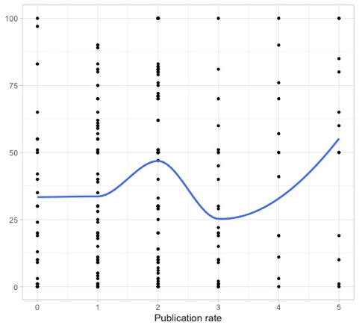 | 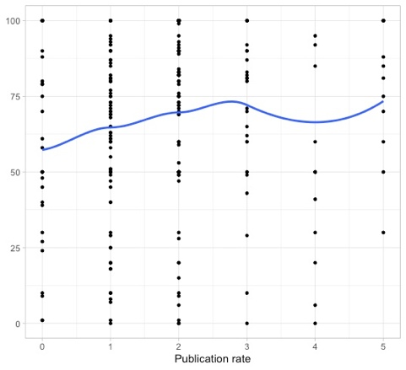 | 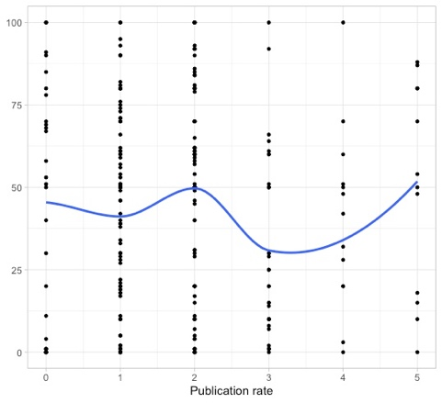 | 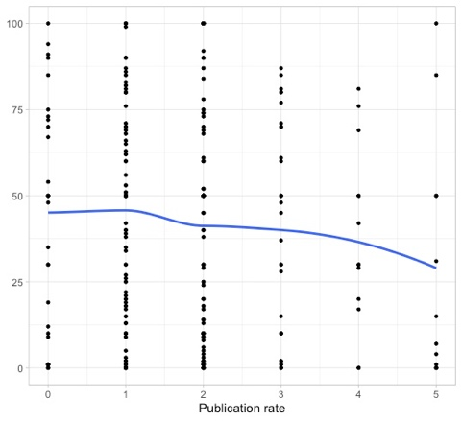
Replications build academic reputations  (Q1.4.5) | Replications verify previous results  (Q1.4.6) | Replications are negatively evaluated by reviewers  (Q1.4.7) | Replications expand previous results  (Q1.4.8)
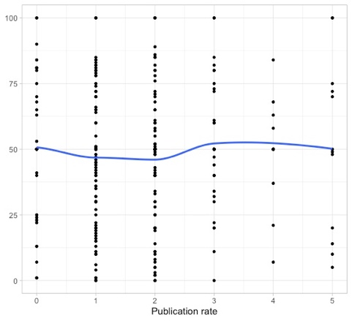 | 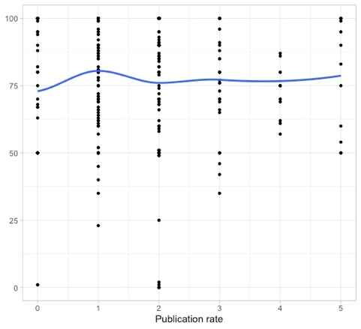 | 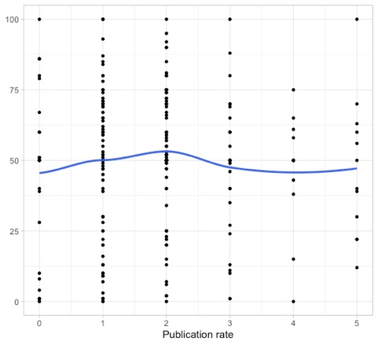 | 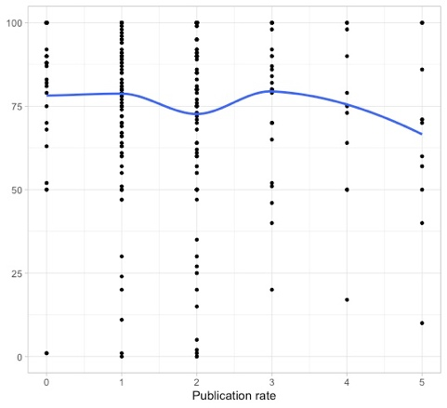
Replications establish knowledge  (Q1.4.9) | Replications are used to learn about research methods  (Q1.4.10) | Replications are relevant to L2 research  (Q1.4.11) | Replications strengthen a discipline  (Q1.4.12)
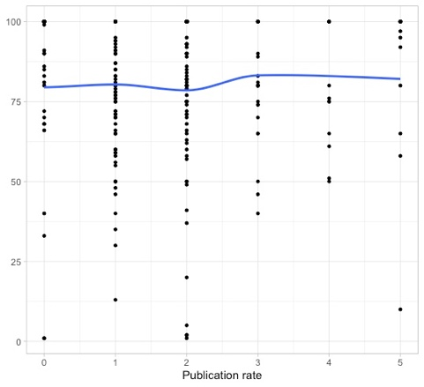 | 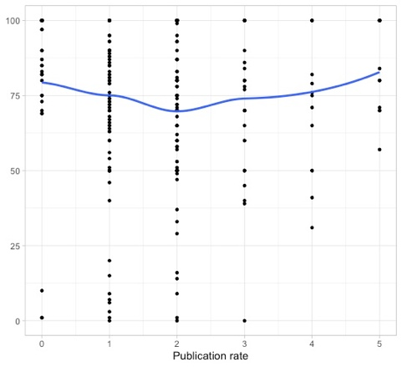 | 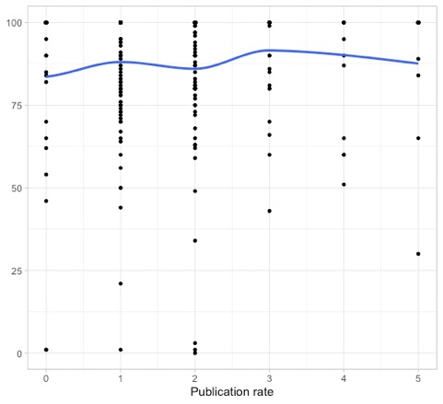 | 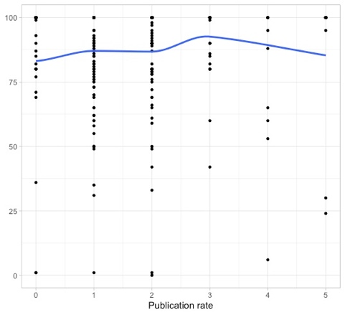
Replications consolidate previous results  (Q1.4.13) | Replications are valuable to the field  (Q1.4.14) | Replications lack innovation  (Q1.4.15)
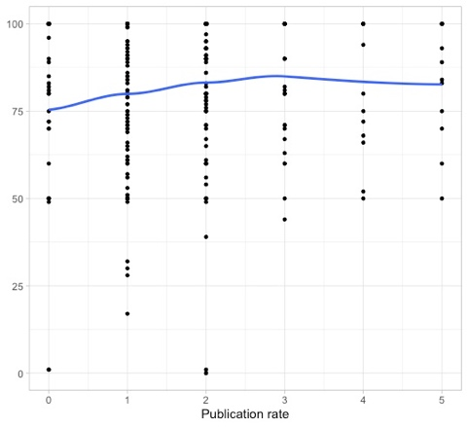 | 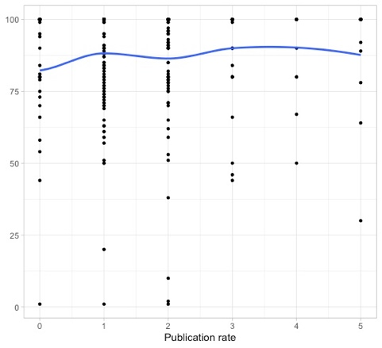 | 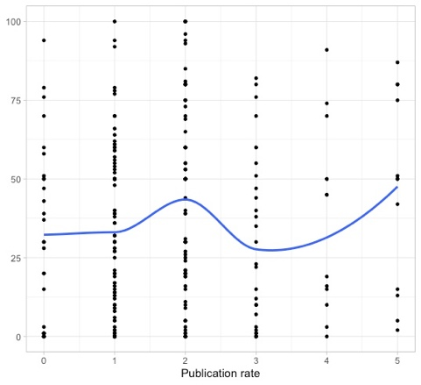

Scatter plots showing correlations between attitudes towards replication (Q1.4) and years since PhD (Q3.2_1)

Replications lack originality (Q1.4.1) | Replications generalize previous results  (Q1.4.2) | Replications question the original researcher and their findings  (Q1.4.3) | Replications are not a priority in L2 research right now  (Q1.4.4)
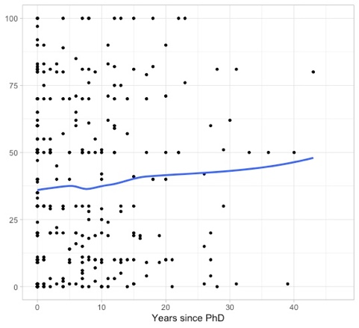 | 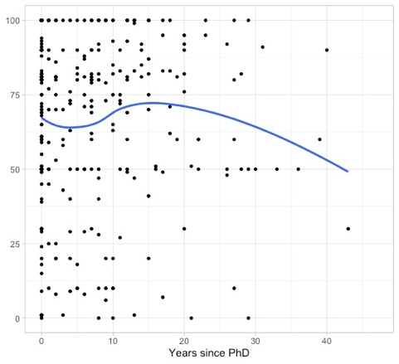 | 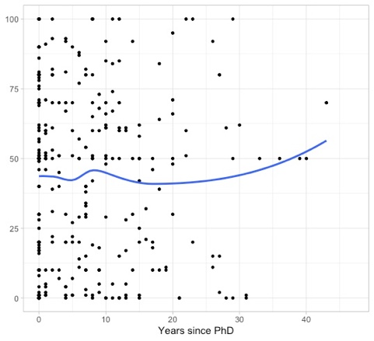 | 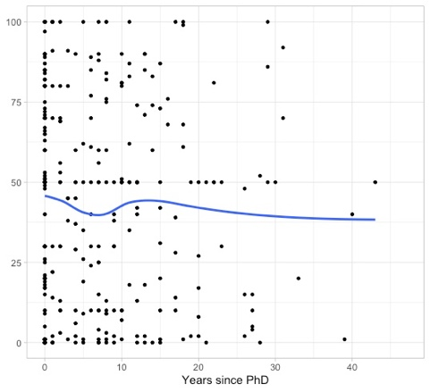
Replications build academic reputations  (Q1.4.5) | Replications verify previous results  (Q1.4.6) | Replications are negatively evaluated by reviewers  (Q1.4.7) | Replications expand previous results  (Q1.4.8)
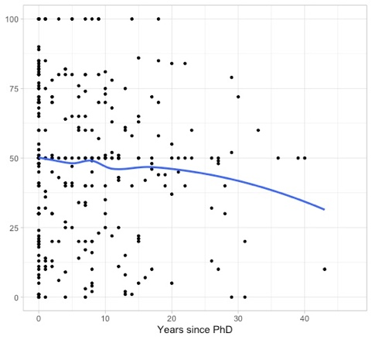 | 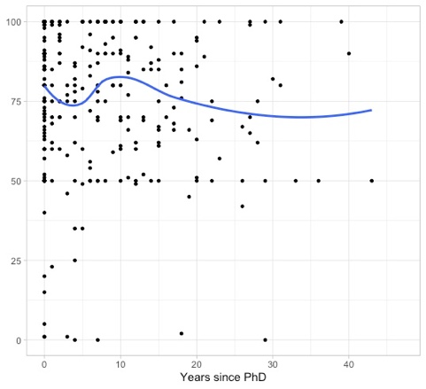 | 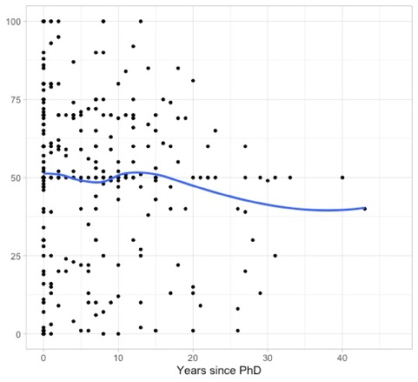 | 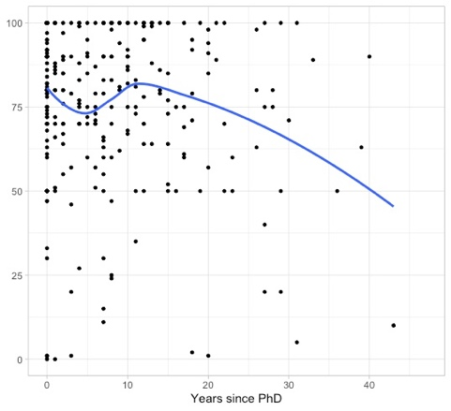
Replications establish knowledge  (Q1.4.9) | Replications are used to learn about research methods  (Q1.4.10) | Replications are relevant to L2 research  (Q1.4.11) | Replications strengthen a discipline  (Q1.4.12)
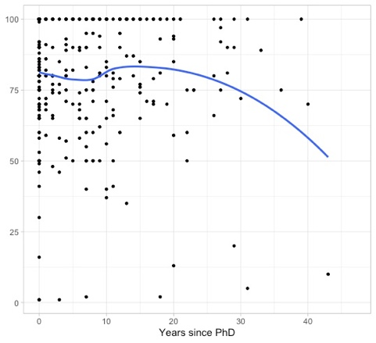 | 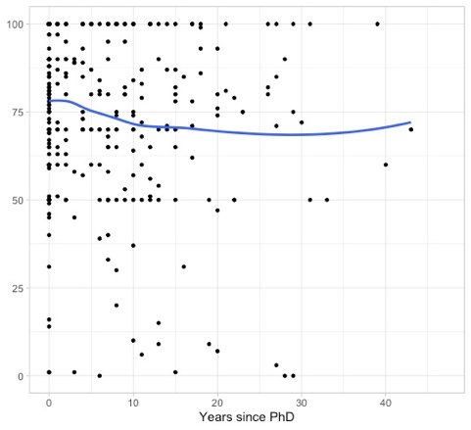 | 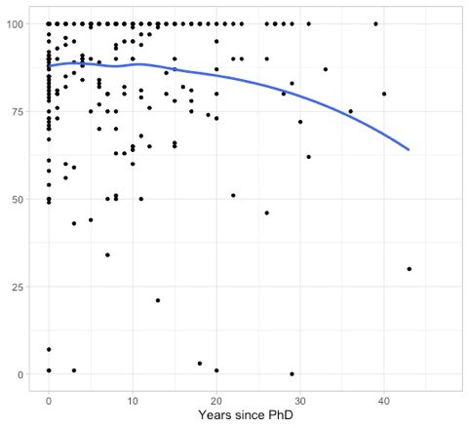 | 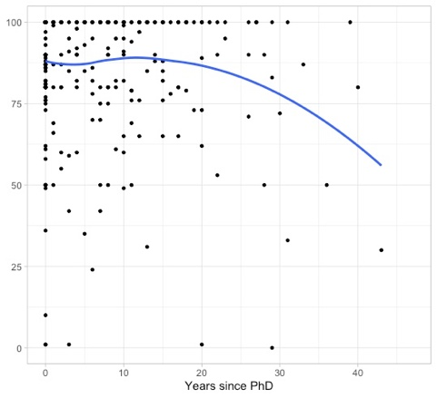
Replications consolidate previous results  (Q1.4.13) | Replications are valuable to the field  (Q1.4.14) | Replications lack innovation  (Q1.4.15)
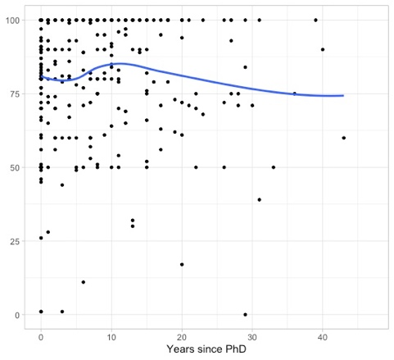 | 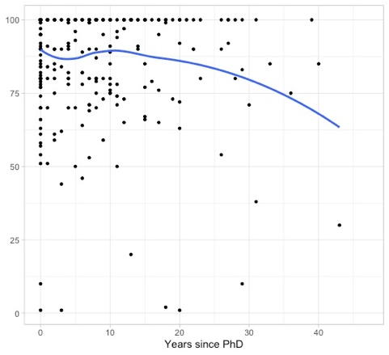 | 