Supplementary Materials A: 110 Coded Studies
Authors | Year
Albaladejo Albaladejo, Coyle, & Roca de Larios | 2018
Bao | 2015
Boers, Dang, & Strong | 2017
Boers, Demecheleer, Coxhead, & Webb | 2014
Boers, Eyckmans, & Stengers | 2007
Boers, Eyckmans, Kappel, Stengers, & Demecheleer | 2006
Boers, Piquer Piriz, Stengers, & Eyckmans | 2009
Busse, Cenoz, Dalmann, & Rogge | 2020
Candry, Decloedt, & Eykmans | 2020
Chang | 2007
Chang | 2019
Choi | 2017
de la Fuente | 2002
de la Fuente | 2006
Dolean | 2014
Elgort, Beliaeva, & Boers | 2020
Eyckmans, Boers, Lindstromberg | 2016
Farley, Ramonda, & Liu | 2012
Feng & Webb | 2020
File & Adams | 2010
Folse | 2006
Fukkink, Hulstijn, & Simis | 2005
Gablasova | 2014
Gass & Alverez Torres | 2005
Hirschel & Fritz | 2013
Huang & Lin | 2014
Huang, Kim, & Christianson | 2019
Hulstijn & Laufer | 2001
Hummel | 2010
Jin | 2020
Kaplan_Rakowski & Loranc-Paszylk | 2019
Kasahara | 2011
Khezrlou, Ellis, Sadeghi | 2017
Kim | 2008
Kim | 2008
Kim | 2006
Laufer & Rozovski-Roitblat | 2011
Lee & Levine | 2020
Lee & Lin | 2019
Lee & Muncie | 2006
Lee & Macaro | 2013
Lee & Pulido | 2017
Li & Tong | 2020
Lu | 2013
Malone | 2018
Mancilla-Martinez | 2010
Mizumoto & Takeuchi | 2009
Moonen, de Graaf, Westhoff, & Brekelmans | 2014
Morimoto & Loewen | 2007
Moskovsky, Jiang, Libert, & Fagan | 2015
Nakata | 2015a
Nakata | 2015b
Nakata | 2017
Nakata & Suzuki | 2019
Nakata & Webb | 2016
Nassaji & Tian | 2010
Nguyen & Boers | 2019
Niu & Helms-Park | 2014
Ong & Zhang | 2018
Pattemore & Muñoz | 2020
Perez | 2020
Perez, Peters, & Desmet | 2015
Peters | 2014
Peters | 2020
Peters & Webb | 2018
Pham, Donovan, Dam, & Contant | 2018
Puimège & Peters | 2020
Rassaei | 2017
Rassaei | 2020
Reynolds & Shih | 2019
Rodriguez & Sadoski | 2000
Rogers & Cheung | 2020
Rogers, Webb, Nakata | 2015
Rott | 2007
Rott, Williams, & Cameron | 2002
Saeedakhtar, Bagerin, & Abdi | 2020
Sagarra & Alba | 2006
Saito | 2013
Saito & Wu | 2014
Schuetze | 2015
Shen | 2010
Shintani | 2011
Shintani | 2012
Shintani | 2013
Showalter | 2020
Serrano & Huang | 2018
Strong & Boers | 2019
Teng | 2020
Tian & Macaro | 2012
Toomer & Elgort | 2019
Traxler & Nakatsukasa | 2020
Tsai | 2020
Tseng, Liu, & Chou | 2020
Van Den Broek, Takashima, Segers, & Verhoeven | 2018
Verspoor & Lowie | 2003
Walters & Bozkurt | 2009
Webb & Chang | 2016
Webb | 2005
Webb & Chang | 2015
Webb & Kagimoto | 2009
Webb, Newton, & Chang | 2013
Wei | 2015
Yan | 2020
Yang, Shintani, Li, & Zhang | 2017
Yasuda | 2010
Yilmaz & Yuksel | 2011
Yu | 2009
Zhang & Graham | 2020
Zou | 2017
Zyzik | 2011

Supplementary Materials B: Spearman’s ρ Assumption Checks
The following section contains the results of the assumption checks for the correlations presented in the report (both whole report pool and spilt samples by cluster check analyses). Consider the scatterplot in Figure B1, which illustrates an extreme example of monotonicity violation when a binary 1/0 variable is correlated with a ranked year variable. The scatterplot shows that the reports rated as “1” (i.e., yes) have a negative association from 2000 until 2005-2015 but then a negative from 2015 to 2000. This data violates the assumption of monotonicity because a line of fit decreases and then increases in value when connecting the data points. Alternatively, Figure B2 highlights a perfect monotonic association, whereby the reports published before 2010 were ranked “0” (i.e., no) and the reports published after 2010 were ranked “1” (i.e., yes). In this case the line of fit is monotonic because it maintains a positive association with no clear change of direction.
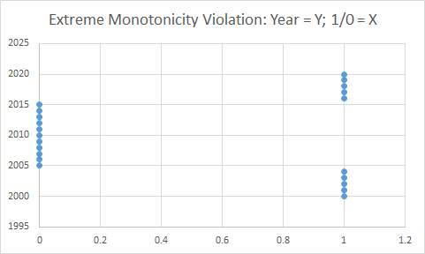
Figure B1. Extreme violation of monotonic assumption
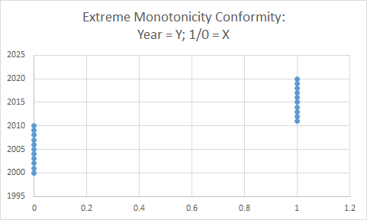
B2. Perfect Monotonic Association.
Figures B3 through B5 display the relationships between and time and sample-size planning, time and random assignment, and time and multi-site sample use respectively. These scatterplots reveal no clear violation of the monotonicity assumption. The ρ coefficient in a general sense empirically assesses the assumption where ρ = 1 equates to a perfect monotonic association (Field, 2018) and thus the assumption is somewhat weak as highlighted by Glass (1965).
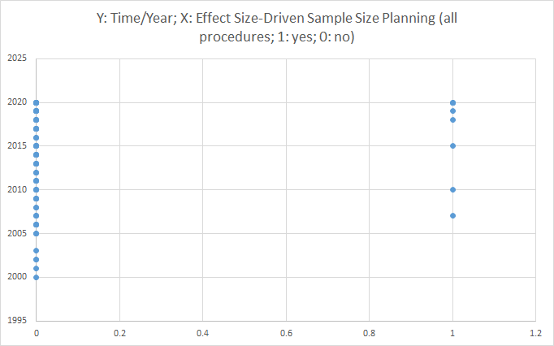
B3. Time and effect size-driven sample size planning
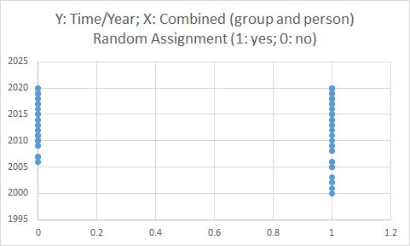
Figure B4. Time and random assignment
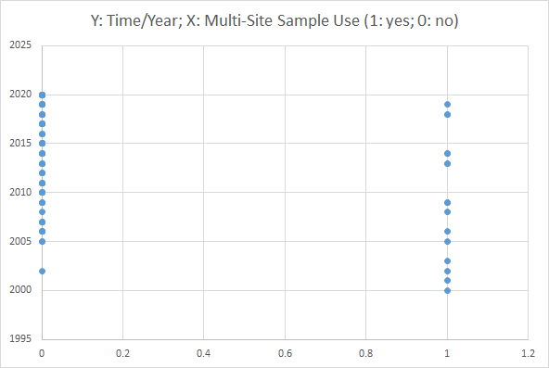
Figure B5. Time and Multi-Site Sample Use

