On-line Supplementary Materials
Table S1.
Interrater Agreement for EIT Items across 3 Studies
 | Son Dissertation  (r = 2, n = 93) |  |  | Isbell Dissertation  (r = 3, n = 20) |  |  | Isbell Pilot  (r = 2, n = 5)
Item | Agreement (%) | ICC2a |  | Agreement (%)* | ICC2a |  | Agreement (%) | ICC2a
I01 | 84 | 0.82 |  | 75 | 0.62 |  | 80 | 0.88
I02 | 83 | 0.96 |  | 45 | 0.71 |  | 80 | 0.93
I03 | 86 | 0.93 |  | 40 | 0.70 |  | 60 | 0.83
I04 | 79 | 0.91 |  | 65 | 0.62 |  | 80 | 0.93
I05 | 73 | 0.89 |  | 65 | 0.89 |  | 100 | 1.00
I06 | 85 | 0.96 |  | 65 | 0.84 |  | 60 | 0.83
I07 | 81 | 0.95 |  | 40 | 0.78 |  | 80 | 0.88
I08 | 77 | 0.93 |  | 60 | 0.89 |  | 60 | 0.69
I09 | 87 | 0.97 |  | 60 | 0.81 |  | 80 | 0.96
I10 | 78 | 0.95 |  | 75 | 0.86 |  | 80 | 0.96
I11 | 80 | 0.94 |  | 60 | 0.93 |  | 80 | 0.60
I12 | 82 | 0.96 |  | 40 | 0.86 |  | 100 | 1.00
I13 | 81 | 0.94 |  | 65 | 0.93 |  | 40 | 0.75
I14 | 81 | 0.93 |  | 65 | 0.94 |  | 40 | 0.75
I15 | 75 | 0.88 |  | 55 | 0.90 |  | 40 | 0.40
I16 | 84 | 0.93 |  | 60 | 0.89 |  | 40 | 0.50
I17 | 80 | 0.93 |  | 65 | 0.90 |  | 100 | 1.00
I18 | 76 | 0.91 |  | 55 | 0.89 |  | 80 | 0.87
I19 | 80 | 0.95 |  | 50 | 0.85 |  | 60 | 0.71
I20 | 85 | 0.97 |  | 50 | 0.86 |  | 80 | 0.60
I21 | 84 | 0.95 |  | 50 | 0.90 |  | 60 | 0.80
I22 | 81 | 0.90 |  | 50 | 0.83 |  | 100 | 1.00
I23 | 80 | 0.96 |  | 70 | 0.96 |  | 80 | 0.80
I24 | 76 | 0.88 |  | 55 | 0.89 |  | 100 | 1.00
I25 | 82 | 0.93 |  | 70 | 0.95 |  | 40 | -0.20
I26 | 77 | 0.90 |  | 70 | 0.94 |  | 80 | 0.71
I27 | 80 | 0.94 |  | 75 | 0.95 |  | 80 | 0.00
I28 | 81 | 0.92 |  | 55 | 0.92 |  | 80 | 0.87
I29 | 74 | 0.89 |  | 60 | 0.90 |  | 60 | 0.81
I30 | 75 | 0.91 |  | 60 | 0.91 |  | 60 | 0.64
Mean | 80 | 0.93 |  | 59 | 0.86 |  | 72 | 0.75
*Exact agreement was reached for all 3 scorers.

Table S2.
Measurement Summary of 3-Facet RSM (Integrated Data, All Scorers)
Facet | N | Measure M(SD) | Measure Range | Infit Range | Outfit Range | Sep. Strata | Rel.
Persons | 318 | 0.09 (1.57) | -4.90 – 4.16 | 0.39 – 2.25 | 0.24 – 7.89 | 6.91 | 0.98
Scorers | 5 | 0.00 (0.08) | -0.10 – 0.11 | 0.76 – 1.12 | 0.94 – 1.33 | 2.32 | 0.84
Items | 30 | 0.00 (0.99) | -2.36 – 1.46 | 0.70 – 2.08 | 0.66 – 4.98 | 17.14 | 1.00

Table S3
Category Statistics of 3-Facet RSM (Integrated Data, All Scorers)
Score | N | Average Measure | Expected Measure | Outfit | Rasch-Andrich Threshold (SE)
0 | 3437 | -2.20 | -2.18 | 1.0 | -
1 | 2054 | -0.99 | -0.91 | 0.9 | -0.98 (.03)
2 | 2446 | 0.17 | -0.02 | 1.7 | -0.63 (.03)
3 | 2617 | 0.82 | 0.88 | 0.9 | 0.35 (.03)
4 | 3124 | 2.06 | 2.08 | 1.0 | 1.26 (.03)
Note. The Average Measure is the average Rasch person ability measure of all examinees who received a particular score on the rating scale, while the Expected Measure is model-predicted average Rasch person ability measure of examinees who receive a particular score. Outfit indicates the degree to which unexpected observations are present for a score; values near 1.0 are ideal. Rasch-Andrich thresholds indicate the point in the examinee ability continuum at which two adjacent categories are equally probable.

Table S4.
Measurement Summary of 2-Facet RSM (Integrated Data, Single Scorer)
Facet | N | Measure M(SD) | Measure Range | Infit Range | Outfit Range | Sep. Strata | Rel.
Persons | 318 | 0.09 (1.57) | -4.90 – 4.16 | 0.36 – 2.48 | 0.40 – 8.17 | 6.91 | 0.98
Items | 30 | 0.00 (0.99) | -2.36 – 1.46 | 0.70 – 2.03 | 0.66 – 4.23 | 17.14 | 1.00
Note. Rating scale thresholds: 0/1 = -1.06 logits, 1/2 = -0.59 logits, 2/3 = 0.38 logits, 3/4 = 1.27 logits.

Table S5.
Linear regression EIT item averages on select linguistic features following Kim et al. (2016)
 | Estimate | SE | ß | p
Intercept | 3.87 | 0.40
Syllables | -0.07 | 0.04 | -0.35 | 0.10
Relative Clauses | -0.27 | 0.20 | -0.21 | 0.18
Vocabulary Score | -0.09 | 0.05 | -0.34 | 0.08
F(3,26) = 9.55, p = 0.0002, Multiple R² = 0.54, Adjusted R² = 0.47.

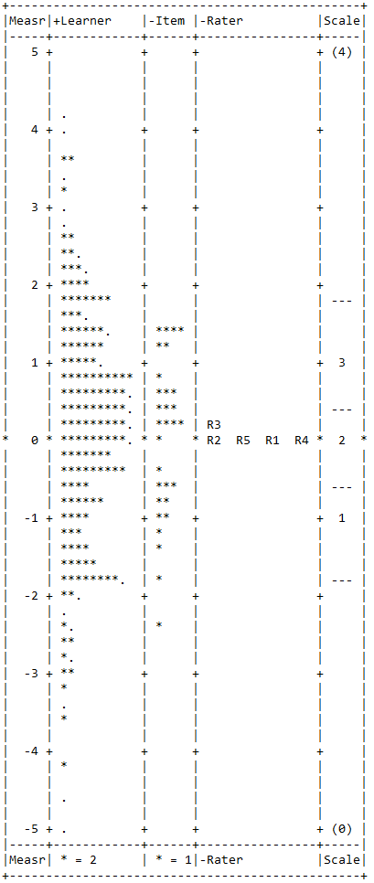
Figure S1. Wright Map summarizing the 3-facet model with all raters.

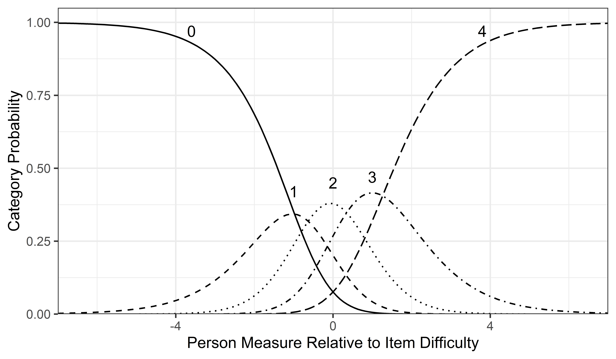
Figure S2. Category probability curves for the 3-facet RSM.

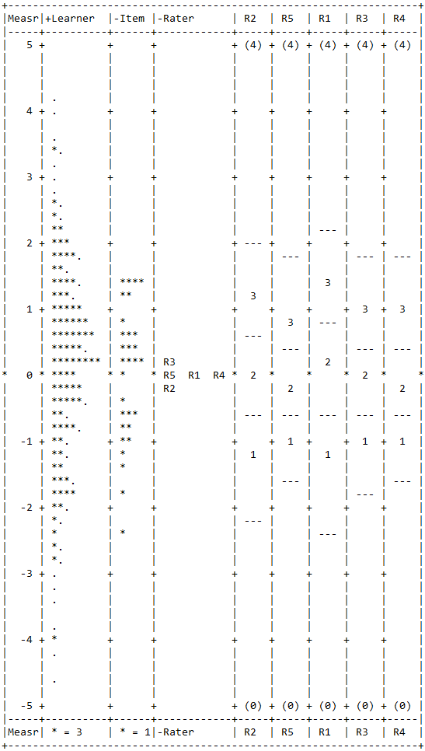
Figure S3. Wright Map summarizing a 3-facet hybrid model with rating scale category threshold estimated separately for each rater.

