Appendix A. Training Materials and scripts of the model speech
“Chase”
- John is a 10-year-old boy. Last week, he went shopping. It took him a long time to do his shopping and he caught a bus home late in the evening. It was dark when he got off the bus. He accidentally dropped a small box then.
- John had to walk home through dark woods, and he felt a little frightened. Suddenly he heard a noise.
- There was a strange man following John. John thought that the man would attack him.
- John began to run home quickly, and the man also ran after him quickly. Then they crossed a bridge over the river.
- He found his house a long way off. The next moment the man caught him and held his arm.
- The man gave John the small box that John had dropped. He said that he followed John to give him the box. John was surprised but very glad. He thanked the man.
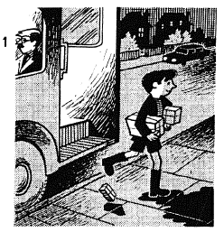
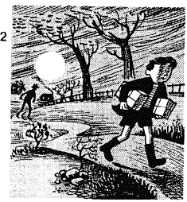
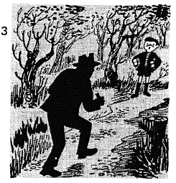
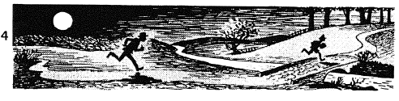
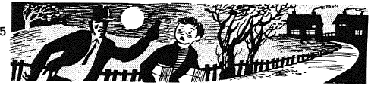
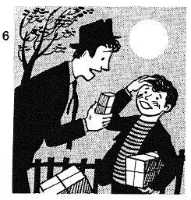

“Surprise”
- Jack is a businessman. Three weeks ago, he arrived at an airport with a big basket. It was too heavy to carry, so he put it down. Two people were watching him from behind. One was a short boy with a striped shirt. The other was a tall man, and he wore sunglasses.
- The short boy came close to Jack. When they started to talk, the tall man picked up the big basket.
- When Jack realized that the two people were thieves and stole his basket, they ran away from the airport.
- Jack hurried to a police officer and asked for help. The police officer tried to stop the thieves. He couldn’t stop them. The thieves got into a car and drove off.
- The car passed a zoo and went into the woods.
- When it reached the woods, it stopped, and the two people got out. They opened the basket that they had stolen and suddenly a snake appeared!

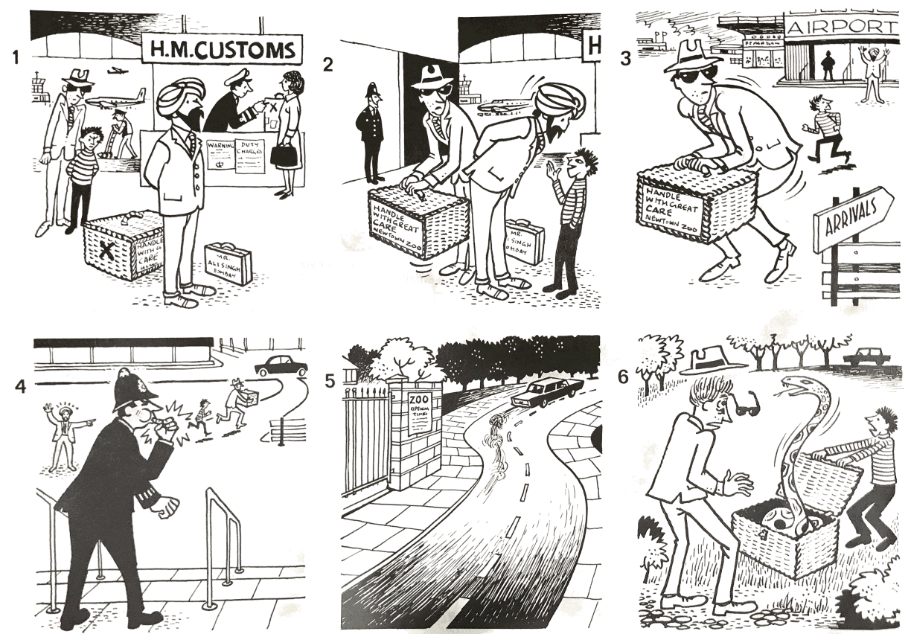

Appendix B. Test Material
“Bicycle” “Bus”
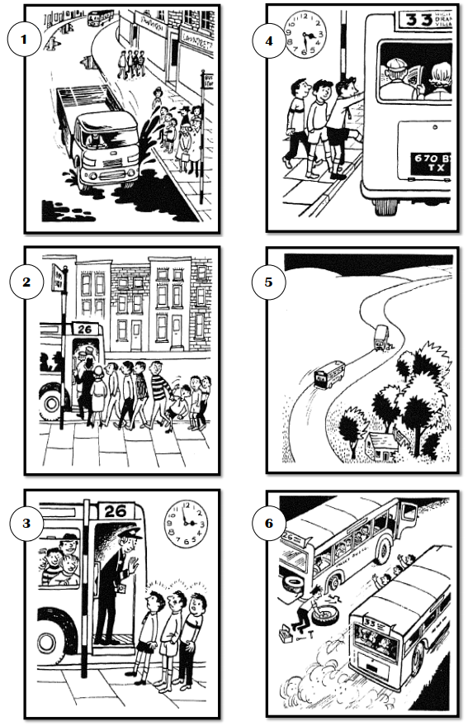
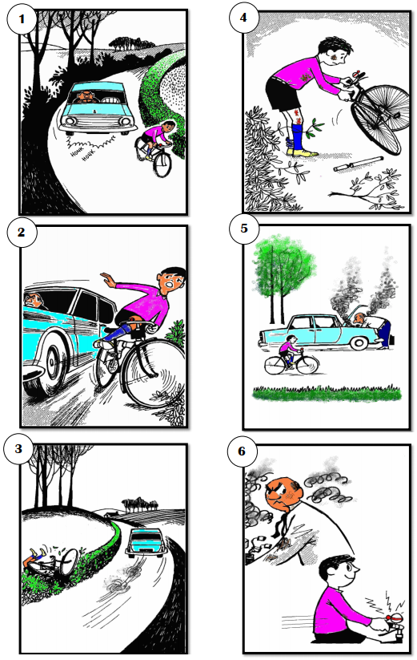

“Race”
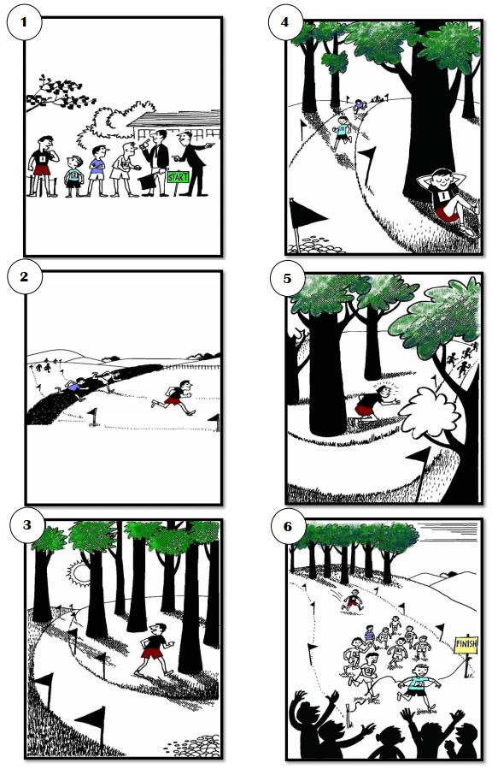

Appendix C. Descriptive Statistics for Training Data
[Articulation Rate]
 | Massed Group |  |  |  |  |  |  | Short-Spaced Group |  |  |  |  |  |  | Long-spaced Group
 |  |  | 95% CI |  |  |  |  |  |  |  |  | 95% CI |  |  |  |  | 95% CI
 | M | SD |  | Lower | Upper |  |  | M | SD |  | Lower |  | Upper |  | M | SD |  | Lower | Upper
Time 1 | 158.51 | 20.73 |  | 148.81 | 168.21 |  |  | 158.15 | 29.41 |  | 145.43 |  | 170.87 |  | 148.46 | 24.03 |  | 137.52 | 159.40
Time 2 | 163.51 | 20.31 |  | 154.38 | 172.64 |  |  | 157.88 | 23.72 |  | 148.19 |  | 167.58 |  | 149.57 | 22.19 |  | 140.07 | 159.06
Time 3 | 156.90 | 21.80 |  | 147.10 | 166.71 |  |  | 156.91 | 25.78 |  | 146.38 |  | 167.45 |  | 158.92 | 21.60 |  | 149.69 | 168.16
Time 4 | 163.23 | 18.73 |  | 154.81 | 171.65 |  |  | 161.97 | 28.06 |  | 150.51 |  | 173.44 |  | 152.50 | 26.16 |  | 141.31 | 163.69
Time 5 | 169.39 | 18.41 |  | 161.11 | 177.67 |  |  | 164.88 | 31.68 |  | 151.93 |  | 177.82 |  | 157.74 | 25.00 |  | 147.05 | 168.43
Time 6 | 169.97 | 14.16 |  | 163.60 | 176.34 |  |  | 171.04 | 30.31 |  | 158.65 |  | 183.42 |  | 156.70 | 22.48 |  | 147.09 | 166.31
One-week retention | 159.31 | 18.51 |  | 150.98 | 167.63 |  |  | 150.38 | 22.95 |  | 141.00 |  | 159.76 |  | 152.35 | 27.97 |  | 140.39 | 164.31

[Mid-Clause Pause Duration]
 | Massed Group |  |  |  |  |  |  | Short-Spaced Group |  |  |  |  |  |  | Long-spaced Group
 |  |  | 95% CI |  |  |  |  |  |  |  |  | 95% CI |  |  |  |  |  | 95% CI
 | M | SD |  | Lower | Upper |  |  | M | SD |  | Lower |  | Upper |  | M | SD | Lower |  | Upper
Time 1 | 0.07 | 0.15 |  | -0.002 | 0.14 |  |  | 0.11 | 0.18 |  | 0.04 |  | 0.19 |  | 0.13 | 0.11 | 0.08 |  | 0.18
Time 2 | 0.00 | 0.14 |  | -0.06 | 0.06 |  |  | 0.05 | 0.17 |  | -0.02 |  | 0.12 |  | 0.08 | 0.12 | 0.03 |  | 0.13
Time 3 | -0.02 | 0.10 |  | -0.06 | 0.02 |  |  | 0.06 | 0.15 |  | 0.00 |  | 0.12 |  | 0.01 | 0.12 | -0.04 |  | 0.06
Time 4 | -0.04 | 0.16 |  | -0.11 | 0.03 |  |  | -0.03 | 0.14 |  | -0.09 |  | 0.02 |  | 0.08 | 0.10 | 0.04 |  | 0.13
Time 5 | -0.07 | 0.11 |  | -0.12 | -0.02 |  |  | -0.04 | 0.12 |  | -0.09 |  | 0.01 |  | 0.00 | 0.11 | -0.05 |  | 0.04
Time 6 | -0.09 | 0.09 |  | -0.13 | -0.05 |  |  | -0.09 | 0.12 |  | -0.14 |  | -0.04 |  | -0.04 | 0.13 | -0.09 |  | 0.02
One-week retention | -0.02 | 0.12 |  | -0.08 | 0.03 |  |  | 0.01 | 0.15 |  | -0.06 |  | 0.07 |  | 0.00 | 0.13 | -0.06 |  | 0.05

[Clause-Final Pause Duration]
 | Massed Group |  |  |  |  |  |  | Short-Spaced Group |  |  |  |  |  |  | Long-spaced Group
 |  |  | 95% CI |  |  |  |  |  |  |  |  | 95% CI |  |  |  |  | 95% CI
 | M | SD |  | Lower | Upper |  |  | M | SD |  | Lower |  | Upper |  | M | SD | Lower | Upper
Time 1 | 1.30 | 0.27 |  | 1.17 | 1.43 |  |  | 1.42 | 0.33 |  | 1.28 |  | 1.56 |  | 1.39 | 0.31 | 1.25 | 1.54
Time 2 | 1.29 | 0.34 |  | 1.14 | 1.44 |  |  | 1.47 | 0.28 |  | 1.35 |  | 1.58 |  | 1.40 | 0.30 | 1.28 | 1.53
Time 3 | 1.21 | 0.22 |  | 1.11 | 1.31 |  |  | 1.33 | 0.24 |  | 1.23 |  | 1.43 |  | 1.33 | 0.23 | 1.23 | 1.43
Time 4 | 1.17 | 0.20 |  | 1.09 | 1.26 |  |  | 1.27 | 0.26 |  | 1.16 |  | 1.37 |  | 1.45 | 0.30 | 1.32 | 1.59
Time 5 | 1.22 | 0.27 |  | 1.10 | 1.34 |  |  | 1.24 | 0.24 |  | 1.14 |  | 1.34 |  | 1.36 | 0.32 | 1.23 | 1.50
Time 6 | 1.13 | 0.20 |  | 1.04 | 1.22 |  |  | 1.23 | 0.25 |  | 1.13 |  | 1.33 |  | 1.28 | 0.23 | 1.18 | 1.38
One-week retention | 1.17 | 0.22 |  | 1.07 | 1.27 |  |  | 1.32 | 0.30 |  | 1.19 |  | 1.44 |  | 1.25 | 0.24 | 1.15 | 1.35

[Mid-Clause Pause Frequency]
 | Massed Group |  |  |  |  |  |  | Short-Spaced Group |  |  |  |  |  |  | Long-spaced Group
 |  |  | 95% CI |  |  |  |  |  |  |  |  | 95% CI |  |  |  |  | 95% CI
 | M | SD |  | Lower | Upper |  |  | M | SD |  | Lower |  | Upper |  | M | SD |  | Lower | Upper
Time 1 | 20.15 | 4.27 |  | 18.16 | 22.15 |  |  | 18.88 | 6.96 |  | 15.87 |  | 21.89 |  | 18.24 | 4.33 |  | 16.27 | 20.21
Time 2 | 21.22 | 6.44 |  | 18.33 | 24.12 |  |  | 17.41 | 5.07 |  | 15.34 |  | 19.48 |  | 17.97 | 4.63 |  | 15.99 | 19.95
Time 3 | 17.70 | 4.40 |  | 15.72 | 19.67 |  |  | 16.84 | 5.09 |  | 14.76 |  | 18.92 |  | 19.93 | 4.21 |  | 18.13 | 21.73
Time 4 | 18.67 | 4.69 |  | 16.56 | 20.78 |  |  | 18.48 | 5.44 |  | 16.25 |  | 20.70 |  | 16.46 | 3.89 |  | 14.80 | 18.12
Time 5 | 20.50 | 5.81 |  | 17.89 | 23.12 |  |  | 18.93 | 5.04 |  | 16.87 |  | 20.99 |  | 18.32 | 3.85 |  | 16.67 | 19.97
Time 6 | 19.38 | 5.19 |  | 17.05 | 21.72 |  |  | 18.71 | 4.76 |  | 16.77 |  | 20.66 |  | 17.84 | 4.05 |  | 16.11 | 19.58
One-week retention | 19.82 | 4.48 |  | 17.81 | 21.83 |  |  | 19.37 | 5.61 |  | 17.08 |  | 21.66 |  | 16.76 | 4.07 |  | 15.02 | 18.51

[Clause-Final Pause Frequency]
 | Massed Group |  |  |  |  |  |  | Short-Spaced Group |  |  |  |  |  |  | Long-spaced Group
 |  |  | 95% CI |  |  |  |  |  |  |  |  | 95% CI |  |  |  |  | 95% CI
 | M | SD |  | Lower | Upper |  |  | M | SD |  | Lower |  | Upper |  | M | SD |  | Lower | Upper
Time 1 | 0.94 | 0.16 |  | 0.87 | 1.02 |  |  | 0.89 | 0.15 |  | 0.82 |  | 0.95 |  | 0.85 | 0.18 |  | 0.77 | 0.94
Time 2 | 0.93 | 0.16 |  | 0.86 | 1.00 |  |  | 0.91 | 0.13 |  | 0.86 |  | 0.97 |  | 0.86 | 0.12 |  | 0.81 | 0.91
Time 3 | 0.99 | 0.13 |  | 0.93 | 1.05 |  |  | 0.94 | 0.10 |  | 0.90 |  | 0.98 |  | 0.88 | 0.14 |  | 0.82 | 0.94
Time 4 | 1.00 | 0.16 |  | 0.93 | 1.07 |  |  | 0.99 | 0.11 |  | 0.94 |  | 1.04 |  | 0.89 | 0.11 |  | 0.84 | 0.94
Time 5 | 0.96 | 0.15 |  | 0.89 | 1.02 |  |  | 0.96 | 0.13 |  | 0.91 |  | 1.01 |  | 0.94 | 0.13 |  | 0.89 | 1.00
Time 6 | 1.03 | 0.12 |  | 0.98 | 1.09 |  |  | 1.02 | 0.14 |  | 0.96 |  | 1.08 |  | 0.99 | 0.12 |  | 0.94 | 1.04
One-week retention | 0.99 | 0.13 |  | 0.93 | 1.05 |  |  | 0.94 | 0.14 |  | 0.88 |  | 1.00 |  | 0.98 | 0.13 |  | 0.92 | 1.03

[Repetitions]
 | Massed Group |  |  |  |  |  |  | Short-Spaced Group |  |  |  |  |  |  | Long-spaced Group
 |  |  | 95% CI |  |  |  |  |  |  |  |  | 95% CI |  |  |  |  | 95% CI
 | M | SD |  | Lower | Upper |  |  | M | SD |  | Lower |  | Upper |  | M | SD |  | Lower | Upper
Time 1 | 0.38 | 0.26 |  | 0.25 | 0.50 |  |  | 0.37 | 0.26 |  | 0.26 |  | 0.48 |  | 0.44 | 0.21 |  | 0.35 | 0.54
Time 2 | 0.41 | 0.22 |  | 0.31 | 0.51 |  |  | 0.28 | 0.26 |  | 0.17 |  | 0.38 |  | 0.30 | 0.17 |  | 0.23 | 0.37
Time 3 | 0.34 | 0.25 |  | 0.22 | 0.45 |  |  | 0.32 | 0.29 |  | 0.20 |  | 0.44 |  | 0.31 | 0.25 |  | 0.21 | 0.42
Time 4 | 0.35 | 0.25 |  | 0.24 | 0.46 |  |  | 0.30 | 0.27 |  | 0.19 |  | 0.41 |  | 0.29 | 0.24 |  | 0.19 | 0.39
Time 5 | 0.28 | 0.28 |  | 0.15 | 0.40 |  |  | 0.29 | 0.31 |  | 0.16 |  | 0.41 |  | 0.25 | 0.20 |  | 0.16 | 0.34
Time 6 | 0.34 | 0.30 |  | 0.21 | 0.48 |  |  | 0.32 | 0.29 |  | 0.20 |  | 0.44 |  | 0.25 | 0.24 |  | 0.14 | 0.35
One-week retention | 0.44 | 0.26 |  | 0.32 | 0.56 |  |  | 0.31 | 0.33 |  | 0.17 |  | 0.44 |  | 0.25 | 0.22 |  | 0.16 | 0.35

[Repairs]
 | Massed Group |  |  |  |  |  |  | Short-Spaced Group |  |  |  |  |  |  | Long-spaced Group
 |  |  | 95% CI |  |  |  |  |  |  |  |  | 95% CI |  |  |  |  | 95% CI
 | M | SD |  | Lower | Upper |  |  | M | SD |  | Lower |  | Upper |  | M | SD |  | Lower | Upper
Time 1 | 2.56 | 1.51 |  | 1.85 | 3.27 |  |  | 2.09 | 1.41 |  | 1.48 |  | 2.71 |  | 2.13 | 1.55 |  | 1.42 | 2.83
Time 2 | 3.12 | 1.55 |  | 2.42 | 3.82 |  |  | 2.15 | 1.37 |  | 1.59 |  | 2.70 |  | 2.65 | 1.26 |  | 2.11 | 3.18
Time 3 | 2.26 | 1.06 |  | 1.78 | 2.73 |  |  | 1.89 | 1.62 |  | 1.23 |  | 2.56 |  | 2.70 | 1.78 |  | 1.93 | 3.46
Time 4 | 2.82 | 1.87 |  | 1.97 | 3.66 |  |  | 2.40 | 1.46 |  | 1.80 |  | 3.00 |  | 2.23 | 1.73 |  | 1.49 | 2.97
Time 5 | 3.33 | 1.74 |  | 2.55 | 4.11 |  |  | 3.01 | 2.23 |  | 2.09 |  | 3.92 |  | 3.33 | 1.77 |  | 2.57 | 4.09
Time 6 | 3.34 | 1.74 |  | 2.56 | 4.12 |  |  | 2.63 | 1.85 |  | 1.87 |  | 3.38 |  | 3.03 | 1.89 |  | 2.22 | 3.83
One-week retention | 3.72 | 1.58 |  | 3.01 | 4.43 |  |  | 3.00 | 1.81 |  | 2.26 |  | 3.74 |  | 2.98 | 1.89 |  | 2.17 | 3.78

Appendix D: Results of Univariate ANCOVAs for training data
[Time 4]
Fluency measure | df | MS | F | p | η_{p}²
Articulation Rate
Intercept | 1 | 3339.32 | 11.42 | .00 | .16
Pretest | 1 | 20470.44 | 70.02 | .00 | .53
Condition | 2 | 35.69 | 0.12 | .88 | .00
Error | 60 | 292.33
Mid-clause pause duration
Intercept | 1 | 0.09 | 8.04 | .00 | .11
Pretest | 1 | 0.39 | 32.94 | .00 | .35
Condition | 2 | 0.06 | 5.64 | .00 | .15
Error | 60 | 0.01
Final-clause pause duration
Intercept | 1 | 0.93 | 23.69 | .00 | .28
Pretest | 1 | 1.62 | 40.99 | .00 | .40
Condition | 2 | 0.32 | 8.09 | .00 | .21
Error | 60 | 0.04
Final-clause pause frequency
Intercept | 1 | 0.66 | 56.24 | .00 | .48
Pretest | 1 | 0.29 | 24.70 | .00 | .29
Condition | 2 | 0.04 | 3.60 | .03 | .10
Error | 60 | 0.01
Repetitions
Intercept | 1 | 0.12 | 2.73 | .10 | .04
Pretest | 1 | 1.13 | 24.53 | .00 | .29
Condition | 2 | 0.04 | .87 | .42 | .02
Error | 60 | 0.04

[Time 6]
Fluency measure | df | MS | F | p | η_{p}²
Articulation Rate
Intercept | 1 | 5031.05 | 16.41 | .00 | .21
Pretest | 1 | 18916.36 | 61.72 | .00 | .50
Condition | 2 | 310.38 | 1.01 | .36 | .03
Error | 60 | 306.46
Mid-clause pause duration
Intercept | 1 | 0.42 | 32.44 | .00 | .35
Pretest | 1 | 0.14 | 11.22 | .00 | .15
Condition | 2 | 0.01 | 0.93 | .39 | .03
Error | 60 | 0.01
Final-clause pause duration
Intercept | 1 | 0.99 | 29.64 | .00 | .33
Pretest | 1 | 1.20 | 35.95 | .00 | .37
Condition | 2 | 0.05 | 1.48 | .23 | .04
Error | 60 | 0.03
Final-clause pause frequency
Intercept | 1 | 0.90 | 73.95 | .00 | .55
Pretest | 1 | 0.23 | 18.82 | .00 | .23
Condition | 2 | 0.00 | 0.18 | .83 | .00
Error | 60 | 0.01
Repetitions
Intercept | 1 | 0.06 | 1.08 | .30 | .01
Pretest | 1 | 1.33 | 24.08 | .00 | .28
Condition | 2 | 0.10 | 1.87 | .16 | .05
Error | 60 | 0.05

[One-week Retention]
Fluency measure | df | MS | F | p | η_{p}²
Articulation Rate
Intercept | 1 | 4401.31 | 14.86 | .00 | .20
Pretest | 1 | 15930.53 | 53.80 | .00 | .47
Condition | 2 | 471.62 | 1.59 | .21 | .05
Error | 59 | 296.07
Mid-clause pause duration
Intercept | 1 | 0.15 | 13.17 | .00 | .18
Pretest | 1 | 0.40 | 33.92 | .00 | .36
Condition | 2 | 0.00 | 0.23 | .79 | .00
Error | 59 | 0.01
Final-clause pause duration
Intercept | 1 | 1.10 | 23.84 | .00 | .28
Pretest | 1 | 1.19 | 25.69 | .00 | .30
Condition | 2 | 0.04 | 0.91 | .40 | .03
Error | 59 | 0.04
Final-clause pause frequency
Intercept | 1 | 0.75 | 54.64 | .00 | .48
Pretest | 1 | 0.25 | 18.24 | .00 | .23
Condition | 2 | 0.01 | 1.07 | .34 | .03
Error | 59 | 0.01
Repetitions
Intercept | 1 | 0.07 | 1.37 | .24 | .02
Pretest | 1 | 1.51 | 29.27 | .00 | .33
Condition | 2 | 0.24 | 4.67 | .01 | .13
Error | 59 | 0.05

Appendix E. Results of Multiple Comparison of Training Task Performance
[Time 4] | Adjusted M | 95% CI | Short-spaced | Long-spaced
Articulation rate
Massed | 159.396 | [151.73, 167.07] | -0.02 [-0.62, 0.58]  p = 1.00 | 0.12 [-0.49, 0.73]  p = 1.00
Short-spaced | 159.745 | [152.59,166.90] |  | 0.14 [-0.47, 0.76]  p = 1.00
Long-spaced | 157.315 | [149.76,164.87]
Mid-clause pause duration
Massed | -0.01 | [-0.60, .038] | 0.22 [-0.38, 0.83]  p = 1.00 | -0.73 [-1.37, -0.10]  p = .06+
Short-spaced | -0.04 | [-.081, .010] |  | -0.99 [-1.64, -0.34]  p = .006*
Long-spaced | 0.07 | [.023, .119]
Clause-final pause duration
Massed | 1.22 | [1.13, 1.31] | -0.09 [-0.69, 0.51]  p = 1.0 | -1.09 [-1.75, -0.44]  p = .002*
Short-spaced | 1.24 | [1.16, 1.32] |  | -1.04 [-1.69, -0.38]  p = .004*
Long-spaced | 1.45 | [1.36, 1.53]
Clause-final pause frequency
Massed | 0.976 | [0.93, 1.02] | -0.13 [-0.73, 0.47]  p = 1.0 | 0.61 [-0.01, 1.24]  p = .15
Short-spaced | 0.991 | [0.95, 1.04] |  | 0.78 [0.14, 1.41]  p = .03*
Long-spaced | 0.907 | [0.86, 0.95]
Repetitions
Massed | 0.35 | [0.25, 0.45] | 0.15 [-0.45, 0.75]  p = 1.0 | 0.4 [-0.22, 1.02]  p = .58
Short-spaced | 0.316 | [0.23, 0.41] |  | 0.25 [-0.36, 0.87]  p = 1.0
Long-spaced | 0.262 | [0.17, 0.36]

[Time 6] | Adjusted M | 95% CI | Short-spaced | Long-spaced
Articulation rate
Massed | 164.59 | [156.74, 172,44] | -0.24 [-0.84, 0.36]  p = 1.0 | 0.18 [-0.43, 0.80]  p = 1.0
Short-spaced | 168.90 | [161.57, 176.22] |  | 0.42 [-0.18, 1.02]  p = .48
Long-spaced | 161.33 | [153.60, 169.06]
Mid-clause pause duration
Massed | -0.06 | [-0.11, -0.01] | 0.27 [-0.33, 0.88]  p = 1.0 | -0.11 [-0.72, 0.50]  p = 1.0
Short-spaced | -0.09 | [-0.14, -0.04] |  | -0.39 [-0.98, 0.21]  p = .57
Long-spaced | -0.05 | [-0.10, 0.00]
Clause-final pause duration
Massed | 1.17 | [1.09, 1.26] | -0.17 [-0.77, 0.43]  p = 1.0 | -0.52 [-1.14, 0.11]  p = .29
Short-spaced | 1.21 | [1.13, 1.28] |  | -0.35 [-0.94, 0.25]  p = .74
Long-spaced | 1.27 | [1.19, 1.35]
Clause-final pause frequency
Massed | 1.01 | [0.96, 1.06] | -0.12 [-0.72, 0.48]  p = 1.0 | 0.04 [-0.57, 0.66]  p = 1.0
Short-spaced | 1.02 | [0.98, 1.07] |  | 0.17 [-0.42, 0.76]  p = 1.0
Long-spaced | 1.00 | [0.95, 1.05]
Repetitions
Massed | 0.35 | [0.24, 0.45] | 0.05 [-0.55, 0.65]  p = 1.0 | 0.54 [-0.09, 1.16]  p = .25
Short-spaced | 0.34 | [0.24, 0.43] |  | 0.48 [-0.12, 1.08]  p = .33
Long-spaced | 0.22 | [0.12, 0.32]

[One-week Retention] | Adjusted M | 95% CI | Short-spaced | Long-spaced
Articulation rate
Massed | 156.48 | [148.54, 164.54] | 0.44 [-0.16, 1.05]  p = .43 | -0.02 [-0.63, 0.59]  p = 1.0
Short-spaced | 148.61 | [141.41, 155.81] |  | -0.47 [-1.07, 0.13]  p = .36
Long-spaced | 156.85 | [149.24, 164.46]
Mid-clause pause duration
Massed | 0.00 | [-0.05, 0.05] | 0.03 [-0.57, 0.63]  p = 1.0 | 0.18 [-0.43, 0.80]  p = 1.0
Short-spaced | 0.00 | [-0.05, 0.05] |  | 0.16 [-0.43, 0.75]  p = 1.0
Long-spaced | -0.02 | [-0.07, 0.03]
Clause-final pause duration
Massed | 1.20 | [1.10, 1.30] | -0.41 [-1.01, 0.20]  p = .55 | -0.18 [-0.79, 0.43]  p = 1.0
Short-spaced | 1.30 | [1.20, 1.39] |  | 0.23 [-0.36, 0.83]  p = 1.0
Long-spaced | 1.24 | [1.15, 1.34]
Clause-final pause frequency
Massed | 0.97 | [0.91, 1.02] | 0.22 [-0.38, 0.82]  p = 1.0 | -0.2 [-0.82, 0.41]  p = 1.0
Short-spaced | 0.94 | [0.89, 0.99] |  | -0.43 [-1.03, 0.17]  p = .44
Long-spaced | 0.99 | [0.94, 1.04]
Repetitions
Massed | 0.45 | [0.34, 0.55] | 0.05 [-0.11, 1.11]  p = .30 | 0.94 [0.29, 1.58]  p = .01*
Short-spaced | 0.33 | [0.23, 0.42] |  | 0.44 [-0.16, 1.04]  p = .42
Long-spaced | 0.23 | [0.13, 0.33]
Appendix F: Descriptive statistics for pretest, immediate posttest and delayed posttest
 | Pretest |  |  |  |  |  |  |  |  |  |  | Immediate Posttest |  |  |  |  |  |  |  | Delayed Posttest
 |  |  |  |  | 95% CI |  |  |  |  |  |  |  |  |  |  | 95% CI |  |  |  |  |  |  |  |  | 95% CI
 | M |  | SD |  |  |  | Lower |  | Upper |  |  | M | SD |  | Lower |  | Upper |  |  | M |  | SD |  |  | Lower | Upper
Articulation rate
Massed Group | 166.87 | 25.01 |  |  |  | 155.17 |  | 178.58 |  |  |  | 144.03 | 22.55 |  | 134.15 |  | 153.92 |  | 156.74 |  | 20.23 |  |  | 147.87 |  | 165.61
Short-spaced Group | 163.74 | 38.01 |  |  |  | 147.31 |  | 180.18 |  |  |  | 155.40 | 30.77 |  | 142.82 |  | 167.98 |  | 153.83 |  | 30.59 |  |  | 141.33 |  | 166.33
Long-spaced Group | 162.32 | 31.96 |  |  |  | 147.77 |  | 176.86 |  |  |  | 180.99 | 20.62 |  | 153.17 |  | 170.80 |  | 158.83 |  | 25.55 |  |  | 147.90 |  | 169.75
Control Group | 180.13 | 31.39 |  |  |  | 162.75 |  | 197.51 |  |  |  | 180.10 | 24.02 |  | 167.94 |  | 192.25 |  | 159.59 |  | 27.29 |  |  | 145.78 |  | 173.40
Mid-clause pause duration
Massed Group | 1.28 | 0.57 |  |  |  | 1.02 |  | 1.55 |  |  |  | 1.45 | 0.53 |  | 1.22 |  | 1.69 |  | 1.40 |  | 0.54 |  |  | 1.16 |  | 1.63
Short-spaced Group | 1.54 | 0.56 |  |  |  | 1.29 |  | 1.78 |  |  |  | 1.25 | 0.38 |  | 1.09 |  | 1.41 |  | 1.35 |  | 0.47 |  |  | 1.15 |  | 1.54
Long-spaced Group | 1.48 | 0.50 |  |  |  | 1.26 |  | 1.71 |  |  |  | 1.46 | 0.64 |  | 1.19 |  | 1.73 |  | 1.42 |  | 0.44 |  |  | 1.23 |  | 1.61
Control Group | 1.22 | 0.27 |  |  |  | 1.07 |  | 1.38 |  |  |  | 1.10 | 0.24 |  | 0.98 |  | 1.23 |  | 1.14 |  | 0.28 |  |  | 0.99 |  | 1.29
Final-clause pause duration
Massed Group | 0.26 | 0.24 |  |  |  | 0.14 |  | 0.38 |  |  |  | 0.27 | 0.21 |  | 0.17 |  | 0.37 |  | 0.24 |  | 0.18 |  |  | 0.16 |  | 0.32
Short-spaced Group | 0.32 | 0.17 |  |  |  | 0.25 |  | 0.40 |  |  |  | 0.31 | 0.19 |  | 0.23 |  | 0.39 |  | 0.31 |  | 0.19 |  |  | 0.23 |  | 0.39
Long-spaced Group | 0.43 | 0.17 |  |  |  | 0.35 |  | 0.51 |  |  |  | 0.37 | 0.19 |  | 0.29 |  | 0.45 |  | 0.32 |  | 0.18 |  |  | 0.24 |  | 0.40
Control Group | 0.21 | 0.18 |  |  |  | 0.10 |  | 0.31 |  |  |  | 0.24 | 0.15 |  | 0.16 |  | 0.32 |  | 0.27 |  | 0.17 |  |  | 0.18 |  | 0.36
Mid-clause pause frequency
Massed Group | 21.15 | 7.56 |  |  |  | 17.61 |  | 24.69 |  |  |  | 18.35 | 4.28 |  | 16.47 |  | 20.23 |  | 19.27 |  | 7.39 |  |  | 16.03 |  | 22.51
Short-spaced Group | 19.39 | 6.18 |  |  |  | 16.72 |  | 22.06 |  |  |  | 21.40 | 6.69 |  | 18.67 |  | 24.13 |  | 18.25 |  | 6.89 |  |  | 15.43 |  | 21.06
Long-spaced Group | 18.80 | 5.28 |  |  |  | 16.39 |  | 21.20 |  |  |  | 20.38 | 6.27 |  | 17.70 |  | 23.07 |  | 19.59 |  | 4.52 |  |  | 17.65 |  | 21.52
Control Group | 22.07 | 6.06 |  |  |  | 1.57 |  | 18.71 |  |  |  | 22.63 | 1.88 |  | 21.90 |  | 23.81 |  | 20.66 |  | 5.52 |  |  | 17.86 |  | 23.45
Final-clause pause frequency
Massed Group | 8.20 | 3.27 |  |  |  | 6.67 |  | 9.73 |  |  |  | 5.27 | 2.61 |  | 4.12 |  | 6.41 |  | 7.99 |  | 3.34 |  |  | 6.53 |  | 9.45
Short-spaced Group | 6.68 | 2.97 |  |  |  | 5.39 |  | 7.96 |  |  |  | 6.16 | 2.13 |  | 5.29 |  | 7.04 |  | 7.33 |  | 3.51 |  |  | 5.90 |  | 8.77
Long-spaced Group | 6.25 | 3.38 |  |  |  | 4.71 |  | 7.79 |  |  |  | 5.42 | 2.22 |  | 4.47 |  | 6.37 |  | 6.67 |  | 2.70 |  |  | 5.51 |  | 7.82
Control Group | 7.05 | 3.06 |  |  |  | 5.35 |  | 8.74 |  |  |  | 7.26 | 2.49 |  | 5.99 |  | 8.52 |  | 6.97 |  | 2.55 |  |  | 5.68 |  | 8.26
Repetitions
Massed Group | 0.40 | 0.24 |  |  |  | 0.28 |  | 0.51 |  |  |  | 0.51 | 0.27 |  | 0.39 |  | 0.63 |  | 0.38 |  | 0.26 |  |  | 0.27 |  | 0.50
Short-spaced Group | 0.40 | 0.25 |  |  |  | 0.29 |  | 0.51 |  |  |  | 0.27 | 0.26 |  | 0.16 |  | 0.38 |  | 0.32 |  | 0.23 |  |  | 0.22 |  | 0.42
Long-spaced Group | 0.31 | 0.22 |  |  |  | 0.20 |  | 0.41 |  |  |  | 0.33 | 0.22 |  | 0.23 |  | 0.42 |  | 0.35 |  | 0.28 |  |  | 0.23 |  | 0.47
Control Group | 0.40 | 0.26 |  |  |  | 0.26 |  | 0.55 |  |  |  | 0.43 | 0.18 |  | 0.33 |  | 0.52 |  | 0.40 |  | 0.25 |  |  | 0.28 |  | 0.53
Repairs
Massed Group | 0.46 | 0.20 |  |  |  | 0.37 |  | 0.56 |  |  |  | 0.52 | 0.19 |  | 0.44 |  | 0.60 |  | 0.51 |  | 0.23 |  |  | 0.40 |  | 0.61
Short-spaced Group | 0.46 | 0.25 |  |  |  | 0.35 |  | 0.57 |  |  |  | 0.59 | 0.23 |  | 0.49 |  | 0.68 |  | 0.46 |  | 0.20 |  |  | 0.37 |  | 0.54
Long-spaced Group | 0.38 | 0.29 |  |  |  | 0.25 |  | 0.51 |  |  |  | 0.54 | 0.22 |  | 0.44 |  | 0.63 |  | 0.49 |  | 0.22 |  |  | 0.39 |  | 0.58
Control Group | 0.51 | 0.19 |  |  |  | 0.41 |  | 0.61 |  |  |  | 0.57 | 0.24 |  | 0.45 |  | 0.69 |  | 0.56 |  | 0.23 |  |  | 0.44 |  | 0.67

Appendix G: Results of Mixed ANCOVAs on the posttests

 | Condition |  |  |  | Time |  |  |  | Condition × Time
 | F | p | ηp² |  | F | p | ηp² |  | F | p | ηp²
Articulation rate | 3.33 | .02* | 0.12 |  | 0.74 | .39 | 0.01 |  | 7.11 | <.001* | .22
Mid-clause pause dur. | 2.13 | .10 | 0.08 |  | 0.01 | .93 | 0.00 |  | 0.46 | .71 | .02
Clause-final pause dur. | 0.16 | .93 | .01 |  | 2.61 | .11 | 0.04 |  | 1.42 | .24 | .06
Mid-clause pause freq. | 2.50 | .07+ | .09 |  | 4.07 | .05* | 0.05 |  | 2.91 | .04* | .11
Clause-final pause freq. | 0.79 | .50 | .03 |  | 1.36 | .25 | 0.02 |  | 2.76 | .05+ | .10
Repetitions | 3.00 | .04* | .11 |  | 0.06 | .80 | 0.00 |  | 1.80 | .15 | .07
Repairs | 0.20 | .90 | .01 |  | 2.00 | .16 | 0.03 |  | 0.96 | .42 | .04
Note. p < .05

Appendix H: Results of Univariate ANCOVAs on the posttests
[Immediate Posttest]
Fluency measure | df | MS | F | p | η_{p}²
Articulation Rate
Intercept | 1 | 7897.45 | 35.96 | .00 | .32
Pretest | 1 | 30825.14 | 140.36 | .00 | .65
Condition | 3 | 2547.13 | 11.59 | .00 | .32
Error | 74 | 219.60
Mid-clause pause frequency
Intercept | 1 | 13339.09 | 31.17 | .00 | .29
Pretest | 1 | 4494.27 | 10.50 | .00 | .12
Condition | 3 | 1467.77 | 3.43 | .02 | .12
Error | 74 | 427.92
Final-clause pause frequency
Intercept | 1 | 177.49 | 39.24 | .00 | .34
Pretest | 1 | 80.26 | 17.74 | .00 | .19
Condition | 3 | 17.14 | 3.79 | .01 | .13
Error | 74 | 4.52
Repetitions
Intercept | 1 | .718 | 17.20 | .00 | .19
Pretest | 1 | 1.26 | 30.19 | .00 | .29
Condition | 3 | 0.20 | 4.91 | .00 | .16
Error | 73 | 0.04

[Delayed Posttest]
Fluency measure | df | MS | F | p | η_{p}²
Articulation Rate
Intercept | 1 | 11318.85 | 29.31 | .00 | .28
Pretest | 1 | 23268.84 | 60.26 | .00 | .44
Condition | 3 | 248.22 | 0.64 | .59 | .02
Error | 74 | 386.12
Mid-clause pause frequency
Intercept | 1 | 6114.86 | 16.83 | .00 | .18
Pretest | 1 | 12008.92 | 33.05 | .00 | .30
Condition | 3 | 582.93 | 1.60 | .19 | .06
Error | 74 | 363.33
Final-clause pause frequency
Intercept | 1 | 283.24 | 33.71 | .00 | .31
Pretest | 1 | 97.27 | 11.57 | .00 | .13
Condition | 3 | 2.02 | 0.24 | .86 | .01
Error | 74 | 8.40
Repetitions
Intercept | 1 | 0.61 | 12.15 | .00 | .14
Pretest | 1 | 1.22 | 24.43 | .00 | .25
Condition | 3 | 0.32 | 0.596 | .62 | .02
Error | 73 | 0.05

Appendix I. Results of Multiple Comparison for Posttests
[Immediate Posttest] | Adjusted M | 95% CI | Short-spaced | Long-spaced | Control
Articulation rate
Massed | 144.28 | [137.68, 150.88] | -0.88 [-1.51, -0.25]  p = .02 | -1.38 [-2.06, -0.69]  p < .001 | -1.73 [-2.06, -0.95]  p < .001
Short-spaced | 157.62 | [151.45, 163.78] |  | -0.49 [-1.10, 0.11]  p = .59 | -0.94 [-1.63, -0.26]  p = .03
Long-spaced | 165.10 | [158.64, 171.57] |  |  | -0.43 [-1.10, -0.24]  p = 1.0
Control | 172.01 | [164.26, 179.75]
Mid-clause pause frequency
Massed | 28.51 | [19.28, 37.73] | -0.62 [-1.23, 0.00]  p = .25 | -0.63 [-1.25, 0.00]  p = .27 | -0.98 [-1.69, -0.27]  p = .01
Short-spaced | 41.54 | [32.94, 50.14] |  | -0.01 [-0.60, 0.58]  p = 1.0 | -0.42 [-1.08, 0.24]  p = 1.0
Long-spaced | 41.77 | [32.70, 50.85] |  |  | -0.39 [-1.06, 0.28]  p = 1.0
Control | 50.48 | [39.71, 61.24]
Clause-final pause frequency
Massed | 4.88 | [3.92, 5.85] | -0.64 [-1.25, -0.02]  p = .23 | -0.36 [-0.98, 0.26]  p = 1.0 | -1.02 [-1.73, -0.31]  p = .01
Short-spaced | 6.28 | [5.39, 7.16] |  | 0.28 [-0.32, 0.87]  p = 1.0 | -0.45 [-1.11, 0.21]  p = 1.0
Long-spaced | 5.67 | [4.74, 6.60] |  |  | -0.68 [-1.37, 0.00]  p = .19
Control | 7.25 | [6.15, 8.34]
Repetitions
Massed | 0.49 | [0.40, 0.58] | 1.13 [0.48, 1.77]  p = .002 | 0.61 [-0.02, 1.24]  p = .29 | 0.38 [-0.30, 1.05]  p = 1.0
Short-spaced | 0.26 | [0.17, 0.34] |  | -0.52 [-1.12, 0.08]  p = .52 | -0.73 [-1.40, -0.06]  p = .16
Long-spaced | 0.37 | [0.27, 0.45] |  |  | -0.20 [-0.87, 0.46]  p = 1.0
Control | 0.41 | [0.30, 0.52]

[Delayed Posttest] | Adjusted M | 95% CI | Short-spaced | Long-spaced | Control
Articulation rate
Massed | 156.96 | [148.20, 165.71] | 0.06 [-0.54, 0.66]  p = 1.0 | -0.23 [-0.84, 0.39]  p = 1.0 | 0.21 [-0.46, 0.88]  p = 1.0
Short-spaced | 155.76 | [147.58, 163.93] |  | -0.29 [-0.88, 0.31]  p = 1.0 | 0.16 [-0.49. 0.81]  p = 1.0
Long-spaced | 161.53 | [152.96, 170.11] |  |  | 0.42 [-0.25, 1.09]  p = 1.0
Control | 152.56 | [142.29, 162.83]
Mid-clause pause frequency
Massed | 36.47 | [27.97, 44.97] | 0.07 [-0.53, 0.67]  p = 1.0 | -0.45 [-1.07, 0.17]  p = .89 | -0.40 [-1.08, 0.27]  p = 1.0
Short-spaced | 35.08 | [27.15, 43.00] |  | -0.53 [-1.13, 0.07]  p = .47 | -0.50 [-1.16, 0.16]  p = .80
Long-spaced | 45.35 | [36.99, 53.71] |  |  | 0.03 [-0.63, 0.69]  p = 1.0
Control | 44.77 | [34.85, 54.68]
Clause-final pause frequency
Massed | 7.57 | [6.25, 8.88] | 0.04 [-0.56, 0.64]  p = 1.0 | 0.21 [-0.41, 0.82]  p = 1.0 | 0.19 [-0.48, 0.86]  p = 1.0
Short-spaced | 7.46 | [6.25, 8.66] |  | 0.17 [-0.42, 0.76]  p = 1.0 | 0.17 [-0.48, 0.82]  p = 1.0
Long-spaced | 6.95 | [5.67, 8.22] |  |  | 0.00 [-0.67, 0.66]  p = 1.0
Control | 6.96 | [5.47, 8.45]
Repetitions
Massed | 0.37 | [0.27, 0.47] | 0.27 [-0.33, 0.87]  p = 1.0 | -0.08 [-0.70, 0.53]  p = 1.0 | -0.07 [-0.74, 0.60]  p = 1.0
Short-spaced | 0.31 | [0.21, 0.40] |  | -0.35 [-0.94, 0.25]  p = 1.0 | -0.34 [-0.99, 0.32]  p = 1.0
Long-spaced | 0.39 | [0.29, 0.49] |  |  | 0.01 [-0.65, 0.67]  p = 1.0
Control | 0.39 | [0.27, 0.50]
Appendix J. Results of Brief Questionnaire

According to Kruskal-Wallis tests, the participants in the massed practice group felt more bored and less concentrated during the task performance than those assigned to the other groups, X²(2, N = 64) = 13.59, p = .001, and X²(2, N = 64) = 7.59, p = .02, respectively. Note that the difference between massed and short-spaced groups did not reach significance for the item on concentration (p = .21).

[Results of multiple comparisons for questionnaire items among three groups]

 | Mean (SD) | Short-spaced | Long-spaced
I got bored of performing the same task repeatedly.
Massed | 5.10 (1.29) | p = .001 | p =.03
Short-spaced | 3.43 (1.38) |  | p =.99
Long-spaced | 3.95 (1.36)
I lost my attention during the training.
Massed | 4.40 (1.43) | p =.21 | p =.02
Short-spaced | 3.57 (1.67) |  | p =.98
Long-spaced | 3.10 (1.45)

