Online supplementary materials

Critical items for Experiment 1

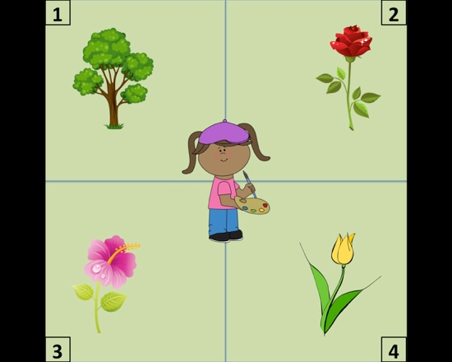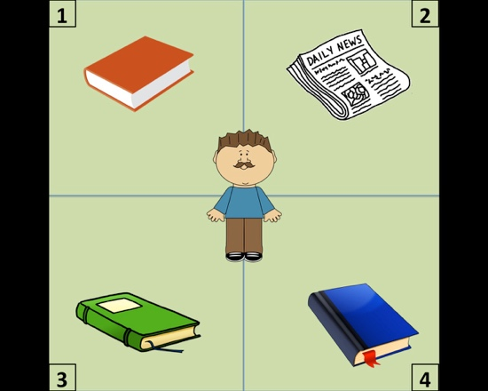

1. The painter will want to draw the/a… 2. The man will read the/a…

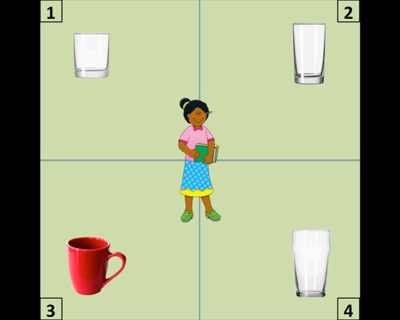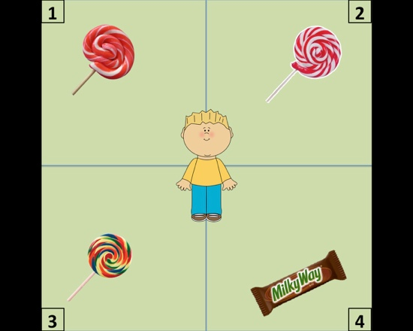

3. The woman will buy the/a… 4. The child will eat the/a…

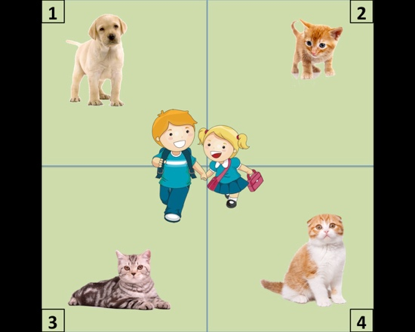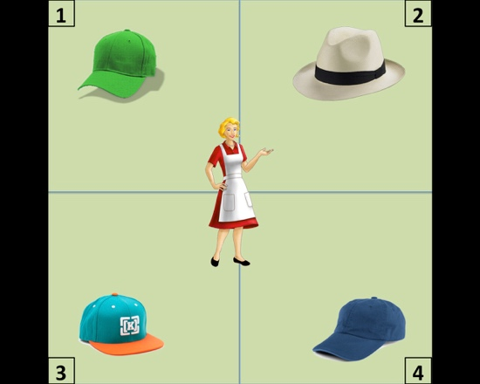

5. The children will buy the/a… 6. The lady will choose the/a…

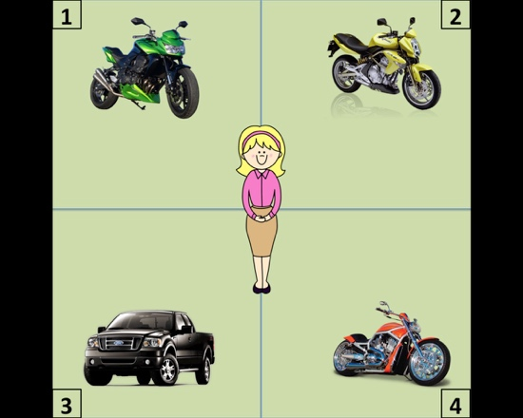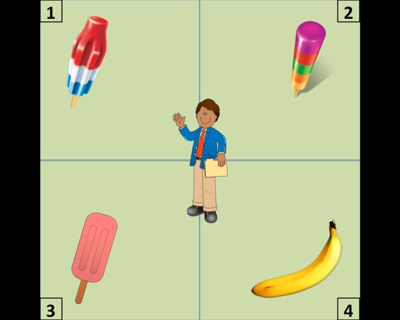

7. The woman will test−drive the/a… 8. The man will taste the/a…

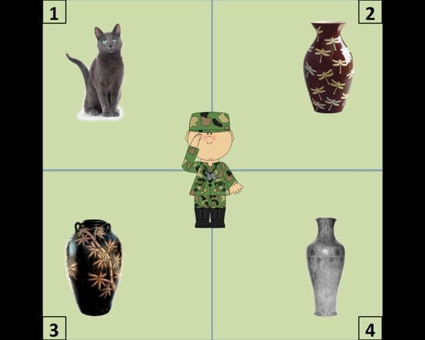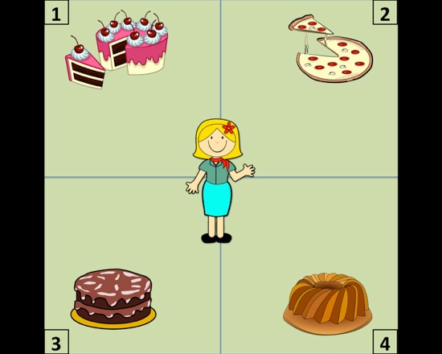

9. The soldier will photograph the/a… 10. The customer will order the/a…

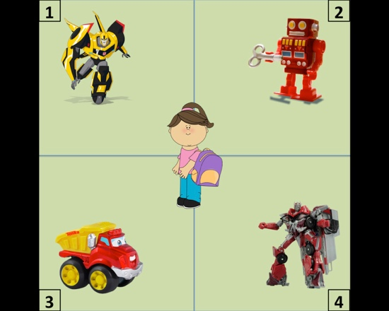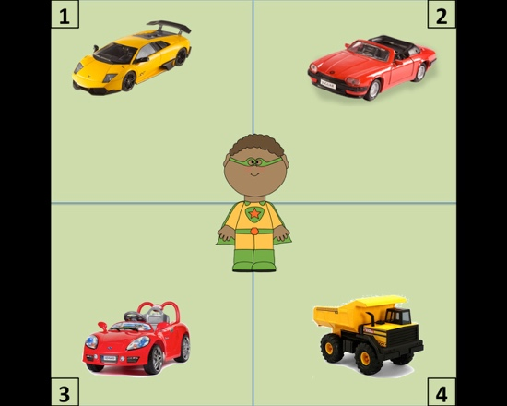

11. The girl will select the/a… 12. The boy will purchase the/a…

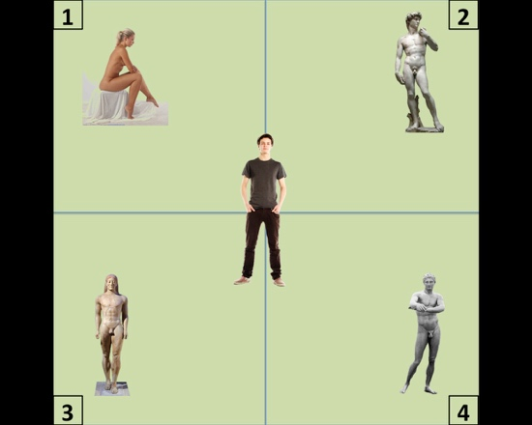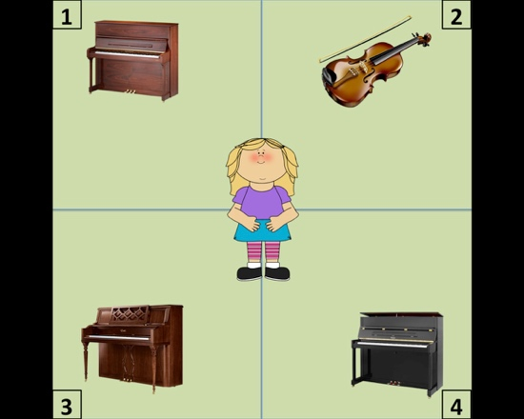

13. The painter will paint the/a… 14. The kid will try the/a…

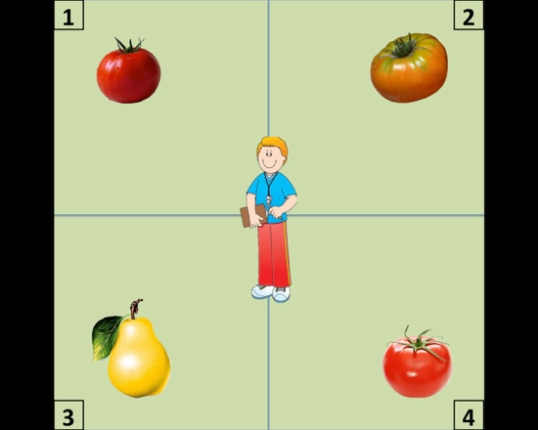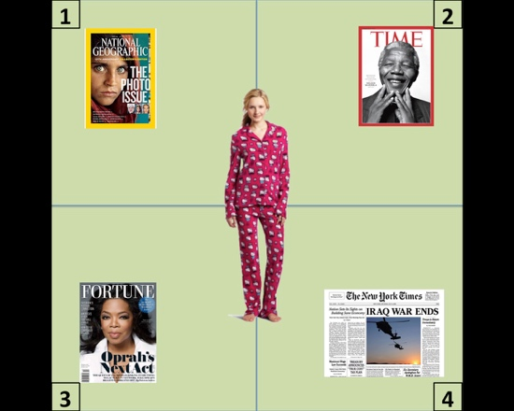

15. The man will throw the/a… 16. The woman will toss the/a…

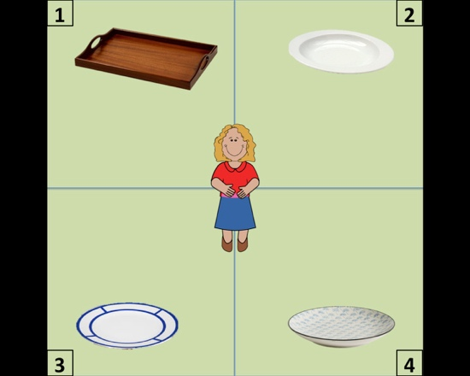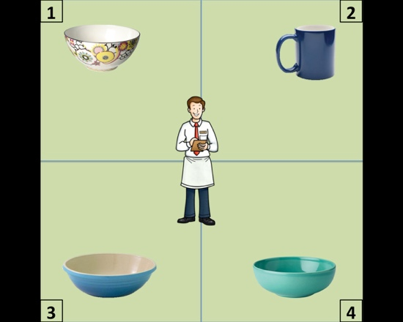

17. The lady will carry the/a… 18. The guy will wash the/a…

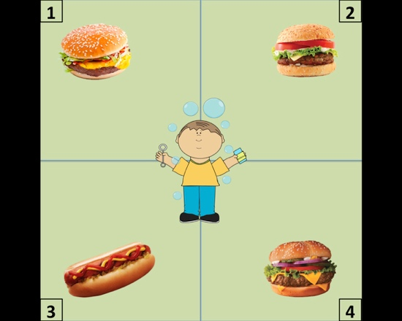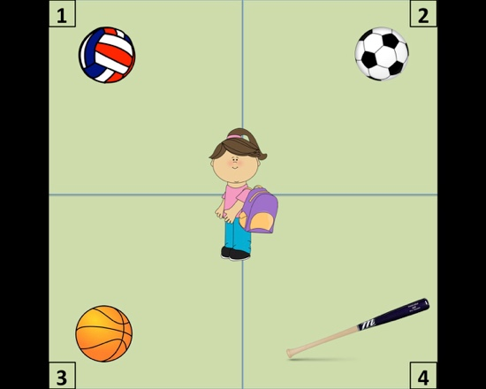

19. The boy will take the/a… 20. The girl will pick the/a…

Critical items for Experiment 2

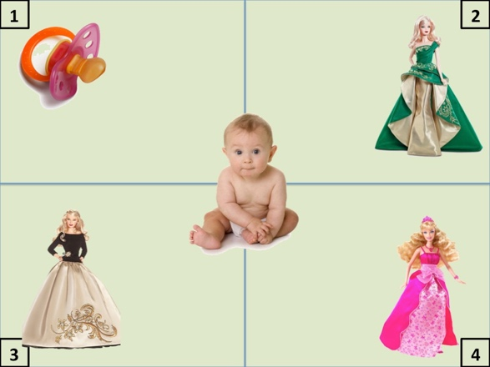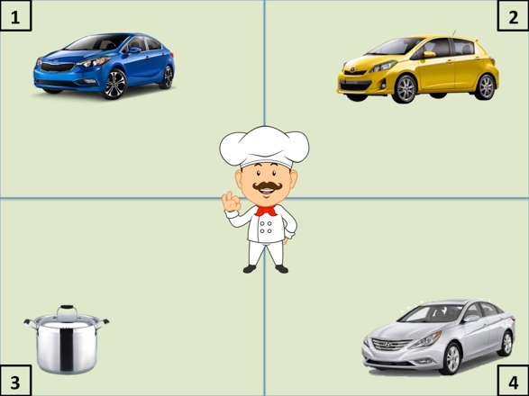

1. The baby wants to get the/a pacifier 2. The cook will probably buy the/a pot

Barbie doll car

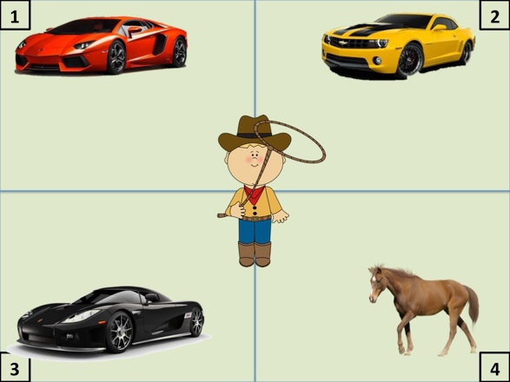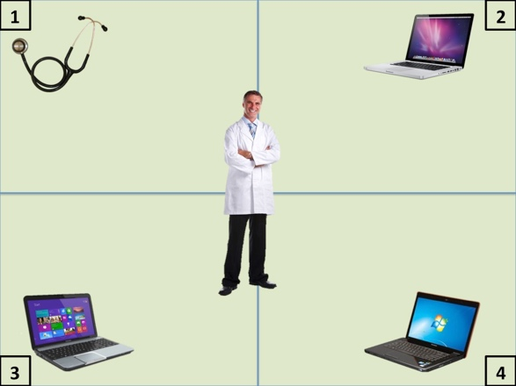

3. The boy will want to ride the/a horse 4. The man will want to use the/a stethoscope

car laptop

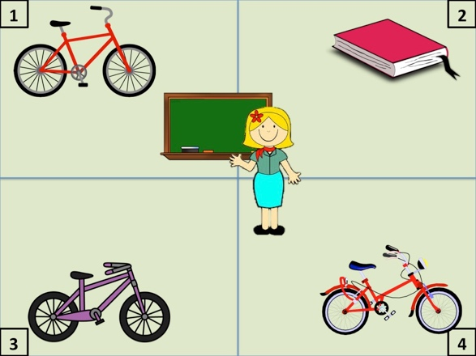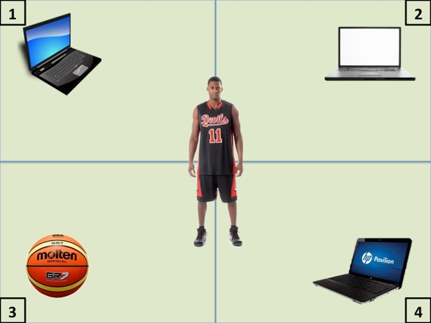

5. She will probably want the/a book 6. The man will probably want the/a basketball

bike computer

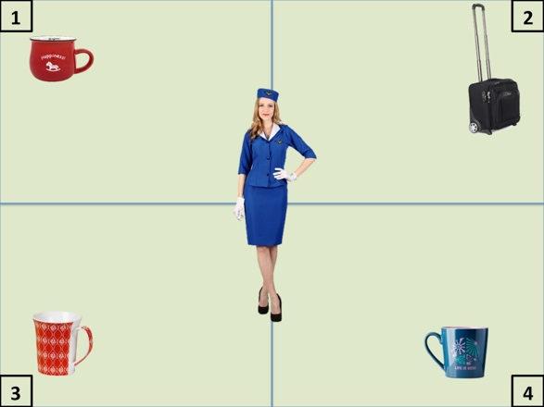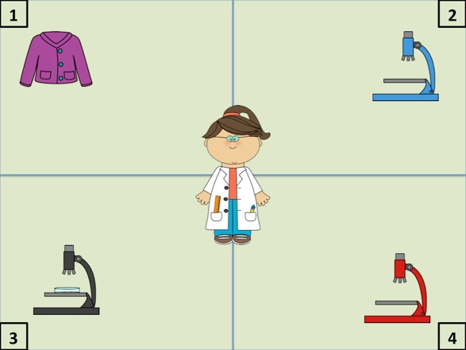

7. The woman will want to purchase the/a suitcase 8. She will want to get the/a microscope

mug sweater

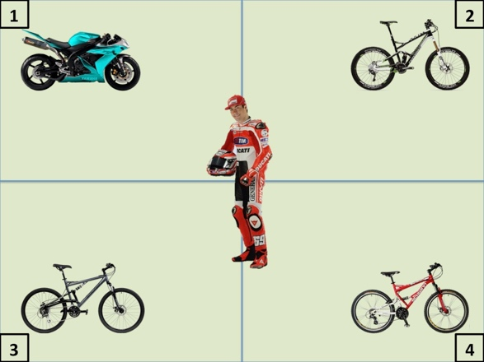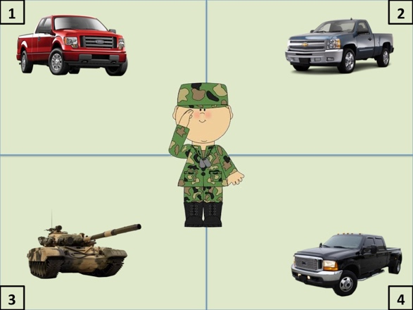

9. The man will want to ride the/a motorcycle 10. He will want to ride the/a tank

bicycle truck

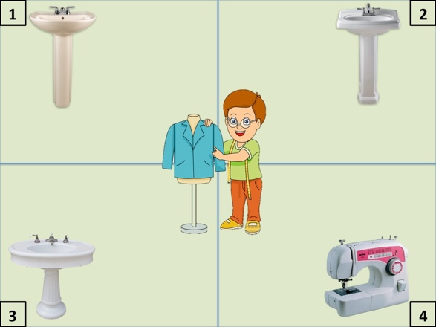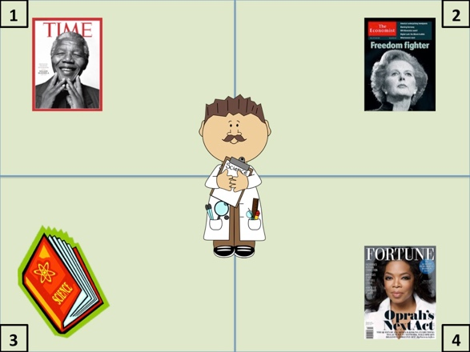

11. The man will want to repair the/a sawing machine 12. He will want to read the/a science book

bathroom sink magazine

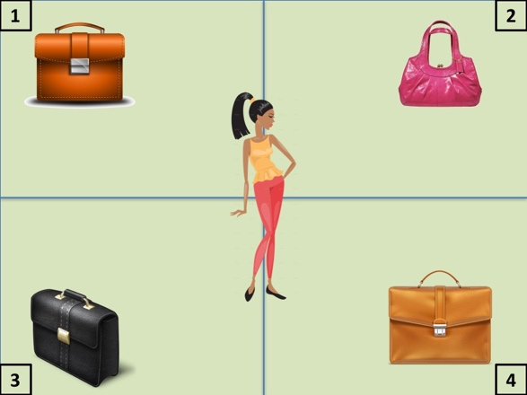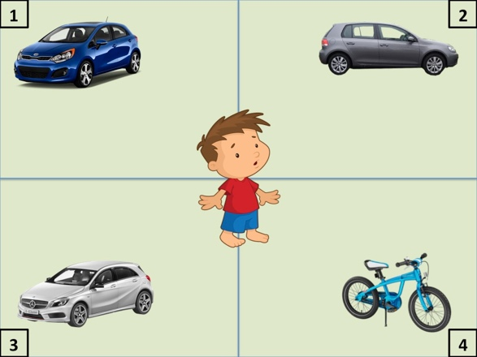

13. She will probably want the/a handbag 14. The boy will want to ride the/a bike

briefcase car

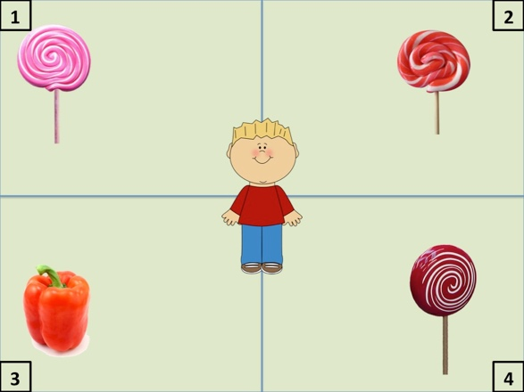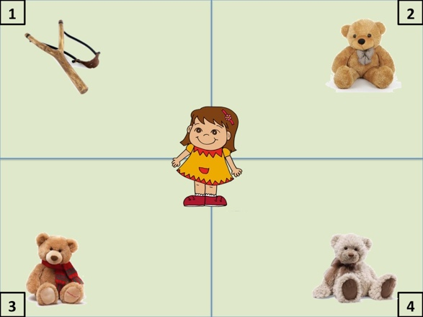

15. The child wants to taste the/a lollipop 16. The girl will want to get the/a teddy bear

bell pepper slingshot

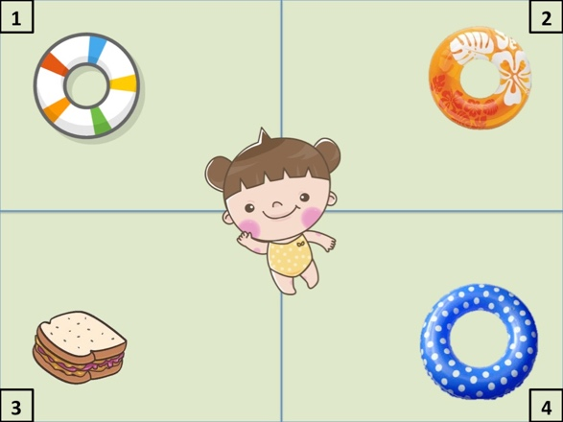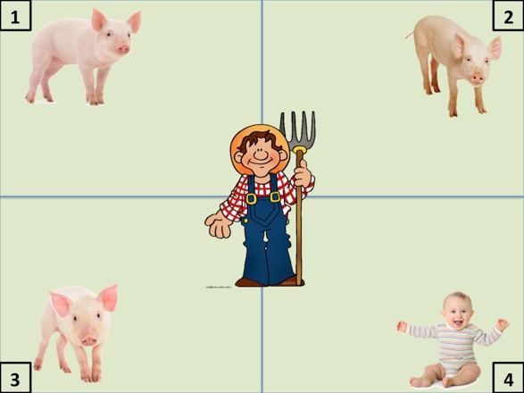

17. The girl will probably want the/a inner tube 18. The man will probably feed the/a pig

sandwich baby

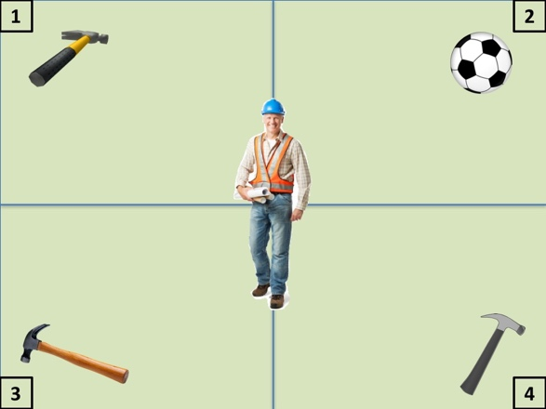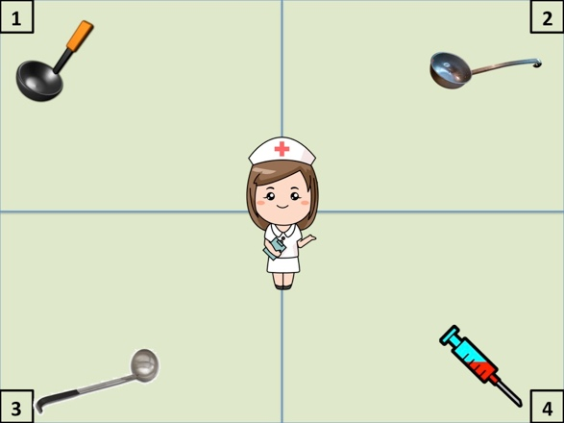

19. The man will want to get the/a hammer 20. She will want to use the/a syringe

ball ladle

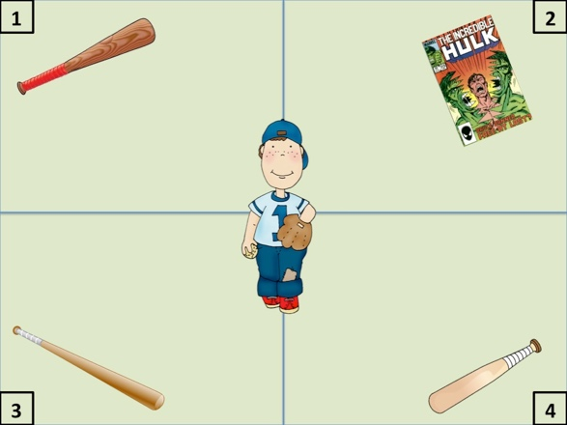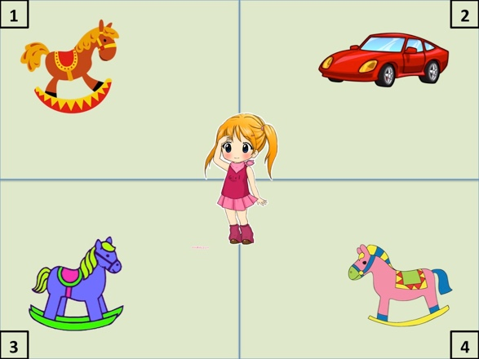

21. The boy will want to get the/a baseball bat 22. The girl will want to ride the/a horse

comic book car

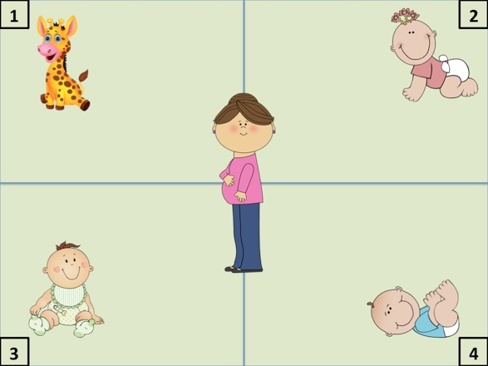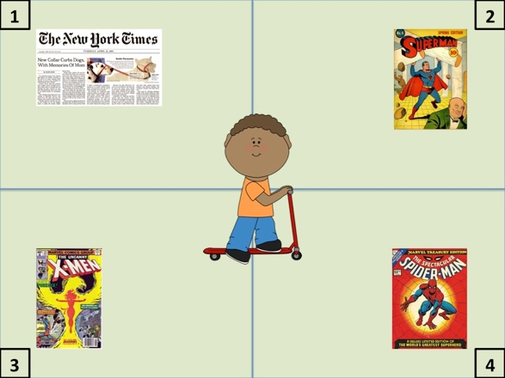

23. She will feed the/a baby 24. He will want to read the/a comic book

giraffe newspaper

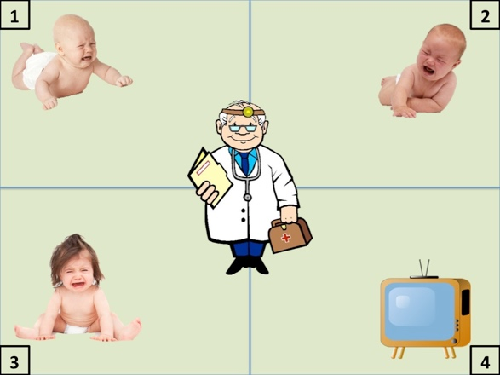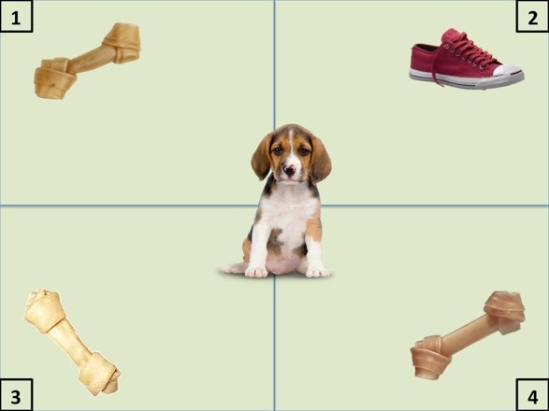

25. The man will examine the/a baby 26. The puppy will want to chew on the/a bone

TV shoe

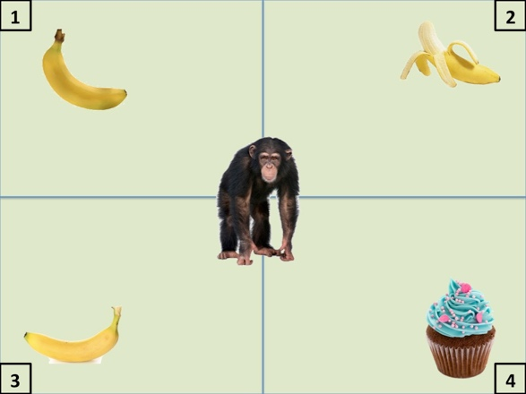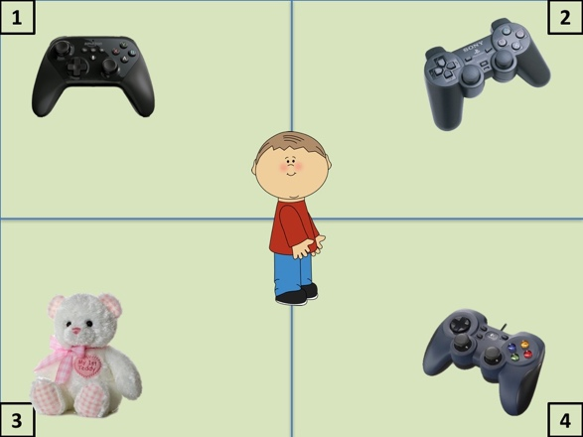

27. The chimpanzee will want to eat the/a banana 28. The child will want to play with the/a Gameboy

cupcake teddy bear

Additional Statistics

Table S1. With article – L1

Fixed Effects
 |  | Estimate |  | SE |  | Lower CI |  |  | Upper CI |  |  | t value |  | Pr(>|t|)
(Intercept) |  | −0.102 |  | 0.052 |  | −0.205 |  | 0.000 |  |  | −1.963 |  | 0.060 |  | .
EG |  | 0.047 |  | 0.050 |  | −0.052 |  | 0.145 |  |  | 0.928 |  | 0.354
PW |  | 0.234 |  | 0.084 |  | 0.070 |  | 0.399 |  |  | 2.798 |  | 0.009 |  | **
article |  | −0.033 |  | 0.050 |  | −0.131 |  | 0.066 |  |  | −0.647 |  | 0.518
EG:PW |  | −0.213 |  | 0.101 |  | −0.410 |  | −0.016 |  |  | −2.121 |  | 0.034 |  | *
EG:article |  | −0.098 |  | 0.199 |  | −0.489 |  | 0.292 |  |  | −0.493 |  | 0.626
PW:article |  | −0.043 |  | 0.101 |  | −0.240 |  | 0.154 |  |  | −0.432 |  | 0.666
EG:PW:article |  | −0.413 |  | 0.304 |  | −1.009 |  | 0.184 |  |  | −1.355 |  | 0.187
Random effects:
Groups | Name |  | Variance |  | Std.Dev |  | Corr
Subject | (Intercept) |  | 0.009 |  | 0.094
 | PW |  | 0.044 |  | 0.209 |  | 0.3
item | (Intercept) |  | 0.052 |  | 0.228
 | PW |  | 0.092 |  | 0.304 |  | −0.71
Residual |  |  | 0.568 |  | 0.754

Table S2. With article – L2

Fixed Effects
 | Estimate | SE | Lower CI | Upper CI | t value | Pr(>|t|)
(Intercept) | -0.062 | 0.059 | -0.178 | 0.054 | -1.049 | 0.303
EG | -0.091 | 0.041 | -0.171 | -0.011 | -2.235 | 0.034 | *
PW | 0.147 | 0.039 | 0.072 | 0.223 | 3.811 | 0.000 | ***
article | -0.061 | 0.041 | -0.141 | 0.018 | -1.506 | 0.144
EG:PW | -0.069 | 0.078 | -0.221 | 0.083 | -0.892 | 0.372
EG:article | 0.081 | 0.232 | -0.373 | 0.534 | 0.348 | 0.731
PW: article | -0.023 | 0.078 | -0.175 | 0.130 | -0.293 | 0.770
EG:PW:article | -0.177 | 0.155 | -0.480 | 0.125 | -1.149 | 0.251
Random Effects
Groups | Name | Variance | Std.Dev. | Corr
Subject | (Intercept) | 0.006 | 0.079
item | (Intercept) | 0.083 | 0.289
 | agk1 | 0.004 | 0.063 | -0.11
Residual |  | 0.424 | 0.651

Table S3. Pairwise Comparisons between Conditions in Experiment 2 – L1 Speakers

Unique Target Referent |  |  |  |  | estimate | SE | t.ratio | p.value
the | stethoscope | vs. | a | stethoscope | −0.142 | 0.105 | −1.361 | 0.524
the | stethoscope | vs. | the | laptop | −0.260 | 0.135 | −1.928 | 0.228
the | stethoscope | vs. | a | laptop | −0.145 | 0.136 | −1.073 | 0.707
a | stethoscope | vs. | the | laptop | −0.117 | 0.134 | −0.873 | 0.819
a | stethoscope | vs. | a | laptop | −0.003 | 0.135 | −0.022 | 1
the | laptop | vs. | a | laptop | 0.114 | 0.100 | 1.146 | 0.661
Non-unique Target Referents |  |  |  |  | estimate | SE | t.ratio | p.value
a | hammer | vs. | the | hammer | −0.164 | 0.098 | −1.668 | 0.341
a | hammer | vs. | a | soccer ball | −0.423 | 0.133 | −3.175 | 0.013
a | hammer | vs. | the | soccer ball | −0.417 | 0.133 | −3.144 | 0.014
the | hammer | vs. | a | soccer ball | −0.259 | 0.133 | −1.945 | 0.222
the | hammer | vs. | the | soccer ball | −0.253 | 0.132 | −1.909 | 0.237
a | soccer ball | vs. | the | soccer ball | 0.006 | 0.101 | 0.057 | 1.000

Table S4. Pairwise Comparisons between Conditions in Experiment 2 – Advanced L2 Speakers
Unique Target Referent |  |  |  |  | estimate | SE | t.ratio | p.value
the | stethoscope | vs. | a | stethoscope | 0.106 | 0.082 | 1.289 | 0.572
the | stethoscope | vs. | the | laptop | −0.149 | 0.078 | −1.904 | 0.227
the | stethoscope | vs. | a | laptop | 0.049 | 0.081 | 0.610 | 0.929
a | stethoscope | vs. | the | laptop | −0.255 | 0.080 | −3.183 | 0.011
a | stethoscope | vs. | a | laptop | −0.057 | 0.079 | −0.719 | 0.890
the | laptop | vs. | a | laptop | 0.198 | 0.079 | 2.510 | 0.065
Non-unique Target Referents |  |  |  |  | estimate | SE | t.ratio | p.value
a | hammer | vs. | the | hammer | 0.007 | 0.079 | 0.083 | 1
a | hammer | vs. | a | soccer ball | −0.215 | 0.076 | −2.819 | 0.025
a | hammer | vs. | the | soccer ball | −0.162 | 0.078 | −2.074 | 0.170
the | hammer | vs. | a | soccer ball | −0.221 | 0.079 | −2.817 | 0.030
the | hammer | vs. | the | soccer ball | −0.168 | 0.077 | −2.196 | 0.125
a | soccer ball | vs. | the | soccer ball | 0.053 | 0.078 | 0.676 | 0.906

