On-line Supplementary Materials for
“Elicited Imitation as a Measure of L2 Proficiency: New Insights from a Comparison of Two L2 English Parallel Forms,” by Shu-Ling Wu, Yee Pin Tio, & Lourdes Ortega, forthcoming in Studies in Second Language Acquisition, accepted on Dec 16, 2020
Table A The relationship between EI performances and CAF measures across nine EIT studies
Study & L2 of EIT | General Measures
 | Syntactic Complexity | Lexical Complexity | Accuracy | Fluency
Iwashita (2006), Japanese | number of clauses per T-unit (r=.49), mean length of T-unit (r=.35)
Tracy-Ventura et al. (2014), French |  | D on oral interviews (r=.62) |  | syllables per minute (r= .67)
Kim et al. (2016), Korean | number of morphemes per clause (r= .55) |  | correct clause rate (r=.47) | number of morphemes per minute (r=.62)
Huensch & Tracy-Ventura (2017), French & Spanish |  |  |  | EIT plus 2 other factors together contribute to mean syllable duration (R²=.33) and mean silent pause duration within AS-unit (R²=.19) on Time 1 only (before studying abroad)
Duran-Karaoz & Tavakoli (2020), English |  |  |  | syllables per minute (R²=48%)
Park et al. (2020), Spanish | number of words per number of AS-units (R²=10%) |  | number of error-free clauses divided by number of clauses (R²=50%) | length of pauses (R²=3%), syllables divided by total speech time (r=.60)
Study & L2 of EIT | Specific Measures
 | Syntactic Complexity | Lexical Complexity | Accuracy | Fluency
Wu & Ortega (2013), Mandarin |  | number of motion verb types (r=.53) | number of motion clauses (r=.53) | number of clauses (r=.48)
Park (2020)¹, English | frequency of path in motion events (r=.55; stepwise regression, 30.7%), frequency of manner in motion events (r=.29, in regression 8.6%) | path verbs like to cross (7.7%), manner verbs like to walk (10.1%), generic motion verbs like to get (into the room) (6.4%), and non-motion verbs like the copula be (14.8%)
McManus & Liu (2020), Mandarin |  | number of motion verb types (r =.73) | number of motion clauses (r =.75) | number of clauses (r =.74)
Notes. 1. Information retrieved from Park’s (2015) dissertation [Park, H. I. (2015). Language and cognition in monolinguals and bilinguals: A study of spontaneous and caused motion events in Korean and English. (Unpublished Ph.D. dissertation). Georgetown University, Washington, DC.]
2. Studies are listed by chronological order.
3. All EIT instruments were designed and scored after Ortega et al. (2002).
4. Results reported by authors as Pearson correlations are given in r, as multiple regression in R² or %.
5. AS-unit = Analysis of Speech unit; T-unit = Terminal unit. D = lexical diversity measure.

Table B EIT scoring rubric (based on Ortega et al., 2002)
Item Score | Description | Illustration of Item 11 on EIT A & B
4 | Perfect repetition | - The little boy whose kitten died yesterday is sad.  - The young man whose horse ran away yesterday is mad.
3 | Accurate content repetition with some (ungrammatical or grammatical) changes of form | -The little boy whose kitten died yesterday is very sad.  -The young man whose horse run away yesterday is mad.
2 | Changes in content or in form that affect meaning | - The little boy whose cat died was sad.  - The young man whose horse…was mad
1 | Repetition of half or less of the stimulus leading to substantial loss of meaning | - The boy is sad.  - The young man whose horse
0 | Silence, only one word repeated, or unintelligible repetition | -No response  -The man
Note. Illustrations are sampled from the data in the present study.

Table C Descriptive statistics on Can-Do Statements and complexity-accuracy-fluency (CAF) measures (N=82)
 |  | Mean | SD | 95% CIs | Min-Max
Can-Do Statements | Listening | 41.06 | 7.36 | 39.44, 42.68 | 26-55
 | Speaking | 41.20 | 9.07 | 39.20, 43.19 | 22-55
CAF Measures | Number of Clauses | 19.51 | 8.05 | 17.74,21.28 | 5-68
 | Number of Motion Clauses | 12.96 | 4.02 | 12.08, 13.85 | 3-25
 | Number of Motion Verb Types | 7.77 | 2.45 | 7.23, 8.31 | 2-17
 | Speech Rate | 106.82 | 36.18 | 99.09, 114.55 | 35.13-181.09
Notes: 1. The maximum possible score for Can-Do Statements was 55.
2. Speech Rate is expressed in syllables per minute.

Table D Recruitment grouping by proficiency cluster grouping
 | All | Low | Mid | High | Advanced
Full-time Employees | 26 | 13 | 10 | 3 | 0
Non-English Majors | 21 | 0 | 6 | 10 | 5
English Majors | 20 | 0 | 4 | 7 | 9
Overseas Chinese | 15 | 0 | 2 | 9 | 4
Total | 82 | 13 | 22 | 29 | 18

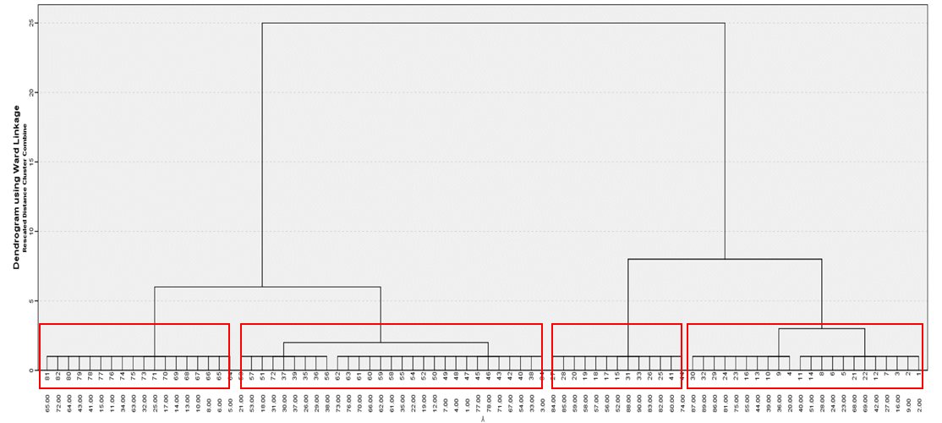
Figure A Dendrogram of cluster analysis

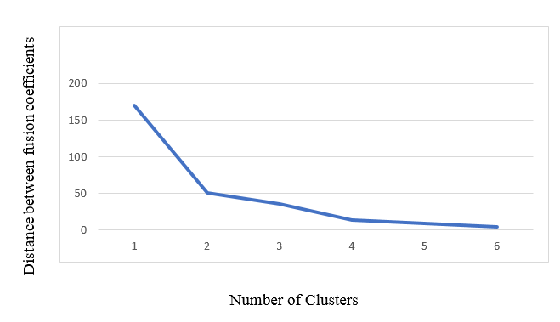
Figure B Distance between fusion coefficients against number of clusters

Appendix A: Sentence stimuli (with syllable length in parentheses)
English Elicited Imitation Task A (original from Ortega et al., 2002)
1. I have to get a haircut. (7)
2. The red book is on the table. (8)
3. The streets in this city are wide. (8)
4. He takes a shower every morning. (9)
5. What did you say you were doing today? (10)
6. I doubt that he knows how to drive that well. (10)
7. After dinner I had a ling, peaceful nap. (11)
8. It is possible that it will rain tomorrow. (12)
9. I enjoy movies which have a happy ending. (12)
10. The houses are very nice but too expensive. (12)
11. The little boy whose kitten died yesterday is sad. (13)
12. That restaurant is supposed to have very good food. (13)
13. I want a nice, big house in which my animals can live. (14)
14. You really enjoy listening to country music, don't you? (14)
15. She just finished painting the inside of her apartment. (14)
16. Cross the street at the light and then just continue straight ahead. (15)
17. The person I'm dating has a wonderful sense of humor. (15)
18. She only orders meat dishes and never eats vegetables. (15/16)
19. I wish the price of town houses would become affordable. (15)
20. I hope it will get warmer sooner this year than it did last year. (16)
21. A good friend of mine always takes care of my neighbor’s three children. (16)
22. The black cat that you fed yesterday was the one chased by the dog. (16)
23. Before he can go outside, he has to finish cleaning his room. (16)
24. The most fun I've ever had was when we went to the opera. (16)
25. The terrible thief whom the police caught was very tall and thin. (17)
26. Would you be so kind as to hand me the book which is on the table? (17)
27. The number of people who smoke cigars is increasing every year. (17/18)
28. I don't know if the 11:30 train has left the station yet. (18)
29. The exam wasn't nearly as difficult as you told me it would be. (18)
30. There are a lot of people who don’t eat anything at all in the morning. (19)

English Elicited Imitation Task B (developed for the present study by Wu, Tio, & Ortega)
1. I have to buy a bus pass. (7)
2. The blue hat is under the bed. (8)
3. The parks in this town are old. (8)
4. She takes a walk every afternoon. (9)
5. Where did you think you were going tonight? (10)
6. I doubt that she knows what to say that fast. (10)
7. Before lunch I watched a funny TV show. (11)
8. It is likely that it will be sunny this week. (12)
9. I dislike novels which have many characters. (12)
10. The dresses are too long but very beautiful. (12)
11. The young man whose horse ran away yesterday is mad. (13)
12. That liquor store is supposed to have excellent wine. (13)
13. I want a large, quiet yard in which he can grow flowers. (14)
14. They really like hanging out with their college friends, don’t they? (14)
15. She just started cleaning the bottom of the microwave. (14)
16. Turn right at the next traffic light and then stay in the left lane. (15)
17. The friend I’m visiting has a fantastic set of guitars. (15)
18. She usually wears baggy jeans and hardly puts on makeup. (15)
19. I wish the cost of modern homes could become reasonable. (15)
20. I hope it will be hotter later this week than it was last week. (16)
21. A neighbor of mine always kindly helps with my father’s two cats. (16)
22. The white cup that you broke today was the one ordered by your mom. (16)
23. After I pick up the laundry, I plan on catching a movie. (16)
24. The worst time I’ve ever had was when we had a car accident. (16)
25. The sweet nurse whom the patient hired was really nice and caring. (16)
26. Would you be so nice as to pass me the glass which is in the cupboard? (17)
27. The pool of people who meet the requirements is expanding each month (17)
28. I’m not sure if the 7:45 flight has taken off on time. (17)
29. The competition wasn’t as intensive as you suggested it would be. (18)
30. There are many solutions that haven’t been brought up yet to resolve the issue. (19)

Appendix B: Self-diagnostic survey

Regarding the English Repetition Task
1. How do you evaluate the overall level of difficulty of the repetition task?
5: Extremely difficult
4: Quite difficult
3: Somewhat difficult
2: Slightly difficult
1: Not at all difficult

2. How do you evaluate your overall performance on the repetition task?
5: Excellent
4: Good
3: Average
2: Fair
1: Needs improvement

3. Please use the following scale to rate how frequently each statement below affects your performance on the repetition task.
5: almost always
4: frequently
3: sometimes
2: occasionally
1: never

____ I find some sentences hard to understand because there are vocabulary words I don’t know.
____ I find some sentences hard to understand because the sentences are too long to follow.
____ I find some sentences hard to understand because the grammar/structure throws me off.
____ I find some sentences hard to understand because they are isolated sentences without context.
____ I find some sentences hard to understand because the pace of speech is too fast for me to follow.
____ I find some sentences hard to understand because of insufficient time for me to process the meaning.
____ I find some sentences hard to understand because the accent and pronunciation are unfamiliar to me.
____ Other. Please elaborate______________________________________________________

4. Please use the following scale to rate how frequently each statement affects you.
5: almost always
4: frequently
3: sometimes
2: occasionally
1: never

____ I find it hard to repeat because I don’t understand a portion of some sentences I heard.
____ I find it hard to repeat because some sentences are too long to remember.
____ I find it hard to repeat because I have a hard time reproducing some grammar/structure.
____ I find it hard to repeat because I have a hard time pronouncing some vocabulary words.
____ I find it hard to repeat because I remember the main idea of the sentence but forget the exact wording or the details of it.
____ I find it hard to repeat because I speak too slow to repeat the sentence within the given time.
_______ Other. Please elaborate ___________________________________________________

5. In this repetition task, which is more challenging to you, understanding the sentence or repeating the sentence? Why?

Regarding Your English Language Ability
6. Based on your own assessment, how would you rate your overall listening skills?
5: Excellent
4: Good
3: Average
2: Fair
1: Needs improvement
7. Please use the following scale to rate how well you can perform the following tasks in English.
5: not at all difficult
4: slightly difficult
3: somewhat difficult
2: quite difficult
1: extremely difficult

___ I can understand greetings.
___ I can understand days of the week and the hour.
___ I can sometimes understand a simple transaction between a customer and a sales clerk.
___ I can understand questions about my likes and dislikes.
___ I can understand that an event is being postponed or cancelled.
___ I can understand a voice message from the airlines about changes to a flight schedule.
___ I can understand short presentations about famous people in history.
___ I can understand an interview with a famous person, such as a rock star, politician, or actor.
___ I can understand a group leader’s justification for protesting a cut in programs.
___ I can understand a speech on a historical period.
___ I can understand the plot and cultural implications of oral narratives such as folk and fairy tales.
8. Based on your own assessment, how would you rate your overall speaking skills?
5: Excellent
4: Good
3: Average
2: Fair
1: Needs improvement
9. Please use the following scale to rate how well you can perform the following tasks.
5: not at all difficult
4: slightly difficult
3: somewhat difficult
2: quite difficult
1: extremely difficult

___ I can say hello and goodbye.
___ I can introduce myself and provide basic personal information.
___ I can ask for directions to a place.
___ I can make a reservation.
___ I can give reasons for my preferences.
___ I can talk about my family history.
___ I can explain how life has changed since I was a child and respond to questions on the topic.
___ I can discuss future plans, such as where I want to live and what I will be doing in the next few years.
___ I can usually defend my views in a debate.
___ I can put forth and react to others’ complex ideas during a business discussion.
___ I can use my language persuasively to advocate a point of view that is not necessarily my own.

Regarding Your History of Learning the English Language
1. What is your major in college? __________________
2. At what age did you start to learn English? ______________ (years old)
3. How long (in years) in total have you studied English at school? _________________ (years)
4. Have you visited/lived in an English-speaking country? □ No □ Yes (if YES, see below)
I have been to ____________ (name of the country) for _____________ (week/month/year)
I have been to ____________ (name of the country) for _____________ (week/month/year)
5. Use the following scale to rate how often you hear or use English in your daily life?
5: almost always 4: frequently 3: sometimes 2: occasionally 1: never
6. If you circled scale 3, 2, or 1 for question 5, how long (in years) have you stopped studying or using English regularly? __________________ (years)

Appendix C: Oral narrative task
Source: Wu & Ortega (2013) shown with copyright permission of artist and authors.

Instructions: You will see 12 sequential pictures in this task. Your job is to tell a story in English to describe what you see in as much detail as you can.
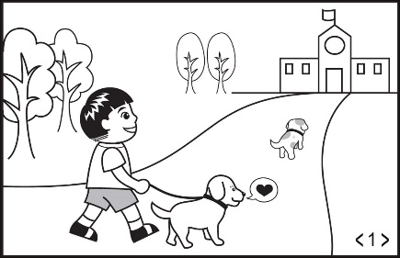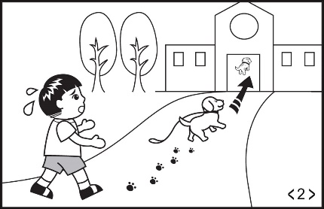
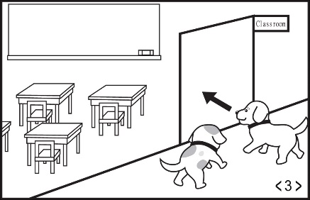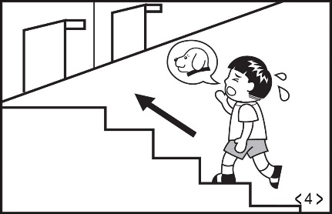
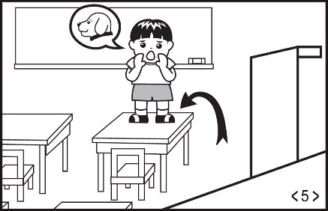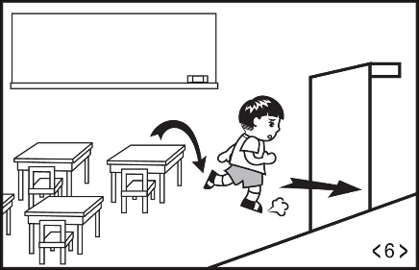
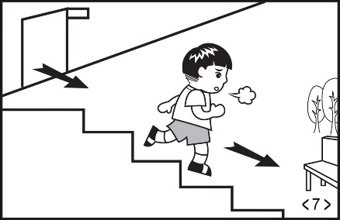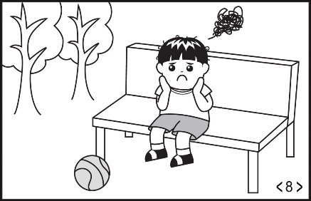
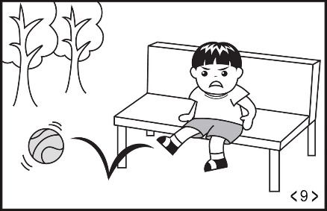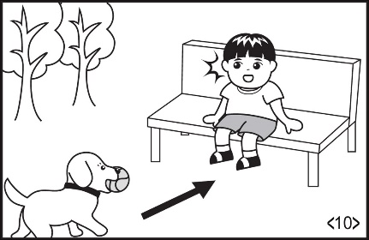
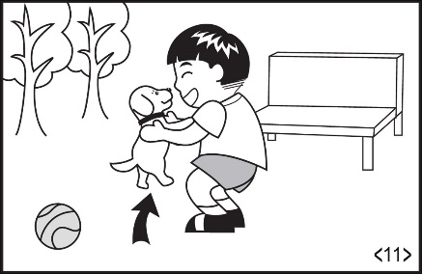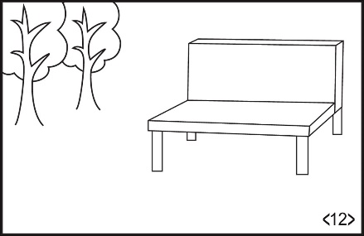

Appendix D: Sentence stimuli (revised and blended)
Revised Form A (odd-number items from EIT A, even-number items from EIT B)
Note. The blended and revised forms below include modification to two sentences from Form B:
1) Item 26 of the revised Form A was changed to: “Would you be so nice as to pass me the hat which is under the bed?” This change removes the more difficult vocabulary “glass” and “cupboard” and creates a priming effect after Item 2 “The blue hat is under the bed” is presented, making it comparable to Item 2 and Item 26 of the revised Form B.
2) Item 13 of the revised Form B was changed to: I want a large, quiet yard in which I can grow flowers. The pronoun in the relative clause was changed from “he” to “I” to reduce the larger burden in repetition caused by a change of pronoun in the relative clause.

1. I have to get a haircut. (7)
2. The blue hat is under the bed. (8)
3. The streets in this city are wide. (8)
4. She takes a walk every afternoon. (9)
5. What did you say you were doing today? (10)
6. I doubt that she knows what to say that fast. (10)
7. After dinner I had a long, peaceful nap. (11)
8. It is likely that it will be sunny this week. (12)
9. I enjoy movies which have a happy ending. (12)
10. The dresses are too long but very beautiful. (12)
11. The little boy whose kitten died yesterday is sad. (13)
12. That liquor store is supposed to have excellent wine. (13)
13. I want a nice, big house in which my animals can live. (14)
14. They really like hanging out with their college friends, don’t they? (14)
15. She just finished painting the inside of her apartment. (14)
16. Turn right at the next traffic light and then stay in the left lane. (15)
17. The person I'm dating has a wonderful sense of humor. (15)
18. She usually wears baggy jeans and hardly puts on makeup. (15)
19. I wish the price of town houses would become affordable. (15)
20. I hope it will be hotter later this week than it was last week. (16)
21. A good friend of mine always takes care of my neighbor’s three children. (16)
22. The white cup that you broke today was the one ordered by your mom. (16)
23. Before he can go outside, he has to finish cleaning his room. (16)
24. The worst time I’ve ever had was when we had a car accident. (16)
25. The terrible thief whom the police caught was very tall and thin. (17)
26. Would you be so nice as to pass me the hat which is under the bed? (17)
27. The number of people who smoke cigars is increasing every year. (17/18)
28. I’m not sure if the 7:45 flight has taken off on time. (17)
29. The exam wasn't nearly as difficult as you told me it would be. (18)
30. There are many solutions that haven’t been brought up yet to resolve the issue. (19)

Revised Form B (odd-number items from EIT A, even-number items from EIT B)
1. I have to buy a bus pass. (7)
2. The red book is on the table. (8)
3. The parks in this town are old. (8)
4. He takes a shower every morning. (9)
5. Where did you think you were going tonight? (10)
6. I doubt that he knows how to drive that well. (10)
7. Before lunch I watched a funny TV show. (11)
8. It is possible that it will rain tomorrow. (12)
9. I dislike novels which have many characters. (12)
10. The houses are very nice but too expensive. (12)
11. The young man whose horse ran away yesterday is mad. (13)
12. That restaurant is supposed to have very good food. (13)
13. I want a large, quiet yard in which I can grow flowers. (14)
14. You really enjoy listening to country music, don't you? (14)
15. She just started cleaning the bottom of the microwave. (14)
16. Cross the street at the light and then just continue straight ahead. (15)
17. The friend I’m visiting has a fantastic set of guitars. (15)
18. She only orders meat dishes and never eats vegetables. (15/16)
19. I wish the cost of modern homes could become reasonable. (15)
20. I hope it will get warmer sooner this year than it did last year. (16)
21. A neighbor of mine always kindly helps with my father’s two cats. (16)
22. The black cat that you fed yesterday was the one chased by the dog. (16)
23. After I pick up the laundry, I plan on catching a movie. (16)
24. The most fun I've ever had was when we went to the opera. (16)
25. The sweet nurse whom the patient hired was really nice and caring. (16)
26. Would you be so kind as to hand me the book which is on the table? (17)
27. The pool of people who meet the requirements is expanding each month (17)
28. I don't know if the 11:30 train has left the station yet. (18)
29. The competition wasn’t as intensive as you suggested it would be. (18)
30. There are a lot of people who don’t eat anything at all in the morning. (19)

