Appendix A. Descriptive Statistics of the LLAMA Sub-components
 | n | Mean | SD | Min | Max | Possible Max
LLAMA_B | 59 | 13.58 | 3.98 | 3 | 20 | 20
LLAMA_D | 59 | 23.47 | 2.45 | 18 | 29 | 30
LLAMA_E | 54 | 17.59 | 2.46 | 11 | 20 | 20
LLAMA_F | 59 | 28.42 | 3.98 | 17 | 35 | 35
LLAMA_D (RT) | 58 | 1984 | 316 | 1,272 | 2,905 | -
LLAMA_D (CV) | 58 | 0.46 | 0.16 | 0.22 | 0.94 | -
Note. Responses provided by one participant were deemed an outlier (z > 3. 29) and this data point was removed when calculating the RT and CV of LLAMA_D. The responses provided by five participants on the LLAMA_E subtest were not recorded due to technical issues.

Appendix B. Reliability (Cronbach alpha) of LLAMA subtests

 | Current Study | Bokander and Bylund (2019)
LLAMA_B | .78 | .81
LLAMA_D | .20 (.55 and .47) | .54
LLAMA_E | .67 | .74
LLAMA_F | .73 | .60
Note. The reliability of LLAMA_F test was higher in this study compared to that obtained by Bokander and Bylund. This is most likely to be due to the inclusion of the additional 15 items in the LLAMA_F test phase. Cronbach alpha of the original 20 items (.55) was lower in the current study.

Appendix C. Correlation and Principal Component Analyses of LLAMA Tests
Correlations among the LLAMA subtests are reported in Table 1. As predicted, LLAMA_B was significantly related to LLAMA_E (r = .29, p = .03) and LLAMA_F (r = .42, p = .001), whereas no relationship between LLAMA_D (accuracy) and other subtests was noted. A weak association between RT and CV of LLAMA_D was obtained (r = .27, p = .04).

Table 1.
Correlations among the LLAMA Subtests
 | B | D | E | F | D (RT) | D (CV)
LLAMA_B | - | .05 | .29* | .42** | -.16 | .01
LLAMA_D |  | - | -.12 | -.04 | -.01 | .24
LLAMA_E |  |  | - | .15 | -.09 | .10
LLAMA_F |  |  |  | - | .03 | -.09
LLAMA_D (RT) |  |  |  |  | - | .27*
LLAMA_D (CV) |  |  |  |  |  | -
* p < .05, ** p <.01

Principal component analysis (PCA) with Varimax rotation was conducted on the four LLAMA subtest scores. Two assumptions—The Kaiser-Meyer-Olkin (KMO) of sampling adequacy and Bartlett’s test of sphericity—were checked. KMO was .53 (slightly below the satisfactory level of .60), but Barlett’s test of sphericity was significant (p = .01). Two factors were extracted, the first of which (eigenvalue = 1.60) accounted for 40.10% of the total variance, and the second (eigenvalue = 1.07) accounted for 26.77% of additional variance. This solution explained nearly 67% of the total variance, which is almost identical to the value previously reported by Bokander and Bylund (2019). The rotated solution shows that LLAMA_B and LLAMA_F loaded onto the first factor, while LLAMA_D loaded strongly onto the second factor (see Table 2). The size of LLAMA_E loading was comparable for the two factors, but the sign was positive for the first factor and negative for the second factor.

Table 2.
Loadings for Principal Component Analysis (Varimax Rotation)

 | Component
 | 1 | 2
LLAMA_B | .85 | .03
LLAMA_D | .15 | .90
LLAMA_E | .51 | -.53
LLAMA_F | .77 | .02

Because in this study the modified LLAMA_D yielded two additional indices (RT and CV), another PCA was conducted on those two measures, along with the four LLAMA subtest scores. KMO was not satisfactory (.49), and Barlett’s test of sphericity was marginally significant (p = .06). Given the violation of these two assumptions, the results presented here should be interpreted with caution. Three factors with the eigenvalues exceeding 1.00 were extracted. The first factor (eigenvalue = 1.60) accounted for 26.72% of the total variance, the second factor (eigenvalue = 1.36) accounted for the additional 22.74%, and the third factor (eigenvalue = 1.04) accounted for further 17.35%, yielding the total of 66.81%. The rotated factor loadings presented in Table 3 indicate that three LLAMA subtests (B, E, and F) loaded strongly on the first component. While RT and CV of LLAMA_D loaded on the second component, the accuracy score of LLAMA_D loaded on the third component. This suggests that accuracy and RT/CV of the LLAMA_D tap into different abilities.

Table 3.
Loadings for Principal Component Analysis with LLAMA_D Speed Measures (Varimax Rotation)

 | Component
 | 1 | 2 | 3
LLAMA_B | .81 | -.16 | .12
LLAMA_D | -.10 | .02 | .93
LLAMA_E | .61 | -.01 | -.21
LLAMA_F | .72 | .16 | -.01
LLAMA_D (RT) | -.10 | .87 | -.16
LLAMA_D (CV) | .15 | .69 | .41

Appendix D. Descriptive Statistics of Familiar and New LLAMA_D Items

Measure | Item Type | Mean | SD | Min | Max
Accuracy | Familiar | 11.69 | 2.09 | 7.00 | 15.00
 | New | 11.78 | 1.86 | 7.00 | 15.00
RT | Familiar | 1857 | 410 | 1252 | 3340
 | New | 2133 | 383 | 1296 | 3080
CV | Familiar | 0.37 | 0.14 | 0.12 | 0.69
 | New | 0.44 | 0.21 | 0.19 | 1.10

 | t | df | p | Cohen's d
Accuracy | -.21 | 58 | .83 | 0.03
RT | -4.50 | 57 | .00 | -0.59
CV | -1.87 | 57 | .07 | -0.25

Appendix E. Mean and SD of Accuracy and RT for Different Confidence Levels

[Accuracy Data]
Item Types | Confidence Rating | n | Mean | SD
Familiar | 1. Not confident at all | 37 | 0.405 | 0.365
 | 2. Slightly confident | 58 | 0.665 | 0.316
 | 3. Very confident | 54 | 0.891 | 0.211
 | 4. 100% confident | 50 | 0.982 | 0.081
New | 1. Not confident at all | 49 | 0.8 | 0.225
 | 2. Slightly confident | 59 | 0.711 | 0.233
 | 3. Very confident | 48 | 0.799 | 0.287
 | 4. 100% confident | 31 | 0.866 | 0.26

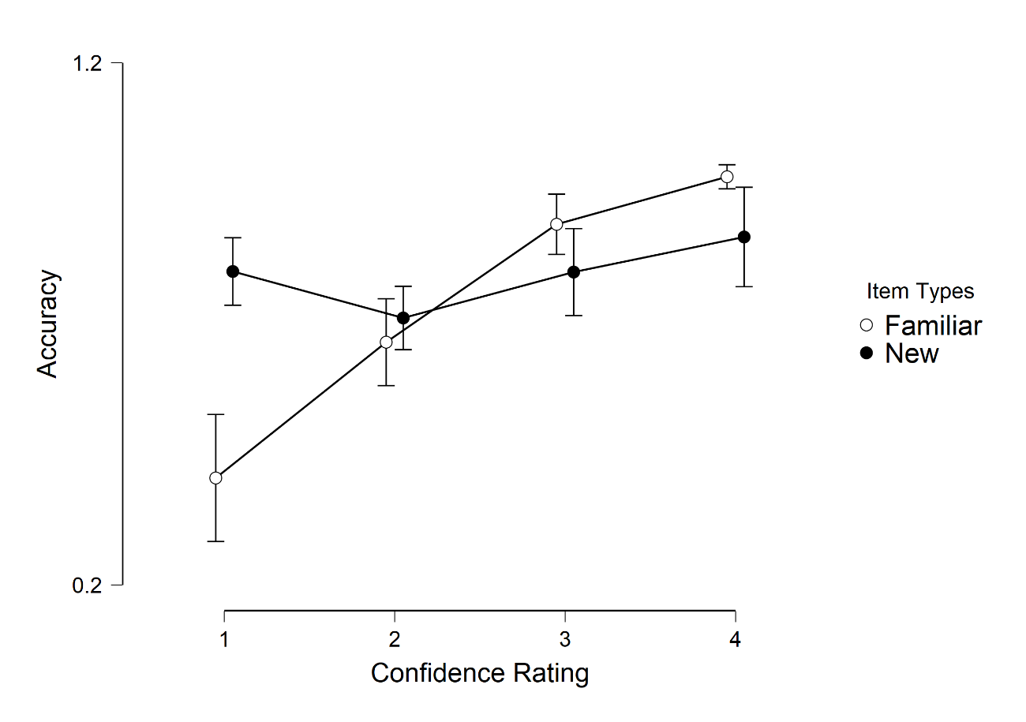

[RT Data]
Item Types | Confidence Rating | n | Mean | SD
Familiar | 1. Not confident at all | 25 | 2762 | 935
 | 2. Slightly confident | 50 | 2211 | 745
 | 3. Very confident | 52 | 1729 | 509
 | 4. 100% confident | 50 | 1544 | 387
New | 1. Not confident at all | 47 | 2419 | 753
 | 2. Slightly confident | 56 | 2256 | 727
 | 3. Very confident | 45 | 1809 | 432
 | 4. 100% confident | 30 | 1558 | 399

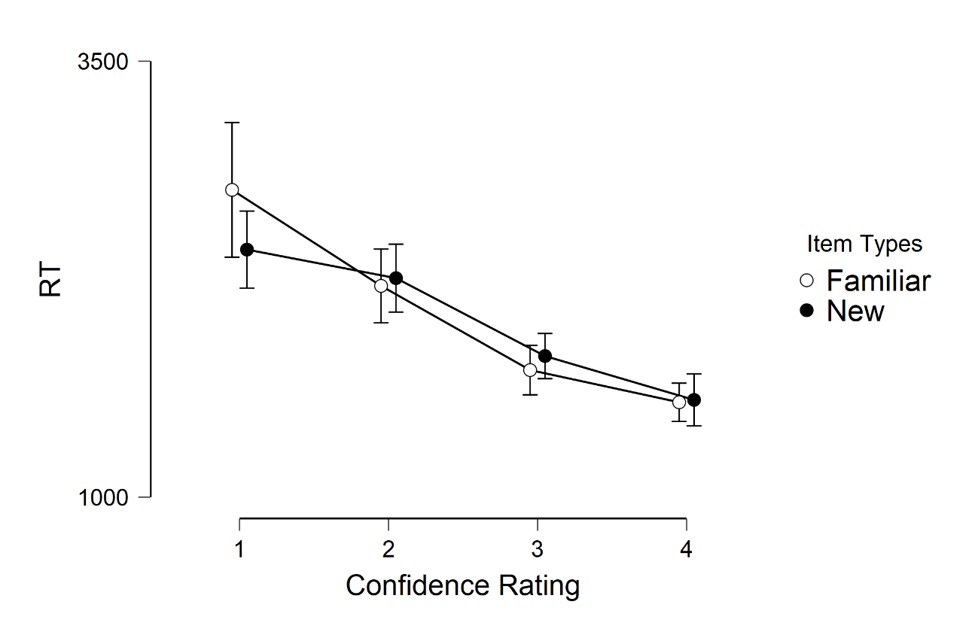

Appendix F. Pearson’s Correlations between LLAMA Scores and Fluency Measures

 | B | D | E | F | D (RT) | D (CV)
Articulation rate | -.17 | .02 | .06 | -.02 | -.19 | .10
Mid-clause pause duration | -.16 | -.14 | -.09 | .06 | -.06 | .16

