These materials contain the following additional information:
A1. Additional details for participants
A2. Additional details for stimulus design
A3. Stimuli used in the lexical decision task
A4. Grand average waveforms for all critical electrodes
A5. Additional details on primary statistical analysis
A6. Alternative ERP analysis including all trials
A7. Additional description of individual L2 participant patterns
A8. By-item accuracy and confidence for the offline vocabulary test
A1. Additional details FOR PARTICIPANTS
As a measure of their basic tone perception abilities, all participants completed a tone identification task using monosyllabic and disyllabic stimuli. Stimuli consisted of nonwords that do not occur in the standard Mandarin (Putonghua) lexicon: monosyllabic /tʃʰei/, /pou/, /fai/, /tʰiou/, and disyllabic /tʃʰeipa/, /poupa/, /faipa/, /tʰioupa/. Stimuli were produced by four Mandarin speakers (two men, two women) from northern regions of China. Each target was produced with each of the four tones. For disyllabic stimuli, the second syllable was always produced with a neutral tone. For each trial, participants had to identify the tone on only the first syllable of the target stimulus. Overall accuracy for the L1 and L2 groups is reported in Table A1.1.
Table A1.1 Group results on tone identification task
Group |  | mean (sd)
L1 | overall | 91.8 (7.4)
 | monosyllables | 91.3 (6.5)
 | disyllables | 92.3 (9.0)
L2 | overall | 85.3 (7.8)
 | monosyllables | 89.3 (4.1)
 | disyllables | 81.2 (12.4)
Full details for the tone identification experiment can be found in AUTHOR (XXXX).

A2. Additional details FOR stimulus design
We selected as many words as possible from a widely used Chinese textbook series (Intergrated Chinese, 2008); where the textbook wordlist proved insufficient, additional high frequency words were selected from the SUBTLEX-CH corpus (Cai & Brysbaert, 2010). Six critical real words were chosen for each tone combination (T1T1, T1T2, T1T3, T1T4, T2T1, etc.), avoiding words with neutral tones or erhua (a syllable final “-r” [ɚ]). An additional 32 words were chosen as fillers, two for each tone combination.
T3 sandhi is a phonological process that affects words (or phrases) with underlying sequences of T3T3, so that they are commonly realized in speech as T2T3 (for more details, see, e.g., Chao, 1968; Duanmu, 2007). There were two ways in which T3 sandhi processes might have obscured the nature of nonwords in our stimuli. We avoided both situations. First, when a word had an underlying T3T3 sequence, it was always produced by the speaker as T2T3 (i.e., applying sandhi), and its nonword competitor was never a T2T3 sequence. For words with an underlying T2T3 sequence, we never selected nonwords with an underlying T3T3 sequence (which would become T2T3 if sandhi was applied). Instead, where either of these cases applied, T1 and T4 changes were balanced across those items. This means that in the initial syllables of the stimuli overall there is a slightly higher representation of T1 and T4, and a slightly lower representation of T2 and T3.
The first syllables of all nonwords were checked against the most frequent 5000 words in the SUBTLEX-CH corpus to be sure there were viable disyllabic lexical competitors. In a small number of cases, this restriction was waved because there were competitor words L2 learners were likely to be familiar with even though they were not in the most frequent 5000 (e.g., the syllable shao3 in vowel nonword shao3du2 occurs in the word shao3shu4 ‘minority’, a somewhat less frequent word that L2 learners are nevertheless likely to know). Nonwords were checked against several large comprehensive Mandarin dictionaries using the Pleco Chinese dictionary app (Pleco Chinese Dictionary for IOS, 2018).
To minimize potential long-distance priming effects, the initial syllable of critical stimuli was never repeated within an experimental list (if fillers repeated a syllable, the filler trial always occurred after the relevant critical word).
The program WaveSurfer (Sjolander, 2000) was used for recording, which was conducted in a sound booth at the University of Maryland using the internal microphone of a laptop computer. Audio was recorded at 48,000 Hz with 16 bits per sample. Each word or nonword was presented to the speaker in Pinyin (Mandarin romanization) in a random order using a presentation script in Praat (Boersma & Weenink, 2018). Any items that were judged to be mispronounced were later re-recorded by the same speaker under the same conditions. Out of necessity, eleven items were re-recorded in a different sound booth at Beijing Normal University (these items were accidentally recorded at 44,100 Hz and later resampled to 48,000Hz). Using Praat, all stimuli were cut out of the original audio files to create individual .wav files. The average intensity of each file was scaled to 70dB, and 200 ms of silence were appended at the end of each file.
Average duration of stimuli was examined using Praat and is shown in Table A2.1. There were small differences in duration between real words and nonwords. However, given the diversity of initial syllables involved, the fact that none of them were repeated across items in a list, and that a given real word and its nonword counterpart never occurred in the same list, it seems unlikely that duration alone could be used to notice differences between conditions.
TABLE A2.1. Average durations of auditory stimuli for the Lexical Decision Task
condition | avg. dur. (sd)
real words | 600 (83)
vowel nonwords | 621 (70)
tone nonwords | 615 (73)
fillers | 600 (73)

Durations for the real words, according to their tones, are listed in Table A2.2, along with durations for the corresponding nonwords. Note that some difference in duration is to be expected due to vowel and tone changes affecting the nonwords. All T3T3 words were produced with tone sandhi.

Table A2.2. Durations of stimuli according to real word tone sequences.
tone sequence | real word | vowel nonword | tone nonword
 | mean (sd) | mean (sd) | mean (sd)
T1T1 | 616 (85) | 603 (53) | 641 (60)
T1T2 | 663 (54) | 702 (41) | 684 (69)
T1T3 | 492 (45) | 550 (77) | 605 (62)
T1T4 | 579 (61) | 614 (65) | 600 (39)
T2T1 | 601 (36) | 618 (55) | 648 (68)
T2T2 | 661 (10) | 651 (70) | 648 (49)
T2T3 | 592 (107) | 682 (71) | 618 (64)
T2T4 | 572 (97) | 626 (70) | 565 (69)
T3T1 | 614 (50) | 657 (48) | 594 (18)
T3T2 | 684 (86) | 660 (47) | 665 (74)
T3T3 | 580 (61) | 580 (63) | 598 (75)
T3T4 | 591 (78) | 570 (84) | 559 (63)
T4T1 | 616 (63) | 646 (36) | 628 (21)
T4T2 | 683 (69) | 670 (73) | 672 (50)
T4T3 | 547 (55) | 584 (43) | 528 (74)
T4T4 | 523 (83) | 541 (50) | 602 (80)

Audio files for all stimuli are available on osf.io:

https://osf.io/ve6pz/?view_only=2020be6355e74322a639d3d0d21d006a

A3. Stimuli used in the Lexical Decision Task
Real Word | Pinyin | Translation | Log  Freq | Citation  Tones | Tone Switch | Tone  Nonword | Vowel Nonword
春天 | chūntiān | spring | 2.43 | 11 | 1/2 | chúntiān | chuāntiān
发音 | fāyīn | pronunciation | 2.37 | 11 | 1/2 | fáyīn | fūyīn
医生 | yīshēng | doctor | 3.49 | 11 | 1/3 | yǐshēng | yēshēng
咖啡 | kāfēi | coffee | 3.29 | 11 | 1/3 | kǎfēi | kēfēi
公司 | gōngsī | company | 3.43 | 11 | 1/4 | gòngsī | guāngsī
飞机 | fēijī | airplane | 3.21 | 11 | 1/4 | fèijī | fājī
生活 | shēnghuó | life | 3.68 | 12 | 1/2 | shénghuó | shānghuó
英雄 | yīngxióng | hero | 3.11 | 12 | 1/2 | yíngxióng | yāngxióng
身材 | shēncái | figure | 2.71 | 12 | 1/3 | shěncái | shāncái
科学 | kēxué | science | 2.88 | 12 | 1/3 | kěxué | kāxué
空调 | kōngtiáo | air conditioner | 2.28 | 12 | 1/4 | kòngtiáo | kāngtiáo
规则 | guīzé | rule | 2.95 | 12 | 1/4 | guìzé | gūzé
婚礼 | hūnlǐ | wedding | 2.96 | 13 | 1/2 | húnlǐ | huānlǐ
方法 | fāngfǎ | method | 3.39 | 13 | 1/2 | fángfǎ | fēngfǎ
思想 | sīxiǎng | thought | 2.82 | 13 | 1/3 | sǐxiǎng | sāxiǎng
观点 | guāndiǎn | viewpoint | 2.85 | 13 | 1/3 | guǎndiǎn | gāndiǎn
歌手 | gēshǒu | singer | 2.81 | 13 | 1/4 | gèshǒu | gūshǒu
机场 | jīchǎng | airport | 2.91 | 13 | 1/4 | jìchǎng | jūcǎng
兄弟 | xiōngdì | brother | 3.43 | 14 | 1/2 | xióngdì | xīngdì
书店 | shūdiàn | bookstore | 2.18 | 14 | 1/2 | shúdiàn | shādiàn
家具 | jiājù | furniture | 2.48 | 14 | 1/3 | jiǎjù | jiējù
宗教 | zōngjiào | religion | 2.67 | 14 | 1/3 | zǒngjiào | zēngjiào
车祸 | chēhuò | car accident | 2.75 | 14 | 1/4 | chèhuò | chāhuò
商店 | shāngdiàn | store | 2.90 | 14 | 1/4 | shàngdiàn | shēngdiàn
文章 | wénzhāng | article | 2.73 | 21 | 2/1 | wēnzhāng | wánzhāng
服装 | fúzhuāng | clothing | 2.69 | 21 | 2/3 | fǔzhuāng | féizhuāng
同屋 | tóngwū | roommate | 1.34 | 21 | 2/3 | tōngwū | téngwū
白天 | báitiān | daytime | 2.67 | 21 | 2/3 | bǎitiān | bátiān
阳光 | yángguāng | sunlight | 2.87 | 21 | 2/4 | yàngguāng | yóngguāng
原因 | yuányīn | reason | 3.58 | 21 | 2/4 | yuànyīn | yúnyīn
和平 | hépíng | peace | 2.81 | 22 | 2/1 | hēpíng | hóupíng
银行 | yínháng | bank | 3.01 | 22 | 2/1 | yīnháng | yánháng
职员 | zhíyuán | office worker | 2.37 | 22 | 2/3 | zhǐyuán | zhéyuán
邮局 | yóujú | post office | 2.02 | 22 | 2/3 | yǒujú | yújú
留言 | liúyán | message | 2.91 | 22 | 2/4 | liùyán | lóuyán
人民 | rénmín | (the) people | 2.85 | 22 | 2/4 | rènmín | ránmín
门口 | ménkǒu | doorway | 2.83 | 23 | 2/1 | mēnkǒu | mǐnkǒu
传统 | chuántǒng | tradition | 2.93 | 23 | 2/1 | chuāntǒng | chúntǒng
存款 | cúnkuǎn | deposit | 2.13 | 23 | 2/1 | cūnkuǎn | cánkuǎn
情感 | qínggǎn | emotion | 2.74 | 23 | 2/4 | qìnggǎn | qiánggǎn
结果 | jiéguǒ | result | 3.51 | 23 | 2/4 | jièguǒ | jiúguǒ
财产 | cáichǎn | property | 2.80 | 23 | 2/4 | càichǎn | cíchǎn
程度 | chéngdù | degree | 2.98 | 24 | 2/1 | chēngdù | chóngdù
环境 | huánjìng | environment | 2.96 | 24 | 2/1 | huānjìng | hánjìng
学校 | xuéxiào | school | 3.39 | 24 | 2/3 | xuěxiào | xiéxiào
条件 | tiáojiàn | condition | 3.04 | 24 | 2/3 | tiǎojiàn | táojiàn
模特 | mótè | model | 2.70 | 24 | 2/4 | mòtè | máotè
毛病 | máobìng | defect | 2.88 | 24 | 2/4 | màobìng | miáobìng
酒吧 | jiǔbā | bar | 3.15 | 31 | 3/1 | jiūbā | jiǎbā
傻瓜 | shǎguā | fool | 3.10 | 31 | 3/1 | shāguā | shǐguā
母亲 | mǔqīn | mother | 3.37 | 31 | 3/2 | múqīn | mǒuqīn
早餐 | zǎocān | breakfast | 2.92 | 31 | 3/4 | zàocān | zǒucān
首都 | shǒudū | capital | 2.30 | 31 | 3/4 | shòudū | shǎodū
果汁 | guǒzhī | fruit juice | 2.48 | 31 | 3/4 | guózhī | gǔzhī
舞台 | wǔtái | stage | 2.76 | 32 | 3/1 | wūtái | wǒtái
种族 | zhǒngzú | race | 2.60 | 32 | 3/1 | zhōngzú | zhěngzú
演员 | yǎnyuán | actor | 3.06 | 32 | 3/2 | yányuán | yǐnyuán
主题 | zhǔtí | theme | 2.77 | 32 | 3/2 | zhútí | zhǐtí
导游 | dǎoyóu | tour guide | 1.82 | 32 | 3/4 | dàoyóu | duǒyóu
小时 | xiǎoshí | hour | 3.63 | 32 | 3/4 | xiàoshí | xǐshí
选手 | xuǎnshǒu | athlete | 2.81 | 33 | 3/1 | xuānshǒu | xiǎnshǒu
诊所 | zhěnsuǒ | clinic | 2.55 | 33 | 3/1 | zhēnsuǒ | zhǎnsuǒ
表姐 | biǎojiě | female cousin | 1.78 | 33 | 3/1 | biāojiě | bǎojiě
美女 | měinǚ | beautiful girl | 2.97 | 33 | 3/4 | mèinǚ | mǐnǚ
领导 | lǐngdǎo | leader | 2.79 | 33 | 3/4 | lìngdǎo | lěngdǎo
水果 | shuǐguǒ | fruit | 2.59 | 33 | 3/4 | shuìguǒ | shuǎiguǒ
体育 | tǐyù | physical training | 2.60 | 34 | 3/1 | tīyù | tǔyù
勇气 | yǒngqì | courage | 2.91 | 34 | 3/1 | yōngqì | yǐngqì
晚饭 | wǎnfàn | dinner | 3.03 | 34 | 3/2 | wànfàn | wěnfàn
喜剧 | xǐjù | comedy | 2.62 | 34 | 3/2 | xíjù | xǔjù
比赛 | bǐsài | competition | 3.25 | 34 | 3/2 | bísài | bǎsài
米饭 | mǐfàn | rice | 1.91 | 34 | 3/4 | mìfàn | měifàn
辣椒 | làjiāo | chili pepper | 2.15 | 41 | 4/1 | lājiāo | lùjiāo
帅哥 | shuàigē | handsome guy | 2.20 | 41 | 4/1 | shuāigē | shuìgē
现金 | xiànjīn | cash | 2.90 | 41 | 4/1 | xiānjīn | xìnjīn
作家 | zuòjiā | author | 2.72 | 41 | 4/2 | zuójiā | zàojiā
律师 | lǜshī | lawyer | 3.26 | 41 | 4/3 | lǚshī | làshī
战争 | zhànzhēng | war | 3.06 | 41 | 4/3 | zhǎnzhēng | zhènzhēng
话题 | huàtí | topic | 2.92 | 42 | 4/1 | huātí | huòtí
少年 | shàonián | youth | 2.47 | 42 | 4/1 | shāonián | shòunián
性格 | xìnggé | disposition | 2.66 | 42 | 4/2 | xínggé | xiànggé
爱情 | àiqíng | romance | 2.98 | 42 | 4/2 | áiqíng | àoqíng
大学 | dàxué | university | 3.26 | 42 | 4/3 | dǎxué | dàixué
距离 | jùlí | distance | 3.00 | 42 | 4/3 | jǔlí | jìlí
背景 | bèijǐng | background | 2.80 | 43 | 4/1 | bēijǐng | bàijǐng
办法 | bànfǎ | means | 3.57 | 43 | 4/1 | bānfǎ | bènfǎ
入口 | rùkǒu | “in” door | 2.58 | 43 | 4/2 | rúkǒu | rèkǒu
饭馆 | fànguǎn | restaurant | 1.72 | 43 | 4/2 | fánguǎn | fènguǎn
地铁 | dìtiě | subway | 2.45 | 43 | 4/2 | dítiě | dàtiě
字典 | zìdiǎn | dictionary | 2.08 | 43 | 4/3 | zǐdiǎn | zuìdiǎn
报告 | bàogào | report | 3.28 | 44 | 4/1 | bāogào | bàgào
政治 | zhèngzhì | politics | 2.85 | 44 | 4/1 | zhēngzhì | zhàngzhì
照片 | zhàopiàn | photograph | 3.39 | 44 | 4/2 | zháopiàn | zhùpiàn
社会 | shèhuì | society | 3.05 | 44 | 4/2 | shéhuì | shùhuì
运动 | yùndòng | exercise | 3.04 | 44 | 4/3 | yǔndòng | yuàndòng
动物 | dòngwù | animal | 3.09 | 44 | 4/3 | dǒngwù | dàngwù
FILLERS
将军 | jiāngjūn | general | 2.70 | 11
高中 | gāozhōng | high school | 3.04 | 11
阿姨 | āyí | aunt | 2.59 | 12
新闻 | xīnwén | news | 3.21 | 12
餐馆 | cānguǎn | restaurant | 2.79 | 13
风景 | fēngjǐng | scenery | 2.50 | 13
周末 | zhōumò | weekend | 3.12 | 14
黑色 | hēisè | black | 2.83 | 14
明星 | míngxīng | celebrity | 3.05 | 21
邻居 | línjū | neighbor | 3.04 | 21
厨房 | chúfáng | kitchen | 3.02 | 22
年级 | niánjí | grade | 2.88 | 22
团体 | tuántǐ | organization | 2.52 | 23
食品 | shípǐn | foodstuff | 2.67 | 23
红色 | hóngsè | red | 2.94 | 24
能力 | nénglì | ability | 3.28 | 24
海鲜 | hǎixiān | seafood | 1.91 | 31
粉丝 | fěnsī | fan | 2.67 | 31
语言 | yǔyán | language | 2.87 | 32
口红 | kǒuhóng | lipstick | 2.15 | 32
想法 | xiǎngfǎ | idea | 3.41 | 33
老板 | lǎobǎn | boss | 3.21 | 33
广告 | guǎnggào | advertisement | 2.98 | 34
考试 | kǎoshì | test | 2.69 | 34
日期 | rìqī | date | 2.62 | 41
快餐 | kuàicān | fast food | 2.05 | 41
坏人 | huàirén | bad person | 2.81 | 42
外婆 | wàipó | wife | 2.21 | 42
号码 | hàomǎ | number | 3.19 | 43
路口 | lùkǒu | intersection | 2.20 | 43
汉字 | hànzì | Chinese character | 1.11 | 44
教室 | jiàoshì | classroom | 2.36 | 44

A4. Grand average waveforms for all CRITICAL electrodes
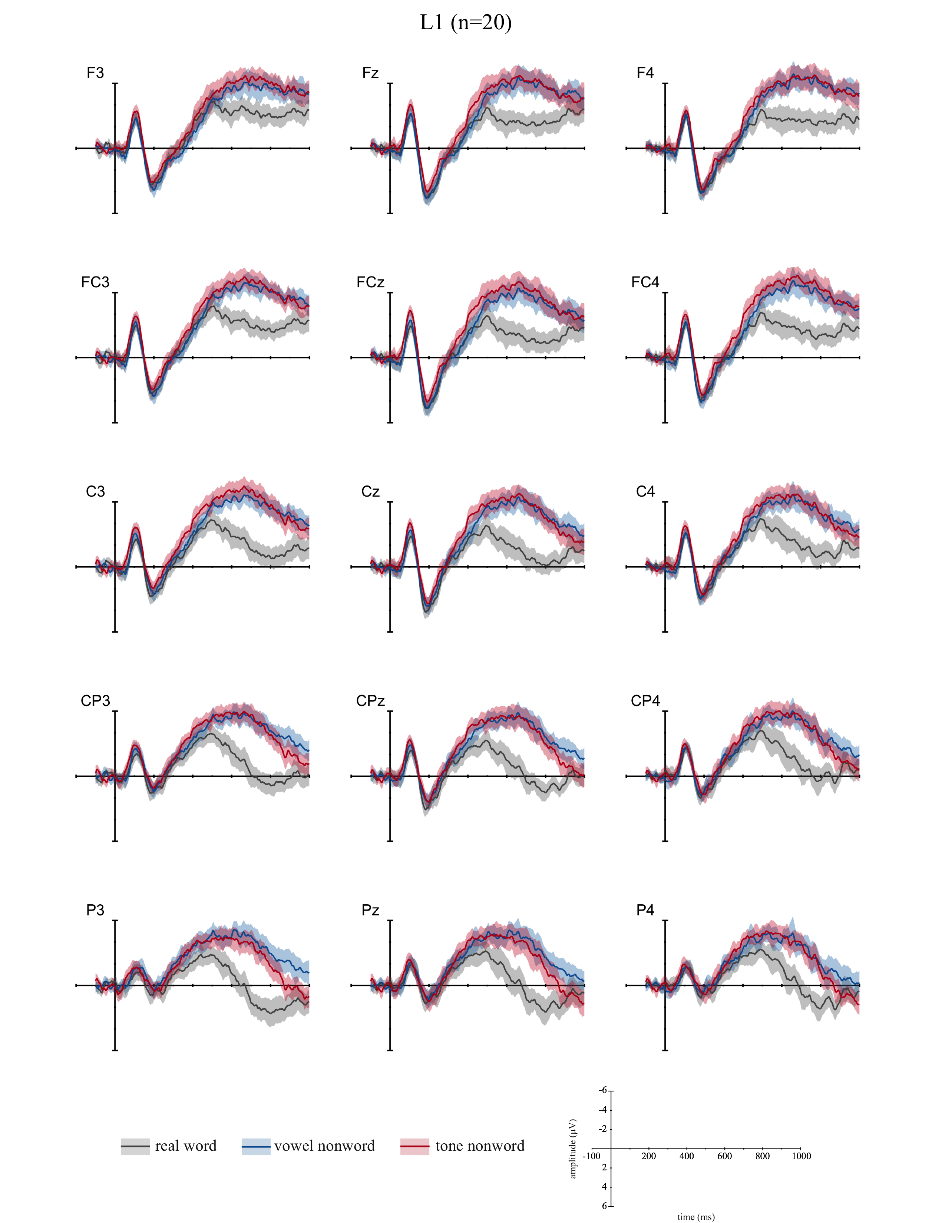

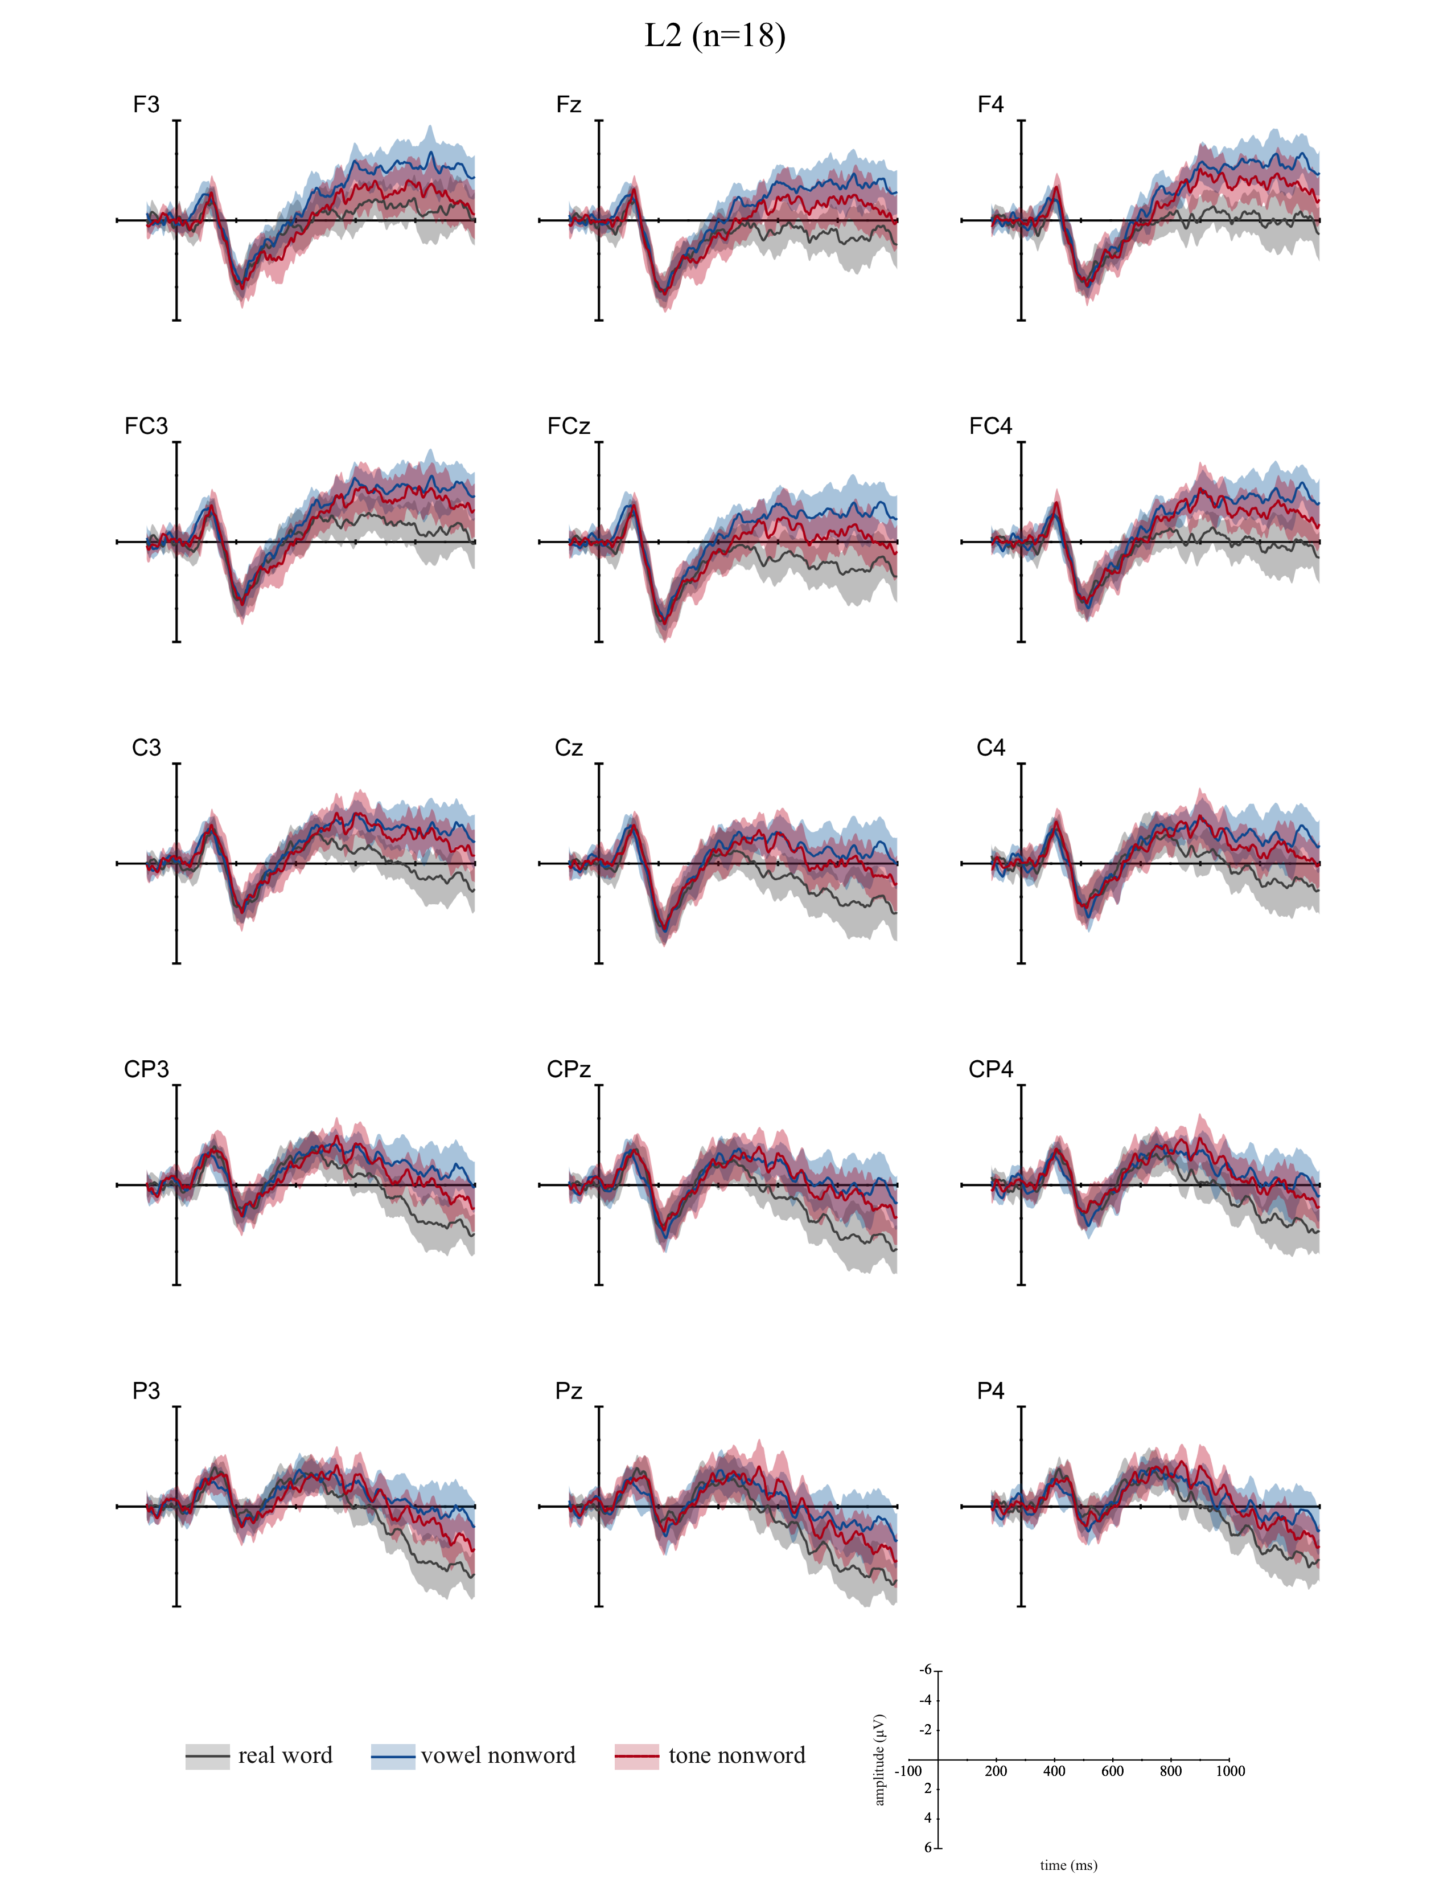

A5. Additional DETAILS ON PRIMARY statistical ANALYSIS
Here we provide full model output from R for each of our statistical models.

TABLE A5.1 Mixed model behavioral accuracy estimates in Lexical Decision Task

Generalized linear mixed model fit by maximum likelihood (Laplace Approximation) ['glmerMod']
Family: binomial ( logit )
Formula: correct ~ cond * group + (1 + re1.cond1 + re1.cond2 || subj) + (1 + re2.cond1 + re2.cond2 + re2.group1 || item)
Data: data
Control: glmerControl(optimizer = "bobyqa", optCtrl = list(maxfun = 50000))

AIC BIC logLik deviance df.resid
2195.9 2276.5 -1084.9 2169.9 3635

Scaled residuals:
Min 1Q Median 3Q Max
-6.6289 0.0906 0.1647 0.3029 2.0770

Random effects:
Groups Name Variance Std.Dev.
item re2.group1 0.2281 0.4776
item.1 re2.cond2 0.6191 0.7868
item.2 re2.cond1 0.6466 0.8041
item.3 (Intercept) 0.4549 0.6745
subj re1.cond2 0.2053 0.4531
subj.1 re1.cond1 0.3234 0.5687
subj.2 (Intercept) 0.2887 0.5373
Number of obs: 3648, groups: item, 96; subj, 38

Fixed effects:
Estimate Std. Error z value Pr(>|z|)
(Intercept) 3.02729 0.16647 18.185 < 2e-16 ***
cond1 0.58340 0.18803 3.103 0.00192 **
cond2 -0.80180 0.16292 -4.921 8.59e-07 ***
group1 1.21935 0.13563 8.990 < 2e-16 ***
cond1:group1 0.05415 0.16075 0.337 0.73621
cond2:group1 0.35392 0.13167 2.688 0.00719 **
---
Signif. codes: 0 ‘***’ 0.001 ‘**’ 0.01 ‘*’ 0.05 ‘.’ 0.1 ‘ ’ 1

Correlation of Fixed Effects:
(Intr) cond1 cond2 group1 cnd1:1
cond1 0.160
cond2 -0.207 -0.322
group1 0.307 0.127 -0.092
cond1:grop1 0.118 0.372 -0.238 0.152
cond2:grop1 -0.042 -0.248 0.341 -0.114 -0.375

TABLE A5.2 Sum coding applied to model coefficients for behavioral accuracy in Lexical Decision Task

Coding of contrasts: Condition
[,1] [,2]
real 1 0
vowel 0 1
tone -1 -1

Coding of contrasts: Group
[,1]
L1 1
L2 -1

TABLE A5.3 Mixed model N400 (400-900 ms) amplitude estimates in Lexical Decision Task (correct responses only)

Linear mixed model fit by REML. t-tests use Satterthwaite's method ['lmerModLmerTest']
Formula: mean.amp ~ cond * group + (1 + re1.cond1 + re1.cond2 || subj) +
(1 + re2.cond1 + re2.cond2 + re2.group1 + re2.cond1_by_group1 + re2.cond2_by_group1 || item)
Data: data
Control: lmerControl(optimizer = "bobyqa", optCtrl = list(maxfun = 1e+06))

REML criterion at convergence: 305410.9

Scaled residuals:
Min 1Q Median 3Q Max
-5.9651 -0.6335 0.0026 0.6270 6.8033

Random effects:
Groups Name Variance Std.Dev.
item re2.cond2_by_group1 2.5544 1.5983
item.1 re2.cond1_by_group1 3.4564 1.8591
item.2 re2.group1 2.2428 1.4976
item.3 re2.cond2 3.2710 1.8086
item.4 re2.cond1 3.6149 1.9013
item.5 (Intercept) 2.2286 1.4929
subj re1.cond2 0.8146 0.9026
subj.1 re1.cond1 1.1334 1.0646
subj.2 (Intercept) 7.0799 2.6608
Residual 62.1649 7.8845
Number of obs: 43567, groups: item, 96; subj, 38

Fixed effects:
Estimate Std. Error df t value Pr(>|t|)
(Intercept) -2.25268 0.46153 44.23506 -4.881 1.41e-05 ***
cond1 1.38768 0.26864 99.46653 5.166 1.24e-06 ***
cond2 -0.78135 0.24506 104.58943 -3.188 0.001887 **
group1 -1.66123 0.46162 44.23084 -3.599 0.000803 ***
cond1:group1 0.65274 0.26552 97.18078 2.458 0.015725 *
cond2:group1 -0.03491 0.22928 96.32941 -0.152 0.879318
---
Signif. codes: 0 ‘***’ 0.001 ‘**’ 0.01 ‘*’ 0.05 ‘.’ 0.1 ‘ ’ 1

Correlation of Fixed Effects:
(Intr) cond1 cond2 group1 cnd1:1
cond1 -0.005
cond2 -0.006 -0.020
group1 -0.047 0.003 0.003
cond1:grop1 0.003 -0.026 -0.007 -0.005
cond2:grop1 0.004 -0.007 -0.027 -0.006 -0.022

TABLE A5.4 Sum coding applied to model coefficients for N400 (400-900 ms) amplitude in Lexical Decision Task

Coding of contrasts: Condition
[,1] [,2]
real 1 0
vowel 0 1
tone -1 -1

Coding of contrasts: Group
[,1]
L1 1
L2 -1

Table A5.5 Mixed model behavioral accuracy estimates in Best Case Scenario Lexical Decision Task

Generalized linear mixed model fit by maximum likelihood (Laplace Approximation) ['glmerMod']
Family: binomial ( logit )
Formula: correct ~ cond + (1 + re1.cond1 || subj) + (1 + re2.cond1 || item)
Data: data
Control: glmerControl(optimizer = "bobyqa", optCtrl = list(maxfun = 50000))

AIC BIC logLik deviance df.resid
600.4 626.8 -294.2 588.4 598

Scaled residuals:
Min 1Q Median 3Q Max
-3.0492 0.1666 0.3120 0.4816 1.2890

Random effects:
Groups Name Variance Std.Dev.
item re2.cond1 0.80473 0.8971
item.1 (Intercept) 0.39922 0.6318
subj re1.cond1 0.09555 0.3091
subj.1 (Intercept) 0.53860 0.7339
Number of obs: 604, groups: item, 93; subj, 17

Fixed effects:
Estimate Std. Error z value Pr(>|z|)
(Intercept) 1.5256 0.2477 6.159 7.31e-10 ***
cond1 -0.6574 0.1809 -3.635 0.000278 ***
---
Signif. codes: 0 ‘***’ 0.001 ‘**’ 0.01 ‘*’ 0.05 ‘.’ 0.1 ‘ ’ 1

Correlation of Fixed Effects:
(Intr)
cond1 -0.180

TABLE A5.6 Sum coding applied to model coefficients for behavioral accuracy in Best Case Scenario Lexical Decision Task

Coding of contrasts: Condition
[,1]
tone 1
vowel -1

A6. Alternative ERP analysis including all trials
The first notable difference when retaining all trials is that the L2 tone nonword response is much less than when incorrect responses are excluded (Table A6.1).
TABLE A6.1 Average mean amplitude for all trials
group cond mean se
L1 real -1.90 0.0970
L1 vowel -4.87 0.0982
L1 tone -5.18 0.0949
L2 real -0.268 0.0985
L2 vowel -1.57 0.0989
L2 tone -0.377 0.0964

Inclusion of all data introduces a difficult modeling choice, namely, whether to include accuracy of responses as a factor in the model. This improves model fit, and makes sense for L2 data, where many responses were inaccurate. However, for L1, it leads to very sparse data for incorrect responses, potentially warping model outcomes. For this reason, we have opted not to include accuracy as a factor in our models.
A6.2 present modeling results including for data with all trials. Post hoc comparisons are parallel to those reported in the main article. As can be seen in those comparisons and Figure A6.2.1, the results are again substantively the same as those in our primary analysis, with statistically significant L1 N400 effects for tone and vowel nonwords, but only significant L2 N400 effects for vowel nonwords.

A6.2 MODEL RESULTS FOR ALL TRIALS INCORPORATING RESPONSE ACCURACY

Outcomes for linear mixed model fit by REML. T-tests use Satterthwaite's method ['lmerModLmerTest']

Formula: mean.amp ~ cond * group + (1 + re1.cond1 + re1.cond2 || subj) +
(1 + re2.cond1 + re2.cond2 + re2.group1 + re2.cond1_by_group1 + re2.cond2_by_group1 || item)
Data: data
Control: lmerControl(optCtrl = list(maxfun = 1e+06), optimizer = "bobyqa")

REML criterion at convergence: 349667.9

Scaled residuals:
Min 1Q Median 3Q Max
-5.9625 -0.6324 -0.0002 0.6300 6.7700

Random effects:
Groups Name Variance Std.Dev.
item re2.cond2_by_group1 2.4190 1.5553
item.1 re2.cond1_by_group1 2.8688 1.6937
item.2 re2.group1 1.9596 1.3999
item.3 re2.cond2 2.5869 1.6084
item.4 re2.cond1 3.6519 1.9110
item.5 (Intercept) 1.8289 1.3524
subj re1.cond2 0.7457 0.8636
subj.1 re1.cond1 0.8900 0.9434
subj.2 (Intercept) 7.1428 2.6726
Residual 62.4362 7.9017
Number of obs: 49882, groups: item, 96; subj, 38

Fixed effects:
Estimate Std. Error df t value Pr(>|t|)
(Intercept) -2.29050 0.45788 42.63527 -5.002 1.02e-05 ***
cond1 1.27482 0.25483 107.95788 5.003 2.21e-06 ***
cond2 -0.84238 0.22359 101.84672 -3.767 0.000276 ***
group1 -1.66649 0.45929 43.12812 -3.628 0.000750 ***
cond1:group1 0.72965 0.23827 98.71018 3.062 0.002830 **
cond2:group1 0.01484 0.21963 98.70481 0.068 0.946276
---
Signif. codes: 0 ‘***’ 0.001 ‘**’ 0.01 ‘*’ 0.05 ‘.’ 0.1 ‘ ’ 1

Correlation of Fixed Effects:
(Intr) cond1 cond2 group1 cnd1:1
cond1 -0.001
cond2 -0.001 -0.027
group1 -0.045 -0.001 -0.001
cond1:grop1 -0.001 -0.014 -0.001 -0.001
cond2:grop1 -0.001 -0.001 -0.014 -0.001 -0.029

Coding of contrasts: Condition
[,1] [,2]
real 1 0
vowel 0 1
tone -1 -1

Coding of contrasts: Group
[,1]
L1 1
L2 -1

Mixed Model Anova Table (Type 3 tests, S-method)

Model: mean.amp ~ cond * group + (cond || subj) + (cond * group || item)
Data: n4.mean
num Df den Df F Pr(>F)
cond 2 113.996 19.1192 6.914e-08 ***
group 1 43.128 13.1655 0.0007504 ***
cond:group 2 108.829 4.7013 0.0110077 *
---
Signif. codes: 0 ‘***’ 0.001 ‘**’ 0.01 ‘*’ 0.05 ‘.’ 0.1 ‘ ’ 1

Planned comparisons (parallel to Table 9 in main report)

Simultaneous Tests for General Linear Hypotheses

Linear Hypotheses:
Estimate Std. Error z value Pr(>|z|)
L1realvowel == 0 2.8320 0.4724 5.994 1.43e-08 ***
L1realtone == 0 3.1814 0.7510 4.236 0.000137 ***
L1voweltone == 0 0.3494 0.7034 0.497 1.000000
L2realvowel == 0 1.4024 0.4784 2.931 0.016873 *
L2realtone == 0 0.2331 0.7627 0.306 1.000000
L2voweltone == 0 1.1693 0.7142 1.637 0.406394
L1vsL2voweltone == 0 1.5186 0.9872 1.538 0.406394
---
Signif. codes: 0 ‘***’ 0.001 ‘**’ 0.01 ‘*’ 0.05 ‘.’ 0.1 ‘ ’ 1
(Adjusted p values reported -- holm method)

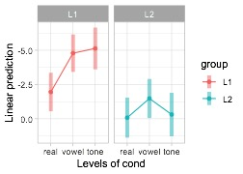
FIGURE A6.2.1 Summary of model estimates when all trials are included

A7. Additional description of individual L2 Participant patterns

Though space is limited in the main article, we would like to take a moment to consider possible relationships between various individual differences such as proficiency and pitch aptitude, and performance on the tone-related tasks in this study.
Here we provide additional descriptions of vocabulary test results, to provide further insight into the variation found across participants. Figure A6.1 depicts the number of correctly identified tones and definitions for each L2 participant. Impressionistically, there is no relationship between knowledge of definitions and knowledge of tones.

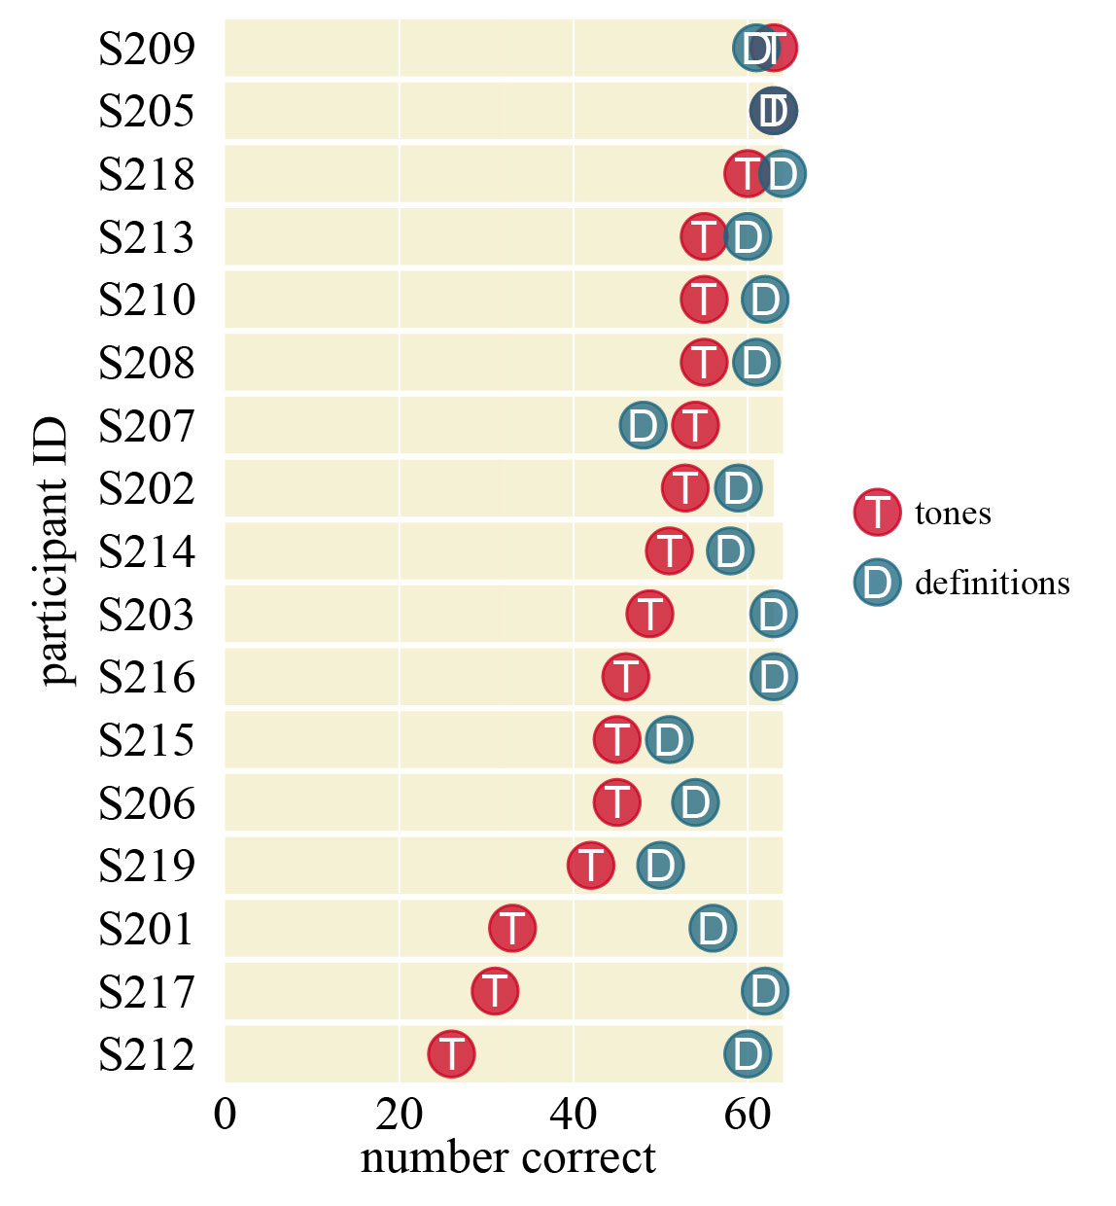
FIGURE A7.1 Individual results for vocabulary test. Correctly provided tones and definitions indicated for each participant. Participants (n=17) are ordered on the y-axis according to their accuracy in providing tones. (Note that, because one L2 participant’s offline vocabulary test data were lost, that participant is not included in this figure. Additionally, some participants only had data for 63 out of 64 possible trials.)

Figure A7.2 depicts relations among our various measures of tone ability/knowledge, including results of the lexical decision task for tone nonwords, knowledge of tones in the vocabulary test, and accuracy in tone identification. The visual impression is that lexical decision performance for tone nonwords is strongly related to knowledge of tones for words, and a bit less strongly to tone identification performance. This is supported by correlations between these variables (Table A7.1). Correlations also suggest that the Can-do self-assessment relates relatively strongly to lexical decision performance.

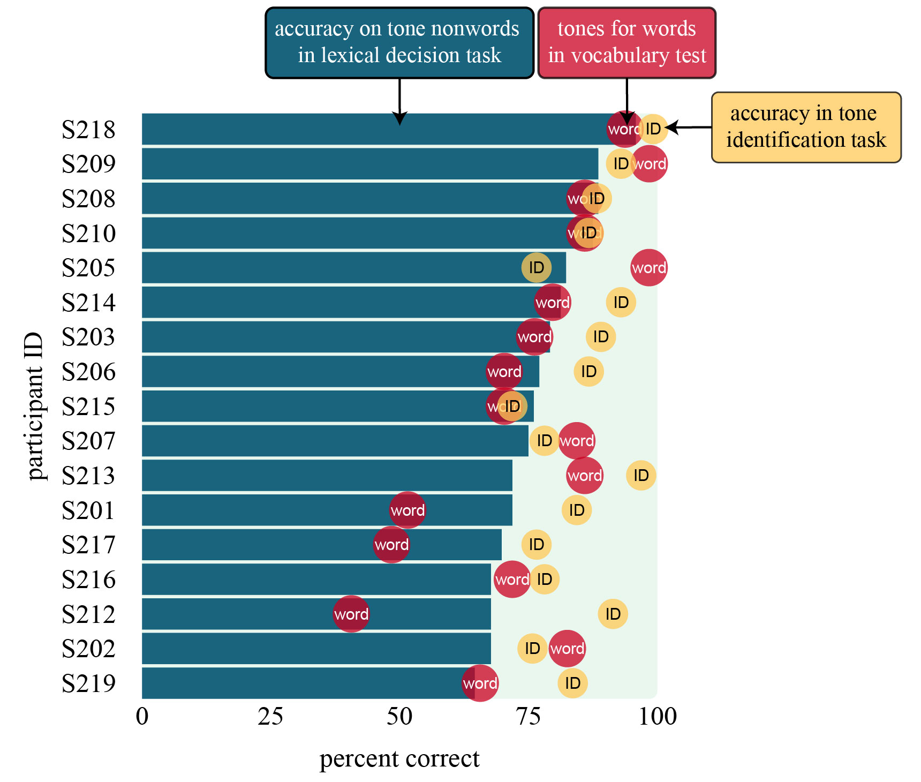

FIGURE A7.2 Individual results for all tone measures: tone nonword in the LDT, tone identification, and providing tones for vocabulary test. Participants (n=17) are ordered on the y-axis in according to their performance on the tone nonwords in the lexical decision task. (Note that, because one L2 participant’s offline vocabulary test data were lost, that participant is not included in this figure.)

TABLE A7.1 Correlations between tone and proficiency measures for L2 participants (n=17)*
 | tones | definitions | Can-do | VSA | years | tone ID | LDT
definitions | 0.22
Can-do | 0.22 | 0.49
VSA | 0.22 | 0.45 | 0.42
years | 0.36 | 0.25 | 0.25 | 0.63
tone ID | 0.21 | 0.35 | 0.24 | 0.07 | 0.33
LDT | 0.68 | 0.39 | 0.41 | 0.31 | 0.10 | 0.47
ERP | -0.19 | -0.13 | 0.07 | 0.14 | 0.51 | -0.26 | -0.47

tones = accuracy in providing correct tones for words in the offline vocabulary test
definitions = accuracy in providing definitions for words in the offline vocabulary test
VSA = score (percent) for vocabulary self-assessment (one of the proficiency screening tests)
can-do = score (percent) for Can-do self assessment (one of the proficiency screening tests)
years = years of study, i.e., the length of time participants reported learning Mandarin
tone ID = mean overall accuracy on the tone identification task
LDT = mean accuracy in rejecting tone nonwords in the lexical decision task
ERP = mean N400 amplitude for tone nonwords in the lexical decision task (expected to be negatively correlated with other measures)

* Note that, because one L2 participant’s offline vocabulary test data were lost, that participant is not included in these correlational results

A8. By-item accuracy and confidence for the offline vocabulary test
This table reports by-item accuracy (ACC) and confidence (CONF) measures. Accuracy indicates percent of L2 participants who responded correctly. Confidence indicates an averaged confidence rating from 0-3. As some data were missing, not all items have equal numbers of responses. The number of responding participants is indicated in the ‘number subjects’ column.

Word | Pinyin | Translation | number  subjects | tones  ACC | tones  CONF | definitions  ACC | definitions  CONF
春天 | chūntiān | spring | 11 | 100 | 2.82 | 100 | 3.00
发音 | fāyīn | pronunciation | 11 | 82 | 2.64 | 100 | 2.91
医生 | yīshēng | doctor | 12 | 83 | 2.92 | 100 | 3.00
咖啡 | kāfēi | coffee | 11 | 100 | 3.00 | 100 | 3.00
公司 | gōngsī | company | 12 | 92 | 3.00 | 100 | 2.92
飞机 | fēijī | airplane | 11 | 100 | 3.00 | 100 | 3.00
生活 | shēnghuó | life | 11 | 82 | 3.00 | 100 | 3.00
英雄 | yīngxióng | hero | 11 | 45 | 2.09 | 82 | 2.45
身材 | shēncái | figure | 12 | 67 | 2.42 | 67 | 2.00
科学 | kēxué | science | 11 | 45 | 2.82 | 100 | 3.00
空调 | kōngtiáo | air conditioner | 11 | 55 | 2.82 | 100 | 3.00
规则 | guīzé | rule | 12 | 83 | 2.50 | 100 | 2.58
婚礼 | hūnlǐ | wedding | 11 | 82 | 2.64 | 91 | 3.00
方法 | fāngfǎ | method | 12 | 75 | 2.83 | 100 | 2.67
思想 | sīxiǎng | thought | 11 | 64 | 2.82 | 100 | 3.00
观点 | guāndiǎn | viewpoint | 11 | 82 | 2.73 | 91 | 2.82
歌手 | gēshǒu | singer | 11 | 100 | 3.00 | 91 | 2.91
机场 | jīchǎng | airport | 12 | 83 | 2.67 | 100 | 3.00
兄弟 | xiōngdì | brother | 11 | 64 | 2.73 | 100 | 2.91
书店 | shūdiàn | bookstore | 12 | 83 | 2.75 | 100 | 3.00
家具 | jiājù | furniture | 11 | 91 | 2.73 | 82 | 2.73
宗教 | zōngjiào | religion | 11 | 64 | 2.73 | 100 | 2.91
车祸 | chēhuò | car accident | 12 | 75 | 2.25 | 67 | 1.67
商店 | shāngdiàn | store | 11 | 73 | 2.64 | 100 | 3.00
文章 | wénzhāng | article | 11 | 64 | 2.82 | 100 | 3.00
服装 | fúzhuāng | clothing | 11 | 73 | 2.36 | 82 | 2.73
同屋 | tóngwū | roommate | 12 | 92 | 2.83 | 100 | 3.00
白天 | báitiān | daytime | 12 | 75 | 2.58 | 75 | 2.67
阳光 | yángguāng | sunlight | 11 | 82 | 2.64 | 82 | 2.64
原因 | yuányīn | reason | 11 | 73 | 2.91 | 100 | 3.00
和平 | hépíng | peace | 11 | 82 | 2.91 | 100 | 3.00
银行 | yínháng | bank | 11 | 73 | 2.64 | 100 | 3.00
职员 | zhíyuán | office worker | 11 | 73 | 1.91 | 73 | 1.91
邮局 | yóujú | post office | 12 | 42 | 2.50 | 92 | 2.67
留言 | liúyán | message | 11 | 82 | 2.64 | 73 | 1.64
人民 | rénmín | (the) people | 12 | 92 | 2.83 | 100 | 3.00
门口 | ménkǒu | doorway | 12 | 75 | 2.83 | 100 | 2.92
传统 | chuántǒng | tradition | 11 | 73 | 2.64 | 100 | 3.00
存款 | cúnkuǎn | deposit | 11 | 64 | 2.36 | 64 | 2.09
情感 | qínggǎn | emotion | 11 | 64 | 2.64 | 91 | 2.09
结果 | jiéguǒ | result | 11 | 91 | 2.45 | 100 | 3.00
财产 | cáichǎn | property | 12 | 100 | 2.42 | 75 | 2.33
程度 | chéngdù | degree | 11 | 100 | 2.64 | 82 | 2.55
环境 | huánjìng | environment | 11 | 82 | 2.82 | 100 | 3.00
学校 | xuéxiào | school | 11 | 73 | 2.91 | 100 | 3.00
条件 | tiáojiàn | condition | 11 | 91 | 2.82 | 100 | 2.91
模特 | mótè | model | 12 | 67 | 2.25 | 75 | 2.50
毛病 | máobìng | defect | 12 | 58 | 2.50 | 42 | 2.25
酒吧 | jiǔbā | bar | 11 | 73 | 2.91 | 100 | 3.00
傻瓜 | shǎguā | fool | 12 | 42 | 1.92 | 58 | 1.67
母亲 | mǔqīn | mother | 12 | 67 | 2.42 | 100 | 2.83
早餐 | zǎocān | breakfast | 11 | 82 | 3.00 | 100 | 3.00
首都 | shǒudū | capital | 11 | 73 | 2.82 | 100 | 3.00
果汁 | guǒzhī | fruit juice | 11 | 64 | 2.73 | 100 | 3.00
舞台 | wǔtái | stage | 11 | 82 | 2.55 | 100 | 2.82
种族 | zhǒngzú | race | 12 | 58 | 2.33 | 67 | 2.25
演员 | yǎnyuán | actor | 11 | 73 | 2.36 | 91 | 2.91
主题 | zhǔtí | theme | 11 | 91 | 2.82 | 82 | 2.73
导游 | dǎoyóu | tour guide | 11 | 91 | 2.73 | 100 | 2.91
小时 | xiǎoshí | hour | 12 | 92 | 2.83 | 92 | 2.92
选手 | xuǎnshǒu | athlete | 11 | 45 | 2.36 | 9 | 1.27
诊所 | zhěnsuǒ | clinic | 11 | 0 | 2.00 | 64 | 1.91
表姐 | biǎojiě | female cousin | 11 | 45 | 2.55 | 91 | 2.73
美女 | měinǚ | beautiful girl | 12 | 58 | 3.00 | 100 | 3.00
领导 | lǐngdǎo | leader | 12 | 25 | 2.58 | 92 | 2.92
水果 | shuǐguǒ | fruit | 11 | 91 | 2.73 | 100 | 3.00
体育 | tǐyù | physical training | 11 | 82 | 2.73 | 100 | 2.55
勇气 | yǒngqì | courage | 11 | 55 | 1.91 | 73 | 2.09
晚饭 | wǎnfàn | dinner | 11 | 91 | 3.00 | 100 | 3.00
喜剧 | xǐjù | comedy | 12 | 58 | 2.50 | 58 | 2.50
比赛 | bǐsài | competition | 11 | 100 | 2.91 | 100 | 3.00
米饭 | mǐfàn | rice | 12 | 75 | 2.83 | 100 | 3.00
辣椒 | làjiāo | chili pepper | 12 | 67 | 2.50 | 83 | 2.83
帅哥 | shuàigē | handsome guy | 11 | 100 | 2.91 | 100 | 2.91
现金 | xiànjīn | cash | 11 | 73 | 2.64 | 100 | 3.00
作家 | zuòjiā | author | 11 | 100 | 2.91 | 100 | 2.82
律师 | lǜshī | lawyer | 12 | 83 | 2.58 | 100 | 3.00
战争 | zhànzhēng | war | 11 | 82 | 2.82 | 100 | 2.82
话题 | huàtí | topic | 12 | 83 | 2.75 | 92 | 2.83
少年 | shàonián | youth | 11 | 45 | 2.64 | 91 | 2.45
性格 | xìnggé | disposition | 8 | 100 | 2.63 | 100 | 2.63
爱情 | àiqíng | romance | 11 | 91 | 2.73 | 100 | 3.00
大学 | dàxué | university | 11 | 91 | 3.00 | 100 | 3.00
距离 | jùlí | distance | 12 | 75 | 2.08 | 83 | 2.00
背景 | bèijǐng | background | 12 | 83 | 2.58 | 100 | 2.92
办法 | bànfǎ | means | 11 | 100 | 2.82 | 100 | 3.00
入口 | rùkǒu | “in” door | 11 | 100 | 2.91 | 100 | 3.00
饭馆 | fànguǎn | restaurant | 12 | 75 | 2.67 | 100 | 3.00
地铁 | dìtiě | subway | 11 | 55 | 2.73 | 100 | 3.00
字典 | zìdiǎn | dictionary | 11 | 73 | 2.82 | 100 | 3.00
报告 | bàogào | report | 11 | 91 | 2.91 | 100 | 2.82
政治 | zhèngzhì | politics | 12 | 67 | 2.50 | 92 | 2.92
照片 | zhàopiàn | photograph | 11 | 82 | 2.82 | 100 | 3.00
社会 | shèhuì | society | 12 | 92 | 2.92 | 100 | 3.00
运动 | yùndòng | exercise | 11 | 91 | 2.91 | 100 | 2.82
动物 | dòngwù | animal | 11 | 82 | 2.73 | 100 | 3.00

References
Boersma, P., & Weenink, D. (2018). Praat: Doing phonetics by computer (Version 6.0.42) [Computer software]. www.praat.org
Cai, Q., & Brysbaert, M. (2010). SUBTLEX-CH: Chinese word and character frequencies based on film subtitles. PLoS One, 5(6), e10729.
Chao, Y. R. (1968). Grammar of Spoken Chinese. Unversity of California Press.
Duanmu, S. (2007). The Phonology of Standard Chinese (2nd edition). Oxford University Press.
Liu, Y., Yao, T., Bi, N.-P., Ge, L., & Shi, Y. (2008). Integrated Chinese, Level 1, Part 1 (Third edition). Cheng & Tsui.
Pleco Chinese Dictionary for iOS (Version 3.2.30). (2018). [Computer software].
Sjolander, K. (2000). WaveSurfer (Version 1.8.8p5-1701261420) [Computer software]. https://sourceforge.net/projects/wavesurfer/

