Appendix A: Studies included in Yousefi and Nassaji (2019) and justifications for inclusion/ exclusion
Insufficient statistical information for calculating effect sizes:
Barekat, B., & Mehri, M. (2013). Investigating the effect of metalinguistic feedback in L2 pragmatic instruction. International Journal of Linguistics, 5, 197–208. https://doi.org/10.5296/ijl.v5i2.3032
Cunningham, J. (2016). Request Modification in Synchronous Computer-Mediated Communication: The Role of Focused Instruction. The Modern Language Journal, 100, 484–507. https://doi.org/10.1111/modl.12332
Dastjerdi, H. V., & Farshid, M. (2011). The role of input enhancement in teaching compliments. Journal of Language Teaching & Research, 2(2), 460–466. https://doi.org/10.4304/jltr.2.2.460‐466
Farahian, M., Rezaee, M., & Gholami, A. (2012). Does direct instruction develop pragmatic competence? Teaching refusals to EFL learners of English. Journal of Language Teaching & Research, 3, 814–821. https://doi.org/10.4304/jltr.3.4.814‐821
Martínez-Flor, A., & Alcón-Soler, E. (2007). Developing pragmatic awareness of suggestions in the EFL classroom: A focus on instructional effects. Canadian Journal of Applied Linguistics, 10, 47–76.
Rafieyan, V. (2016). Effect of ‘Focus on Form’ versus ‘Focus on Forms’ Pragmatic Instruction on Development of Pragmatic Comprehension and Production. Journal of Education and Practice, 7, 41–48.
Rafieyan, V., Sharafi-Nejad, M., Khavari, Z., Siew Eng, L., & Mohamed, A.R. (2014). Pragmatic Comprehension Development through Telecollaboration. English Language Teaching, 7, 11–19. https://doi.org/10.5539/elt.v7n2p11
Same data reported in another article:
Nguyen, T. T. M. (2013). Instructional effects on the acquisition of modifiers in constructive criticisms by EFL learners. Language Awareness, 22, 76–94. https://doi.org/10.1080/09658416.2012.658810
Articles retained in the re-analysis:
Alcón-Soler, E. (2015). Instruction and pragmatic change during study abroad email communication. Innovation in Language Learning and Teaching, 9, 34–45.
Alcón-Soler, E. (2012). Teachability and Bilingualism Effects on Third Language Learners’ Pragmatic Knowledge. Intercultural Pragmatics 9: 511–541. https://doi.org/10.1515/ip‐2012‐0028
Alcón-Soler, E. & Guzman-Pitarch, J. (2010). The Effect of Instruction on Learners’ Pragmatic Awareness: A Focus on Refusals. International Journal of English Studies, 10 (1), 65–80. https://doi.org/10.6018/ijes/2010/1/113981
Alcón-Soler, E.A., & Martinez-Flor, A. (2008). Investigating pragmatics in foreign language learning, teaching and testing. Bristol: Multilingual Matters. https://doi.org/10.21832/9781847690869
Bardovi-Harlig, K., Mossman, S., & Vellenga, H.E. (2015). The effect of instruction on pragmatic routines in academic discussion. Language Teaching Research. 19, 324–350. https://doi.org/10.1177/1362168814541739
Chen, Y. S. (2011). The effect of explicit teaching of American compliment exchanges to Chinese learners of English. English Teaching & Learning, 35, 1–42.
Derakhshan, A., & Eslami, Z. (2015). The Effect of Consciousness-raising Instruction on the pragmatic Development of Apology and Request. The Electronic Journal for English as a Second Language. 18(4).1–24.
Eslami, Z.R., & Liu, C.N. (2013). Learning pragmatics through computer-mediated communication in Taiwan. Iranian Journal of Society, Culture, and Language, 52–73.
Eslami, Z.R., & Eslami-Rasekh, A. (2008). Enhancing the pragmatic competence of non- native English-speaking teacher candidates (NNESTCs) in an EFL context. In
E. Alcón-Soler & Martinez-Flor, A. (eds.), Investigating pragmatics in foreign language learning, teaching and testing. Bristol, UK: Multilingual Matters, 178–197. https://doi.org/10.21832/9781847690869‐011
Felix-Brasdefer, J.C. (2008). Pedagogical intervention and the development of pragmatic competence in learning Spanish as a foreign language. Issues in Applied Linguistics 16, 49–84.
Fordyce, K. (2014). The differential effects of explicit and Implicit Instruction on EFL Learners’ Use of Epistemic Stance. Applied Linguistics, 35, 6–28. https://doi.org/10.1093/applin/ams076
Fukuya, Y., & Martinez-Flor, A. (2008). The interactive effects of pragmatic-eliciting tasks and pragmatics instruction. Foreign Language Annuals, 41, 478–500. https://doi.org/10.1111/j.1944‐9720.2008.tb03308.x
Furniss, E. (2016). Teaching the pragmatics of Russian conversation using a corpus referred website. Language Learning and Technology, 20, 38–60.
Ghobadi, A., & Fahim, M. (2009). The effect of explicit teaching of English ‘Thanking formulas on Iranian EFL intermediate level students at English language institutes. System, 37, 526–537. https://doi.org/10.1016/j.system.2009.02.010
Gu, X.L. (2011). The effect of explicit and implicit instructions of request strategies. Intercultural Communication Studies, 20(1), 104–123.
Hernandez, T.A. (2011). Re-examining the role of explicit instruction and input flood on the acquisition of Spanish discourse markers. Language Teaching Research, 15, 159–182. https://doi.org/10.1177/1362168810388694
Jernigan, J. (2012). Output and English as a second language pragmatic development: The effectiveness of output-focused video-based instruction. English Language Teaching, 5(4), 2–14. https://doi.org/10.5539/elt.v5n4p2
Li, Q. (2012). Effects of instruction on adolescent beginners’ acquisition of request modification. TESOL Quarterly, 46, 30–55. https://doi.org/10.1002/tesq.2
Li, S. (2012). The effect of input-based practice on pragmatic development in L2 Chinese. Language Learning, 62, 403–438. https://doi.org/10.1111/j.1467‐9922.2011.00629.x
Li, S. (2013). Amount of practice and pragmatic development of request-making in L2 Chinese. In N. Taguchi & J.M. Sykes (eds.), Technology in interlanguage pragmatics research and teaching (pp. 43–70). Amsterdam/Philadelphia: John Benjamins. https://doi.org/10.1075/lllt.36.04li
Narita, R. (2012). The effects of pragmatic consciousness-raising activity on the development of pragmatic awareness and use of hearsay evidential markers for learners of Japanese as a foreign language. Journal of Pragmatics, 44, 1–29. https://doi.org/10.1016/j.pragma.2011.09.016
Nguyen, T.T.M., Do, T.T.H., Nguyen, A.T., & Pham, M.H. (2015). Teaching email requests in the academic context: a focus on the role of corrective feedback, Language Awareness, 24(2), 169–195. https://doi.org/10.1080/09658416.2015.1010543
Nguyena, T. T. M., Phamb, T. H., & Phamb, M. T. (2012). The relative effects of explicit and implicit form-focused instruction on the development of L2 pragmatic competence. Journal of Pragmatics, 44, 416–434. https://doi.org/10.1016/j.pragma.2012.01.003
Simin, S., Eslami, Z., Eslami-Rasekh, A., & Ketabi, S. (2014). The effects of explicit teaching of apologies on Persian EFL learners’ performance: When e-communication helps. International Journal of Research Studies in Language Learning 3, 71–84.
Tajeddin, Z., Keshavarz, M.H., & Zand Moghaddam, A. (2012). The Effect of Task-Based Language Teaching on EFL Learners’ Pragmatic Production, Metapragmatic Awareness, and Pragmatic Self-Assessment. Iranian Journal of Applied Linguistics (IJAL), 15, 139–166.
Takimoto, M. (2007). The effects of referential oriented activity in the structured input task on the development of learners’ pragmatic proficiency. New Zealand Studies in Applied Linguistics, 13, 46–60.
Takimoto, M. (2012a). Assessing the effects of identical task repetition and task type repetition on learners’ recognition and production of second language request downgraders. Intercultural Pragmatics, 9, 71–96. https://doi.org/10.1515/ip‐2012‐0004
Takimoto, M. (2012b). Metapragmatic discussion in interlanguage pragmatics. Journal of Pragmatics, 44, 1240–1253. https://doi.org/10.1016/j.pragma.2012.05.007
Tan, K.H., & Farashaiyan, A. (2012). The effectiveness of teaching formulaic politeness strategies in making request to undergraduates in an ESL classroom. Asian Social Science 8, 189–196. https://doi.org/10.5539/ass.v8n15p189
Tanaka, H., & Oki, N. (2015). An attempt to raise Japanese EFL learners’ pragmatic awareness using online discourse completion tasks. The jalt call Journal. 11(2).143–154.
Tateyama, Y. (2007). The effects of instruction on pragmatic awareness. In K. Bradford-Watts (ed.), JALT 2006 Conference Proceedings. Tokyo: JALT, 1189–1200. Available online at http://jalt-publications.org/archive/proceedings/2006/E128.pdf
Tateyama, Y. (2009). Requesting in Japanese: The effect of instruction on JFL learners’ pragmatic competence. In N. Taguchi (ed.), Pragmatic competence. Berlin: Mouton De Gruyter, 129–166.

Appendix B:
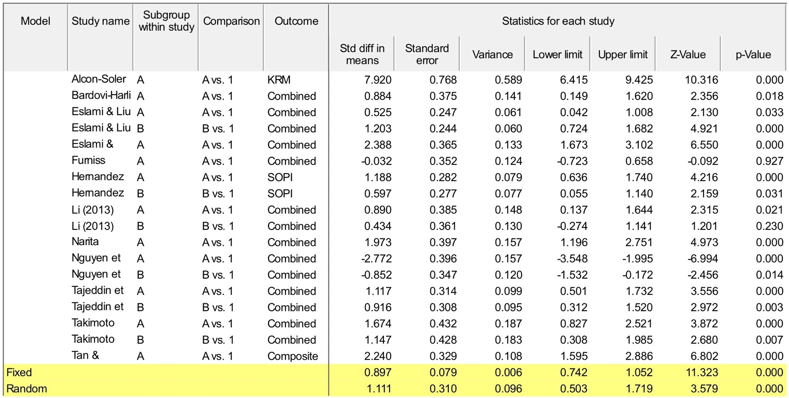
Between-groups, effects of pragmatics instruction

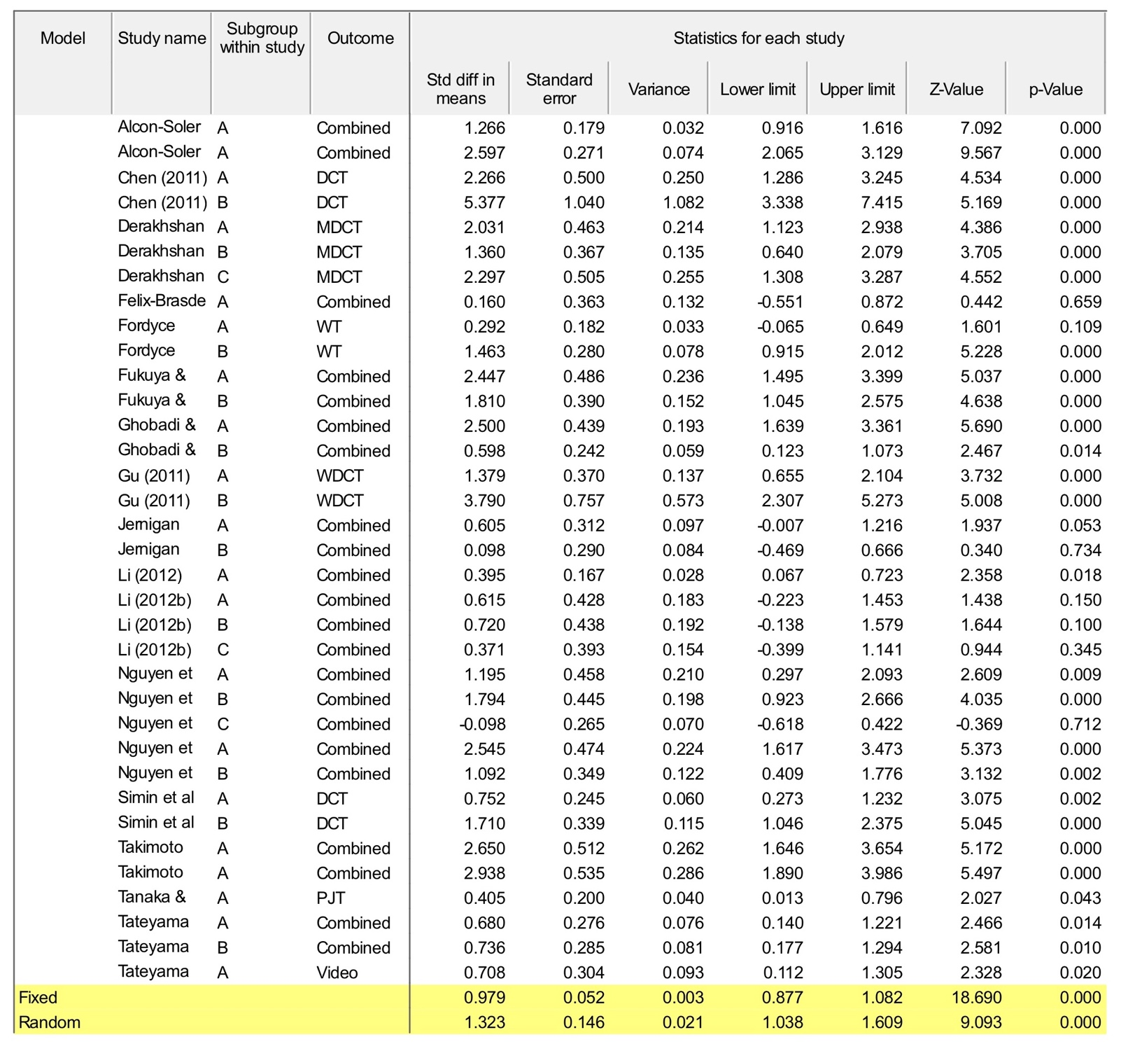
Within groups, effects of pragmatics instruction

Appendix C:
Between-groups, moderator analysis
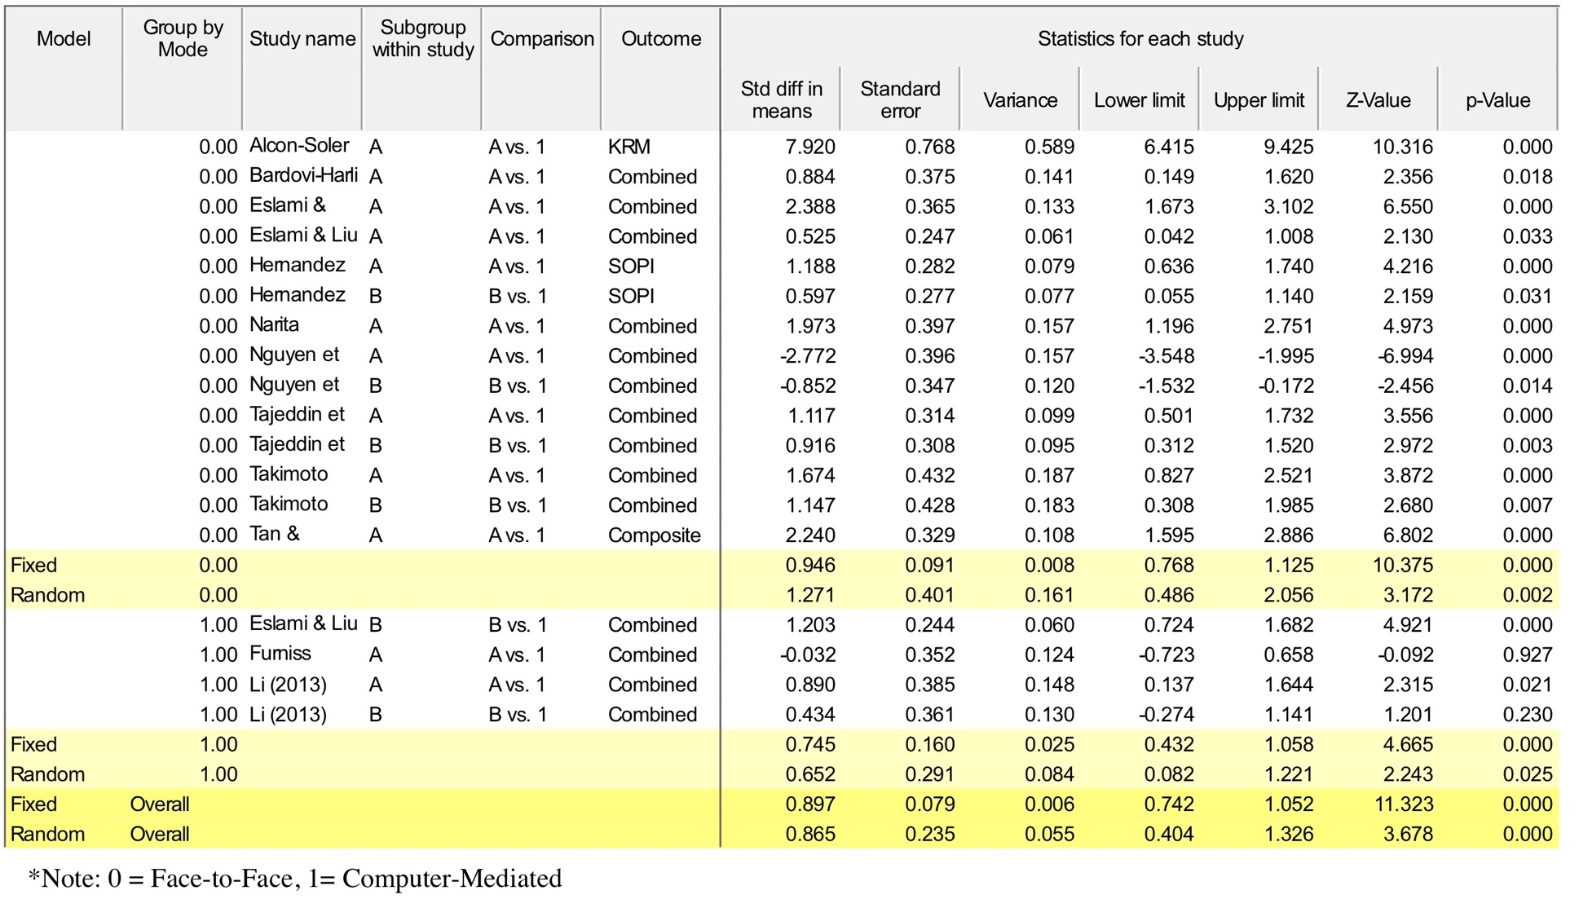

Within-groups, moderator analysis
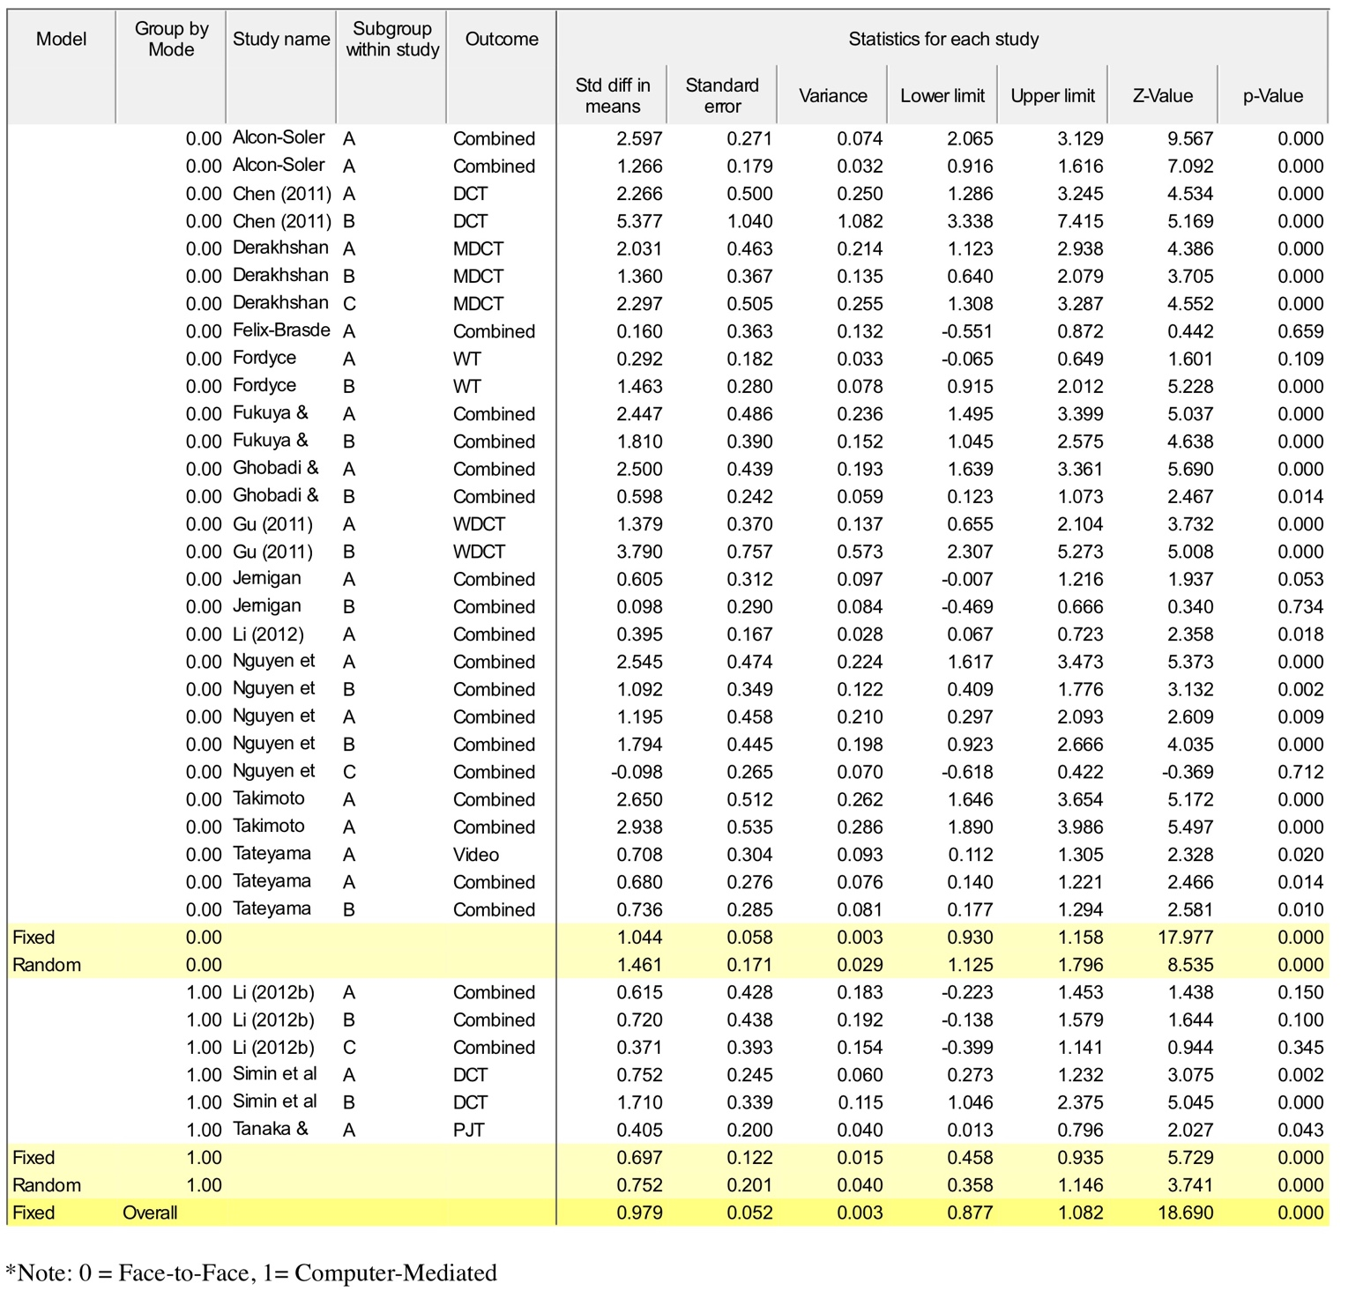

Appendix D: Studies included in Lee, Warschauer and Lee (2019) and justifications for inclusion/ exclusion
Both treatment conditions involved corpus use, but implemented in different ways:
Sun, Y.-C. and L.-Y. Wang. 2003. 'Concordancers in the EFL classroom: Cognitive approaches and collocation difficulty,' Computer Assisted Language Learning 16/1: 83-94.
Supatranont, P. 2005. A Comparison of the Effects of the Concordance-based and the Conventional Teaching Methods on Engineering Students’ English Vocabulary Learning. Unpublished doctoral dissertation, Chulalongkorn University.
Learning outcomes do not constitute the dependent variable:
Frankenberg-Garcia, A. 2012. 'Learners’ use of corpus examples,' International Journal of Lexicography 25/3: 273-96.
Frankenberg-Garcia, A. 2014. 'The use of corpus examples for language comprehension and production,' ReCALL 26/2: 128-46.
Kaur, J. and V. Hegelheimer. 2005. 'ESL students’ use of concordance in the transfer of academic word knowledge: An exploratory study,' Computer Assisted Language Learning 18/4: 287-310. (See endnote 2)
Stevens, V. 1991. 'Concordance-based vocabulary exercises: A viable alternative to gap-fillers,' Classroom Concordancing: English Language Research Journal 4: 47-61.
It is impossible to tell if treatment effects are due to guided inductive learning or to corpus use:
Anani Sarab, M. R. and A. Kardoust. 2014. ‘Concordance-based data-driven learning activities and learning English phrasal verbs in EFL classrooms,’ Issues in Language Teaching 3/1: 112–89.
Poole, R. 2012. 'Concordance-based glosses for academic vocabulary acquisitio,' CALICO Journal 29/4: 679-93.
Sripicharn, P. 2003. 'Evaluating classroom concordancing: The use of corpus-based materials by a group of Thai students,' Thammasat Review 8/1: 203-36.
Vyatkina, N. 2016. ‘Data-driven learning for beginners: The case of German verb-preposition collocations,’ ReCALL 28/2: 207–26.
Yunus, K. and S. A. Awab. 2012. ‘The effects of the use of module-based concordance materials and data-driven learning (DDL) approach in enhancing the knowledge of collocations of prepositions among Malaysian undergraduate law students,’ International Journal of Learning 18/9: 165–81.
Input-test congruency, practice-test congruency, or additional time spent on the target vocabulary advantaging the experimental group:
Daskalovska, N. 2014. 'Corpus-based versus traditional learning of collocations,' Computer Assisted Language Learning 28/2: 130-44.
Karras, J. N. 2016. ‘The effects of data-driven learning upon vocabulary acquisition for secondary international school students in Vietnam,’ ReCALL 28/2: 166–86.
Mirzaei, A., M. R. Domakani, and S. Rahimi. 2016. ‘Computerized lexis-based instruction in EFL classrooms: Using multi-purpose LexisBOARD to teach L2 vocabulary,’ ReCALL 28/1: 22–43.
Rahimi, M. and G. Momeni. 2012. ‘The effect of teaching collocations on English language proficiency,’ Procedia-Social and Behavioral Sciences 31: 37–42.
Rezaee, A. A., H. Marefat, and A. Saeedakhtar. 2015. ‘Symmetrical and asymmetrical scaffolding of L2 collocations in the context of concordancing,’ Computer Assisted Language Learning 28/6: 532–49.
Reports lacking essential information:
Al-mahbashi, A., N. M. Noor, and Z. Amir. 2015. ‘The effect of data driven learning on receptive vocabulary knowledge of Yemeni University learners,’ 3L: Language, Linguistics and Literature - The Southeast Asian Journal of English Language Studies 21/3: 13–24.
Çelik, S. 2011. 'Developing collocational competence through web based concordance activities,' Novitas ROYAL (Research on Youth and Language) 5/2: 273-86.
Gan, S.,-L., F. Low, and N. F. Yaakub. 1996. 'Modeling teaching with a computer-based concordancer in a TESL preservice teacher education program,' Journal of Computing in Teacher Education 12/4: 28-32.
Gordani, Y. 2013. ‘The effect of the integration of corpora in reading comprehension classrooms on English as a Foreign Language learners’ vocabulary development,’ Computer Assisted Language Learning 26/5: 430–45.
Koosha, M. and A. A Jafarpour. 2006. 'Data-driven learning and teaching collocation of prepositions: The case of Iranian EFL adult learners,' Asian EFL Journal Quarterly 8/4: 192-209.
Yılmaz, E. and A. Soruç. 2015. ‘The use of concordance for teaching vocabulary: A data-driven learning approach,’ Procedia-Social and Behavioral Sciences 191/2: 2626–30.
Yunxia, S., Y. Min, and S. Zhuo. 2009. ‘An empirical study on a computer-based corpus approach to English vocabulary teaching and learning’ in W. Li and J. Zhou (eds): Proceedings of the 2nd International Conference on Computer Science and Information Technology. IEEE Xplore, pp. 218–21.
No obvious issues with eligibility, and thus retained for the re-calculation of an average effect (using effect sizes reported in Lee et al., 2019, online supplement):
Cobb, T. 1997. 'Is there any measurable learning from hands-on concordancing?,' System 25/3: 301-15.
Cobb, T. 1999. 'Applying constructivism: A test for the learner-as-scientist,' Educational Technology Research & Development 47/3: 15-33.
Kim, E. 2015. ‘Enhancing a corpus-based approach to teach English phrasal verbs to Korean learners,’ The Journal of Studies in Language 31/2: 295–312.
Tongpoon, A. 2009. The Enhancement of EFL learners' Receptive and Productive Vocabulary Knowledge through Concordance-based Methods. Unpublished doctoral dissertation, Northern Arizona University.
Yang, J. 2015. ‘Effects of collaborative corpus-based learning on the acquisition and retention of delexical verb collocation,’ The Journal of Studies in Language 31/1: 67–94.

Appendix E: Studies included in Bryfonski and McKay (2019) and justifications for inclusion/ exclusion
TBLT is not the independent variable of interest:
Lai, C. & X. Lin (2015). Strategy training in a task-based language classroom. The Language Learning Journal 43.1, 20–40.
Li, G. & X. Ni (2013). Effects of a technology-enriched, task-based language teaching curriculum on Chinese elementary students’ achievement in English as a foreign language. International Journal of Computer-Assisted Language Learning and Teaching 3.1, 33–49.
Shabani, M. B. & A. Ghasemi (2014). the effect of task-based language teaching (TBLT) and content-based language teaching (CBLT) on the Iranian intermediate ESP learners’ reading comprehension. Procedia: Social and Behavioral Sciences 98, 1713–1721.
Activities are not tasks under re-analysis criteria:
Amin, A. A. (2009). Task-based and grammar-based English language teaching: An experimental study in Saudi Arabia. PhD dissertation, University of Newcastle Upon Tyne.
Birjandi, P. & A. Malmir (2009). The effect of task-based approach on the Iranian advanced EFL learners’ narrative vs. expository writing. Iranian Journal of Applied Language Studies 1.2, 1–26.
Hasan, A. (2014). The effect of using task-based learning in teaching English on the oral performance of the secondary school students. International Interdisciplinary Journal of Education 3.2, 250–264.
Kasap, B. (2005). The effectiveness of task-based instruction in the improvement of learner’s speaking skill. M.A. thesis, Bilkent University, Ankara, Turkey.
Keyvanfar, A. & M. Modarresi (2009). The impact of task-based activities on the reading skill of Iranian EFL young learners at the beginner level. Journal of Applied Linguistics 2.1, 81–102.
Lochana, M. & G. Deb (2006). Task-based teaching: Learning English without tears. The Asian EFL Journal Quarterly 8, 140–164.
Murad, T. M. (2009). The effect of task-based language teaching on developing speaking skills among the Palestinian secondary EFL students in Israel and their attitudes towards English. PhD dissertation, Yarmouk University, Irbid, Jordan.
Sarani, A. & L. F. Sahebi (2012). The impact of task-based approach on vocabulary learning in ESP courses. English Language Teaching 5.10, 118–128.
Seyedi, S. H. & A. A. K. Farahani (2014). The application of task-based writing and traditional writing on the development of reading comprehension of EFL advanced Iranian learners. International Journal of English Language Education 2.1, 225–240.
Wu, X., L. Liao & T. K. DeBacker (2016). Implementing task-based instruction in ESP Class: An empirical study in Marine Engineering English. Journal of Language Teaching Research 7, 936–945.
Lack of clarity about tasks:
De Ridder, I., L. Vangehuchten & M. S. Gómez, M.S. (2007). Enhancing automaticity through task-based language learning. Applied Linguistics 28.2, 309–315.
Mesbah, M. (2016). Task-based Language Teaching and its effect on medical students’ reading comprehension. Theory and Practice in Language Studies 6.2, 431–438.
Mesbah, M. & M. Faghani (2015). Task-based and grammar translation teaching methods in teaching reading comprehension to nursing students: An action research. Aula Orientals 1, 319–325.
Herrera Mosquera, L. (2012). A research study on task-based language assessment. Revista de Lenguas Modernas 16, 215–227.
Rahimpour, M. (2008). Implementation of task-based approaches to language teaching. Pazhuhesh-E Zabanha-Ye Khareji 41, 45–61.
Rezaeyan, M. (2014). On the impact of task-based teaching on academic achievement of Iranian EFL learners: Case study: Female high school students in Yasuj. International Journal of Language Learning and Applied Linguistics World 7.3, 476–493.
Tan, Z. (2016). An empirical study on the effects of grammar–translation method and task-based language teaching on Chinese college students’ reading comprehension. International Journal of Liberal Arts and Social Science 4.3, 100–109.
Ting, L. (2012). The implementation of task-based language teaching approach in EFL oral English teaching in art academy. Overseas English 8, 90–92.
Practice–test congruency giving an advantage to the “TBLT” group:
Lai, C., Y. Zhao & J. Wang (2011). Task-based language teaching in online ab initio foreign language classrooms. Modern Language Journal 95. Supplement 1, 81–103.
Park, M. (2012). Implementing computer-assisted task-based language teaching in the Korean secondary EFL context. In A. Shehadeh & C. A. Coombe (eds.), Task-based language teaching in foreign language contexts: Research and implementation. Philadelphia, PA: John Benjamins.
Torky, S. (2006). The effectiveness of a task-based instruction program in developing the English language speaking skills of secondary stage. PhD dissertation, Ain Shams University, Cairo, Egypt.
Yang, J. (2008). The task-based approach and the grammar translation method with computer-assisted instruction on Taiwanese EFL college students’ speaking performance. Unpublished doctoral dissertation, Alliant International University, San Diego, CA, USA.
Not sure of group equivalence prior to treatment:
González-Lloret, M. & K. B. Nielson (2015). Evaluating TBLT: The case of a task-based Spanish program. Language Teaching Research 19.5, 525–549.
No obvious issues with eligibility, and thus retained for inclusion:
Phuong, H. Y., K. Van den Branden, E. Van Steendam & L. Sercu (2015). The impact of PPP and TBLT on Vietnamese students’ writing performance and self-regulatory writing strategies. ITL-International Journal of Applied Linguistics 116.1, 37–93.

