Appendix

On-line supplementary material

Bayesian data analysis
This study employs Bayesian Data Analysis for quantitative inferential statistics. Specifically, this implies that we use Bayesian credible intervals—and other metrics—for our statistical inferences. A Bayesian model calculates a posterior distribution, i.e., a distribution of plausible parameter values, given the data, a data-generating model, and any prior information we have about those parameter values. Posterior distributions are computationally costly. For this reason, we use the Hamiltonian Markov Chain Monte Carlo algorithm to obtain a sample that includes thousands of values from the posterior distribution. In practical terms, what this means is that we do not calculate a single point estimate for an effect β like in a traditional frequentist framework, but rather we draw a sample of 4,000 plausible values for β. This allows us to quantify our uncertainty regarding β by summarizing the distribution of those values. We will use four statistics to describe the posterior distribution: (1) the mean, (2) the highest density credible interval (HDI), (3) the proportion of the HDI that falls within a Region of Practical Equivalence (ROPE), and (4) the Maximum Probability of Effect (MPE). The mean provides a point estimate for the distribution. The 95% highest density credible interval provides bounds for the effect. The ROPE designates a region of practical equivalence around a point null value and calculates the proportion of the HDI that falls within this interval. The MPE calculates the proportion of the posterior distribution that is of the median’s sign (or the probability that the effect is positive or negative).
If, for instance, a hypothesis states that β > 0, we judge there is compelling evidence for this hypothesis if the mean point estimate is a positive number, if the 95% HDI of β does not contain 0 and is outside the ROPE, and the posterior P(β > 0) is close to one. Together these four statistics allow us to quantify our uncertainty and provide an intuitive interpretation of any given effect. Consider a case in which the posterior mean of β is 100 and the 95% HDI is [40, 160]. The interval tells us that we can be 95% certain the true value of β is between 40 and 160, given the data, our model, and our prior information. Furthermore, the interval allows us to specify areas of uncertainty. In this example, we can conclude that the effect is almost certain to be positive. The lower interval value of 40 tells us that 95% of the plausible values are greater than 40. We also note that the interval covers a wide range of values, thus we also conclude that we are not very certain about the size of the effect. This type of interpretation is not possible under a frequentist paradigm.
For more information regarding how BDA differs from more traditional frequentist analyses, see Kimball, Shantz, Eager, and Roy (2016). Additionally, Kruschke and Liddell (2018) and Nicenboim and Vasishth (2016) provide tutorials designed for linguists, and Schoot and Depaoli (2014) provides a general presentation of reporting BDA results for the Social Sciences.

Supplementary analyses
In this section we provide additional tables and figures that complement the analysis reported in the Results section of the manuscript. A Bayesian multilevel model was fit to the 2AFC data. Specifically, the formula below modeled the probability of ‘voiceless’ responses as a function of VOT, context, z-LexTALE, and order.
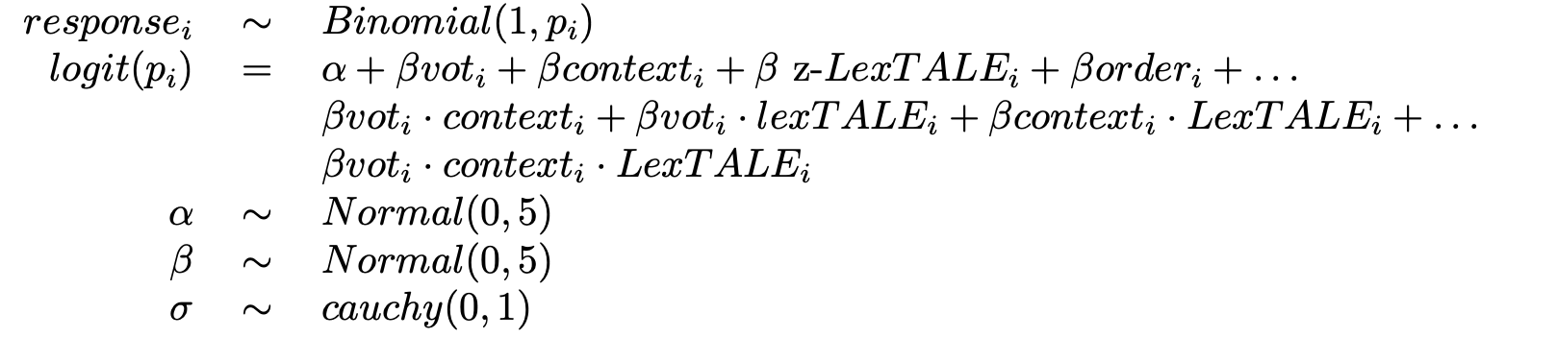
The results of the model are summarized graphically in Figure 3 of the manuscript and numerically in Table 1 below.
Table 1: Summary of the posterior distribution modeling voiceless responses as a function of VOT, context, z-LexTALE, and order. The table includes posterior means, the 95% HDI, the percentage of the HDI within the ROPE, and the maximum probability of effect (MPE).
Parameter | Estimate | HDI | ROPE | MPE
Intercept | −0.85 | [−1.00, −0.68] | 0.00 | 1.00
VOT | 3.55 | [3.19, 3.93] | 0.00 | 1.00
Context | −0.23 | [−0.37, −0.07] | 0.00 | 1.00
z-LexTALE | 0.24 | [−0.03, 0.50] | 0.06 | 0.96
Order | −0.15 | [−0.39, 0.07] | 0.16 | 0.90
VOT × Context | −0.23 | [−0.53, 0.10] | 0.09 | 0.92
VOT × z-LexTALE | 0.28 | [−0.41, 0.95] | 0.09 | 0.80
Context × z-LexTALE | −0.24 | [−0.47, 0.00] | 0.04 | 0.97
VOT × Context × z-LexTALE | −0.74 | [−1.35, −0.06] | 0.00 | 0.99

The results support three main conclusions. First, independent of proficiency, there were more ‘voiceless’ responses as VOT increased. Second, in the “English” context, perceptual categorization is unaffected by changes in proficiency. Third, in the “Spanish” context, as proficiency in Spanish increases so do ‘voiceless’ responses, which is manifested as a shift to the left of the identification function after around −10 ms.
As an alternative method of understanding the results of the first analysis, we can use the solved version of the linear equation mentioned above to calculate the probability of responding ‘voiceless’ for any VOT and z-LexTALE values. Table 2 summarizes the probability of responding ‘voiceless’ for each step in the VOT continuum (including 0), in each context (Spanish, English) at −2, 0, and 2 proficiency (z-LexTALE).
Table 2: Posterior predictions of the probability of responding ‘voiceless’ for each step of the VOT continuum (including 0).
z-LexTALE | Context | -35 | -30 | -25 | -20 | -15 | -10 | -5 | 0 | 5 | 10 | 15 | 20 | 25 | 30 | 35
-2 | English | 2.2 | 3.1 | 4.6 | 6.6 | 9.5 | 13.5 | 18.7 | 25.4 | 33.5 | 42.7 | 52.5 | 62.0 | 70.7 | 78.2 | 84.1
0 | English | 2.7 | 3.8 | 5.4 | 7.6 | 10.5 | 14.3 | 19.3 | 25.5 | 32.8 | 41.2 | 50.0 | 58.8 | 67.1 | 74.5 | 80.7
2 | English | 4.0 | 5.4 | 7.1 | 9.4 | 12.3 | 15.9 | 20.3 | 25.6 | 31.7 | 38.5 | 45.8 | 53.3 | 60.6 | 67.5 | 73.7
-2 | Spanish | 3.7 | 5.0 | 6.9 | 9.3 | 12.5 | 16.6 | 21.7 | 27.9 | 35.0 | 42.8 | 51.0 | 59.2 | 66.9 | 73.8 | 79.6
0 | Spanish | 3.0 | 4.5 | 6.5 | 9.5 | 13.7 | 19.2 | 26.3 | 34.9 | 44.7 | 54.8 | 64.6 | 73.2 | 80.4 | 86.1 | 90.3
2 | Spanish | 2.1 | 3.6 | 6.0 | 9.9 | 15.8 | 24.3 | 35.4 | 48.3 | 61.5 | 73.2 | 82.4 | 88.9 | 93.2 | 95.9 | 97.6

One can again observe that the probability of ‘voiceless’ responses varies minimally at each proficiency level in the “English” context. The differences are more pronounced in the “Spanish” context beginning around the middle region of the continuum, which represents a boundary shift to the left. Additionally, Figure 7 illustrates the relationship between VOT, context and proficiency by plotting the identification functions faceting by context. This plot underscores the fact that the perceptual categorization of the participants only changes in the Spanish context.
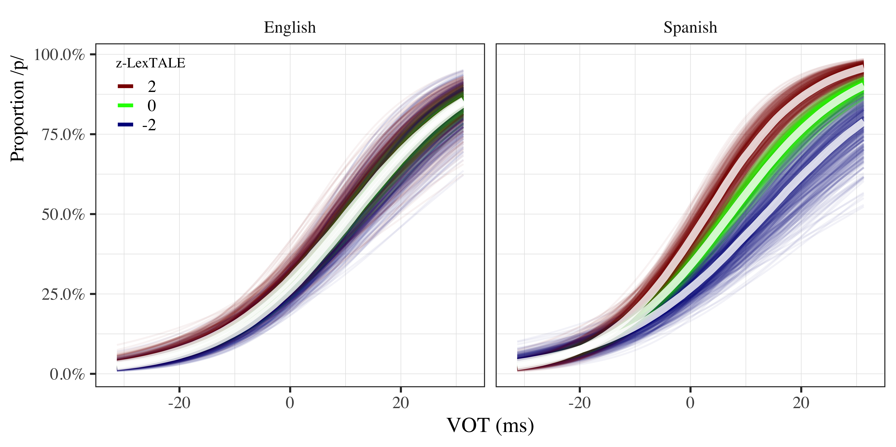
Figure 7. Conditional effects of ‘voiceless’ responses as a function of VOT and proficiency (z-LexTALE) in the English and Spanish contexts.

As a compliment to the model-based visualization provided in Figures 3 and 7, as well as the numeric summaries provided in Tables 1 and 2, we additionally illustrate the boundary shift using the raw data in Figure 8. Given that we operationalize proficiency as a continuous variable, we plot the raw data by trichotimizing the z-LexTALE scores using the lower and upper thirds of the distribution (see Gelman & Park, 2009).
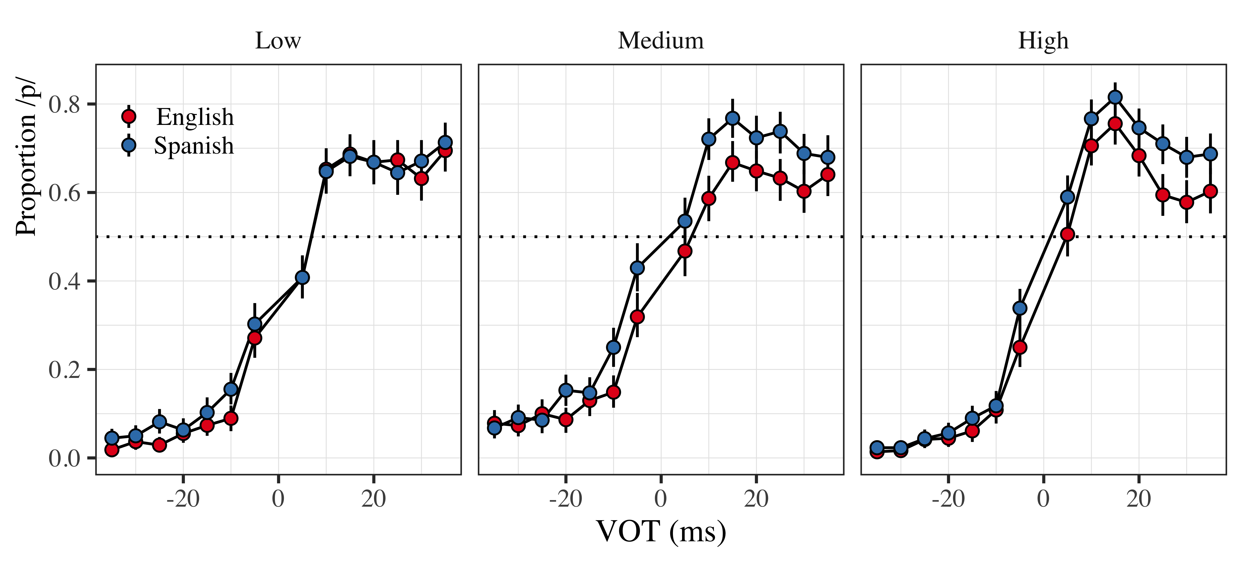
Figure 8. Proportion of ‘voiceless’ responses as a function of VOT and language context for low, medium and high z-LexTALE scores. Points represent mean values ± 95% bootstrapped confidence intervals.

The visualization of the raw data support the general conclusion from the statistical analysis: there is a shift to the left of the identification function in the “Spanish” context at higher z-LexTALE scores. That is, we observe increased ‘voiceless’ responses at higher proficiency levels when the participants believe they are hearing Spanish. Additionally, we calculated the point at which the probability of ‘voiceless’ responses reached 50% in each condition using the following formula:
$$\text{C}{\text{O}}_{\text{i}}\text{=}\frac{\text{β}{\text{0}}_{\text{i}}}{\text{β}{\text{vot}}_{\text{i}}}\text{× }\text{-}\text{1}$$
where the boundary crossover point (CO_{i}) is the intercept (β₀) divided by the slope (β_{vot}) multiplied by −1. Figure 9 plots the crossover points in each condition. Importantly, one can observe that the “English” 50% crossover point is constant at approximately 13 ms, while the “Spanish” crossover point shifts to left at medium and high proficiency.
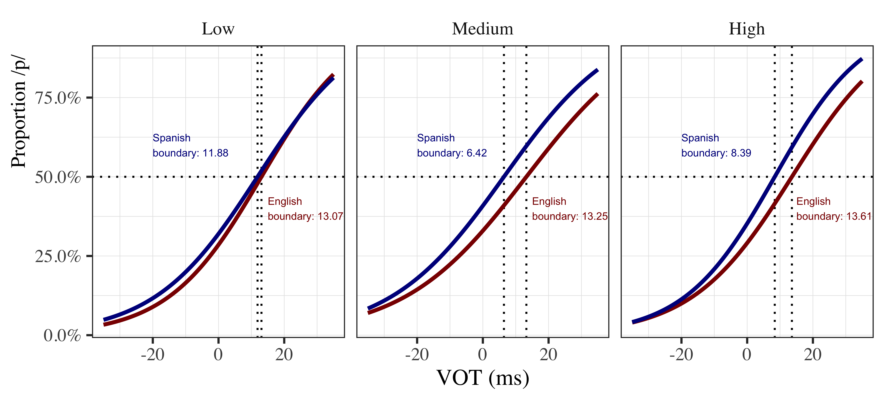
Figure 9. Proportion of ‘voiceless’ responses as a function of VOT, context and proficiency. Vertical discontinuous lines represent the 50% crossover point for Spanish (blue) and English (red).

Another option for scrutinizing phoneme boundaries is to use the posterior distribution from the omnibus model to calculate an entire distribution of plausible 50% crossover points for each language. The contour plot in the left panel of Figure 10 plots 6,000 draws from the posterior at the average proficiency level (z-LexTALE = 0). The lighter the color the more plausible the values for the English and Spanish boundaries. We can see that the center of gravity of the distribution falls at approximately 12.95 ms for English and 9.29 ms for Spanish. Thus, at the average proficiency level, the most plausible Spanish boundary is lower (i.e., further to the left) than the most plausible English boundary. We can quantify and summarize the difference between the two boundaries by subtracting the 6,000 most plausible Spanish boundaries from the 6,000 most plausible English boundaries. We see that at the average proficiency level there is strong evidence that the difference is greater than 0 (x̄ = 3.68, HDI = [1.32, 6.03]). The right panel of Figure 10 plots the distribution of the differences between English and Spanish boundaries, along with summary statistics.
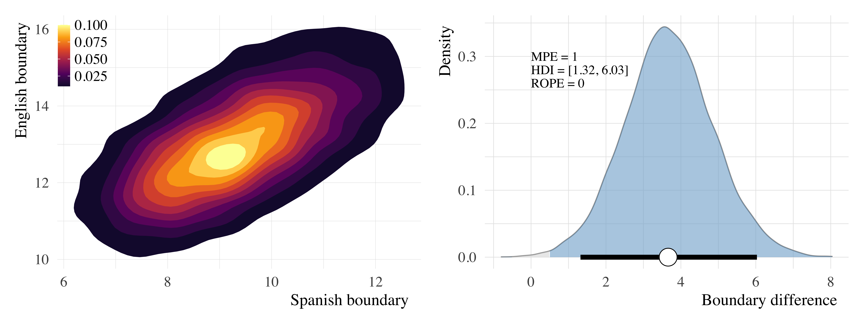
Figure 10. Posterior estimates of Spanish and English boundaries (left panel) and boundary differences (right panel).

In the next step of our analysis we conditioned the difference between the two boundaries, the phonemic boundary effect, on proficiency. The results of the model are summarized graphically in Figure 5 of the manuscript and numerically in Table 3 below.
Table 3: Summary of the posterior distribution modeling the phonemic boundary effect as a function of z-LexTALE. The table includes posterior means, the 95% HDI, the percentage of the HDI within the ROPE, and the maximum probability of effect (MPE).
Parameter | Estimate | HDI | ROPE | MPE
Intercept | 0.03 | [−0.05, 0.10] | 0.39 | 0.77
z-LexTALE | 0.16 | [0.03, 0.28] | 0.00 | 0.99

The contour plot in the left panel of Figure 11 plots 6,000 draws from the posterior. The lighter the color the more plausible the values for the joint density of the intercept and the slope of the model. We can see that the center of gravity of the distribution falls at approximately 0.16 standardized units on the horizontal access. The right panel of Figure 11 plots the marginal density of β-LexTALE and provides further evidence that the slope is a non-zero, positive value outside the established ROPE.
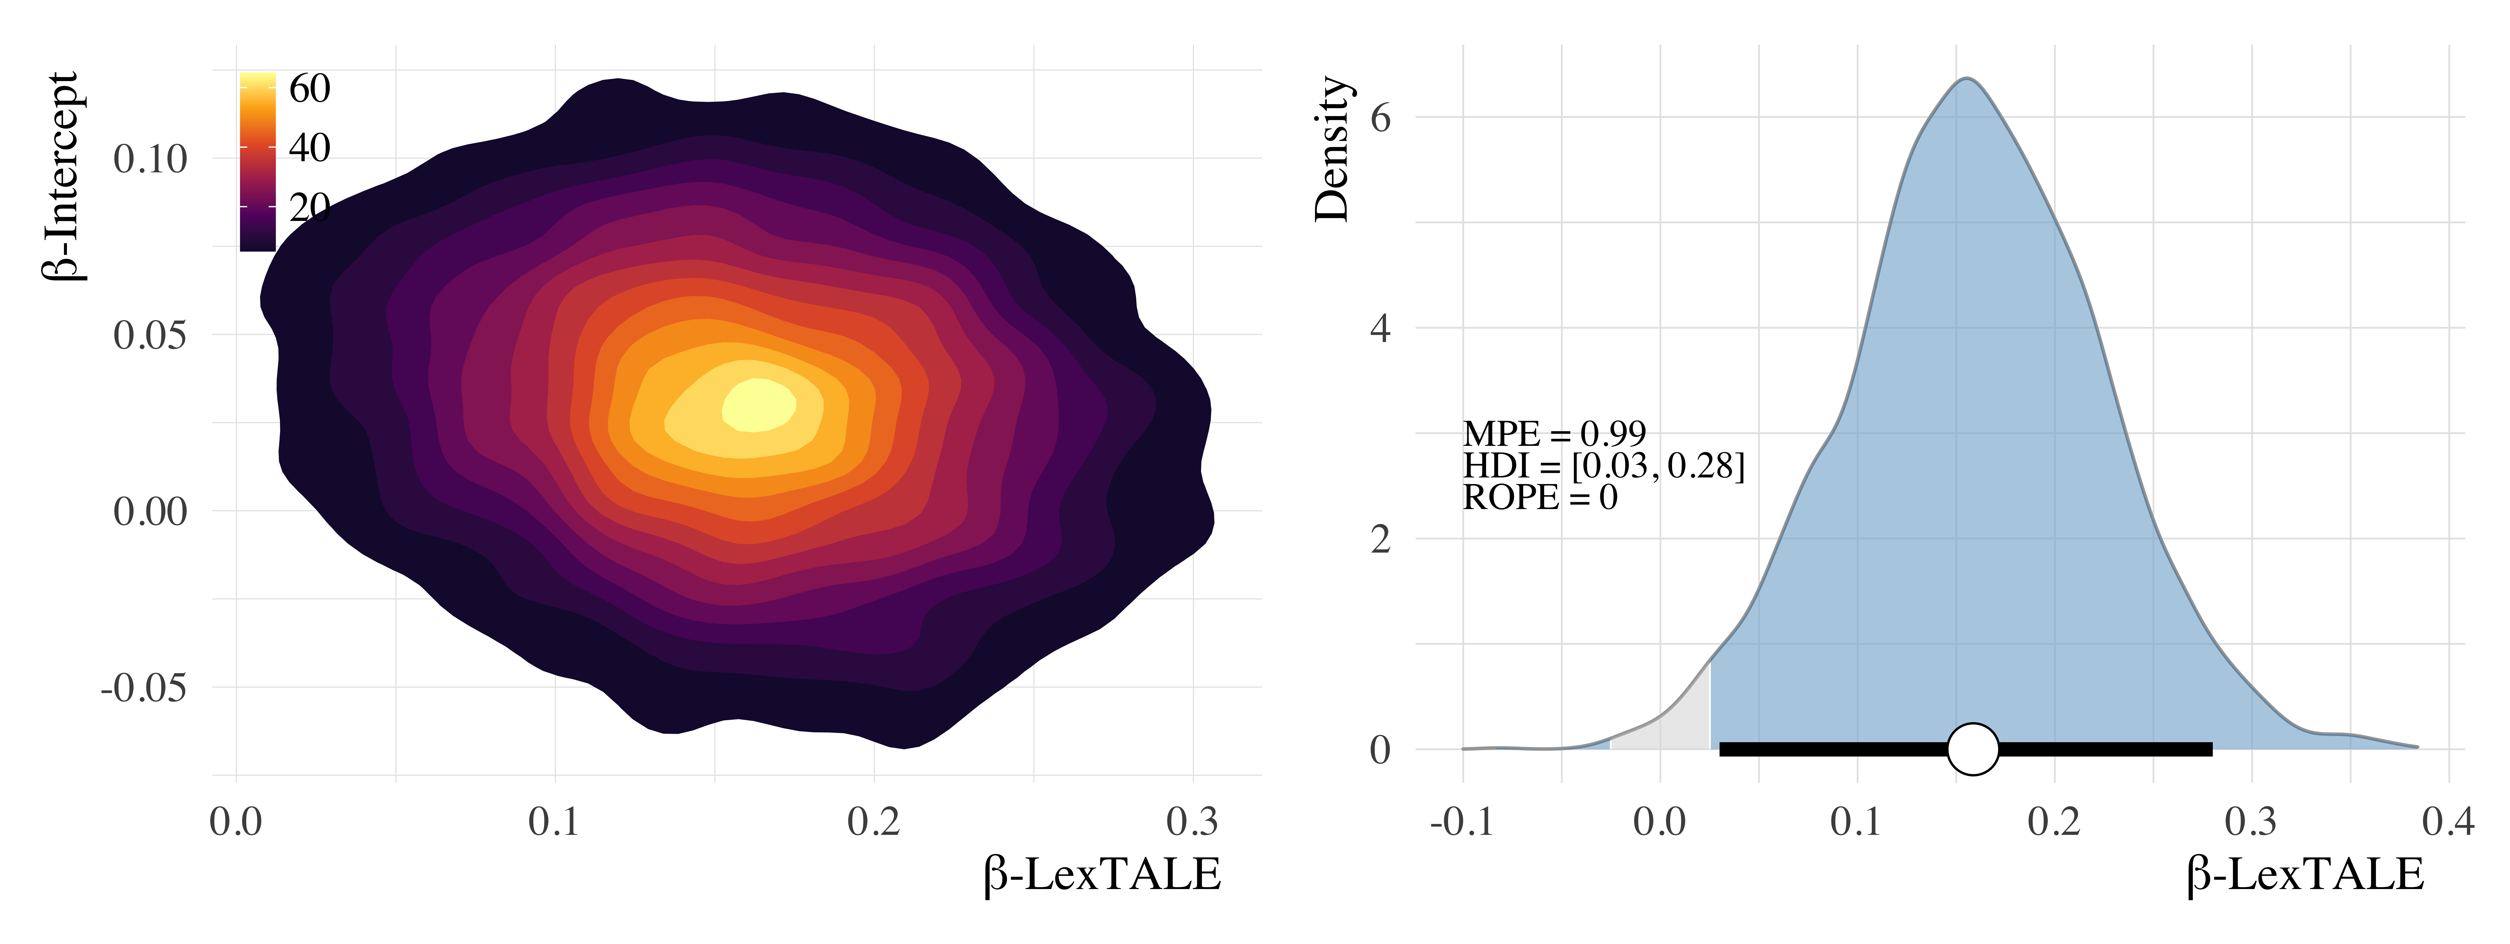
Figure 11. Joint density of the posterior distribution of the model fitting phonemic boundary effect as a function of proficiency (left panel) and the marginal density of the posterior distribution of β-LexTALE, along with the HDI and ROPE (right panel).

Some researchers have used rank boundaries to assess perceptual categorization when dealing with a distribution of 50% crossovers that are non-normal (see Gonzales et al., 2019). For the sake of completeness we include plots illustrating rank boundaries from group estimates (Figure 12) and individual posterior distributions derived from the random effects of the omnibus model (Figure 13).
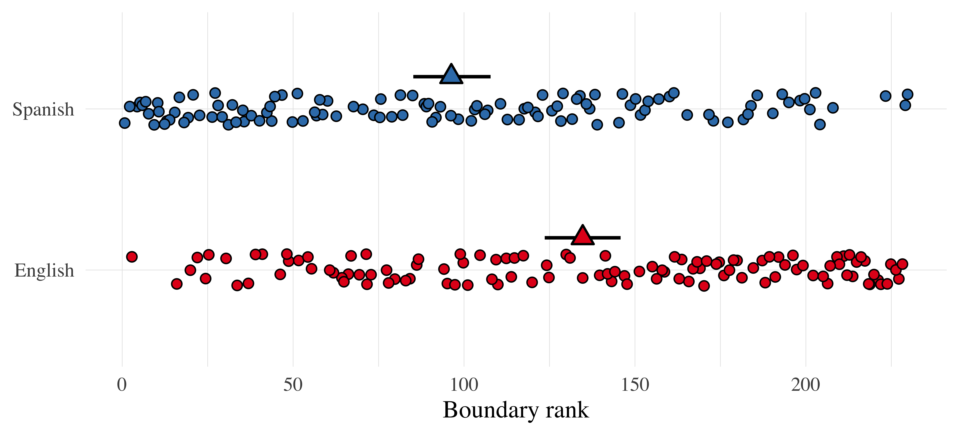
Figure 12. Rank boundaries derived from the posterior means of the random effects output of the omnibus model. Blue and red circles represent Spanish and English individual boundaries, respectively. Triangles represent means ± 95% bootstrapped confidence intervals.

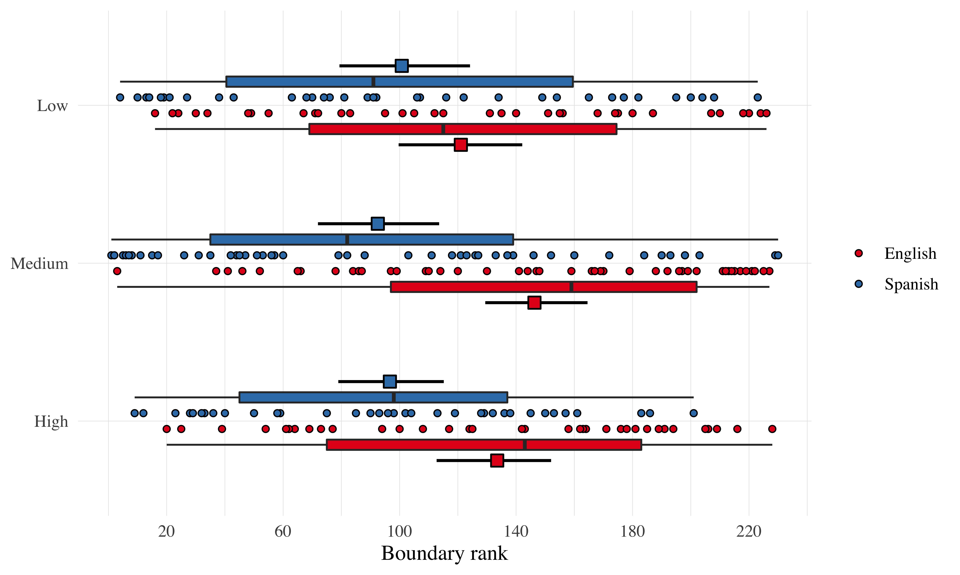
Figure 13. Rank boundaries derived from the posterior means of the random effects output of the omnibus model as function of proficiency. Blue and red circles represent Spanish and English individual boundaries, respectively. Squares represent means ± 95% bootstrapped confidence intervals.
The figures depict a scenario that corroborates the previous analyses. At the average proficiency level, the “Spanish” boundary is shifted to the left with regard to the “English” boundary. When proficiency is taken into consideration, boundary differences are negligible at low proficiency and more pronounced at higher levels.

Reproducibility information
About this document
This document was written in RMarkdown using papaja (Aust & Barth, 2018).
Session info
version R version 4.0.0 (2020-04-24)
os macOS Catalina 10.15.4
system x86_64, darwin17.0
ui X11
language (EN)
collate en_US.UTF-8
ctype en_US.UTF-8
tz America/New_York
date 2020-05-31
loadedversion date
abind 1.4-5 2016-07-21
arrayhelpers 1.1-0 2020-02-04
assertthat 0.2.1 2019-03-21
backports 1.1.7 2020-05-13
base64enc 0.1-3 2015-07-28
bayesplot 1.7.1 2019-12-01
bayestestR 0.6.0 2020-04-20
beeswarm 0.2.3 2016-04-25
bookdown 0.19 2020-05-15
bridgesampling 1.0-0 2020-02-26
brms 2.12.0 2020-02-23
Brobdingnag 1.2-6 2018-08-13
broom 0.5.6 2020-04-20
callr 3.4.3 2020-03-28
cli 2.0.2 2020-02-28
coda 0.19-3 2019-07-05
codetools 0.2-16 2018-12-24
colorspace 1.4-1 2019-03-18
colourpicker 1.0 2017-09-27
crayon 1.3.4 2017-09-16
crosstalk 1.1.0.1 2020-03-13
desc 1.2.0 2018-05-01
devtools 2.3.0 2020-04-10
digest 0.6.25 2020-02-23
dplyr 0.8.5 2020-03-07
DT 0.13 2020-03-23
dygraphs 1.1.1.6 2018-07-11
ellipsis 0.3.1 2020-05-15
evaluate 0.14 2019-05-28
fansi 0.4.1 2020-01-08
fastmap 1.0.1 2019-10-08
forcats 0.5.0 2020-03-01
fs 1.4.1 2020-04-04
future 1.17.0 2020-04-18
generics 0.0.2 2018-11-29
ggbeeswarm 0.6.0 2017-08-07
ggdag 0.2.2 2020-02-13
ggplot2 3.3.0 2020-03-05
ggridges 0.5.2 2020-01-12
globals 0.12.5 2019-12-07
glue 1.4.1 2020-05-13
gridExtra 2.3 2017-09-09
gtable 0.3.0 2019-03-25
gtools 3.8.2 2020-03-31
here 0.1 2017-05-28
highr 0.8 2019-03-20
hms 0.5.3 2020-01-08
htmltools 0.4.0 2019-10-04
htmlwidgets 1.5.1 2019-10-08
httpuv 1.5.2 2019-09-11
igraph 1.2.5 2020-03-19
inline 0.3.15 2018-05-18
insight 0.8.4 2020-05-13
knitr 1.28 2020-02-06
later 1.0.0 2019-10-04
lattice 0.20-41 2020-04-02
lifecycle 0.2.0 2020-03-06
listenv 0.8.0 2019-12-05
loo 2.2.0 2019-12-19
magrittr 1.5 2014-11-22
markdown 1.1 2019-08-07
Matrix 1.2-18 2019-11-27
matrixStats 0.56.0 2020-03-13
memoise 1.1.0 2017-04-21
mime 0.9 2020-02-04
miniUI 0.1.1.1 2018-05-18
munsell 0.5.0 2018-06-12
mvtnorm 1.1-0 2020-02-24
nlme 3.1-147 2020-04-13
papaja 0.1.0.9942 2020-05-19
patchwork 1.0.0 2019-12-01
pillar 1.4.4 2020-05-05
pkgbuild 1.0.8 2020-05-07
pkgconfig 2.0.3 2019-09-22
pkgload 1.0.2 2018-10-29
plyr 1.8.6 2020-03-03
png 0.1-7 2013-12-03
prettyunits 1.1.1 2020-01-24
processx 3.4.2 2020-02-09
promises 1.1.0 2019-10-04
ps 1.3.3 2020-05-08
purrr 0.3.4 2020-04-17
R6 2.4.1 2019-11-12
Rcpp 1.0.4.6 2020-04-09
readr 1.3.1 2018-12-21
remotes 2.1.1 2020-02-15
reshape2 1.4.4 2020-04-09
rlang 0.4.6 2020-05-02
rmarkdown 2.1.4 2020-05-17
rprojroot 1.3-2 2018-01-03
rsconnect 0.8.16 2019-12-13
rstan 2.19.3 2020-02-11
rstantools 2.0.0 2019-09-15
scales 1.1.1 2020-05-11
sessioninfo 1.1.1 2018-11-05
shiny 1.4.0.2 2020-03-13
shinyjs 1.1 2020-01-13
shinystan 2.5.0 2018-05-01
shinythemes 1.1.2 2018-11-06
StanHeaders 2.19.2 2020-02-11
stringi 1.4.6 2020-02-17
stringr 1.4.0 2019-02-10
svUnit 1.0.3 2020-04-20
testthat 2.3.2 2020-03-02
threejs 0.3.3 2020-01-21
tibble 3.0.1 2020-04-20
tidybayes 2.0.3 2020-04-04
tidygraph 1.2.0 2020-05-12
tidyr 1.1.0 2020-05-20
tidyselect 1.1.0 2020-05-11
usethis 1.6.1 2020-04-29
vctrs 0.3.0 2020-05-11
vipor 0.4.5 2017-03-22
withr 2.2.0 2020-04-20
xfun 0.14 2020-05-20
xtable 1.8-4 2019-04-21
xts 0.12-0 2020-01-19
yaml 2.2.1 2020-02-01
zoo 1.8-8 2020-05-02
-05-02

Following Kruschke (2018), we established a ROPE of ± 0.05 for standardized values in logistic regression. For the linear model assessing phonemic boundaries the continuous variables were standardized to have a mean of 0 and a standard deviation of 0.5, thus the ROPE was ± 0.025 to reflect this difference. For non-standardized values in other contexts, Kruschke (2018) suggests a ROPE of ± 0.1—half of what is considered a small effect using Cohen’s D (Cohen, 1988, 2013)—, or calculating a rope using the following formula: $\frac{{\text{μ}}_{\text{1}}\text{-}{\text{μ}}_{\text{2}}}{\sqrt{\frac{{\text{σ}}_{\text{1}}^{\text{2}}\text{+}{\text{σ}}_{\text{2}}^{\text{2}}}{\text{2}}}}$.

