Appendix A
List of Exposure Items
Experimental Group
O-S-V word order (1-13: plausible, 14-25: implausible), 4 words
(1) This bike-o John-ga bought
(2) This wall-o Mary-ga painted
(3) The cake-o Mike-ga ate
(4) The ink-o Stacey-ga spilled
(5) Those songs-o James-ga sang
(6) The door-o Karen-ga broke
(7) A homework-o Tim-ga finished
(8) The fire-o Angela-ga lighted
(9) That pen-o Tom-ga used
(10) The video-o Cathy-ga watched
(11) This chair-o Dwight-ga carried
(12) A key-o Linda-ga dropped
(13) Those words-o Steve-ga learned
(14) A door-o Tom-ga drank
(15) The dish-o Cathy-ga spoke
(16) The girl-o Dwight-ga built
(17) A phone-o Linda-ga wrote
(18) The schools-o Steve-ga played
(19) Those shoes-o Pamela-ga tasted
(20) The book-o Jeff-ga inspired
(21) A room-o Nicole-ga warned
(22) The guitar-o John-ga peeled
(23) A year-o Mary-ga moved
(24) A letter-o Mike-ga offended
(25) This bucket-o Stacey-ga soothed

O-S-I-V word order (1-13: plausible, 14-25: implausible), 6 words
(1) The picture-o John-ga his friends-ni sent
(2) A letter-o Mary-ga her boss-ni faxed
(3) This language-o Mike-ga his students-ni taught
(4) A sweater-o Stacey-ga her husband-ni presented
(5) His license-o James-ga the police-ni showed
(6) The salt-o Karen-ga her brother-ni passed
(7) A bone-o Tim-ga the dog-ni gave
(8) A peace-o Angela-ga the government-ni demanded
(9) A restaurant-o Tom-ga his parents-ni recommended
(10) A letter-o Cathy-ga her boyfriend-ni wrote
(11) This present-o Dwight-ga his friend-ni bought
(12) Some money-o Linda-ga a bank-ni deposited
(13) That computer-o Steve-ga his son-ni bought
(14) A question-o Tom-ga the book-ni asked
(15) Some money-o Cathy-ga a cat-ni lent
(16) The secret-o Dwight-ga this table-ni told
(17) A job-o Linda-ga that rocket-ni offered
(18) A ball-o Steve-ga a stone-ni threw
(19) This cookie-o Pamela-ga her bag-ni baked
(20) The medal-o Jeff-ga the towel-ni awarded
(21) A song-o Nicole-ga a tax-ni sang
(22) A story-o John-ga the town-ni recited
(23) A deal-o Mary-ga a virus-ni proposed
(24) This flower-o Mike-ga the quality-ni brought
(25) This food-o Stacey-ga a ladder-ni fed

O-S-[S-V]-V word order (1-8: plausible, 9-16: implausible), 7 words
(1) The diamond-o John-ga this man-ga stole thought
(2) The tuition-o Mary-ga her school-ga raised mentioned
(3) The donuts-o Mike-ga his dog-ga ate realized
(4) That vase-o Stacey-ga her spouse-ga broke said
(5) His car-o James-ga a cyclist-ga damaged thought
(6) That girl-o Karen-ga the police-ga found mentioned
(7) His health-o Tim-ga the smoking-ga hurt realized
(8) A gun-o Angela-ga a robber-ga shot said
(9) Some milk-o Tom-ga his mother-ga added thought
(10) The governor-o Cathy-ga her collague-ga abused mentioned
(11) Those kids-o Dwight-ga his friend-ga scared realized
(12) This sushi-o Linda-ga that chef-ga made said
(13) The job-o Steve-ga his father-ga quit thought
(14) An emphasis-o Tom-ga the train-ga hit mentioned
(15) The theater-o Cathy-ga a singer-ga played realized
(16) An ability-o Dwight-ga the fire-ga burned said
(17) An outcome-o Linda-ga her boss-ga fired thought
(18) Those books-o Steve-ga the waitress-ga spilled mentioned
(19) This paper-o Pamela-ga her colleague-ga drove realized
(20) Those plants-o Jeff-ga the boy-ga drank said
(21) That news-o Nicole-ga her teacher-ga reprimanded thought
(22) A blanket-o John-ga his friend-ga flew mentioned
(23) A book-o Mary-ga an elephant-ga drank realized
(24) This lamp-o Mike-ga his teacher-ga started said
(25) The fear-o Stacey-ga her daughter-ga loaded thought

O-S-[S-I-V]-V word order (1-13: plausible, 14-25: implausible), 9 words
(1) Some food-o John-ga his wife-ga their dog-ni brought thought
(2) The documents-o Mary-ga her workmate-ga their boss-ni faxed mentioned
(3) This coffee-o Mike-ga a student-ga the professor-ni brought realized
(4) A present-o Stacey-ga the boy-ga his mother-ni sent said
(5) The book-o James-ga his sister-ga her friend-ni lent thought
(6) A bribe-o Karen-ga her colleague-ga their boss-ni offered mentioned
(7) A tip-o Tim-ga his friend-ga the driver-ni gave realized
(8) A letter-o Angela-ga her husband-ga the mayor-ni wrote said
(9) A necklace-o Tom-ga his friend-ga his wife-ni gave thought
(10) That car-o Cathy-ga her husband-ga the neighbor-ni sold mentioned
(11) The secret-o Linda-ga her boyfriend-ga his mother-ni told realized
(12) Some money-o Dwight-ga his uncle-ga a man-ni spared said
(13) The pizza-o Steve-ga his friend-ga a roommate-ni saved thought
(14) A car-o Tom-ga his parents-ga the beauty-ni bought mentioned
(15) A bike-o Cathy-ga her aunt-ga a taste-ni presented realized
(16) A waitress-o Dwight-ga his wife-ga his son-ni read said
(17) A medal-o Linda-ga the president-ga the future-ni awarded thought
(18) An honor-o Pamela-ga the king-ga a relief-ni bestowed said
(19) The sorrow-o Steve-ga his manager-ga his friend-ni proposed realized
(20) A misery-o Jeff-ga the student-ga his teacher-ni asked said
(21) A victory-o Nicole-ga her father-ga the police-ni showed thought
(22) A number-o John-ga the waitress-ga a customer-ni offered mentioned
(23) A letter-o Mary-ga her colleague-ga the patience-ni wrote realized
(24) The book-o Mike-ga his professor-ga the movement-ni lent said
(25) A conflict-o Stacey-ga her spouse-ga her son-ni bought thought

Control Group
O-S-V word order (1-13: plausible, 14-25: implausible), 4 words
(1) John-ga this bike-o bought (S-ga O-o V)
(2) Mary-ga painted this wall-o (S-ga V O-o)
(3) Ate Mike-ga the cake-o (V S-ga O-o)
(4) Spilled the ink-o Stacey-ga (V O-o S-ga)
(5) Songs-o James-ga sang (O-o S-ga V)
(6) The door-o broke Karen-ga (O-o V S-ga)
(7) Tim-o a homework-ga finished (S-o O-ga V)
(8) Angela-o lighted the fire-ga (S-o V O-ga)
(9) Used Tom-o that pen-ga (V S-o O-ga)
(10) Watched the video-ga Cathy-o (V O-ga S-o)
(11) This chair-ga Dwight-o carried (O-ga S-o V)
(12) A key-ga dropped Linda-o (O-ga V S-o)
(13) Steve-ga those words-o learned (S-ga O-o V)
(14) Tom-ga drank a door-o (S-ga V O-o)
(15) Spoke Cathy-ga the dish-o (V S-ga O-o)
(16) Built the girl-o Dwight-ga (V O-o S-ga)
(17) A phone-o Linda-ga wrote (O-o S-ga V)
(18) The schools-ga played Steve-o (O-ga V S-o)
(19) Pamela-o those shoes-ga tasted (S-o O-ga V)
(20) Jeff-o inspired the book-ga (S-o V O-ga)
(21) Warned Nicole-o a room-ga (V S-o O-ga)
(22) Pealed the guitar-ga John-o (V O-ga S-o)
(23) A year-ga Mary-o moved (O-ga S-o V)
(24) A letter-ga offended Mike-o (O-ga V S-o)
(25) Stacey-ga this backet-o soothed (S-ga O-o V)
Frequency: SOV (5), SVO (4), VSO (4), VOS (4), OSV (4), OVS(4)
S-ga (12), S-o (13), O-ga (13), O-o (12)

O-S-I-V word order (1-13: plausible, 14-25: implausible), 6 words
(1) John-ga his friends-ni the picture-o sent (S-ga I-ni O-o V)
(2) Mary-o her boss-ga faxed a letter-ni (S-o I-ga V O-ni)
(3) Mike-ni this language-ga his students-o taught (S-ni O-ga I-o V)
(4) Stacey-ga a sweater-o her presented husband-ni (S-ga O-o V I-ni)
(5) James-o showed the police-ga his license-ni (S-o V I-ga O-ni)
(6) Karen-ni passed her brother-ga the salt-o (S-ni V O-ga I-o)
(7) The dog-ni Tim-ga a bone-o gave (I-ni S-ga O-o V)
(8) The government-ga Angela-o demanded a peace-ni (I-ga S-o V O-ni)
(9) His parents-o a restaurant-ga Tom-ni recommended (I-o O-ga S-ni V)
(10) Her boyfriend-ni a letter-o wrote Cathy-ga (I-ni O-o V S-ga)
(11) His friend-ga bought Dwight-o this present-ni (I-ga V S-o O-ni)
(12) A bank-o deposited some money-ga Linda-ni (I-o V O-ga S-ni)
(13) That computer-o Steve-ga his son-ni bought (O-o S-ga I-ni V)
(14) A question-ni Tom-o asked the book-ga (O-ni S-o V I-ga)
(15) Some money-ga a cat-o Cathy-ni lent (O-ga I-o S-ni V)
(16) The secret-o this table-ni told Dwight-ga (O-o I-ni V S-ga)
(17) Linda-o that rocket-ga a job-ni offered (S-o I-ga O-ni V)
(18) Steve-ni a stone-o threw a ball-ga (S-ni I-o V O-ga)
(19) Pamela-ga this cookie-o her bag-ni baked (S-ga O-o I-ni V)
(20) Jeff-o the medal-ni awarded the towel-ga (S-o O-ni V I-ga)
(21) Nicole-ni sang a tax-o a song-ga (S-ni V I-o O-ga)
(22) John-ga recited a story-o the town-ni (S-ga V O-o I-ni)
(23) A virus-ga Mary-o a deal-ni proposed (I-ga S-o O-ni V)
(24) The quality-o Mike-ni brought this flower-ga (I-o S-ni V O-ga)
(25) A ladder-ni this food-o Stacey-ga fed (I-ni O-o S-ga V)
Frequency: SIOV (2), SIVO (2), SOIV (2), SOVI (2), SVIO (2), SVOI (2), ISOV (2), ISVO (2), IOSV (2), IOVS (1), IVSO (1), IVOS (1), OSIV (1), OSVI (1), OISV (1), OIVS (1).
S-ga (9), S-o (8), S-ni (8), I-ga (8), I-ni (9), I-o (8), O-ga (8), O-ni (8), O-o (9).

O-S-[S-V]-V word order (1-8: plausible, 9-16: implausible), 7 words
(1) John-ga this man-ga the diamond-o stole thought (S-ga S-ga O-o V V)
(2) Mary-o her school-o raised the tuition-ga mentioned (S-o S-o V O-ga V)
(3) Mike-ga his dog-ga ate realized the donuts-o (S-ga S-ga V V O-o)
(4) Stacey-o that vase-ga her spouse-o broke said (S-o O-ga S-o VV)
(5) James-ga his car-o a damaged cyclist-ga thought (S-ga O-o V S-ga V)
(6) Karen-o that girl-ga found mentioned the police-o (S-o O-ga V V S-o)
(7) Tim-ga hurt the smoking-ga his health-o realized (S-ga V S-ga O-o V)
(8) Angela-o shot a robber-o said a gun-ga (S-o V S-o V O-ga)
(9) Tom-ga added some milk-o his mother-ga thought (S-ga V O-o S-ga V)
(10) Cathy-o abused the governor-ga mentioned her colleague-o (S-o V O-ga V S-o) (11) His kids-o Dwight-ga a friend-ga scared realized (O-o S-ga S-ga V V)
(12) This sushi-ga Linda-o made this chef-o said (O-ga S-o V S-o V)
(13) The job-o Steve-ga quit thought his father-ga (O-o S-ga V V S-ga)
(14) An emphasis-ga hit Tom-o the train-o mentioned (O-ga V S-o S-o V)
(15) The theater-o played Cathy-ga realized a singer-ga (O-o V S-ga V S-ga)
(16) An ability-ga burned said Dwight-o the fire-o (O-ga V V S-o S-o)
(17) Fired Linda-ga her boss-ga an outcome-o thought (V S-ga S-ga O-o V)
(18) Spilled Steve-o the waitress-o mentioned those books-ga (V S-o S-o V O-ga) (19) Drove Pamela-ga this paper-o her colleague-ga realized (V S-ga O-o S-ga V) (20) Drank Jeff-o those plants-ga said the boy-o (V S-o O-ga V S-o)
(21) Reprimanded that news-o Nicole-ga her teacher-ga thought (V O-o S-ga S-ga V) (22) Flew a blanket-ga John-o mentioned his friend-o (V O-ga S-o V S-o)
(23) Drank a book-o realized Mary-ga an elephant-ga (V O-o V S-ga S-ga)
(24) Started said Mike-o his teacher-o this lamp-ga (V V S-o S-o O-ga)
(25) Loaded thought Stacey-ga the fear-o her daughter-ga (V V S-ga O-o S-ga)
Frequency: SSOVV (1), SSVOV (1), SSVVO (1), SOSVV (1), SOVSV (1), SOVVS (1), SVSOV (1), SVSVO (1), SVOSV (1), SVOVS (1), OSSVV (1), OSVSV (1), OSVVS (1), OVSSV (1), OVSVS (1), OVVSS (1), VSSOV (1), VSSVO (1), VSOSV (1), VSOVS (1), VOSSV (1), VOSVS (1), VOVSS (1), VVSSO (1), VVSOS (1).
S-ga (26), S-o (24), O-ga (12), O-o (13)

O-S-[S-I-V]-V word order (1-13: plausible, 14-25: implausible), 9 words
(1) John-ga his wife-ga a dog-ni some food-o brought thought (S-ga S-ga I-ni O-o V
V)
(2) Mary-ni her workmate-ni her boss-o faxed the documents-ga mentioned (S-ni S-ni
I-o V O- ga V)
(3) Mike-o a student-o the professor-ga this brought realized this coffee-ni (S-o S-o I-gaVVO-ni)
(4) Stacey-ga the boy-ga sent said his mother-ni a present-o (S-ga S-ga V V I-ni O-o)
(5) James-ni his sister-ni the book-ga lent thought her friend-o (S-ni S-ni O-ga V V I-
o)
(6) Her boss-ga Karen-o her colleague-o a bribe-ni offered mentioned (I-ga S-o S-o
O-ni V V)
(7) The driver-ni Tim-ga his friend-ga gave a tip-o realized (I-ni S-ga S-ga V O-o V)
(8) The mayor-o Angela-ni a letter-ga wrote said her husband-ni (I-o S-ni O-ga V V
S-ni)
(9) His wife-ga Tom-o his A necklace-ni gave friend-o thought (I-ga S-o O-ni V S-o
V)
(10) The neighbor-ni Cathy-ga sold mentioned her husband-ga that car-o (I-ni S-ga V
V S-ga O- o)
11) His mother-o Linda-ni told her boyfriend-ni the secret-ga realized (I-o S-ni V S-ni
O-ga V)
(12) Some money-ni Dwight-o his uncle-o a man-ga spared said (O-ni S-o S-o I-ga V
V)
(13) The pizza-o Steve-ga his friend-ga saved a roommate-ni thought (O-o S-ga S-ga
V I-ni V)
(14) A car-ga Tom-ni the beauty-o bought mentioned his parents-ni (O-ga S-ni I-o V
V S-ni)
(15) A bike-ni Cathy-o taste-ga a presented her aunt-o realized (O-ni S-o I-ga V S-o
V)
(16) A waitress-o Dwight-ga read said his wife-ga his son-ni (O-o S-ga V V S-ga I-
ni)
(17) A medal-ga Linda-ni awarded the president-ni the future-o thought (O-ga S-ni V
S-ni I-o V)
(18) Bestowed Pamela-o the king-o a relief-ga an honor-ni said (V S-o S-o I-ga O-ni
V)
(19) Proposed Steve-ga his friend-ni the sorrow-o realized his manager-ga (V S-ga I-
ni O-o V S- ga)
(20) Asked Jeff-ni his teacher-o a misery-ga said the student-ni (V S-ni I-o O-ga V S-
ni)
(21) Showed Nicole-o a victory-ni thought her father-o the police-ga (V S-o O-ni V
S-o I-ga)
(22) Offered John-ga mentioned the waitress-ga a customer-ni a number-o (V S-ga V
S-ga I-ni O-o)
(23) Wrote Mary-ni the patience-o realized her colleague-ni a letter-ga (V S-ni I-o V
S-ni O-ga)
(24) Lent Mike-o the book-ni his professor-o the movement-ga said (V S-o O-ni S-o
I-ga V)
(25) Bought Stacey-ga thought her son-ni a conflict-o her spouse-ga (V S-ga V I-ni
O-o S-ga)
Frequency: SIOVV (1), SSIVOV (1), SSIVVO (1), SSVVIO (1), SSVIOV (1), SSOVVI (1), ISSOVV (1), ISSVOV (1), ISOVVS (1), ISOVSV (1), ISVVSO (1), ISVSOV (1), OSSIVV (1), OSSVIV (1), OSIVVS (1), OSIVSV (1), OSVVSI (1),
OSVSIV (1), VSSIOV (1), VSIOVS (1), VSOVSI (1), VSVSIO (1), VSIVSO (1), VSOSI (1), VSVIOS (1)
S-ga (18), S-o (16), S-ni (16), O-ga (8), O-o (9), O-ni (9), I-ga (8), I-o (8), I-ni (9)

Appendix B
U-AGJT Stimuli

List 1
Grammatical
O-S-V (4 words)
(1) This cake-o Daniel-ga favored
(2) The table-o Sarah-ga wiped
(3) The admission-o Nick-ga secured
(4) A parcel-o Emma-ga received
(5) The street-o Chris-ga crossed
(6) These lessons-o Alison-ga studied
(7) A dog-o Ben-ga had
(8) The hairstyle-o Rachel-ga changed

O-S-I-V (6 words)
(1) The application-o Bruce-ga a university-ni mailed
(2) A party-o Vivian-ga her mother-ni threw
(3) A lesson-o Richard-ga his students-ni gave
(4) That ball-o Ellie-ga a player-ni tossed
(5) An autograph-o Elvis-ga his fan-ni signed
(6) This computer-o Daisy-ga her father-ni chose
(7) That money-o Tony-ga a church-ni donated
(8) The truth-o Lyla-ga her professor-ni told

O-S-[S-V]-V (7 words)
(1) The exam-o Bill-ga his friend-ga passed said
(2) These toys-o Claire-ga her child-ga wanted realized
(3) Those kids-o Boris-ga that man-ga helped mentioned
(4) Her heart-o Lydia-ga her boyfriend-ga destroyed thought
(5) The war-o Scott-ga the soldiers-ga survived said
(6) The professor-o Laura-ga her colleague-ga upset realized
(7) His paper-o Will-ga the journal-ga accepted mentioned
(8) Those students-o Patty-ga the dean-ga warned thought

O-S-[S-I-V]-V (9 words)
(1) A story-o Phillip-ga his wife-ga their son-ni narrated said
(2) A check-o Holly-ga her friend-ga the salesman-ni wrote realized
(3) The law-o Allan-ga the congress-ga the President-ni proposed mentioned
(4) This document-o Judie-ga her colleague-ga their boss-ni faxed thought
(5) A scarf-o Ethan-ga his brother-ga their mother-ni gave said
(6) The flowers-o Nora-ga her neighbor-ga her sister-ni sent realized
(7) A deal-o Brad-ga his colleague-ga a customer-ni offered mentioned
(8) Her secret-o Olivia-ga her brother-ga their parents-ni told thought

Ungrammatical
O !V S (4 words)
(1) A car-o washed Daniel-ga
(2) A boat-o rowed Sarah-ga
(3) The dinner-o cooked Nick-ga
(4) The baby-o fed Emma-ga
(5) A ladder-o climbed Chris-ga
(6) This computer-o used Alison-ga
(7) The radio-o fixed Ben-ga
(8) An apple-o peeled Rachel-ga

O S V !I (7 words)
(1) A latte-o Bruce-ga brewed his wife-ni
(2) An email-o Vivian-ga forwarded her colleague-ni
(3) The profit-o Richard-ga shared his employees-ni
(4) A legacy-o Ellie-ga left her children-ni
(5) A dollar-o Elvis-ga paid the cashier-ni
(6) A lullaby-o Daisy-ga sang her child-ni
(7) Some money-o Tony-ga bet his friend-ni
(8) A dress-o Lyla-ga made her daughter-ni

O S V !S V (7 words)
(1) The promise-o Bill-ga broke his wife-ga said
(2) A vase-o Claire-ga broke her son-ga realized
(3) Those men-o Boris-ga stopped the police-ga mentioned
(4) The tree-o Lydia-ga decorated her father-ga thought
(5) A monster-o Scott-ga released the captain-ga said
(6) That computer-o Laura-ga fixed her boyfriend-ga realized
(7) The country-o Will-ga liberated the military-ga mentioned
(8) Five languages-o Patty-ga spoke her professor-ga thought

O S S V !I V (9 words)
(1) An advice-o Phillip-ga his wife-ga gave a boy-ni said
(2) Those wounds-o Holly-ga her husband-ga showed a doctor-ni realized
(3) The grades-o Allan-ga her teacher-ga reported the principal-ni mentioned
(4) A car-o Judie-ga her parents-ga loaned their son-ni thought
(5) His debt-o Ethan-ga his brother-ga paid the bank-ni said
(6) Her symptoms-o Nora-ga her sister-ga explained a nurse-ni realized
(7) An iPhone-o Brad-ga his parents-ga presented his brother-ni mentioned
(8) An access-o Olivia-ga the government-ga granted her colleague-ni thought

Case Missing (6 words: !-ga, !-o, !-ni)
(1) The information-o Daniel his colleague-ni provided (!-ga)
(2) The rule Sarah-ga her friend-ni described (!-o)
(3) A bike-o Nick-ga his son bought (!-ni)
(4) A success-o Emma her boyfriend-ni wished (!-ga)
(5) This notebook Chris-ga his sister-ni returned (!-o)
(6) Her transcript-o Alison-ga her parents showed (!-ni)
(7) A plan-o Ben his boss-ni offered (!-ga)
(8) The incident Rachel-ga her neighbor-ni described (!-o)

Case Mixing (6 words: ga-o, ga-ni, o-ni)
(1) An invitation-ga Bruce-o his colleagues-ni sent (ga-o)
(2) The injection-o Vivian-ni her dog-ga gave (ga-ni)
(3) A package-ni Richard-ga his parents-o delivered (o-ni)
(4) A reform-ga Ellie-o the council-ni demanded (ga-o)
(5) His time-o Elvis-ni his child-ga devoted (ga-ni)
(6) Two tickets-ni Daisy-ga her parents-o reserved (o-ni)
(7) A cappuccino-ga Tony-o his customer-ni brewed (ga-o)
(8) A baguette-o Lyla-ni her husband-ga baked (ga-ni)

List 2
Grammatical
O-S-V (4 words)
(1) The key-o Daniel-ga found
(2) Some food-o Sarah-ga shopped
(3) His car-o Nick-ga repaired
(4) These shoes-o Emma-ga brushed
(5) A window-o Chris-ga closed
(6) The carpet-o Alison-ga cleaned
(7) A chair-o Ben-ga made
(8) Her voice-o Rachel-ga recorded

O-S-I-V (6 words)
(1) A quiz-o Bruce-ga his son-ni gave
(2) The information-o Vivian-ga her lawyer-ni requested
(3) An collaboration-o Richard-ga his colleague-ni offered
(4) A plan-o Ellie-ga her boss-ni proposed
(5) The reason-o Elvis-ga his friend-ni explained
(6) The schedule-o Daisy-ga her co-workers-ni emailed
(7) A motorbike-o Tony-ga his brother-ni lent
(8) A sweater-o Lyla-ga her daughter-ni knitted

OSSVV (7 words)
(1) His cloth-o Bill-ga his wife-ga reused said
(2) The TV-o Claire-ga his son-ga broke realized
(3) This topic-o Boris-ga the committee-ga discussed mentioned
(4) Her picture-o Lydia-ga that stranger-ga took thought
(5) Some money-o Scott-ga his boss-ga paid said
(6) Her song-o Laura-ga that singer-ga copied realized
(7) A monkey-o James-ga a scientist-ga studied mentioned
(8) That cheese-o Patty-ga a mouse-ga stole thought
O-S-[S-I-V]-V (9 words)
(1) A bicycle-o Phillip-ga his wife-ga their son-ni presented said
(2) The document-o Holly-ga her husband-ga the police-ni showed realized
(3) Ten dollars-o Allan-ga his colleague-ga a stranger-ni gave mentioned
(4) A house-o Judie-ga her boyfriend-ga her brother-ni found thought
(5) Extra fees-o Ethan-ga the police-ga his wife-ni charged said
(6) The file-o Nora-ga her colleague-ga their boss-ni sent realized
(7) A song-o Brad-ga his child-ga his wife-ni sang mentioned
(8) Their research-o Olivia-ga her colleague-ga the committee-ni presented thought

Ungrammatical
O !V S (4 words)
(1) A microwave-o used Daniel-ga
(2) This wallet-o dropped Sarah-ga
(3) The rumor-o spread Nick-ga
(4) New neighbors-o welcomed Emma-ga
(5) His friend-o deceived Chris-ga
(6) That restaurant-o disliked Alison-ga
(7) Hot coffee-o ordered Ben-ga
(8) The future-o glimpsed Rachel-ga

O S V !I (7 words)
(1) English literature-o Bruce-ga taught his students-ni
(2) A book-o Vivian-ga read her kids-ni
(3) The dinner-o Richard-ga prepared his wife-ni
(4) The seats-o Ellie-ga reserved her parents-ni
(5) A door-o Elvis-ga held a woman-ni
(6) An issue-o Daisy-ga described her student-ni
(7) A fee-o Tony-ga charged his friend-ni
(8) That wine-o Lyla-ga ordered her boyfriend-ni

O S V !S V (7 words)
(1) The problem-o Bill-ga avoided his friend-ga said
(2) Their mother-o Claire-ga hugged her sister-ga realized
(3) His proposal-o Boris-ga accepted his girlfriend-ga mentioned
(4) A guy-o Lydia-ga slapped her friend-ga thought
(5) That man-o Scott-ga employed his boss-ga said
(6) A news-o Laura-ga preached the church-ga realized
(7) That kid-o Will-ga recognized his friend-ga mentioned
(8) The citizen-o Patty-ga united the president-ga thought

O S S V !I V (9 words)
(1) Those clothes-o Phillip-ga his wife-ga chose their daughter-ni said
(2) A secret-o Holly-ga her husband-ga whispered their son-ni realized
(3) The revenge-o Allan-ga his colleague-ga urged their boss-ni mentioned
(4) A longevity-o Judie-ga her sister-ga wished their parents-ni thought
(5) That vehicle-o Ethan-ga his wife-ga sold a neighbor-ni said
(6) A mercy-o Nora-ga her brother-ga begged their enemy-ni realized
(7) A pie-o Brad-ga his mother-ga baked his father-ni mentioned
(8) The saving-o Olivia-ga her husband-ga deposited a bank-ni thought

Case Missing (6 words: !-ga, !-o, !-ni)
(1) An appointment-o Bill his student-ni promised (!-ga)
(2) A lunch Claire-ga her colleagues-ni brought (!-o)
(3) Confidential information-o Boris-ga his friend revealed (!-ni)
(4) The t-shirt-o Lydia her husband-ni bought (!-ga)
(5) The truth Scott-ga his psychiatrist-ni disclosed (!-o)
(6) A friend-o Laura-ga his parents introduced (!-ni)
(7) The food-o Will his dog-ni fed (!-ga)
(8) A song Patty-ga her boyfriend-ni wrote (!-o)

Case Switching (6 words: ga-o, ga-ni, o-ni)
(1) A word-ga Phillip-o his teacher-ni spelled (ga-o)
(2) Her collection-o Holly-ni her friend-ga showed (ga-ni)
(3) A ring-ni Allan-ga his wife-o sent (o-ni)
(4) A news-ga Judie-o the public-ni reported (ga-o)
(5) A marriage-o Ethan-ni his girlfriend-ga promised (ga-ni)
(6) Strong patience-ni Nora-ga her parents-o demanded (o-ni)
(7) The data-ga Brad-o his colleague-ni shared (ga-o)
(8) Her number-o Olivia-ni a guy-ga gave (ga-ni)

Appendix C
WMT Items

List 1
Grammatical (Target: underlined)
O-S-V (Before target words: 7 words)
(1) To earn money, the drug-o Daniel-ga tested several months ago.
(2) During the day, her car-o Sarah-ga washed very carefully.
(3) In the morning, a homework-o Nick-ga finished in a special hurry.
(4) A month ago, a celebrity-o Emma-ga visited with an excitement.
(5) For some money, a book-o Chris-ga wrote during the summer break.
(6) In midnight yesterday, her boyfriend-o Alison-ga called with a mounting anger.
(7) During his study, biology lectures-o Ben-ga hated more than anything else.
(8) An hour ago, her child-o Rachel-ga scolded for a discipline.

O-S-I-V (Before target word: 9 words)
(1) For a surprise, a dog-o Bruce-ga his daughter-ni bought yesterday night.
(2) For her birthday, a package-o Vivian-ga her mother-ni sent a couple months ago.
(3) With a gratitude, a job-o Richard-ga his friend-ni offered in the last month.
(4) With some hesitance, her bicycle-o Ellie-ga her brother-ni lent in yesterday
evening.
(5) During the meeting, his opinions-o Elvis-ga the professor-ni told with true
honesty.
(6) With her strategies, an insurance-o Daisy-ga her customer-ni sold a few minutes
ago.
(7) At eleven o’clock, the document-o Tony-ga his boss-ni faxed as soon as possible.
(8) For their anniversary, a restaurant-o Lyla-ga her parents-ni reserved at yesterday’s
celebration party.

Case Missing
(1) After the ride, fifty dollars-o Dwight-ga the driver-ni handed in front of his house. (2) An hour ago, a seat-o Linda-ga her husband-ni saved at a movie theater.
(3) Before the exam, his computer-o Steve-ga his brother-ni lent for a few days.
(4) At the work, nice lunch-o Pamela-ga her colleague-ni brought during a lunch
break.
(5) At the party, his wife-o Jeff-ga his parents-ni introduced for the first time.
(6) With some reluctance, her condominium-o Nicole-ga a businessman-ni sold a
week before the move-out.
(7) At his house, some pictures-o Eric-ga his girlfriend-ni showed before dinner
today.
(8) At 12 o’clock, a lunch-o Anna-ga her husband-ni cooked as usual.

Case Mixing
(1) At the stadium, a ball-o Dwight-ga a player-ni tossed during the yesterday’s game. (2) In the meeting, her point-o Linda-ga her boss-ni explained very succinctly.
(3) From his dormitory, his transcript-o Steve-ga his parents-ni faxed at the end of the
semester.
(4) As a present, a necklace-o Pamela-ga her daughter-ni gave yesterday night.
(5) To make money, his car-o Jeff-ga his friend-ni sold in the afternoon yesterday.
(6) In the morning, a letter-o Nicole-ga her parents-ni wrote as soon as arriving on
campus.
(7) After the exam, his score-o Eric-ga his friends-ni boasted repeatedly.
(8) In yesterday night, some sushi-o Anna-ga her husband-ni ordered for his dinner.

O-S-[S-V]-V (Before target word, 9 words)
(1) In the court, his mind-o Bill-ga his company-ga broke said very allegedly.
(2) The last month, the grasses-o Claire-ga her husband-ga cut realized very quickly. (3) For a lunch, a sandwich-o Boris-ga his brother-ga ate mentioned in the afternoon. (4) The last year, a restaurant-o Lydia-ga her friend-ga ran thought as a business.
(5) After the accident, their son-o Scott-ga his wife-ga missed said for multiple times. (6) For no reason, the money-o Laura-ga her colleague-ga wasted realized in the
meeting.
(7) After the incident, all citizen-o Will-ga the president-ga disturbed mentioned in an
interview.
(8) In the discussion, a fact-o Patty-ga his husband-ga denied thought to disagree with
her.

O-S-[S-I-V]-V (Before target word: 10 words)
(1) Two days ago, a dress-o Phillip-ga his wife-ga their daughter-ni ordered said for a
surprise.
(2) Without her knowing, a ticket-o Holly-ga her husband-ga his friend-ni sold
realized last night.
(3) Yesterday at work, the salary-o Allan-ga his company-ga the employees-ni paid
mentioned in contrast to his expectation.
(4) At her work, a report-o Judie-ga her colleague-ga their boss-ni submitted thought
without consulting her.
(5) More than anything, a happiness-o Ethan-ga his mother-ga his brother-ni wished
said at the party.
(6) With a piffany, an idea-o Nora-ga her friend-ga their professor-ni suggested
realized after the meeting.
(7) After the success, her article-o Brad-ga his girlfriend-ga a journal-ni submitted
mentioned during a conversation.
(8) With her appeals, a raise-o Olivia-ga her boss-ga all employees-ni promised
thought at her work.

Ungrammatical (ungrammatical element: bold & target: underlined)
O !V S (Before target word: 7 words)
(1) In yesterday morning, Mt. Everest-o climbed Daniel-ga for his lifelong dream.
(2) An hour ago, her husband-o called Sarah-ga with some tears.
(3) On his computer, several sentences-o typed Nick-ga during a conversation
yesterday.
(4) An hour ago, her clothes-o packed Emma-ga for her trip to Hawaii.
(5) In this morning, his flight-o caught Chris-ga at the very last seconds.
(6) For her research, an insect-o observed Alison-ga very closely in the lab.
(7) For his audience, three languages-o spoke the governor-ga in his speech today.
(8) As her masterpiece, that mural-o painted Rachel-ga in the last month.

O S V !I (Before target word: 9 words)
(1) As a present, a computer-o Bruce-ga bought his daughter-ni for her birthday.
(2) On the internet, a hotel-o Vivian-ga booked her husband-ni yesterday night.
(3) After the class, a favor-o Richard-ga asked his teacher-ni on his way home.
(4) As a researcher, her potential-o Ellie-ga showed her boss-ni during the meeting.
(5) Through an email, his paper-o Elvis-ga submitted his instructor-ni very late
yesterday.
(6) At a hospital, comic books-o Daisy-ga brought her child-ni five minutes ago.
(7) During a break, a lunch-o Tony-ga shared his colleague-ni at the work yesterday. (8) During the class, a clue-o Lyla-ga gave her students-ni very briefly today.

O S V !S V (Before target words: 9 words)
(1) On Sunday night, the schedule-o Bill-ga monitored his friend-ga said very
convincingly.
(2) With a good mood, a music-o Claire-ga played her friend-ga realized at the party.
(3) In the news, a missile-o Boris-ga lunched the air-force-ga mentioned a few hours
ago.
(4) On the article, the information-o Lydia-ga fabricated her colleague-ga thought
before submission.
(5) During a conversation, a stranger-o Scott-ga helped his son-ga said with a pride.
(6) During a conference, the revenue-o Laura-ga tripled her company-ga realized in
that quarter.
(7) Yesterday, at last, a contract-o Will-ga reviewed his team-ga mentioned during
the interview.
(8) After her graduation, a business-o Patty-ga started her friend-ga thought in this
economy.

O S S V !I V (Before target word: 9 words)
(1) In the meeting, the issue-o Phillip-ga his colleague-ga explained their customer-
ni said a few hours ago.
(2) For his birthday, a boat-o Holly-ga her husband-ga bought their son-ni realized
yesterday night.
(3) In the class, the rules-o Allan-ga his teacher-ga explained the students-ni
mentioned very carefully.
(4) At an intersection, a map-o Judie-ga her husband-ga showed a traveler-ni thought
in this afternoon.
(5) After the class, a homework-o Ethan-ga his professor-ga gave the students-ni
said with a disappointment.
(6) During a battle, his weakness-o Nora-ga her husband-ga revealed their enemy-ni
realized very anxiously.
(7) After the closing, a task-o Brad-ga his boss-ga assigned his co-workers-ni
mentioned very furiously.
(8) After the recession, some money-o Olivia-ga her husband-ga transferred her
cousin-ni thought at the bank.

Case Missing (!-ga, !-o, !-ni)
(1) At the park, five dollars-o Dwight a boy-ni gave for his help. (!-ga)
(2) An hour ago, a message Linda-ga her colleagues-ni relayed through the email. (!-
o)
(3) For his birthday, his car-o Steve-ga his son loaned in the afternoon today. (!-
ni)
(4) At a restaurant, this pasta-o Pamela her husband-ni ordered with no doubt. (!-ga)
(5) On her bed, a story Jeff-ga his daughter-ni read at 9 o’clock. (!-o)
(6) Two hours ago, a hotel-o Nicole-ga her friend reserved for her visit. (!-ni)
(7) At the door, a gift-o Eric his friend-ni delivered a few minutes ago. (!-ga)
(8) About the product, a detail Anna-ga her customer-ni provided over the phone. (!-
o)

(F) Case Mixing (ga-o, ga-ni, o-ni)
(1) At the store, a bill-ga Dwight-o the cashier-ni handed for his diet coke. (ga-o)
(2) At the school, some sandwiches-o Linda-ni her colleague-ga shared during a
lunch break. (ga-ni)
(3) Today, at last, a house-ni Steve-ga his family-o built on his own. (o-ni)
(4) In the library, this book-ga Pamela-o her friend-ni kept for her study. (ga-o)
(5) Two days ago, a bonus-o Jeff-ni his employees-ga paid for the first time in years.
(ga- ni)
(6) In this winter, a sweater-ni Nicole-ga her husband-o knitted for his outing. (o-
ni)
(7) At the store, a skirt-ga Eric-o his daughter-ni bought with no hesitance. (ga-o)
(8) At the work, the regulation-o Anna-ni her friend-ga explained very carefully.
(ga-ni)

List 2
Grammatical (target: underlined)
O-S-V (Before target words: 7 words)
(1) Before moving out, his moped-o Daniel-ga sold at a garage sale.
(2) An hour ago, the professor-o Sarah-ga called in the middle of the night.
(3) On his phone, the price-o Nick-ga calculated for a new computer.
(4) To the audience, the issue-o Emma-ga addressed in yesterday’s news.
(5) In the morning, a pizza-o Chris-ga ordered for a breakfast.
(6) At nine o’clock, her house-o Alison-ga left in a hurry yesterday.
(7) After the flight, his watch-o Ben-ga adjusted as soon as arriving in Tokyo.
(8) In the meeting, the problem-o Rachel-ga identified very cleverly.

O-S-I-V (Before target word: 9 words)
(1) At a dinner, a friend-o Bruce-ga his wife-ni introduced very briefly yesterday.
(2) Five minutes ago, her debts-o Vivian-ga the bank-ni paid finally after her
bankruptcy.
(3) On her birthday, a flight-o Richard-ga his mother-ni booked very secretly.
(4) On the street, her clothes-o Ellie-ga a woman-ni sold at a free market.
(5) At a bar, a beer-o Elvis-ga his customer-ni brewed for free yesterday.
(6) For his retirement, a cake-o Daisy-ga her father-ni baked in the kitchen yesterday. (7) In the meeting, his plan-o Tony-ga his mentor-ni described a few hours ago.
(8) With a chat, a message-o Lyla-ga her boyfriend-ni sent a few minutes ago.

Case Missing
(1) For a present, golf clubs-o Dwight-ga his father-ni bought on his way home.
(2) At a school, English literature-o Linda-ga her children-ni taught on every
Tuesday.
(3) An hour ago, his blood-o Steve-ga Red Cross-ni donated for the first time.
(4) After the work, a lunch-o Pamela-ga her brother-ni offered for his help.
(5) During a class, a pen-o Jeff-ga his friend-ni lent out of his kindness.
(6) For her car, a price-o Nicole-ga her neighbor-ni proposed with some reluctance.
(7) At 9 o’clock, an adventure-o Eric-ga his son-ni narrated for a bedtime story.
(8) In the meeting, an answer-o Anna-ga the committee-ni demanded very
persistently.

Case Mixing
(1) In his speech, a wisdom-o Dwight-ga graduating students-ni imparted yesterday.
(2) From a movie, a line-o Linda-ga her boyfriend-ni quoted on their date.
(3) During the gamble, his car-o Steve-ga his colleague-ni bet with his folly.
(4) At a conference, the research-o Pamela-ga her colleagues-ni presented very quickly.
(5) After the championship, a trophy-o Jeff-ga his student-ni awarded for his first place.
(6) Ten minutes ago, those seeds-o Nicole-ga her parrot-ni fed for the first time today.
(7) In a hurry, the reports-o Eric-ga his boss-ni faxed after the meeting.
(8) For some money, those books-o Anna-ga her friend-ni sold at her house.

O-S-[S-V]-V (Before target words: 9 words)
(1) In the afternoon, green tee-o Bill-ga his wife-ga enjoyed said at a tee party.
(2) In the meeting, their plan-o Claire-ga her colleague-ga finalized realized without
any careful consideration.
(3) At the work, new interns-o Boris-ga his boss-ga hired mentioned in the beginning
of the year.
(4) With careful thinking, many problems-o Lydia-ga today’s economy-ga caused
thought in a lecture today.
(5) After the dinner, the restaurant-o Scott-ga his wife-ga rated said when leaving.
(6) On a computer, a software-o Laura-ga her husband-ga programmed realized
without her knowing.
(7) At 10am today, his power-o Will-ga the President-ga exercised mentioned in a
broadcast news.
(8) About the incident, a story-o Patty-ga her colleague-ga recalled thought at a police
station.
O-[S-S-I-V]-V (Before target word: 10 words)
(1) Two years ago, a trip-o Phillip-ga his wife-ga her parents-ni planned said for their
anniversary.
(2) At a shop, those clothes-o Holly-ga her husband-ga their kids-ni bought realized
without any consultation.
(3) At the party, a song-o Allan-ga his brother-ga his girlfriend-ni made mentioned
with a jealousy.
(4) During the presentation, a rationale-o Judie-ga her colleague-ga the audience-ni
explained thought very beautifully.
(5) Five minutes ago, a pill-o Ethan-ga his wife-ga their son-ni gave said for his awful
cold.
(6) In a class, a handout-o Nora-ga his professor-ga his students-ni brought realized
for the first time.
(7) An hour ago, term paper-o Brad-ga his colleague-ga their instructor-ni submitted
mentioned two hours after the due.
(8) In the midnight, a singal-o Olivia-ga her husband-ga their neighbor-ni
communicated thought with Morse codes.

Ungrammatical (ungrammatical: bold & target: underlined)
O !V S (Before target words: 7 words)
(1) Before the due, his assignment-o finished Daniel-ga with no difficulty.
(2) As an architect, that bridge-o designed Sarah-ga a few years ago.
(3) At a concert, that singer-o hated Nick-ga after his terrible performance.
(4) A year ago, the championship-o won Emma-ga with her effortless practice.
(5) With his friends, that window-o broke Chris-ga with his baseball bat.
(6) In the morning, her clothes-o packed Alison-ga for her trip to U.K.
(7) After the practice, a shower-o took Ben-ga quickly in his room.
(8) On every Sunday, a movie-o watched Rachel-ga with her daughter.

O S V !I (Before target word: 9 words)
(1) In Barcelona, yesterday, Spanish words-o Bruce-ga taught his son-ni in a very
clever way.
(2) At a shop, a t-shirt-o Vivian-ga selected her boyfriend-ni with her taste of
clothes.
(3) After his success, life lessons-o Richard-ga lectured his mentee-ni for two
consecutive days.
(4) With her connections, an apartment-o Ellie-ga found her brother-ni for a very
cheap price.
(5) At a garage, his bike-o Elvis-ga gave his brother-ni before moving out yesterday.
(6) During their visit, her room-o Daisy-ga showed her parents-ni with a little
embarrassment.
(7) At 12 o’clock, vegetable soup-o Tony-ga cooked his daughter-ni for her lunch
today.
(8) At her house, five dollars-o Lyla-ga handed a boy-ni for his tireless help.

O S V !S V (9 words)
(1) In the interview, their child-o Bill-ga protected his wife-ga said at the horrible car
accident.
(2) For no reasons, his friends-o Claire-ga hit her son-ga realized at the kindergarten. (3) With unnecessary questions, his presentation-o Boris-ga ruined his colleague-ga
mentioned at a conference today.
(4) On the article, his theory-o Lydia-ga corroborated her professor-ga thought with a new methodology.
(5) Without any consultation, his guitar-o Scott-ga sold his wife-ga said at the free
market.
(6) A year ago, a company-o Laura-ga started her colleague-ga realized as a lifelong
dream.
(7) On December 20th, the Christmas-o Will-ga celebrated his family-ga mentioned a
little bit early than usual.
(8) Three minutes ago, his wallet-o Patty-ga dropped that man-ga realized at an
intersection.

O S S V !I V (Before target: 10 words)
(1) At the party, the piano-o Phillip-ga his son-ga played his wife-ni said very happily
yesterday.
(2) After the walk, some milk-o Holly-ga her husband-ga brought their dog-ni
realized a few minutes ago.
(3) In the kitchen, those cookies-o Allan-ga her daughter-ga baked her mother-ni
mentioned very proudly.
(4) In the meeting, several questions-o Judie-ga her colleague-ga asked their
professor-ni thought without any thoughts.
(5) At the ceremony, an honor-o Ethan-ga the President-ga bestowed his father-ni
said for his contribution to the country.
(6) After the incident, the issue-o Nora-ga her colleague-ga explained their client-ni
realized with a true honesty.
(7) At the school, his son-o Brad-ga his teacher-ga recommended a fellowship-ni
mentioned with an astonishment.
(8) At a bar, a drink-o Olivia-ga that man-ga bought her friend-ni thought with a
jealousy.

Case Missing (!-ga, !-o, !-ni)
(1) In a class, an advice-o Dwight his students-ni gave a day before their graduation.
(!-ga)
(2) At a store, a computer Linda-ga her father-ni chose with her experience. (!-o)
(3) Through a mail, an invitation-o Steve-ga his friends sent two months before his
wedding. (!-ni)
(4) In the speech, an assertion-o Pamela her voter-ni made very passionately. (!-ga) (5) For a day, his cottage Jeff-ga his friend-ni lent for free. (!-o)
(6) In the meeting, a break Nicole-ga her boss proposed after an hour of discussion.
(!-ni)
(7) In a reply, an extension-o Eric his students-ni granted for one more week. (!-ga) (8) In the night, a story Anna-ga her children-ni told before going to bed. (!-o)

Case Switching (ga-o, ga-ni, o-ni)
(1) During a conversation, his feelings-ga Dwight-o his friend-ni revealed honestly. (2) After a purchase, a receipt-o Linda-ni her customer-ga faxed within an hour.
(3) After the injury, his wounds-ni Steve-ga the doctor-o showed very briefly.
(4) An hour ago, a detail-ga Pamela-o her customer-ni provided over the phone.
(5) In the morning, some coffee-o Jeff-ni his wife-ga brewed with some sugar and
milk.
(6) With some hesitance, fifty dollars-ni Nicole-ga her brother-o loaned yesterday. (7) On a paper, his name-ga Eric-o a woman-ni wrote at a restaurant.
(8) At a store, a cappuccino-o Anna-ni her husband-ga ordered out of her kindness.

Grammatical Fillers (target: underlined)
O-S-V
(1) During a lecture, that word-o John-ga defined instead of the professor.
(2) In the meeting, the possibilities-o Mary-ga listed as many as possible.
(3) After the ceremony, his son-o Mike-ga congratulated for his graduation.
(4) At the discussion, her friend-o Stacey-ga supported no matter what.
(5) In the morning, the weather-o James-ga checked for his trip to Canada.
(6) On the article, her critics-o Karen-ga attacked very severely.
(7) At a store, a computer-o Tim-ga purchased for his research.
(8) A month ago, her PhD-o Angela-ga completed at the age of 22.

O-S-I-V
(1) In the meeting, the expense-o John-ga his boss-ni reported as the end-of-year
report.
(2) For her cold, a soup-o Mary-ga her daughter-ni cooked at 12pm today
(3) In the afternoon, the propaganda-o Mike-ga the citizen-ni promoted in front of a
station.
(4) A year ago, an apartment-o Stacey-ga her parents-ni bought to live together.
(5) After the incident, the news-o James-ga the station-ni transmitted as soon as
possible.
(6) For many years, her life-o Karen-ga her parents-ni dedicated very vigorously.
(7) During a meeting, a joke-o Tim-ga his friend-ni told for many times.
(8) At 9 o’clock, a story-o Angela-ga her son-ni read before going to bed.

O-S-[S-V]-V
(1) During the lecture, the military-o John-ga his ancestor-ga led said with a pride.
(2) Without her knowing, her picture-o Mary-ga her husband-ga took realized at her
birthday party.
(3) During the conversation, their son-o Mike-ga his wife-ga convinced mentioned
very perseveringly.
(4) In the laboratory, chemical compounds-o Stacey-ga her colleague-ga analyzed
thought right before her presentation.
(5) Several days ago, the club-ni James-ga his friend-ga joined said after his persistent
persuasion.
(6) During the speech, her language-o Karen-ga his husband-ga corrected realized
very covertly.
(7) At the conference, the theory-o Tim-ga his professor-ga advocated mentioned in
his presentation.
(8) In the meeting, a decision-o Angela-ga her boss-ga made thought after an hour of
discussion.
(9) After the fire, the damage-o Tom-ga his lawyer-ga estimated said over the phone.

O-S-[S-I-V]-V
(1) In the report, most expenditure-o John-ga the mayor-ga the infrastructures-ni
invested said instead of education.
(2) On a street, several sentences-o Mary-ga her husband-ga the traveler-ni
interpreted realized in the afternoon today.
(3) For their research, a license-o Mike-ga the commissioner-ga his colleague-ni
authorized mentioned after an hour of consultation with some professionals.
(4) During the meeting, his viewpoint-o Stacey-ga her boss-ga all attendants-ni
articulated thought very neatly.
(5) For a surprise, a gift-o James-ga his wife-ga his parents-ni sent said with a
gratitude.
(6) Given her potential, an approval-o Karen-ga her professor-ga her colleague-ni
gave realized during a conversation.
(7) Given his success, the knighthood-o Tim-ga the Queen-ga his father-ni awarded
mentioned on the national TV.
(8) At the store, soy milk-o Angela-ga her husband-ga their children-ni bought
thought for their lactose intolerance.
(9) Without consulting him, their cottage-o Tom-ga his wife-ga the neighbor-ni sold
said with a rage.

Appendix D
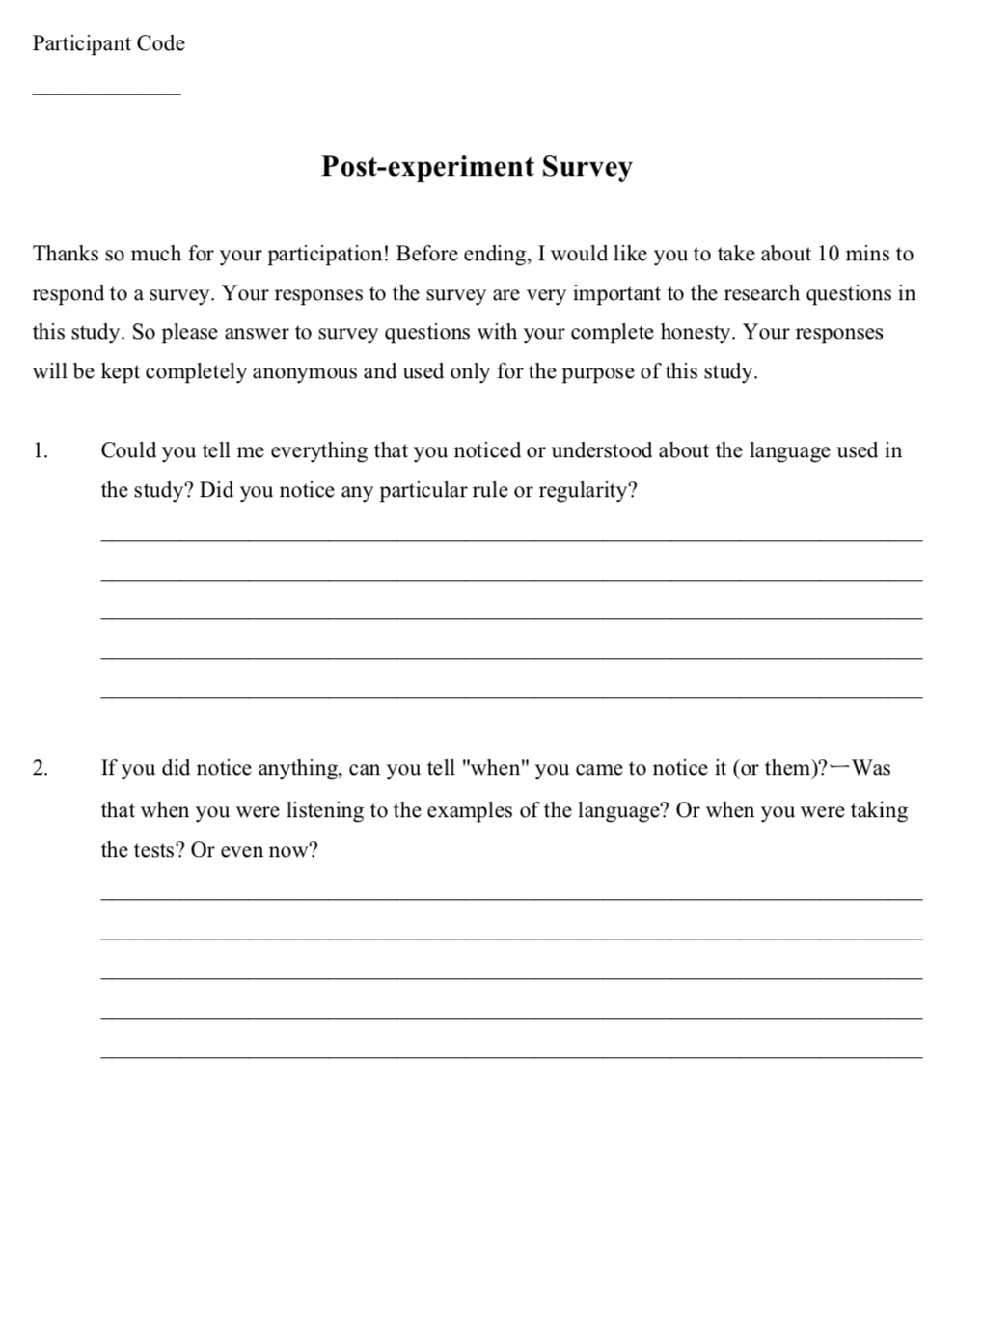
Written Questionnaire
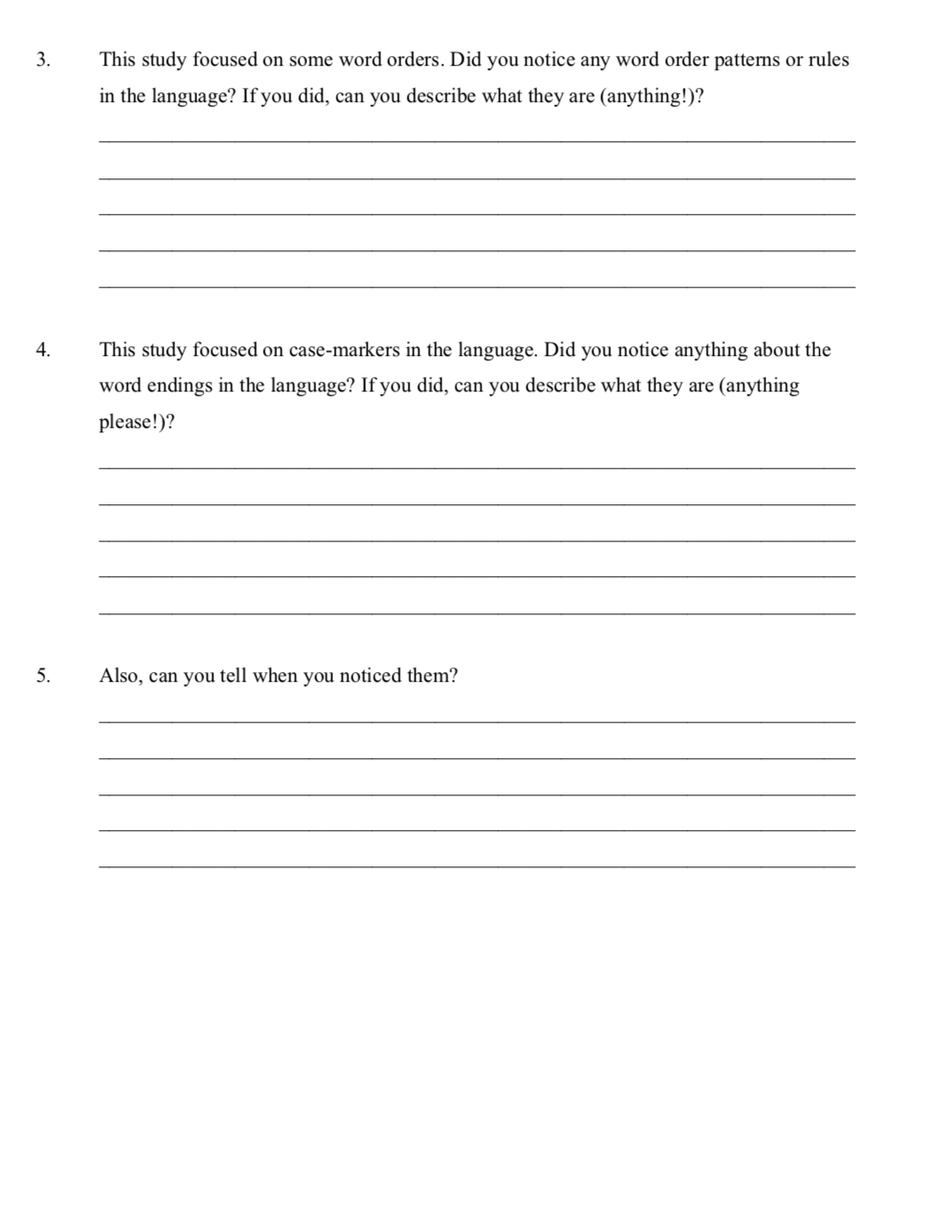
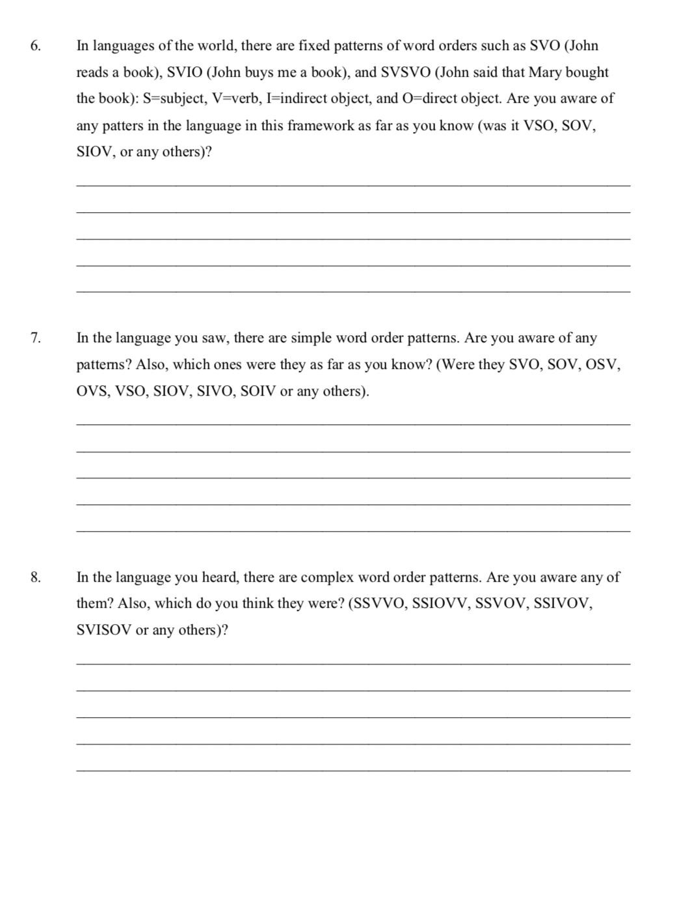
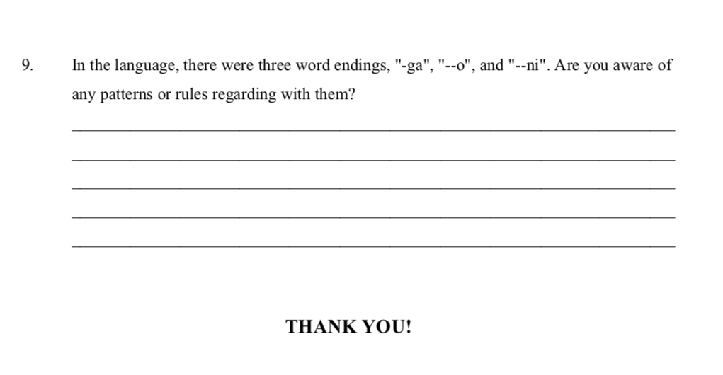

Appendix E
Tests of Statistical Assumptions
MANOVAs on U-AGJT and WMT. Since there was no direct test to examine multivariate normality of the dataset, its status was inferred from testing univariate normality (Field, Miles, & Field, 2012). Results based on the Kolmogorov-Smirnov Test and skewness and kurtosis of each dependent variable are summarized in Table S1, Table S2, Table S3, and Table S4 for Immediate U-AGJT, Delayed U-AGJT, Immediate WMT, and Delayed WMT, respectively. Considering the skewness and the kurtosis, the data seemed to follow the shape of normal distribution fairly well except the word monitoring latencies of the experimental group on grammatical OSSSVV items at the delayed posttest: K-S = 0.29, p = .01; skewness = 3.72; kurtosis = 14.99. Results of the follow-up ANOVAs on this variable, however, did not differ from those of the other variables in the main analysis, so it was considered as a non-issue in the current analysis. Lastly, it must be noted that results of the Kolmogorov-Smirnov Test may not be highly trustworthy, as the sample sizes for the two groups were small (n = 28 and n = 21 for the experimental and the control group, respectively). The point to be taken, however, is that at the multivariate level, the overall data followed the shape of normal distribution well. See Figure S1, S2, S3, and S4 for a quantile-quantile plot for a visual summary of each U-AGJT variable, and Figure S5, S6, S7, S8, S9, S10, S11, and S12 for those of WMT.
Secondly, the data were tested for homogeneity of covariance matrices on performing MANOVAs. Results based on the Box M test showed that the observed covariance matrices were equal across the groups on Immediate U-AGJT, F(21, 6814) = 1.26, p = .18, Box’s M = 30.909, on Delayed U-AGJT, F(21, 6814) = 1.02, p = .42, Box’s M = 25.14, on Immediate WMT, F(63, 17816) = 1.01, p = .45, Box’s M = 72.30, and on Delayed WMT, F(63, 17816) = 0.91, p = .66, Box’s M = 65.80. The assumption of homogeneity of covariance matrices was thus satisfied in each MANOVA analysis in the present study.
Follow-up ANOVAs on U-AGJT and WMT. Results of univariate normality for the ANOVA analyses were already summarized in Table S1, Table S2, Table S3, and Table S4. One of the dependent variables, Grammatical OSSVV items on Delayed WMT by the experimental group had an extreme value of skewness (3.72) and kurtosis (14.99), which signaled a violation of the assumption of the normality. As discussed above, however, this was considered as non-problematic, as the results of the follow-up ANOVAs on this variable did not differ from those of the other variables in the main analysis.
Second, results of univariate homogeneity of variance based on the Levene’s Test are summarized in Table S5 and Table S6 for U-AGJT and WMT, respectively. It was found that the groups significantly differed in their data variance of OSIV (p = .03) and OSSIVV items (p = .003) on Immediate U-AGJT and of OSSIVV (p = .04) on Delayed U-AGJT. However, the impact of these violations on the main analysis were considered non-substantial, as the standard deviation of the dependent variables was not three times larger than the smallest standard deviation of them (Houser, 2008). Furthermore, ANOVA is considered reasonably robust when the sample size is more than 20. For descriptive statistics of each dependent variable on U-AGJT and WMT, see Table S13, Table S14, Table, S15, and Table S16 in Appendix F.
T-Tests on the Confidence Ratings. Although the assumption of normality was tested for each dependent variable in the analysis of the confidence ratings, p-values associated with the Kolmogorov-Smirnov Test should not be trusted because the sample (or the number of data points) is so large that any small deviation from the shape of normal distribution could have been detected as significant (see Table S7 and Table S8 for the results). To illustrate this point, consider the result for Incorrect OSSVV items in the delayed posttest. Although the distribution of the variable showed a skewness of 0.006 and a kurtosis of -0.828, which are considered to be within the limit of normal distribution (Field, 2009), the Kolmogorov-Smirnov Test reached significance at p < .000 level. Hence, the skewness and kurtosis of each variable should rather be the yardstick to understand whether the data followed the shape of normal distribution. Here, it seemed that they were within what is considered as an acceptable range of skewness and kurtosis, between +2 and -2 (Field, 2009).
Again, homogeneity of variance was tested based on the Levene’s Test, results of which are summarized in Table S9. It was found that the data variance of the confidence level on correct and incorrect responses significantly differed for OSSVV (p = .008) and OSSIVV (p = .005) at the immediate posttest, and for OSV (p = .002) and OSSIVV (p = .02) at the delayed posttest. As was the case for the test of normality, however, these p-values should not be trusted, as the data points in each variable were quite large. By looking at the standard deviations of the data presented in Table 2 (see the primary manuscript), these inequalities of variance were considered permissible, for the larger standard deviations of the variable were not three times bigger than the smaller ones. Furthermore, 95% confidence intervals of the means also showed that the confidence levels were significantly different across correct and incorrect responses on those item types (as was confirmed in the main analysis with t-tests): [3.05, 3.26] for OSSVV Correct vs. [2.65, 2.90] for OSSVV Incorrect, and [3.06, 3.30] for OSSIVV Correct vs. [2.58, 2.84] for OSSIVV Incorrect at the immediate posttest; [3.82, 4.01] for OSV Correct vs. [3.30, 3.66] for OSV Incorrect, and [3.09, 3.33] for OSSIVV Correct vs. [2.78, 3.04] for OSSIVV Incorrect at the delayed posttest.
ANOVA and One-Sample T-test Analyses on Retrospective Verbal Reports. Results of testing univariate normality on d-prime scores of the aware and the unaware groups for each construction type are presented in Table S10 and Table S11, at Immediate U-AGJT and Delayed U-AGJT, respectively. It seemed that most of the dependent variables remained with the range of normal distribution discussed above, except OSV and OSIV items by the aware group at the delayed posttest (p = .029 for OSV and p = .050 for OSIV). Homogeneity of variance was also tested based on the Levene’s Test, which showed that the two groups significantly differed in the data variance on Case Mixing items at the delayed posttest, F(5, 22) = 4.477, p = .006, but they were equivalent on the other construction types (see Table S12). For Case Mixing items at the delayed posttest, the standard deviation of d-prime scores by the aware group was 0.869 and by the unaware group was 1.373. This difference was considered permissible, as one is not three times larger than the other.

Table S1. Results of Normality Test for Immediate U-AGJT
 | Experimental
 | K-S | df | Skewness | Kurtosis | p
OSV | 0.15 | 28 | - 0.38 | - 1.06 | .55
OSIV | 0.14 | 28 | 0.22 | - 1.37 | .63
OSSVV | 0.16 | 28 | 0.47 | - 0.94 | .39
OSSIVV | 0.14 | 28 | 0.16 | - 1.10 | .60
CaseMis | 0.19 | 28 | 0.12 | - 1.04 | .25
CaseMix | 0.10 | 28 | 0.22 | 0.08 | .92
 | Control
OSV | 0.12 | 21 | 0.12 | - 0.47 | .89
OSIV | 0.21 | 21 | 0.55 | - 0.99 | .26
OSSVV | 0.13 | 21 | - 0.05 | - 0.71 | .86
OSSIVV | 0.17 | 21 | - 0.19 | 0.08 | .51
CaseMis | 0.15 | 21 | 0.79 | 0.94 | .71
CaseMix | 0.22 | 21 | 0.99 | 0.33 | .22
Note. * p <.05, ** p < .01

Table S2. Results of Normality Test for Delayed U-AGJT
 | Experimental
 | K-S | df | Skewness | Kurtosis | p
OSV | 0.21 | 28 | - 0.07 | - 1.62 | .10
OSIV | 0.18 | 28 | 0.01 | - 1.27 | .28
OSSVV | 0.12 | 28 | 0.35 | - 1.25 | .79
OSSIVV | 0.08 | 28 | - 0.20 | - 0.87 | .92
CaseMis | 0.11 | 28 | - 0.17 | - 1.18 | .87
CaseMix | 0.11 | 28 | - 0.30 | - 0.74 | .86
 | Control
OSV | 0.18 | 21 | 0.47 | - 0.86 | .48
OSIV | 0.18 | 21 | 0.44 | - 1.05 | .49
OSSVV | 0.14 | 21 | 0.72 | - 0.22 | .77
OSSIVV | 0.21 | 21 | 0.73 | 0.78 | .28
CaseMis | 0.25 | 21 | 1.23 | 1.58 | .12
CaseMix | 0.14 | 21 | 0.64 | 0.00 | .76
Note. * p <.05, ** p < .01

Table S3. Results of Normality Test for Immediate WMT
 | Experimental
 |  | K-S | df | Skewness | Kurtosis | p
OSV | Gram | 0.14 | 28 | 0.45 | - 0.49 | .55
 | Ungram | 0.09 | 28 | 0.05 | - 0.94 | .95
OSIV | Gram | 0.13 | 28 | 0.88 | 0.16 | .60
 | Ungram | 0.12 | 28 | 0.49 | - 0.87 | .75
OSSVV | Gram | 0.11 | 28 | 0.61 | - 0.69 | .79
 | Ungram | 0.12 | 28 | 0.36 | -0.49 | .76
OSSIVV | Gram | 0.13 | 27 | 0.12 | 1.09 | .59
 | Ungram | 0.16 | 28 | 0.49 | -0.87 | .42
CaseMis | Gram | 0.16 | 28 | 0.45 | - 1.36 | .42
 | Ungram | 0.10 | 28 | 0.25 | - 0.98 | .88
CaseMix | Gram | 0.16 | 28 | 0.41 | - 0.65 | .38
 | Ungram | 0.16 | 28 | 0.45 | - 0.79 | .36
 | Control
OSV | Gram | 0.13 | 21 | 0.31 | - 0.99 | .81
 | Ungram | 0.16 | 21 | 0.80 | -0.01 | .55
OSIV | Gram | 0.13 | 21 | 0.66 | 0.17 | .79
 | Ungram | 0.15 | 21 | 0.83 | 0.81 | .61
OSSVV | Gram | 0.18 | 21 | 1.11 | 1.18 | .44
 | Ungram | 0.16 | 21 | 0.99 | 0.29 | .57
OSSIVV | Gram | 0.16 | 21 | 0.72 | 1.25 | .60
 | Ungram | 0.20 | 21 | 1.32 | 1.24 | .29
CaseMis | Gram | 0.11 | 21 | 0.53 | 0.03 | .92
 | Ungram | 0.09 | 21 | 0.38 | - 0.40 | .98
CaseMix | Gram | 0.14 | 21 | 0.54 | - 0.44 | .70
 | Ungram | 0.09 | 21 | 0.54 | 0.33 | .98
Note. * p <.05, ** p < .01

Table S4. Results of Normality Test for Delayed WMT
 | Experimental
 |  | K-S | df | Skewness | Kurtosis | p
OSV | Gram | 0.10 | 28 | - 0.10 | - 1.10 | .88
 | Ungram | 0.12 | 28 | - 0.18 | 0.46 | .80
OSIV | Gram | 0.08 | 28 | 0.34 | - 0.04 | .98
 | Ungram | 0.08 | 28 | - 0.31 | 0.25 | .96
OSSVV | Gram | 0.29 | 28 | 3.72 | 14.99 | .01**
 | Ungram | 0.17 | 28 | 0.09 | - 1.04 | .32
OSSIVV | Gram | 0.08 | 28 | 0.04 | - 0.22 | .99
 | Ungram | 0.16 | 28 | - 0.06 | - 1.10 | .46
CaseMis | Gram | 0.10 | 28 | - 0.15 | - 1.02 | .92
 | Ungram | 0.13 | 28 | - 0.35 | - 0.95 | .72
CaseMix | Gram | 0.13 | 28 | 0.86 | 0.71 | .61
 | Ungram | 0.17 | 28 | - 1.13 | 3.59 | .33
 | Control
OSV | Gram | 0.12 | 21 | - 0.63 | 0.08 | .83
 | Ungram | 0.11 | 21 | 0.67 | -0.06 | .93
OSIV | Gram | 0.11 | 21 | - 0.18 | - 1.15 | .91
 | Ungram | 0.10 | 21 | 0.08 | - 0.82 | .95
OSSVV | Gram | 0.10 | 21 | - 0.22 | - 0.34 | .95
 | Ungram | 0.14 | 21 | 0.14 | - 1.41 | .71
OSSIVV | Gram | 0.09 | 21 | - 0.08 | - 0.98 | .98
 | Ungram | 0.12 | 21 | - 0.12 | - 1.27 | .91
CaseMis | Gram | 0.08 | 21 | - 0.08 | - 0.82 | .99
 | Ungram | 0.09 | 21 | - 0.08 | - 1.08 | .98
CaseMix | Gram | 0.18 | 21 | 0.65 | - 0.98 | .39
 | Ungram | 0.13 | 21 | 0.22 | - 0.98 | .77
Note. * p <.05, ** p < .01

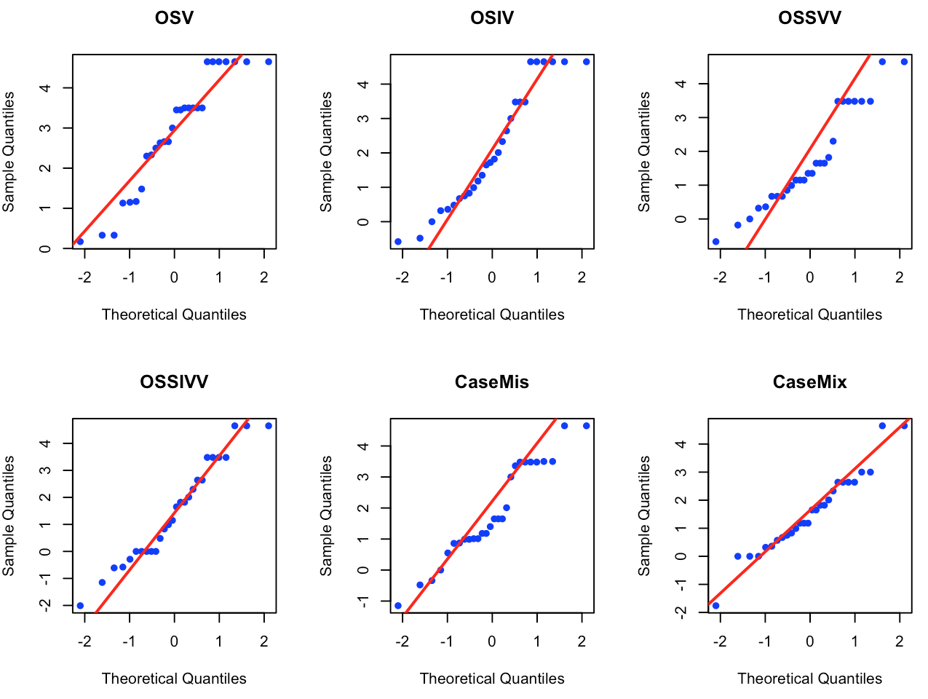
Figure S1. Q-Q plot for Immediate U-AGJT for the Experimental Group
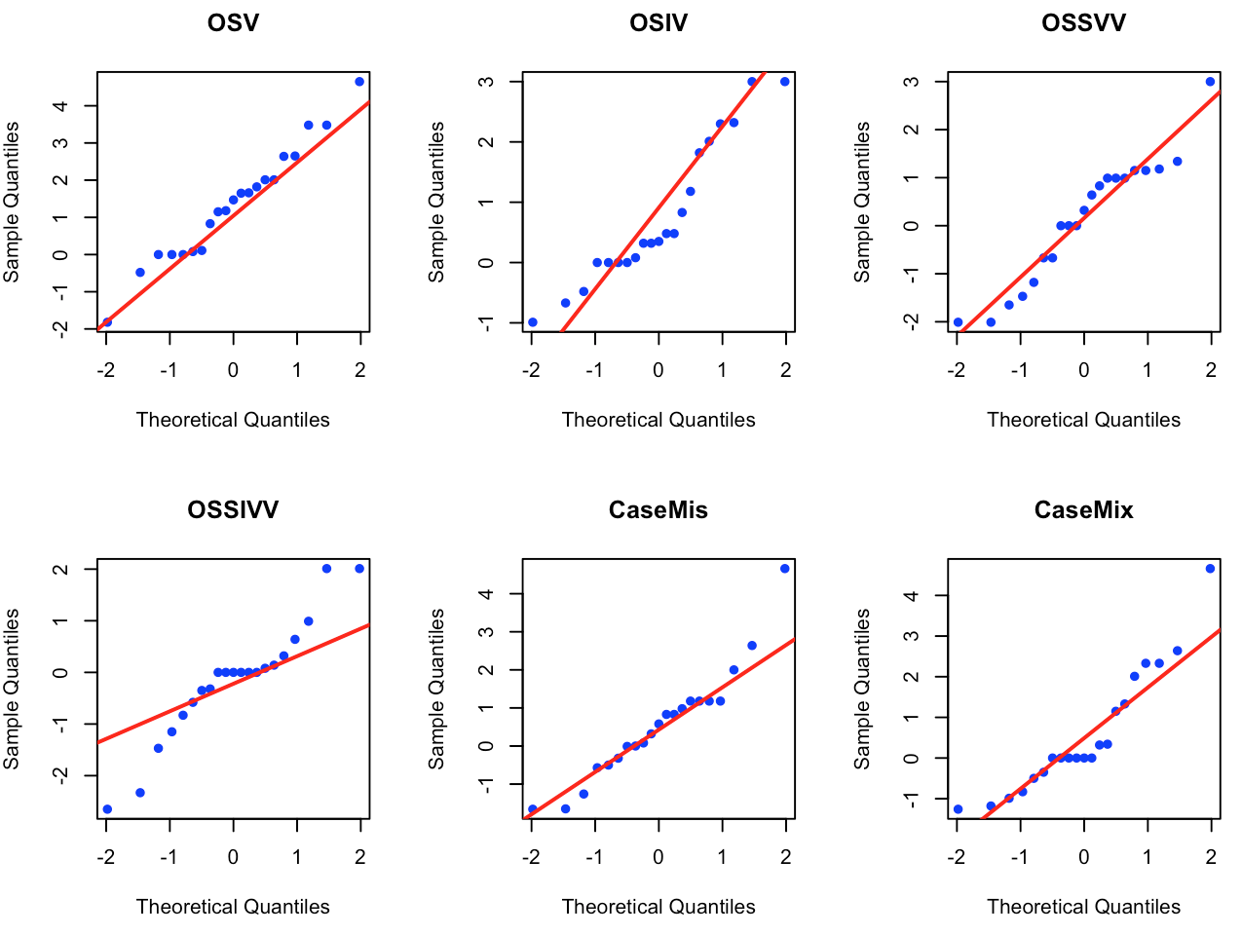
Figure S2. Q-Q plot for Immediate U-AGJT for the Control Group
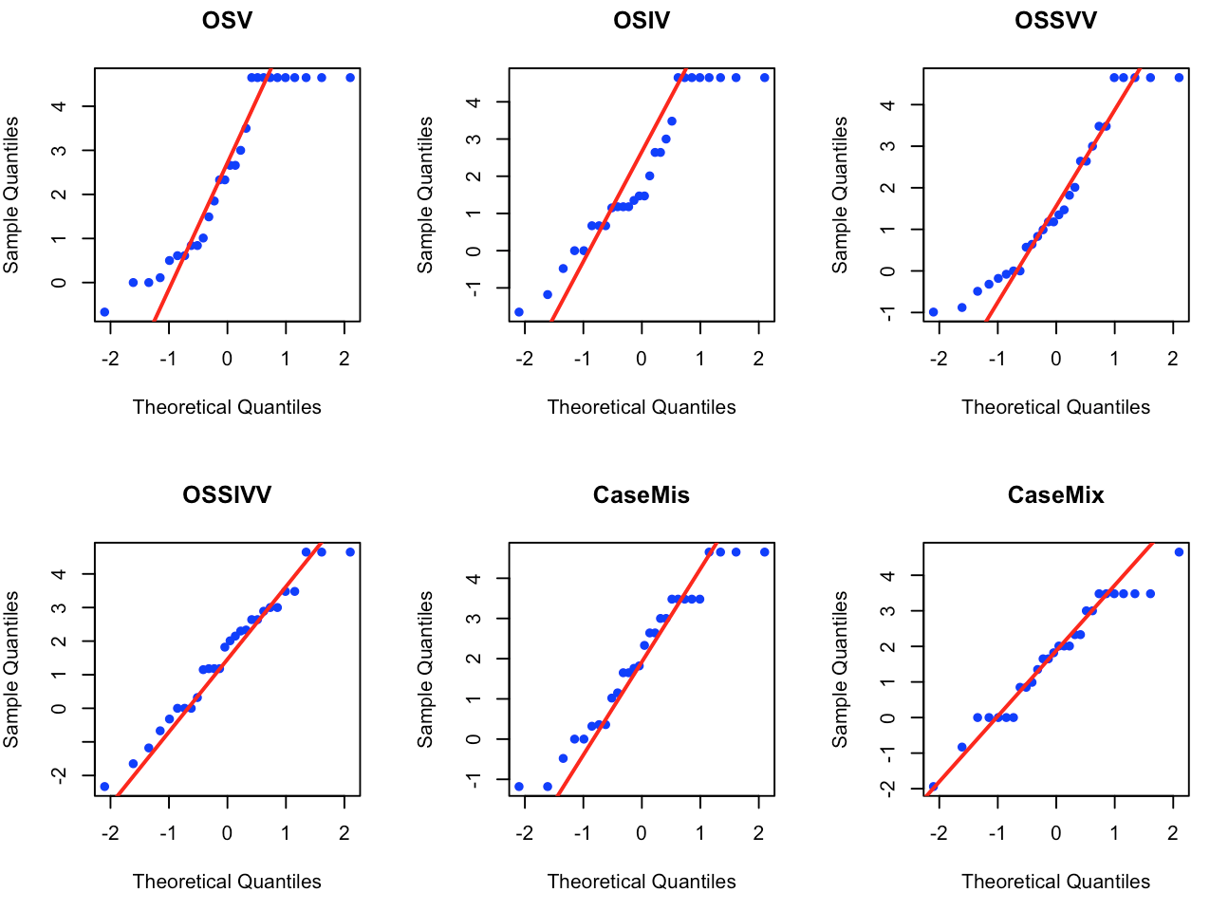
Figure S3. Q-Q plot for Delayed U-AGJT for the Experimental Group

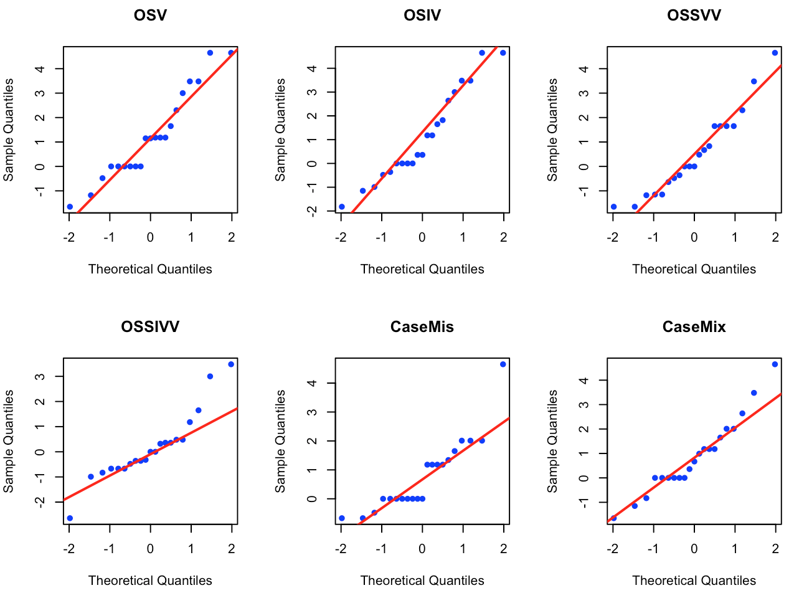
Figure S4. Q-Q plot for Immediate U-AGJT for the Control Group
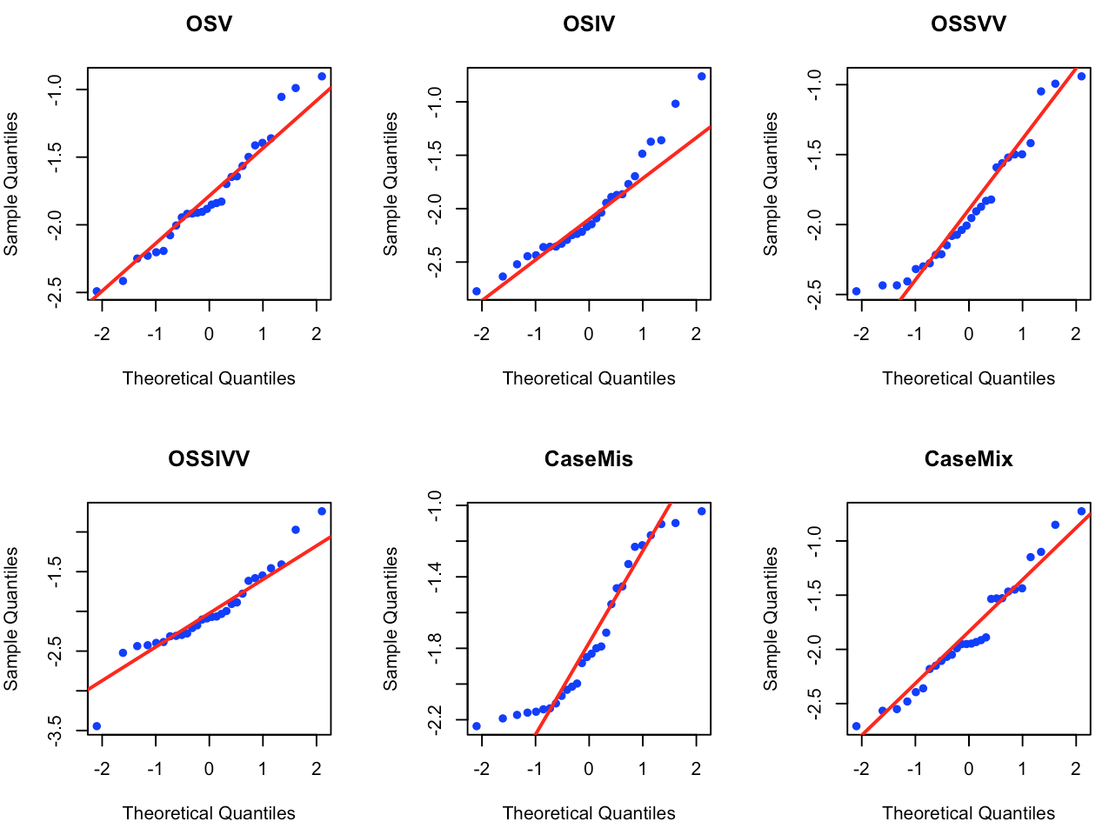
Figure S5. Q-Q plot for Immediate WMT for the Experimental Group on Grammatical Items
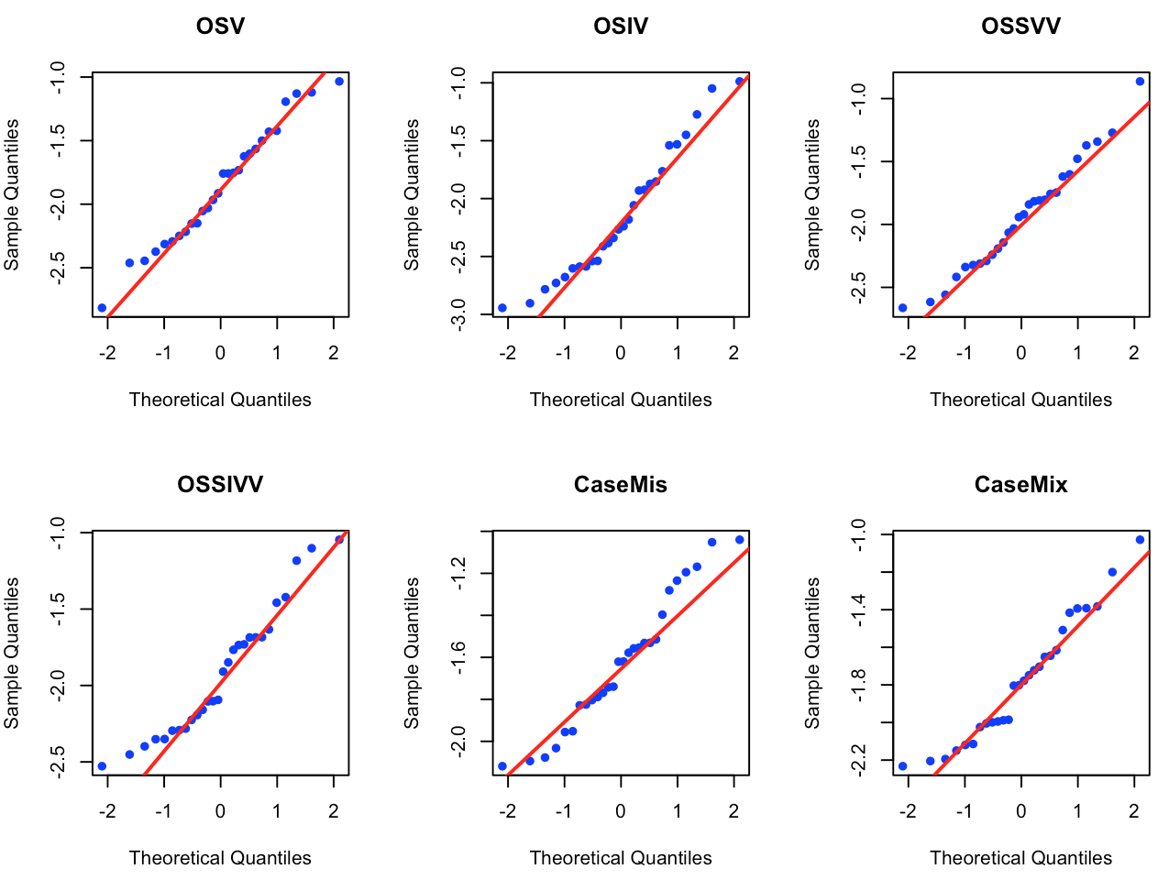
Figure S6. Q-Q plot for Immediate WMT for the Experimental Group on Ungrammatical Items
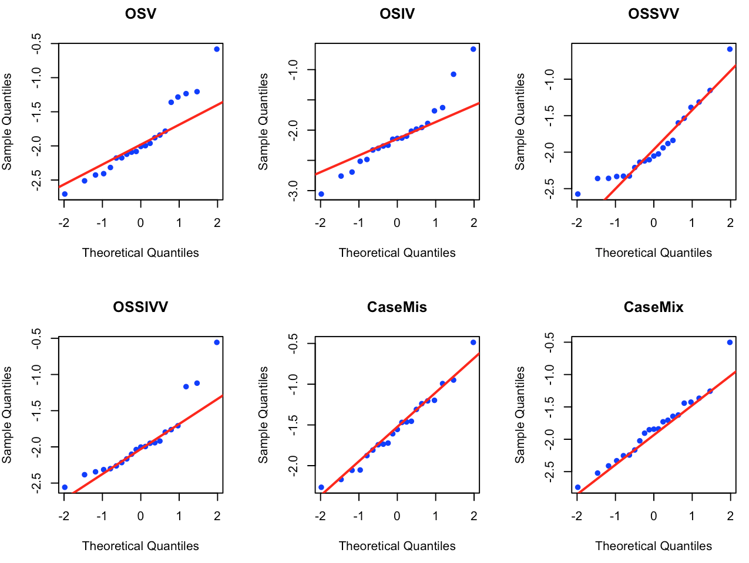
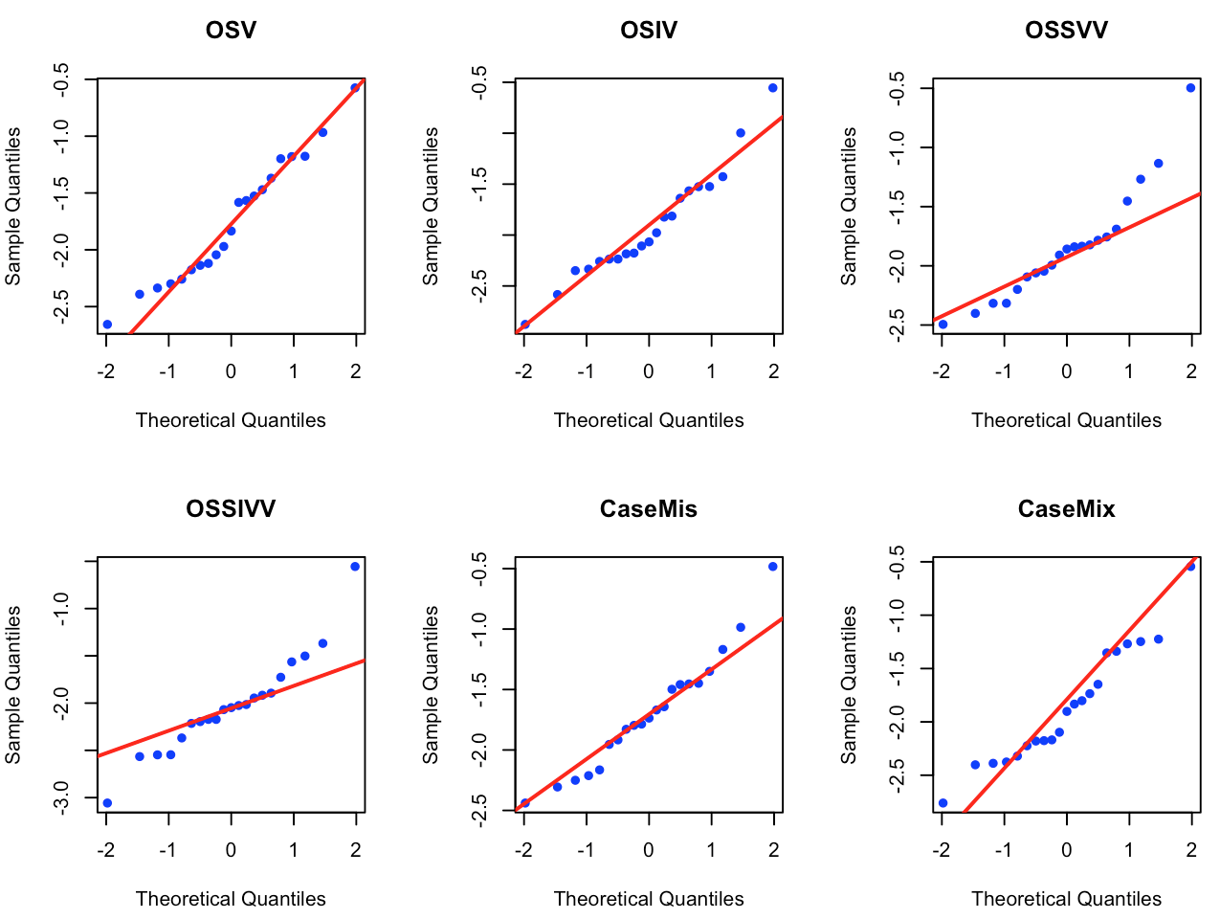
Figure S7. Q-Q plot for Immediate WMT for the Control Group on Grammatical Items
Figure S8. Q-Q plot for Immediate WMT for the Control Group on Ungrammatical Items
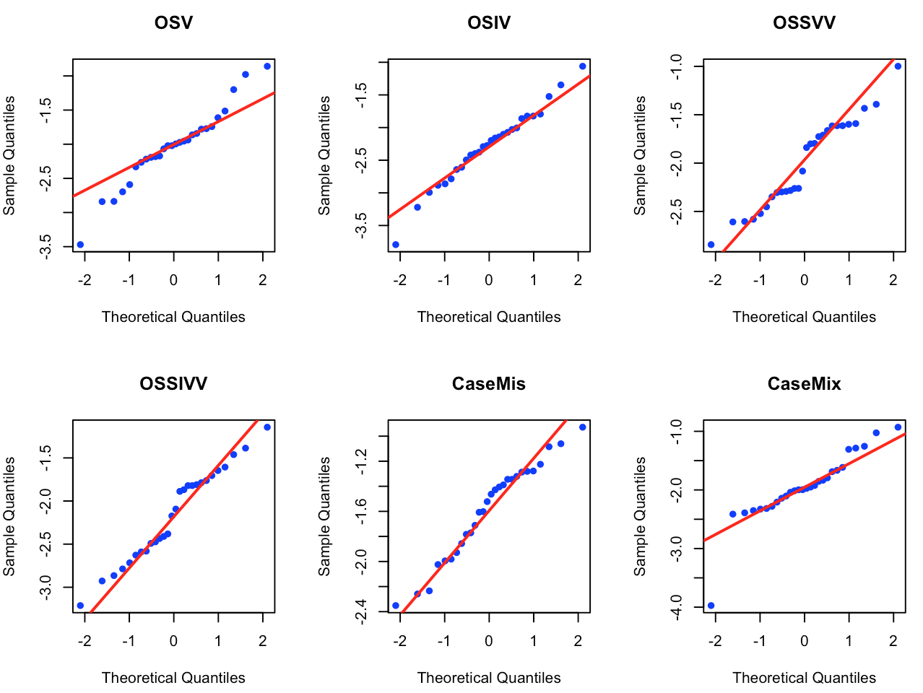
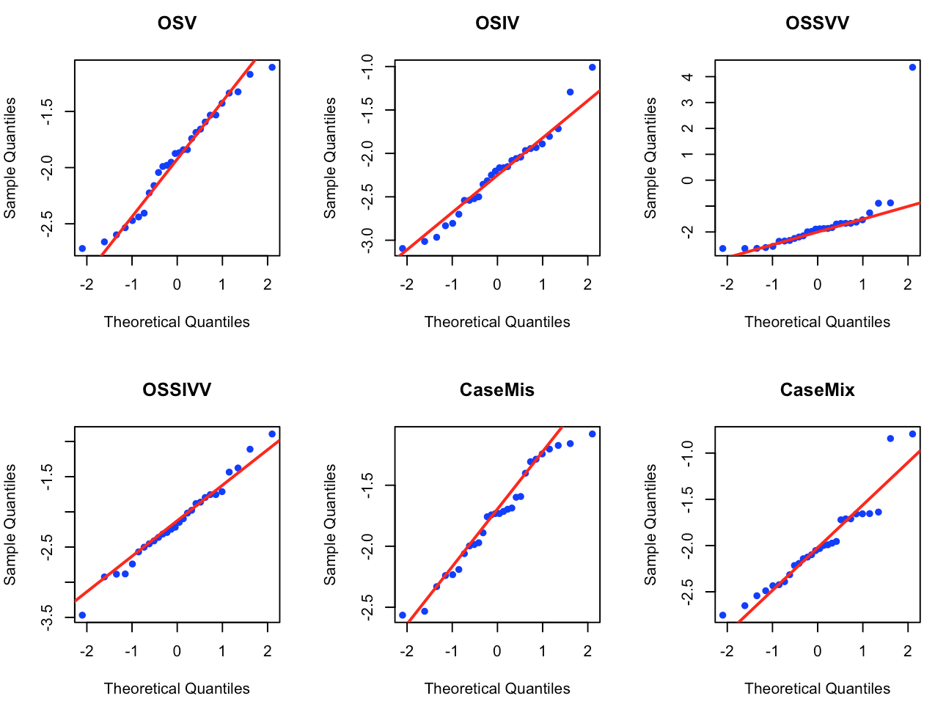
Figure S9. Q-Q plot for Delayed WMT for the Experimental Group on Grammatical Items
Figure S10. Q-Q plot for Delayed WMT for the Experimental Group on Ungrammatical Items
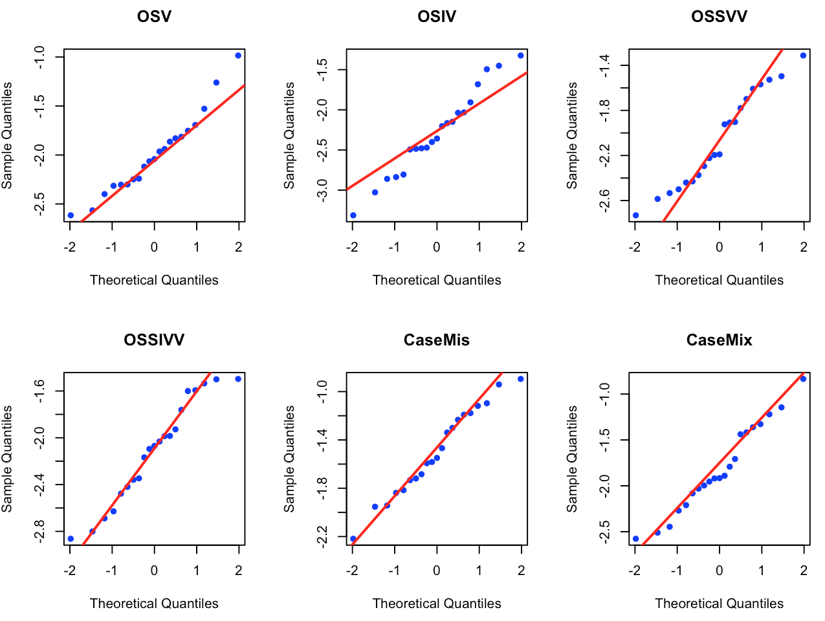
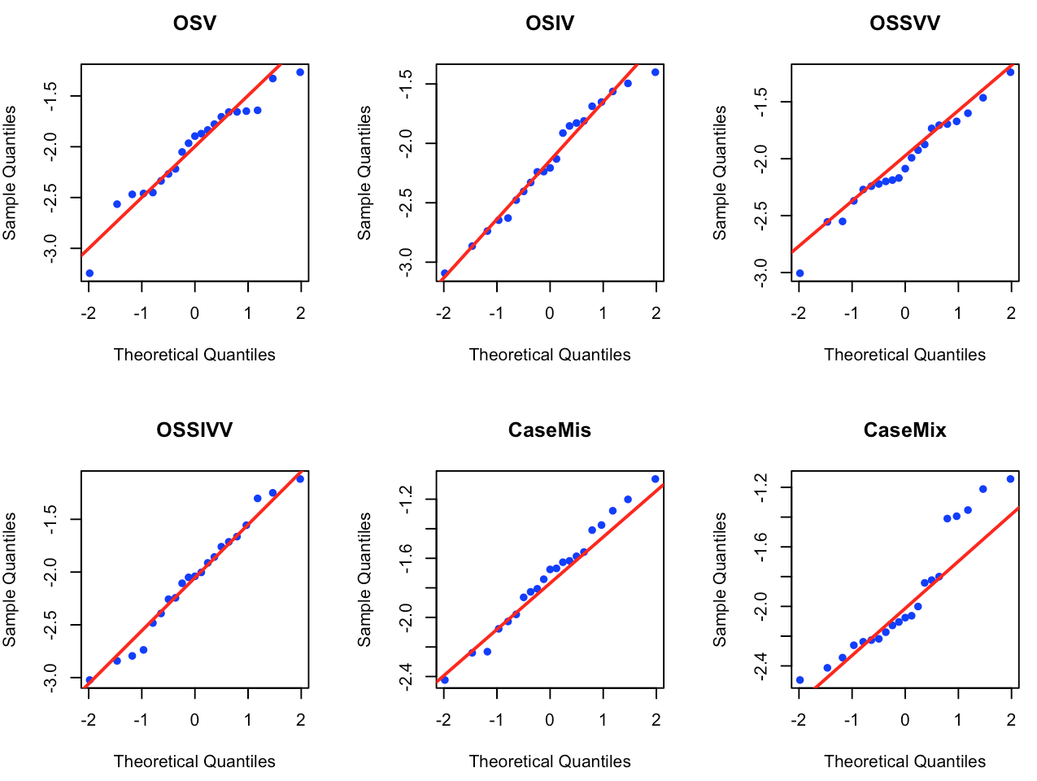
Figure S11. Q-Q plot for Delayed WMT for the Control Group on Grammatical Items
Figure S12. Q-Q plot for Delayed WMT for the Experimental Group on Ungrammatical Items

Table S5. Results of Tests for Univariate Homogeneity of Variance on U-AGJT
 | Immediate |  |  |  | Delayed
 | F | df | p |  | F | df | p
OSV | 0.00 | 1, 47 | .98 |  | 1.03 | 1, 47 | .31
OSIV | 4.48 | 1, 47 | .03* |  | 0.10 | 1, 47 | .74
OSSVV | 0.16 | 1, 47 | .68 |  | 0.48 | 1, 47 | .48
OSSIVV | 9.41 | 1, 47 | .003** |  | 4.20 | 1, 47 | .04*
CaseMis | 0.57 | 1, 47 | .45 |  | 3.55 | 1, 47 | .06
CaseMix | 0.02 | 1, 47 | .88 |  | 0.21 | 1, 47 | .64
Note. * p <.05, ** p < .01

Table S6. Results of Tests for Univariate Homogeneity of Variance on WMT
 | Immediate |  |  |  | Delayed
 | F | df | p |  | F | df | p
OSV | 1.18 | 3, 94 | .32 |  | 0.25 | 3, 94 |  | .85
OSIV | 0.38 | 3, 94 | .76 |  | 0.17 | 3, 94 |  | .91
OSSVV | 0.07 | 3, 94 | .97 |  | 0.86 | 3, 94 |  | .46
OSSIVV | 0.08 | 3, 94 | .97 |  | 0.56 | 3, 94 |  | .63
CaseMis | 0.97 | 3, 94 | .40 |  | 0.25 | 3, 94 |  | .85
CaseMix | 1.57 | 3, 94 | .20 |  | 0.17 | 3, 94 |  | .91
Note. * p <.05, ** p < .01

Table S7. Results of Normality Test on Confidence Level at Immediate Posttest
 |  | K-S | df | Skewness | Kurtosis | p
OSV | Correct | 0.26 | 580 | - 0.78 | - 0.31 | .00**
 | Incorrect | 0.15 | 180 | - 0.13 | - 1.10 | .00**
OSIV | Correct | 0.17 | 512 | - 0.26 | - 0.96 | .00**
 | Incorrect | 0.15 | 245 | 0.01 | - 0.98 | .00**
OSSVV | Correct | 0.16 | 506 | - 0.01 | - 0.95 | .00**
 | Incorrect | 0.20 | 257 | 0.11 | - 0.69 | .00**
OSSIVV | Correct | 0.26 | 445 | - 0.15 | - 1.10 | .00**
 | Incorrect | 0.19 | 312 | 0.16 | - 0.69 | .00**
CaseMis | Correct | 0.17 | 174 | - 0.20 | - 1.41 | .00**
 | Incorrect | 0.17 | 206 | 0.01 | - 0.90 | .00**
CaseMix | Correct | 0.16 | 160 | 0.06 | - 1.04 | .00**
 | Incorrect | 0.19 | 221 | - 0.21 | - 0.81 | .00**
Note. * p <.05, ** p < .01

Table S8. Results of Normality Test on Confidence Level at Delayed Posttest
 |  | K-S | df | Skewness | Kurtosis | p
OSV | Correct | 0.24 | 575 | -0.85 | -0.23 | .00**
 | Incorrect | 0.18 | 193 | -0.36 | -1.07 | .00**
OSIV | Correct | 0.18 | 528 | -0.37 | -1.01 | .00**
 | Incorrect | 0.16 | 245 | -0.24 | -0.84 | .00**
OSSVV | Correct | 0.17 | 488 | -0.19 | -0.98 | .00**
 | Incorrect | 0.20 | 281 | 0.01 | -0.83 | .00**
OSSIVV | Correct | 0.15 | 469 | -0.14 | -0.10 | .00**
 | Incorrect | 0.18 | 291 | 0.15 | -0.94 | .00**
CaseMis | Correct | 0.18 | 161 | -0.41 | -0.93 | .00**
 | Incorrect | 0.17 | 224 | -0.20 | -0.79 | .00**
CaseMix | Correct | 0.15 | 155 | -0.14 | -1.13 | .00**
 | Incorrect | 0.17 | 229 | -0.23 | -0.85 | .00**
Note. * p <.05, ** p < .01

Table S9. Results of Tests for Homogeneity of Variance on Confidence Ratings
 | Immediate |  |  |  | Delayed
 | F | df | p |  | F |  | df | p
OSV | 3.11 | 1, 755 | .07 |  | 10.08 | 1, 775 |  | .002**
OSIV | 0.96 | 1, 752 | .32 |  | 0.79 | 1, 776 |  | .37
OSSVV | 7.01 | 1, 760 | .008** |  | 2.61 | 1, 755 |  | .10
OSSIVV | 7.73 | 1, 753 | .005** |  | 5.61 | 1, 771 |  | .02*
CaseMis | 3.27 | 1, 376 | .07 |  | 0.21 | 1, 385 |  | .64
CaseMix | 0.81 | 1, 378 | .36 |  | 2.58 | 1, 387 |  | .10
Note. * p <.05, ** p < .01

Table S10. Results of Normality Test on Retrospective Verbal Reports at Immediate Posttest
 | Aware
 | K-S | df | Skewness | Kurtosis | p
OSV | 0.24 | 15 | 0.03 | - 1.45 | .36
OSIV | 0.30 | 11 | - 1.06 | - 0.34 | .27
CaseMis | 0.27 | 11 | - 0.50 | - 1.07 | .42
CaseMix | 0.17 | 11 | 0.46 | - 1.10 | .90
 | Unaware
OSV | 0.17 | 13 | 0.49 | - 1.19 | .84
OSIV | 0.11 | 17 | 0.17 | - 1.09 | .97
CaseMis | 0.19 | 17 | 0.32 | - 0.21 | .57
CaseMix | 0.15 | 17 | - 0.28 | - 0.21 | .83
Note. * p <.05, ** p < .01

Table S11. Results of Normality Test on Retrospective Verbal Reports at Delayed Posttest
 | Aware
 | K-S | df | Skewness | Kurtosis | p
OSV | 0.38 | 15 | - 0.57 | - 1.59 | .03*
OSIV | 0.41 | 11 | - 1.87 | 2.36 | .05*
CaseMis | 0.21 | 11 | - 0.38 | - 1.31 | .70
CaseMix | 0.24 | 11 | 0.03 | - 1.41 | .534
 | Unaware
OSV | 0.27 | 13 | 1.36 | 1.01 | .31
OSIV | 0.19 | 17 | 0.60 | - 0.41 | .54
CaseMis | 0.16 | 17 | 0.12 | - 1.29 | .80
CaseMix | 0.15 | 17 | - 0.02 | - 0.61 | .81
Note. * p <.05, ** p < .01

Table S12. Results of Tests for Univariate Homogeneity of Variance on Retrospective Verbal Reports
 | Immediate |  |  |  | Delayed
 | F | df | p |  | F | df | p
OSV | 2.47 | 5, 22 | .06 |  | 2.16 | 5, 22 | .10
OSIV | 1.29 | 5, 22 | .31 |  | 0.89 | 5, 22 | .50
CaseMis | 0.99 | 5, 22 | .44 |  | 1.82 | 5, 22 | .15
CaseMix | 0.91 | 5, 22 | .49 |  | 4.48 | 5, 22 | .006**
Note. * p <.05, ** p < .01

References
Field, A. (2009). Discovering statistics using SPSS. London: SAGE.
Field, A., Miles, J., & Field, Z. (2012). Discovering statistics using R. London: SAGE.
Houser, R. (2008). Counseling and educational research: Evaluation and application. London:
SAGE.

Appendix F
Table S13. Mean Accuracy of the Experimental Group on Immediate U-AGJT
 | Overall
 | Mean | Median | SD | SE | Max | Min | 95% CI
OSV | 84.35 | 93.75 | 21.88 | 2.92 | 100 | 12.50 | [78.49, 90.21]
OSIV | 75.29 | 87.50 | 28.70 | 3.83 | 100 | 0 | [67.60, 82.97]
OSSVV | 72.99 | 75.00 | 23.73 | 3.17 | 100 | 25.00 | [66.63, 79.34]
OSSIVV | 68.34 | 75.00 | 30.37 | 4.06 | 100 | 0 | [60.23, 76.46]
CaseMis | 72.56 | 80.00 | 29.16 | 3.90 | 100 | 0 | [64.75, 80.37]
CaseMix | 68.37 | 75.00 | 29.63 | 3.96 | 100 | 0 | [60.43, 76.30]
 | Grammatical
 | Mean | Median | SD | SE | Max | Min | 95% CI
OSV | 83.89 | 87.50 | 20.65 | 3.90 | 100 | 16.67 | [75.87, 91.89]
OSIV | 88.07 | 93.75 | 13.88 | 2.62 | 100 | 62.50 | [82.69, 93.45]
OSSVV | 71.43 | 75.00 | 24.81 | 4.69 | 100 | 25.00 | [61.80, 81.04]
OSSIVV | 75.62 | 87.50 | 27.23 | 5.15 | 100 | 0 | [65.05, 86.17]
CaseMis | 88.07 | 93.75 | 13.88 | 2.62 | 100 | 62.50 | [82.69, 93.45]
CaseMix | 88.07 | 93.75 | 13.88 | 2.62 | 100 | 62.50 | [82.69, 93.45]
 | Ungrammatical
 | Mean | Median | SD | SE | Max | Min | 95% CI
OSV | 84.82 | 100 | 23.41 | 4.42 | 100 | 12.50 | [75.74, 93.89]
OSIV | 62.50 | 75.00 | 33.85 | 6.40 | 100 | 0 | [49.37, 75.62]
OSSVV | 74.55 | 75.00 | 22.94 | 4.34 | 100 | 25.00 | [65.65, 83.45]
OSSIVV | 61.05 | 62.50 | 32.05 | 6.06 | 100 | 0 | [48.62, 73.48]
CaseMis | 57.05 | 62.50 | 32.27 | 6.10 | 100 | 0 | [44.54, 69.56]
CaseMix | 48.66 | 50.00 | 28.12 | 5.31 | 100 | 0 | [37.75, 59.56]

Table S14. Mean Accuracy of the Control Group on Immediate U-AGJT
 | Overall
 | Mean | Median | SD | SE | Max | Min | 95% CI
OSV | 66.04 | 75.00 | 34.20 | 5.41 | 100 | 0 | [55.10, 76.97]
OSIV | 59.02 | 68.75 | 34.51 | 5.46 | 100 | 0 | [47.97, 70.05]
OSSVV | 54.06 | 62.50 | 62.50 | 4.30 | 100 | 0 | [45.36, 62.76]
OSSIVV | 46.34 | 50.00 | 30.36 | 4.80 | 100 | 0 | [36.63, 56.04]
CaseMis | 56.12 | 62.50 | 34.76 | 5.50 | 100 | 0 | [44.99, 67.23]
CaseMix | 57.32 | 62.50 | 34.01 | 5.38 | 100 | 0 | [46.44, 68.19]
 | Grammatical
 | Mean | Median | SD | SE | Max | Min | 95% CI
OSV | 88.33 | 100 | 19.38 | 4.33 | 100 | 25.00 | [79.26, 97.40]
OSIV | 82.41 | 87.50 | 18.30 | 4.09 | 100 | 37.50 | [73.84, 90.97]
OSSVV | 59.38 | 62.50 | 22.17 | 4.96 | 87.50 | 0 | [49.00, 69.74]
OSSIVV | 45.89 | 37.50 | 31.95 | 7.15 | 100 | 0 | [30.93, 60.84]
CaseMis | 82.41 | 87.50 | 18.30 | 4.09 | 100 | 37.50 | [73.84, 90.97]
CaseMix | 82.41 | 87.50 | 18.30 | 4.09 | 100 | 37.50 | [73.84, 90.97]
 | Ungrammatical
 | Mean | Median | SD | SE | Max | Min | 95% CI
OSV | 43.75 | 37.50 | 31.28 | 7.15 | 100 | 0 | [29.10, 58.39]
OSIV | 35.62 | 25.00 | 30.96 | 4.09 | 100 | 37.50 | [21.13 50.11]
OSSVV | 48.75 | 50.00 | 31.12 | 6.96 | 100 | 0 | [34.18, 63.31]
OSSIVV | 46.79 | 50.00 | 29.49 | 6.60 | 100 | 0 | [32.98, 60.58]
CaseMis | 29.82 | 28.57 | 26.27 | 5.87 | 100 | 0 | [17.52, 42.11]
CaseMix | 32.23 | 25.00 | 26.74 | 5.98 | 100 | 0 | [19.71, 44.74]

Table S15. Mean Accuracy of the Experimental Group on Delayed U-AGJT
 | Overall
 | Mean | Median | SD | SE | Max | Min | 95% CI
OSV | 78.73 | 87.50 | 28.26 | 3.78 | 100 | 0 | [71.16, 86.29]
OSIV | 74.55 | 87.50 | 32.33 | 4.32 | 100 | 0 | [65.89, 83.21]
OSSVV | 69.61 | 75.00 | 28.20 | 3.77 | 100 | 12.50 | [62.05, 77.16]
OSSIVV | 68.78 | 75.00 | 33.11 | 4.42 | 100 | 0 | [59.91, 77.64]
CaseMis | 74.64 | 87.50 | 30.41 | 4.06 | 100 | 0 | [66.49, 82.77]
CaseMix | 71.68 | 81.25 | 30.63 | 4.09 | 100 | 0 | [63.48, 79.88]
 | Grammatical
 | Mean | Median | SD | SE | Max | Min | 95% CI
OSV | 85.71 | 93.75 | 19.75 | 3.73 | 100 | 37.50 | [78.05, 93.37]
OSIV | 91.52 | 92.71 | 11.81 | 2.23 | 100 | 62.50 | [86.93, 96.09]
OSSVV | 74.94 | 75.00 | 26.16 | 4.94 | 100 | 25.00 | [64.79, 85.08]
OSSIVV | 81.25 | 100 | 29.76 | 5.62 | 100 | 0 | [69.71 92.78]
CaseMis | 91.52 | 92.71 | 11.81 | 2.23 | 100 | 62.50 | [86.93, 96.09]
CaseMix | 91.52 | 92.71 | 11.81 | 2.23 | 100 | 62.50 | [86.93, 96.09]
 | Ungrammatical
 | Mean | Median | SD | SE | Max | Min | 95% CI
OSV | 71.75 | 87.50 | 33.70 | 6.37 | 100 | 0 | [58.67, 84.81]
OSIV | 57.59 | 62.50 | 37.32 | 7.05 | 100 | 0 | [43.11, 72.06]
OSSVV | 64.29 | 62.50 | 29.60 | 5.59 | 100 | 12.50 | [52.80, 75.76]
OSSIVV | 56.31 | 50.00 | 32.02 | 6.05 | 100 | 0 | [43.89, 68.72]
CaseMis | 57.75 | 62.50 | 33.96 | 6.42 | 100 | 0 | [44.58, 70.92]
CaseMix | 51.85 | 53.57 | 30.90 | 5.84 | 100 | 0 | [39.86, 63.83]

Table S16. Mean Accuracy of the Control Group on Delayed U-AGJT
 | Overall
 | Mean | Median | SD | SE | Max | Min | 95% CI
OSV | 66.96 | 87.50 | 40.84 | 6.30 | 100 | 0 | [54.23, 79.69]
OSIV | 61.61 | 75.00 | 38.09 | 5.88 | 100 | 0 | [49.73, 73.47]
OSSVV | 66.65 | 56.25 | 33.50 | 5.17 | 100 | 0 | [45.21, 66.09]
OSSIVV | 50.30 | 50.00 | 29.67 | 4.58 | 100 | 0 | [41.05, 59.54]
CaseMis | 51.79 | 37.50 | 39.58 | 6.11 | 100 | 0 | [39.45, 64.12]
CaseMix | 55.65 | 62.50 | 38.97 | 6.01 | 100 | 0 | [43.51 67.79]
 | Grammatical
 | Mean | Median | SD | SE | Max | Min | 95% CI
OSV | 93.45 | 100 | 9.37 | 2.04 | 100 | 75.00 | [89.18, 97.71]
OSIV | 83.93 | 100 | 23.10 | 5.04 | 100 | 25.00 | [73.41 94.44]
OSSVV | 72.02 | 75.00 | 24.01 | 5.24 | 100 | 25 | [61.09, 82.95]
OSSIVV | 59.52 | 50.00 | 27.92 | 6.09 | 100 | 25 | [46.81, 72.23]
CaseMis | 83.93 | 100 | 23.10 | 5.04 | 100 | 25.00 | [73.41 94.44]
CaseMix | 83.93 | 100 | 23.10 | 5.04 | 100 | 25.00 | [73.41 94.44]
 | Ungrammatical
 | Mean | Median | SD | SE | Max | Min | 95% CI
OSV | 40.48 | 12.50 | 43.10 | 9.41 | 100 | 0 | [20.85, 60.09]
OSIV | 39.29 | 25.00 | 37.35 | 81.5 | 100 | 0 | [22.28, 56.28]
OSSVV | 39.29 | 25.00 | 34.07 | 7.43 | 100 | 0 | [23.77, 54.79]
OSSIVV | 41.07 | 25.00 | 29.09 | 6.35 | 87.50 | 0 | [27.83, 54.31]
CaseMis | 19.64 | 12.50 | 22.56 | 4.92 | 100 | 0 | [9.37, 29.91]
CaseMix | 27.38 | 12.50 | 38.30 | 6.55 | 100 | 0 | [13.72, 41.03]

Appendix G
Detailed Statistical Summary of Results on Source Attributions
Table S17. Mean Accuracy on Source Attribution Categories at Immediate Posttest
 | OSV | OSIV | OSSVV | OSSIVV | CaseMis | CaseMix
Guess  SD  95% CI  N | 50.81  50.40  [37.90, 63.72]  61 | 51.25  50.29  [40.05, 62.44]  80 | 61.65*  49.05  [51.86, 69.44]  122 | 50.37  50.18  [20.54, 56.87]  135 | 38.70  49.51  [20.54, 56.87]  31 | 58.33  49.82  [43.86, 72.80]  79
Intuition  SD  95% CI  N | 69.33**  46.26  [61.86, 76.79]  150 | 60.45*  49.00  [53.94, 66.96]  220 | 58.70*  49.33  [43.54, 56.45]  247 | 50.00  50.10  [43.54, 56.45]  235 | 35.59*  48.08  [26.82, 44.35]  118 | 35.71**  48.10  [27.23 44.19]  244
Memory  SD  95% CI  N | 71.25**  45.39  [64.32, 78.19]  168 | 67.44**  46.99  [60.36, 74.51]  1173 | 67.20**  47.07  [60.39, 74.01]  186 | 59.42*  49.24  [52.08, 66.77]  175 | 37.03*  48.59  [26.29, 47.78]  81 | 36.98*  48.61  [25.64, 48.32]  154
Rule  SD  95% CI  N | 85.22**  35.53  [81.63, 88.81]  380 | 79.36**  41.24  [73.53, 83.20]  284 | 77.77**  41.64  [72.06, 83.48]  207 | 72.98**  44.50  [66.94, 79.02]  211 | 59.45*  49.26  [51.45, 67.46]  148 | 45.11  49.94  [36.54, 53.68]  281
Note. * p < .05. ** significant after Bonferroni correction. The proportion of correct responses on each source attribution category was tested with one-sample test for a binomial proportion.

Table S18. Mean Accuracy on Source Attribution Categories at Delayed Posttest
 | OSV | OSIV | OSSVV | OSSIVV | CaseMis | CaseMix
Guess  SD  95% CI  N | 52.63  50.37  [39.26, 65.99]  57 | 46.66  51.92  [35.11, 58.22]  76 | 57.60  49.61  [48.81,66.38]  123 | 51.44  50.22  [43.00, 59.89]  136 | 40.00  49.48  [25.93, 54.06]  51 | 51.92  50.45  [37.87, 65.96]  103
Intuition  SD  95% CI  N | 69.85**  46.05  [62.04, 77.66]  136 | 56.75  49.67  [49.55, 63.96]  184 | 50.90  50.10  [44.25, 57.56]  218 | 53.02  50.02  [46.29, 59.74]  214 | 30.69**  46.35  [21.54, 39.84]  97 | 27.27**  44.76  [18.34, 36.20]  195
Memory  SD  95% CI  N | 57.30*  49.06  [49.96, 64.64]  177 | 66.13**  47.44  [59.32, 72.94]  188 | 60.10*  49.10  [52.94, 67.27]  176 | 55.21  49.88  [47.49, 62.92]  159 | 33.33*  47.42  [23.04, 43.62]  81 | 33.33**  47.41  [23.22, 43.43]  165
Rule  SD  95% CI  N | 85.22**  35.53  [81.75, 88.68]  392 | 79.33**  40.55  [74.93, 83.72]  315 | 77.91**  41.56  [72.72, 83.10]  245 | 75.09**  43.32  [69.77, 80.41]  247 | 52.63  50.09  [44.60, 60.65]  151 | 47.68  50.11  [39.62, 55.74]  299
Note. * p < .05. ** significant after Bonferroni correction. The proportion of correct responses on each source attribution category was tested with one-sample test for a binomial proportion.

Appendix H
Table S19. Mean Word Monitoring Latencies by the Experimental Group on Immediate WMT
 | Overall
 | Mean | Median | SD | SE | Max | Min | 95% CI
OSV | 586.01 | 535.13 | 167.93 | 22.44 | 1107.35 | 355.16 | [541.03, 630.98]
OSIV | 522.86 | 454.87 | 188.29 | 25.16 | 1313.66 | 339.70 | [472.43, 573.28]
OSSVV | 558.44 | 513.39 | 169.94 | 22.71 | 1158.20 | 375.52 | [512.93, 603.95]
OSSIVV | 547.45 | 481.00 | 181.18 | 24.21 | 1061.84 | 290.29 | [498.92, 595.96]
CaseMis | 623.71 | 569.56 | 151.87 | 20.29 | 968.22 | 447.25 | [583.04, 664.38]
CaseMix | 590.71 | 519.93 | 187.73 | 25.09 | 1007.46 | 369.28 | [540.43, 640.98]
 | Grammatical
 | Mean | Median | SD | SE | Max | Min | 95% CI
OSV | 596.59 | 535.84 | 175.32 | 33.13 | 1107.35 | 401.43 | [545.41, 604.91]
OSIV | 536.99 | 463.34 | 202.68 | 38.30 | 1313.66 | 499.96 | [458.39, 615.57]
OSSVV | 568.67 | 505.03 | 179.00 | 33.83 | 1062.92 | 403.76 | [499.26, 638.07]
OSSIVV | 543.01 | 481.00 | 210.54 | 39.79 | 1352.13 | 290.29 | [461.37, 624.64]
CaseMis | 608.10 | 543.55 | 164.85 | 31.15 | 968.22 | 447.25 | [544.18, 672.02]
CaseMix | 597.64 | 513.17 | 236.33 | 44.66 | 1376.74 | 369.28 | [505.99, 689.27]
 | Ungrammatical
 | Mean | Median | SD | SE | Max | Min | 95% CI
OSV | 575.43 | 545.44 | 162.72 | 30.75 | 967.19 | 355.16 | [512.33, 638.52]
OSIV | 508.73 | 444.02 | 175.30 | 33.13 | 1012.41 | 339.70 | [440.75, 576.70]
OSSVV | 548.21 | 517.09 | 163.01 | 30.81 | 1158.20 | 375.52 | [485.00, 611.42]
OSSIVV | 551.89 | 500.62 | 150.02 | 28.35 | 955.73 | 395.54 | [493.71, 610.05]
CaseMis | 639.33 | 138.94 | 138.94 | 26.26 | 961.53 | 472.07 | [585.44, 693.20]
CaseMix | 583.78 | 125.87 | 125.87 | 23.79 | 972.89 | 447.90 | [534.97, 632.59]

Table S20. Mean Word Monitoring Latencies by the Control Group on Immediate WMT
 | Overall
 | Mean | Median | SD | SE | Max | Min | 95% CI
OSV | 620.75 | 504.04 | 297.49 | 45.90 | 1738.64 | 369.61 | [528.04, 713.45]
OSIV | 563.13 | 471.86 | 283.69 | 43.77 | 1801.71 | 327.20 | [474.73, 651.53]
OSSVV | 599.32 | 508.37 | 311.32 | 48.04 | 2013.69 | 388.52 | [502.30, 696.33]
OSSIVV | 569.65 | 492.35 | 300.39 | 46.35 | 1801.46 | 327.09 | [476.03, 663.25]
CaseMis | 701.27 | 603.96 | 346.87 | 53.52 | 2071.15 | 410.02 | [593.17, 809.35]
CaseMix | 614.17 | 540.94 | 321.63 | 49.63 | 1989.21 | 362.25 | [513.94, 714.40]
 | Grammatical
 | Mean | Median | SD | SE | Max | Min | 95% CI
OSV | 651.42 | 545.03 | 306.46 | 66.88 | 1738.64 | 376.44 | [511.91, 790.91]
OSIV | 593.91 | 483.80 | 312.01 | 68.09 | 1801.71 | 347.56 | [451.88, 735.93]
OSSVV | 613.45 | 538.17 | 342.02 | 74.64 | 2013.69 | 400.86 | [457.75, 769.13]
OSSIVV | 556.83 | 488.30 | 301.08 | 65.70 | 1801.46 | 327.09 | [419.78, 693.88]
CaseMis | 671.23 | 575.91 | 353.02 | 77.03 | 2071.15 | 410.02 | [510.53, 831.91]
CaseMix | 614.09 | 525.82 | 315.06 | 68.75 | 1838.44 | 362.25 | [470.67, 757.49]
 | Ungrammatical
 | Mean | Median | SD | SE | Max | Min | 95% CI
OSV | 590.07 | 497.95 | 292.46 | 63.82 | 1718.42 | 396.61 | [456.94, 723.19]
OSIV | 532.36 | 467.91 | 256.20 | 55.91 | 1511.48 | 327.20 | [415.73, 648.97]
OSSVV | 585.19 | 487.06 | 285.12 | 62.22 | 1700.35 | 388.52 | [455.40, 714.97]
OSSIVV | 582.46 | 499.45 | 306.58 | 66.90 | 1797.89 | 390.94 | [442.90, 722.01]
CaseMis | 731.31 | 642.91 | 346.61 | 75.64 | 2053.93 | 441.51 | [573.53, 889.07]
CaseMix | 614.26 | 542.21 | 335.86 | 73.29 | 1989.21 | 364.75 | [461.38, 767.14]

Table S21. Mean Word Monitoring Latencies by the Experimental Group on Delayed WMT
 | Overall
 | Mean | Median | SD | SE | Max | Min | 95% CI
OSV | 545.15 | 509.32 | 167.18 | 22.34 | 1164.67 | 288.19 | [500.38, 589.92]
OSIV | 470.40 | 454.40 | 137.03 | 18.31 | 991.18 | 263.65 | [433.70, 507.09]
OSSVV | 535.37 | 517.43 | 171.30 | 22.89 | 1139.51 | 229.33 | [489.49, 581.24]
OSSIVV | 500.55 | 462.77 | 155.47 | 20.78 | 1119.27 | 288.33 | [458.91, 542.18]
CaseMis | 635.41 | 591.12 | 159.44 | 21.31 | 1076.91 | 389.89 | [592.71, 678.11]
CaseMix | 548.67 | 500.59 | 190.84 | 25.50 | 1260.38 | 251.73 | [497.56, 599.77]
 | Grammatical
 | Mean | Median | SD | SE | Max | Min | 95% CI
OSV | 536.98 | 501.76 | 174.28 | 13.45 | 1260.38 | 229.33 | [510.43, 563.52]
OSIV | 472.27 | 457.76 | 138.03 | 26.09 | 991.18 | 323.07 | [418.74, 525.79]
OSSVV | 542.37 | 517.43 | 199.91 | 37.78 | 1139.51 | 229.33 | [464.85, 619.89]
OSSIVV | 507.89 | 458.03 | 177.41 | 33.53 | 1119.27 | 288.33 | [439.09, 576.68]
CaseMis | 604.96 | 577.4 | 153.76 | 29.06 | 926.03 | 389.89 | [545.34, 664.58]
CaseMix | 541.04 | 489.47 | 207.04 | 39.13 | 1260.38 | 363.29 | [460.75, 621.31]
 | Ungrammatical
 | Mean | Median | SD | SE | Max | Min | 95% CI
OSV | 536.96 | 497.92 | 190.43 | 35.99 | 1164.67 | 288.19 | [463.12, 610.80]
OSIV | 468.52 | 447.41 | 138.53 | 26.18 | 942.40 | 263.65 | [414.81, 522.23]
OSSVV | 528.36 | 511.92 | 140.38 | 26.53 | 1001.02 | 351.77 | [473.92, 582.79]
OSSIVV | 493.21 | 468.95 | 132.86 | 25.11 | 874.18 | 311.31 | [441.69, 544.72]
CaseMis | 665.86 | 670.19 | 161.92 | 30.60 | 1076.91 | 425.27 | [603.07, 728.64]
CaseMix | 556.30 | 503.86 | 176.65 | 33.38 | 1075.58 | 251.73 | [487.80, 624.80]

Table S22. Mean Word Monitoring Latencies by the Control Group on Delayed WMT
 | Overall
 | Mean | Median | SD | SE | Max | Min | 95% CI
OSV | 523.32 | 508.95 | 132.14 | 20.39 | 1015.91 | 308.16 | [484.14, 566.49]
OSIV | 475.71 | 450.02 | 116.28 | 17.94 | 755.36 | 301.79 | [439.46, 511.94]
OSSVV | 509.45 | 470.00 | 109.99 | 16.97 | 806.05 | 332.66 | [475.17, 543.72]
OSSIVV | 508.54 | 488.97 | 129.81 | 20.03 | 894.21 | 330.82 | [468.09, 548.99]
CaseMis | 657.24 | 616.50 | 167.96 | 25.92 | 1117.28 | 412.60 | [604.89, 709.57]
CaseMix | 571.02 | 506.43 | 171.38 | 26.44 | 1197.23 | 388.07 | [517.61, 624.42]
 | Grammatical
 | Mean | Median | SD | SE | Max | Min | 95% CI
OSV | 521.59 | 527.60 | 119.19 | 26.01 | 789.39 | 308.16 | [467.33, 575.84]
OSIV | 487.66 | 453.19 | 111.48 | 24.33 | 713.50 | 323.30 | [436.92, 538.40]
OSSVV | 511.68 | 479.10 | 110.59 | 24.13 | 806.05 | 332.66 | [461.33, 562.01]
OSSIVV | 523.17 | 490.19 | 152.10 | 33.19 | 894.21 | 129.59 | [453.94, 592.40]
CaseMis | 604.35 | 596.86 | 134.13 | 29.27 | 940.23 | 412.60 | [543.29, 665.40]
CaseMix | 543.54 | 481.74 | 141.24 | 30.82 | 874.13 | 400.83 | [479.24, 607.83]
 | Ungrammatical
 | Mean | Median | SD | SE | Max | Min | 95% CI
OSV | 529.05 | 489.75 | 146.82 | 32.04 | 1015.91 | 382.25 | [462.21, 595.88]
OSIV | 463.75 | 424.13 | 122.45 | 26.72 | 755.36 | 301.79 | [408.01, 519.48]
OSSVV | 507.23 | 456.55 | 112.06 | 24.45 | 761.77 | 366.15 | [456.21, 558.23]
OSSIVV | 493.92 | 483.33 | 104.70 | 22.85 | 667.99 | 349.26 | [446.25, 541.57]
CaseMis | 710.13 | 645.66 | 184.30 | 40.22 | 1117.28 | 450.82 | [626.23, 794.02]
CaseMix | 598.50 | 521.82 | 196.67 | 42.92 | 1197.23 | 388.07 | [508.98, 688.02]

Appendix I
Retrospective Verbal Reports
A written questionnaire was administered at the end of the experiment, which was intended to elicit retrospective verbal reports from the participants. There were nine questions that were structured such that they became more increasingly explicit and directing in probing the level of awareness the participants possessed. The questions asked whether they noticed any rules or patterns during the experiment, and if they did, when they noticed and if they could verbalize them. In the analysis, three levels of conscious awareness based on Schmidt’s (1990, 2001) Noticing Hypothesis were adopted to classify the participants according to their verbal reports: (a) no report, (b) noticing, and (c) understanding. Conscious awareness at the level of understanding was operationalized as a correct provision of rule of specific word orders or case markers. On the other hand, the status of conscious awareness that did not yield any correct rules but showed awareness of their existence was considered as sufficient evidence of noticing. Hence, any mention of the simple and complex word orders and case markers sufficed to be the evidence of noticing. These two constructs of awareness have been widely recognized in SLA research (see Robinson, Mackey & Gass, 2012 for a recent review) and it seemed justified to employ this categorization scheme. The questionnaire is listed in Appendix D.
Results from the verbal reports are summarized in Table S23. Most of the experimental participants noticed or understood the simple word orders and the case markers of Japlish, accounting for more than 85% of the participants. Furthermore, more than one third of the experimental group reached the correct rules for those construction types, except the indirect marker, -ni. Second, a smaller proportion of the participants noticed or understood the complex word order types. However, 64.3% of the participants still reported or referred to the existence of those structures, although the number of those who figured out the correct rule was much smaller (i.e., only two for OSSVV and five for OSSIVV).
In order to understand whether awareness contributed to learning of the target structures, a mixed ANOVA was conducted on d-prime scores for those items. Following the way that the previous studies operationalized the construct of awareness, the participants were deemed to be aware if they were able to verbalize the rules correctly (i.e., understanding) or unaware if they did not (i.e., noticing or no report). Factors considered here included Group, whether the participants were aware of the target structures, and Time, whether the scores came from the immediate or the delayed posttest. Note, however, that the analysis could not be performed for the complex word order types due to a small number of participants deemed aware of those structures. Results showed that there was a significant main effect of Group for all of the item
types, F(1, 26) = 28.57, p < .00, ω² = .43 for OSV; F(1, 26) = 45.49, p < .00 ω² = .57 for OSIV; F(1, 26) = 27.39, p < .00, ω² = .41 for Case Missing; F(1, 26) = 23.91, p < .00, ω² = .38 for Case Mixing. There was also a significant interaction of Group and Time, F(1, 26) = 7.76, p = .01, ω² = .02 for OSV, but the interaction on the other structures as well as a main effect of Time were not significant (see Table S24 in Appendix H for a table summary and Figure S13 for a visual summary). Mean d-prime scores of aware and unaware participants on the complex word orders also suggested that awareness played a role in learning the targets successfully. At the same time, however, those unaware participants performed significantly above chance for all of the constructions, suggesting that the knowledge was both explicit and implicit.
Overall, the retrospective verbal reports indicated that the participants acquired both explicit and implicit knowledge of all Japlish constructions investigated (see Table S25). It was particularly interesting to see that most of the participants reached awareness at the level of understanding on the simple word orders and the case markings, but very few did so on the complex word orders. This is in line with a claim made by Reber (1989) that a complex stimulus domain is a methodological prerequisite for occurrence of implicit learning, because such stimulus is hard to intentionally encode in memory. At the same time, the results also illustrated that verbal reports can be an insensitive measure of awareness in that participants do not verbalize rules, especially complex ones, because they just cannot explain about them verbally (e.g., Hama & Leow, 2010; Rebuschat, 2013; Shanks & St. John, 1994). Hence, it seems that verbalization is able to detect explicit knowledge of simple structures reliably well, but they underestimate that of complex structures.

Table S23. Results of Retrospective Verbal Reports
 | OSV | OSIV | OSSVV | OSSIVV | -ga | -o | -ni
No Report | 2 (7.1) | 4 (14.2) | 10 (35.7) | 10 (35.7) | 0 (0.0) | 4 (14.2) | 4 (14.2)
Noticing | 11 (39.2) | 13 (46.4) | 15 (53.5) | 13 (46.4) | 11 (39.2) | 13 (46.4) | 19 (67.8)
Understanding | 15 (53.5) | 11 (39.2) | 2 (7.1) | 5 (17.8) | 17 (60.7) | 11 (39.2) | 5 (17.8)
Note. Percentile in parentheses.

Table S24. Results of One-Sample T-Test of Unaware Participants
 | Immediate
 | OSV** | OSIV** | OSSVV | OSSIVV | CaseMis** | CaseMix**
Aware | 3.65 | 3.72 | 4.65 | 2.94 | 3.07 | 2.53
Unaware | 2.00 | 1.08 | 1.53 | 1.16 | 1.04 | 0.91
 | Delayed
 | OSV* | OSIV* | OSSVV | OSSIVV | CaseMis* | CaseMix*
Aware | 3.81 | 3.97 | 4.06 | 3.66 | 3.49 | 3.53
Unaware | 0.99 | 0.88 | 1.51 | 1.14 | 1.08 | 0.89
Note. * p < .05. ** significant after Bonferroni correction. The status of awareness for the case-markings was determined by a criterion of whether the participants were aware of at least two of the three case markers. One-sample t-test was not performed for OSSVV and OSSIVV due to a small number of unaware participants.
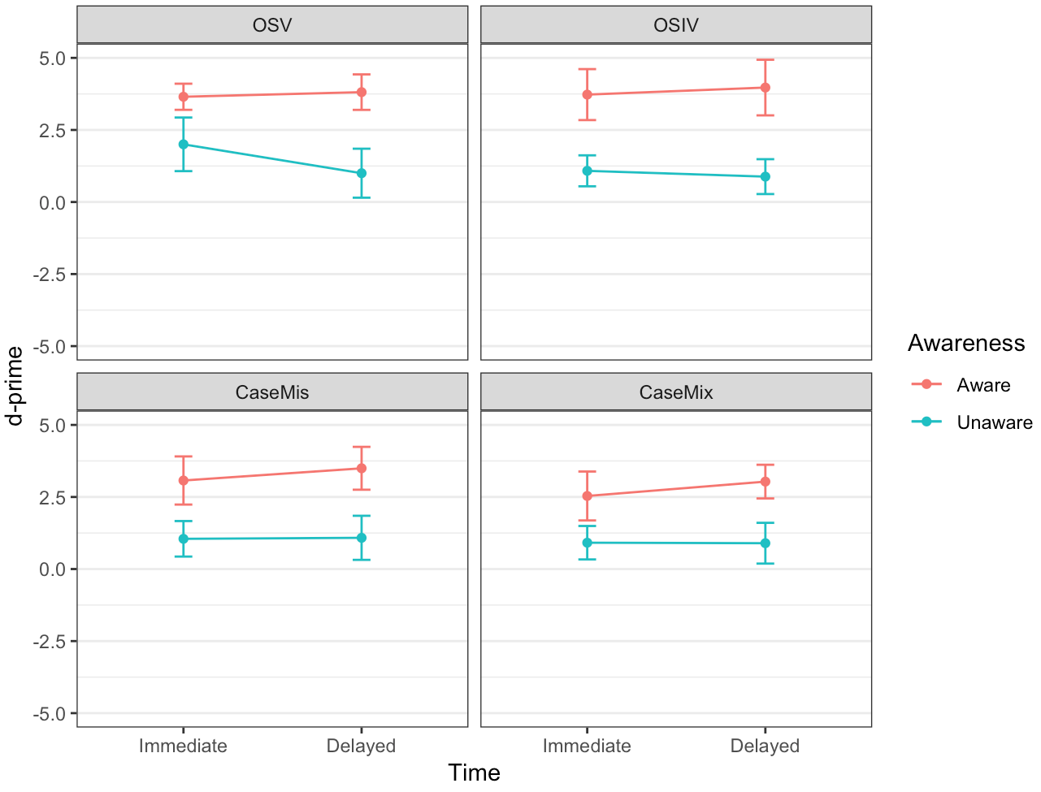
Figure S13. Differences between Aware and Unaware Participants

Table S25. Summary of Findings on Retrospective Verbal Reports.
 | Immediate
 | OSV | OSIV |  | OSSVV |  | OSSIVV |  | CaseMis |  | CaseMix
Verbal Reports | Both | Both |  | Both |  | Both |  | Both |  | Both
 | Delayed
 | OSV |  | OSIV |  | OSSVV |  | OSSIVV |  | CaseMis |  | CaseMix
Verbal Reports | Both | Both |  | Both |  | Both |  | Both |  | Both

References
Hama, M., & Leow, R. P. (2010). Learning without awareness revisited. Studies in Second
Language Acquisition, 32(3), 465–491.
Reber, A. S. (1989). Implicit learning and tacit knowledge. Journal of Experimental Psychology:
General, 118(3), 219–235.
Rebuschat, P. (2013). Measuring implicit and explicit knowledge in second language research.
Language Learning, 63(3), 595–626.
Robinson, P., Mackey, A., Gass, S.M., & Schmidt, R. (2012). Attention and awareness in second
language acquisition. In S. M. Gass & A. Mackey (Eds.), The Routledge handbook of second language acquisition (pp. 247–267).
Schmidt, R. W. (1990). The role of consciousness in second language learning. Applied
Linguistics 11(2), 129–158.
Schmidt, R.W. (2001). Attention. In P. Robinson (Ed.), Cognition and second language
instruction (pp. 3–32). Cambridge: Cambridge University Press.
Shanks, D. R., & St. John, M. F. (1994). Characteristics of dissociable human learning systems.
Behavioral and Brain Sciences, 17(3), 367–447.

