Appendix A. Items Used for Training Sessions
1 | That is the boy who is kissing the dog.
2 | That is the girl who is pushing the cat.
3 | That is the girl who is carrying the man.
4 | That is the girl who is massaging the grandmother.
5 | That is the man who is washing the pig.
6 | That is the girl who is watching the bird.
7 | That is the father who is hugging the mother.
8 | That is the girl who is kicking the boy.
9 | That is the kangaroo which is massaging the boy.
10 | That is the monkey which is hugging the boy.
11 | That is the girl who is carrying the man.
12 | That is the girl who is massaging the grandmother.
13 | That is the hamster which is kissing the woman.
14 | That is the monkey which is washing the boy.
15 | That is the father who is hugging the mother.
16 | That is the girl who is kicking the boy.
17 | That is the lion which is kicking the horse.
18 | That is the hamster which is pushing the mouse.
19 | That is the kangaroo which is massaging the boy.
20 | That is the monkey which is hugging the boy.
21 | That is the bird which is watching the cat.
22 | That is the monkey which is carrying the rabbit.
23 | That is the hamster which is kissing the woman.
24 | That is the monkey which is washing the boy.
25 | That is the lion which is kicking the horse.
26 | That is the hamster which is pushing the mouse.
27 | That is the boy who is kissing the dog.
28 | That is the girl who is pushing the cat.
29 | That is the bird which is watching the cat.
30 | That is the monkey which is carrying the rabbit.
31 | That is the man who is washing the pig.
32 | That is the girl who is watching the bird.
33 | That is the man whom the cat is massaging.
34 | That is the girl whom the monkey is hugging.
35 | That is the girl whom the father is watching.
36 | That is the girl whom the man is carrying.
37 | That is the girl whom the lion is kissing.
38 | That is the boy whom the monkey is washing.
39 | That is the girl whom the boy is kicking.
40 | That is the man whom the woman is pushing.
41 | That is the monkey which the girl is massaging.
42 | That is the monkey which the girl is hugging.
43 | That is the girl whom the father is watching.
44 | That is the girl whom the man is carrying.
45 | That is the hamster which the woman is kissing.
46 | That is the dog which the man is washing.
47 | That is the girl whom the boy is kicking.
48 | That is the man whom the woman is pushing.
49 | That is the lion which the horse is kicking.
50 | That is the hamster which the mouse is pushing.
51 | That is the monkey which the girl is massaging.
52 | That is the monkey which the girl is hugging.
53 | That is the bird which the cat is watching.
54 | That is the hamster which the bird is carrying.
55 | That is the hamster which the woman is kissing.
56 | That is the dog which the man is washing.
57 | That is the lion which the horse is kicking.
58 | That is the hamster which the mouse is pushing.
59 | That is the man whom the cat is massaging.
60 | That is the girl whom the monkey is hugging.
61 | That is the bird which the cat is watching.
62 | That is the hamster which the bird is carrying.
63 | That is the girl whom the lion is kissing.
64 | That is the boy whom the monkey is washing.

Appendix B. Sample Items Used for Outcome Tests
1 | That is the girl who is hugging the bear.
2 | That is the man who is pushing the sheep.
3 | That is the man who is massaging the grandfather.
4 | That is the father who is kissing the mother.
5 | That is the pig which is watching the mouse.
6 | That is the bird which is carrying the mouse.
7 | That is the panda which is washing the woman.
8 | That is the horse which is kicking the man.
9 | That is the woman whom the panda is washing.
10 | That is the man whom the horse is kicking.
11 | That is the grandfather whom the man is massaging.
12 | That is the mother whom the father is kissing.
13 | That is the mouse which the pig is watching.
14 | That is the mouse which the bird is carrying.
15 | That is the bear which the girl is hugging.
16 | That is the sheep which the man is pushing.

Appendix C. Reliability of Outcome Tests

 |  | Pretest | Immediate Posttest | Delayed Posttest
Comprehension Test | Accuracy | 0.58 | 0.69 | 0.72
 | Speed | - | 0.93 | 0.92
Production Test | Accuracy | 0.71 | 0.87 | 0.87
 | Speed | - | 0.70 | 0.92

Appendix D. Results of ANOVA on Pretest Scores

Accuracy Scores of Comprehension Test

 | Sum of Squares | df | Mean Square | F | p
Between Groups | 2843.48 | 5 | 568.70 | 2.39 | .04
Within Groups | 29281.04 | 123 | 238.06
Total | 32124.52 | 128

Tukey’s multiple comparisons demonstrated that the production_mixed group scored significantly higher than the comprehension_blocked group (p = .02). The rest of the comparisons were not significant (p > .10)

Accuracy Scores of Production Test
 | Sum of Squares | df | Mean Square | F | p
Between Groups | 3782877.01 | 5 | 756575.40 | 0.90 | .49
Within Groups | 57339961.11 | 68 | 843234.72
Total | 61122838.12 | 73

RT of Comprehension Test

 | Sum of Squares | df | Mean Square | F | p
Between Groups | 610.77 | 5 | 122.15 | .47 | .80
Within Groups | 32240.49 | 123 | 262.12
Total | 32851.26 | 128

Appendix E. Results of Logistic Mixed-Effects Models (Accuracy Scores)

Comprehension Tests

 | Immediate posttest |  |  |  |  |  |  |  |  |  | Delayed posttest
 | Subject |  |  |  |  | Item |  |  |  |  | Subject |  |  | Item
Random effects | Variance | SD |  |  | Variance |  | SD |  |  | Variance |  | SD |  | Variance | SD
Intercept | 0.91 | 0.95 |  |  | 0.35 |  | 0.59 |  |  | 1.14 |  | 1.07 |  | 0.24 | 0.24
Pretest | 0.10 | 0.32 |  |  | 0.09 |  | 0.30 |  |  | - |  | - |  | - | -
Fixed effects | Estimate | SE |  |  | z |  | p |  |  | Estimate |  | SE |  | z | p
Intercept | 2.30 | 0.29 |  |  | 8.07 |  | .00 |  |  | 2.45 |  | 0.31 |  | 7.98 | .00
Practice | 0.00 | 0.25 |  |  | 0.02 |  | .99 |  |  | 0.11 |  | 0.27 |  | 0.40 | .69
Schedule (Interleaved) | 0.11 | 0.30 |  |  | 0.37 |  | .71 |  |  | 0.49 |  | 0.34 |  | 1.42 | .16
Schedule (Hybrid) | 0.34 | 0.28 |  |  | 1.20 |  | .23 |  |  | 0.05 |  | 0.31 |  | 0.16 | .88
Pretest | 0.28 | 0.17 |  |  | 1.68 |  | .09 |  |  | 0.59 |  | 0.14 |  | 4.26 | .00
Note. The fixed effect of practice was centered using deviation coding, while the effect of schedule was dummy coded with blocked practice as a reference group. Model formula for the immediate posttest: accuracy ~ Practice + Schedule + Pretest + (1 + Pretest | Subject) + (1 + Pretest | Item)
Model formula for the delayed posttest: accuracy ~ Practice + Schedule + Pretest + (1 | Subject) + (1 | Item)

Production Tests

 | Immediate posttest |  |  |  |  |  | Delayed posttest
 | Subject |  |  | Item |  |  | Subject |  |  |  |  | Item
Random effects | Variance | SD |  | Variance | SD |  | Variance | SD |  |  | Variance |  | SD
Intercept | 1.45 | 1.20 |  | 0.51 | 0.72 |  | 2.05 | 1.43 |  |  | 1.17 |  | 1.08
Fixed effects | Estimate | SE |  | z | p |  | Estimate | SE |  |  | z |  | p
Intercept | 2.00 | 0.39 |  | 5.13 | .00 |  | 1.34 | 0.40 |  |  | 3.31 |  | .00
Practice | -0.26 | 0.46 |  | -0.56 | .58 |  | -0.60 | 0.29 |  |  | -2.10 |  | .04
Schedule (Interleaved) | 0.83 | 0.51 |  | 1.63 | .10 |  | -0.01 | 0.37 |  |  | -0.03 |  | .98
Schedule (Hybrid) | 1.05 | 0.50 |  | 2.13 | .03 |  | 0.19 | 0.34 |  |  | 0.56 |  | .58
Pretest | 0.81 | 0.14 |  | 5.98 | .00 |  | 0.95 | 0.15 |  |  | 6.50 |  | .00
Practice x Schedule (Interleaved) | -1.35 | 0.68 |  | -1.98 | .05 |  | - | - |  |  | - |  | -
Practice x Schedule (Hybrid) | -1.95 | 0.64 |  | -3.05 | .00 |  | - | - |  |  | - |  | -
Note. Model formulae for immediate and delayed posttests: accuracy ~ Practice + Schedule + Pretest + Schedule:Practice + (1 | Subject) + (1 | Item)

Appendix F. Results of Linear Mixed-Effects Models (RT)

Comprehension Tests

 | Immediate posttest |  |  |  |  |  | Delayed posttest
 | Subject |  |  | Item |  |  | Subject |  |  | Item
Random effects | Variance | SD |  | Variance | SD |  | Variance | SD |  | Variance | SD
Intercept | 218177 | 467.10 |  | 36780 | 191.80 |  | 149546 | 386.70 |  | 15370 | 124
Fixed effects | Estimate | SE |  | z | p |  | Estimate | SE |  | z | p
Intercept | 4646.17 | 159.30 |  | 29.17 | .00 |  | 4527.89 | 159.90 |  | 28.32 | .00
Practice | -553.08 | 130.54 |  | -4.24 | .00 |  | -474.99 | 133.75 |  | -3.55 | .00
Schedule (Interleaved) | -100.21 | 174.17 |  | -0.58 | .57 |  | 48.30 | 179.28 |  | 0.27 | .79
Schedule (Hybrid) | -379.94 | 156.67 |  | -2.43 | .02 |  | -332.19 | 161.52 |  | -2.06 | .04
Pre.Accuracy | -248.93 | 127.68 |  | -1.95 | .06 |  | -253.27 | 131.22 |  | -1.93 | .06
Pre.RT | 503.34 | 173.07 |  | 2.91 | .01 |  | 691.50 | 184.79 |  | 3.74 | .00
Practice (Comp.) x Pre.RT | 74.68 | 270.40 |  | 0.28 | .78 |  | -177.62 | 282.63 |  | -0.63 | .53
Practice (Prod.) x Schedule (Interleaved) x Pre.RT | 406.76 | 263.22 |  | 1.55 | .13 |  | 63.57 | 273.92 |  | 0.23 | .82
Practice (Comp.) x Schedule (Interleaved) x Pre.RT | -583.52 | 240.24 |  | -2.43 | .02 |  | -562.72 | 248.55 |  | -2.26 | .03
Practice (Prod.) x Schedule (Hybrid) x Pre.RT | 92.91 | 237.99 |  | 0.39 | .70 |  | -234.15 | 248.60 |  | -0.94 | .35
Practice (Comp.) x Schedule (Hybrid) x Pre.RT | -155.25 | 246.77 |  | -0.63 | .53 |  | -188.25 | 254.29 |  | -0.74 | .46
Note. Model formulae for immediate and delayed posttests: rt ~ Practice + Schedule + Pre.Accuracy + Pre.RT + Practice:Pre.RT + Practice:Schedule:PreRT + (1 | Subject) + (1 | Item)

Production Tests

 | Immediate posttest |  |  |  |  |  | Delayed posttest
 | Subject |  |  | Item |  |  | Subject |  |  | Item
Random effects | Variance | SD |  | Variance | SD |  | Variance | SD |  | Variance | SD
Intercept | 947666 | 973.50 |  | 206408 | 454.30 |  | 678965 | 824.00 |  | 156388 | 395.50
Fixed effects | Estimate | SE |  | t | p |  | Estimate | SE |  | t | p
Intercept | 6119.16 | 313.35 |  | 19.53 | .00 |  | 6370.89 | 267.35 |  | 23.83 | .00
Practice | 1045.48 | 276.42 |  | 3.78 | .00 |  | 36.58 | 239.48 |  | 0.15 | .88
Schedule (Interleaved) | -188.70 | 351.46 |  | -0.54 | .59 |  | -41.08 | 298.36 |  | -0.14 | .89
Schedule (Hybrid) | -623.88 | 336.75 |  | -1.85 | .07 |  | -155.39 | 289.14 |  | -0.54 | .59
Pretest | -341.79 | 143.39 |  | -2.38 | .02 |  | -270.85 | 125.97 |  | -2.15 | .04
Note. Model formulae for immediate and delayed posttests: rt ~ Practice + Schedule + Pretest + (1 | Subject) + (1 | Item)

Appendix G. Results of Linear Mixed-Effects Models with Schedule (blocked vs. interleaved practice) as Fixed Effect in Input Practice Condition (RT)

 | Immediate posttest |  |  |  |  |  |  |  |  |  | Delayed posttest
 | Subject |  |  |  |  | Item |  |  |  |  | Subject |  |  | Item
Random effects | Variance | SD |  |  | Variance |  | SD |  |  | Variance |  | SD |  | Variance | SD
Intercept | 149546 | 386.70 |  |  | 15370 |  | 734.10 |  |  | 218177 |  | 467.10 |  | 36780 | 192
Fixed effects | Estimate | SE |  |  | t |  | p |  |  | Estimate |  | SE |  | t | p
Intercept | 4115.85 | 148.39 |  |  | 27.74 |  | .00 |  |  | 4065.42 |  | 132.06 |  | 30.78 | .00
Schedule | -366.16 | 240.28 |  |  | -1.52 |  | .15 |  |  | 35.33 |  | 212.94 |  | 0.17 | .87
Pre.Accuracy | -281.24 | 201.62 |  |  | -1.40 |  | .18 |  |  | -212.53 |  | 178.70 |  | -1.19 | .25
Pre.RT | 381.49 | 124.85 |  |  | 3.06 |  | .01 |  |  | 264.66 |  | 111.97 |  | 2.36 | .03
Schedule x Pre.RT | -728.75 | 249.70 |  |  | -2.92 |  | .01 |  |  | -651.54 |  | 223.86 |  | -2.91 | .01
Note. Model formulae for immediate and delayed posttests: rt ~ Schedule + Pretest + Pre.RT + Schedule:Pre.RT + (1 | Subject) + (1 | Item)

Appendix H. Performance during the Treatment

Comprehension Accuracy

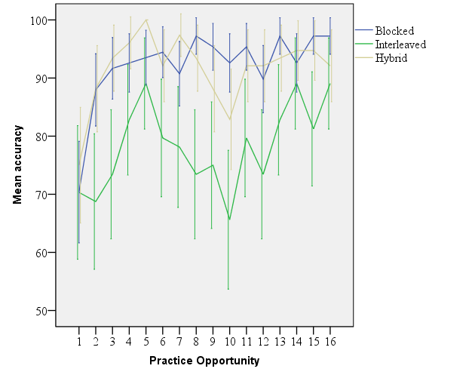

Comprehension RT

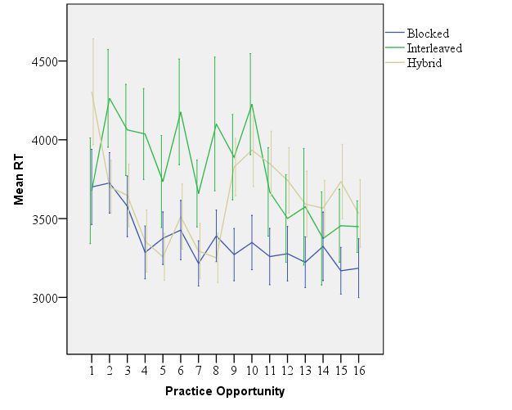

Production Accuracy

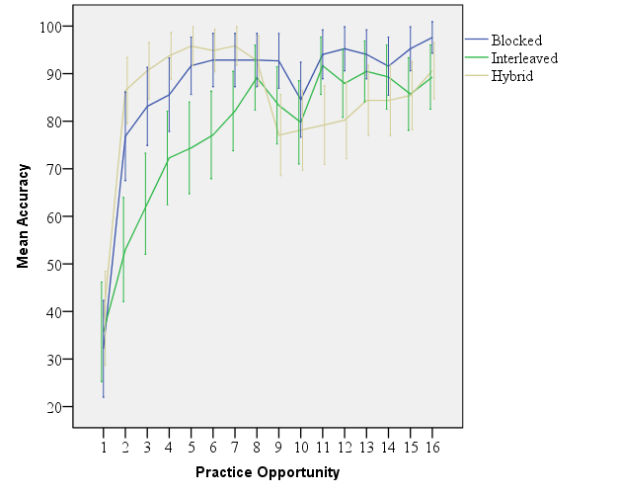

Production RT

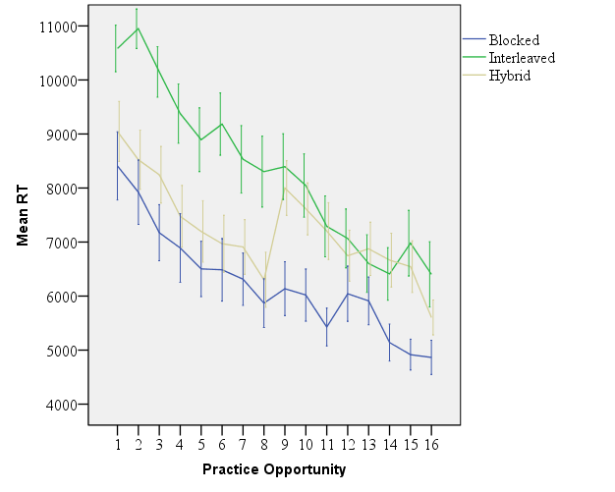
Note. RTs in the production data during the performance indicate the time from the presentation of the prompt to the button press to proceed to the next item (not the utterance duration, as was the case for the analyses on the outcome tests).

Due to the technical problems, some portion of data in the comprehension training were not recorded. The numbers of participants presented in the figures were 19 (blocked), 12 (interleaved), and 18 (hybrid).

