APPENDIX A

Stimuli

- Unaccusative verbs
  - Marina desapareció/Desapareció Marina (Marina disappeared)
    - ¿Qué pasó? (What happened?)
    - ¿Qué hizo Marina? (What did Marina do?)
    - ¿Quién desapareció? (Who disappeared?)
    - ¿Dónde canta Marina? (Where does Marina sing?)
  - Lorena entró/Entró Lorena (Lorena came in)
    - ¿Qué pasó? (What happened?)
    - ¿Qué hizo Lorena? (What did Lorena do?)
    - ¿Quién entró? (Who came in?)
    - ¿Qué escribe Lorena? (What does Lorena write?)
  - Andoni llegó/Llegó Andoni (Andoni arrived)
    - ¿Qué pasó? (What happened?)
    - ¿Qué hizo Andoni? (What did Andoni do?)
    - ¿Quién llegó? (Who arrived?)
    - ¿Cómo baila Andoni? (How does Andoni dance?)
  - Camilo salió/Salió Camilo (Camilo left)
    - ¿Qué pasó? (What happened?)
    - ¿Qué hizo Camilo? (What did Camilo do?)
    - ¿Quién salió? (Who left?)
    - ¿Qué perdió Camilo? (What did Camilo lose?)
  - Elena vino/Vino Elena (Elena came)
    - ¿Qué pasó? (What happened?)
    - ¿Qué hizo Elena? (What did Elena do?)
    - ¿Quién vino? (Who came?)
    - ¿Dónde compra Elena? (Where does Elena shop?)
  - Manuela volvió/Volvió Manuela (Manuela returned)
    - ¿Qué pasó? (What happened?)
    - ¿Qué hizo Manuela? (What did Manuela do?)
    - ¿Quién volvió? (Who returned?)
    - ¿Cuándo juega Manuela? (When does Manuela play?)
- Unergative verbs
  - Alberto lloró/Lloró Alberto (Alberto cried)
    - ¿Qué pasó? (What happened?)
    - ¿Qué hizo Alberto? (What did Alberto do?)
    - ¿Quién lloró? (Who cried?)
    - ¿Dónde trabaja Alberto? (Where does Alberto work?)
  - Andrea gritó/Gritó Andrea (Andrea yelled)
    - ¿Qué pasó? (What happened?)
    - ¿Qué hizo Andrea? (What did Andrea do?)
    - ¿Quién gritó? (Who yelled?)
    - ¿Qué busca Andrea? (What does Andrea look for?)
  - Carola bailó/Bailó Carola (Carola danced)
    - ¿Qué pasó? (What happened?)
    - ¿Qué hizo Carola? (What did Carola do?)
    - ¿Quién bailó? (Who danced?)
    - ¿Cómo viene Carola? (How is Carola coming?)
  - Marcelo estornudó/Estornudó Marcelo (Marcelo sneezed)
    - ¿Qué pasó? (What happened?)
    - ¿Qué hizo Marcelo? (What did Marcelo do?)
    - ¿Quién estornudó? (Who sneezed?)
    - ¿Dónde vive Marcelo? (Where does Marcelo live?)
  - Martina canto/Cantó Martina (Martina sang)
    - ¿Qué pasó? (What happened?)
    - ¿Qué hizo Martina? (What did Martina do?)
    - ¿Quién cantó? (Who sang?)
    - ¿Cuándo vuelve Martina? (When does Martina come back?)
  - Susana sonrió/Sonrió Susana (Susana smiled)
    - ¿Qué pasó? (What happened?)
    - ¿Qué hizo Susana? (What did Susana do?)
    - ¿Quién sonrió? (Who smiled?)
    - ¿Qué estudia Susana? (What is Susana studying?)
- Transitive verbs
  - Carmelo cogió una chaqueta/Cogió una chaqueta Carmelo (Carmelo took a jacket)
    - ¿Qué pasó? (What happened?)
    - ¿Qué hizo Carmelo? (What did Carmelo do?)
    - ¿Quién cogió una chaqueta? (Who took a jacket?)
    - ¿Dónde viajó Carmelo? (Where did Carmelo travel to?)
  - Ignacio robó una cartera/Robó una cartera Ignacio (Ignacio stole a wallet)
    - ¿Qué pasó? (What happened?)
    - ¿Qué hizo Ignacio? (What did Ignacio do?)
    - ¿Quién robó una cartera? (Who stole a wallet?)
    - ¿Qué abrió Ignacio? (What did Ignacio open?)
  - Josema compró una camisa/Compró una camisa Josema (Josema bought a shirt)
    - ¿Qué pasó? (What happened?)
    - ¿Qué hizo Josema? (What did Josema do?)
    - ¿Quién compró una camisa? (Who bought a shirt?)
    - ¿Cómo cocina Josema? (How does Josema cook?)
  - Julieta escribió una novela/Escribió una novela Julieta (Julieta wrote a novel)
    - ¿Qué pasó? (What happened?)
    - ¿Qué hizo Julieta? (What did Julieta do?)
    - ¿Quién escribió una novela? (Who wrote a novel?)
    - ¿Cuándo salió Julieta? (When did Julieta leave?)
  - Melisa comió una paella/Comió una paella Melisa (Melisa ate a paella)
    - ¿Qué pasó? (What happened?)
    - ¿Qué hizo Melisa? (What did Melisa do?)
    - ¿Quién comió una paella? (Who ate a paella?)
    - ¿Dónde durmió Melisa? (Where did Melisa sleep?
  - Rosana adoptó una mascota/Adoptó una mascota Rosana (Rosana adopted a pet)
    - ¿Qué pasó? (What happened?)
    - ¿Qué hizo Rosana? (What did Rosana do?)
    - ¿Quién adoptó una mascota? (Who adopted a pet?)
    - ¿Qué perdió Rosana? (What did Rosana lose?)
APPENDIX B

Example of intonational contours in stimuli with an intransitive verb:

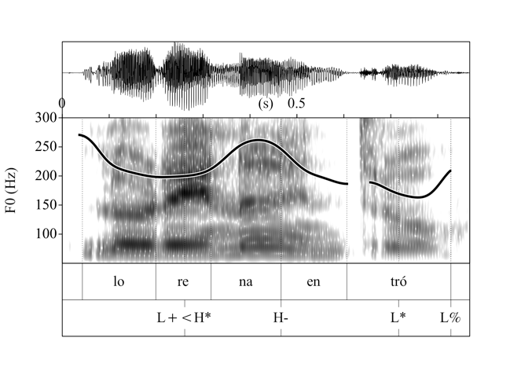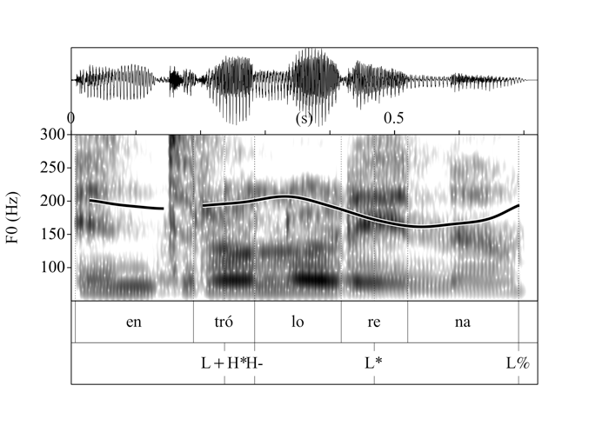
Lorena entró Entró Lorena
Lorena came in Came in Lorena
“Lorena came in” “Lorena came in”

Example of intonational contour in stimuli with a transitive verb:

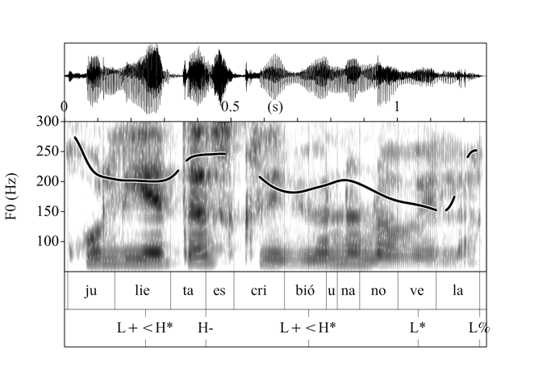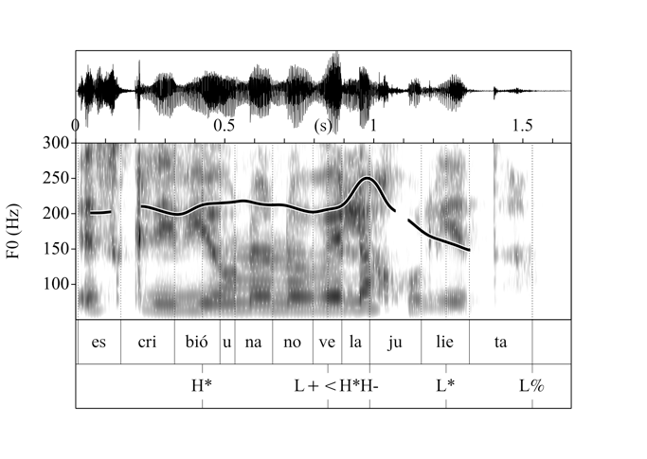
Julieta escribió una novela Escribió una novela Julieta
Julieta wrote a novel Wrote a novel Julieta
“Julieta wrote a novel” “Julieta wrote a novel”

