Appendix S1. Background Information of Participants
Their mean age was 19.63 (SD = .96). None of the participants had learned Spanish before. Twenty-eight participants studied a foreign language other than English at the university (15 and 13 participants in the 3.3-day ISI and 7-day ISI groups, respectively). Overall, languages were equally 7-day ISI between the groups: French (2 and 3), German (1 and 1), Russian (1 and 0), Chinese (5 and 2), Korean (5 and 6), and Hindi (0 and 1). One participant in the 3.3-day ISI learning group studied both French and Korean. No significant difference existed in the mean length of study (in months) between the 3.3-day ISI and the 7-day ISI learning groups (M = 23.00, 21.04; SD = 20.70, 13.15), t (26) = 0.29, p = .77. Note that six participants (4 learners in the 3.3-day ISI group and 2 learners in the 7-day ISI group) could not follow the same schedule due to unexpected incidents (e.g., absence due to sickness). They were included in the analysis as long as the adjustments of their training or/and post-test schedules were only within one or two days. In the 3.3-day interval group, a participant completed Session 3 one day later; another participant completed Session 5 one day later, another completed Session 6 one day earlier; and another completed Sessions 3 and 5 one day later. In the 7-day interval group, a participant took Session 3 one day later. Another participant in the distributed learning group took Post-test 1 in Session 5 one week later than the original schedule, and the analysis excluded the Post-test 1 responses for this participant.

Appendix S2. Sample Display of Tower of London Task
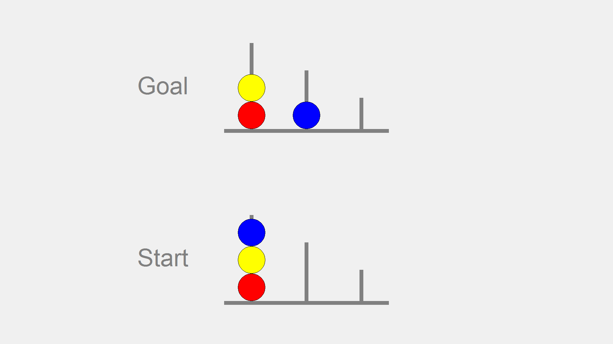

Appendix S3. Training Procedure
Vocabulary practice phase. In the vocabulary practice phase, the participants saw a picture depicting an action verb (Japanese translation was placed on the top right corner as well) and were prompted to say the Supurango word. The picture was presented on the screen for four seconds, followed by the feedback. Feedback was given in both oral and written forms; the word was pronounced once while it remained on the screen for four seconds. The set of 24 verbs was repeated three times in Training 1 and four times in Trainings 2 to 4. Only in the beginning of Session 1, the participants studied vocabulary first by seeing a verb in Supurango and its Japanese translation. Each word was presented for five seconds; two cycles of 24 verbs were repeated. This task was given only in Session 1 so that the learners could first learn the association before the retrieval practice.
Verb conjugation sheet. After the vocabulary learning phase, the participants were provided with a sheet that explained verb conjugations. The participants were encouraged to refer to it any time during the grammar practice in all the sessions. The participants also read a series of slides that explained the conjugations for each category after receiving the explicit information sheet, which was included only in Session 1.
Grammar practice phase. In the grammar practice phase, the participants saw an animation video in which a man performed an action of the verbs. Each video clip lasted eight seconds, and the participants had to orally describe the animation using the PP form of the verb. The set of 24 verbs were repeated four times in each training session.
Check tests. The present study administered the check tests comprised the same three tests as post-tests 1 and 2 (i.e., vocabulary, rule-application, and PP). These check tests were given in the beginning of training Sessions 2–4 (check tests 2A, 3A, and 4A) and at the end of each training session (check tests 2B, 3B, and 4B). No feedback was provided during the tests.

Appendix S4. Cronbach alpha for Transfer and PP Tests
 | Rule Test |  |  | PP Test
 | Accuracy | Speed |  | Accuracy | Speed
Test 1 | .87 | NA |  | .81 | NA
Test 2A | .92 | NA |  | .84 | NA
Test 2B | .85 | .97 |  | .88 | NA
Test 3A | .92 | .75 |  | .92 | NA
Test 3B | .87 | .92 |  | .91 | .85
Test 4A | .89 | NA |  | .92 | NA
Test 4B | .94 | .98 |  | .86 | .96
Test 5 | .93 | .64 |  | .89 | .91
Test 6 | .90 | .70 |  | .84 | .92
Note. NA indicates that Cronbach alpha was not computed due to the insufficient number of test items that were scored correctly by all the participants.
Appendix S5. Accuracy Scores of Outcome Tests
 | 7-day interval |  |  |  | 3.3-day Interval
 | N | M | SD |  | N | M | SD
Rule
Test 1 | 30 | 36.67 | 30.84 |  | 30 | 48.89 | 30.46
Test 2A | 30 | 11.94 | 21.74 |  | 30 | 20.00 | 30.37
Test 2B | 30 | 59.72 | 31.11 |  | 30 | 69.17 | 26.73
Test 3A | 30 | 36.94 | 34.09 |  | 30 | 63.61 | 31.98
Test 3B | 30 | 65.00 | 32.49 |  | 30 | 85.83 | 16.69
Test 4A | 30 | 51.67 | 32.93 |  | 30 | 79.17 | 22.61
Test 4B | 30 | 72.50 | 31.00 |  | 30 | 87.92 | 13.73
Test 5 | 29 | 67.39 | 31.10 |  | 30 | 85.97 | 13.99
Test 6 | 30 | 65.00 | 28.96 |  | 30 | 79.31 | 15.22
PP
Test 1 | 30 | 20.00 | 15.49 |  | 30 | 25.28 | 18.82
Test 2A | 30 | 6.67 | 11.51 |  | 30 | 13.06 | 14.59
Test 2B | 30 | 60.97 | 25.08 |  | 30 | 72.36 | 18.75
Test 3A | 30 | 35.00 | 26.18 |  | 30 | 54.86 | 25.62
Test 3B | 30 | 73.47 | 24.23 |  | 30 | 90.42 | 14.02
Test 4A | 30 | 58.06 | 28.64 |  | 30 | 81.94 | 15.41
Test 4B | 30 | 83.75 | 17.49 |  | 30 | 94.17 | 9.70
Test 5 | 29 | 70.40 | 23.68 |  | 30 | 85.69 | 14.83
Test 6 | 30 | 65.14 | 21.29 |  | 30 | 77.50 | 16.25

Appendix S6. Correlations between TOL Scores and RT and CV of Rule Tests
 | 3.3-day ISI |  |  |  |  |  |  |  |  |  |  | 7-day ISI
 |  |  | ITT |  |  | MET |  |  | OST |  |  |  |  | ITT |  |  | MET |  |  | OST
 | n |  | r | p |  | r | p |  | r | p |  | n |  | r | p |  | r | p |  | r | p
RT
Test 1 | 20 |  | - | - |  | - | - |  | - | - |  | 14 |  | - | - |  | - | - |  | - | -
Test 2A | 8 |  | - | - |  | - | - |  | - | - |  | 4 |  | - | - |  | - | - |  | - | -
Test 2B | 28 |  | .22 | .27 |  | -.38 | .05 |  | -.14 | .47 |  | 25 |  | -.15 | .46 |  | .17 | .43 |  | .07 | .72
Test 3A | 24 |  | .09 | .67 |  | -.37 | .08 |  | -.19 | .36 |  | 14 |  | -.29 | .32 |  | -.03 | .93 |  | -.18 | .55
Test 3B | 30 |  | .10 | .61 |  | -.41 | .02 |  | -.20 | .29 |  | 25 |  | -.03 | .89 |  | -.04 | .85 |  | -.03 | .88
Test 4A | 30 |  | .08 | .69 |  | -.42 | .02 |  | -.22 | .24 |  | 22 |  | -.07 | .75 |  | .26 | .24 |  | .20 | .36
Test 4B | 30 |  | .03 | .89 |  | -.33 | .07 |  | -.18 | .34 |  | 26 |  | .12 | .56 |  | .14 | .49 |  | .21 | .31
Test 5 | 30 |  | .11 | .55 |  | -.42 | .02 |  | -.12 | .54 |  | 24 |  | -.11 | .60 |  | -.05 | .83 |  | -.10 | .65
Test 6 | 30 |  | -.02 | .90 |  | -.51 | .00 |  | -.38 | .04 |  | 25 |  | -.11 | .61 |  | .07 | .74 |  | -.01 | .97
CV
Test 1 | 20 |  | - | - |  | - | - |  | - | - |  | 14 |  | - | - |  | - | - |  | - | -
Test 2A | 8 |  | - | - |  | - | - |  | - | - |  | 4 |  | - | - |  | - | - |  | - | -
Test 2B | 27 |  | -.30 | .13 |  | .08 | .70 |  | -.19 | .34 |  | 25 |  | -.39 | .05 |  | .08 | .70 |  | -.10 | .62
Test 3A | 24 |  | -.18 | .40 |  | .03 | .90 |  | -.18 | .41 |  | 14 |  | -.16 | .60 |  | -.11 | .71 |  | -.12 | .69
Test 3B | 30 |  | .02 | .90 |  | -.12 | .51 |  | -.18 | .34 |  | 24 |  | .38 | .07 |  | -.03 | .90 |  | .19 | .38
Test 4A | 30 |  | -.17 | .38 |  | .13 | .51 |  | .07 | .69 |  | 22 |  | -.31 | .16 |  | .12 | .61 |  | -.01 | .96
Test 4B | 30 |  | -.17 | .36 |  | -.13 | .51 |  | -.27 | .15 |  | 26 |  | -.24 | .23 |  | -.10 | .63 |  | -.18 | .39
Test 5 | 30 |  | .13 | .50 |  | -.08 | .69 |  | .09 | .64 |  | 25 |  | -.22 | .30 |  | .10 | .62 |  | .11 | .59
Test 6 | 30 |  | .16 | .40 |  | .09 | .63 |  | .10 | .60 |  | 25 |  | -.12 | .58 |  | -.02 | .92 |  | -.06 | .76
Note. Shaded cells indicate significant correlation coefficients (p < .05). The correlation coefficients at Test 1 and Test 2A were not computed due to the small number of participants.

Appendix S7. Correlations between TOL Scores and RT and CV of PP Tests
 | 3.3-day ISI |  |  |  |  |  |  |  |  |  |  | 7-day ISI
 |  |  | ITT |  |  | MET |  |  | OST |  |  |  |  | ITT |  |  | MET |  |  | OST
 | n |  | r | p |  | r | p |  | r | p |  | n |  | r | p |  | r | p |  | r | p
RT
Test 1 | 12 |  | - | - |  | - | - |  | - | - |  | 7 |  | - | - |  | - | - |  | - | -
Test 2A | 4 |  | - | - |  | - | - |  | - | - |  | 2 |  | - | - |  | - | - |  | - | -
Test 2B | 30 |  | .12 | .53 |  | -.46 | .01 |  | -.38 | .04 |  | 27 |  | -.13 | .51 |  | .23 | .25 |  | .18 | .38
Test 3A | 25 |  | .17 | .41 |  | -.45 | .02 |  | -.28 | .18 |  | 15 |  | -.30 | .28 |  | -.12 | .67 |  | -.16 | .56
Test 3B | 30 |  | .11 | .56 |  | -.30 | .11 |  | -.23 | .23 |  | 29 |  | -.13 | .50 |  | .30 | .11 |  | .21 | .29
Test 4A | 30 |  | .05 | .79 |  | -.51 | .00 |  | -.42 | .02 |  | 25 |  | -.08 | .70 |  | .08 | .69 |  | .08 | .70
Test 4B | 30 |  | .11 | .56 |  | -.44 | .02 |  | -.35 | .06 |  | 29 |  | .13 | .50 |  | .35 | .06 |  | .35 | .06
Test 5 | 30 |  | .23 | .22 |  | -.46 | .01 |  | -.29 | .12 |  | 26 |  | -.13 | .52 |  | .20 | .32 |  | .16 | .43
Test 6  CV | 30 |  | -.11 | .57 |  | -.34 | .06 |  | -.39 | .03 |  | 26 |  | -.33 | .10 |  | .12 | .57 |  | -.03 | .89
Test 1 | 12 |  | - | - |  | - | - |  | - | - |  | 7 |  | - | - |  | - | - |  | - | -
Test 2A | 4 |  | - | - |  | - | - |  | - | - |  | 2 |  | - | - |  | - | - |  | - | -
Test 2B | 29 |  | .16 | .40 |  | -.09 | .64 |  | .03 | .89 |  | 27 |  | -.26 | .19 |  | -.17 | .41 |  | -.24 | .24
Test 3A | 25 |  | .04 | .86 |  | -.07 | .74 |  | -.02 | .91 |  | 15 |  | .07 | .81 |  | .18 | .53 |  | .19 | .49
Test 3B | 30 |  | .19 | .33 |  | .09 | .64 |  | .15 | .44 |  | 29 |  | -.01 | .94 |  | .34 | .07 |  | .35 | .06
Test 4A | 30 |  | .25 | .19 |  | -.11 | .57 |  | .05 | .80 |  | 25 |  | .00 | 1.00 |  | .08 | .70 |  | .09 | .65
Test 4B | 30 |  | .07 | .70 |  | -.19 | .32 |  | -.18 | .34 |  | 29 |  | .36 | .06 |  | .27 | .16 |  | .40 | .03
Test 5 | 30 |  | .42 | .02 |  | -.14 | .47 |  | .14 | .47 |  | 27 |  | .17 | .40 |  | .30 | .12 |  | .39 | .04
Test 6 | 30 |  | -.01 | .94 |  | -.13 | .51 |  | -.06 | .73 |  | 26 |  | .09 | .68 |  | .23 | .27 |  | .21 | .31
Note. Shaded cells indicate significant correlation coefficients (p < .05). The correlation coefficients at Test 1 and Test 2A were not computed due to the small number of participants.

Appendix S8. Scatterplots for RT (rule-application tests) and MET (Tower of London task)
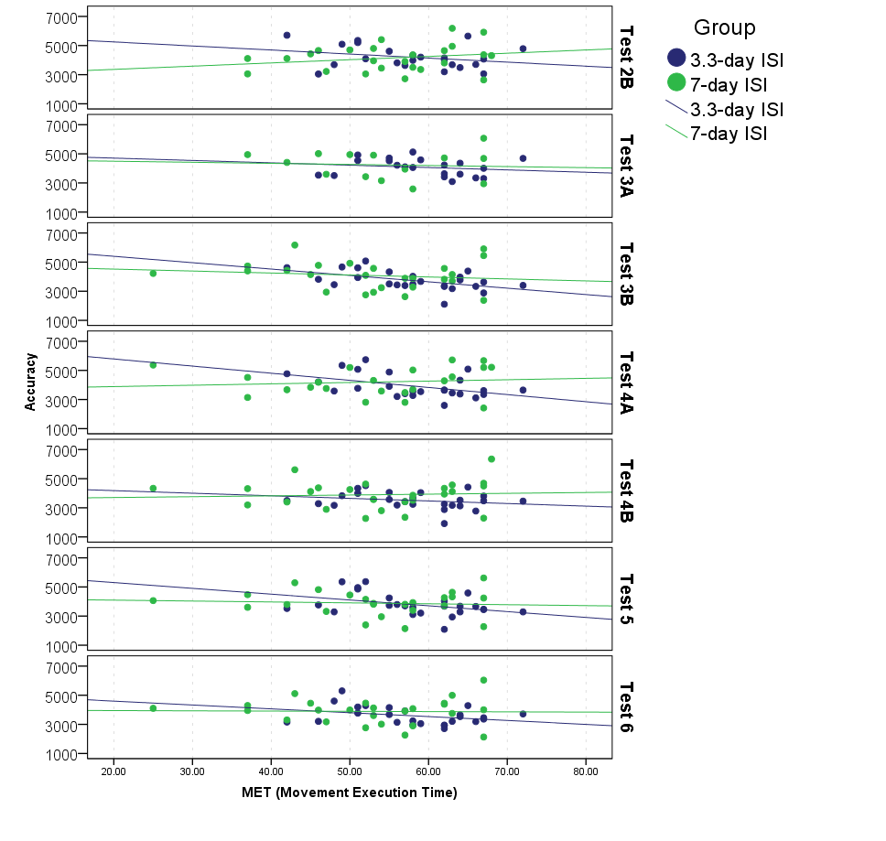
RT (rule-application tests)
Appendix S9. Scatterplots for RT (PP tests) and MET (Tower of London task)
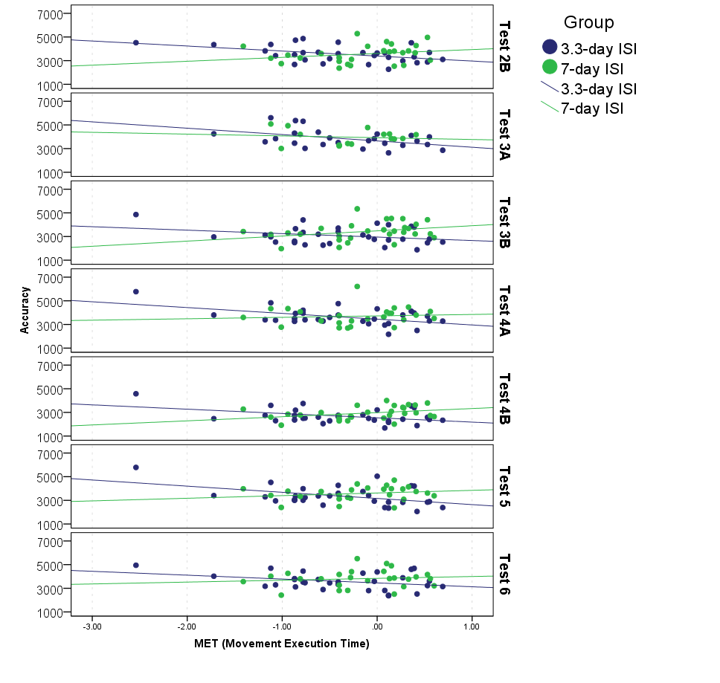
RT (PP tests)
Appendix S10. RT and CV of Vocabulary Test during Training Sessions 3 and 4
 |  | 3.3-day ISI |  |  |  |  |  |  | 7-day ISI
 |  | n | RT_Mean | RT_SD | CV | RT-CV  correlation | p |  | n | RT_Mean | RT_SD | CV | RT-CV  correlation | p
Test 3A |  | 28 | 2587 | 539 | 0.29 | .52 | .00 |  | 19 | 2747 | 691 | 0.32 | .39 | .09
Test 3B |  | 28 | 2177 | 457 | 0.30 | .61 | .00 |  | 19 | 2369 | 500 | 0.32 | .36 | .07
t-test | t |  | 5.72 |  | 0.34 |  |  |  |  | 2.87 |  | 0.16
 | df |  | 27 |  | 27 |  |  |  |  | 18 |  | 18
 | p |  | .00 |  | .74 |  |  |  |  | .01 |  | .87
 | Cohen’s d |  | 1.23 |  | -0.06 |  |  |  |  | 0.66 |  | -0.04
Test 4A |  | 29 | 2440 | 574 | 0.33 | .73 | .00 |  | 27 | 2601 | 653 | 0.31 | .61 | .00
Test 4B |  | 29 | 1998 | 349 | 0.27 | .55 | .00 |  | 27 | 2193 | 447 | 0.29 | .49 | .01
t-test | t |  | 7.07 |  | 3.01 |  |  |  |  | 5.54 |  | 1.35
 | df |  | 28 |  | 28 |  |  |  |  | 26 |  | 26
 | p |  | .00 |  | .01 |  |  |  |  | .00 |  | .19
 | Cohen’s d |  | 1.39 |  | 0.58 |  |  |  |  | 1.07 |  | 0.26

Appendix 11. Correlations between TOL Scores and RT and CV of Vocabulary Tests
 | 3.3-day ISI |  |  |  |  |  |  |  |  |  |  | 7-day ISI
 |  |  | ITT |  |  | MET |  |  | OST |  |  |  |  | ITT |  |  | MET |  |  | OST
 | n |  | r | p |  | r | p |  | r | p |  | n |  | r | p |  | r | p |  | r | p
RT
Test 1 | 11 |  | - | - |  | - | - |  | - | - |  | 9 |  | - | - |  | - | - |  | - | -
Test 2A | 6 |  | - | - |  | - | - |  | - | - |  | 3 |  | - | - |  | - | - |  | - | -
Test 2B | 30 |  | .01 | .98 |  | -.17 | .36 |  | -.24 | .21 |  | 26 |  | .00 | .99 |  | .26 | .21 |  | .19 | .35
Test 3A | 28 |  | .07 | .73 |  | -.41 | .03 |  | -.39 | .04 |  | 21 |  | -.09 | .71 |  | -.14 | .55 |  | -.17 | .45
Test 3B | 30 |  | .13 | .48 |  | -.24 | .21 |  | -.17 | .38 |  | 27 |  | -.04 | .85 |  | -.13 | .51 |  | -.09 | .66
Test 4A | 30 |  | -.20 | .29 |  | .15 | .43 |  | -.07 | .70 |  | 27 |  | .00 | .99 |  | .00 | 1.00 |  | -.04 | .83
Test 4B | 29 |  | -.06 | .76 |  | -.03 | .89 |  | -.07 | .74 |  | 30 |  | .05 | .78 |  | .07 | .72 |  | .10 | .60
Test 5 | 30 |  | .23 | .23 |  | -.13 | .51 |  | .04 | .85 |  | 27 |  | .06 | .77 |  | -.14 | .48 |  | -.10 | .62
Test 6 | 30 |  | .06 | .76 |  | -.32 | .09 |  | -.31 | .10 |  | 27 |  | -.07 | .74 |  | -.04 | .85 |  | -.08 | .69
CV
Test 1 | 11 |  | - | - |  | - | - |  | - | - |  | 9 |  | - | - |  | - | - |  | - | -
Test 2A | 6 |  | - | - |  | - | - |  | - | - |  | 3 |  | - | - |  | - | - |  | - | -
Test 2B | 30 |  | .05 | .79 |  | -.27 | .15 |  | -.13 | .51 |  | 26 |  | .10 | .63 |  | .36 | .07 |  | .36 | .07
Test 3A | 28 |  | .02 | .91 |  | .06 | .77 |  | .06 | .77 |  | 21 |  | .02 | .92 |  | -.07 | .75 |  | -.09 | .70
Test 3B | 30 |  | .17 | .36 |  | -.07 | .71 |  | -.05 | .78 |  | 27 |  | .18 | .37 |  | .04 | .83 |  | .15 | .46
Test 4A | 30 |  | -.15 | .43 |  | .35 | .06 |  | .24 | .19 |  | 27 |  | .02 | .92 |  | -.08 | .70 |  | -.04 | .83
Test 4B | 29 |  | .23 | .24 |  | -.09 | .64 |  | .07 | .72 |  | 30 |  | .35 | .06 |  | .12 | .52 |  | .26 | .17
Test 5 | 30 |  | .36 | .05 |  | .12 | .52 |  | .40 | .03 |  | 28 |  | -.12 | .56 |  | .06 | .75 |  | -.02 | .92
Test 6 | 30 |  | -.15 | .41 |  | .13 | .48 |  | .04 | .82 |  | 27 |  | .17 | .40 |  | -.17 | .40 |  | -.06 | .78

Appendix S12. Correlations between TOL Scores and Accuracy Scores
Vocabulary Tests
 | 3.3-day ISI |  |  |  |  |  |  |  |  |  |  | 7-day ISI
 |  |  | ITT |  |  | MET |  |  | OST |  |  |  |  | ITT |  |  | MET |  |  | OST
 | n |  | r | p |  | r | p |  | r | p |  | n |  | r | p |  | r | p |  | r | p
Test 1 | 30 |  | -.19 | .32 |  | .19 | .31 |  | .04 | .84 |  | 30 |  | -.23 | .22 |  | -.27 | .16 |  | -.28 | .14
Test 2A | 30 |  | -.06 | .76 |  | .12 | .54 |  | .04 | .84 |  | 30 |  | -.23 | .23 |  | -.06 | .74 |  | -.11 | .58
Test 2B | 30 |  | -.12 | .51 |  | -.16 | .39 |  | -.22 | .25 |  | 29 |  | -.36 | .06 |  | -.17 | .37 |  | -.28 | .14
Test 3A | 30 |  | -.36 | .05 |  | .12 | .54 |  | -.12 | .53 |  | 29 |  | -.25 | .20 |  | -.21 | .27 |  | -.25 | .19
Test 3B | 30 |  | .00 | .98 |  | -.18 | .35 |  | -.22 | .25 |  | 28 |  | -.26 | .19 |  | -.17 | .38 |  | -.23 | .23
Test 4A | 30 |  | -.33 | .08 |  | .06 | .77 |  | -.13 | .49 |  | 30 |  | -.28 | .14 |  | -.15 | .42 |  | -.25 | .18
Test 4B | 29 |  | -.15 | .45 |  | -.09 | .65 |  | -.18 | .36 |  | 30 |  | -.31 | .10 |  | -.24 | .20 |  | -.30 | .11
Test 5 | 30 |  | -.41 | .03 |  | .19 | .32 |  | -.08 | .66 |  | 29 |  | -.44 | .02 |  | -.21 | .27 |  | -.38 | .04
Test 6 | 30 |  | -.39 | .03 |  | .19 | .31 |  | -.07 | .70 |  | 30 |  | -.39 | .03 |  | .02 | .92 |  | -.10 | .59

Rule Tests

 | 3.3-day ISI |  |  |  |  |  |  |  |  |  |  | 7-day ISI
 |  |  | ITT |  |  | MET |  |  | OST |  |  |  |  | ITT |  |  | MET |  |  | OST
 | n |  | r | p |  | r | p |  | r | p |  | n |  | r | p |  | r | p |  | r | p
Test 1 | 30 |  | -.11 | .57 |  | .25 | .19 |  | .00 | .98 |  | 30 |  | -.36 | .05 |  | -.16 | .40 |  | -.28 | .14
Test 2A | 30 |  | -.05 | .78 |  | .15 | .42 |  | .03 | .88 |  | 30 |  | .00 | .99 |  | -.21 | .27 |  | -.11 | .56
Test 2B | 30 |  | -.32 | .09 |  | .10 | .60 |  | -.12 | .52 |  | 30 |  | -.22 | .24 |  | -.17 | .36 |  | -.23 | .23
Test 3A | 30 |  | -.12 | .54 |  | .23 | .23 |  | .01 | .97 |  | 30 |  | -.32 | .09 |  | -.29 | .13 |  | -.38 | .04
Test 3B | 30 |  | -.14 | .47 |  | .03 | .87 |  | -.17 | .36 |  | 30 |  | -.35 | .06 |  | -.30 | .10 |  | -.37 | .04
Test 4A | 30 |  | -.13 | .48 |  | .21 | .26 |  | -.01 | .96 |  | 30 |  | -.46 | .01 |  | -.36 | .05 |  | -.45 | .01
Test 4B | 30 |  | .09 | .63 |  | -.07 | .72 |  | -.17 | .38 |  | 30 |  | -.37 | .05 |  | -.35 | .06 |  | -.43 | .02
Test 5 | 30 |  | -.19 | .30 |  | .12 | .52 |  | -.15 | .44 |  | 29 |  | -.45 | .02 |  | -.40 | .03 |  | -.53 | .00
Test 6 | 30 |  | -.22 | .24 |  | .21 | .27 |  | -.08 | .68 |  | 30 |  | -.41 | .02 |  | -.47 | .01 |  | -.57 | .00

PP Tests

 | 3.3-day ISI |  |  |  |  |  |  |  |  |  |  | 7-day ISI
 |  |  | ITT |  |  | MET |  |  | OST |  |  |  |  | ITT |  |  | MET |  |  | OST
 | n |  | r | p |  | r | p |  | r | p |  | n |  | r | p |  | r | p |  | r | p
Test 1 | 30 |  | -.17 | .36 |  | .21 | .27 |  | .00 | .99 |  | 30 |  | -.32 | .08 |  | -.34 | .07 |  | -.34 | .07
Test 2A | 30 |  | -.08 | .69 |  | .19 | .33 |  | .05 | .79 |  | 30 |  | -.07 | .72 |  | -.24 | .20 |  | -.17 | .36
Test 2B | 30 |  | -.07 | .71 |  | .04 | .82 |  | -.01 | .95 |  | 30 |  | -.34 | .07 |  | -.31 | .10 |  | -.40 | .03
Test 3A | 30 |  | -.36 | .05 |  | .36 | .05 |  | .06 | .74 |  | 30 |  | -.36 | .05 |  | -.31 | .09 |  | -.38 | .04
Test 3B | 30 |  | -.21 | .26 |  | .12 | .54 |  | -.06 | .74 |  | 30 |  | -.42 | .02 |  | -.21 | .26 |  | -.32 | .08
Test 4A | 30 |  | -.17 | .38 |  | .07 | .72 |  | -.10 | .62 |  | 30 |  | -.31 | .09 |  | -.35 | .06 |  | -.38 | .04
Test 4B | 30 |  | -.11 | .58 |  | -.14 | .46 |  | -.19 | .32 |  | 30 |  | -.30 | .11 |  | -.29 | .13 |  | -.32 | .09
Test 5 | 30 |  | -.31 | .10 |  | .23 | .22 |  | -.06 | .77 |  | 29 |  | -.46 | .01 |  | -.37 | .05 |  | -.49 | .01
Test 6 | 30 |  | -.35 | .06 |  | .26 | .17 |  | -.05 | .81 |  | 30 |  | -.28 | .13 |  | -.30 | .11 |  | -.34 | .07

