Appendix A. Participant Background Questionnaire
1. Age: _________
2. Gender: ______Male ______Female
3. Major: ______________________________
4. Student status: ______Undergraduate ______Graduate student ______Not a student
5. Native language: ____________
6. a) Did you learn another language? ________Yes ________No
b) If yes, please list the other languages and provide relevant information for each.
Language | Proficiency on a scale of 1 to 10  (1=minimal; 10= near-native) | At what age did you start to learn it? | In which context did you start to learn it?
7. a) Did you have any exposure to Chinese, Cantonese, Thai or Vietnamese? ____Yes ___No
b) If yes, in which context, and for how long? ______________________________________
8. a) Did you have any formal training in any musical instrument (including voice)?
____Yes ____No
b) If yes, please list the instruments and provide relevant information for each.
Instrument | At what age did you start to learn it? | For how long you took lessons in it?

Appendix B. Training Words
Target words in pinyin | English translation | Pictures
mā | mother
má | hemp
mǎ | horse
mà | scold
bā | eight
bá | to pull out
bǎ | target
bà | father
tī | kick
tí | lift | 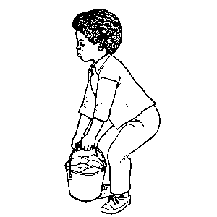
tǐ | body
tì | drawer
tū | bald
tú | picture
tǔ | soil
tù | rabbit

Appendix C. Instruction Sheet
Learning Chinese Words!
In this study, you are going to learn some Chinese words. As there are many dialects in Chinese, we are going to focus on Mandarin Chinese, which is the standard spoken language in Mainland China. The first thing you may need to know about Mandarin Chinese is that Mandarin is a tone language. Each word in Mandarin carries a tone. Tones are changes in pitch that can change the meaning of a word. In other words, to say a Mandarin word requires that you use the correct tone for that word. This means that Mandarin sounds quite different from English.
Mandarin distinguishes between four different tones, or pitch patterns, (audio: dī, dí, dǐ, dì), and the tones are marked by symbols above the letters when Chinese is written with the English alphabet. This way of writing Chinese is called Pinyin. Using Pinyin, the words you just heard look like this:
dī dí dǐ dì
For an illustration of the pitch patterns, take a look at the picture of the four tones. The first tone (audio) dī has a high pitch. It stays high and doesn’t change while you’re producing it. The second tone (audio) dí starts in the middle range of your pitch, then rises. The third tone (audio) dǐ starts low, and then dips. The fourth tone (audio) dì starts high and then drops. In short, Tone 1 is a high-level tone, Tone 2 is a rising tone, Tone 3 is a low-dipping tone, and Tone 4 is a falling tone.
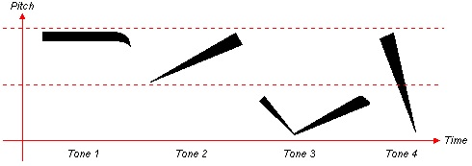
As I said earlier, when you change the tone of a word, you change its meaning. So, di can have four different meanings depending on the tone, (audio) dī (low), (audio) dí (enemy), (audio) dǐ (bottom), (audio) dì (younger brother).
dī | low
dí | enemy
dǐ | bottom
dì | younger brother

The picture for “target” is from Barbati, A. (2006). English: An un-official 80cm FITA archery target. Retrieved from https://commons.wikimedia.org/wiki/File:Archery_Target_80cm.svg. The picture for “lift” is from Szekely, A., D’Amico, S., Devescovi, A., Federmeier, K., Herron, D., Iyer, G., … Bates, E. (2005). Timed action and object naming. Cortex, 41(1), 7–25. Due to copyright issues, the other images used in the study cannot be included here for publication.
This tone diagram is adapted from Zein, P. (2008). Mandarin Chinese Phonetics. from http://www.zein.se/patrick/chinen8p.html

