Supplementary Material
Appendix A
Target utterances, with declarative interpretations followed by the imperative interpretation
Añade la harina “s/he adds the flour” versus. “add-imp the flour”
Devuelve la novela: “s/he returns the novel’ versus “return-imp the novel”
Enrolla el ravioli: ‘s/he rolls up the ravioli’ versus ‘roll up-imp the ravioli’
Envuelve el melón: ‘s/he wraps the melon’ versus ‘wrap-imp the melon’
Nivela el muro: ‘s/he straightens the wall’ versus ‘straighten-imp the wall’
Relava la olla: ‘s/he re-washes the pot’ versus ‘re-wash-imp the pot’
Rellena las aves: ‘s/he re-stuffs the birds’ versus ‘re-stuff-imp he birds”
Remuele la canela: ‘s/he re-grinds the cinnamon’ versus ‘re-grinds-imp the cinnamon’
Revuelve la limonada: ‘s/he re-stirs the lemonade’ versus ‘re-stir-imp the lemonade’

Appendix B
Sample imperative and declarative oral DCTs,
- Declarative with the target utterance añade la harina “he’s adding the flour”
Context: You work in a bakery. A coworker is looking for your boss, Jorge, but he hasn’t found him yet. You know where Jorge is and you tell your coworker that he is near the mixer. Your coworker asks you why Jorge is over there.
  - Tell him that he’s adding the flour
  - You say to him: He’s adding the flour
- Imperative with the target utterance añade la harina “add the flour”
Context: You and a friend, Juan, are making cookies. You are beating the eggs when your friend enters the kitchen and asks you what he should do next. He has barely helped you at all so far.
- Order him to add the flour
- Order him: Add the flour

Appendix C
Focused, task-based intervention: ¡A cocinar!
- Pre-task phase
- Lesson Plan: After building rapport with the students, the instructor began the lesson by asking them things that are included in a recipe. The second part of the pre-task involved a demonstration of how to interpret a recipe by the researcher and the instructor. The lesson plan prompted learners to imagine that the instructor was the head chef of a kitchen, and her newest employee was the researcher. To test the skills of the new cook, the instructor told the class that she would be ordering him to make a typical Spanish recipe: tortilla “Spanish omelet.” The recipe involved ten steps, which were presented one at a time to the students. For each step, the instructor ordered the researcher to perform the action (imperatives), which he pretended to do in front of the class, followed by narrating to the class what he was doing (declaratives). In this way, the students received equal input of both the declarative and imperative form of the utterance from the instructor. After the recipe was completed, which constitutes the nonlinguistic outcome of the task, the instructor asked the students to give a round of applause for her new cook to demonstrate that the outcome of the task is of high importance.
  - FOG condition: The instructor asked the students if they noticed anything about how the imperative is formed in Spanish, to which a student always replied that it is the third-person singular form of the verb. The instructor affirmed to the class that this is how the second-person informal affirmative commands are formed in Spanish, with the exception of some irregular forms such as hacer ‘to make’ (hace ‘s/he makes’ vs. haz ‘make’ 2nd person informal affirmative imperative). The instructor returned to the first two steps of the tortilla recipe and repeat the imperative and declarative contexts.
  - FOG+I condition: This condition received the same instruction as did the FOG condition on how to form the imperative, but in addition they received instruction on the prosodic differences between the two. First, the instructor asked the students if they heard a difference between the two utterances during the recipe demonstration, to which they always replied that they did not notice a difference. As a result, the instructor shared with the students that although the forms of the imperative and declarative look identical to one another with regular verbs, intonation can be used to distinguish the two types of utterances. The instructor then went on to demonstrate this by returning to the first two steps of the tortilla recipe and saying each one first in the imperative and then in the declarative form, instructing the class that the imperative form has la entonación fuerte ‘strong intonation.’ This was all the explicit instruction on the prosodic difference between the imperative and the declarative that the students received (i.e., the instructor did not explicitly teach that she makes a pragmatic distinction via the nuclear configuration).
- Justification: According to Skehan (2009), one possibility for the pre-task phase is to increase students’ cognitive familiarity with the topic of the task and to reduce the cognitive processing load “that students will encounter when actually doing the task” (p. 99). By activating the recipe schematic knowledge, the goal was to activate Spanish vocabulary related to food and recipes to equip students with the necessary vocabulary to perform the task. Having the instructor and researcher demonstrate how recipes are done reduced the cognitive processing load because students had an example of how to perform task.
- During task phase
- Lesson Plan: The instructor created a real-world situation for the students in which they were all studying abroad in a Spanish-speaking country, living with a host family. Each student was asked to form groups of two so that their partner would be their roommate while living abroad. Next, students were shown a picture of their host family with the instruction that the host mom wants them to make two typical dishes from the country in which they are studying for dinner. Each student was given an authentic recipe from a Spanish-speaking country. The recipes were downloaded from the internet, therefore constituting authentic made-for-native-speakers material, but were modified slightly to make all the recipe steps in the infinitive form (so that they would have to conjugate it). The instructor then told the students that they needed to go shopping for their recipe’s ingredients before they were to begin cooking the meal. To simulate the real-world action of going shopping, there were paper cut-outs with pictures of the ingredients from each of the recipes in the front of the classroom, organized according to their food category (e.g., vegetables, seafood, etc.). The students then had to use their recipes to come to the front of the room and look for all the ingredients necessary to make their dish. Once all the ingredients had been gathered, the instructor then told the students that they would take turns ordering their partner to make their recipe, using the ingredients they collected to make the recipe. For example, if student A had the recipe for paella de marisco “seafood paella” then s/he gave the ingredient paper cut-out to their partner and then went through each step of the recipe, ordering their partner to complete these steps. To ensure that the task had real-world consequences, the students receiving the recipe instructions had to use the paper cut-outs to pretend to make the dish. After the first recipe was completed the students switched roles and made the second dish. To aid students with unfamiliar vocabulary, a PowerPoint slide with actions of some of the verbs in the recipes was left on the screen during this phase of the task. Additionally, the instructor circulated through the room monitoring the students’ progress and to assist students with unfamiliar vocabulary.
  - FOG and FOG+I Conditions: There were no differences between the conditions in the during task phase. No feedback was given to the students, whether on grammatical or prosodic form of these recipe imperatives. This decision was made by the researcher to ensure that students were focusing on the meaning of the task, (i.e., performing the real-world action of “cooking” food by following the instructions on the authentic Spanish recipes).
- Justification: The essential part of any task is logically the phase in which students use language to carry out real-world functions, while at the same time experimenting with language to stretch the interlanguage system, (i.e., the during-task phase). This phase has the potential to engage learners in different types of opportunities to restructure their interlanguage based on the design of the task, but the main objective of the present study’s during-task phase was to automatize (Skehan, 1998) the formation of the imperatives in both conditions, and to automatize the prosodic differences between the two sentence types in the FOG+I condition.
- Post-task phase
- Lesson Plan: A volunteer pair of students was asked to give a public performance of their group work. The pair was told that they should choose one of their two recipes to perform in front of the class. As was demonstrated in the pre-task phase, the students were instructed to order their partner to perform the recipe’s steps (imperatives) and then narrate to the class what their partner was doing (declaratives), using the present tense and not the present progressive tense, (e.g., corta las patatas “s/he cuts the potatoes” vs. está cortando las patatas “s/he is cutting the potatoes”). To give each student an equal opportunity to produce output, the instructor told students that they would each be responsible for performing one half of the recipe. Upon the last public performance, the instructor thanked the students for participating in the session and let the researcher direct students back to their computers to complete the posttest.
  - FOG Condition: Metalinguistic feedback (Lyster & Ranta 1997) was provided if there was an error with the grammatical form of the imperative.
    - Taken from the researcher’s fieldwork notes: Recuérdate que hay algunos verbos que son irregulares con los mandatos, y por eso son diferentes que las formas del indicativo. Por ejemplo, tenemos ‘pone’ con el indicativo pero ‘pon’ con los mandatos. “Remember that there are some verbs which are irregular with commands, and because of this they’re different from the present tense forms. For example, we have pone [‘s/he puts’] with the present tense but pon [‘put’] with commands.”
  - FOG+I Condition: Metalinguistic feedback (Lyster & Ranta 1997) was provided if the instructor did not hear a prosodic difference between the imperative and declaratives.
    - Taken from the researcher’s field notes: Recuérdate que hay una entonación especial con los mandatos que es más fuerte que la de las frases normales. Por ejemplo puedes decir ‘hierve el pescado’ para las frases normales pero ‘hierve el pescado’ para los mandatos. ‘Remember, that there’s a special intonation with commands that’s stronger than the one with normal sentences. For example, you can say hierve el pescado ‘boil the fish’ for the normal sentences but hierve el pescado ‘boil the fish’ [with falling tone on pescado] for commands.’
- Justification: A public performance of their task work is an option for the post-task phase identified in Skehan (2009). Furthermore, of interest to the present study was the opportunity to redirect students’ attention to focus on form (Ellis, 2003; Long, 2000) of Spanish imperatives and declaratives, (i.e., grammatical differences in the FOG condition and prosodic differences in the FOG+I condition).

- Justification of how this task met the four criteria outlined in Ellis (2009, p. 223)
  - The primary focus should be on ‘meaning’ (by which is meant that learners should be mainly concerned with processing the semantic and pragmatic meaning of utterances): The meaning in this task was focused on how to “cook” the authentic recipes. Learners processed the semantic meaning of the individual ingredients, recipe steps, and imperatives by performing the task, as well as by participating in the pre- and post-task phases. The pragmatic meaning of declaratives versus imperatives was also present throughout the instructional session.
  - There should be some kind of ‘gap’ (i.e. a need to convey information, to express an opinion or to infer meaning): Group work allowed learners to convey the information that was on their recipe to “cook” it. The person “cooking” did not know what their partner would order them to do beforehand.
  - Learners should largely have to rely on their own resources (linguistic and non-linguistic) in order to complete the activity: The instructor did not intervene in the during-task phase unless asked to by the learners. Therefore, the learners had to rely on their own vocabulary and grammar to complete the task. However, the conscious-raising pre-task phase was designed to activate prior knowledge in addition to possibly teaching students new vocabulary words.
  - There is a clearly defined outcome other than the use of language (i.e. the language serves as the means for achieving the outcome, not as an end in its own right): From the pre-task model it was clear that a successful outcome was the completion of the recipe, which was nonlinguistic in nature but accomplished through the use of the linguistic target structure.

Appendix D
Sample authentic recipe: Arroz con Pollo Peruano (Peru).
Note: All verbs were underlined in the recipes given to the students

Arroz con Pollo Peruano
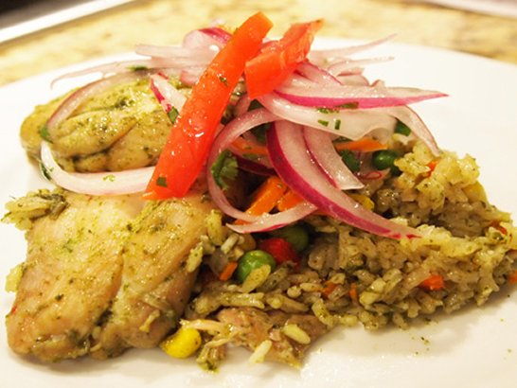
Ingredientes
- 1 1/2 taza de hojas de cilantro
- 4 hojas de espinaca
- 4 piernas y muslos de pollo, sin piel
- Sal y pimienta
- 1/4 taza de aceite vegetal
- 1 taza de cebolla picada fina
- 1 cucharada de ajo picado
- 1/2 taza de pasta de ají amarillo, si la deseas
- 1 taza de cerveza
- 2 tazas de caldo de pollo
- 1/4 taza de alverjitas (petit pois, chícharos)
- 1/4 taza de zanahoria cortada en cubitos
- 1/2 pimiento rojo, cortado en tiras finas
- 1 taza de maíz blanco
- 2 tazas de arroz de grano largo
Preparación
Para hacer la Salsa Criolla
- Cortar 1/2 cebolla roja en láminas muy delgadas a lo largo. Lavarla bien. Escurrirla.
- Mezclarla con 1/2 tomate cortado en tiras muy finas, hojas de cilantro, sal, pimienta, jugo de 1 limón y 1 cucharada de aceite de oliva.

Instrucciones
- En una licuadora, licuar cilantro junto con la espinaca y suficiente agua como para hacer una pasta homogénea (media taza, aproximadamente). Reservarla.

- Secar el pollo con papel toalla. Sazonarlo con sal y pimienta.

- En una olla, calentar el aceite a fuego medio. Freír el pollo hasta que esté dorado por ambos lados, unos 7 minutos. Retirarlo de la olla. Ponerlo en un plato.

- En la misma olla, freír la cebolla, ajo y la pasta de ají amarillo, revolviendo por 5 minutos.

- Incorporar el cilantro licuado. Freír por 3 minutos.

- Agregar la cerveza, caldo de pollo, y el pollo en la olla.

- Hervir todo. Taparla. Bajar el fuego.

- Cocinar por 20 minutos. Echar más sal y pimienta si es necesario.

- En otra olla, calentar 1 cucharada de aceite. Incorporar el arroz. Revolver todo bien.

- Agregar las alverjitas, zanahorias, pimiento, maíz, y 3 1/2 tazas de caldo que utilizaste para cocinar el pollo.

- Taparla. Bajar el fuego al mínimo.

- Dejar cocer por 20 a 25 minutos. Revolverlo con un tenedor.

Cuando el arroz esté a punto, servirlo en cuatro platos. Poner encima una pierna de pollo y Salsa Criolla al costado.

Paper cut outs for the recipe
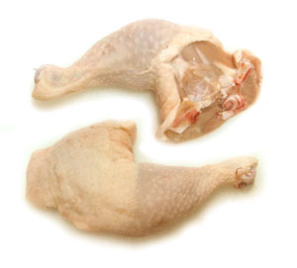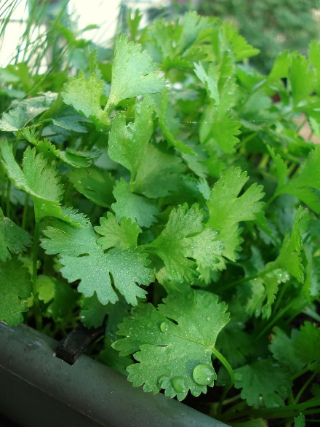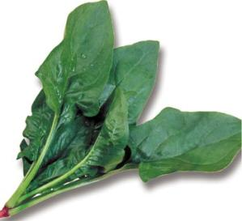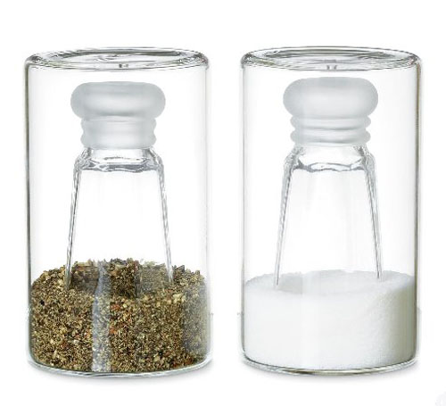
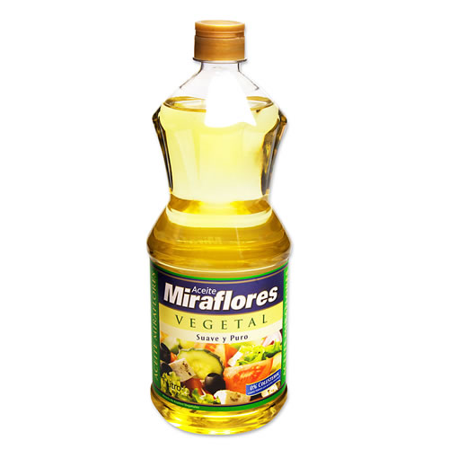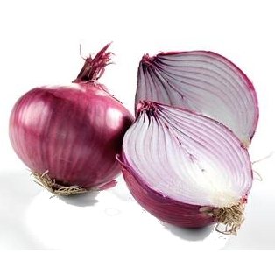
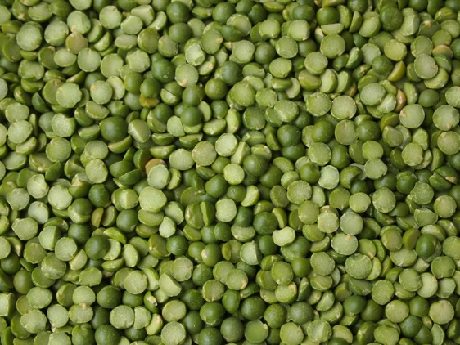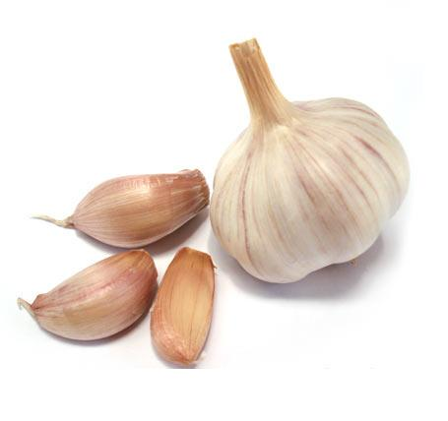
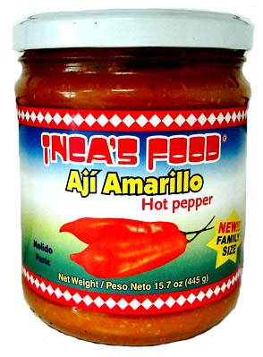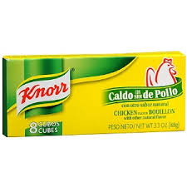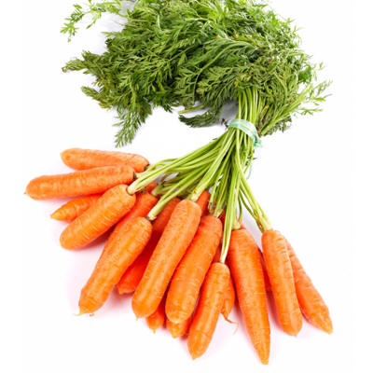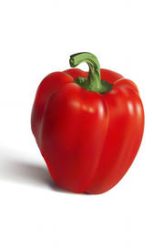
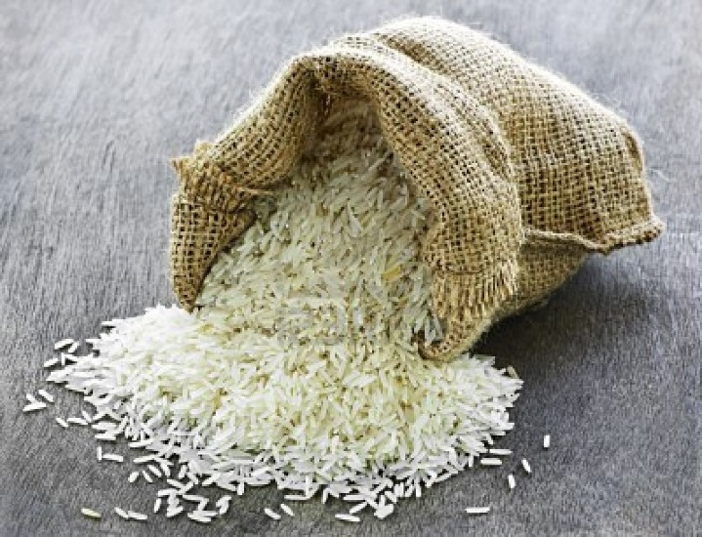
Additional reference
Skehan, P. (1998). Task-based instruction. Annual Review of Applied Linguistics, 18, 268-286.

