Supplementary Materials: Treatment description, activities and stimuli

Contents
- Description of L2-only treatment
- Description of L2+L1 treatment
- Examples of the task essential practice as presented during L2-only and L2+L1 treatments
- Examples of the task essential practice as presented during L2+L1 treatment
- Sample French stimuli sentences, used in the L2-only treatment
- Sample English stimuli sentences, used in the L2+L1 treatment

- Description of L2-only treatment

Sessions 1 and 2: Contrasting present and past uses of IMP in ongoing and habitual contexts

 | Session 1: Ongoingness (present vs past) | Session 2: Habituality (present vs past)
Pre-practice EI | [A six-second video clip of man eating an apple. The apple was never fully eaten.]  To describe this you could say:  Il mange une pomme  or  Il mangeait une pomme  The difference between these two is:  Il mange = ongoing action RIGHT NOW  Il mangeait = ongoing action IN THE PAST | [Four identical images of girl cycling at the gym with text chaque jeudi (‘every Thursday’) and circular arrows between each image, indicating repeated event.]  To describe this you could say:  Elle fait du vélo  or  Elle faisait du vélo  The difference between these two is:  Elle fait = regular action NOWADAYS  Ella faisait = regular action IN THE PAST
 | The ends of the verbs distinguish between an ongoing action in the present versus past e.g. [Four verbs presented in pairs, aurally and in writing]:  Présent RIGHT NOW Imparfait IN PAST  regarde [ʀəgaʀd] regardait [ʀəgaʀdɛ] | The ends of the verbs distinguish between a regularly repeated action in the present versus past e.g. [Four verbs presented in pairs, aurally and in writing]:  Présent RIGHT NOW Imparfait IN PAST  regarde [ʀəgaʀd] regardait [ʀəgaʀdɛ]
Practice | 96 (48 listening; 48 reading) items. Learners must identify whether an ongoing event is taking place “MAINTENANT” (right now) or “DANS LE PASSÉ” (in the past), e.g.:  Il…  - fait du shopping (‘is shopping’)  - parlait français (‘was speaking French’) | 96 (48 listening; 48 reading) items. Learners must identify whether a habitual event is taking place “MAINTENANT” (nowadays) and “DANS LE PASSÉ” (in the past), e.g.:  Il…  - adore la musique (‘loves music’)  - jouait au golf (‘played golf’)
EI given immediately after incorrect responses during practice  (k=number of feedback instances received per condition for each group) | After incorrectly responding ‘MAINTENANT’:  “NOTE: The IMPARFAIT expresses an ongoing event DANS LE PASSÉ, not an ongoing event taking place MAINTENANT”  k= 9 (L2+L1), k=5 (L2-only)  After incorrectly responding ‘DANS LE PASSÉ’:  “REMEMBER: The present tense in French expresses an ongoing event taking place MAINTENANT; not an ongoing action DANS LE PASSÉ”  k= 8 (L2+L1), k=10 (L2-only) | After incorrectly responding ‘MAINTENANT’:  “REMEMBER: the IMPARFAIT expresses a regular event DANS LE PASSÉ; not something done regularly MAINTENANT”  k= 23 (L2+L1), k=21 (L2-only)  After incorrectly responding ‘DANS LE PASSÉ’:  “The present tense in French expresses something done regularly MAINTENANT”.  k= 7 (L2+L1), k=9 (L2-only)

Sessions 3 and 4: Contrasting ongoing and habitual uses of IMP in past contexts only

 | Session 3: Habitual vs Ongoing (in past) | Session 4: Habitual vs. Ongoing vs. Complete (in past)
Pre-practice EI | [Same video and images from Sessions 1 and 2 for ongoingness and habituality].  IMP expresses both meanings and it is not possible to tell which meaning from the verb ending alone (illustrated with three forms, e.g. il jouait)  To distinguish between the Imparfait’s different meanings, you must pay attention to the other forms it is used with:  IMP + IMP = habitual meaning:  - Quand il conduisait au travail, il voyait son chef  ‘when he drove to work, he would see his boss’  IMP + PC = ongoing meaning:  - Quand il conduisait au travail, il a vu son chef  ‘when he was driving to work, he saw his boss’ “ | The ongoing/habitual meaning of IMP can be identified by paying attention to the other verb forms it occurs with:  IMP + IMP = habitual (see 5)  IMP + PC = ongoing (see 6)  These combinations contrast with the ‘complete and one off meaning’:  PC + PC  Quand il a conduit au travail, il a vu son chef  ‘when he drove to work, he saw his boss’
Practice  The same conjunction (quand ‘when’) used throughout.  Equal numbers of target IMP occurring in first or second clause in sentence. | 144 (72 listening; 72 reading) items. Learners must identify whether an event was ongoing/interrupted or habitual e.g.  Il…  - arrivait en retard quand il se levait à 8h  (‘arrived late when he used to get up at 8’)  - grimpait dans un arbre quand il a vu le chat  (‘was climbing a tree when he saw the cat’) | 216 (108 listening; 108 reading) items. Learners must identify whether an event was ongoing/interrupted or habitual or complete e.g.  Il…  - mangeait avec ses amis quand il travaillait tard la nuit  (‘ate with his friends when he used to work late at night’)  - a chanté une chanson quand elle a reçu un SMS  (‘sang a song when she received an SMS’)  - finissait son petit-déjeuner quand la cloche a sonné  (‘was finishing her breakfast when the bell rang’)
[In both sessions, a small image and infinitive verb indicated which verb the learners had to respond to]
EI given as feedback immediately after incorrect responses during practice (k=number of feedback instances received per condition) | After incorrectly responding ‘ongoing/interrupted':  “Look out for what the IMP occurs with. If it occurs with another IMP = REGULARLY REPEATED”  k=60 (L2+L1), k=63 (L2-only)  After incorrectly responding ‘habitual':  “Remember: when the IMPARFAIT occurs with a Passé Composé, IMP = ONGOING”  k=25 (L2+L1), k=28 (L2-only) |  | After incorrectly responding ‘ongoing/interrupted’:  “Remember that IMP + IMP = REGULARLY REPEATED“  k=111 (L2+L1), k=111 (L2-only)  After incorrectly responding ‘habitual’:  “NOTE: IMP + Passé Composé = ONGOING/INTERRUPTED“  k=71 (L2+L1), k=77 (L2-only)  After incorrectly responding ‘complete’: “ Passé Composé + Passé Composé = COMPLETE“  k=87 (L2+L1), k=93 (L2-only)

- Description of L2+L1 treatment

Sessions 1 and 2: Contrasting present and past uses of IMP in ongoing and habitual contexts

 | Session 1: Ongoingness (present vs past) | Session 2: Habituality (present vs past)
Pre-practice EI  Provided before the EI about the L2 | [Same video again as L2-only treatment]  “To describe this you could say:  He is eating an apple  Or  He was eating an apple  The difference between these two is:  ‘he is eating’ = ongoing action RIGHT NOW  ‘he was eating’ = ongoing action IN PAST” | [Same images again as L2-only treatment but with text ‘every Thursday’ in English.]  “To describe this you could say:  She cycles  Or  She used to cycle  The difference between these two is:  ‘she cycles’ = regular action NOWADAYS  ‘she used to cycle’ = regular action IN PAST  There are other ways to talk about regular activities IN PAST:  She used to cycle / would cycle / cycled  BUT NOTE  She used to cycle to the gym has 1 meaning:  regular activity  whereas…  ‘She cycled’ has 2 different meanings:  regular action or complete, one-off action”
 | “To identify ongoing meaning in the present versus the past, you need to focus on the auxiliary.  Look/listen out for ‘is’ or ‘was’ to indicate whether it is an ongoing action taking place RIGHT NOW (present) or it is one IN THE PAST.” | To identify regular activities in the present versus the past, you need to focus on the tense.  She goes = STILL CONTINUES  She used to go = IN THE PAST  She went = IN THE PAST  She used to cycle on Mondays  &  She cycled on Mondays  =>  Elle faisait du vélo le lundi
Practice  Randomly interspersed with the French items | 16 listening and 16 reading items. Learners must identify whether an ongoing event is “RIGHT NOW” or “IN THE PAST”, e.g.  He…  - is eating a sandwich  - was running to the shop | 16 listening and 16 reading items. Learners must identify whether a habitual event is “NOWADAYS” or “IN THE PAST”, e.g.  He…  - plays football  - cycled to work
EI given as feedback after incorrect responses during practice  (k= number of feedback instances received per condition for group) | After incorrectly responding ‘RIGHT NOW’:  “The present tense in English (‘is +ing’) and in French expresses the same thing: ongoing action taking place RIGHT NOW”  Total k=0  After incorrectly responding ‘IN THE PAST’: “The past tense in English (‘was +ing’) is the same as the IMP in French (-ait). They both express an ongoing action IN THE PAST“  Total k=5 | After incorrectly responding ‘NOWADAYS’:  “The English Simple Past (-ed) and ‘used to’ are just like the IMP.  Total k=2  After incorrectly responding ‘IN THE PAST’:  “The present tense in English and in French expresses the same thing. Both express something done regularly NOWADAYS. “  Total k=12

Sessions 3 and 4: Contrasting ongoing and habitual uses of IMP in past contexts only

 | Session 3: Habitual vs Ongoing (in past) | Session 4: Habitual vs. Ongoing vs. Complete (in past)
Pre-practice EI  Delivered before EI about the L2 | [Same video/ images from Sessions 1 & 2 to illustrate ongoingness and habituality.]  “In the past, English uses different tenses for each meaning, but French does not:  He was cycling = il faisait du vélo  He cycled/used to cycle = il faisait du vélo” | Summary of session 1-3: expressing ongoing and habitual action in (a) English, (b) French, and (c) differences between English and French  Elle arrivait = ‘was arriving’ & ‘arrived/used to arrive’  Elle lisait = ‘was reading’ & ‘read/used to read’
Practice  Randomly interspersed with French items  No EI given as feedback, only ‘correct’ or ‘incorrect’ was provided | 24 listening and 24 reading items. Learners must identify whether an event was ongoing/interrupted or habitual e.g.,  She…  - was leaving the house when the postman arrived  - drank a cup of coffee when he woke up early | 24 listening and 24 reading items. Learners must identify whether an event was ongoing/interrupted or habitual or complete/one-off.  She…  - was driving to work when his phone rang  - ate an apple when he used to go to school  - sang a song when her phone rang

- Examples of French task-essential practice in the L2-only and L2+L1 treatments (4 out of 552 exemplars)

The infinitive verb in brackets and the image indicate which verb participants should judge (by pressing either R or O). Similar items are juxtaposed for illustration purposes only – the participants experienced them interspersed with other items.

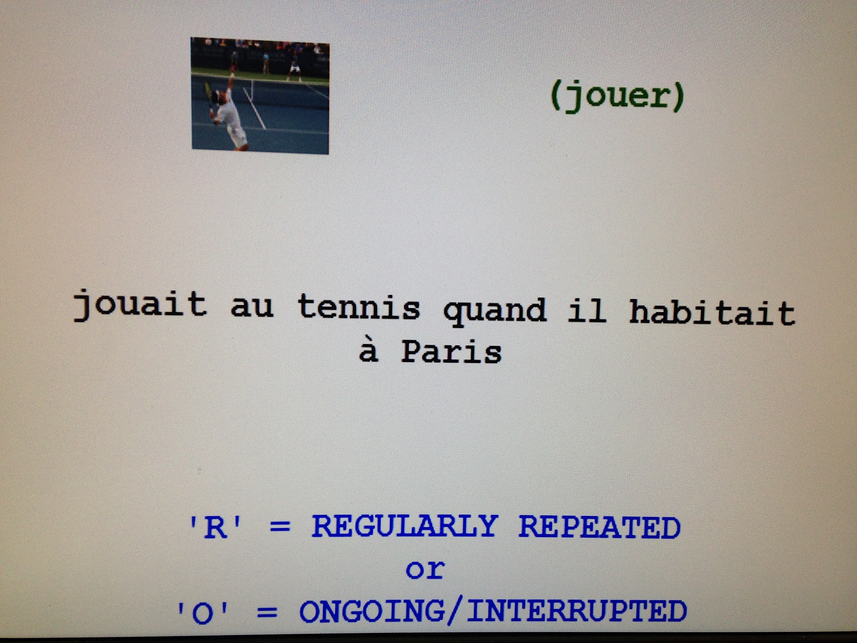 | 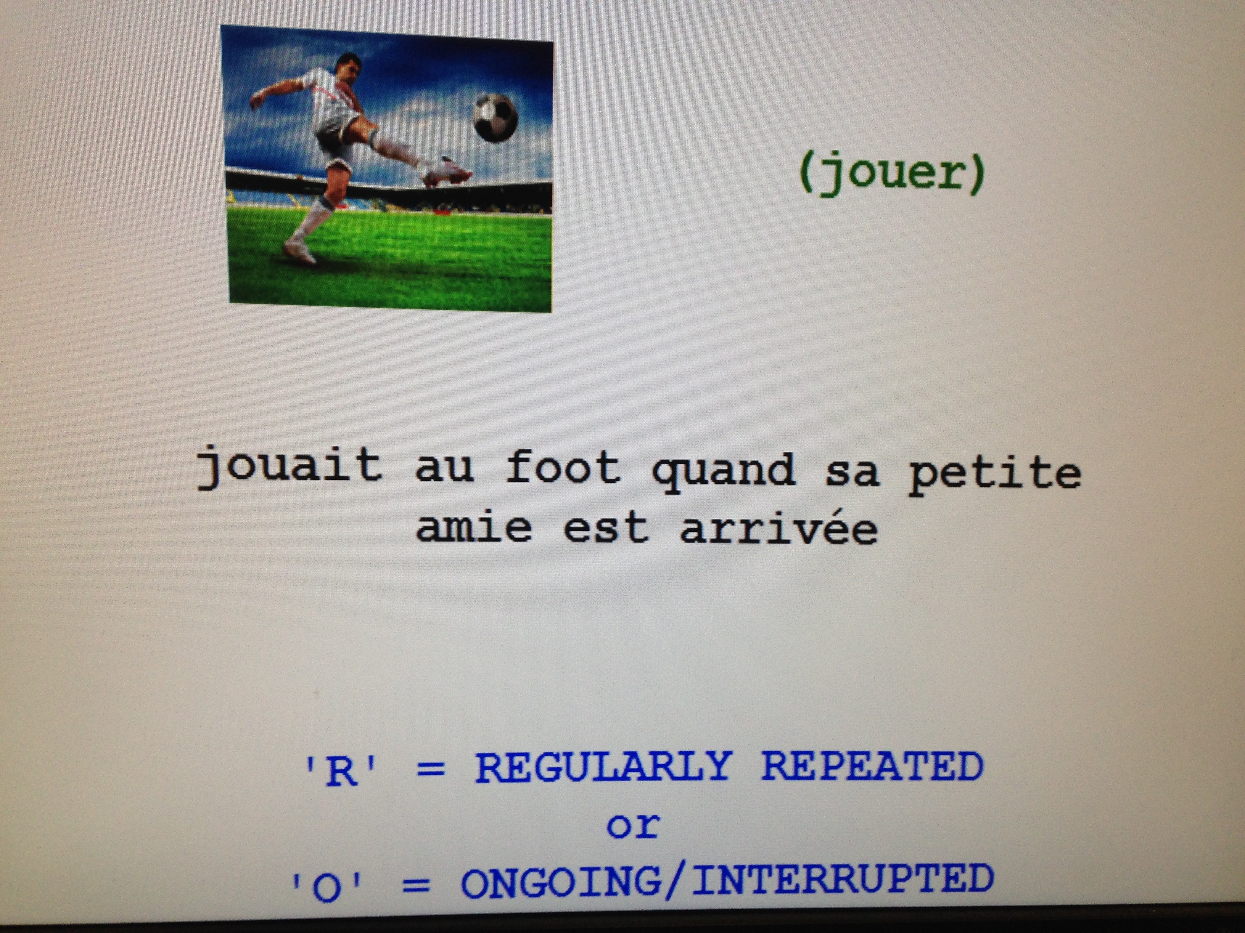
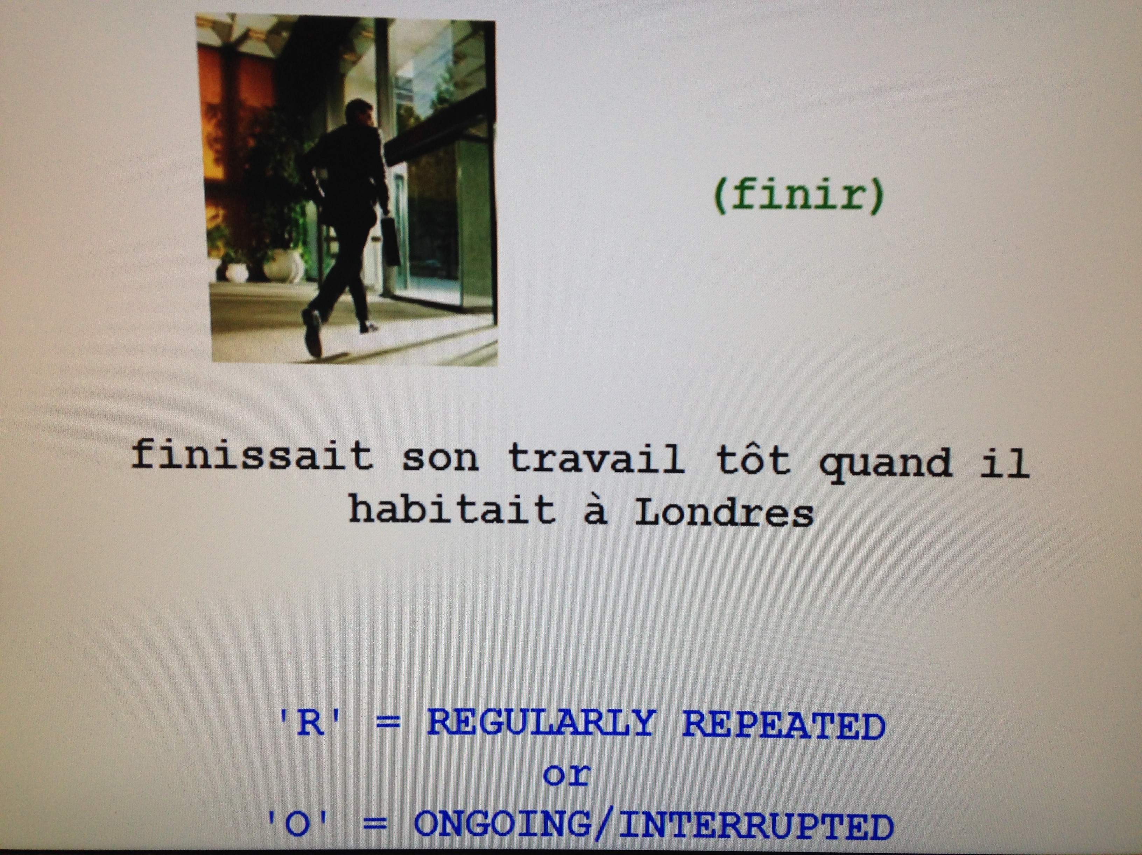 | 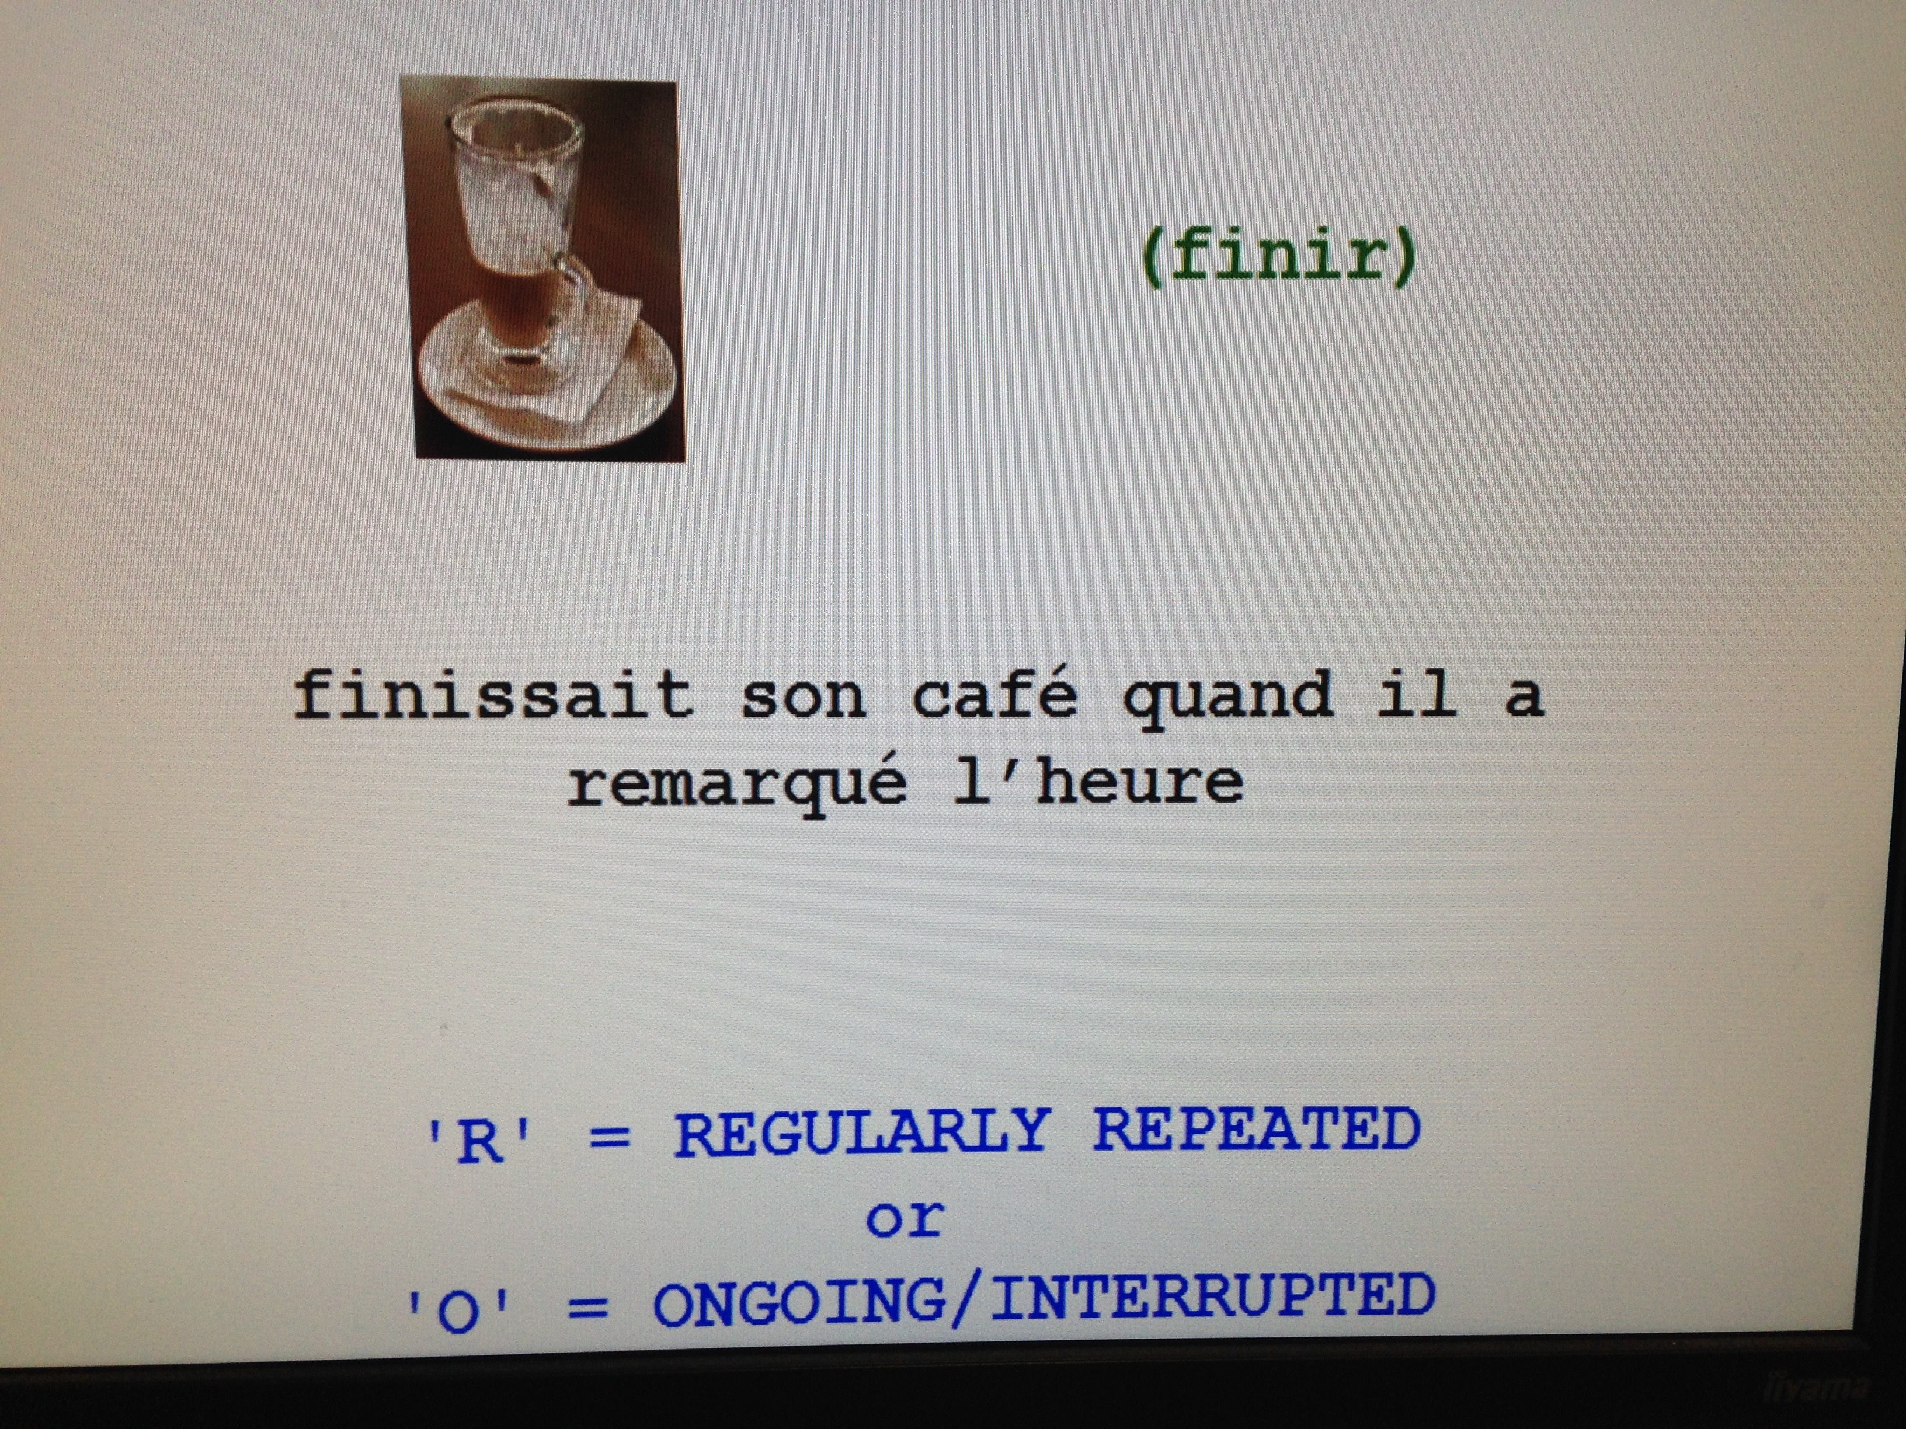

- Examples of English task-essential practice in the L2+L1 treatment (2 out of 160 exemplars)

The infinitive verb in brackets and the image indicate which verb participants should judge (by pressing either R or P). Similar items are juxtaposed for illustration purposes only – the participants experienced them interspersed with other items.

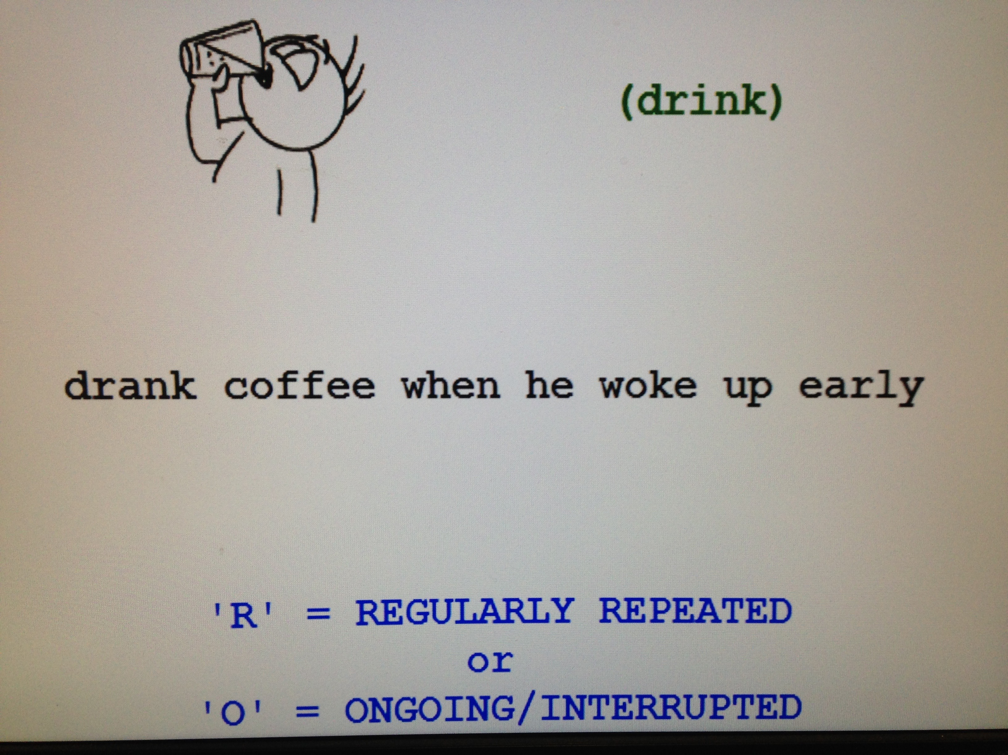 | 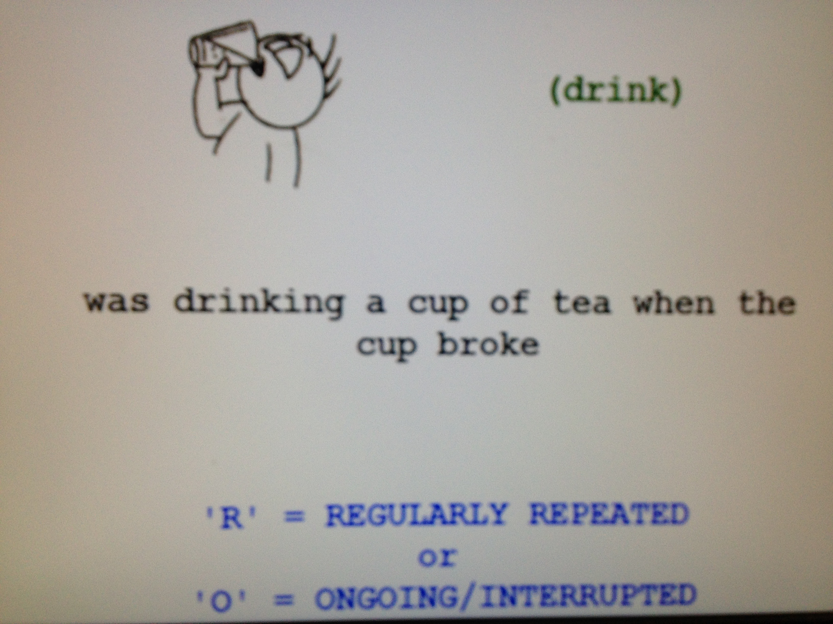

- Sample French stimuli sentences, used in the L2-only treatment

Session 1. Ongoing: Participants had to choose between past vs. present. (16 out of 96 exemplars)

Condition | Statives | Activities | Accomplishments | Achievements
 | Elle… | Elle… | Elle… | Elle…
Past  (IMP) | habitait tout seul  ‘was living alone’ | fumait des cigares  ‘was smoking cigars’ | écrivait une lettre  ‘was writing a letter’ | finissait ses devoirs  ‘was finishing her homework’
Past  (IMP) | savait la réponse  ‘was knowing the answer’ | lisait des journaux  ‘was reading the papers’ | mangeait une pomme  ‘was eating an apple ‘ | sonnait à la porte  ‘was ringing at the door’
Present  (PRES) | parle français  ‘is speaking French’ | nage dans la piscine  ‘is swimming in the pool’ | chante une chanson  ‘is singing a song’ | frappe son ami  ‘is hitting her friend’
Present  (PRES) | déteste les fleurs  ‘is hating the flowers’ | conduit une voiture rouge  ‘is driving a red car’ | lit un roman  ‘is reading a book’ | sort avec sa copine’  ‘is going out with his friend’
Note. IMP=Imparfait, PRES= Présent

Session 2. Habitual: Participants had to choose between past vs. present. (16 out of 96 exemplars)

Condition | Statives | Activities | Accomplishments | Achievements
 | Il… | Il… | Il… | Il…
Past  (IMP) | portait une cravate  ‘wore/used to wear a tie’ | conduisait avec la famille  ‘drove/used to drive with his family’ | regardait un film  ‘watched/used to watch a film’ | perdait sa montre  ‘lost/used to lose his watch’
Past  (IMP) | croyait en dieu  ‘believed/used to believe in god’ | mangeait aux restaurants  ‘ate/used to eat at restaurants’ | marchait vers la poste  ‘walked/used to walk to the post office’ | gagnait 200 Euro  ‘won/used to win 200 Euros’
Present  (IMP) | adore la musique française  ‘loves French music’ | boit du café  ‘drink coffee’ | joue un match de foot  ‘plays a game of football’ | trouve sa voiture  ‘finds his car’
Present  (IMP) | connait peu de gens  ‘knows a few people’ | court dans la rue  ‘runs in the street’ | grimpe dans un arbre  ‘climbs a tree’ | arrive en retard  ‘arrives late’
Note. IMP=Imparfait, PRES= Présent

Session 3. Past: Participants had to choose between ongoing vs. habitual (‘regularly repeated’). (16 out of 144 exemplars). N.B. Words are underlined for illustrative purposes only to indicate which verb the participants had to respond to.

Condition | Statives | Activities | Accomplishments | Achievements
 | Elle… | Elle… | Elle… | Elle…
Ongoing  (IMP +PC) | aimait les fleurs quand son enfant a commencé à pleurer  ‘was liking the flowers when her child began to cry’ | mangeait un sandwich quand la cloche a sonné  ‘was eating a sandwich when the bell rang’ | lisait le journal quand son chef a sonné à la porte  ‘was reading the paper when her boss rang the doorbell’ | quittait la maison quand son ami l’a appelé  ‘was leaving the house when her friend called’
Ongoing  (IMP +PC) | détestait le temps quand le soleil a commencé à briller  ‘was hating the weather when the sun started to shine’ | jouait au foot quand sa mère est arrivée  ‘was playing football when her mother arrived’ | allait à Paris quand elle a vu son ami  ‘was going to Paris when she saw her friend’ | arrivait à la gare quand le train est parti  ‘was arriving at the station when the train departed’
Habitual  (IMP +IMP) | savait manger sainement quand elle allait à la gym  ‘knew/used to know how to eat healthily when she went to the gym’ | conduisait avec la famille quand elle habitait avec son mari  ‘drove/used to drive with the family when she lived with her husband’ | jouait un match de tennis quand il allait à la gym  ‘played/used to a game of tennis when she went to the gym’ | remarquait les touristes quand elle habitait à Paris  ‘noticed/used to notice the tourists when she lived in Paris’
Habitual  (IMP +IMP) | habitait aux Etats-Unis quand il son père travaillait à Washington  ‘lived/used to live in America when her father worked in Washington’. | fumait à l’extérieur quand elle rendait visite à ses amis  ‘smoked/used to smoke outside when she visited her friends’. | grimpait dans arbre quand elle cherchait pour le chat  ‘climbed/used to climb the tree when she looked for the cat’ | finissait son travail tôt quand il habitait à Londres  ‘finished/used to finish her work early when she lived in Paris’
Note. IMP=Imparfait, PC= Passé Composé

Session 4. Past: Participants had to choose between ongoing vs. habitual (regularly repeated) vs. complete. (24 out of 216 exemplars). N.B. Words are underlined for illustrative purposes only to indicate which verb the participants had to respond to. Only main->subordinate ordering illustrated here.

Condition | Statives | Activities | Accomplishments | Achievements
 | Il… | Il… | Il… | Il…
Ongoing  (IMP + PC) | adorait son nouvel album quand il est allé au travail  ‘was loving his new album when he went to work’ | fumait des cigares quand sa femme est arrivée  ‘was smoking cigars when his wife arrived’ | mangeait deux pommes quand le professeur est arrivé  ‘was eating two apples when the teacher arrived’ | finissait son petit-déjeuner quand la cloche a sonné  ‘was finishing his breakfast when the bell rang’
Ongoing  (IMP + PC) | préférait sa baguette quand il a vu la déjeuner d’un ami  ‘was preferring his baguette when he saw his friends lunch’ | parlait anglais quand il vu sa petite amie  ‘was speaking English when he saw his friend’ | regardait un match de foot quand il a reçu un SMS  ‘was watching un football match when he received a text message’ | sortait de la maison quand il a commencé à pleuvoir  ‘was leaving the house when it started to rain’
Habitual  (IMP + IMP) | portait une cravate quand il allait à l'école  ‘wore/used to wear a tie when he went to school’ | rigolait dans le bar quand il buvait avec ses amis  ‘laughed/used to laugh in the bar when he drank with his friends’ | nageait deux mètres quand il habitait près de la mer  ‘swam/used to swim two metres when he lived by the sea’ | trouvait ses clés quand il passait le weekend chez lui  ‘found/used to find his keys when he spent the weekend at his place’
Habitual  (IMP + IMP) | croyait en dieu quand il étudiait à l’université  ‘believed/used to believe in god when he studied at university’ | conduisait sa voiture quand il travaillait à Londres  ‘drove/used to drive his car when he lived in London’ | buvait une bière quand il sortait avec sa femme  ‘drank/used to drink a beer when he went out with his wife’ | frappait à la porte quand il perdait ses clés  ‘knocked/used to knock at the door when he lost his keys
Complete  (PC + PC) | a habité aux Etats-Unis quand il est arrivé en Europe  ‘lived in America when he arrived in Europe’ | a mangé son repas quand sa femme est arrivée  ‘ate his meal when his wife arrived’ | a lu un livre quand sa femme a commencé à jouer au piano  ‘read a book when his wife started to play the piano’ | est sorti de la maison quand il a commencé à pleuvoir  ‘left the house when it started to rain’
Complete  (PC + PC) | a détesté ses chausseurs quand il a commencé à pleuvoir  ‘hated his shoes when it started to rain’ | a couru dans le parc quand il a pris le bus  ‘ran in the park when he took the bus’ | a chanté une chanson quand il a envoyé un SMS  ‘sang a song when he sent a text message’ | a atteint ses objectifs quand il est allé en vacances  ‘achieved his objectives when he went on holiday’
Note. IMP=Imparfait, PC= Passé Composé

- Sample English stimuli sentences, used in the L2+L1 treatment

Session 1. Ongoing: Participants had to choose between past vs. present. (8 out of 32 exemplars)

Condition | Statives | Activities | Accomplishments | Achievements
 | She… | She… | She… | She…
Past  (Past Progressive | was hating all the noise | was playing cards | was eating a sandwich | was ringing his friend
Present  (Present Progressive) | is enjoying the weather | is listening to the music | is walking to the stage | is finishing his drink

Session 2. Habitual: Participants had to choose between past vs. present. (8 out of 32 exemplars)

Condition | Statives | Activities | Accomplishments | Achievements
 | He… | He… | He… | He…
Past  (Past Simple) | liked the weather | did the washing up | ran to the park | found his watch
Present  (Present Simple) | adores his boat | reads in the park | drinks a glass of wine | hits the wall

Session 3. Past: Participants had to choose between ongoing vs. habitual. (8 out of 48 exemplars). N.B. Words are underlined for illustrative purposes only to indicate which verb the participants had to respond to. Only main->subordinate ordering illustrated here.

Condition | Statives | Activities | Accomplishments | Achievements
 | She… | She… | She… | She…
Ongoing  (Past Progressive) | was listening to music when her phone rang | was smoking when the bus arrived | was drinking a cup of tea when the cup broke | was knocking at the door when her phone rang
Habitual  (Past Simple) | enjoyed the weekends when she didn’t work | spoke French when she had a French boyfriend | read the newspaper when she had the time | arrived on time when she lived closer to work

Session 4. Past: Participants had to choose between ongoing vs. habitual vs. complete. (12 out of 48 exemplars). N.B. Words are underlined for illustrative purposes only to indicate which verb the participants had to respond to.

Condition | Statives | Activities | Accomplishments | Achievements
 | He… | He… | He… | He…
Ongoing  (Past Progressive) | was hating the soup when the waiter arrived | was reading when the baby started to cry | was playing a game of football when he fell | was arriving home when his phone rang
Habitual  (Past Simple) | liked museums when he used to go on holiday with his dad | listened to music when he used to lived alone | ate an apple when he used to make his own lunch | left the house when the the postman used to knock
Complete  (Past Simple) | knew the answer when the teacher started to ask questions | cycled to work when it started to rain | wrote a few sentences when the pen broke | finished the race when his wife called

For the co-ordinating clause in the habitual stimuli (as in 2), we used ‘would’ and ‘used to’ in equal proportions (e.g. ‘ate an apple when he used to go to school/he would go to school’).
Answering either ‘habitual’ or ‘complete’ in this activity was accepted for such stimuli.

