Supplementary Materials

S1. Participant Information

Table S1.1
Participant information and scores on independent measures according to location (US v. UK) and exposure condition (Incidental v. Instructed).
 |  | Incidental |  |  | Instructed
 | Score range or unit | US | UK | Combined | US | UK | Combined
Participants |  | 12 | 13 | 25 | 11 | 14 | 25
Male |  | 5 | 1 | 6 | 2 | 3 | 5
Female |  | 7 | 12 | 19 | 9 | 11 | 20
Age Mean |  | 19.00 | 19.54 |  | 18.55 | 19.93
SD |  | 1.05 | 1.13 |  | 1.04 | 1.54
RSpan Mean | 0-42 | 18.91 | 22.62 |  | 21.09 | 24.85
SD |  | 7.37 | 8.64 |  | 8.04 | 8.74
ASRT Mean | 0-18 | 12.50 | -- | -- | 12.80 | -- | --
SD |  | 3.24 | -- | -- | 2.53 | -- | --
SRT Mean | ms | -- | 550 | -- | -- | 240 | --
SD |  | -- | 430 | -- | -- | 251 | --

Statistical analyses for each variable
Gender. A three-way loglinear analysis with location (UK vs. US), condition (incidental vs. instructed), and sex (male v. female) was conducted to determine whether these variables were evenly distributed. The likelihood ratio of this model was χ² (6) = 4.76, p = .575. The highest-order interaction (location X condition X sex) was not significant, χ² (1) = 2.50, p = .114, nor were any two-way interactions (all ps > .19). There was a significant effect of sex, χ² (1) = 16.62, p < .001, in which more females participated than males. In sum, participants were evenly distributed across incidental and instructed conditions in the US and the UK. Overall, there were more female than male participants, but there was no significant difference between the proportions of males and females in each bin (i.e., UK-incidental, UK-instructed, US-incidental, US-instructed).
Age. A 2x2 ANOVA with Condition x Location as factors revealed no main effect of condition, F < 1, and no group X condition interaction, F(1, 44) = 1.383, p = .246. There was a main effect of location, F(1, 44) = 7.160, p = .01. The participants in the UK were on average one year older than the participants in the US, and this difference was significant. However, at this age, the difference of one year should not make a difference in performance on the tasks in this study.
Readings Span. A 2x2 ANOVA with Condition x Location as factors revealed no significant main effects or interactions.
Main effect of Condition: F < 1
Main effect of Location: F(1, 44) = 2.413, p = .126
Condition X Location Interaction: F < 1

(A)SRT. An independent samples t-test revealed no differences between conditions, t < 1.
SRT. An independent samples t-test revealed significant differences between conditions, t(24) = 2.248, p = .034. However, tests of skewness and kurtosis for each group and variance between groups (Levene’s Test of Equality of Variance) are all nonsignificant (p > .05), which demonstrate that the scores are normally distributed and have similar variance between groups, so correlational analyses can be conducted.

Based on the above analyses, we judged that it was appropriate to collapse participants from the US and UK, within their respective conditions. Additionally, there were no differences between conditions that should influence their performance on the GJT, independent of the variable that we manipulated, which was type of exposure.

Language Background
All participants were native speakers of English, but their additional language experience was quite varied. Two participants reported additional second languages, Russian and Mandarin. All but three participants had studied at least one second language (range = 0-4, mean = 1.41, SD = 0.85). Second languages spoken by the participants included French (n = 31), Spanish (n = 19), Mandarin (n = 9), Arabic (n = 3), Japanese (n = 2), Italian (n = 2), Welsh (n = 2), and Latin (n = 2).

S.2 Definitions for Source Attributions
Participants were asked to select the guess category when they believed the judgment to be based on a guess, i.e. they might as well have flipped a coin. If they were somewhat confident in their decision but did not know why it was right, they were supposed to select the intuition category. The memory category was designated for judgments based on the conscious recollection of entire sentences (or parts of sentences) from the training phase. Finally, participants were asked to select the rule category if the judgment was based on a rule that was acquired during the training phase and that they would be able to verbalize at the end of the experiment. All participants were provided with these definitions before starting the testing phase.

S3. Subjective measures of awareness

Table S3.1
Accuracy and proportions (%) across source attributions for all sentence types
 |  | Guess | Intuition | Memory | Rule
Incidental
Accuracy | Mean | 49.1 | 56.8* | 50.9 | 50.7
 | SD | 29.2 | 13.9 | 34.7 | 21.1
Proportion |  | 12.5 | 41.5 | 15.5 | 30.5
Instructed
Accuracy | Mean | 50.0 | 53.6 | 55.9 | 68.8***
 | SD | 32.3 | 19.9 | 30.8 | 26.9
Proportion |  | 6.1 | 26.3 | 24.2 | 43.5
Significance from chance: * p < .05, *** p < .005, **** p < .001

Table S3.2
Accuracy and proportions (%) across source attributions by complexity
 |  | Guess | Intuition | Memory | Rule
Incidental
Simple 1
Accuracy | Mean | 19.0 | 80.6 | 53.9 | 47.2
 | SD | 18.8 | 17.3 | 50.4 | 41.1
Proportion |  | 10.8 | 39.2 | 13.8 | 36.2
Complex 1
Accuracy | Mean | 23.0 | 50.0 | 63.0 | 52.6
 | SD | 22.3 | 16.7 | 37.5 | 19.4
Proportion |  | 10.6 | 38.2 | 19.0 | 32.2
Complex 2
Accuracy | Mean | 42.0 | 90.5* | 67.0 | 42.9
 | SD | 36.7 | 16.5 | 57.7 | 51.5
Proportion |  | 16.0 | 47.2 | 13.8 | 23.0
Instructed
Simple 1
Accuracy | Mean | 50.0 | 66.7* | 87.5 | 100****
 | SD | 7.1 | 0.0 | 17.7 | 0
Proportion |  | 7.0 | 24.4 | 23.4 | 45.2
Complex 1
Accuracy | Mean | 25.0 | 26.8 | 55.0 | 54.2*
 | SD | 35.4 | 2.5 | 7.1 | 5.9
Proportion |  | 5.6 | 26.5 | 26.0 | 41.9
Complex 2
Accuracy | Mean | 17.0 | 60.0 | 90.0*** | 90.0⁺
 | SD | 23.6 | 56.6 | 14.1 | 14.1
Proportion |  | 5.6 | 28.0 | 23.0 | 43.4
Significance from chance: ⁺ p < .1, * p < .05, *** p < .005, **** p < .001

Mixed-effects repeated measures ANOVA to determine the effect of condition, sentence group, and source attribution on accuracy:
Main effects:
No main effect of Sentence Group: F(2, 6) = 2.064, p = .208, partial η² = .408, observed power = .276.
Main effect of SA: F(3, 9) = 7.674, p = .008, partial η² = .719, observed power = .910.
No main effect of Condition: F < 1

Interactions:
No Sentence Group X Condition interaction: F(2, 6) = 1.182, p = .369, partial η² = .283, observed power = .175.
No Sentence Group X SA interaction: F < 1
Trending SA X Condition interaction: F(3, 9) = 3.273, p = .073, partial η² = .522, observed power = .548. (large effect size/power)
No 3-way interaction: F < 1

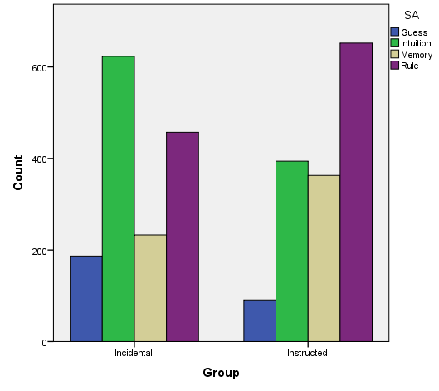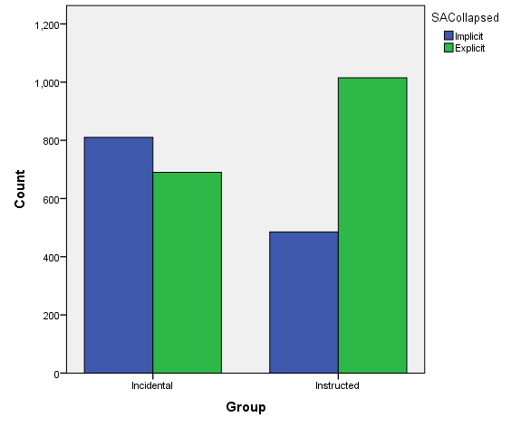
b
a
Figure S3.1. (a) Distribution of all source attributions across the two exposure conditions and (b) distribution of source attributions collapsed into implicit (guess and intuition) and explicit (memory and rule) categories.

Table S3.3
Accuracy and proportions (%) across confidence ratings over all sentence groups
 |  | Not at all confident | Somewhat confident | Quite Confident | Extremely Confident
Incidental
Accuracy | Mean | 54.2 | 54.1⁺ | 57.8* | 52.3
 | SD | 31.8 | 11.2 | 15.3 | 24.7
Proportion |  | 6.5 | 40.9 | 37.9 | 14.7
Instructed
Accuracy | Mean | 49.4 | 54.8 | 66.3**** | 70.7****
 | SD | 37.5 | 21.9 | 21.2 | 25.6
Proportion |  | 4.5 | 26.7 | 39.0 | 29.9
Significance from chance: ⁺ p < .1, * p < .05, *** p < .005, **** p < .001

Mixed-effects repeated measures ANOVA to determine the effect of condition and confidence rating on overall accuracy:
No main effect of CJ on Accuracy: F(3, 84) = 1.152, p = .333
No main effect of Group on Accuracy: F(1, 28) = 1.626, p = .213
No CJ X Group interaction: F(3, 84) = 1.578, p = .201

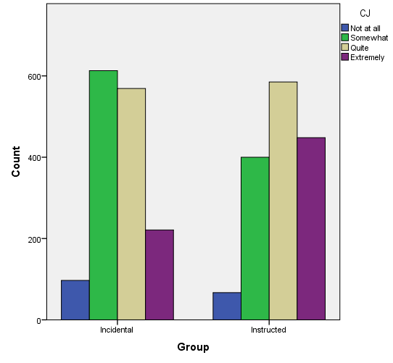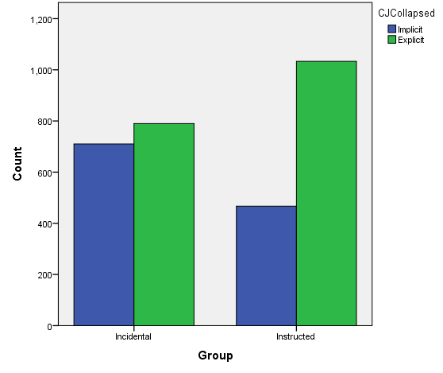
a
b
Figure S3.2. (a) Distribution of all confidence ratings across the two exposure conditions and (b) distribution of confidence ratings collapsed into implicit (guess and intuition) and explicit (memory and rule) categories.

Table S3.4
Accuracy and proportions (%) across confidence ratings by complexity
 |  |  | Not at all confident |  | Somewhat confident |  | Quite Confident |  | Extremely Confident
Incidental
Simple 1
Accuracy | Mean | 42.0 |  | 43.2 |  | 69.7**** |  | 70.4
 | SD | 41.9 |  | 17.0 |  | 14.0 |  | 27.1
Proportion |  | 6.8 |  | 35.4 |  | 37.6 |  | 20.2
Complex 1
Accuracy | Mean | 50.0 |  | 73.7 |  | 55.8 |  | 75.0
 | SD | 40.1 |  | 23.9 |  | 23.3 |  | 50.0
Proportion |  | 4.8 |  | 40.0 |  | 41.0 |  | 14.2
Complex 2
Accuracy | Mean | 13.0 |  | 63.8⁺ |  | 61.7⁺ |  | 62.5
 | SD | 25.0 |  | 29.2 |  | 37.6 |  | 47.9
Proportion |  | 7.8 |  | 47.2 |  | 35.2 |  | 9.8
Instructed
Simple 1
Accuracy | Mean | 33.0 |  | 68.5* |  | 87.5**** |  | 97.0****
 | SD | 28.9 |  | 27.4 |  | 21.7 |  | 5.2
Proportion |  | 4.4 |  | 25.2 |  | 37.8 |  | 32.6
Complex 1
Accuracy | Mean | 19.0 |  | 62.5 |  | 50.0⁺ |  | 72.2*
 | SD | 33.0 |  | 23.2 |  | 22.0 |  | 19.2
Proportion |  | 6.2 |  | 26.5 |  | 43.0 |  | 24.3
Complex 2
Accuracy | Mean | 11.0 |  | 49.8 |  | 66.7* |  | 48.9⁺
 | SD | 19.2 |  | 14.6 |  | 33.3 |  | 42.9
Proportion |  | 2.6 |  | 28.4 |  | 35.7 |  | 33.3
Significance from chance: ⁺ p < .1, * p < .05, *** p < .005, **** p < .001

Mixed-effects repeated measures ANOVA to determine the effect of condition, sentence group, and confidence rating on accuracy:
Main effects:
No main effect of Sentence Group: F(2, 10) = 1.843, p = .208, partial η² = .269, observed power = .296.
Main effect of CJ: F(3, 15) = 9.415, p = .001, partial η² = .653, observed power = .983.
No main effect of Condition: F

Interactions:
No Sentence Group X Condition interaction: F(2, 10) = 1.395, p = .292, partial η² = .218, observed power = .233.
No CJ X Condition interaction: F < 1
No Sentence Group X CJ interaction: F < 1
No 3-way interaction: F < 1

S4. Correlations between GTJ and ID measures

Table S4.1
Average scores and standard deviations for each condition on the RSpan and SRT, and significance of independent samples t-tests comparing the conditions.
 | RSpan | SRT | ASRT | SRTz
Incidental Mean  SD  Range | 20.92  8.13  7-35 | 550  430  -260-1440 | 12.50  3.24  7-18 | 0.21  1.13  -1.99-2.76
Instructed Mean  SD  Range | 23.13  8.47  10-39 | 239  251  -220-640 | 12.80  2.52  8-16 | -.20  .77  -1.64-1.18
p | .361 | .034 | .820 | .156
Note. Scores for each task were computed as follows: RSpan = total number of items in correctly recalled sets, maximum of 42; SRT = reaction time in milliseconds in the random block minus in the last sequence block; ASRT = total number of blocks in which reaction time for sequence trials was less than reaction time for random trials, maximum of 18; SRTz = z-scores of SRT and ASRT

Table S4.2
Correlations between d’ scores on the GJT (overall, and for Simple, Complex 1, and Complex 2 sentence groups) and individual difference measures (RSpan, SRTz).
 | Simple | Complex 1 | Complex 2 | RSpan | SRTz
Both Groups
All | .752**** | .744**** | .710**** | .192 | -.348*
Simple |  | .488**** | .277⁺ | .085 | -.242
Complex 1 |  |  | .256⁺ | .224 | -.173
Complex 2 |  |  |  | .190 | -.337*
RSpan |  |  |  |  | -.307*
Incidental
All | .635**** | .411* | .723**** | .176 | -.586**
Simple |  | .037 | .179 | -.061 | -.244
Complex 1 |  |  | .019 | -.062 | -.205
Complex 2 |  |  |  | .431* | -.543**
RSpan |  |  |  |  | -.501*
Instructed
All | .757**** | .804**** | .710**** | .152 | -.154
Simple |  | .606**** | .242 | .113 | -.120
Complex 1 |  |  | .298 | .346⁺ | -.061
Complex 2 |  |  |  | -.035 | -.076
RSpan |  |  |  |  | -.051
Note: ⁺ p < .1, * p < .05, ** p < .01, *** p < .005, **** p < .001, uncorrected
Bonferroni corrected α = .003 for each group.

S5. Regression analysis

Table S5.1
Regression models examining learning condition, working memory, procedural learning, and performance on the GJT for Simple, Complex 1, and Complex 2 sentences.
 | Simple |  |  |  | Complex 1 |  |  |  | Complex 2
Variable | B | SEB | β |  | B | SEB | β |  | B | SEB | β
Step 1
Constant | .345 | .162 |  |  | .017 | .154 |  |  | .321 | .185
Learning Condition | .607 | .226 | .378* |  | .468 | .216 | .314* |  | .352 | .259 | .203
R² |  | .143 |  |  |  | .099 |  |  |  | .041
F(43) |  | 7.184* |  |  |  | 4.718* |  |  |  | 1.852^{ns}
Step 2
Constant | .516 | .361 |  |  | -.349 | .340 |  |  | .274 | .396
Learning Condition | .564 | .232 | .351* |  | .426 | .219 | .286⁺ |  | .249 | .255 | .144
Procedural Learning | -.141 | .128 | -.167 |  | -.039 | .121 | -.049 |  | -.285 | .141 | -.311*
Working Memory | -.003 | .015 | -.030 |  | .017 | .014 | .190 |  | .004 | .016 | .037
R² |  | .168 |  |  |  | .142 |  |  |  | .143
F(42) |  | 2.763⁺ |  |  |  | 2.267⁺ |  |  |  | 3.464*
Note: ⁺ p < .1, * p < .05

