Supplementary material A1

Trevan Flynn¹*, Jiri Tuma^{2,3}, Tom M. Fayle^{4,2}, Hana Veselá⁵ Jan Frouz^{1,5}
¹Biology Centre of the Czech Academy of Sciences, SoWa Research Infrastructure, Na Sádkach 7, 370 05 České Budějovice, Czech Republic

²Biology Centre of the Czech Academy of Sciences, Institute of Entomology, Branišovská 1160/31, 370 05, České Budějovice, Czech Republic
³Biology Centre of the Czech Academy of Sciences, Institute of Soil Biology, Na Sádkach 7, 370 05, České Budějovice, Czech Republic

⁴School of Biological and Behavioural Sciences, Queen Mary University of London, London, UK

⁵Institute for Environmental studies, Charles University, Benátská 2, 12800 Prague, Czech Republic

⁴Institute for Tropical Biology and Conservation, Universiti Malaysia Sabah, 88400, Kota Kinabalu, Sabah, Malaysia

*Corresponding author’s email: trevanflynn@gmail.com

Summary of theoretical variograms

Summary
Description and mathematical formula for the theoretical variograms tested. Theoretical models are curves modelled from sample variograms (point pairs of observations). For a more in depth look into variogram models please refer to Webster & Oliver (2001).

Symbology
$γ\left(h\right)=$ semivariance at distance $h$
$α$ = range or distance where there is no more spatial dependency
$C=$the semivariance at or above the range

Spherical variogram (Sph)
The spherical model has a clear range where there is no more spatial autocorrelation. At this distance (α) the observations are no longer correlated in space and the variables greater than this range are independent. The sill (C) is the value of the semi variance at or larger than the range. The formula is:
$$γ\left(h\right)=C\left(\frac{3h}{2α}-\frac{h^{3}}{{2α}^{3}}\right) if h< α$$
$$γ\left(h\right)=C, if h≥α$$
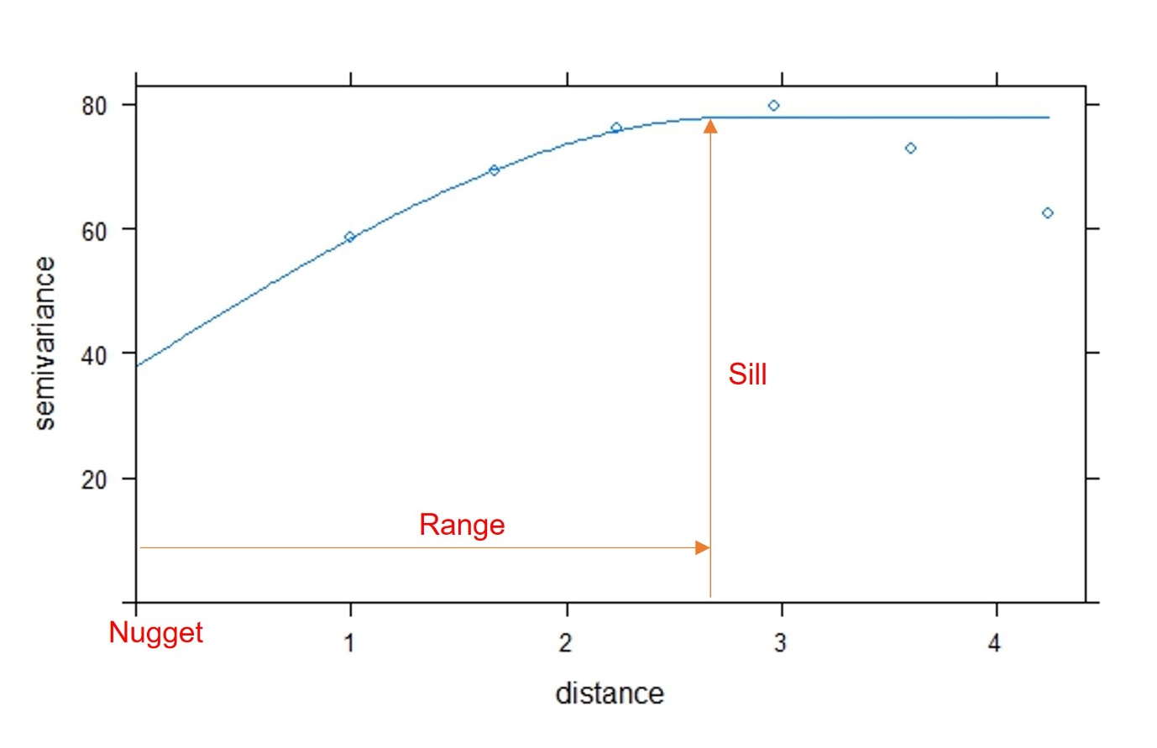
Figure 1: Spherical variogram where the nugget = 38.0, sill = 79.0 and range = 2.80 m.

Exponential variogram (Exp)
The exponential model is similar to the spherical model with a linear increase near the nugget, however, there is no finite range which the sill reaches the limit and are considered still correlated. Therefore, there is an effective range that is defined as 3α that is more or less independent.
$$γ\left(h\right)=C\left(1-e^{-\frac{h}{α}}\right) where C≥0$$
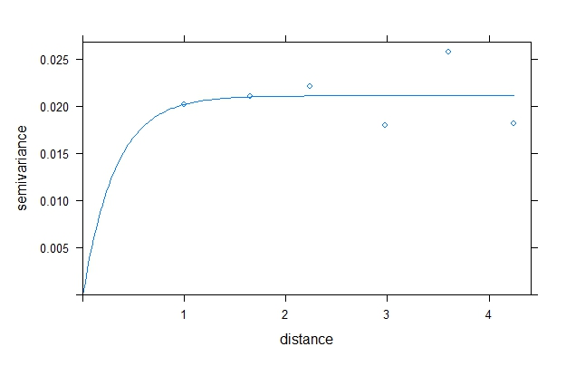
Figure 2: Exponential variogram where the nugget = 0.00, sill = 0.02 and range = 0.03 m.

Gaussian variogram (Gau)
Again, the gaussian model has no limit where there is a range, for this model the effective range is defined as $\sqrt{3α}$. The gaussian is similar to the exponential curve but has a normal probabilistic curve with an inflection point showing a quadratic increase near the nugget. The formula for the gaussian formula is:
$$γ\left(h\right)=C\left(1-e^{-\frac{h^{2}}{α^{2}}}\right) where C≥0$$
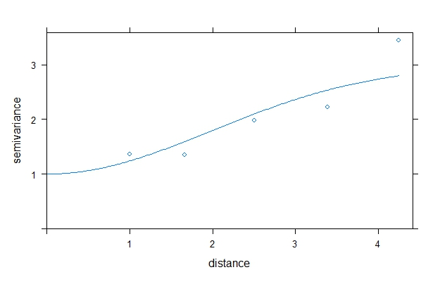
Figure 3: Gaussian variogram where the nugget = 1.00, sill = 3.00 and range = 2.80 m.

Wave variogram (Wav)
The wave model is different than the other three models as it has a “hole effect”, which is known as a periodic spatial structure. In other words, there are positive and negative correlations along the range that becomes less apparent as the range increases. The range for the wave model is the first peak in the sill in the positive direction. The formula is therefore:
$$γ\left(h\right)=C\left(1-π^{-1}\left(\frac{α}{h}\right)sin\left(\frac{πh}{α}\right)\right) where h ≠0$$
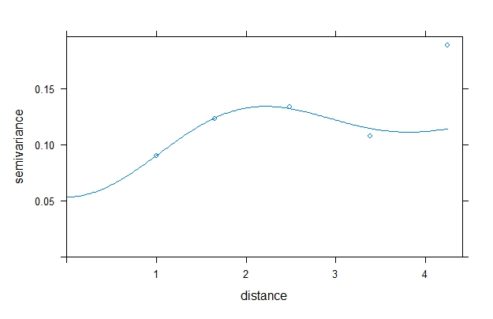
Figure 4: Wave variogram where the nugget = 0.05, sill = 0.13 and range = 1.55 m.

